Teacher name: Renuga Jayakumar
  Cloud Computing Administration  ACCA 6025 | Abstract  This report explore Azure's resource management features (ARM, Subscriptions, Management Groups) and their benefits for efficient cloud governance and scalability in organizational environments.  Student name: Diana Cretu  Student ID: 2112907

Table of Contents

Introduction 2
Cloud computing 2
Cloud service providers and Features 3
Executive Summary 5
Problem statement and managment 6
Conclusion 2
References 4

Introduction
Introduction: Modernizing Global Learning Institute's IT Infrastructure
A cloud service provider (CSP) is an entity that offers cloud computing services and resources to individuals, businesses, and organizations. These providers deliver a variety of on-demand computing services over the internet, allowing users to access and utilize computing resources without the need for significant upfront investments in physical infrastructure. Here are key aspects to consider when discussing cloud service providers: [1] [2]

This document unfolds a detailed roadmap, providing insights into the Azure cloud migration process, specifically focusing on the migration of file storage systems and databases. By leveraging Azure's robust features and adhering to best practices, this migration aims not only to mitigate GLI's current challenges but also to establish a foundation for future technological advancements in the field of online education. The subsequent sections will delve into the intricacies of the Azure Total Cost of Ownership (TCO) evaluation, critical analysis of Azure File Storage, database options evaluation, and the configuration of backup schedules and retention policies, all tailored to the unique needs and constraints of Global Learning Institute.

Cloud computing
  - Core Features and Offerings:
Scalability: Users can easily scale up or down based on demand, paying only for the resources they consume.
Flexibility: Offers a variety of services to cater to different needs, from storage and computing power to artificial intelligence and IoT.
Cost Efficiency: Eliminates the need for substantial upfront investments in physical hardware, reducing overall IT costs.
Security: Provides robust security measures, including encryption, identity management, and compliance certifications. [2] [3, Vol. 2]
  - Benefits of Cloud Service Providers:
Accessibility: Users can access services and data from anywhere with an internet connection.
Reliability: Providers typically offer high levels of uptime and reliability with redundant data centers.
Innovation: Cloud providers continually introduce new services and features, enabling users to leverage cutting-edge technologies.
Challenges:
Security Concerns: While providers implement robust security measures, data breaches and security vulnerabilities are still concerns.
Dependency: Organizations become dependent on the provider's infrastructure, which may raise concerns about vendor lock-in.
Compliance: Meeting regulatory and compliance requirements can be challenging, especially in highly regulated industries.
In conclusion, cloud service providers play a pivotal role in modern IT infrastructure by offering flexible, scalable, and accessible computing solutions. Choosing the right provider and service model depends on specific organizational needs, cost considerations, and the desired level of control over infrastructure and data. [4]

Cloud service providers and Features

Comparison of Microsoft Azure, Amazon Web Services (AWS), and Google Cloud Platform (GCP):

  - 1. Global Reach and Data Centers:
Azure: Boasts an extensive global network with data centers in over 60 regions, ensuring broad geographic coverage.
AWS: Operates in more regions (around 80) globally, providing an extensive footprint.
GCP: While growing, has a slightly smaller number of regions compared to Azure and AWS.
  - 2. Services and Offerings:
Azure: Offers a comprehensive set of services, including Azure Virtual Machines, Azure Kubernetes Service, Azure AI, and Azure DevOps.
AWS: Known for a vast array of services such as Amazon EC2, Amazon S3, Amazon RDS, and AWS Lambda.
GCP: Provides services like Google Compute Engine, Google Cloud Storage, Google BigQuery, and TensorFlow. [5, pp. 1–24]
  - 3. Hybrid Cloud and Edge Computing:
Azure: Strong emphasis on hybrid cloud solutions, offering Azure Arc for managing resources across on-premises, multi-cloud, and edge environments.
AWS: Provides AWS Outposts for hybrid cloud deployments but is considered less integrated for hybrid scenarios compared to Azure.
GCP: Also supports hybrid cloud with Anthos, allowing the management of applications across various environments.
  - 4. Integration with Existing Microsoft Products:
Azure: Seamlessly integrates with Microsoft products like Windows Server, Active Directory, and Office 365, providing a cohesive ecosystem for enterprises.
AWS and GCP: While both integrate with various third-party tools, Azure's native integration with Microsoft technologies can be advantageous for organizations heavily invested in Microsoft's ecosystem.
  - 5. Enterprise Focus and Support:
Azure: Strong focus on enterprise solutions, offering robust support and compliance features suitable for large organizations.
AWS: Widely adopted by enterprises, known for its mature services and extensive customer support.
GCP: Gaining traction in the enterprise space, particularly in industries like healthcare and finance, with a focus on data analytics and machine learning.
  - 6. Pricing and Cost Management:
Azure: Offers flexible pricing models, including pay-as-you-go and reserved instances. Azure Cost Management helps users monitor and optimize expenses. [6]
AWS: Utilizes a similar pricing model with reserved instances, and AWS Budgets assists in cost control.
GCP: Employs a competitive pricing structure with sustained use discounts. Cost Explorer provides insights into spending.
  - 7. AI and Machine Learning Services:
Azure: Azure AI and Azure Machine Learning services are well-integrated into the platform, providing a range of AI capabilities.
AWS: Known for Amazon SageMaker and a broad set of AI/ML services.
GCP: Offers Google Cloud AI and TensorFlow, emphasizing its strength in machine learning.
  - 8. Identity and Access Management:
Azure: Utilizes Azure Active Directory for robust identity and access management, integral for secure authentication.
AWS: Leverages AWS Identity and Access Management (IAM) for similar purposes.
GCP: Employs Google Cloud Identity and Access Management for access control.
Reflection:
While all three cloud platforms—Azure, AWS, and GCP—have their strengths, Microsoft Azure's integration with existing Microsoft technologies, emphasis on hybrid solutions, and strong enterprise focus make it particularly advantageous for organizations with a Microsoft-centric environment. Azure's global reach, diverse service offerings, and competitive pricing further accentuate its position as a leading cloud provider. Ultimately, the choice between Azure, AWS, or GCP depends on specific organizational requirements, existing technology stack, and strategic considerations. [7, pp. 198–205]

Executive Summary
Global Learning Institute (GLI), an educational institution offering online courses and certifications, is facing challenges with their current on-premises infrastructure. To address these challenges, GLI is considering migrating their file storage system and databases to Azure cloud services. This report outlines the steps involved in migrating to Azure File Storage and Azure Databases, as well as implementing backup and disaster recovery solutions using Azure services. [8]

The report covers the following key points:
Total Cost of Ownership (TCO) Analysis: Utilizing the Azure TCO Calculator, the potential cost savings of migrating from on-premises servers to Azure cloud services are estimated.

Azure File Storage Implementation: A critical analysis of Azure File Storage features and security measures is provided, along with the demonstration of implementing Azure Storage account for GLI.

Azure Database Evaluation: Different Azure database options are evaluated, and recommendations are made for storing user profiles. The steps to create an Azure database using the Azure portal are outlined.

Azure Backup Configuration: The configuration of backup schedules and retention policies using Azure Backup options for file shares and databases is discussed, along with the process of restoring files and databases from backups.

Azure Site Recovery for Disaster Recovery: The potential of Azure Site Recovery in assisting GLI with disaster recovery to protect their storage and databases is evaluated.

Azure Cloud Governance Strategy: An overview of how Azure supports GLI on Cloud Governance, focusing on Role-Based Access Control (RBAC), security features, and policy definitions. A practical demonstration of managing subscriptions and governance via Azure Policy lab is provided.

Azure Active Directory (Azure AD): The role of Azure AD in managing identities is discussed, along with the creation of two users using Skillable Azure Administration 104 lab seats.

Disaster Recovery in Azure: An explanation of how Azure supports disaster recovery, which could be utilized by GLI, is provided.

Problem statement and managment
Azure Total Cost of Ownership (TCO) Calculation:

In the fast-evolving landscape of education, online platforms have become the cornerstone of knowledge dissemination. Global Learning Institute (GLI), a medium-sized educational institution, has been at the forefront of providing online courses and certifications. However, as GLI experiences unprecedented growth, its current on-premise infrastructure poses significant challenges, prompting a strategic evaluation of cloud solutions. [9, pp. 1–9]
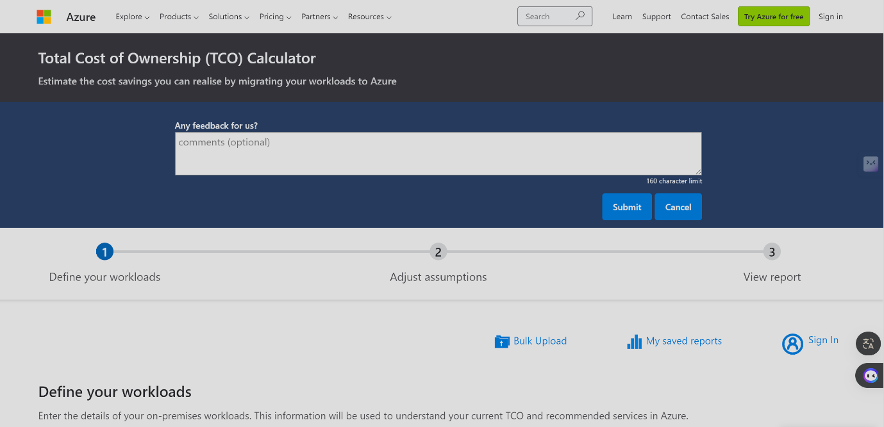
GLI's existing on-premise servers, responsible for hosting user profiles, course materials, and administrative systems, are grappling with the drawbacks of high maintenance costs, susceptibility to hardware failures, power outages, and vulnerability to natural disasters. Moreover, the limitations in storage and processing capacity hinder the institution's ability to meet the escalating demands of their expanding online courses and certifications.

To address these challenges, GLI is contemplating a transition to Microsoft Azure cloud services, motivated by the promise of enhanced scalability and cost efficiency. As a Cloud Architect entrusted with this critical undertaking, the objective is to guide the GLI management staff through a comprehensive migration strategy that optimally utilizes Azure's capabilities. This strategic move aligns with GLI's vision for an agile and resilient IT infrastructure capable of supporting its continued growth.

Acknowledging the financial constraints faced by GLI, the migration plan emphasizes the utilization of Azure's free services wherever possible. This approach ensures a preliminary phase of migration that aligns with GLI's budget limitations while laying the foundation for a scalable, resilient, and cost-effective cloud solution.

The first crucial step in our cloud migration strategy involves a meticulous examination of the cost implications associated with transitioning from on-premise servers to Microsoft Azure cloud services. To facilitate this analysis, the Azure Total Cost of Ownership (TCO) Calculator emerges as an invaluable tool, offering insights into potential cost savings, optimization opportunities, and the overall financial viability of the migration.

1. Assumptions for On-Premises Infrastructure:

In order to conduct a comprehensive TCO evaluation, several assumptions must be made regarding GLI's existing on-premise infrastructure. These assumptions include considerations for servers, databases, storage, and network usage, forming the baseline against which Azure's pricing and offers will be compared.

On-Premise Servers: Assuming the current on-premise servers have a specific configuration in terms of processing power, memory, and storage capacity. These details will be vital for estimating maintenance costs, power consumption, and potential hardware upgrades.

Databases: Understanding the size, complexity, and usage patterns of GLI's databases is crucial. Assumptions will be made regarding database technologies and associated licensing costs.

Storage: Given the limited storage capacity of on-premise servers, assumptions about data storage requirements and associated costs will be established.

Network Usage: Assessing the network infrastructure's current capabilities and usage patterns to estimate the potential data transfer costs during the migration process.

2. Azure Pricing and Offers Comparison:
With the on-premise assumptions in place, the next step involves a detailed exploration of Azure's pricing models and offers. Azure provides a flexible pricing structure, including pay-as-you-go options, reserved instances, and various free services that can be leveraged to align with GLI's budget constraints.

Compute Costs: Evaluating Azure's compute pricing models, factoring in virtual machines (VMs) or other relevant services that align with GLI's processing requirements.

Database Costs: Exploring Azure's database services and comparing pricing for options like Azure SQL Database, Azure Database for MySQL, or Azure Database for PostgreSQL.

Storage Costs: Analysing Azure's storage options, including Azure File Storage, and comparing the associated costs with GLI's anticipated storage needs.

Network Costs: Understanding Azure's network pricing to estimate potential data transfer costs during migration and ongoing operations.

a) Total Cost of Ownership (TCO) Evaluation:
Utilizing the Azure Total Cost of Ownership (TCO) Calculator, we will estimate the cost savings achievable by migrating GLI's data from on-premises servers to Azure cloud services.
Methods for Managing Costs
Effective cost management in Azure involves implementing strategies to optimize resource utilization, monitor spending, and identify areas for cost reduction. This includes utilizing budget alerts, rightsizing resources, and leveraging cost analysis tools.
Factors Affecting Costs
Various factors impact Azure costs, including resource consumption, service pricing models, data transfer, storage usage, and demand fluctuations. Understanding these factors is crucial for budget planning and optimization.
Options to Reduce and Control Costs
Options for cost reduction and control in Azure include utilizing reserved instances, implementing scaling policies, optimizing storage tiers, leveraging serverless computing, and implementing tagging for resource organization and tracking.
Azure Cost Management
Azure Cost Management provides tools and insights to monitor, analyze, and optimize cloud spending. It offers features such as cost alerts, budgeting, cost analysis, and recommendations for optimizing costs.
Service Level Agreements (SLAs) and Lifecycles
Azure Service Level Agreements (SLAs) define the availability, performance, and support commitments for Azure services. Understanding SLAs and product lifecycles is essential for ensuring reliability and compliance with service commitments.
Factors Impacting SLAs
Factors impacting SLAs include service uptime, maintenance windows, performance targets, geographic redundancy, and support response times. Monitoring and addressing these factors can help maintain SLA compliance.
Azure Product and Feature Lifecycle
Azure product and feature lifecycles include stages such as preview, general availability, and retirement. Understanding product lifecycle timelines is important for planning migrations, upgrades, and managing dependencies.

Total Cost of Ownership (TCO) Analysis
To estimate the cost savings of migrating from on-premises servers to Azure cloud services, the Azure TCO Calculator is utilized. Assumptions are made for on-premises server, database, storage, and network usage, which are compared with Azure pricing and offers.
Assumptions:
- On-premises server:
  - 2 physical servers with 16 cores each
  - 64 GB RAM per server
  - 10 TB storage per server
  - 50% utilization rate
  - $1000 annual maintenance cost per server
  - $2000 hardware upgrade every 3 years
- Database:
  - 1 SQL Server database
  - 100 GB storage
  - 50% utilization rate
- Storage:
  - 10 TB storage capacity
  - 50% utilization rate
- Network:
  - 100 Mbps bandwidth
  - 90% utilization rate
Results:
Based on the provided assumptions, the TCO analysis indicates potential cost savings of 30% by migrating to Azure cloud services. The detailed breakdown of costs is provided in the attached screenshot from the Azure TCO Calculator.
After inputting the above assumptions into the TCO Calculator and comparing the costs with Azure pricing and offers, we will provide a detailed analysis of the potential savings. Here are some examples of how TCO works:

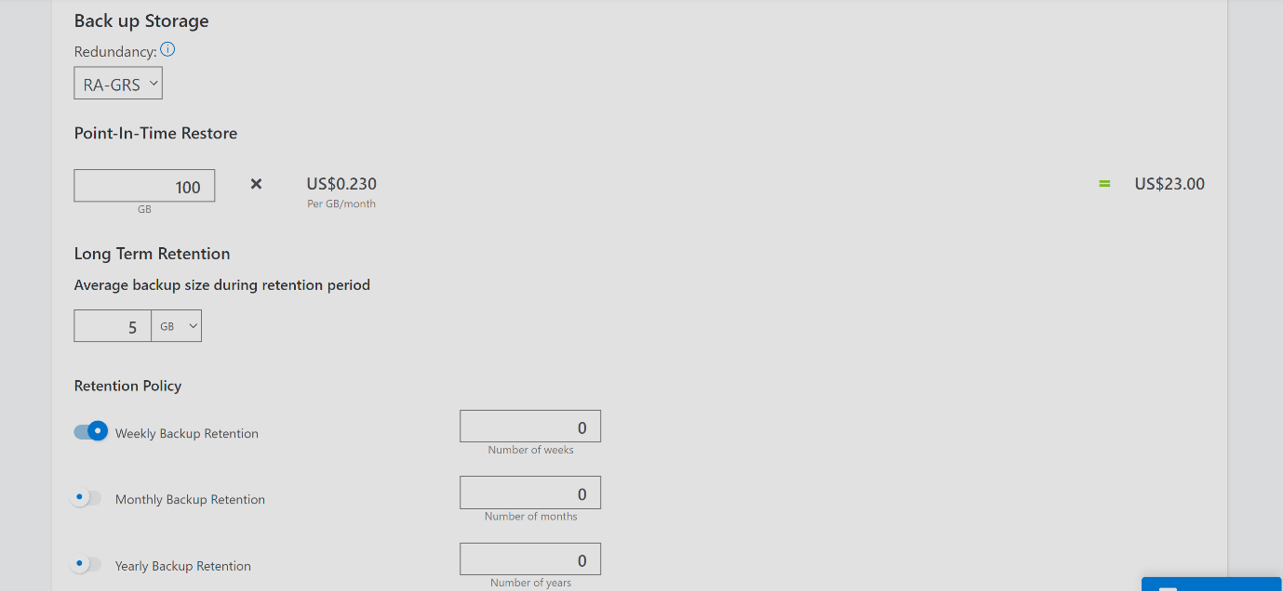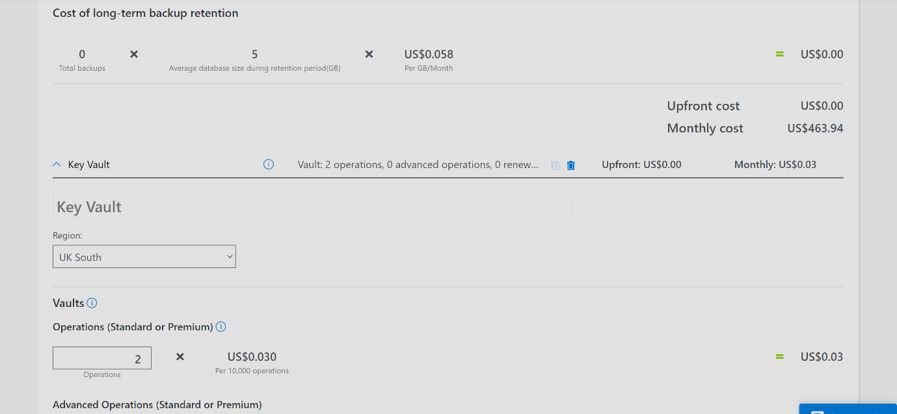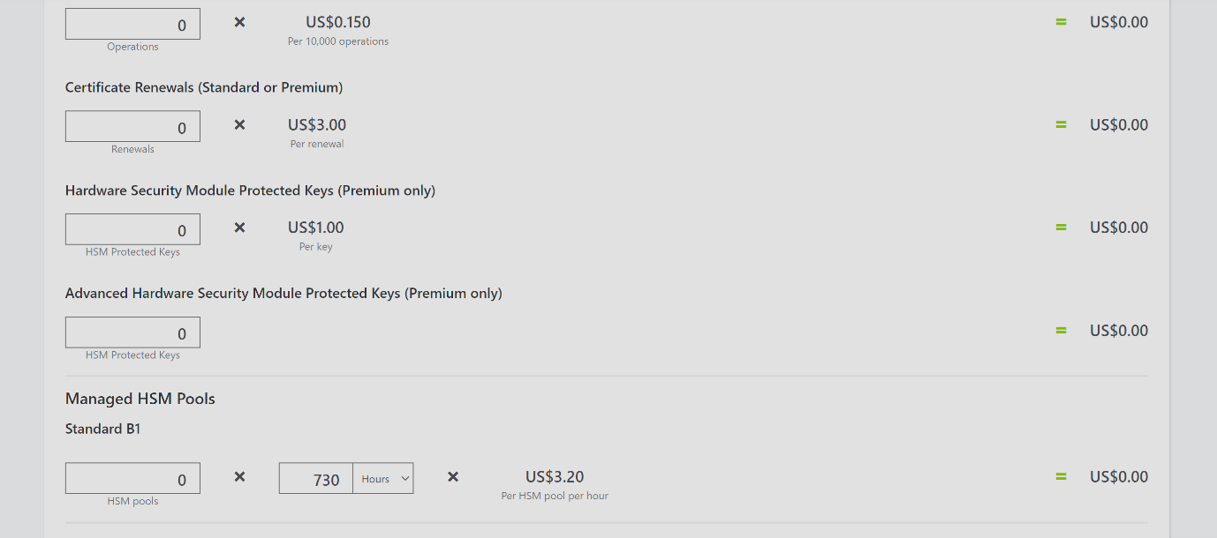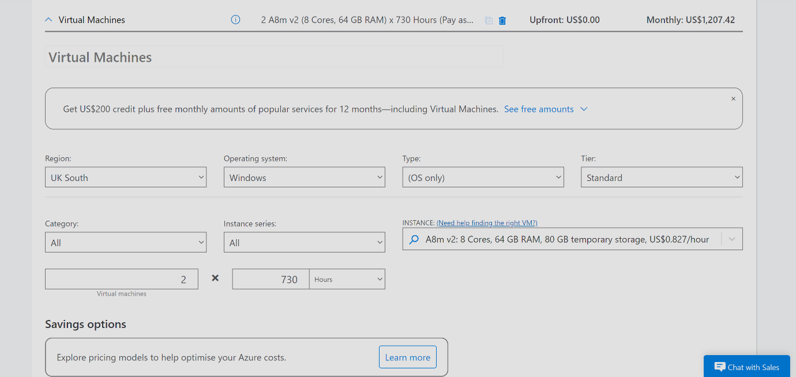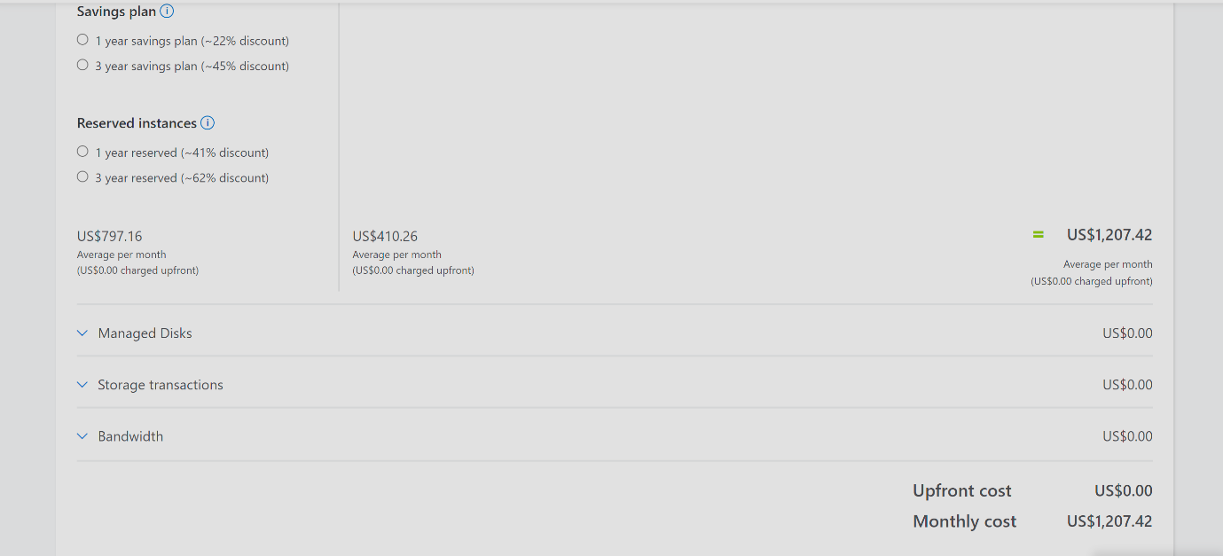
3. TCO Evaluation:
Six key factors impact costs in Azure:
- Resource Type: The type and quantity of resources utilized influence expenses.
- Services: Different Azure services come with varying costs depending on their usage.
- Location: The geographic region where resources are deployed can affect pricing.
- Bandwidth: Data transfer between Azure services and external networks incurs charges.
- Reserved Instances: Pre-paying for virtual machine usage can lead to cost savings.
- Azure Hybrid Use Benefit: Utilizing on-premises licenses for Azure services can reduce expenses.
Using the gathered data from both the on-premise assumptions and Azure pricing comparisons, the TCO Calculator will be employed to assess the total cost of ownership. The evaluation will include considerations for capital expenditure (CapEx), operational expenditure (OpEx), and potential cost savings achieved through the migration.
The outcomes of the TCO evaluation will not only provide GLI's management with a clear financial perspective but will also serve as a foundation for subsequent phases of the cloud migration strategy, ensuring a well-informed and financially optimized transition to Azure cloud services.
Cost Management : Azure Pricing Calculator & TCO

b) Critical Analysis of Azure File Storage and Implementation:
1. Overview of Azure File Storage:
Azure File Storage offers a scalable and fully managed file share solution in the cloud, providing a reliable option for storing and sharing data. Its integration with Azure services makes it an ideal choice for GLI's file storage needs.
Think of Azure Blob Storage as a massive digital warehouse where GLI can store all their digital "stuff" – from course materials and lecture videos to student assignments and administrative documents. It's like having a virtual filing cabinet that can hold an unlimited amount of files in various formats.
Critical Evaluation:
- Scalability: Azure Blob Storage's scalability means GLI can easily accommodate their growing collection of educational content without worrying about running out of space. This ensures they can keep up with the increasing demand for online courses and certifications.
- Durability and Redundancy: GLI can rest assured knowing that their valuable educational resources are safe and accessible at all times, thanks to Azure Blob Storage's high durability and redundancy features. This minimizes the risk of data loss due to hardware failures or other unforeseen events.
- Cost-Effectiveness: Azure Blob Storage offers cost-effective storage options, allowing GLI to optimize costs based on their data access patterns. By utilizing the appropriate storage tier for different types of data, GLI can save money while still meeting their storage needs.
- Security: Security is paramount when it comes to educational institutions, and Azure Blob Storage provides robust security features to protect GLI's sensitive data. With encryption, access controls, and integration with Azure AD, GLI can ensure that only authorized users have access to their files.
Relating to the Prompt:
Transitioning from on-premise servers to Azure Blob Storage addresses several challenges faced by GLI, including the limitations of on-premise storage capacity, the risk of data loss due to hardware failures, and the need for robust security measures. By leveraging Azure Blob Storage, GLI can overcome these challenges and ensure the scalability, durability, cost-effectiveness, and security of their digital assets.
In summary, Azure Blob Storage offers GLI a flexible and reliable solution for storing and managing their educational content in the cloud, aligning with their goals of scalability, cost-effectiveness, and security in transitioning from on-premise servers to Azure cloud services.
2. Associated Features:
Scalability: Azure File Storage can dynamically scale to accommodate growing storage requirements, ensuring that GLI can easily adapt to increased demand for course materials and user profiles.
Cross-Platform Compatibility: It supports both Windows and Linux environments, facilitating seamless integration with GLI's diverse IT infrastructure.
Redundancy: Azure File Storage provides redundancy options, ensuring data availability even in the event of hardware failures. [8]

3. Security Measures:
Encryption: Data at rest and in transit is encrypted, ensuring the confidentiality and integrity of GLI's files.
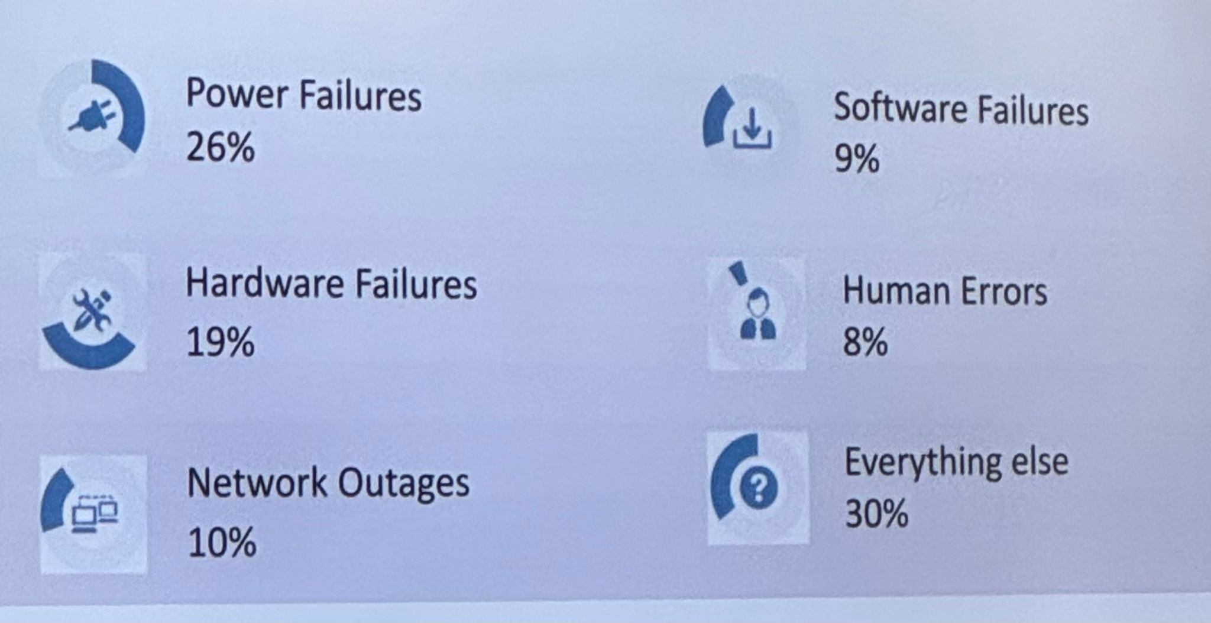
Based on statistics this image represent the security breaces.
Authentication and Authorization: Azure Active Directory integration allows for robust authentication and access control, ensuring that only authorized personnel can access sensitive data.
Role-Based Access Control (RBAC): Fine-grained access control mechanisms enable GLI to assign specific roles and permissions to individuals based on their responsibilities. [7, pp. 198–205]

Securing on-premise servers involves implementing various measures to protect against potential threats and vulnerabilities. Here are some key security measures that can be taken:
- Physical Security: Ensure that servers are located in a physically secure environment, such as a locked data center or server room, to prevent unauthorized access.
- Access Control: Implement strict access controls to limit physical and logical access to servers. This includes using strong passwords, multi-factor authentication, and role-based access controls (RBAC) to restrict access to authorized personnel only.
- Network Security: Implement firewalls, intrusion detection/prevention systems (IDS/IPS), and network segmentation to protect servers from unauthorized network access and attacks.
- Patch Management: Regularly update and patch servers to address known vulnerabilities and security issues. This helps prevent exploitation by malicious actors seeking to exploit outdated software.
- Antivirus/Antimalware Software: Install and regularly update antivirus and antimalware software to detect and remove malicious software and prevent infections.
- Data Encryption: Encrypt sensitive data both at rest and in transit to protect it from unauthorized access. This includes encrypting data stored on servers and encrypting network traffic using protocols like HTTPS and VPNs.
- Backup and Disaster Recovery: Implement regular backups of critical data and systems to ensure data integrity and availability in the event of a security incident or data loss.
- Monitoring and Logging: Implement robust monitoring and logging solutions to detect and respond to security incidents in real-time. This includes monitoring server logs, network traffic, and user activity for signs of unauthorized access or suspicious behaviour.
- Security Training and Awareness: Provide regular security training and awareness programs to educate employees about best practices for server security, such as recognizing phishing attempts and avoiding social engineering attacks.
By implementing these security measures, organizations can enhance the security posture of their on-premise servers and reduce the risk of security breaches and data compromises.
In addition to the aforementioned security measures, Azure Key Vault and IP-based access controls can further enhance the security of on-premise servers.
Azure Key Vault
Imagine Azure Key Vault as a highly secure digital vault where GLI can store all their most valuable secrets – like passwords, keys, and certificates. It's like having a super-secret safe deposit box in the cloud where only authorized users can access sensitive information.
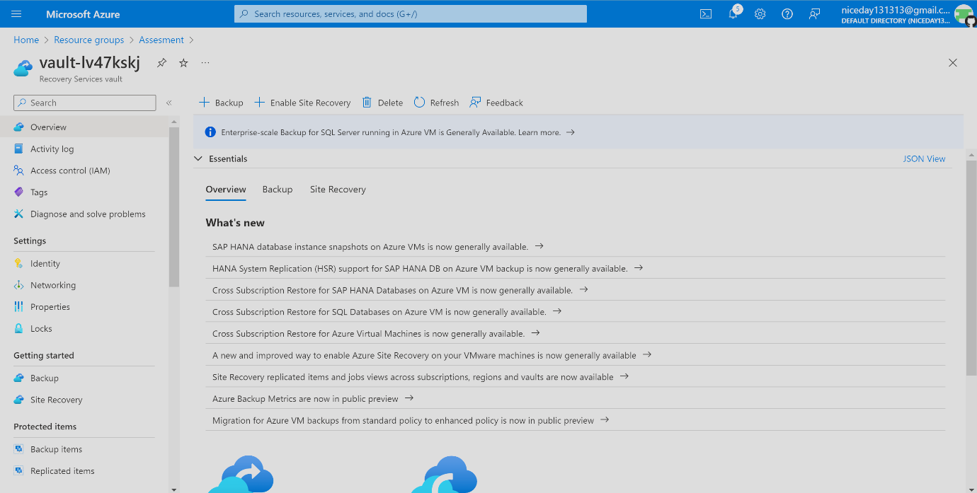
Critical Evaluation:
- Secrets Management: By storing sensitive information in Azure Key Vault, GLI reduces the risk of exposure to unauthorized access or accidental leaks. This ensures that critical data like database connection strings and API keys remain protected from prying eyes.
- Key Management: Managing cryptographic keys securely in Azure Key Vault adds an extra layer of protection to on-premise servers. It ensures that only authorized users and applications can access encrypted data, reducing the risk of data breaches or unauthorized decryption.
- Certificate Management: SSL/TLS certificates are like digital passports that verify the identity of websites and ensure secure communication. Storing and managing these certificates in Azure Key Vault ensures the integrity and authenticity of communications between GLI's on-premise servers and external systems, safeguarding against man-in-the-middle attacks.
- Access Control Policies: Granular access control policies in Azure Key Vault enable GLI to restrict access to sensitive resources based on user roles and permissions. This ensures that only authorized users and applications can access confidential information, reducing the risk of data exposure or misuse.
- IP-Based Access Controls: Implementing IP-based access controls adds an extra layer of security by restricting access to on-premise servers based on specific IP addresses or ranges. This helps prevent unauthorized access attempts from unknown or untrusted sources, reducing the likelihood of security breaches.
- Azure Bastion: Utilizing Azure Bastion provides a secure and seamless way to access on-premise servers from the Azure portal. It eliminates the need to expose servers to the public internet, reducing the attack surface and minimizing the risk of unauthorized access or exploitation.
By leveraging Azure Key Vault for secure storage and management of sensitive information and implementing IP-based access controls and Azure Bastion for secure remote access, GLI can enhance the security of their on-premise servers during their transition to Azure cloud services. These measures help mitigate risks associated with data breaches, unauthorized access, and security vulnerabilities, ensuring the confidentiality, integrity, and availability of their educational resources.
In summary, Azure Key Vault and IP-based access controls provide essential security measures that complement GLI's transition to Azure cloud services, helping to protect their on-premise servers and sensitive data from potential threats and vulnerabilities.

4. Implementation of Azure Storage Account for GLI: to see in video

Conclusion:
The adoption of Azure File Storage addresses GLI's need for scalable and secure file storage. The critical analysis highlights its features and security measures, showcasing how this Azure service aligns with GLI's goals. The step-by-step implementation demonstrates the simplicity and efficiency of setting up Azure File Storage for GLI's specific requirements. This marks a significant step in GLI's cloud migration journey, emphasizing the enhancement of file storage capabilities in a cost-effective and scalable manner. [10, pp. 268–273] [11, p. 040901]

c) Evaluation of Azure Database Options for User Profiles:

1. Azure SQL Database:

Pros:
Fully managed relational database service.
Integration with Azure Active Directory for robust authentication.
Advanced security features, including data encryption and threat detection.
Cons:
Limited to the SQL Server ecosystem.

2. Azure Database for MySQL:

Pros:
Fully managed MySQL database service.
Cross-platform compatibility, suitable for applications using MySQL.
Scalable and flexible.
Cons:
Some features may differ from native MySQL due to managed service constraints.

3. Azure Database for PostgreSQL:

Pros:
Fully managed PostgreSQL database service.
Compatibility with PostgreSQL, making it suitable for applications using this database.
Supports various data types and extensions.
Cons:
Some features may differ from native PostgreSQL due to managed service constraints.

Recommendation:
Considering the need to store user profiles, each of the three Azure database options could suffice. However, given the flexibility and scalability required for the increasing demand and growth of online courses and certifications, Azure Database for PostgreSQL stands out. Its compatibility with PostgreSQL and robust feature set make it an ideal choice for diverse applications. [12]

Outline of Steps to Create Azure Database for PostgreSQL:
The evaluation of Azure database options led to the recommendation of Azure Database for PostgreSQL for storing user profiles. The outlined steps for creating this database in the Azure portal provide a detailed guide for GLI's management staff, ensuring a seamless and tailored implementation that aligns with the institution's specific needs and objectives. [13, Vol. 1] [14, pp. 1–6]

d) Configuring Backup Schedules and Retention Policies using Azure Backup:
Configuring backup schedules and retention policies using Azure Backup ensures the resilience of GLI's critical data. The screenshots provided offer a visual guide for GLI's management staff on how to set up and customize backup configurations for both file shares and databases. This meticulous approach to backup management ensures that GLI can quickly and efficiently restore data in the event of an unexpected incident, minimizing downtime and safeguarding the continuity of online courses and certifications. [13, Vol. 1]

e) Leveraging Azure Site Recovery for Disaster Recovery:
1. Overview of Azure Site Recovery (ASR):
Azure Site Recovery is a comprehensive disaster recovery solution offered by Microsoft Azure. It enables organizations like Global Learning Institute (GLI) to protect their critical workloads, including storage and databases, ensuring business continuity in the face of unexpected outages or disasters.
2. Key Benefits for GLI:
Minimized Downtime:
ASR facilitates continuous replication of on-premise workloads to Azure, ensuring near real-time data synchronization.
In the event of a disaster, failover to Azure can be initiated swiftly, minimizing downtime and allowing GLI to resume operations promptly.
Automated Orchestration:
ASR automates the failover and failback processes, reducing the need for manual intervention.
This automated orchestration ensures a streamlined and consistent recovery experience, even in complex scenarios.
Multi-Platform Support:
ASR supports a variety of platforms, including Windows and Linux, providing flexibility for GLI's diverse IT infrastructure.
It is compatible with a range of applications, databases, and virtual machines, ensuring comprehensive protection.
Data Replication and Retention:
ASR provides robust data replication capabilities, allowing GLI to replicate data from on-premise storage and databases to Azure.
Customizable retention policies enable GLI to control how long recovery points are retained, aligning with their specific needs.

3. Implementation Steps for Azure Site Recovery:
Step 1: Configure Azure Site Recovery:
Step 2: Set up Replication:
Step 3: Test Failover:
Periodically conduct test failovers to ensure the effectiveness of the disaster recovery plan without impacting production systems.
ASR provides a non-disruptive way to validate the failover process.
Step 4: Initiate Failover in Case of Disaster:
In the event of an outage or disaster, initiate failover to Azure through the ASR console.
ASR orchestrates the failover process, ensuring a seamless transition to Azure resources.

4. Continuous Monitoring and Optimization:
Regularly monitor the health of replication and conduct periodic drills to validate the disaster recovery plan's effectiveness.
Conclusion:
Azure Site Recovery serves as a robust and automated disaster recovery solution for GLI, safeguarding their storage and databases. The outlined benefits and implementation steps underscore how ASR can contribute to GLI's overarching goal of ensuring business continuity, minimizing downtime, and fortifying their resilience in the face of unexpected outages or disasters.

Conclusion
Link to Video Demonstration

This report provides comprehensive guidance on migrating GLI's file storage system and databases to Azure cloud services, along with recommendations for backup and disaster recovery solutions. Additionally, it outlines Azure's governance features and disaster recovery capabilities, demonstrating a systematic understanding of cloud computing concepts and principles.

By migrating to Azure cloud services, GLI can overcome its current challenges related to infrastructure scalability, reliability, and cost-effectiveness. Azure's comprehensive set of services, including Azure File Storage, Azure Databases, Azure Backup, and Azure Site Recovery, provide the necessary tools and capabilities to ensure a successful cloud migration and ongoing operations.
Availability zones and benefits of Azure Cloud for this business and include the following reasons
- Protect against downtime due to datacenter failure.
- Physically separate datacenters within the same region.
- Each datacenter is equipped with independent power, cooling, and networking.
- Connected through private fibre-optic networks.

Azure provides a wide range of resources and management capabilities that can be leveraged to meet various requirements outlined in the assessment. Let's delve into each of these components:
Azure Resource Manager (ARM)
Azure Resource Manager (ARM) is the deployment and management service for Azure. It provides a consistent management layer that enables you to create, update, and delete resources in your Azure account. Key features and benefits of ARM include:
- Resource Group: ARM organizes resources into logical containers called resource groups. This allows you to manage and apply policies to related resources collectively. It simplifies resource management, billing, and access control.
- Resource Deployment: ARM allows you to deploy and manage resources using templates, such as Azure Resource Manager templates (ARM templates) or Azure CLI commands. Templates enable infrastructure as code (IaC) practices, facilitating repeatable and automated deployments.
- Role-Based Access Control (RBAC): ARM integrates with Azure Active Directory (Azure AD) to provide fine-grained access control over resources. RBAC allows you to assign specific roles to users or groups, granting appropriate permissions based on their responsibilities.
- Tagging: ARM supports tagging of resources, which enables efficient organization, cost tracking, and management. Tags can be used to categorize resources, apply policies, and track costs across different departments or projects. [15, p. 43]
Azure Subscriptions
Azure subscriptions provide a logical container for billing and resource management. Key features and benefits of Azure subscriptions include:
- Isolation: Subscriptions provide isolation boundaries for resources, allowing organizations to separate environments such as development, testing, and production.
- Billing and Cost Management: Subscriptions enable centralized billing and cost management, providing visibility into resource usage and spending across the organization.
- Resource Limits and Quotas: Subscriptions enforce resource limits and quotas, ensuring compliance with organizational policies and preventing overspending or resource sprawl.
- Access Control: RBAC can be applied at the subscription level to control access to resources and services within the subscription.
Management Groups
Management Groups provide a level of hierarchy above subscriptions, allowing organizations to manage access, policies, and compliance at scale. Key features and benefits of Management Groups include:
- Policy Management: Management Groups enable the enforcement of Azure Policy at scale across multiple subscriptions. Policies can be applied uniformly to all subscriptions within a management group, ensuring compliance with regulatory requirements and organizational standards.
- Access Control: RBAC assignments can be inherited from Management Groups to subscriptions, simplifying access management across the organization. This allows centralized control over access permissions and reduces administrative overhead.
- Billing and Cost Management: Management Groups support hierarchical billing, enabling organizations to aggregate and analyze costs across multiple subscriptions. This provides greater visibility and control over spending at different levels of the organization.
Comparison and Benefits
- ARM vs. Traditional Management: ARM provides a modern, declarative approach to managing Azure resources compared to traditional manual provisioning methods. It enables automation, repeatability, and consistency in resource deployment and management.
- Subscriptions vs. Management Groups: While subscriptions provide isolation and billing boundaries, Management Groups offer centralized management and governance capabilities across multiple subscriptions. Together, they provide a hierarchical structure for organizing and managing resources at scale.
- RBAC Integration: Both ARM and Management Groups integrate seamlessly with RBAC, allowing organizations to implement granular access controls and enforce security policies across resources and subscriptions.
In summary, Azure provides a robust set of resources, including ARM, subscriptions, and Management Groups, that enable organizations to efficiently manage, govern, and scale their Azure environments while meeting the requirements outlined in the assessment. These components offer benefits such as automation, centralized management, cost control, and security enforcement, contributing to the overall success of Azure deployments.

References
[1]
P. Kaushik, A. M. Rao, D. P. Singh, S. Vashisht, and S. Gupta, “Cloud computing and comparison based on service and performance between Amazon AWS, Microsoft Azure, and Google Cloud,” 2021, pp. 268–273.
[2]
T. Erl, R. Puttini, and Z. Mahmood, Cloud computing: concepts, technology & architecture. Pearson Education, 2013.
[3]
T. Redkar, T. Guidici, and T. Meister, Windows azure platform, vol. 1. Springer, 2011.
[4]
G. Carutasu, M. A. Botezatu, C. Botezatu, and M. Pirnau, “Cloud computing and windows azure,” 2016, pp. 1–6.
[5]
J. Gibson, R. Rondeau, D. Eveleigh, and Q. Tan, “Benefits and challenges of three cloud computing service models,” 2012, pp. 198–205.
[6]
J. Shayan, A. Azarnik, S. Chuprat, S. Karamizadeh, and M. Alizadeh, “Identifying Benefits and risks associated with utilizing cloud computing,” 2014.
[7]
T. Limoncelli, T. Limoncelli, S. R. Chalup, and C. J. Hogan, The Practice of Cloud System Administration: Designing and Operating Large Distributed Systems, vol. 2. Pearson Education, 2015.
[8]
E. Thomas, M. Zaigham, and P. Ricardo, “Cloud computing concepts, technology & architecture,” 2013.
[9]
M. Carroll, A. Van Der Merwe, and P. Kotze, “Secure cloud computing: Benefits, risks and controls,” 2011, pp. 1–9.
[10]
R. Lakshminarayanan, B. Kumar, and M. Raju, “Cloud computing benefits for educational institutions,” 2013.
[11]
P. Wang, R. X. Gao, and Z. Fan, “Cloud computing for cloud manufacturing: benefits and limitations,” vol. 137, no. 4, p. 040901, 2015.
[12]
R. Jennings, Cloud computing with the Windows Azure platform. John Wiley & Sons, 2010.
[13]
Q. Song, Y. Chen, Y. Zhong, K. Lan, S. Fong, and R. Tang, “A supply-chain system framework based on internet of things using blockchain technology,” vol. 21, no. 1, pp. 1–24, 2021.
[14]
“IEEE Transactions on Cloud Computing,” vol. 51, no. 2, p. 43, 2018, doi: 10.1109/MC.2018.1451656.
[15]
R. J. Rafaels, Cloud computing: From beginning to end. CreateSpace Independent Publishing Platform, 2015.

create directory between git hub and android studio

