
Professional Career Development

Table of Contents
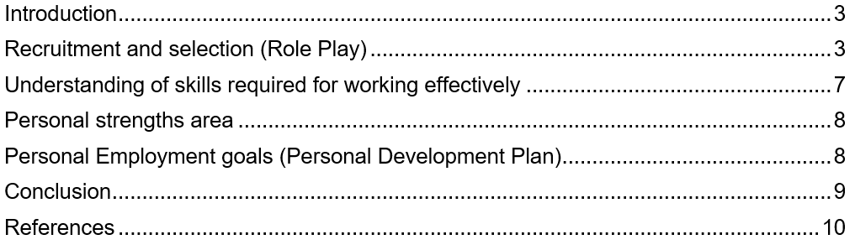

Introduction
The learning process through reflection increases the ability of the learners to learn more implicit and explicit knowledge about any particular topic (Suleman, 2018). Here, the assessment has been developed as a reflection in which the reflection about my role as a nervous within a healthcare institution has been given. Here, a discussion-based between myself and one of my class partners has been regarding the recruitment and selection system in the healthcare sector for the nurses. The report has been prepared by using the theory of reflection provided by Gibbs. Besides, my areas of strength and weaknesses have been identified throughout this assessment, and also I have found some of the future opportunities and threats of my skills regarding nursing and the recruitment and selection process of the institutions across the UK. Here, my personal employment goal has been selected as to become a healthcare professional in a large healthcare institution in the UK. Also, I focused on that employment plan my reflection from the learning of role-playing and career development stages has been discussed in this assessment.

Recruitment and selection (Role Play)
As already discussed that I have played a role play station with one of my classmates regarding the recruitment and selection of nurses in healthcare institutions (Wickramasinghe and Perera, 2010). The role-play has been played as a nurse in me and my friend has acted as one of the researchers who want to research the recruitment process of different institutions in the health and social care sector. Now, my learning regarding this particular role play station has been discussed below with the use of the Gibbs model of reflection.
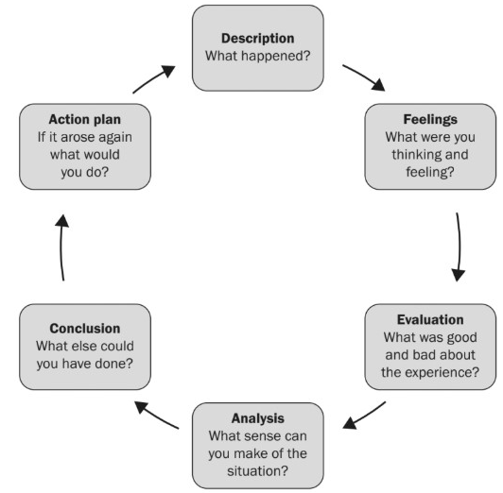
Figure: Gibbs model of Reflection
Source: (Rosenberg, et al. 2012)
Description
Here, myself has played the role of a nurse and have also been involved in different internal activities of a small-medium type of healthcare institution (Markkanen, et al. 2020). Here, we both have discussed some of the common procedures in the UK institutions in the health and social care sector for recruiting nurses. Here, we discuss the fact that the online and offline processes are available in the Recruitment and selection process of the nurses in those institutions. Here, we that any individual need to prepare an effective CV and then they need to submit the digital copy of the CV in the official email address of any institution. Then, the Human resource department evaluates that particular CV, and then the Human resource department contact the interview and for the examination rules for selecting the better employees as nurses in the institution (Rosenberg, et al. 2012). We also discussed the compensation plan developed by HR professionals in the health and social care sector for attracting the staff in the institutions. Also, we talked about the initial onboarding process of every health institution for the nurses.
Feelings
Regarding the role-play interview with my partner, my feeling was quite good initially. Also, personally feel that I have been able to express my ideas with my partner which has made the role-playing session more effective and informative (Lowden, et al. 2011). Also, we faced difficulties initially because my partner was not as good as me in speaking English so I had to focus on her language to understand what she was trying to say. Besides, I also feel that she was quite narrow was initially because it was her first time to play a role in any interview session in the class. Besides, I also feel that I have used lots of phases and idioms during the conversation with my partner which has made it quite good and both of us have enjoyed the session for 20 minutes.
Evaluation
In the evaluation stage, I would like to discuss some of the good and bad experiences regarding the interview session. Here, among some good experiences I have found that I have used my phrases and idioms related learning in the discussion we have improved my confidence level in public speaking (Laguna-Sánchez, et al. 2020). Also, both I and my partner have been quiet extroverts in nature which was another good experience regarding this discussion session. Also, another good experience as we understood each other and we discussed some of the authentic qualitative information that has increased the level of knowledge for both of us regarding the recruitment and selection process for nurses in health and social care institutions in the UK. Now, let’s discuss the view of the bad experiences among them only 20 minutes has been the worst thing in this interview session (He, et al. 2018). Also, the mentor during the class has not been quite supportive which has made both of us nervous in the initial stages of the interview session which was another bad experience regarding the role play station. Also, both of us have less knowledge about some of the current practices of recruitment and selection process in healthcare institutions which have been another bad experience regarding the role-play session.
Analysis
My observation analyses that the discussion is going to be quite important for both of us because we discussed lots of qualitative information regarding recruitment and selection of the Health and social care sector (Chen, 2021). Also, we discussed a few of the tactics of the Human resource department of Health and social care institutions which increase my knowledge about effective HR practices regarding the selection process. Besides, I believe that the discussion session that has been held between myself and my partner will also improve my interaction skills to communicate with any individual to exchange information about any topic. Also, my knowledge has been increased regarding the handling of an individual who has less knowledge and proficiency over English.
Conclusion
In the conclusion stage, I would like to discuss the view of the fact that I could have done better in the role play station with my partner. Here, I believe that I could have done better if I have on researched the topic of recruitment and selection in learning to prepare more effective questions in the interview session (Adeani, et al. 2020). Also, if I could have used my skills to write down some notes during the interview session and then I could have made more use of those 20 minutes allocated for us to conduct the discussion session. Besides, I could have used my smartphone to search for some existing data and information about the recruitment and selection process of nurses in the hospitality sector to make the discussion process much informative and effective.
Action plan
The action plan is the last stage of the model in which an individual discusses the actions that will be taken by the individual house if the situation arises again (Laguna-Sánchez, et al. 2020). Here, I would like to say that if I involve myself in this type of interview session in the future I would note down different information of the discussion in a paper. I will also use Cornell’s model of note-taking to take notes of the interview session. Also, I will focus on understanding the language of my partner if he is not from a British background. Besides, I will start the conversation with my partner in an informal way why we reach both of us can be very relaxed before involved in the main interview part. Those are some of the actions that I will focus on in the future if I involve myself in such interview sessions in future.

Understanding of skills required for working effectively
- Communication skills
Here, communication skills are very important for working effectively as a nurse in any health care institution (Markkanen, et al. 2020). Any individual needs to collect data and also share different types of data with professionals and doctors which requires good communication skills. Both written and verbal communication skills are required by an individual to become a successful nurse.
- Technological knowledge
Any individual needs to have proper IT skills to work effectively as a nurse in any health and social care institution. A person needs to know about using the computer and digital data server in the health care institution to contribute to the development of the institution (Rosenberg, et al. 2012). Also, the person needs to have proper PowerPoint presentation skills to present any topic in front of the doctors or health care professionals.
- Leading skills
Any individual needs to have proper leading skills to become a good nurse in any health and social care institution (Suleman, 2018). By having better research skills, any individual can promote themselves upward to become a healthcare professional in any institution.
- Managerial skills
Any person needs to have proper managerial skills to manage all the activities within the given time as a nurse to maintain the flow of activities in the health and professional sector (Adeani, et al. 2020). Also, managerial skills improve the option and opportunity to think about developing different tactics in the institution that makes the work process much easier for any nurse.

Personal strengths area
- I have better strength in public speaking and interacting with others with my language skills.
- I also have good theoretical knowledge about the roles and responsibilities of energy in any healthcare institution.
- I have good problem-solving skills which are very useful in the nursing profession across the world.
- I have much proficiency in using computers and Microsoft Excel which is one of the crucial skills to have as a nurse in the workplace.

Personal Employment goals (Personal Development Plan)
The personal development plan has been prepared in this regard in my employment goal of becoming a Health care professional in the future in any large institution in the UK (Rosenberg, et al. 2012). Here, in this assessment, I have already discussed a few of the areas of my strength and now I have prepared a personal development plan to improve a few of my areas of lacking which may be useful to increase my employability in the future.
Area of improvement | Actions to be taken | Implementation in future | Time Horizon
Research skills | I will join an online course for 4 months to improve my research skills. There, I will learn about both qualitative and quantitative research that is used in the professional sector of nursing in the internal institution. | By using my research skills in the future I will be able to analyze the internal requirements of the institution in the health and social care sector (Wickramasinghe and Perera, 2010). Also, I will be able to improve my knowledge about any topic by searching them on the online platform by conducting the secondary research. | 4 months
Time management | To my knowledge regarding time management, I will prepare my routing and try to strictly follow the personal routine in my regular life (He, et al. 2018). Also, I will watch different motivational videos from motivational speakers to learn more about the importance of time management and prepare an effective routine for myself. | I will use my time management skill in the future to accomplish various activities within the given time. Also, I will be able to prepare an effective work routine for all. | 4 months

Conclusion
So, at last, it can be said that the professional activities for any individual to become in h in future requires lots of research about various effective practices. Also, the reflection shows that I and my partner had a good session among ourselves regarding the discussion about recruitment and selection of nurses in healthcare institutions. Also, the report has discussed my areas of strength and also prepared the table of my future employability skill development regarding two different areas one is time management another one is research skills. Also, I believe that by improving my existing research skills and increasing my time management skills I will be able to improve my employability skill as a nurse and will be able to become a Health care professional in the future.

References
Adeani, I.S., Febriani, R.B. and Syafryadin, S., 2020. USING GIBBS’REFLECTIVE CYCLE IN MAKING REFLECTIONS OF LITERARY ANALYSIS. Indonesian EFL Journal, 6(2), pp.139-148.
Chen, J.H., 2021. Augmenting Student and Professional Training with Peer Learning Groups: Results from Focus Group Interviews (Doctoral dissertation, Rutgers The State University of New Jersey, Graduate School of Applied and Professional Psychology).
He, K.N., Parkinson, L. and Doyle, A.K., 2018. Gibbs’ Reflective Cycle.
Husebø, S.E., O'Regan, S. and Nestel, D., 2015. Reflective practice and its role in simulation. Clinical Simulation in Nursing, 11(8), pp.368-375.
Laguna-Sánchez, P., Abad, P., de la Fuente-Cabrero, C. and Calero, R., 2020. A university training programme for acquiring entrepreneurial and transversal employability skills, a students’ assessment. Sustainability, 12(3), p.796.
Lowden, K., Hall, S., Elliot, D. and Lewin, J., 2011. Employers’ perceptions of the employability skills of new graduates. London: Edge Foundation.
Markkanen, P., Välimäki, M., Anttila, M. and Kuuskorpi, M., 2020. A reflective cycle: Understanding challenging situations in a school setting. Educational Research, 62(1), pp.46-62.
Rosenberg, S., Heimler, R. and Morote, E.S., 2012. Basic employability skills: A triangular design approach. Education+ Training.
Suleman, F., 2018. The employability skills of higher education graduates: insights into conceptual frameworks and methodological options. Higher Education, 76(2), pp.263-278.
Wickramasinghe, V. and Perera, L., 2010. Graduates', university lecturers' and employers' perceptions towards employability skills. Education+ Training.

