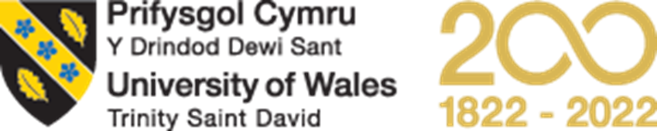
Nilupa Begum 2114298

BMPS5011
Based on one theory/concept or idea that you have studied within the module, create an E-Portfolio Evidence of Learning (2000 words)

Task 1
Link https://uowtsdmy.sharepoint.com/:p:/g/personal/2114298_student_uwtsd_ac_uk/EZHX_0X2ctlIgrAtoSP8gQ4B3_CAkNpiykKJ2lNWxkMmQw?e=BYos0w
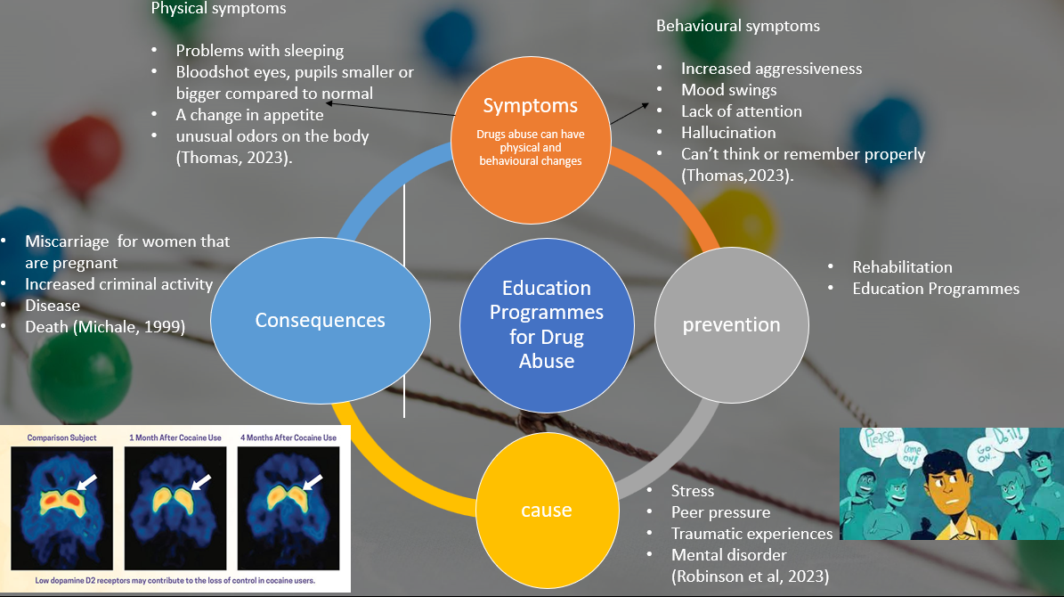

Task 2
The idea I have chosen is Education programmes for drug abuse to help, educate and aware people within society about drug misuse. Young people are vulnerable to using drugs as they are more likely to become addicted. Therefore, this can be dangerous for them as the brains of young people continue to develop and grow until they are in their mid-20s. According to (National Library of Medicine, 2019) young adults still have a developing prefrontal cortex, which is where decisions are made. Drug use when young can obstruct the brain's natural developmental processes. It may also influence how they make decisions. They might engage in risky behaviours like unsafe sex and reckless driving more frequently. Which will lead to an increase in criminal activities. My idea adds social, cultural, and economic, influence value to the research. As Education Programmes are set to improve individual decision-making when it comes to taking drugs, they’ll be aware of the consequences and the effect on health. Therefore, having knowledge about drugs may help to reduce the number of people taking drugs in society as well as reduce drug-related criminal offences. For example, dangerous driving, stealing, assault and many more. This means Education Programmes may have a positive effect on society. This programme also includes influence value as this could be an eye-opener for young adults. As this can help to reduce substance use and encourages positive thinking and a positive attitude. Changes in one person may influence another to change in order to have a better life. Which may lead them to pursue a career leaving them with a professional job or employment (Alcohol and Drug Foundation 2020). The education programme also adds economic value as this programme will help to improve an individual's knowledge. Therefore, the people that were unemployed, unhealthy, and uneducated will have positive changes in them after participating in the programme.

Task 3
Link to presentation : https://uowtsd-my.sharepoint.com/:p:/g/personal/2114298_student_uwtsd_ac_uk/EVghxaOY6p9Gsw4Zo_N7aMUBRUmwkH7vqjCPjbqpHQyKkg?e=ARxaJA
Link to poster: https://uowtsd-my.sharepoint.com/:w:/g/personal/2114298_student_uwtsd_ac_uk/EZAtDaIZ-aBKsCD3forMCq8BTWJWYwaGp__dZADldU1jRg?e=f5btuE

Task 4
Link to flyer : https://uowtsd-my.sharepoint.com/:w:/g/personal/2114298_student_uwtsd_ac_uk/ERgNgHVK5whEsxiLr6ZofaUBQaj-QFYAmLJg61wHLY6VXw?e=GN7VEp

Reference List

Alcohol and Drug Foundation (2020) Available at:https://adf.org.au/insights/drug-education-schools/ (Accessed: 18th April 2023).
Darcy, C. (2020) 'Drug education best practices for health, community and youth workers', Sage Journals, Volume 80, Issue . Available at:https://journals.sagepub.com/doi/full/10.1177/0017896920950338 (Accessed: 18th April 2023.
Department of Education (2021) Available at: https://www.education.vic.gov.au/school/teachers/teachingresources/discipline/physed/Pages/drugeducation.aspx (Accessed:19 April 2023).
Grusec, J. E. (1994). Social learning theory and developmental psychology: pp. 473–497. Available at:https://psycnet.apa.org/record/1994-98230-016. (Accessed: 20 April 2023)
Harm Reduction International(2034) Available at: https://hri.global/what-is-harm-reduction/ (Accessed: 20th April 2023).
Health Research Board (2022) Available at: https://www.drugsandalcohol.ie/19906/ (Accessed: 20 April 2023).
Madell, R. (2020) Healthline. Available at: https://www.healthline.com/health/heart-disease/exercise-stress-relief (Accessed: 19 April 2023).
Michale, D.(1999) 'medical consequences of substance abuse', Psychiatric Clinics, volume 22, issue 2, pages 351-370. Available at: https://www.sciencedirect.com/science/article/abs/pii/S0193953X05700812 (accessed: 14 April 2023
National Library of Medicine (2019) Drugs and Young People. Available at: https://medlineplus.gov/drugsandyoungpeople.html (18 April 2023).
NIDA.(2020) Drug Misuse and Addiction. Available at: https://nida.nih.gov/publications/drugs-brains-behavior-science-addiction/drug-misuse-addiction (Accessed: 19 April 2023)
Peer to Peer (2002) Available at: https://www.unodc.org/pdf/youthnet/handbook_peer_english.pdf(Accessed: 20 April 2023).
Robinson, L. et al. (2023) HelpGuide.org. Available at: https://www.helpguide.org/articles/addictions/drug-abuse-and-addiction.htm (Accessed: 18 April 2023).
Rosenstock,I,M. (1974) The Health Belief Model and HIV Risk Behavior Change Available at: https://link.springer.com/chapter/10.1007/978-1-4899-1193-3_2 (Accessed: 20 April 2023).
Thomas, S. (2023) Common Signs Symptoms of Substance Abuse. Available at: https://drugabuse.com/symptoms-signs-drug-abuse-effects/ (Accessed 14 April 2023)

