REPORT

Models of communication and communication skills

Written by: Dzheylyan Basrieva 2023967

MODULE: BMSW4002
LECTURER: ANITA NAN

Contents
1.0 Introduction 3
2.0 Main body 3
2.1.1 Shannon – Weaver model 3
2.1.2 Schramm Comunication model 5
2.1.3 Berlo`s communication model 6
3.0 Communication Types 7
3.1 Spoken communication 8
3.3 Nonverbal Communication 8
4.0 Workplace Communication 9
4.1: Barriers to Effectiveness of Workplace Communication. 9
4.2 How Can Workplace Communication be improved 10
5.0 Conclusion 10
References 11
Appendix 12

1.0 Introduction
This report is based on models of communication and communication skills looked in the class of this module BMSW4002. Also, in other to demonstrate understanding of the communication and its models, I will use the case studies and examples from the class exercises communication and communication skills. In this report I will discuss three models of communications which are: Shannon and Weaver (1948), Schramm (1954) and Berlo (1960) models of communication. Also, I will explain how we understand the communication models and give examples from the case study and examples form the workplaces. In addition, the following report will also look at types of communication - verbal and non-verbal communication. Lastly, in this report we will talk about workplace communication and suggest how it could be improved.

2.0 Main body

2.1: Communication
The process of demonstrating or exchanging information or expressing your ideas, thoughts, feelings to someone else by using words, sounds, signs or behaviour is called communication. It is a two-way process whereby information is exchanged between two people. There are various models of communication in the textbook, but we will only focus on the ones discussed in class. First model was created in 1948 by Shannon (mathematician and electronic engineer) and Weaver (scientist) called Shannon- Weaver model of communication. Other communication models created in the future after this model follow Shannon-Weaver model of communication and they said that model is the Shannon-Weaver (1948) model of communication is the ‘mother’ of all models of communication.

2.1.1 Shannon – Weaver model
Shannon-Weaver (1948) model of communication is a one-way model of communication between the sender and receiver. The Shannon-Weaver (1948) model shows how information is travels from the sender to the receiver via a channel. As information travel noise can affect it. The image below shows how communication takes place between the sender and receiver:

Information source – the person or organiation that creates information or the message which they want to sended to the receiver.
Transmiter: this is the encoder of the message or information into signals. Singnals are the ways we express our thoughts this can be written, spoken, singing or body language.
Channel: is the place where we choose how to send the information this can be spoken or electronical transmision such as phone or computer. Here noise may affect the message
Receiver: is the decoder of the sent information in this point is where the reciever decodes the messages and understands the message.
Destination: is the final step of the model where the information has been received and interpreted by their undurstanding.
The main aid in this model is the channel where the message is recived by the reciver it can be affected by side effect like noise.
EXAMPLE :
Eizabeth(information sourse) call (telephone- transmiter) her husband (reciver) Mark. Mark is a builder he is at work.Elizabeth was wondering to let Mark know that she will cook a chicken for diner. When she was saying cook the noise form Marks work affects the message and he cannot hear what exactly Elizabeth said. Mark believes that Elizabeth said meet me in the Kitchen. He mistakes chicken for kitchen.
The Shannon – Weaver (1948) model is one of the simpliest and one of the first communication models of course it is not perfect. This model has been critised for over simplifying the process, and making the communication linear and one-way. This model is more efective person to person instead of group communication. The negatives of this communication model is no feedback of the conversation because feedback would have corect the error in communication.

2.1.2 Schramm Comunication model
In 1954 Wilburg Schramm published the circular communication model,based on the model by Charles Egerton Osgood in his book “The Process and Effects of Mass Communication”. According to the Schramm`s model, communication is circular and the sender and reciever of the message can be the same person, encoding and decoding are the two essential processes for an effective communication. This model of communication is not completed untill the sender recives a feedback from the reciepient.

Source- the source of the message or information is the sender. Sender is sending the message and when he is sends the message, it is must to be clear and must show why it is important for the reader to receive the message or information. The information must be useful, relevant and accurate.
Recipient – the person or group where the information has been sent and decoded by. It is important for the recipient of the message to have knowledge about the topic of the information. Communication is successful when the recipient correctly interprets the message from the source.
Message – is the core content of the communication, and it can be a text, audio, video, or combination of all.
Feedback – it is a fact that the recipient has a significant role in communication. Feedback is crucial to understand for the sender whether the receiver has understood the information correctly. This improves the effectiveness of the communication.

Example:
Two employees a Bulgarian and Turkish are colleague in the same company in England. The Bulgarian person thinks that his Turkish colleague looks like a Bulgarian and he started to talk to him with Bulgarian language:
- Hi, how are you? How long you have been here? (in Bulgarian language)
- Sorry I can’t understand you. Said Turkish person
Then the Bulgarian person understands that he is in mistake and correct his self and as such he started to talk in English:
- Excuse me you look to me Bulgarian that is why I just start to talk on my language. Where are you from?
- It is fine, I am from Turkey.
Schramm`s communication model is practically more useful then the Shannon - Weaver (1948) model. This model can be considered as a combination of classic elements as well as modern elements like feedback. It has more practical application than other communication models.

2.1.3 Berlo`s communication model
Berlo `s communication model was created by David Berlo in 1960 and it follows Shannon- Weaver communication model. The four basic components are source, message, channel and receiver. For first time Berlo uses `effect` component for the five channels of the model. Every channel has five components which can affect negative or positive on the communication. (Uma Narula, 2006)
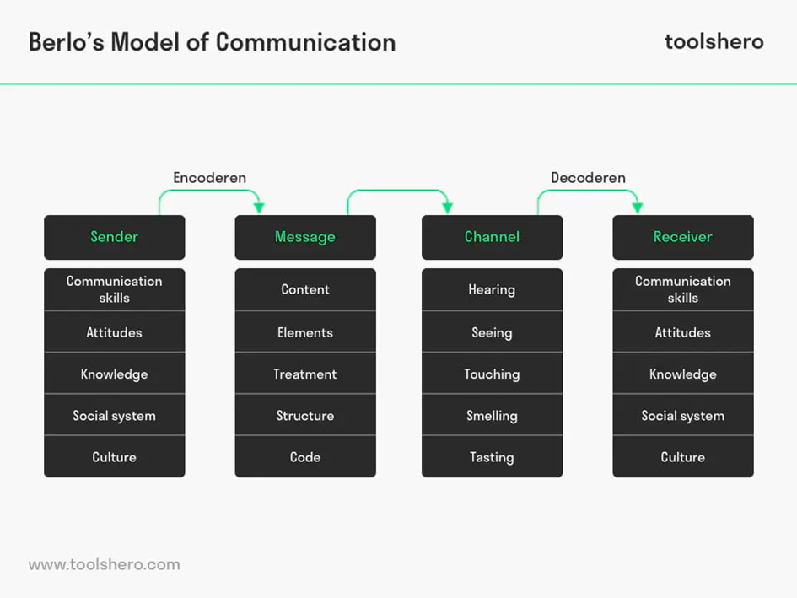
Here, the sender sends a message via a channel to the receiver. Which is the same as previous communication models, but in this model Berlo includes various component of how communication can be affected by five different effects. Also, Berlo includes that effects of components must be same between sender and receiver.
Example: in this case we can use Schramm`s example if the Bulgarian and Turkish person was same if both was Bulgarian or Turkish communication probably would have been more effective.
In conclusion Berlo`s communication model is same as Shannon- Weaver communication model linear model there is no feedback and if the sender and receiver not sharing same platform the communication cannot be effective.

3.0 Communication Types
Communication can be divided into two types: verbal and non-verbal communication. Also, verbal communication can also be divided into two-written or spoken communication. I will now talk on this type of communication

3.1 Spoken communication
Spoken or Oral communication is the use of words to share information with others. Therefore, it can include oral and written communication. However, many people use them only to describe oral communication. The linguistic elements of communication have to do with the words you choose and how they are heard and interpreted.
Example of oral communication is communication between two people or communication in classroom between teacher and students. E.g. face-to-face conversation, speeches, broadcast.
- Face-to-face communications is ability to see differences between each other or multiple parties in a conversation. It allows for better exchange of information, because both the speaker and listener can see and interpret body language and facial expressions.
- Radio – the main purpose of radio is to transmit information from one place to other through intermediate media without wires. In addition to transmitting sound and television signals, radio is also used to transmit data in the encoded form.
3.2 Written Communication
This is communication that is done through writing of message. Example of written communication: letters, text messages, emails.
- Letters are short messages that are sent to recipients who are generally outside the organization (Bovee and Till, 2020). They are printed on the letterhead and use a page or two to represent a business or organization.
- The frequency of texting and email may be higher today, and effective business correspondence remains a common form of written communication. It can be used to introduce you to potential employers, advertise product or services, and even convey feeling and emotions.

3.3 Nonverbal Communication

Nonverbal communication is the use of body language to convey information, including eye contact, facial expressions, and gestures. For example, smiling when you meet someone indicates friendliness, acceptance, and openness. Everyone has been using nonverbal communication, whether they know it or not.
There are several types of nonverbal communication you should be aware of, including:
- Body language is the way someone positions their body based on the situation, environment, and feelings. Example: if someone is feeling angry or nervous, they can cross their arms.
- Exercise: the way you move your arms and legs, such as walking fast or slow, standing, sitting, or fidgeting, can convey different messages to viewers.
Example: Sit quietly in a meeting and focus on expressing respect and concern.
- Facial expressions: the use of eyebrows, mouth, eyes, and facial muscles to convey emotions or information is very effective.
- Eye contact: using visual content strategically is an extremely effective way to convey your attention and interest.
Example: looking away or on your phone show as disinterest or disrespect.

4.0 Workplace Communication
Workplace communication is the communication that takes place between employees in an organisation. Workplace communication is important for task to be completed among staffs in an organisation.

4.1: Barriers to Effectiveness of Workplace Communication.
Communication is one of the most common way of development in all areas. However, it is not matter how good is the communication is and how well and strong is formed it can be disrobed by barriers in the communication, whether it is in an organization or communication between friends or colleagues. In communication system we can see some of the most common barriers.
Language: Language can be a barrier to effectiveness of Workplace communication. The language is one of the biggest barriers in the workplace this do not means that if you have communication in same language you cannot have difficulties in the communication sometimes when you use same language but different jargon can cause a misunderstanding or not understanding between sender and receiver. For example, if the message is whit special jargon and it is from one organization and it is sent to someone who don’t knows the jargon or not understands the organisation work then the message will be not understand. The language provides the understanding of the task that someone want to express to others and when the people in the communication process are sharing and understanding same language then the communication will be effective. For example, when international students go to study in England, they use English there in stead of the own languages in this way all the students and lecturers and everyone in the organization can understand each other and have an effective communication.
Religion: religion makes use of different forms of communication aimed at disclosing reality and creating community: prayer and preaching, worship and witnessing, reading and listening to sacred text, singing and sharing, ritual practice. For example, Christians and Muslims have different cultures and celebration calendar, or Indian new year Diwali is different than worlds new year.

4.2 How Can Workplace Communication be improved
There are many communication barriers in the communication system no matter they can be small or big and they can cause of bag communication to improve our communication and avoid as less as we can communication barriers we can use following steps for good and effective communication:
- Make your task clear before communication
- Have a good time management for your communication
- Use a simple and clear language which can be understood by the receiver.
- Your information must be short and direct.
- Make sure that the information you provide is clearly understand by the receiver.
- Be aware of your tone, language and message task.
- Good listening
- Do not interrupt when someone else is speaking
- Your message must be open for criticism.
Before our communication if we can just follow this steps, this will be help us to improve our communication.

5.0 Conclusion

Communication is the most important skill which we have. When we communicate, we fill fuller and happier. One of most important thing humans live is to share and this is happening by different types, schemes, and ways of communication. However, it is more necessary to learn the art of the effective communication to get the main point correctly. Communication is not just language, but a mixture of tone and body language. You can effectively use your tone and body language to convey your message. It is generally recommended to make eye contact whenever possible, rather than other forms of indirect communication. This can cause a misunderstanding between sender and receiver. This report looks at communication, models of communication and workplace communication.

References
- Andy Cheng (2020) The importance of effective communication in the workplace https://www.ringcentral.com/us/en/blog/the-importance-of-effective-communication-in-the-workplace/
- Berlo David K.(1960) The Process of Communication (New York: Holt, Rinehart, and Winston, Inc. 1960).
- Cobley, P. and Schulz, P.J. eds., 2013. Theories and models of communication (Vol. 1). Walter de Gruyter.
- Erik Hollande, David D. Woods (2005) Joint Cognitive Systems: Foundations of Cognitive Systems Engineering
- Janse, B. (2018) Berlo`s model of communication. Retrieved [07.12.2021] from ToolHero: https://www.toolshero.com/communication-skills/berlo’s-smcr-model-of-communication/
- Griffith, BA, & Dunham, EB 2014, Working in Teams : Moving From High Potential to High Performance, SAGE Publications, Thousand Oaks. Available from: ProQuest Ebook Central. [7 December 2021].
- Hitesh Basin (2021) Schramm’s Model of Communication | Elements, Advantages & Limitations.
- Koptseva, N.P., Liia, M. and Kirko, V.I., 2015. The Concept of “Communication” in Contemporary Research.
- Schram, W. E. (1954) The process and effects of mass communication
- Sypher, B. D., Bostrom, R. N. And Seibert, J. H. (1989) ‘Listening, Communication Abilities, and Success at Work’, Journal of Business Communication, 26(4), pp. 293–303.
- Uma Narula (2006) Communication models published by Atlantic Publisher & Distributors(P) Ltd.

Appendix





