2015755@student.uwtsd.ac.uk
FSg tool&die
Process improvement methodologies
- University of Wales Trinity saint david
- Quality and Buisness Improvement
- ACMA4004
- Will Holmes
- 2015755

Table of Contents
1.0 Introduction 2
Context: 2
2.0 Findings: 2
2.1 Lean principles 2
Defining the value 2
Mapping the value stream 2
Making the process flow 3
Pull from the customer 3
Working towards perfection 3
Limitations of lean & challenges of implementation 4
Lean implementation at FSG Tool & Die 4
2.2 Six-Sigma 4
Defining what it entails 4
What is six-sigma? 4
What are the advantages of six-sigma? 5
Six-sigmas ideologies 5
2.3 DMAIC process 5
The phases of DMAIC 6
2.4 DMADV process 7
The phases of DMADV 7
2.5 Levels of six-sigma 7
2.6 Lean six-sigma 8
What are the differences between Lean and Six-Sigma? 8
What is lean Six-Sigma? 8
Advantages of Lean Six-Sigma 8
3.0 Six-Sigma implementation at FSG Tool & Die 9
4.0 Referenece list 10

1.0 Introduction

Context:
This report’s focus is on six sigma and lean methodologies for process improvement. It identifies and discusses the main stages and elements of six sigma and lean initiatives; it also discusses the principles of lean and six sigma implementations with a focus on how associating principles can be utilised in industry.

2.0 Findings:

2.1 Lean principles

Defining the value
The lean manufacturing or lean production methodology focuses on the important ideology to continue optimising processes and eliminating waste. Waste also known as “Muda” (the Japanese word for waste) refers to activity that consumes time, resources and space but does not add any value to the production or service. Womack & Jones (1996) argue that a lean way of thinking allows companies to “specify value, line up value creating actions in the best sequence, conduct these activities without interruption whenever someone requests them, and performs them increasingly efficiently”.

Mapping the value stream
Most decisions involving lean are made considering how they will be affecting the customer value. This also ties in with mapping the value stream, mapping the workflow of the organisation, focusing on the actions and parties involved in the process. This helps identify which parts of the process add value and which ones do not. A value stream map (VSM) is a visual display of all the steps, delays and information required to deliver a product or service to the customer. (VSM) gives an analysis of the current state map in terms of identifying barriers of flow and waste.

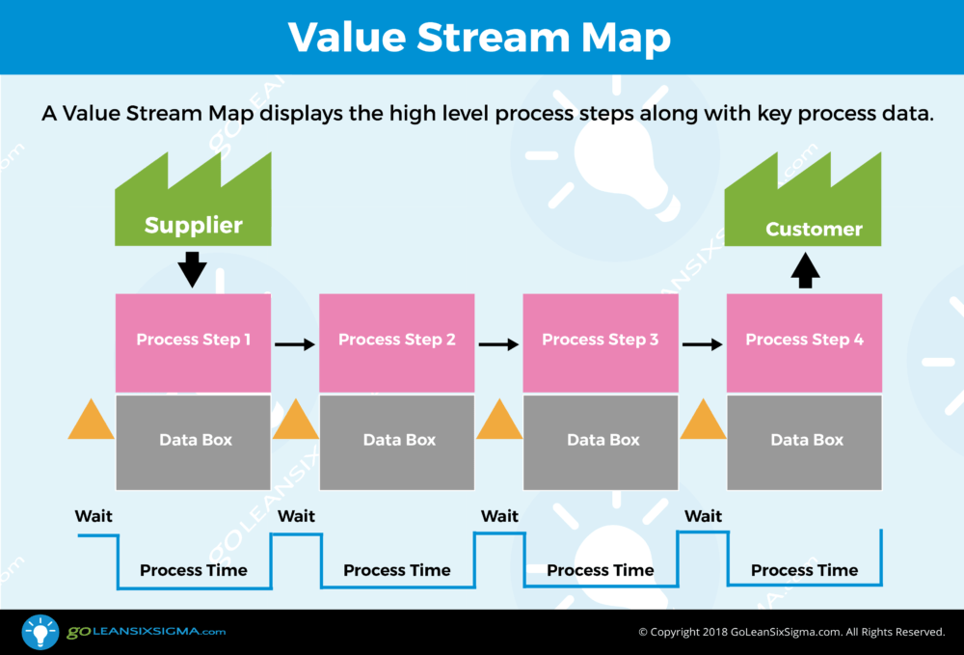(Fig 2.0)

Making the process flow

Creating flow is also a very important process in lean, making sure to break up the work into smaller units and visualise the workflow to identify and handle speed bumps to the process easily. Every member of the team must have a clear understanding of the goals of the organisation, which will encourage individuals to find ways to drive further success with the organisation doing well. This also ties in with continuous improvement with emphasis on cross functional collaboration and communication. Focusing on addressing complex questions, rather than short term fixes will have a better effect on the business in the long run.
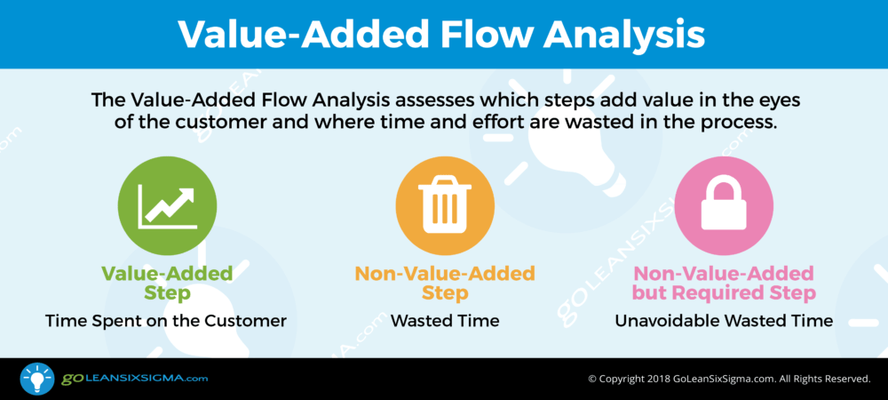 (Fig 2.1)

Pull from the customer

Establishing pull from the customer is an important part of the lean process as it set up a system where products are created only when there is a demand for it. This helps to optimise resources available at any given point which also optimises the capacity. Womack & Jones (1996) said “Don’t make anything until it is needed, then make it very quickly.” “Sell one, buy one.” “Ship one, make one.”

Working towards perfection
The final process talks about working towards perfection, which is a big part of the lean process as leans focus is striving for constant improvement, Womack & Jones (1996)” everyone must know what you are attempting to achieve and what area is the first priority”. as it never has an end goal only to continuously improve all aspects throughout the production process. According to Bicheno & Howleg (2016) “lean is about moving ever closer to uninterrupted flow to the sequence of operations that deliver perfect quality”

Limitations of lean & challenges of implementation
Limitations of lean and the challenges of implementation, is a role which stems from leadership. The major culture change agent is when you act and behave as If they are trying to create a continuous improvement culture. This entails encouraging people to take part, ask questions, coach, and develop in their way forward. Not to delegate and put it to the to lean team or management team already in place, it must start with senior management. Senior management do not see culture change as part of their role or a focus.
Having a platform to build on is big part of implementing a lean process I the workplace, looking at the companies situation what limitations are caused? for example in the UK Brexit has a large impact on every decision which is made. The best way of implementation such a process is when you do not have to, everyone is highly focused on a goal or always trying to continuously improve. If senior management aren’t engaging with shop floor personnel the communication barrier is broken and goals become unclear and difficult to obtain. This is summarized perfectly by Goldratt. E (1984) “Doing work and making money are not the same thing. Not all work leads to making money. Much of it is wasted.

Lean implementation at FSG Tool & Die
An example of implementation of lean methodology at FSG Tool & Die which focused on the ideology of optimising the processes and eliminating waste by re-thinking the design and incorporating solutions such an automatic feed and a limit switch to the waste management system.
Another area for the application of this methodology at FSG is in the stores department. The cutting of raw billots is an opportunity to implement the lean process, if the parameters of the billot cutting at the stores department were reduced. The time then expended at the CNC machines would be significantly reduced. As it takes around 5:1 for an operator to remove excess material.

2.2 Six-Sigma

Defining what it entails

What is six-sigma?
Six- sigma is a quality based methodology which was developed by Motorola in 1986. The method is a data based review to limit or even eliminate mistakes or defects in everyday activities or business processes. Six sigma states that in mathematical terms it takes a six- standard deviation event from the mean for an error to occur. It also focuses on achieving a different goal never being satisified and always striving for something more.

What are the advantages of six-sigma?
- Production of a road map that can help reduce an organizations risks and operational costs
- Improving efficiency and timeliness of the overall process
- decreasing defects which is a main goal, improving tracking and monitoring
- helping improve customer and vendor satisfaction
- improvement in cash-flow
- overall improvement in regulatory compliance

Six-sigmas ideologies
Six- sigma has three core ideologies.
- Buisness success which is greatly dependant on continous efforts that will and can achieve stable and predictale process results.
- Buisness and manufcturing processes have characteristics that can be defined, measured, analised and controlled.
- Top- level management also plays a significant role in achieving sustained quality, along with the rest of the organisation.
These ideologies are are the main focuses on statistical improvemnts to a buisness process, mainly advocating qualitative data measurements of success which are noted using markers. If the six-sigma process is being used correctly in your workplace you should be producing a staggering 3.4 defects per 1 million. This would mean all processes in place are working smoothly and effieciently, Goldratt (1984) “Making an employee work and profiting from that work are two different things” this I believe summarises the whole point of having a process such as lean or six-sigma in place.

2.3 DMAIC process
The DMAIC process is one of the most commonly used methodologies in six-sigma. It’s main purpose is make continuous improvement to an existing process through objective problem solving. The DMAIC process methodology seeks to improve quality of a product or service by concentrating not on the final output but the processes that make up the output. The idea is to concentrate on all the processes leading up to the output, to pin point the root cause of the problem making it a more effective, and also creating permenant solutions.

The phases of DMAIC
- Deifne
- Measure
- Analyse
- Improve
- Control
Defining the issue at hand will open up opportunities for improvement, using a problem statement will help kick start the process. This can be one of the hardest parts of process improvement. Defining the goal parameters for the improvement will also have a good impact as it gives employees something to work towards. For example decreasing how late certain items are leaving the factory from 10% to 5%.
Measurement is one of the key factors within six-sigma. It allows you to set up data collection in order to measure the level of success your currrently receiving from a processes within the workplace. The measurement system analysis (MSA) is an experimental and mathematical method of determining how much of a varition is within measurement process, which helps pin point areas where improvement can be implemented. It also contributes to overall process variability. This includes 5 parameters to investigate throughout this process:
- Bias
- Lineraity
- Stability
- Repeatability
- Reproductability

Analysing the problem and the process will help determine the root causes of the defects, as well as variation. Often managerial teams will initiate projects with assumptions about the process issues. When this is done the root cause is often overlooked. Therefore the implementing solutions are failing to resolve the problem at hand.
This of course wastes time and resources, and creates more variation and uncovers more or exisiting problems. The ideal way to finding the root cause is to anyalyse data and find clues on what might be the root cause. The main idea of this is developing hypotheses to find why the problems exist in the first place, and then working towards proving or disproving them.
Improving, this phase works on determining the potential solutions to the problems at hand. It will look at the root cause and ensure all areas around the issue will be addressed giving the maximum effectiveness for the solution.
Controlling the new process is of upmost importance. A detailed monitoring plan will have to be set in place, this will ensure the required performnace to reach any targets set is maintained. This will define and validate the monotoring system, which will help develop standards, procedures, verifiying benefits and profit growth for the newly implemented process.During this phase of the process the post-implemention reuslts will be evaluated

2.4 DMADV process
DMADV also known as (DFSS) design for six-sigma is a process which is more uncommon of the two six-sigma methodologies. It’s a process used for when a new product is being introduced and is being created from the ground up as oppsed to to improving a previously existing one.

The phases of DMADV
- Define
- Measure
- Analyse
- Design
- Verify

The first 3 phases of the DMADV methodology matches those of the DMAIC methodology as stated above.
The fourth phase design concentrates on the different elements of the design and takes a closer look at the details, and it also optimises the the whole design to ensure all customer needs are met. A detailed model will first be made into a prototype to test the deign in the working enviroment to ensure all specifications are met.
The fifth and final phase is to verify. During this phase the team will decide if it’s an acceptable deisgn and validate it. At this point all the serious questions will be asked. Will the design perform to the expectations of the design? Will the protoype design transition into the working process easily? And will the new process changes be sustaible under pressure?
If the all the phases above the verification are flawed or certain detials have been overlooked. The final product won’t perform. Therfore loosing the customer valuble time and money and the company money, resources and most importantly reputation.

2.5 Levels of six-sigma
There are several levels to a six-sigma team all of which important in their own way. Giving their own inisght to the problem snd giving solutions.
The levels starting at 7 novice which is a basic understanding of principles and the methodology of the program. They will work locally by supporting projects and solving relatively small issues, they are also the foundation for the ones deciding thre course of the program. Through to Level 1- Executive: representing the highest level of leadershipin a six-sigma team. They use their training and experience to set up six sigma projects that are in accordance with the organisations goals. They also ensure all projects add value and are succesful.
Inbetween are:
- Level 6- Yellow belt
- Level 5- green belt
- Level 4- Black belt
- Level 3- Master black belt
- Level 2- Champion

2.6 Lean six-sigma

What are the differences between Lean and Six-Sigma?

Both of these methodologies work towards a similar goal, which is reducing the waste (MUDA) from a process and to create a more free flowing efficient process.
Lean focuses more on an analytical approach looking at the workflow to reduce waste, it emphasises on improving customer value while minimising resource usage.
Six-Sigma concentrates on achieving perfect results, and never having an end goal in sight. It’s aim is to reduce costs and improve customer saisfaction.

What is lean Six-Sigma?
Lean Six-Sigma is a combined methodology that focuses on eliminating problems, removing waste (MUDA) and inefficiency, and improving the working conditions to satisfy the customers needs. It provides a different insight and can help give different but more effective solutions to the problems at hand. It combines the tools, methods, ideologies and principles of lean and Six-sigma.

Advantages of Lean Six-Sigma
- Helps streamline processes to provide customers with a better experience
- Drives higher results with more effiecient process flows
- It prevents defects, reduces costs, and removes waste
- Helps organisations handle day to day problems with ease
- Decreased lead times helps increase capacity and profitability
- Improves morale and people development

3.0 Six-Sigma implementation at FSG Tool & Die

In applying the principles of six-sigma in the workplace at FSG tool & die it was observed that the organisation’s management system and workload distribution could be significantly improved. In the current system jobs are scheduled in accordance with the following factors :
- Amount of work remaining
- Date allocted for the distribution to the customer
- Prioroty
- Availability

However, as a result of competing demands and separate requests from individuals in the management team, planned jobs and tooling are often reprioritised on an ad hoc basis; resulting in a negative impact on the overall workflow and efficiency of outputs. The impact of the ad hoc approach resulting in the need to constinously stop start and reconfigure setup for different or competing jobs. The outcome of the approach resulting in resource and time wastage. If all leadership were working towards the same goal.
the result would be improved efficiency and timeliness for each job and the overall planning process; also improving customer and vendor satisfaction.
If a six-sigma driven process was implemented in relation to job planning process the ‘Team’ would be working cohesively towards the same goal, the process of job selection could be made easier by following a predetermined prioritised plan.

4.0 Referenece list

- Bicheno, J. & Holweg, M. (2016), The lean toolbox 5th ed. Buckinghaam : PICSIE Books

- Womack, J. & Jones, D (1996), Lean thinking: Simon & Schuster

- Womack, J. & Daniel, J. & Roos, D. (2007), The machine that changed the world: Simon & Shuster

- Goldratt,M. (1984) The Goal 1st ed: North River Press

- Goleansixsigma.com ( charts used)

- Holmes, W. (2021) Application of quality tools and root cause analysis

- Liker J (2004) The Toyota way 1st ed : Mcgraw-Hill

- Fig(2.0), Value Stream Map

- Fig(2.1), Value- Added Flow Analysis

