

Reflective Report: Principles of Health and Social Care Practice
Student Name: Abass Bundu Kamara
Student Number: 2416734
Module Code: BMHP5016
Module Title: Principles of Health and Social Care Practice
Assignment Title: Reflective Report
Lecturer Name Dr Itse Olaoye
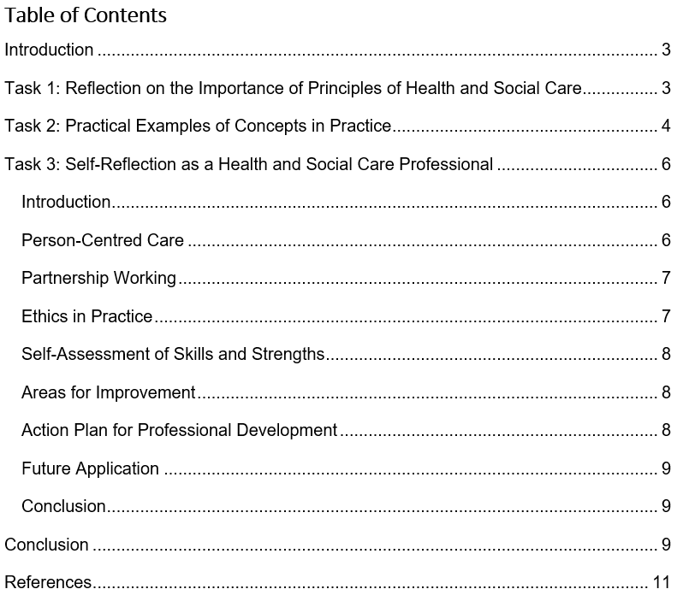

Introduction
This reflective report discusses the guidelines of health and social care including person centred care, partnership working and ethics. It demonstrates the way these principles inform safe, effective and dignified service delivery to service users. I discuss the ways I can implement the principles in practise to improve the outcomes and support lifelong learning using practical examples, self-reflection, and assessment of my strengths and areas of development.

Task 1: Reflection on the Importance of Principles of Health and Social Care
I learned about person-centred care which ensures that people get individually oriented care. Person-centred care is a holistic model that relies on the values of dignity, compassion and respect. The fact that it is putting people at the centre is what I believe will make them feel more dignified, well and in the end health outcomes as well (Laranjeira, 2025). Patients become more engaged in managing their health when care decisions account for lifestyle preferences. Working in partnership, teamwork between professionals, patients and families is reinforced. Effective partnership working helps to ensure that care decisions are coordinated, timely and based with shared knowledge. That communication within teams reduces mistakes and increases patient safety, I have reflected over again. Care is holistic (clinical and social) when experts share responsibilities. Ethics is embedded in my professional practice and daily ensures safe, equitable, fair, accountable decision-making. I get those ethical principles protect vulnerable people and support professional integrity in practice. Autonomy helps people to make their decisions based on their values and beneficence helps to make sure that the care they get is helpful. Justice focuses on equality in distribution whereas non-maleficence requires me to avoid causing harm. It is a balance between patient autonomy and safety, and therefore, making ethical decisions is the most significant, and I can sense how I am standing on the balance. By adhering to either NMC Code or HCPC Standards, I will have a chance to ensure that my practise complies with the expectations of me as a professional. Person-centred care, in my opinion, is associated with the Hierarchy of Maslow that is based on physical, social and emotional needs. By fulfilling these needs, humans become more well and have increased quality of life. Ethics offer a system of practising which is organised, just and accountable. Partnership working helps to make the process more collaborative and reduce the probability of making mistakes and maximise the considerations with regard to individualised care (Albargi, 2025). As an illustration, the Care Act 2014 stipulated explicit requirements in the delivery of personalised care that is safe. Health and Care Act 2022 defines more of professional responsibilities and ethical standards of practise. I have explained that these tenets are practical instruments of action, communication and choices. Person-centred care improves patient satisfactions, access and trust in the health system. Everyone working together in a partnership means better service efficiency, shared learning among staff and less waiting around for care to begin. Ethical practice guarantees care is human rights-focused, dignity-preserving and gentle with those in need. I recognize that the integration of such principles strengthens professional competence and supports lifelong learning. Using multiple methodologies showed improved outcomes over many of the traditional methods for delivery of holistic care, this included ethics, partnership and person-centred approaches. I have seen that a structured approach to applying principles reduces risk and makes for safer practices. Reflective practice ensures accountability, and engagement for ethical decision-making aligns with the standards by which staff in UK Healthcare settings are governed (Galway et al., 2025). In person-centred care patients are empowered, this develops helpful relations between service users and healthcare providers. Partnership working promotes proper working in teams, sharing of information, decision making and eventually improved patient outcomes. Lastly, ethical and collaboration, as well as person-centred care, enhance the quality of care. These principles can help me to provide safe and ethical care to the patients.

Task 2: Practical Examples of Concepts in Practice
I have seen good person-centred care model being implemented in dementia from the point of view of elderly population and their use of a care home. In these settings, daily integrated care plans take into account individual routines, preferences, abilities and personal identity. Residents engaged in their meal and activity choices, consistently leads to greater engagement and autonomy. Person-centred care also encourages residents to contribute actively in their care, which is helpful for dignity and wellbeing I have expressed that, where feasible, collaboration among staff, families and the professionals who work with individuals in care is a force multiplier of positive outcomes in care delivery. In partnership working, every team member contributes their domain knowledge to ensure effective and safe resident care (Dener and Elçin, 2025). Responsibilities and expertise are shared among multi-disciplinary teams comprising nurses, social workers, therapists and families. I have watched physiotherapists create exercise programmes and dietitians prescribe nutrition plans to the people successfully. Through consistent communication and coordination, the team can ensure that care is addressing all of resident’s needs. The importance of partnership working also mitigates risk, enhances safety and supports continuity of care for residents. I realise that ethical practise is required in cases when residents continuously fail to make consistent decisions. The mental capacity act of 2005 provides guidance to the staff in making decisions that are in the best interests of the residents. Professional judgement, awareness and ethical thinking are required to balance the dignity and safety. Employees must behave in the most ethical way ensuring that they respect the rights of the residents, whilst ensuring that they are not harmed or endangered by accidents daily. I discovered that ethics implementation is miraculous in relation to the establishment of trust among residents and families and medical practitioners. As the decisions made about the care consider the preferences and the wishes of the residents that were made at an earlier age, it respects the individuals and they feel to be respected and valued (Chen et al., 2025). When employees take ethical choices and explain the choice in straightforward, sincere manner, the families are also reassured. Higher levels of employee contentment as ethical frameworks inform their joint decision-making and protection of professional integrity. Such care has standard frameworks based on policies and guidelines such as NICE Dementia Guidelines 2022. CQC Fundamental Standards assist in the provision of assurances that each day a care home is able to live up to the legal, ethical and quality expectations. I believe on the integration of theory, legislation and guidelines brings effective control in practice. For holistic care to be achieved, ethical principles, person-centred care and partnership working need to work in synergy It is known that consistently applying these principles helps minimize errors and avoids any significant risks. I have observed that teamwork facilitates problem-solving and empowers staff to tailor care according to individuals’ needs. Staff who encourage involvement and give recognition of personal preferences when it comes to routines in every day, increasing the autonomy of residents (Haug et al., 2025). The collaborative approach allows professionals to address the physical, cognitive and emotional health needs concurrently. From personal experience I have observed that with multi-disciplinary decision making it enhances the quality of care and creates a more positive experiences. Ethics inform challenging decisions, such as limiting dangerous behaviour but still encouraging safe independence.

Task 3: Self-Reflection as a Health and Social Care Professional

Introduction
I understand that my practise is based on person-centred care, partnership working, and ethics. In order to apply these principles, I understand that I will require self-awareness, reflective thinking and commitment to a constant learning. The combination of theory and legislation with practical skills will assist me in exploiting my ability as a health professional (Røe et al., 2025). Reflective practise would assist me to cheque my strengths and weaknesses and what I can do to improve. The principles will be applied to make sure that I am providing safe, legal and good-quality care in the course of my practise.

Person-Centred Care
My daily role revolves around service users, they are at the heart of making care decisions. I have suggested that engaging individuals in their care to increase autonomy, motivation, and overall wellbeing. I guarantee residents are consulted about personal choices, habits and activities in their life care. I know that even small choices like what to eat or how to spend our time uphold a received dignity. I plan to cultivate active listening to gather full understandings of residents' needs, emotions and expectations. My plans to extend empathy is by regularly reinforcing experience and ability awareness. I do personalised care planning, ensuring each individual’s physical, social and emotional needs are addressed. I have learned that person-centred care enhances trust, communication, and relationships between residents and staff. The goal is to document preferences such that they can deliver constant, individualized, and respectful care throughout (Jandaghian-Bidgoli et al., 2025). I think that the considerations of cultural, religious and personal values are very well positioned to effect inclusivity and resident engagement.

Partnership Working
I believe that the optimal partnering results are working smart and enhance care delivery. The multi-disciplinary teams will guarantee that the information flow between the staff and families is accurate. I represented the fact that poor communication causes errors, inefficiencies and lapses in the delivery of care to the resident. I am focused on such activities as team meetings where I can contribute and also participate in taking decisions. I like the fact that the importance of expertise of colleagues fosters cooperation, mutual trust and mutual responsibility within teams. It is due to this that I will incorporate families into the care planning process as a source of reliable support and trust. I have noted that co-working meets complex needs in a holistic manner, and eventually contributes to enhancing the wellbeing of residents. Good interaction with fellow workers, residents to prevent misunderstandings and get outcomes (Ghattas and Abdou, 2025). I would wish to develop negotiation skills so that I can be able to arrive at a unanimous decision as the multidisciplinary discussions progress.

Ethics in Practice
Professional behaviour and decision making is always guided by ethical principles, and I realise that. I have imagined the problematic cases where it is extremely hard to balance patient choice and protect responsibilities. I wish to be able to implement the NMC Code, HCPC Standards and Mental Capacity Act safely in my decisions. I understand that ethical practise guidance improves autonomy, beneficiary, non-maleficence and justice under every circumstance. I will strive to adhere to the rights of service users, but at the same time, I will be conscious of potential threats to their safety and wellbeing. Ethical dilemmas are often required to be considered in reflection, discourse and professional judgement to make sure that we are doing the right thing (Brüggen et al., 2025). I will endeavour to be upright, open and integrity oriented in my dealing with the residents and colleagues. Hence, I know very well that when ethical frameworks are followed, they help to safeguard the resident/family and the professional in terms of harm and/or legal consequences. I will practise action reflectively to evaluate actions as well as identify aspects of improvement in ethics. I admit that moral acumen can be applied to make difficult decisions, including those that relate to safeguarding and end-of-life care.

Self-Assessment of Skills and Strengths
In retrospect, I have determined factors of strengths that make me effective in the practise of being a health and social care professional. I am also determined to be empathetic, patient and clear in all my interactions with residents and colleagues. Detailed focus ensures that the care is provided safely and documented in a precise manner in my experience (Alruwaili et al., 2025). I will be able to develop a good rapport with the residents and create trust, engagement and positive relationship with the residents at the daily basis. My teamwork and organisation skills are effective in facilitating the results of care planning. I am sure that I will be able to extend the minimum of knowledge about legislation and professional codes to ordinary circumstances. I observed that organisation and time management can be used to accomplish tasks in the time frame and maintain quality.

Areas for Improvement
I am aware that I should study legislations such as Care Act 2014 and Health and Care Act 2022. These are policies that I will revise to utilise with complex care situations with confidence. I would wish to be less sensitive with respect to high pressure events or bad behaviours. I aspire to acquire problem-solving abilities so that any ethical issues and unexpected difficulties in care may be managed adeptly. Being part of the group discussions and engaging in brainstorming (Akhyar et al., 2025).

Action Plan for Professional Development
Another goal of mine is to be an active participant of the workshop and online classes to improve knowledge of legislation, ethics, and best practises. I will form a journal of reflection to reflect on experiences, progress and development areas. Requesting experts to mentor them to gain practise and a code of conduct (Bourke et al., 2025). I will also take inter-professional learning opportunities to enable cooperation, development of communication and teamwork skills. I am not a patient man and will wait to hear what you have to say but I have a whole book of research and publications by other professionals to scan through. The idea is that the writing about the day is intended to maintain a track in order to learn and make changes.

Future Application
I embedded person-centred care, partnership working, and ethics into my professional practice. My focus is on delivering treatment that is tailored, ethical and collaborative in approach to help meet the needs of service users as best I can. Whether through retrospective interpretation or pursuit of continuing education from a bioethical perspective, I can affect the change in patients and services (Brownson et al., 2026). My goal in every interaction with residents and colleagues is to be professional, considerate and ethical. I know I will never stop growing as a health and social care specialist and that it takes work.

Conclusion
I have reflected on the areas of my professional self-concerning person-centred care and partnership working and ethics. I would be able to rely on these principles each time to make my actions, behaviour, and decisions with residents families and others. I can provide quality and safe care through reflection, self-assessment and professional development (Hill and Sankey, 2026). These principles of ethics, interprofessional collaboration and person-centred approach are some of the principles that I hope to maintain in my future practise. With the help of these principles, I will be able to use my competence, advocate, and care toward residents in both roles in all respect and safety.

Conclusion
Lastly, high-quality, safe, and respectful care can only be offered through person-centred care, partnership working, and ethics. My reflection on my experiences has helped to reinforce my knowledge about these principles and determine the areas of improvement. Being ready to learn constantly, develop professionally, and reflect on own experiences, I can make sure that my future as a health and social care professional can be effective, ethical, and patient-centred.

References
Alruwaili, A.N., Alshammari, A.M., Alhaiti, A., Elsharkawy, N.B., Ali, S.I. and Elsayed Ramadan, O.M., 2025. Neonatal nurses’ experiences with generative AI in clinical decision-making: A qualitative exploration in high-risk NICUs. BMC Nursing, 24(1), p.386.
Akhyar, M., Sabri, A. and Zukdi, I., 2025. Small group discussion method in forming students' collaboration and creativity competencies. Al Qalam: Jurnal Ilmiah Keagamaan dan Kemasyarakatan, 19(5), pp.2825–2838.
Albargi, A.A., 2025. Technology in Patient Care Harnessing Interprofessional Collaboration to Improve Safety, Efficiency, and Outcomes. Saudi J Med Pharm Sci, 11(10), pp.989-996.
Bourke, L., Conway, C. and Abdalla, M.E., 2025. Mentorship in surgical training: A systematic scoping review to inform a mentorship framework for ophthalmology trainees. BMC Medical Education, 25(1), p.373.
Brownson, R., O’Sullivan, I. and Firn, J., 2026. Clinical ethics consultation for patients with eating disorders: A single center retrospective content analysis. Eating Disorders, pp.1–15.
Brüggen, L., Gianni, R., de Haan, F., Hogreve, J., Meacham, D., Post, T. and van der Werf, M., 2025. AI-based financial advice: An ethical discourse on AI-based financial advice and ethical reflection framework. Journal of Public Policy & Marketing, 44(3), pp.436–456.
Chen, D.R., Young, Y., Shayya, A., Perre, T. and O’Grady, T., 2025. Cultural interplay in end-of-life care decisions: Comparing advance directive beliefs and preferences among adults in the US and Taiwan. BMC Palliative Care, 24(1), p.104.
Dener, H. and Elçin, M., 2025. The experiences of cardiovascular surgeons and nurses with mutual support through interprofessional collaboration in the intensive care unit. Nursing in Critical Care, 30(4), p.e13220.
Ghattas, A.H.S. and Abdou, H.A., 2025. Challenges and best practices for moving forward in interprofessional collaboration in critical care units: Nurses’ perspectives. BMC Nursing, 24(1), p.317.
Galway, R., Wilkinson, D., Mistry, D., Beryl, R., Mackay, K.L., Gaynor, B., Leah, K., Seagrief, J., Siddall, Y., Beason, S. and White, J.P., 2025. Rapid review of facilitating reflective practice groups with staff in adult inpatient mental health settings. Reflective Practice, 26(2), pp.277–291.
Hill, R. and Sankey, L., 2026. Self-assessment of professional behaviours: A preregistration nurse development initiative. British Journal of Nursing, 35(1), pp.38–46.
Haug, R.E., Dahl, S.L., Sørlie, E., Moe, K.B., Larsen, G.E., Angelskår, C.B. and Stallvik, M., 2025. The challenge of balance: Exploring structure, adolescents' participation and relations with staff in milieu therapeutic settings in therapeutic residential care. Child & Family Social Work.
Jandaghian-Bidgoli, M., Jamalnia, S., Pashmforosh, M., Shaterian, N., Darabiyan, P. and Rafi, A., 2025. Personalized nursing as the missing link of providing care: A systematic review. BMC Nursing, 24(1), p.239.
Laranjeira, C., 2025. Dignity, health, and well-being. In: Handbook of Concepts in Health, Health Behavior and Environmental Health, pp.1–13. Singapore: Springer Nature Singapore.
Røe, Y., Johansen, T.S. and Bruset, E.B., 2025, February. Empowering digital competence through peer-assisted learning and virtual reality in health professions education. In: Frontiers in Education, 10, p.1550396. Frontiers Media SA.

