Mohi Tuki
Portfolio
2216172

Task 1
Personal Brand and Career Development
My personal brand revolves around being a dedicated, reliable, and empathetic individual, with strong communication and problem-solving skills. I aim to position myself as a compassionate and competent professional in the health and social care sector. Developing this personal brand involves enhancing my skills through continuous learning, gaining relevant certifications, and gaining practical experience. Building a strong online presence, such as a professional LinkedIn profile, will also help showcase my skills, values, and commitment to the field. Networking with industry professionals can further strengthen my personal brand and open up employment opportunities. According to Montoya and Vandehey (2015), a personal brand is created through consistent actions and a clear message that aligns with your career goals. Additionally, managing your online reputation is crucial, as potential employers often research candidates online (Kaplan & Haenlein, 2010). By focusing on these strategies, I can develop a strong personal brand that highlights my strengths and aligns with my ambitions in health and social care, ultimately improving my chances of securing meaningful employment.
References:
Montoya, P., & Vandehey, M. (2015). The Personal Branding Phenomenon. McGraw-Hill Education.
Kaplan, A. M., & Haenlein, M. (2010). Users of the world, unite! The challenges and opportunities of social media. Business Horizons, 53(1), 59-68.
Task 2
Network Map and Rationale
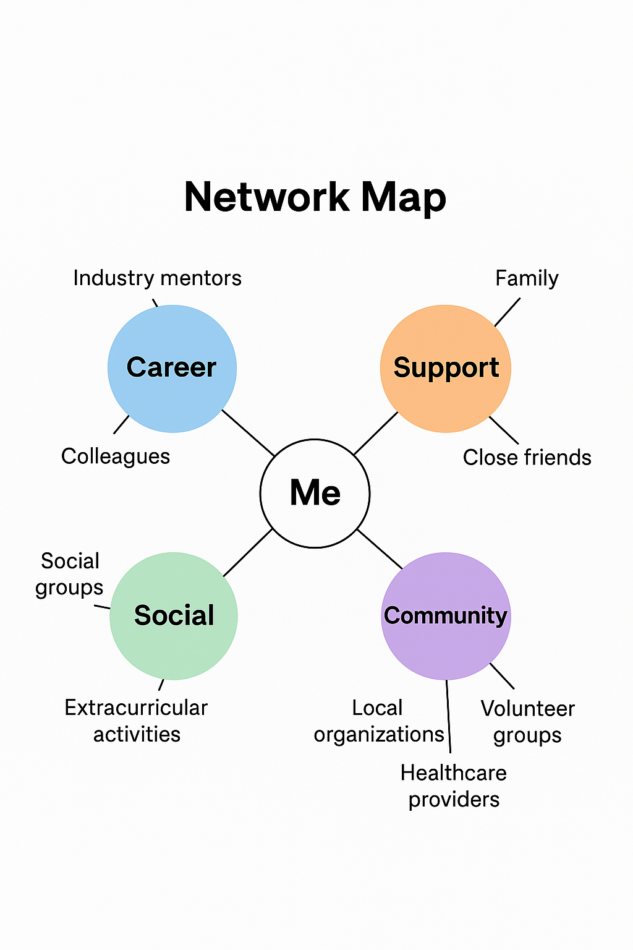

My personal network comprises various connections across career, support, social, and community dimensions. Professionally, I am connected with industry mentors, colleagues, and educational contacts who provide guidance, advice, and opportunities for growth. Support networks include family and close friends who offer emotional and practical assistance. Socially, I engage with peers through social groups and extracurricular activities, fostering a sense of belonging and shared interests. Community connections involve local organizations, volunteer groups, and healthcare providers that help me stay informed about local opportunities and resources.
This diverse network is crucial for my career development and personal well-being. According to Burt (2000), networks facilitate access to valuable information and opportunities, which can accelerate career progression. Moreover, Lin (2001) emphasizes that social capital derived from these networks can enhance both individual success and community resilience. Critically, a balanced and well-maintained network ensures support across different life aspects, reducing vulnerability to setbacks and opening pathways for advancement. Developing and nurturing these relationships will enable me to access resources, mentorship, and support essential for reaching my employment goals in health and social care.

References:
Burt, R. S. (2000). The network structure of social capital. Research in Organizational Behavior, 22, 345-423.
Lin, N. (2001). Social Capital: A Theory of Social Structure and Action. Cambridge University Press.
Task 3
The Impact of Workforce Shortages in UK Health and Social Care
The UK health and social care sector is currently facing a significant challenge: workforce shortages. This issue has been exacerbated by the COVID-19 pandemic, which placed immense pressure on healthcare professionals and highlighted existing staffing gaps. The shortage of qualified staff affects the quality of care provided to patients and service users, leading to longer waiting times, increased workloads for existing staff, and a potential decline in overall service standards. One major factor contributing to workforce shortages is the aging population, which increases demand for health and social care services. Simultaneously, many care workers are leaving the sector due to burnout, low wages, and limited career progression opportunities. According to the Health Foundation (2022), there is a projected shortfall of over 100,000 NHS staff by 2030 if current trends continue.

Addressing this issue requires strategic planning and investment. The government has announced initiatives to improve pay and working conditions, as well as programs to recruit more care workers from abroad. However, retaining existing staff through better support and career development is equally important. Ensuring a well-trained, adequately staffed workforce is essential for maintaining high standards of care and safeguarding the health of the nation.
For the UK to meet future healthcare demands, a collaborative effort involving government, healthcare providers, and communities is vital. Only through sustained investment and policy changes can we secure a resilient health and social care system for all.
References:
The Health Foundation. (2022). NHS Workforce: Challenges and Opportunities. Retrieved from https://www.health.org.uk
Task 4
1. What is the primary goal of the NHS Equality, Diversity, and Inclusion Improvement Plan?
The primary goal is to create a more equitable, inclusive, and diverse NHS workforce and environment that improves patient care and staff experience.

2. How does the NHS EDI Improvement Plan propose to tackle the gender pay gap?
It aims to address the gender pay gap by promoting transparency, ensuring equal pay for equal work, and implementing targeted initiatives to support women's career progression.

3. What is meant by the term ‘intersectionality’ as used in the NHS EDI Improvement Plan?
Intersectionality refers to understanding how different protected characteristics, such as race, gender, and disability, overlap and impact individuals’ experiences of inequality.

4. Why is it important for the NHS to create a psychologically safe work environment?
A psychologically safe environment encourages open communication, reduces bullying and harassment, and supports staff well-being, leading to better patient care.

5. How does the NHS EDI Improvement Plan suggest improving the experience of internationally recruited staff?
It recommends providing tailored support, culturally sensitive induction programs, and ensuring fair treatment to help internationally recruited staff integrate smoothly.

6. What role does leadership play in advancing EDI objectives according to the NHS Improvement Plan?
Leadership is crucial for setting priorities, fostering inclusive cultures, and holding staff accountable for progress in EDI initiatives.

7. Identify one way the NHS EDI Improvement Plan aims to reduce health inequalities within the workforce.
It promotes targeted interventions and support programs for underrepresented groups to ensure equitable career development opportunities.

8. Why does the NHS EDI Improvement Plan emphasise the importance of collecting and analysing data on protected characteristics?
Data collection helps identify disparities, monitor progress, and inform effective strategies to improve equality and diversity.

9. Explain how flexible working policies can contribute to equality and inclusion in the NHS workforce.
Flexible working allows staff to balance work and personal commitments, supporting those with caring responsibilities and promoting a more inclusive environment.

10. What is one strategy mentioned in the NHS EDI Improvement Plan to combat bullying and harassment in the workplace?
Implementing clear reporting procedures, providing training, and fostering a culture of respect are strategies to reduce bullying and harassment.

Task 5
Dear Younger Me,

I know that times in the past have felt overwhelming, especially when struggling with things like using technology and speaking in front of others. I want you to know that these challenges are completely normal, and over time, I’ve learned how important emotional intelligence and resilience are in overcoming them.

Developing emotional intelligence understanding your feelings and managing them would have helped you handle moments of frustration and self-doubt. Recognizing what you’re feeling can give you the strength to stay calm and focused, rather than giving in to anxiety. Resilience, or the ability to bounce back from setbacks, is equally vital. Every mistake or awkward moment is a chance to learn and grow, and with time, you will become more confident.

Now, I’ve come a long way. I can use tech more comfortably and speak in public with greater confidence. These skills didn’t develop overnight; they came from practicing patience, staying positive, and not giving up when things felt tough. If I had started cultivating emotional intelligence and resilience earlier, I believe I would have faced challenges with more courage and less fear.

Remember, growth is a journey. Be kind to yourself, stay persistent, and trust that each difficulty is an opportunity to become stronger.

With love and encouragement,
Mohi Tuki

Task 6
Gantt Chart for Achieving Future Employment Goals

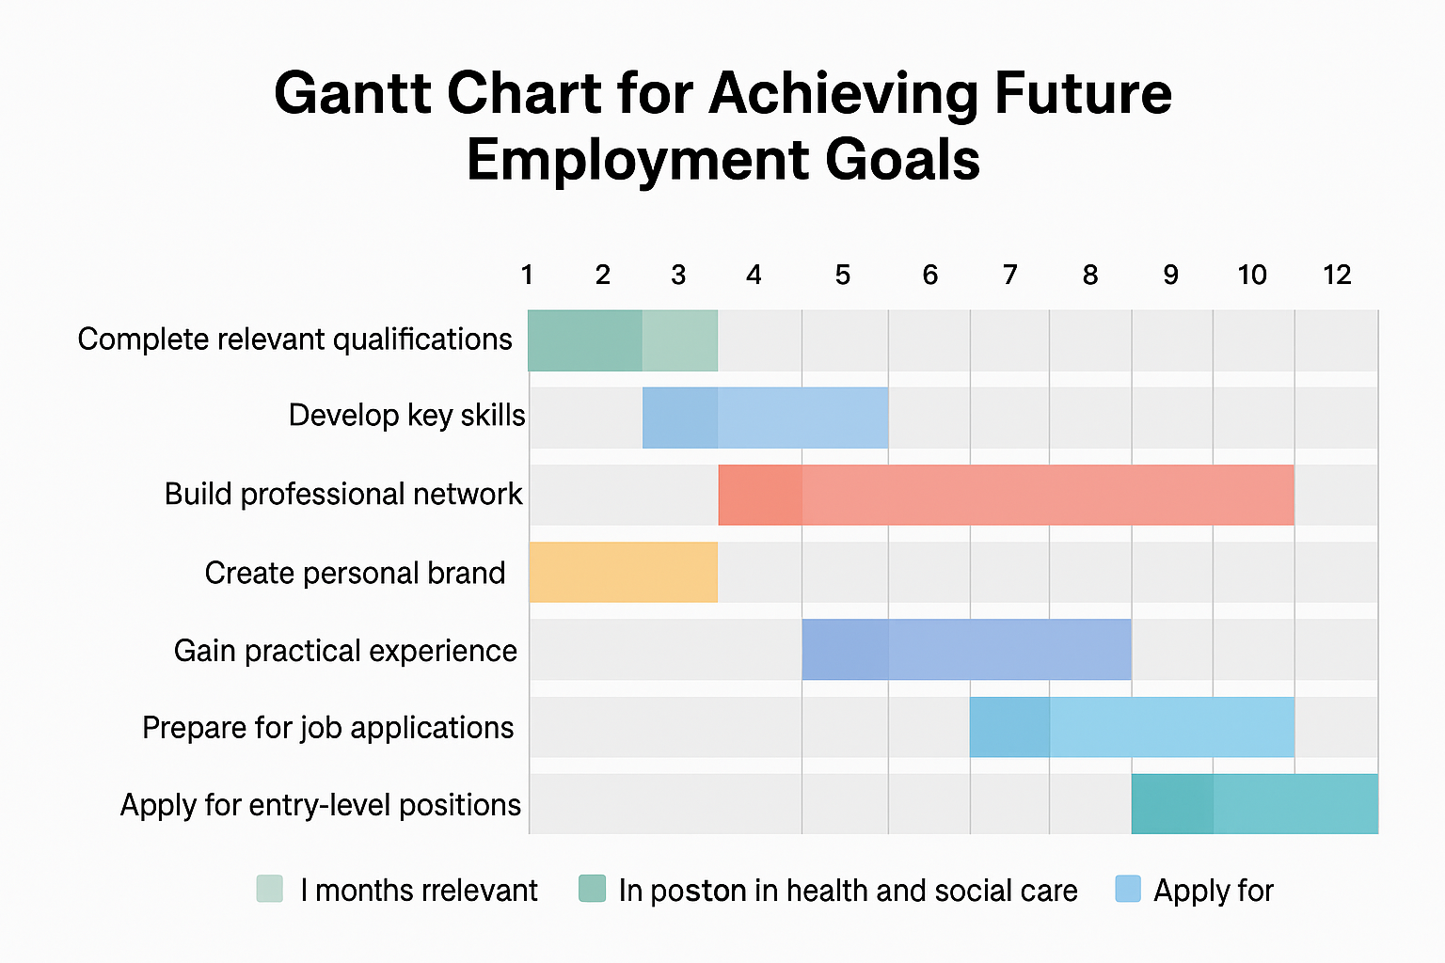

To reach my employment goals in health and social care, I have structured a plan with specific tasks and timelines. The first step is to complete relevant qualifications, such as health and social care courses, which I aim to finish within the first three months. Parallel to this, I will work on developing key skills like communication and teamwork through workshops and volunteering, scheduled over the next six months.

Next, I plan to build my professional network by attending industry events and connecting with practitioners on LinkedIn, starting from month four and continuing throughout the year. Simultaneously, I will create a strong personal brand and update my CV and online profiles within the first two months. Once I gain some practical experience through placements or volunteering, I will prepare for job applications by the eighth month.Finally, I will apply for entry-level positions in health and social care, aiming to secure employment within 12 months. Regular reviews of my progress will be scheduled monthly to adjust my plan as needed and stay on track.This structured approach, illustrated in my Gantt chart, ensures systematic progress towards my career aspirations.
Task 7
Report on Implementing a Staff Wellbeing Program in the Care Home

As the manager of the care home, I propose implementing a staff wellbeing program to improve staff morale, reduce burnout, and enhance overall care quality. The first step involves conducting a needs assessment through staff surveys and focus groups to identify key areas of concern. Based on the feedback, tailored interventions such as stress management workshops, flexible working arrangements, and access to mental health support will be introduced.

To ensure successful implementation, strong leadership and effective communication skills are essential. Leaders must motivate staff, foster an inclusive environment, and promote open dialogue. Additionally, change management models like Lewin’s Three-Step Model (Unfreeze-Change-Refreeze) will guide the process. According to Lewin (1951), this model emphasizes preparing staff for change, implementing new practices, and solidifying these changes into routine work.

Potential barriers include resistance to change due to fear of increased workload or skepticism about new initiatives. To address this, involving staff in the planning process and clearly communicating the benefits are crucial. Providing ongoing support and acknowledging staff contributions can also facilitate acceptance.

By applying these strategies, I aim to create a healthier, more motivated workforce, ultimately leading to better resident care and a positive work environment.

References:
Lewin, K. (1951). Field Theory in Social Science. Harper & Row.
Kotter, J. P. (1996). Leading Change. Harvard Business Review Press.

Task 8
Self-Reflection Using Gibbs’ Reflective Cycle

Throughout this module, I have gained valuable knowledge and insight into health and social care, which has significantly contributed to my personal and professional development. Using Gibbs’ Reflective Cycle (1988), I will reflect on my learning journey.

In the description phase, I realize I initially lacked confidence in communicating complex ideas clearly, especially when discussing sensitive topics. The feelings phase revealed I sometimes felt overwhelmed by the breadth of knowledge required. During the evaluation, I recognized that developing emotional intelligence and resilience has helped me manage stress and improve my interactions with others.

The analysis highlighted that understanding the importance of equality, diversity, and inclusion has enhanced my awareness of social issues affecting both clients and colleagues. This awareness has motivated me to adopt a more inclusive approach in my future practice. In the conclusion, I acknowledge that engaging in reflective practice has improved my self-awareness and critical thinking skills, enabling me to evaluate my actions and adapt accordingly.

Finally, in the action plan, I aim to continue developing my communication skills, particularly in public speaking and using technology confidently. This reflection has informed my understanding that continuous learning and self-awareness are essential for effective practice in health and social care, ensuring I provide respectful, inclusive, and person-centered support.

Reference:
Gibbs, G. (1988). Learning by Doing: A Guide to Teaching and Learning Methods. Oxford Polytechnic.
Reference list
Montoya, P., & Vandehey, M. (2015). The Personal Branding Phenomenon. McGraw-Hill Education.
Kaplan, A. M., & Haenlein, M. (2010). Users of the world, unite! The challenges and opportunities of social media. Business Horizons, 53(1), 59-68.
Burt, R. S. (2000). The network structure of social capital. Research in Organizational Behavior, 22, 345-423.
Lin, N. (2001). Social Capital: A Theory of Social Structure and Action. Cambridge University Press.
The Health Foundation. (2022). NHS Workforce: Challenges and Opportunities. Retrieved from https://www.health.org.uk
Lewin, K. (1951). Field Theory in Social Science. Harper & Row.
Kotter, J. P. (1996). Leading Change. Harvard Business Review Press.
Gibbs, G. (1988). Learning by Doing: A Guide to Teaching and Learning Methods. Oxford Polytechnic.

