Max Cobb

The purpose of this study is to demonstrate I can perform And construct a new five storey hotel, restaurant and bar and conference area on a building footprint where there was previously a Tesco as well as a car park located in Swansea. This project is to help with the growing demand for housing and rising population of the area especially near the LC2 entertainment building. this project will cover multiple different things such as ground investigation the appropriate foundations to use and what the area was previously used as and what was built there.
A lot of research will be required for this project as I have mentioned the ground has previously been built on before therefore making it a brownfield site. Being a brownfield site means additional research is required to test potential issues like loose soil for example after the demolition of Tesco which could have caused the soil to become more loose after the demolition of the previous building. another issue could potentially be ground contamination so this will be tested for as well to ensure the ground we will be building on isn’t contaminated. Being a brownfield site can mean that the ground is compacted due to the weight of the structure on it before and an increased chance of contamination to the soil.
I would look at maps of previo8se structures in that area as well as ensure ground testing is done on the ground to check the quality of the soil and make sure its safe to commence with the construction of the project. In this scenario the project was previously a Tesco so has been built of before as I have just mentioned a soil test will be done as well as checking maps over history to check if was built on prior to the Tesco and get the appropriate reports done of the soil to check for anything that could cause a problem such as loose soil, contaminated soil, remaining building materials from the demolition of the Tesco and a lot more other issues that could stop or delay the commencement of the project. So as I have just mentioned the area was previously a Tesco with a carpark unfortunately I was not able to find detailed records that confirm what was built in the area before the Tesco was constructed but I did find a map which looks like the area could have previously been a gas works which I haven’t been able to confirm but I will say that this is a prime area for the hotel due to it being located near the city centre and as I have previously mentioned and will go into more detail about later on in this report is located next to the popular LC2 building. I was unable to find any previous soil tests for this area so it is essential that this area is checked before the commencement especially after the demolition and it being a brownfield site

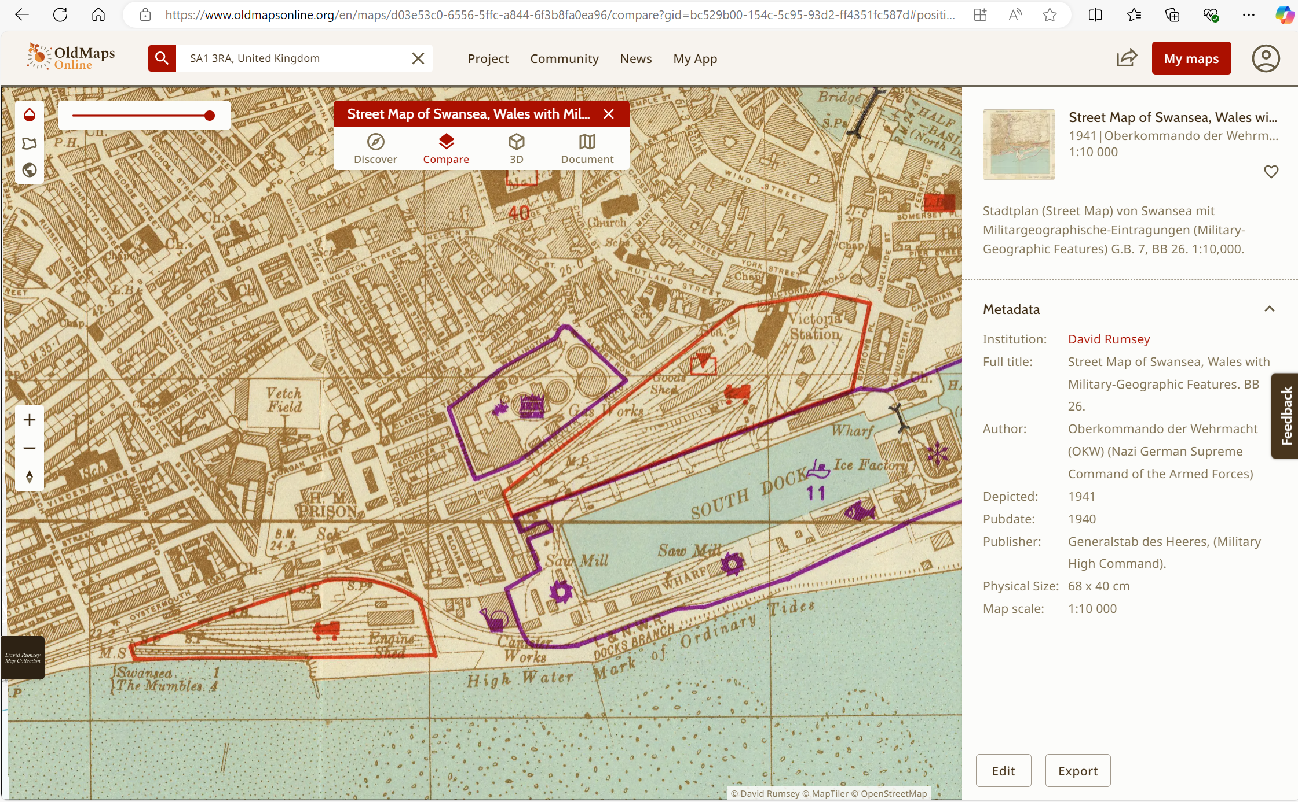
Map showing the area could have previously been a gas works before it was demolished to become a Tesco
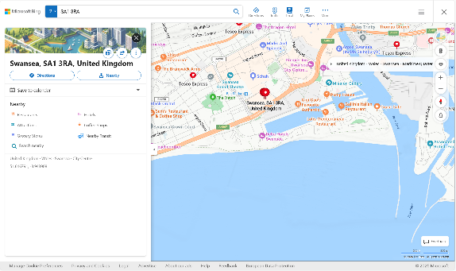
Map showing the area which is now a Tesco

As the area that is going to be built on (Tesco) is very near to Swansea centre it is a populated area with a lot of people with is also increased due to different structures nearby. Due to it being a highly populated area we must take this into account and ensure that noise is kept to certain time as not to effect anyone in the areas sleep as well as other possible problems that could be caused by this or even complaints, its important to keep a good relationship with the public. Dust is also another problem to take into account dust will need to be minimised to ensure the people are kept safe and not effected negatively by the project. one way to ensure the public’s perception of us throughout the project is to follow the considerate constructors scheme (CCS) which was created. Other types of building site nuisances include the following: vibrations, dust and smoke, light pollution, noise pollution large vehicle movements and unplanned road and pavement closures. To combat these the (CCS) says that machinery can be operated from the hours of 7am and 7pm from Monday to Friday and 8am and 1pm on Saturdays. If these rules are broken or nuisance is caused the council will come and stop works and could also issue us with a fine. So to combat noise works can be done between certain times. To combat noise we will monitor dust and issue out regular toolbox talks on dust. Its important to monitor and keep under control as same as noise the council will stop works and issue a fine if a nuisance problem is failed to deal with.
This study will go over everything required such as best type of foundation for the hotel depending on the size, quality and condition of the soil. when constructing this project we will follow all building standards. Geotechnical tests will be conducted before the construction begins such as a test to conduct what the soil is made out of the baring capacity of the soil seeing how much it can hold and if there is water in the ground beneath. I will explain more about the geotechnical tests, firstly pre the construction of the hotel the type of soil must be found out. Although I could not find the specific Tesco area soil type I was able to find a geology map of Swansea (Geology of the Swansea district: a brief explanation. Sheet 247). Which according to the map tests concluded the ground was mostly sandstone and mudstone. There are many different geotechnical tests that could have been conducted to come to this result I will list some of these test such as: Borehole drilling, standard penetration test, cone penetration test particle size distribution test, plate test and groundwater monitoring. As well as these tests other tests can be done such as environmental tests to test for things such as soil contamination. Going back to the geotechnical tests I will explain in more detail the process that is used to determine the type of soil, borehole drilling is a process where boreholes are drilled to certain depths and sent off to a lab where they can test the different sections of soil to determine the type and the condition as well as testing for contamination if required. A plate test is done to determine the appropriate load the ground can hold to determine if it is able to support the foundation of the structure. Standard penetration test is measuring how hard it is to drive a metal rod into the ground that is going to be built on allowing you to assess the strength of the soil that will end up underneath the hotel supporting its weight. If the metal rod is easy to drive into the ground then it could mean that the soil is loose and unstable and therefor not suitable to construct the hotel on due to the piling foundation or any other foundation chosen may not be able to hold the weight or evenly distribute the load causing the structure to become unstable.
For this specific hotel project after the demolition of the Tesco environmental test is crucial to check for contamination to the ground. As this land was previously industrial due to it having a Tesco on previously making it a brownfield site due to this being the case it is critical to perform multiple tests and also ensure nothing is left over from the demolition of the Tesco such as rubble or waste from the building that could compromise the construction of the new hotel. Aswell as this as the building before Tesco could have potentially been a gas works it is crucial to test for gasses as well as there could be traces of gasses in the ground from the previous structures, these gasses could be harmful or even explosive.
The tests I would choose to investigate the ground would be borehole testing as I previously mentioned before which requires a sample of ground to be drilled and sent off to a laboratory where they are able to analyse the sample and determine certain conditions of the ground such as whether the ground is contaminated the borehole test will also let us know what the ground for the specific area is made out of and would also let the engineer for the site know if this specific footprint of land has the strength to support the hotel we are to construct. This will let us know if we are required to make any changes to enable the ground to support the structure. The borehole testing also allows us to see how deep the ground is before we hit water and if its suitable to build on. In this case due to a large Tesco being built on before I would assume the ground can hold the weight of the structure but these tests would still be crucial as the demolition may have shifted or affected the stability of the ground. If there is water underneath the soil depending on the depth it could make the land unstable to build on.
The location of the hotel is ideal as it is located near the LC2 in s2ansea which is a popular area and popular for events which could require people to travel down bringing more people to the area with the option of staying in the hotel located nearby. With the hotel being here it could attract more people to the are as the option to stay in the hotel with the restaurant and bar could be appealing as well as the fact it will also contain a conference are which allows people to host there business meetings and serves as a location for meetings. Although it is a positive that the area is populated we also have to be wary of the disruptions that we may cause in the construction of this project such as noise disruption and dust. I have briefly gone over the noise and dust before and part of the reason I would choose bored piles is because they are quieter than piles such as driven piles which release a lot more noise and being in a populated area especially with the city centre close do not want to deter the public or receive any complaints from the noise as I mentioned could result in a fine and the council to stop works. To combat thit we will follow the considerate constructor scheme which keeps our works to a certain set time ensuring that no one is woken up early hours of the morning or kept from sleeping late at night. We also have to be very cautious of dust that is released as dust does not aways cause problems instantly but can lead to serious health problems later on in life. To avoid problems like traffic which could be caused by deliveries being brought into site we would arrange for set times and let the public know as we wouldn’t want to irritate the public by holding up the traffic and cause problems such as causing people to be late to work which could once again end up with us receiving a fine or having the works stopped.
For this specific project I would choose piling foundation to construct the hotel as the hotel is to be 5 stories with 400 rooms isn’t going to be light and for a building this heavy. Piling pillars are concrete pillars that are placed deep into the ground which distribute the load of the building evenly supporting heavier buildings and allowing the hotels load to be evenly distributed over the ground as I mentioned this specific project will be heavy therefor limits the certain foundations that can be used as other foundations could cause the structure to become unstable and therefor unsafe. There are a few different pile foundations such as bored piles, screw pies and driven piles which all have their own advantages and disadvantages. Driven piles are usually made from steel and are driven into the ground these are easy and quick to install but can cause vibrations and disrupt the ground as well as being incredibly noisy and due to this project being constructed close to the city centre in a popular area this could lead to some complaints being risen.
To conclude this report this project would take what was previously a Tesco with a carpark and before that potentially a gas works which will end up being a key project for Swansea as this development will bring in and attract more people with the five storey hotel, bar and restaurant. This project will provide accommodation from the LC2 which is a popular building and will guarantee that the hotel will be in demand due to the location. This report has highlighted the history of the site with the previous buildings as well as the sites history as a brownfield site whilst also going over safe construction and development of the project the site investigation I have suggested will ensure that the soil is appropriately tested and deemed safe to build on as well as the foundation I have chosen which will be perfect for supporting the size and weight of the five storey hotel. Furthermore if the ground beneath the Tesco does end up being sandstone the piling is the appropriate method to be placed into the ground whilst being able to support the structure. The project has potential to bring many benefits to Swansea such as new jobs and boost the local economy.

References:

Construction noise and pollution | nibusinessinfo.co.uk
Swansea city centre - Google Maps
Odour, dust and smoke nuisances | nibusinessinfo.co.uk
4 Types of Geotechnical Testing: choose the best option
Geology of the Swansea district: a brief explanation. Sheet 247

