

University of Wales Trinity Saint David
School of Engineering

Conrod Dynamic Forces
Calum McGowan Franklin
1803213

Motorsport Engineering/HNC/HND
Date 18/10/2019
Module code
M4x02193

Abstract

The main objective of this report is to examine the dynamic forces acting upon a connecting rod by modelling input data within a spreadsheet, generating graphs and data and analysing the results.
In the first part of this report the height of the connecting rod against the function of time was obtained, confirming oscillatory motion with a consistent sine wave. As the RPM changed the height remained consistent but with a larger time interval between oscillations.
Secondly this report investigates the force acting on the connecting rod and the acceleration of the piston against the function of time and the angle of the crankshaft. These results confirm that maximum force occurs between 5-10° before TDC and BDC this also correlates with piston acceleration which is at its greatest magnitude when approaching TDC or BDC.
It is the conclusion of this report that the maximum forces on the connecting rod occurs approaching TDC or BDC, this is in unison with peak piston acceleration but the inverse of peak piston velocity which reaches its greatest magnitude approximately 90°before or after TDC or BDC.
Contents
Abstract 2
List of figures 4
Introduction 5
Research/literature review 6
Manufacturing process 7
Methodology 10
Analysis 11
Conclusion 18
References 19

List of figures
Figure 1- Volvo 850 V70 1996 specifications.
Figure 2- Height of connecting rod against function of time at 6100RPM.
Figure 3- Force and acceleration of the connecting rod against the function of time.
Figure 4- Maximum forces occurring at 6100RPM with regards to crank position and time.
Figure 5- Minimum forces occurring at 6100RPM with regards to crank position and time.
Figure 6- Velocity of piston against the function of time at 6100RPM.
Figure 7- Maximum piston velocity with regards to crank position and time.
Figure 8- Minimum piston velocity with regards to crank position and time.
Figure 9- Height of connecting rod against function of time at 2000RPM
Figure 10- Force and acceleration of the connecting rod against the function of time at 2000RPM.
Figure 11- Maximum forces occurring at 2000RPM with regards to crank position and time.
Figure 12- Minimum forces occurring at 2000RPM with regards to crank position and time
Image 1- Connecting rod example.
Image 2- Four stroke cycle
Image 3- Connecting rod forging
Image 4- Connecting rod machining

Introduction
This report will be investigating the forces that occur at the connecting rod of an internal combustion engine by analysing the different variable factors that encompass the connecting rod such as the crank radius, piston and gudgen pin mass, length of the connecting rod and the RPM. Modelling these variables into a spreadsheet and analysing the graph results will give an insight into how these variables affect the dynamic forces acting upon the conrod.

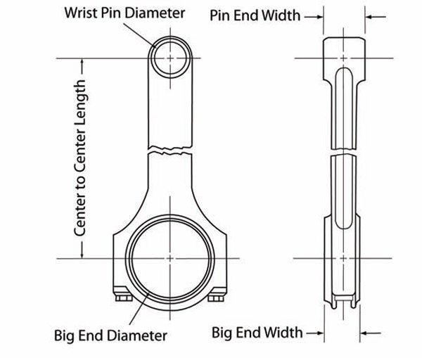
Image 1, Connecting rod example. (musclecardiy,2018)

Research/literature review
The connecting rod is a critical component of any internal combustion engine, it connects the reciprocating piston to the rotating crankshaft, carrying the power from the piston to the crank pin, converting the linear force of the piston into a rotational force at the crankshaft. (mycardictionary,2019). The connecting rod transmits a huge amount of power and is therefore subjected to large tensile stresses, of up to 20 MPa( sciencedirect,2019) and thus must be rigid and strong.
Whilst a four stroke internal combustion engine is in operation it goes through four phases with the piston making two complete passes whilst turning the crankshaft 720 degrees (University of Windsor,2019), within this cycle the connecting rod is subjected to various forces such as cylinder pressure, piston acceleration and retardation and frictional forces (Bin Zheng, Yongqi Liu, Ruixiang Liu, 2013).
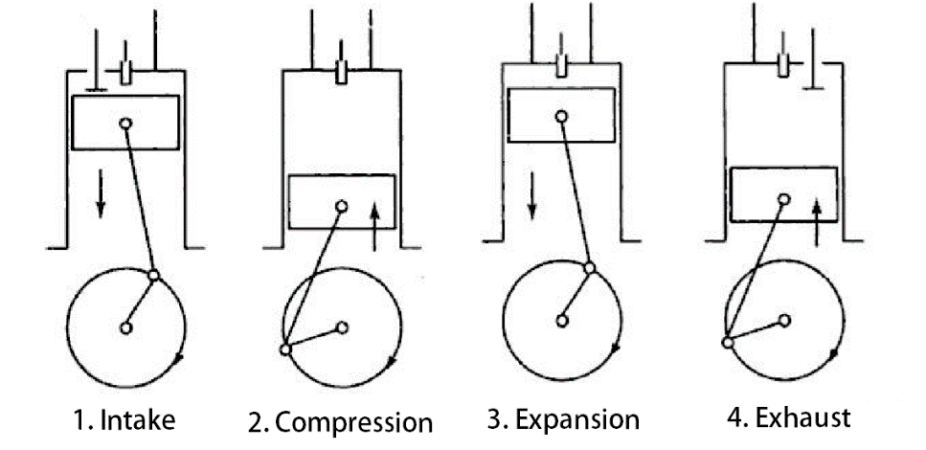
Image 2, Four stroke cycle (Dannana Sundar, 2018)
When a material is experiencing external forces acting upon it, the components internal forces must resist the loading or become deformed. Whilst in this state of resistance the material is in a state of stress. These forces of stress are described as either an external pull, being a tensile force, a tensile stress, or an external thrust, a compressive force and compressive stress (Zammit SJ, 1987,p 14). A connecting rod is subjected to high compressive and tensile loads due to the combustion in the cylinder and the momentum of the reciprocating components (Shaik Himam Saheb, P. Sampath Kumar, A. Ramesh, 2014).

Manufacturing process
Connecting rods are manufactured in a variety of materials and processes that all offer different pros and cons depending on the application they are intended for; Principally con rods are made from aluminium and forged steel, but titanium and powdered metal are also used.
Aluminium rods are forged from heat treated 7075 t6 aluminium alloy with a tensile strength of 83,000 psi and are predominantly used in drag racing as they offer great weight savings, up to 65% lighter than steel rods (musclecardiy,2018). However, they have short life cycles, and at half the strength of steel these weight savings are offset by the increased bulk of design needed to maintain the strength of the rod resulting in a need to modify blocks to accommodate the larger design.
Steel Rods are the most widely used due to long term durability and familiar dimensions. They are forged from 4130 or 4340 alloy steel offering a tensile strength of 145,000 psi (Don Creason,2013).
Racing rods are frequently manufactured from vacuum carbon-arc deoxidised e4340 alloy that offer a tensile strength of 186000 psi (musclecardiy,2018).
The two main processes used to create a connecting rod are forging and billet manufacturing. Again, both offer pros and cons depending on the application they are intended for.
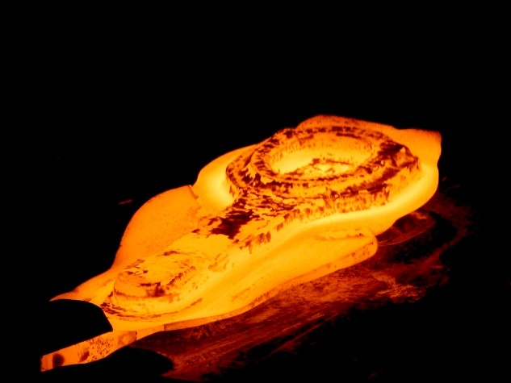
Image 3, Connecting rod forging (steelforging,2018)
Forging is essentially using negatives, heat, and pressure to obtain a blank which is then taken for final machining as well as stress relieved, heat treated and finely tuned for weight proportions. The assets of this method is that large quantities can be manufactured from the same die bringing costs down, however the initial outlay for dies can be very expensive making it redundant with smaller production runs (Don Creason,2013). Another advantage of forging is that grain flow can be manipulated and aligned, this allows the mechanical properties with respect to orientation to be manipulated to offer superior strength in essential directions (Drop Forging, 2019). In essence forging is a good manufacturing process to create strong uniform parts but the financial advantages only become apparent with large quantities.

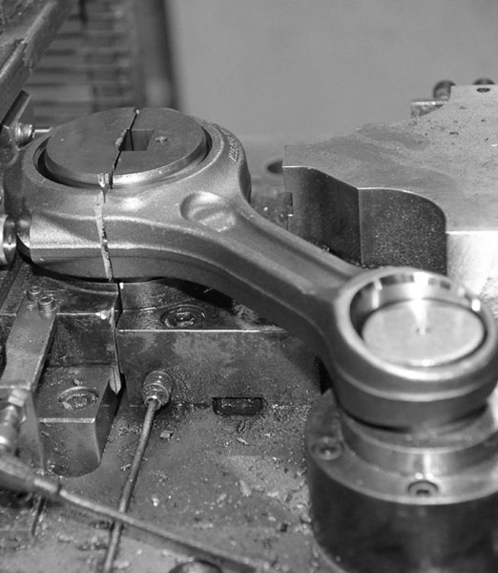
Image 4, Connecting rod machining (albonplc, 2019)
Billet-rod manufacturing processes are created using a CAD type programme which is then cut using a CNC or water jet machine from a single piece of steel (Don Creason, 2013). The improvement of this method is that dies are unnecessary and new designs can be made on programmes allowing improvements and variations towards the components intended use. A manufacturer can make up different size and shapes to fit a whole plethora of machines without the added cost of dies. However, the time needed to create designs, setup machines and finish processes can be labour intensive and as the parts are often made in smaller batches this results in a more expensive product. Additionally, grain structure cannot be manipulated with billet processes.

Methodology
To gain an understanding of the dynamic forces that act upon a conrod, a Volvo v70 850 will be modelled from the published specifications then examined and analysed using an excel spreadsheet that was provided for the purpose of investigation and the graphs that will be produced from the data value input.
The Variables that will be focused upon will be;
- Crank radius
- Conrod length
- RPM
- Mass of piston etc.
The engine that will be under inquiry will be a Volvo 850 v70 1996, specifications as follows;
-Crank radius: | 26.55mm
-Conrod length: | 139.5mm
-Piston mass: | 349g
-Max RPM: | 6100RPM
Figure 1, Volvo 850 V70 1996 specifications.
By inputting this data into the spreadsheet provided a series of graphs are generated. From these graphs it is possible to identify how the height, velocity, force and acceleration of the piston generate different loads upon the connecting rod and at which moment these forces occur with regards to both timing and crankshaft position.
The aim within this report is to analyse these dynamic forces and at which point they occur, as to gain an understanding of the dynamic forces the connecting rod is subjected to, when these forces occur and how the change in the variables shown above affect them

Analysis

Figure 2. Height of connecting rod against function of time at 6100RPM.
Figure 2 models the vehicle at a maximum rev range of 6,100RPM. The Y axis represents the height between the top of the conrod and the crankshaft against the function of time along the X axis which is measured in milliseconds. The graph shows a consistent sinewave with oscillations occurring at every 0.0096 seconds with a maximum height of 166.05mm and a minimum height of 112.979mm.
A second trendline confirms the systematic oscillations.

Figure 3, force and acceleration of the connecting rod against the function of time at 6100RPM.
Figure 3 has the force and acceleration plotted along the Y axis against the function of time in intervals of milliseconds along the X axis.
Once again, a sine wave has been generated demonstrating uniform work done, the graph also displays that maximum force is directly correlated with peak moments of piston acceleration. Looking at the results from figure two and the data generated within the spreadsheet the maximum and minimum forces can be correlated with crank angle and time.
The results show that the maximum forces occurring at 6100RPM are;
Crank radius (°) | Force (N) | Time(s)
175.68 | 3058.695 | 0.0048
351.36 | -4489.93 | 0.0096
534.36 | 3059.628 | 0.0146
710.04 | -4484.71 | 0.0194
Figure 4, maximum forces occurring at 6100RPM with regards to crank position and time.
The results show that maximum tensile and compressive forces occur between 5-10° of TDC or BDC, the compressive forces caused from the pressure in the cylinder above the piston and the tensile and compressive forces caused by the momentum of the reciprocating components of the engine, mainly the crankshaft.

The minimum forces occurring at 6100RPM are:
Crank position (°) | Force (N) | Time (s)
73.2 | 66.41869 | 0.002
270.84 | 162.8183 | 0.0074
431.88 | -31.1454 | 0.0118
629.52 | 257.9832 | 0.0172
Figure 5, minimum forces occurring at 6100RPM with regards to crank position and time.
The results display that minimum forces occur when the crank position is approximately 90°before or after TDC, this would indicate that at this moment the crankshaft is doing less work and the pressure above the piston is at its furthest from compression, thus creating less force upon the connecting rod.

Figure 6, Velocity of piston against the function of time at 6100RPM.
Figure 6 has the piston velocity along the Y axis against the function of time on the X axis. From the spreadsheet provided the maximum and minimum velocity can be generated into a table.
Maximum velocity turned through 720° at 6100RPM
Velocity (m/s) | Crank position (°) | Time (s)
-17.2298 | 73.2 | 0.002
17.24584 | 278.16 | 0.0076
-17.2212 | 439.2 | 0.012
17.25169 | 636.84 | 0.0176
Figure 7, maximum piston velocity with regards to crank position and time.

Minimum velocity turned through 720° at 6100RPM
Velocity (m/s) | Crank radius (°) | Time (s)
-0.15815 | 175.68 | 0.0048
-0.82333 | 358.68 | 0.0098
-0.47441 | 534.36 | 0.0144
-0.359 | 717.36 | 0.0196
Figure 8, minimum piston velocity with regards to crank position and time.
Turning through 720° the piston is at its maximum velocity when it is approximately 90° between TDC and BDC. Additionally, the piston is at its minimum velocity within 5° of TDC or BDC.

When modelling the data at 2000RPM, the results varied in the following ways:

Figure 9, Height of connecting rod against function of time at 2000RPM
As figure 9 expresses, the maximum and minimum height remain the same with a maximum height of 166.05mm and a minimum height of 112.979mm however the oscillations are much more spread out as the connecting rod is moving at a slower rate.

Figure 10, force and acceleration of the connecting rod against the function of time at 2000RPM.
The graph in figure 10 displays a sine wave with very wide oscillations as the connecting rod is moving at a slower rate but in a uniform pattern, once again the graph displays that maximum forces are in conjunction with peak acceleration of the piston.
The maximum and minimum forces are as follows:
Maximum forces
Crank position (°) | Force (N) | Time (s)
177.6 | 329.078 | 0.0148
352.8 | -1449026 | 0.0294
Figure 11, maximum forces occurring at 2000RPM with regards to crank position and time.
Minimum forces
Crank position (°) | Force (N) | Time (s)
76.8 | -3.07862 | 0.0064
278.4 | -3.07862 | 0.0232
Figure 12, minimum forces occurring at 2000RPM with regards to crank position and time.
It is apparent that maximum forces develop when the crank radius is within 10° of TDC and BDC and the minimum forces occur when the crank position is halfway between TDC and BDC.

Conclusion
It is conclusive that at lower RPM the maximum force acting on the connecting rod occurs at a smaller crank angle as it approaches TDC and BDC and as the RPM increases the maximum force generated through the connecting rod, occurs at a larger crank angle.
This is due to spark advancement at a higher RPM, igniting the cylinder mixture earlier as to compensate the delay in the combustion process, putting more pressure into the cylinder earlier and thus increasing the load upon the piston and in turn the connecting rod. Additionally, the crankshafts momentum will increase creating even more force acting through the con rod.
When looking at the piston velocity it is decisive that the piston is at its peak velocity when the force on the connecting rod is at its minimum and the piston velocity is at its minimum when the force is at its greatest. In essence the pistons maximum velocity is the inverse to the maximum force on the connecting rod.
Maximum reciprocating force is just before TDC and BDC, this is directly related to piston acceleration, as the rate of change of speed is at its greatest when the piston moves from an upwards force to a downward as it returns down the cylinder, at this point the rate of change of speed and therefore the force is at its greatest. Whilst the piston is traveling at its fastest the tensile and compressive forces are at their least.

References
Albon plc. (2019). connecting rods. Available: https://www.albonplc.com/development/connecting-rods. Last accessed 28/10/2019.
Bin Zheng, Yongqi Liu* and Ruixiang Liu. (2013). Stress and Fatigue of Connecting Rod in Light Vehicle Engine. The Open Mechanical Engineering Journal. 7, 14-17.
Don Creason. (2013). Connecting Rod Tech: Forged And Billet Steel Rods. Available: https://www.enginelabs.com/tech-stories/connecting-rod-tech-forged-and-billet-steel-rods/. Last accessed 28/10/2019.
Dannana Sundar. (2018). What is a 4 stroke Diesel engine?. Available: https://extrudesign.com/4-stroke-diesel-engine/. Last accessed 28/10/2019.
drop forging. (2019). How does Forging Affect Grain Structure?. Available: http://www.dropforging.net/how-does-forging-affect-grain-structure.html. Last accessed 28/10/2019.
muscle car diy. (2018). How to Build Racing Engines: Connecting Rods Guide. Available: https://www.musclecardiy.com/performance/how-to-build-racing-engines-connecting-rods-guide/. Last accessed 28/10/2019.
my Card Dictionary. (2019). Connecting Rod. Available: https://www.my-cardictionary.com/engine/connecting-rod.html. Last accessed 28/10/2019
science direct. (2019). engine connecting rod. Available: https://www.sciencedirect.com/topics/engineering/engine-connecting-rod. Last accessed 28/10/2019.
Shaik Himam Saheb, P. Sampath Kumar and A. Ramesh . (2014). Design and Analysis of a Connecting Rod for the 117kw Six Cylinders Turbocharged Diesel Engine . Advance Research and Innovations in Mechanical, Material Science, Industrial Engineering and Management . 1 (1), 172-176.
steel forging. (2018). Hot Forging of Connecting Rod. Available: http://www.steelforging.org/hot-forging-of-connecting-rod/. Last accessed 28/10/2019.
university of windsor. (2019). four stroke cycle engines. Available: https://courses.washington.edu/engr100/Section_Wei/engine/UofWindsorManual/Four%20Stroke%20Cycle%20Engines.htm. Last accessed 28/10/2019.
Zammit S J (1987). motor vehicle engineering science. Harlow, United Kingdom: Pearson Education Limited. 14-17.

