Poetic essay film
In this essay, I try to make deep understand of poetic essay film,what is it,why some people fascinated with that and,how to create poetic feeling of this.
For professional Master Degree of Master of UWTSD

BY
SI BO ZHENG
2507317
Dissertation Supervisor:Kylie Boon
MAY 4TH 2026

Poetic essay film
By Si Bo Zheng

Introduction
Where i heard this concept from a coincident in Timi’s course,from this idea,offer me some inspiration,why it called essay film and why it is poetic or called a kind poetic,how we contact with that,those question came into my mind.And later,one new word appear in Kylie’s course: Existentialism,in academic translation,it is much formal meaning,about human condition,freedom,but in my view,if i can use this concept to insert my essay film,perhaps I will get more meaning of poetic,because in the essay film,I would think it is more about feeling of your present,like your mood,your environment and everything in front of you.
I remember one of my memorable experience in the past,in that time I was 22 years old,it is first time I travel with my mom to a nature landscape place,before,I always growled up in the big city accompany by crowd and skyscrapers,I never imagine that outside the city what scene it is. When I first time surrounded by wind,plants and primitive ethic minorities,I find a certain feeling in my mind,in that time it is hard to describe,seems like you make certain connection with your present environment,and you want to express something through your eyes,through your present feeling,it look like some complete different thing in front of you,you want to express,but in that time there was no suitable way to express,later when I went to university I just know in that period of time this experience could be a prose in my mind,I already had some material save in my mind.
So,in this essay,I want to figure out what is essay film,what kind of essay film can be poetic,and also how poetic essay film can make connection with my audience,bring them sense of empathy.

Internal and external linkages of essay films
What kind of films could think it is essay films?this is a basic question,is it beautiful or narrative or explore meaning of existence?it is a philosophy question.First,I want to use internal view to define this kind of films,a iconic representative is Tarkovsky and a French movie <La Jetée>,in those two films,you can feel that everything especially the time is flowing,is not like standard narrative,is most like make a feeling which can intouch with,different person has different sense of that,for me,most time I felt some certain scene was Déjà vu,this Déjà vu feeling from certain characte’s experience or some location you already through the dream or in person to went.
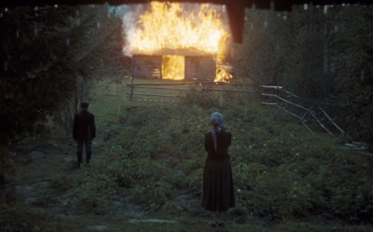 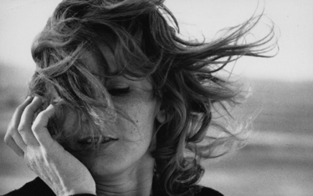
Figure 3. La Jetée (1962), dir. Chris Marker.
Source: Film still.

However,internal view is much about when you look at this kind of films,your present mood or vibe,is tend to personal,everyone has different feeling and thoughts about that.
When every time I try to get into this kind of film,I have always ask myself a question,how to make depth understand with character or is there some scene which touch with me?at this moment,i just realize in some way,it may has another view of feeling,I think it is external.Indeed,if internal is much about my present feeling,the external is tend to make touch with author or scene,like some of this kind of film,some people may think it is bord,it is always slowly,not has to much fluctuation,in some specific works,it even like a slide,just one after another scene.But in the external view,I try to set out from my heart,from my past experience,from this perspective to get into the scene,could find that fascinating.

What patterns do I see?
I already highly clear what type or style of this film I would to produce,is much about journey,philosophy and humanities,for this perspective,only one thing I should do or focus on is much attention about every tiny elements,is not just about perspective,it is most about the ways of looking at the world or life.Life is so fascinating topic,when I was 22,I just knew some person always living in their place of birth,they do not know outside of their homeland,but they keep,save a kind of Innocence and simple happiness,I remember a proverb says: The more you possess, the deeper the pain.For me,the one patterns is understand,understand my surrounding and every single tiny thing beside me,every person who around me,for me this is the real pattern,is not just technique,it is a skill for how intouch with this real world,before I have heard a noun called critical state,it basically describe if people keep a relatively mood,it can into a higher state:Flow state,in this state,you can feel that evey tiny detail around you,I remember when last I felt this feeling was at Highland,in that time,rain storm was cross in my body,there was no one else,I can heard my breathe,heartbeat,I had lots thoughts about,my insight then go with this feeling,this experience also remind me a course before,called ethnography.I think in that time my role transfer from experienced to observer,from bystander view to look at everything surdding by me.

About essay film
This kind of film I would treat it as a poetry form,like visual notes,but for my view,it is much highp remier form than record,it express author present mood through aesthetic way,the form is free,but for me,I will much care about the light and space,and distance.
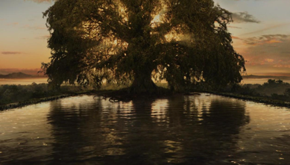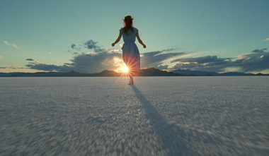
Figure 2. < The Tree of Life>
Source: Film still.

For my opinion,I like describe it like a transition,transforming everyday life into poetic expression,when a gust of wind or a tree into poetic expression,is not ordinary anymore.
Indeed,different eyes look at the world which is different,how can we find meaning of life?remaind us time past or some memorable moment that you want to keep,in my life,so far,I collect lots instant in my mind,every love,move,scene,relation,push me flowing,in past memory determines your present work,for my research subjects,Tarkovsky he said his film explore person with them homeland relation,however we also find some clue in some of commercial films,like Nolan,in his film,he like to break up lots scene and then rebuild a new space,lead audience get into a already familiar but much strangeness scene.
Looking back at essay film,in this field there was less of example or reasch,because this form of art is diverse,every video,record,even a series of photo could be essay film,what important I think?is expression,I have always think life is made up by lots fragments,some we already forget,some save in your deep mind,those fragments which save in your deep mind in some day,specific time or scene it may re stimulate,is like if you go to somewhere,you would feel familiar,but you make sure you never been there before,or look at some painting you can feel a certain mood,those kinds of fragments I would think it is a visual essay,but is just not materialized,is just in your mind or flash in your eyes.

Poetic interpretation
After discussing the general idea of essay film, I begin to think more deeply about what “poetic” really means in this context. For me, poetic is not simply about visual beauty or aesthetic composition. It is something more internal. It is a kind of emotional resonance that exists between image and perception.
When I watch films such as Mirror, directed by Andrei Tarkovsky, I do not feel like I am watching a structured narrative. Instead, I feel like I am entering into a state of memory. The images do not explain themselves, and they do not guide me in a traditional storytelling way. Rather, they create a space for feeling.
Poetic interpretation, therefore, is not about decoding meaning. It is about experiencing meaning.
For example, a simple image such as wind moving across a field may not have narrative significance, but it carries emotional weight. The duration of the shot, the sound of the wind, and the stillness of the camera all work together to create a moment that feels alive. This moment does not need explanation. It exists as a poetic experience.
In this sense, poetic essay film transforms ordinary reality into emotional presence. It shifts the focus from “what is happening” to “what is being felt”.
Another important aspect of poetic interpretation is ambiguity. Unlike traditional cinema, where meaning is often clearly structured, poetic essay film allows for multiple interpretations. Each viewer brings their own memory and experience into the film.
This idea is particularly visible in works such as La Jetée by Chris Marker. The film is composed almost entirely of still images, yet it creates a powerful narrative and emotional journey. This suggests that movement is not essential for cinematic expression. Instead, the relationship between images is what creates meaning.Poetic interpretation, therefore, is not fixed. It is fluid, subjective, and deeply personal.
When I continue to think about poetic essay film, I start to realise that “poetic” is not only about what we see, but also about what is not shown. Absence becomes as important as presence.
In many poetic essay films, there is a strong use of silence. Silence is not empty. It allows the audience to project their own thoughts into the film. In this way, the film becomes a shared space between the filmmaker and the viewer.
Another aspect is slowness. In mainstream cinema, speed is often used to maintain attention. However, in poetic essay film, slowness creates depth. When a shot lasts longer than expected, the viewer begins to notice details that would normally be ignored. Time becomes visible.
This idea connects with my own experience. When I was in the natural environment that I described earlier, time felt slower. I was more aware of my surroundings. This awareness is what I try to translate into my understanding of poetic film.
Poetic essay film also challenges the idea of clarity. It does not always aim to be understood immediately. Instead, it creates a space for reflection. The viewer may not fully understand the film during the first viewing, but certain images may stay in their mind.
This delayed understanding is important. It suggests that poetic meaning is not instant, but develops over time.
Image, Memory and Poetic Structure
In poetic essay film, image is not only a visual representation. It becomes a way of thinking. Each image carries emotional weight, and when images are combined, they create a structure similar to memory.
In Mirror, directed by Andrei Tarkovsky, time is fragmented. Childhood memories, dreams, and present moments are mixed together. This creates a sense of disorientation, but also intimacy. The viewer is not guided, but invited.
For example, the recurring image of wind moving through grass appears simple, but it becomes symbolic. It suggests the passing of time, but also something more personal. It feels like a memory that cannot be clearly explained.
The use of long takes is also important. Duration allows the viewer to stay with the image. Instead of moving quickly to the next event, the film allows time to unfold. This creates a meditative experience.
In La Jetée, Chris Marker uses still images to construct the entire film. This decision removes the illusion of movement, and forces the viewer to focus on each frame. Each image becomes significant.
The narrative is built through sequence, not action. This demonstrates that cinema does not require movement to create meaning. Instead, meaning emerges from the relationship between images.
The use of still images also creates a sense of distance. It feels as though we are looking at memories rather than reality. This distance is essential for reflection.
In contrast, The Tree of Life by Terrence Malick introduces movement and fluidity. The camera often moves freely, almost like a human presence. This creates a feeling of immersion.
The film moves between personal memory and cosmic imagery. This contrast expands the meaning of the film. It suggests that individual experience is connected to something larger.
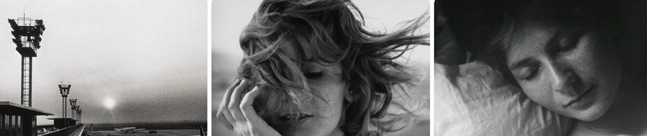
Figure 3. La Jetée (1962), dir. Chris Marker.
Source: Film still.
The use of voice-over is also significant. It does not explain the narrative, but expresses internal thoughts. It creates another layer of meaning.
In Columbus, directed by Kogonada, space becomes the central element. The use of architecture, symmetry, and framing creates a visual language of isolation.
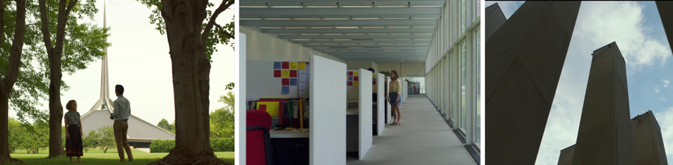
Figure 4. Frames from Columbus, directed by Kogonada.
Source: Film still.
Characters are often placed at a distance, surrounded by large structures. This creates a sense of separation. The viewer becomes aware of space, and how it influences emotion.
This idea is closely related to my own practice. I am interested in how spatial composition can express feeling without relying on narrative.
Through these examples, I understand that poetic essay film is not defined by a single technique. It is defined by a way of seeing.

Limitations of Poetic Essay Film
Although poetic essay film offers a unique way of expression, it also has limitations.
One of the main issues is accessibility. For many audiences, this type of film can be difficult to understand. Without a clear narrative, viewers may feel disconnected.
Some people may describe these films as slow or even boring. This reaction is understandable, because the viewing experience is very different from mainstream cinema.
Another limitation is that poetic essay film often relies heavily on personal experience. While this can create strong emotional depth, it can also make the work too subjective.
If the audience cannot connect with the filmmaker’s perspective, the film may lose its impact.
There is also a risk of over-aestheticisation. When focusing too much on visual beauty, the film may lose meaning. Poetic image should not only be beautiful, but also meaningful.
In my own work, I need to be aware of these limitations. I must find a balance between personal expression and audience engagement.

How Should I Investigate?
My investigation process is both theoretical and practical. Because poetic essay film is highly subjective, I cannot rely only on academic theory. I must also rely on my own experience and observation.
The first method I use is observation. This involves paying attention to small details in everyday life. Light, sound, movement, and silence all become important.
For example, I may observe how sunlight changes a room at different times of the day. Or how a person behaves when they are alone. These moments may seem insignificant, but they contain emotional depth.
The second method is memory. Memory is not accurate, but it is meaningful. It contains emotional truth. By revisiting my own memories, I can find fragments that can be translated into visual form.
The third method is film analysis. By studying directors such as Tarkovsky, Marker, and Malick, I can understand how they construct poetic meaning. I focus on elements such as:
- duration
- rhythm
- framing
- sound
Finally, I experiment with my own practice. I test different approaches, including camera movement, composition, and sound design. Through this process, I gradually develop my own visual language.
Investigation, therefore, is not a fixed method. It is an ongoing process of observation, reflection, and experimentation.

What Will I Create?
Based on my research, I plan to create a poetic essay film that explores loneliness, memory, and spatial experience.
The film will not follow a traditional narrative. Instead, it will consist of fragments. These fragments may include:
- landscapes
- urban environments
- personal moments
- observational scenes
The structure of the film will reflect memory rather than chronology. Scenes will be connected through emotion rather than logic.
Visually, I will focus on:
- natural light
- minimal composition
- distance between subject and camera
I am particularly interested in the concept of “edge”. This includes:
- boundary between light and shadow
- boundary between inside and outside
- boundary between presence and absence
These edges represent transition. They are moments where meaning is unstable, and therefore poetic.
Sound design will be minimal. I will use natural sound, such as wind or footsteps, to create atmosphere. Voice-over may be included, but it will function as internal reflection rather than explanation.
The goal of the film is not to tell a story, but to create a feeling. I want the audience to:
- pause
- reflect
- connect with their own memory
If the film can create this kind of experience, then it achieves the purpose of poetic essay film.

The Role of Viewer and Emotional Participation
Another important aspect of poetic essay film that I begin to understand through this research is the role of the viewer. Unlike traditional cinema, where the audience is guided through a structured narrative, poetic essay film requires a different type of engagement.
In narrative cinema, the viewer is often positioned as a receiver. The film presents a story, and the viewer follows it. The meaning is usually constructed in a clear direction. However, in poetic essay film, this relationship changes.
The viewer is no longer passive. Instead, they become an active participant.
This participation is not based on action, but on perception. The viewer is invited to interpret, to connect, and to reflect. Because the film does not provide clear explanations, the viewer must fill the gaps.
This idea is very important for understanding why some audiences feel disconnected from poetic essay film. Without clear narrative guidance, it can be difficult to know how to engage with the film. However, this difficulty is also what makes the experience meaningful.
The absence of clear meaning creates space.
This space allows the viewer to bring their own memories, emotions, and experiences into the film. In this way, the film becomes different for each person.
For example, when I watch a scene of a person standing alone in a large space, I may connect it with my own experience of loneliness. Another viewer may interpret it differently. The image itself does not change, but the meaning changes depending on the viewer.
This flexibility is a key characteristic of poetic essay film.
It also connects with the concept of empathy. In traditional cinema, empathy is often created through character development and narrative events. The audience understands the character because they follow their story.
In poetic essay film, empathy works differently. It is not based on story, but on feeling.
The viewer may not know the character, but they can still feel something through the image. This feeling does not need to be explained. It exists on a more intuitive level.
This idea relates to my own intention as a filmmaker. I am not trying to tell a complete story. Instead, I want to create a situation where the viewer can feel something, even if they cannot fully explain it.
Another important factor is duration. In many poetic essay films, shots are longer than expected. This duration gives the viewer time to think.
In fast-paced cinema, the viewer does not have time to reflect. The film controls the rhythm. In poetic essay film, the rhythm is slower, and the viewer has more freedom.
This freedom can be uncomfortable, but it is also valuable. It allows the viewer to become more aware of their own perception.
I also notice that repetition plays an important role. Certain images may appear more than once. This repetition creates familiarity, but also variation. Each time the image appears, it may feel slightly different.
This process is similar to memory. When we remember something, it is never exactly the same. It changes depending on our current state.
Therefore, poetic essay film does not only represent memory. It behaves like memory.
From this perspective, the viewer is not just watching the film, but experiencing something similar to remembering.
This connection between film and memory is one of the reasons why poetic essay film can create a strong emotional impact, even without a clear narrative.
At the same time, this approach requires careful balance. If the film is too abstract, the viewer may feel lost. If it is too structured, it may lose its poetic quality.
As a filmmaker, I need to consider how much guidance to provide. I need to create enough structure for the viewer to engage, but also enough openness for interpretation.
This balance is not easy, but it is essential.
Through this research, I begin to understand that poetic essay film is not only about image, but also about relationship. The relationship between filmmaker, film, and viewer.
This relationship is dynamic. It changes with each viewing.
And this is what makes poetic essay film unique.

Conclusion
Poetic essay film cannot be defined by a fixed structure. It exists between cinema, poetry, and philosophy. It challenges traditional storytelling, and offers a different way of experiencing image.
Through this research, I have come to understand that poetic cinema is not only about aesthetics, but about perception. It changes how we see time, space, and memory.
One of the most important aspects is the relationship between filmmaker and audience. Poetic essay film does not deliver meaning directly. Instead, it invites the audience to participate.
This participation creates empathy. The viewer connects not through narrative, but through feeling.
In my own practice, I aim to explore this connection. By focusing on space, memory, and loneliness, I try to create images that resonate beyond their visual form.
At the same time, I am aware of the limitations of this approach. Poetic expression must remain grounded. It should not become purely abstract.
Finally, poetic essay film reminds us that cinema is not only a medium of storytelling, but also a medium of thinking and feeling. It allows us to slow down, to observe, and to reflect.
This is why it continues to be meaningful in contemporary practice.

Tarkovsky, Andrei. Mirror. Mosfilm, 1975.
Marker, Chris. La Jetée. Argos Films, 1962.
Marker, Chris. Sans Soleil. Argos Films, 1983.
Malick, Terrence. The Tree of Life. Fox Searchlight Pictures, 2011.
Kogonada. Columbus. Depth of Field, 2017.
Rascaroli, Laura. The Essay Film: Problems, Definitions, Textual Commitments. Wallflower Press, 2009.
Corrigan, Timothy. The Essay Film: From Montaigne, After Marker. Oxford University Press, 2011.

