BMIH5007 FINANCIAL MANAGEMENT FOR THE HOTEL INDUSTRY A1

Business Report - Comparison of Two Hospitality Organisations

Word Count: 2090
Student Name:
Student Number:
Name of Lecturer:

Contents
Introduction 3
Total Revenue 4
Market Position 7
Growth Potential 10
Financial Commitment to CSR 12
Recommendations 14
Conclusion 15
References 16

Introduction
The objective of this report is to conduct an in-depth analysis in regards to the comparison of the two prominent players in the industry i.e. Mandarin Oriental Hotel Group and Premier Inn. This report will assess these two hotels concerning four parameters that are Market position, total revenue, CSR activities, and Growth potential. These parameters of both the companies would be analyzed and evaluated in this report and based on that, recommendations to both the companies would be given to be able to improve their growth and generate potential results. The purpose of this report is to present a comprehensive business report that will appraise Mandarin Oriental Hotel Group and Premier Inn Companies in respect to financial management practices and strategies for the four parameters mentioned above.

Total Revenue
Revenue of Both Companies for the Last 3 Years (Amounts in Thousands)-
Company Name | 2020 | 2021 | 2022
Mandarin Oriental Hotel Group | 183,700 | 316,900 | 454,100
Premier Inn | 2071.5 | 1703.4 | 589.4

(Source: Author, 2023).
According to Whitbread.Co.UK (2020), the above table and graphs show the amount of revenue that is being generated by each of the organization i.e. Mandarin Oriental Hotel Group and Premier Inn Group. From the results, it is evident that the revenue of Premier Inn Group was high in 2020, whereas the revenue of Mandarin Oriental Hotel Group was high in 2022. This demonstrates that the performance of Premier Inn Group Hotel has not been better due to lower revenues when compared to Mandarin Oriental Hotel Company.
Sources of Revenue-
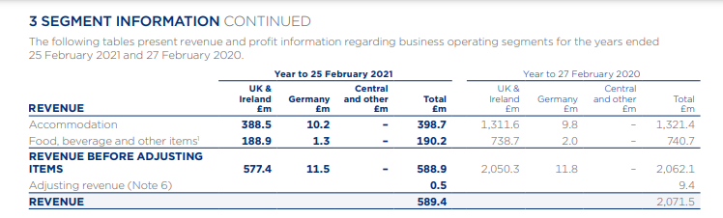
(Source: Whitbread.Co.UK, 2021).
According to Whitbread.Co.UK (2021), the above picture demonstrates the source of revenue for the Premier Inn Group. It can be seen that the UK & Ireland, Germany, and Central are the major segments for the Premier Inn Group through which the company generates its final earnings and the highest is from the UK & Ireland. The analysis of financial data of Premier Inn Company has been from the segment information which has been extracted from annual reports. The revenue is coming from two areas i.e. accommodation & food and beverage. These are the sources from which the revenue is generated. Accommodation accounts for 67.7% and food & beverage accounts for 32.3% of the overall revenue.
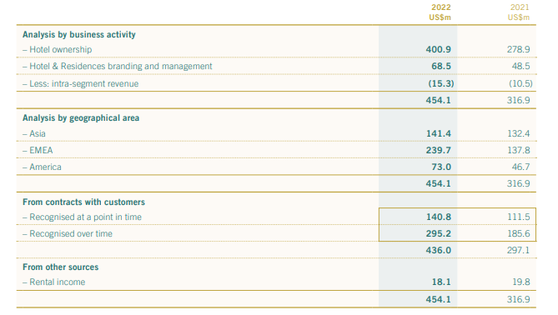
(Source: Mandarin Oriental, 2022).
Mandarin Oriental (2022) has represented the different sources of revenue generated by Mandarin Oriental Group as Asia, EMEA, and America have been the major sources. From the above picture, it has been observed that hotels are the main sources for the Mandarin Oriental Group through which revenue is being generated. Revenue has been increased from US $M 278.9 to US $M 400.9 from 2021 to 2022. This shows that Mandarin Group has been focusing on their services which have led the revenue to be high. Hence, it can be said that approx. 90% of the revenue comes from hotels and around 10% comes from residences branding and management.
Revenue Trends- According to Mandarin Oriental (2023d), revenue management efforts of inventory, distribution, pricing and selling has been the core focus of Mandarin Oriental Group that drives the generation of the revenue. According to Sweney, (2023), for Premier Inn Group, increased occupancy rates and 54% increase in average room for each room has been the trend for the business.
Factors Driving Revenue Growth or Decline- The factor that has led to a decline in revenue of both companies has been showing that the pandemic has been the major reason in the initial years for Mandarin Hotel Group and Premier Inn Group, 2021 year was been affected. According to Whitbread.Co.UK (2021a), this was the major factor that led to such poor performance. Restrictions were also the reason due to which Premier Inn Company was badly impacted by the low revenue margins.
Revenue Comparison-
Considering the sources of revenue, Mandarin Oriental Group has two sources i.e. hotels and branding & management whereas for Premier Inn, accommodation & food and beverage are the sources of revenue. The revenue of Mandarin Oriental Group has been high as shown in above graph. The diversification of both the hotels has been diversified as both the hotels are engaged in more than one source of revenue. Premier Inn earns 67% approx. from accommodation whereas Mandarin Oriental Group earns 90% approx. from hotels. This shows that Mandarin Oriental Group’s performance has been better.

Market Position
According to Mandarin Oriental (2023d), an ample and careful amount of research has been done for Mandarin Oriental Group on a consistent and regular basis to assess the ability of the business to maximize its revenues. Stephenson (2023), has said that effective branding and marketing of Premier Inn Group has been able to make an increase of 19% in profits when compared to pre-pandemic levels.
Market Share-
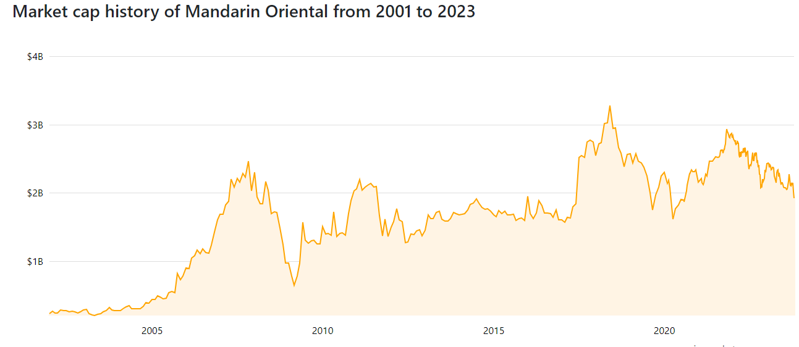
(Source: Companies Market Cap, 2023).
Companies Market Cap (2023) has depicted the above graph which shows the market cap history of the Mandarin Oriental and it has been demonstrated that there have been fluctuations in the market capitalization. However, as of October 2023 month, the market cap of the company is $1.92 billion which has made Mandarin Oriental as 3193th most valuable company. This means that Mandarin Oriental share in the market is comparison to Premier In Group.
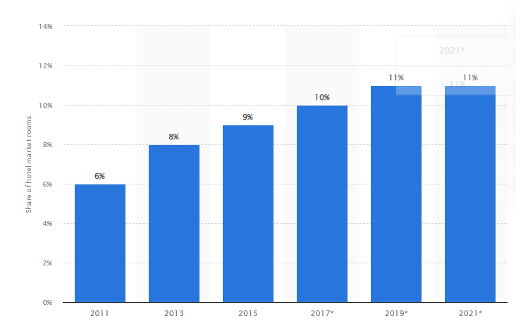
(Source: Statista, 2021).
According to Statista, (2021), the above graph demonstrates the market share of rooms of Premier Inn Group in the total hotel market of the UK respectively. Having such high market share of room indicates that Premier Inn Group has been able to sell their hotel rooms to higher extent when compared to competitive market.
Customer Demographics-
- Mandarin Oriental Group- As per Martin Roll (2020), the core goal of the Mandarin Oriental Group is steeped in providing and delivering the customers with the best guest experience by blending Asian Cultures. The bars of the hotel offer Sakura-Themed Drinks which shows that the needs of the customers of Tokyo are anticipated in advance for better service.
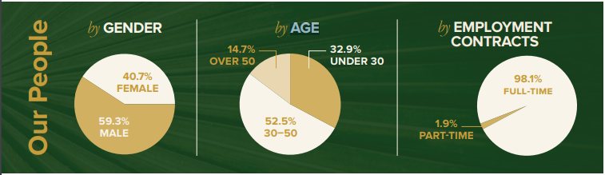
(Source: Mandarin Oriental, 2022a).
The above picture shows the gender, age and employment contracts of Mandarin Oriental Group. It shows that Mandarin Oriental has 40.7% of female and 59.3% of male. In addition, mostly people (employees) are from the age group of 30-50 age group which accounts for 52.5% which is the highest percentage. Mandarin Oriental Group has hired 98.1% full time employees in their business.
- Premier Inn Group-
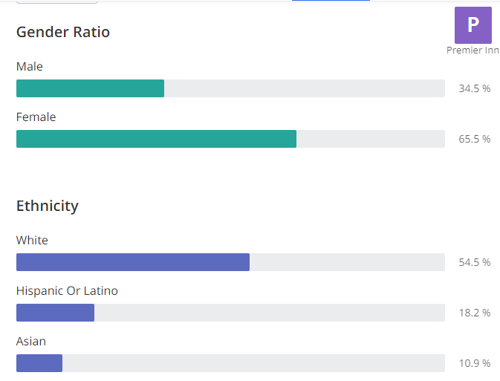
(Source: Zippia, 2023).
According to Zippia (2023), the gender ratio and ethnicity of the employees of Premier Inn Group have been disclosed above. The number of females is high when compared to males. In addition, the ethnicity is highest for the White. This shows that Premier Inn supports female contribution more.
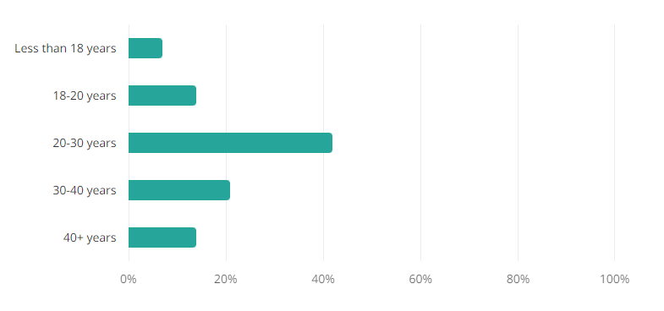
(Source: Zippia, 2023).
The most common age range that has been found in the case of Premier Inn has been 20-30 years which accounts for 43%. However, the least age range that has been found is in the case of less than 18 years i.e. 7%.
Brand Perception-
- Mandarin Oriental Group- As per Mandarin Oriental (2023d), the recognition of the Mandarin Oriental Group brand by the industry and the customers is for the outstanding service and exceptional design and architecture which make the hotel a unique brand.
- Premier Inn Group- According to the study by Price (2017), Premier Inn has been considered the world’s strongest hotel brand. This study has considered Premier Inn as a strongest hotel in terms of valuation and strategy consultancy Brand Finance. Premier Inn scored 88.7 out of 100 on the Brand Strength Index.
Bowman’s Strategy Clock-
According to Chumba (2019), bowman’s strategy clock is a theory that attempts to explain how a business firm can provide and offer the specific and particular products that are required by the customers to attain competitive edge and advantage for their respective customers. As per the clock, Premier Inn Group comes under 6th stage i.e. high risky margins as Premier Inns Group has reduced their profit margins over the last few years and Mandarin Oriental Group comes under 4th stage i.e. differentiation as the hotel provides unique services to its customers by providing customized messages and relevant offers.

Growth Potential
Following Gill (2023), Premier Inn Company has been into its expansion as they have already added 11 properties over the UK. The company has been looking forward to Ireland and the UK by increasing the number of locations to more than 160 in these defined places.
As per Mandarin Oriental (2023d), it has been observed that the growth potential of the hotel has increased. The business has accelerated its growth as they have developed itself as a brand in the strategic locations of the business. As per Mandarin Oriental (2023d), the luxury experience of Mandarin Oriental has the power to provide the employees with the best environment. It has also been observed that the pandemic has brought various challenges; however, commitment to the exceptional environment has allowed the business to be able to generate the best potential results.
- Expansion Strategies-
- Mandarin Oriental Group- According to the Breaking Travel News (2023) release, Mandarin Oriental Group Company has been seeking to expand their business and leisure in destinations in Europe respectively. In addition, the business is also considering expansion as a portfolio in Asia. Key regions for future expansion also include the United States and the Caribbean. This is the current strategy that the business is looking down for better growth.
- Premier Inn Group- The unique business model of Premier Inn Group provides the company with a competitive advantage and the company is looking forward to expanding its business in Germany along with the UK (Whitbread.Co.UK, 2023). The vertically integrated business model differentiates the company and the major three strategies of Premier Inn Group are-
- Grow and innovate in the core markets of the UK
- Focus on the strengths and competitive advantage to expand in Germany
- Enhancing the capabilities to be able to ensure Long-Term Growth (Whitebread.Co.UK, 2023).
- Market Opportunities-
- Mandarin Oriental Group- As the company is highly focused on driving operational efficiencies, the market opportunities for the company are consistently increasing which will allow the business to modernize its scalability, and implementation of the HR operating model will simplify the technology platform most easily for better growth in the market. Through the HR operating model, HR of Mandarin Oriental Group can introduce various updated technologies in the business. This will eventually improve the process of the hotel. Metrics such as revenue and expenses will be reviewed on a regular basis that will allow Mandarin Oriental Group to improve their overall financial and non-financial performance.
- Premier Inn Group- Wild (2023) has stated that the Premier Inn Group has been focusing and aiming at innovating the growth through the existing pipeline which is allowing the business to continue winning the market share. For the business, Germany has been observed as a remarkably exciting opportunity for the business like the UK. A decrease in hotel supply will enable Premier Inn Group to have better market opportunities in Germany. As Premier Inn Group is considering Germany as a potential market, reduction in current supply of the rooms in UK and expansion in other potential market of Germany will lead Premier Inn Group to generate profits in Germany as well.
- Potential Barriers to Growth-
- Mandarin Oriental Hotel Group- As per Mandarin Oriental (2022), Foreign Exchange risk and net investments in foreign operations are the barriers that can hinder the growth of the Mandarin Oriental Hotel Group. The credit risk of the company is also exposed to the deposits with the bank which might also influence the operations to a greater extent. Expanding into other cities and countries can restrict Mandarin Oriental Group to expand effectively as exchange rate fluctuations might allow Mandarin Oriental Group to have lower profit margins.
- Premier Inn Group- Barnes (2023), has said that staff Shortages and Supply Chain Problems have been the major barriers for Premier Inn Group. These two barriers are the ones that can hinder the growth of the Premier Inn Group Company to a greater extent. The re-start of the business travel post-pandemic has been a key metric towards poor growth of the business. Having few labour in the future can restrict Premier Inn Group business to provide limited amount of services to the customers as no proper amount of services to the customers can lead to dissatisfaction among the customers.

Financial Commitment to CSR
- Commitment to CSR Initiatives-
- Mandarin Oriental Group- Mandarin Oriental (2022a), has said that in the concern of environmental impact, Mandarin Oriental Group has undertaken green commitments policies to improve energy and water to ensure that the changing climate change does not impact the business. For Social Impact, the use of diversity & inclusion policy is being applied to ensure that modern slavery and human trafficking are being eliminated. Lastly, for government impact, the governance structure of the Mandarin Oriental Group Company chooses a colleague who outshines in performance and that person is being given toolkits for diversified perspectives in the future.
- Premier Inn Group- As per Premier Inn.Com (2022), for the environmental aspect, net zero transition by 2040 has been the main goal of Premier Inn Group. Reducing waste is another initiative that Premier Inn Group has been consistently attached to. For social impact, the diversity commitment of Premier Inn Group i.e. 40% female representation in the leadership and 8% to ethnic minority is one of the examples.
- Sustainability Practices-
- Mandarin Oriental Group- As per Mandarin Oriental (2022a), the main sustainable practice and initiative that has been taken by Mandarin Oriental Group is “Plastic Free”. Implementation of sustainable and luxurious spas has also been in the portfolio of the company that promotes mindfulness and encouragement to society. The company has achieved a 30% reduction in carbon and a 16% reduction in water wastage which has been positively impacting society.
- Premier Inn Group- As per Reuters (2021), the Company has taken a pledge to reach zero carbon emissions (net) by the end of 2040 effectively. Premier Inn Group has been the first hotel that has targeted this as a sustainability Programme for the consumers and the society. Another sustainable practice that has been undertaken is maintaining the use of renewable energy at 100%. Moreover, installing solar panels has also been an initiative.
- Community Engagement-
- Mandarin Oriental Group- Mandarin Oriental (2022a) has specified the focus of the group towards the promotion of social inclusion in the most effective manner by engaging the colleagues and the overall community to the fullest respectively. To connect with the ‘community’, Mandarin Oriental Group has raised GBP10,000 for the food distribution charity respectively.
- Premier Inn Group- According to Premier Inn.Com (2023), the company has stated that every time a new hotel is opened, the support is extended by the group for sponsoring each of the team members at the new sites. This allows volunteering for three hours respectively.
- Ethical Business Practices-
- Mandarin Oriental Group- Mandarin Oriental (2023) has stated in their human rights policy that they put integrity towards everything they do and have accountability for all the mechanisms. There is no forced labor or even human trafficking.
- Premier Inn Group- According to Whitbread. Co.UK. (2020), the audit conducted by the business following International Standards on Auditing, it has been observed that the requirement of the company is independent and is in association with the ethical requirements that are required during the process of audited financial statements.
Comparison and Contrast-
Both Mandarin Oriental and Premier Inn Group have been focusing on CSR goals and sustainability practices. Mandarin Oriental has been focusing more towards social diversity whereas Premier Inn Group has been focusing on reaching net zero emission. Their CSR efforts are although similar, however, it can be said that both business organizations wants to provide the best customer service. Both companies are focusing towards CSR activities and spending enough amounts.

Conclusion
The analysis has assisted in providing detailed aspects of the financial management of both hotels. The report has focused on delivering the different parameters and their respective information regarding total revenue, CSR initiatives, growth potential, and market position. Both companies have been fulfilling the needs of the customers and other stakeholders as well. Key areas have also been discussed and this has shown that it is important to undertake each parameter for growth in the businesses. From the report, it can be summarized that Mandarin Oriental Group has better performance in comparison to Premier Inn Group. In addition, both companies have been focusing on CSR initiatives which have allowed the company to attract customers.

Recommendations
Opportunities for Growth- Based on the analysis covered above, Mandarin Oriental Group is recommended for growth opportunities. The major reason behind the same has been higher market capitalization and the ability to generate profit. In the past years, the growth of the hotel has been increased. Therefore, it can be said that Mandarin Oriental Group has multiple opportunities that are underlying. Although Mandarin Oriental Group has been able to generate profits in the past few years, it means that Mandarin Oriental Group can easily emerge by expanding their operations in other countries for better customer retention.
Potential for Outsourcing- Outsourcing is defined as the process of a company being into an agreement with another company to be responsible for planned or any existing activity to be carried out. In the case of outsourcing, in the last year 2022, Premier Inn Group’s revenue has been influenced. Hence, Premier Inn Group is recommended for outsourcing as the business has adequate cash flow till 2021, which has not been utilized in 2022. Hence, for future years, Premier Inn Group shall consider outsourcing for higher profit margins. Having adequate cash, Premier Inn should look for outsourcing to other companies with expertise. Such expertise will provide great efforts to Premier Inn in respect to improvement in the performance of the business.

References
Barnes, O. (2023) Premier Inn owner says inflation and labour shortages offer ‘growth opportunities’. Available at: https://www.ft.com/content/e4c6f668-cfeb-466a-8db9-3e68d49612f5 (Accessed: 14 October 2023).
Breaking Travel News (2023) Mandarin Oriental Exclusive Homes Announces Strategic Portfolio Growth And Expansion Plans. Available at: https://www.breakingtravelnews.com/news/article/mandarin-oriental-exclusive-homes-announces-strategic-portfolio-growth-and/ (Accessed: 17 October 2023).
Companies Market Cap (2023) Market capitalization of Mandarin Oriental (M04.SI). Available at: https://companiesmarketcap.com/mandarin-oriental/marketcap/ (Accessed: 19 October 2023).
Gill, R. (2023) Premier Inn looks for further growth in the UK. Available at: https://www.businesstravelnewseurope.com/Accommodation/Premier-Inn-looks-for-further-growth-in-the-UK (Accessed: 18 October 2023).
Mandarin Oriental (2020) Sustainability Report 2020. Available at: https://photos.mandarinoriental.com/is/content/MandarinOriental/mandarin-oriental-sustainability-report-2020-2 (Accessed: 16 October 2023).
Mandarin Oriental (2022) Annual Report 2022. Available at: https://photos.mandarinoriental.com/is/content/MandarinOriental/corporate-22arMOIL (Accessed: 18 October 2023).
Mandarin Oriental (2022a) Sustainability Report 2022. Available at: https://photos.mandarinoriental.com/is/content/MandarinOriental/_Corporate/PDFs/mandarin-oriental-sustainability-report-2022.pdf (Accessed: 14 October 2023).
Mandarin Oriental (2023) Mohg Human Rights Policy. Available at: https://photos.mandarinoriental.com/is/content/MandarinOriental/corporate-human-rights-policy (Accessed: 16 October 2023).
Mandarin Oriental (2023d) Business Profile. Available at: https://photos.mandarinoriental.com/is/content/MandarinOriental/corporate-business-profile (Accessed: 18 October 2023).
Martin Roll (2020) Mandarin Oriental – An Iconic Asian Luxury Hotel Brand. Available at: https://martinroll.com/resources/articles/asia/mandarin-oriental-a-leading-asian-hospitality-brand/ (Accessed: 19 October 2023).
Premier Inn.Com (2022) Environmental, Social and Governance Report 2021/22. Available at: https://www.premierinn.com/content/dam/pi/websites/desktop/why/force%20for%20good/final-esg-report-2021-2022.pdf (Accessed: 17 October 2023).
Premier Inn.Com (2023) We’re a Force for Good. Available at: https://www.premierinn.com/gb/en/why/force-for-good.html#:~:text=Every%20time%20a%20new%20hotel,local%20residents%20are%20passionate%20about (Accessed: 16 October 2023).
Price, K. (2017) Premier Inn ‘world's strongest hotel brand'. Available at: https://www.thecaterer.com/news/hotel/premier-inn-worlds-strongest-hotel-brand (Accessed: 19 October 2023).
Reuters (2021) Premier-Inn owner vows to reach net zero carbon emissions by 2040. Available at: https://www.reuters.com/business/sustainable-business/premier-inn-owner-vows-reach-net-zero-carbon-emissions-by-2040-2021-04-21/ (Accessed: 18 October 2023).
Statista (2021) Premier Inn's share of hotel rooms in the total hotel market in the United Kingdom (UK) from 2011 to 2021. Available at: https://www.statista.com/statistics/755691/premier-inn-share-of-hotel-market-rooms-united-kingdom-uk/ (Accessed: 14 October 2023).
Stephenson, J. (2023) Premier Inn owner hails brand marketing a ‘powerful tool’. Available at: https://www.marketingweek.com/premier-inn-marketing-powerful-tool/ (Accessed: 14 October 2023).
Sweney, M. (2023) Premier Inn owner surpasses pre-Covid profits as travelers seek deals. Available at: https://www.theguardian.com/business/2023/apr/25/premier-inn-whitbread-pre-covid-profits-deals#:~:text=Premier%20Inn%20UK%20reported%20a,%C2%A359.45%20year%20on%20year. (Accessed: 27 January 2023).
Whitbread.Co.UK (2020) Annual Report and Accounts 2020/21. Available at: https://cdn.whitbread.co.uk/media/2021/05/05141427/23076_Whitbread_AR2020_web.pdf (Accessed: 19 October 2023).
Whitbread.Co.UK (2021) Premier Inn Hotels Limited: Annual Report and Financial Statements. Available at: https://cdn.whitbread.co.uk/media/2021/02/12122648/pihl-accounts-final-signed.pdf (Accessed: 17 October 2023).
Whitbread.Co.UK (2021a) FY21 Full Year Results 27 April 2021. Available at: https://cdn.whitbread.co.uk/media/2021/04/26173332/Whitbread-FY21-Full-Year-Results_1.pdf
Whitbread.Co.UK (2023) Our Business Model and Strategy. Available at: https://www.whitbread.co.uk/about-us/our-business-model/ (Accessed: 17 October 2023).
Wild, R. (2023) Whitbread Announces “Outstanding” Trading At Premier Inn As Group Sales Rise 19%. Available at: https://www.forbes.com/sites/roystonwild/2023/06/22/whitbread-announces-outstanding-trading-at-premier-inn-as-group-sales-rise-19/?sh=5d5582c1ea82 (Accessed: 17 October 2023).
Zippia (2023) Premier Inn Demographics and Statistics. Available at: https://www.zippia.com/premier-inn-careers-645194/demographics/ (Accessed: 16 October 2023).

