Jjjnn
Strategic Sport Event Management – Assignment 1

(BMSM6006)
Chelsea Jenkins - 1910104

Table of Contents
i. List of Figures 3
1. PART 1 – Event Scoping and Feasibility 4
1.1 Introduction 4
1.2 Objectives and Concepts 5
1.3 Feasibility and Strategic Fit 5
1.4 Potential Impacts 6
1.5 Target Audience and Competition 7
1.6 SWOT Analysis 8
2. PART 2 – Strategic Marketing Overview 8
2.1 Attract and Retain Spectators/Customers 8
2.2 Market Segmentation 9
2.3 Marketing Mix 9
2.4 Marketing Objectives & Specific Tactics 11
3. Reference List 12
4. Appendix 16
4.1 Appendix 1 – Event Scoping and Feasibility Figures 16
4.2 Appendix 2 – Strategic Marketing Overview 19
4.2.1 Appendix 2a – Figures 19
4.2.2 Appendix 2b – Swansea Local Vision Definition 24

List of Figures
Figure 1 – Singleton Park 4
Figure 2 – Mumbles Beach 5
Figure 3 – Vetch Field 5
Figure 4 – Museum Park 5
Figure 5 – Dylan Thomas Centre 5
Figure 6 – Swansea Average Salary Comparison 5
Figure 7 – Average Salary Comparison of Swansea and Surrounding Areas from 1999-2021 7
Figure 8 – Net House Income Map of Swansea and Surrounding Areas 19
Figure 9 – Kolter and Keller (2012,.p326) Different Product Levels 19
Figure 10 – Examples of Promotion Poster 20
Figure 11– Example of Promotion Leaflet 20
Figure 12 – Example of Poster for Students 21
Figure 13 – Example of Promotion Poster for Children 21
Figure 14 – Example of Toddler Volleyball Activity 22
Figure 15 – Example of Children’s Volleyball Activity 22
Figure 16 – Example of Children’s Volleyball Game 23

1. PART 1 – Event Scoping and Feasibility:
1.1 Introduction
Masterman (2003a, b,2004,2011, p, 70,71), highlights that there are several key factors that are required to planning a successful event (Hall, 1997). He clarifies that you need clear objectives and concept along with feasibility, short- and long-term goals, sustainability, evaluation, and feedback.
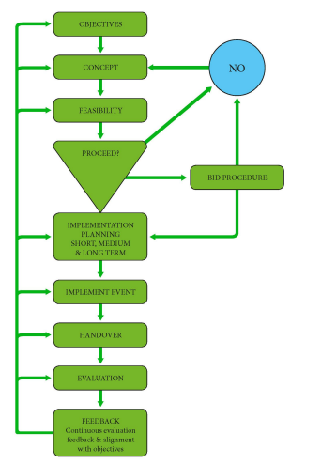
The Event Planning Process (Masterman, 2014, p.71)
The Sport Event shall be planning is one of the British Volleyball Championship stops on the tour hosted by Swansea. The decision was chosen for British Volleyball Championship due to Cardiff have previously hosted Wales section of the tour and have proven they can successfully host the event. In addition, Jiri Popelka (2017), stated that volleyball is a very popular sport at grassroots in the UK, with tens of thousands playing the sport each week and has been increasing resulting in it being called “one of the World’s most popular and growing sports. For example, Volleyball is the 6th most popular sport in the World in 2021, with 900 million followers (Devano, 2021). In 2020, Welsh Volleyball announced they were looking for both male and female athletes to represent Wales in their first Commonwealth team in Birmingham 2022 (Welsh Volleyball,2020).
This links to the Future Generation Act 2015, under a Healthier Wales along with the Welsh Governments 2020 Vision to have Wales be recognised as an outstanding destination for major events. Welsh Government (2020) added that this would enhance Wales well-being of the population and its communities.
1.2 Objectives and Concepts:
One of the objectives of this event is to be a Type D Event (Jago and Shaw, 1998), “a major competitive event generating limited economic activity with being a part of the annual cycle of sport events.”
Additionally, the aim of the event is to hopefully increase the level of physical activity within Wales. General physical activities were compromised by the Covid-19 pandemic, resulting in an increase in inactivity and increased levels of obesity (Puccinelli et al, 2021). A secondary aim would be to increase the usage of Welsh natural resources by setting all aspects of the event outdoors.
Before considering my short and long-term goals they had to be specific, measurable, attainable, relevant and time – bound (Fresch, 2021). The short-term goals are for the event to be deemed a success along with the effects of the fan zone being shown as fun, easy to play and get involved as well as families realising it does not cost a lot to buy a volleyball and it’s easy to play anywhere (Williams, 2019). The long-term goals are to increase the further popularity of the sport and therefore increasing the levels of physical activity across Wales as a family (Getz, 2005).
The event would take place in June and replace Cardiff as the Welsh location on the tour. Furthermore, unlike Cardiff’s layout of having all courts located in one park, Swansea will have courts spread across the city to increase attendance and economic benefit whilst also showcasing the best of Swansea. Due to there being multiple courts across the area they will only be temporarily built, consequently leaving no physical legacy (Bernstein, 2002).
1.3 Feasibility and Strategic Fit:
Getz (2005), Watt (1998), Smith and Stewart (1999), all state that feasibility is a key stage of the planning process due to it clarifying whether the event will work or not. The main concept of the event is to showcase Swansea by having multiple courts spread across the city. After deliberating, the five locations that have been chosen are: Singleton Park, Mumbles Beach, Vetch Fields, Museum Park and outside the Dylan Thomas Centre (See Appendix 1, Figure 2,3,4,5,6).
McGee and Channon (2014), describe strategic fit as controlled balance of an organisation therefore matching their resources and capabilities with opportunities that arise in the external environment. This means for our event that to ensure the event is a success we need to establish potential opportunities for Wales, Swansea, and society. For example, using Swansea’s natural resources and infrastructure already in place.
The partners of the event will include Swansea Council, Welsh Government, Sport Wales, Volleyball Wales, UK Volleyball, University of Trinity St David’s (UWTSD) and Mikassa. Welsh Government and Sport Wales are partners because the event aligns with their 2020 mission vision (Welsh Government, 2020) along with the Sport Wales “Be Active” campaign (Sport Wales, 2021). Thus, the decision to have UWTSD involved in the event was to allow university sport students the opportunity to gain vital experience locally, as well as helping to reduce additional costs due to them being volunteers throughout the event. Likewise, to have the support and backing of Swansea Council as the host of the event is critical to the success of the bid and successful delivery of the event (Getz, 2005). Mikassa is one of the main volleyball ball brands and them supplying equipment would be a huge benefit along with reassurances that the event has professional support as well as sponsorship.
1.4 Potential Impacts:
When determining the impacts of a sport event Hover et al (2016), p.13, highlights there are 4 impacts i.e., social, economic, environmental, and physical (refer to appendix 1, figure 7).
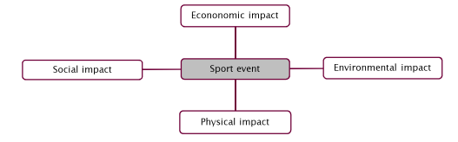
Impacts of a Sport Event (Hover et al, 2016, p.13)
Governments are willing to spend a high amount to attract and host a sporting event, because they believe that it generates significant additional economic impact (Saayman and Saayman, 2014). Moreover, Wilson (2007), highlights that sport events “generates unequivocal” economic benefit to the hosts communities as well as creating opportunities i.e., local businesses and tourism.
Hosting sporting events is known to have potential positive effects on local communities (Haubois et al, 2019, p.335). Crompton (2004) and Kim and Walker (2012), state that there has been a growing interest in non-strictly economic impact including well-being, quality of life, civic pride, and sense of belonging. Along with destination image (Berkowitz, 2007 and Armenakyanetal, 2012). This will be prevalent for Swansea hosting the UK Volleyball Championships bringing the community together after being apart and needing to work on their well-being due to the ongoing Covid-19 pandemic.
Furthermore, another social impact of the event could possibly be “soft legacy”. The idea of soft legacy involves the event linking to people’s experiences, attitudes, and behaviours (Holt and Ruta, 2011). Additionally, Dickson et al (2007), argues that we should consider the concept of space and time when linking to legacy i.e., legacy can change over time and could be different region by region. For example, Beijing Olympics 2008, there was an overview that showed there was substantial differences of the legacy between citizens in different Chinese provinces (Manzeneriter, 2014).
1.5 Target Audience & Competition:
The target audience for the event are families of the local and surrounding areas, University students and current supporters of volleyball. Families of the local and surrounding areas were chosen as part of the target audience because one of the main objectives of the event is to encourage participation in volleyball after the event. Exercising with the whole family has been proven to make families stronger and closer (Graham, 2016).
The competition for hosting the event is Cardiff because they have proven since 2016, they can successfully host the major event along with having their first volleyball tournament in Barry Island in September this year (Powell, 2021). Other competition for the event is ensuring if tourists come to stay of the event Swansea isn’t losing them to hotels in Pembrokeshire and Llanneli.
1.6 -SWOT Analysis:
Strength | Weakness | Opportunity | Threat
Don’t’ need to build facilities. | Not as developed as Cardiff e.g., structurally or volleyball isn’t as known in Swansea as Cardiff. | For local people to use Swansea’s natural resources more e.g., mumbles beach and singleton park. | Losing the bid to Cardiff because they have successfully run the event since 2016.
Using natural resources of Swansea. | Carparking maybe an issue in some event locations. | To increase tourism e.g., profit for small local businesses. | Pembrokeshire has similar natural resources.
Increasing popularity sport in Wales. | Lack of high-end hotels. | Using an additional streaming service will increase followers to the sport and showcase Swansea. | Covid-19 Pandemic makes it certain the event will go ahead.
Low Budget Sport event. (showcasing/profit without spending loads). |  | For university students at UWTSD to gain vital experience to help advertise the university on TV. | Due to some locations being on the coast could have difficulties with wind.
Meets Welsh Government and Sport Wales aims (Welsh Government, 2020). |  | Summer holidays = more families attending/ publicity | Cardiff as a location has a bigger reputation for hosting sport events.
Well, run public transport e.g., frequent buses to event locations.
2. PART 2 – Strategic Marketing Overview:
2.1 Attract and Retain Spectators/Customers:
Funk et al. (2008) states that only a heighten understanding of the consumers behaviour can you market and develop communication strategies to enhance their experience whilst highlighting the elements of the consumers decision making process. They continue by noting that sport consumers behaviour is the same whether it be watching or participating in a sport event due to it all being about the experience. Additionally, ensuring that the needs and wants of the consumer are met with sport products and services (Shillbury et al, 2009).
For the event we shall be offering a range of commemorative products such as reusable cups and t-shirts. This will be offered within packages for consumers pre-event whilst purchasing their tickets. To attract families, we will be offering for every adult ticket a child can enter for free, therefore making the event more accessible and affordable for local families. This was influenced by Swansea’s local population having 11.5% of deprivation linking to the 10% most deprived in Wales (Welsh Index of Multiple Deprivation, 2019). As a result, attracting this group was important for succeeding in our objectives to increase participation in the local community.
2.2 Market Segmentation:
Shank (2005) recognises 6 elements of segmentation i.e., demographic, socioeconomic, psychological, geographic, behavioural and benefits. However, Bourgeon and Bouchet (2001) identify 4 sport event segment behaviours i.e., opportunist, aesthete, supporter and interactive.
Segmentation is putting customers and potential customers into distinct groups to see common themes of characteristics in their buying patterns (Harris and Elliot, 2005). Demographic, geographic and socioeconomic will be the 3 main areas the event will be focusing on. After researching we know that Swansea and its surrounding areas have an average annual income of £31,500 which is significantly lower than the UK average of £38,100 (Plumplot, 2021) - refer to appendix 2, figure 8,9. This will need to be considered when deciding on prices of tickets, products, and packages to ensure local families can attend the event.
In 2017, Swansea City Council released a report stating a local vision. The report highlighted that the people of Swansea will have better access to modern health and social care, along with increasing the city population’s well-being, exercise and linking to a resilient Wales (City & County of Swansea Mental Health Commissioning Strategy, p.9, 2017) – refer to appendix 2b. The event hopes to work towards Swansea’s local vision with the objectives of the event.
2.3: Marketing Mix:
The marketing mix was created by E.J McCarthy in 1960 as a clear interactor on what basic marketing involves i.e., 4 P’s of marketing – product, place, price, and promotion.
Mullins et al (2016), highlights that the product section of the marketing mix focuses on the wants and needs of the customer. Kolter and Keller (2012, p326) states there are different products levels and for this event I will be focusing on core benefit (refer to appendix 2, figure 11). Core benefit involves sports fans who buy products or attend events for the entertainment, excitement, relaxation, or a reason to spend time with family and friends (Kolter and Keller 2012, p326). For the event, it is critical that all spectators enjoy the experience along with having time to relax with friends and family. Moreover, we will be offering a streaming service for the event due to 73% of British sports fan stating they prefer streaming since the current pandemic (Steve McCaskill, 2021).
For the promotion of the event there will be advertising online and throughout the local community such as, social media posts, posters, and leaflets for children to take home to show their family along with going into local schools to do presentations to tell children personally about the event and a brief understanding of volleyball (refer to appendix 2, figure 12,13,14,15 for examples). Therefore, targeting and informing a range of audiences for the event. Additionally, as well as the main event of the volleyball championships there will be a fan zone in Singleton Park for children and their family to have the opportunity to try different games and activities of volleyball (refer to appendix 2, figure 16,17,18 for examples). This will hopefully aid us in achieving our objective to increase participation in physical activity.
Tickets/Packages | Prices
Standard Adult Ticket | £20 (includes one free child entry)
Pre -sale Tickets | £15 (includes one free child entry)
Online Pre-sale  Package 1 | £40 (includes 2 adults’ tickets, 2 free children entry + reusable cup)
Online Pre-sale  Package 2 | £60 (includes 2 adults, 2 free children entry, reusable cup, 2 children’s t-shirts specifically for the event +volleyball)

Products | Prices
Reusable Cup | £10
T-shirts | Children (£7) Adult (£15)
Volleyball | £15
Pens/pencils/bands | £3-5

2.4 Marketing Objectives & Specific Tactics:
Linking to the event’s main objectives, the marketing objectives will include ensuring the event is more improve awareness and demand around the events and its products i.e., streaming service and merchandise e.g., tops and volleyballs. In addition, increase positive product and event reviews, launch product and event in a new market (target audience) (Pritchard, 2021).
To best achieve this, we will use specific tactics such as, having a range of packages for the event. Including, for every adult a child enters free together with if you pre-purchase your tickets online you will receive an event limited edition top and an hour early entry to the fan zone before standard tickets are allowed in. Furthermore, when we go into primary schools, we will hand out along with posters a voucher to have a free useable cup specific to the event.
After the event, we will ask spectators and customers of the event to complete a questionnaire of the event so we can retain feedback to see their favourite and most enjoyable bites of the day as well as what we could do next time to improve the overall experience. Furthermore, we will have a push button feedback system at exits of event locations and fan zone to gather quick data during the event therefore resulting in more accurate data (Hall, 1997).

3. Reference List:
Berkowitz, P., Gjermano, G., Gomez, L. and Schafer, G., 2007. Brand China: Using the 2008 Olympic Games to enhance China's image. Place Branding and Public Diplomacy, [online] 3(2), pp.164-178. Available at: <https://link.springer.com/article/10.1057/palgrave.pb.6000059#citeas> [Accessed 21 November 2021].
Bernstein, H. (2002). Interview with chief executive, Manchester City Council, at Chief Executive’s Office, Manchester Town Hall, 28 June.
Bourgeon, D., and Bouchet, P. (2001). La recherde d’experiences dans la consummation du spectale sportif. Revue Europeenne de Management du Sport, 6, 1-47. In Parent, M.M, and Smith-Swan, S. (2013). Managing Major Sports Events – Theory and Practice. Oxon: Routledge.
Crompton, J., 2004. Conceptualization and alternate operationalizations of the measurement of sponsorship effectiveness in sport. Leisure Studies, [online] 23(3), pp.267-281. Available at: <https://www.tandfonline.com/doi/abs/10.1080/0261436042000183695> [Accessed 21 November 2021].
Devano, S., 2021. Top 10 Most Popular Sports In The World | 2022 Power Ranking. [online] Available at: <https://sportsbrowser.net/most-popular-sports/> [Accessed 21 November 2021].
Dickinson, J., Jones, I. and Leask, A., 2007. Event tourism; enhancing destinations and the visitor economy. [online] Research Gate. Available at: <https://www.researchgate.net/publication/248018118_Event_tourism_enhancing_destinations_and_the_visitor_economy> [Accessed 21 November 2021].
Dwyer, L., Forsyth, P. and Spurr, R., 2006. Economic Impact of Sport Events: A Reassessment. ingenta, [online] 10(4), p.207. Available at: <https://www.ingentaconnect.com/content/cog/tri/2006/00000010/00000004/art00002> [Accessed 19 November 2021].
Elliott, D., Harris, K. and Baron, S., 2005. Crisis management and services marketing. [online] Research Gate. Available at: <https://www.researchgate.net/publication/235322930_Crisis_Management_and_Service_Marketing> [Accessed 21 November 2021].
Fresch, M., 2021. SMART Goal Setting for Event Planners. [Blog] Evenbrite, Available at: <https://www.eventbrite.co.uk/blog/goal-setting-for-event-planners-ds00/> [Accessed 17 November 2021].
Funk, D., Alexandris, K. and McDonald, H., 2008. Consumer Behaviour in Sport and Events. 1st ed. London: Routledge, p.272.
Getz, D., 2005. Event Management & Event Tourism. 2nd ed. New York: Cognizant Communication Corporation.
Getz, D. (1997). Event Management and Event Tourism. New York: Cognizant Communication.
Graham, J., 2016. How exercising together makes your family stronger. [online] Deseret News. Available at: <https://www.deseret.com/2016/2/21/20582800/how-exercising-together-makes-your-family-stronger#mother-and-daughter-doing-yoga-exercises-on-grass-in-the-park-at-the-day-time> [Accessed 19 November 2021].
Hall, C.M. (1997). Hallmark Tourist Events: Impacts, Management and Planning. Chichester, UK: John Willey: Chichester. In Masterman, G. (2014). Strategic Sports Event Management, Third Edition. Oxon: Routledge.
Hautboi, C., Djaballah, M. and Desbordes, M., 2019. The social impact of participative sporting events: a cluster analysis of marathon participants based on perceived benefits. Taylor and Francis Online, [online] 23(2), pp.335, 353. Available at: <https://www.tandfonline.com/doi/abs/10.1080/17430437.2019.1673371> [Accessed 17 November 2021].
Hover, P., Dijk, B., Breedveld, K., Eekeren, F. and Slender, H., 2016. Creating social impacts with sport events. Utrecht University, pp.7, 13.
Jago, L. and Shaw, R. (1998). Special Events: a conceptual and differential.
Kim, W. and Walker, M., 2012. Measuring the social impacts associated with Super Bowl XLIII: Preliminary development of a psychic income scale. Sport Management Review, [online] 15(1), pp.91-108. Available at: <https://www.sciencedirect.com/science/article/abs/pii/S144135231100043X> [Accessed 21 November 2021].
Kotler, P. and Keller, K.L. (2012) Marketing Management. 14th Edition, Pearson Education.
Manzenreiter, W., 2014. Magical Thought and the Legacy Discourse of the 2008 Beijing Games. Leveraging Legacies from Sports Mega-Events, [online] pp.119-129. Available at: <https://link.springer.com/chapter/10.1057/9781137371188_11> [Accessed 21 November 2021].
Masterman, G. (2014). Strategic Sports Event Management, Third Edition. Van der Wagen and White (2010) Events Management for tourism, cultural, business and sporting events (Ch25)
Masterman, G. (2014). Strategic Sports Event Management, Third Edition. London: Routledge.
McCarthy, E., 1960. Basic marketing, a managerial approach. 1st ed. Homewood, Ill., R.D. Irwin.
McCaskill, S., 2021. Sports Fans Are Ready To ‘Cut The Cord’ If Streaming Services Can Step Up. [Blog] Forbes, Available at: <https://www.forbes.com/sites/stevemccaskill/2021/07/31/sports-fans-are-ready-to-cut-the-cord-if-streaming-service-can-step-up/?sh=9a297463eef7> [Accessed 21 November 2021].
McGee, J., 2014. Strategic Fit. John Wiley & Sons, 12(3), p.2.
Mullin, B.J., Hardy, S., and Sutton, W.A. (2000). Sport Marketing (2nd edn.). Champaign, IL: Human Kinetics. In Parent, M.M, and Smith-Swan, S. (2013). Managing Major Sports Events – Theory and Practice. Oxon: Routledge
Mullins, L., 2016. Management and Organisational Behaviour. 11th ed. Pearson.
Parent, M.M, and Smith-Swan, S. (2013). Managing Major Sports Events – Theory and Practice. Routledge.
Plumplot.2021. Swansea Average salary and unemployment rates in graphs and numbers. [online] Available at: <https://www.plumplot.co.uk/Swansea-salary-and-unemployment.html> [Accessed 20 November 2021].
Popelka, J., 2017. How Big Is Volleyball In The UK?. [Blog] Volley Country, Available at: <https://volleycountry.com/news/big-volleyball-uk> [Accessed 21 November 2021].
Powell, L., 2021. Why there will be non-stop beach volleyball action at Barry Island this weekend. [online] South Wales Argus. Available at: <https://www.southwalesargus.co.uk/news/19508813.welsh-beach-volleyball-tournament-debut-barry-island/> [Accessed 19 November 2021].
Pritchard, K., 2021. 9 marketing objective examples to guide your next digital strategy meeting (+ one bonus). [online] Impactplus.com. Available at: <https://www.impactplus.com/blog/marketing-objectives-examples> [Accessed 21 November 2021].
Puccinelli, P., da Costa, T., Seffrin, A., de Lira, C., Vancini, R., Nikolaidis, P., Knechtle, B., Rosemann, T., Hill, L. and Andrade, M., 2021. Reduced level of physical activity during COVID-19 pandemic is associated with depression and anxiety levels: an internet-based survey. BMC Public Health, [online] 21(1). Available at: <https://bmcpublichealth.biomedcentral.com/articles/10.1186/s12889-021-10470-z> [Accessed 21 November 2021].
Saayman, M. and Saayman, A., 2014. Appraisal of measuring economic impact of sport events. [online] 36(3). Available at: <https://journals.co.za/doi/abs/10.10520/EJC163540> [Accessed 19 November 2021].
Sebastiano Mereu, D., 2021. The Marketing Mix in the Digital Age Part 1: Price, Product, Promotion, and Place in the Context of Sports Brands. [online] Sports Business Research. Available at: <https://sportsbusinessresearch.blog/2020/08/26/the-marketing-mix-in-the-digital-age-part-1-price-product-promotion-and-place-in-the-context-of-sports-brands/> [Accessed 21 November 2021].
Shank, M. (2005). Sports Marketing: A Strategic Perspective. 3rd Edition. Pearson Prentice-Hall. In Foster, G,. O’Reilly, N., and Davila, A. (2016). Sports Business Management – Decision Making Around the Globe. Oxon: Routledge.
Shilbury, D., Westerbeek, H., Quick, S., Funk, D.C., and Karg, A. (2014). Strategic Sport Marketing, 4th Edition. Sydney: Allen and Unwin.
Sport Wales. 2021. Being active: the benefits for all - Sport Wales. [online] Available at: <https://www.sport.wales/beactivewales-campaign/beactivewales-page-benefits-of-being-active/> [Accessed 17 November 2021].
Swansea Council. 2019. Information from the 2019 Welsh Index of Multiple Deprivation (WIMD).. [online] Available at: <https://www.swansea.gov.uk/wimd2019> [Accessed 20 November 2021].
Watt, D.C. (1998) Event Management in Leisure and Tourism. Harlow, UK :Addison Wesley Longman.
Welsh Government 2020. Education in Wales - Our national mission: update October 2020 [HTML] | GOV.WALES. [online] Available at: <https://gov.wales/education-wales-our-national-mission-update-october-2020 html#:~:text=Our%20national%20mission%20is%20to,in%20all%20parts%20of%20Wales.&text=%E2%80%9CWe%20can%20be%20confident%20our,Kirsty%20Williams%2C%20Minister%20for%20Education.> [Accessed 21 November 2021].
Welsh Government. 2020. Well-being of Future Generations (Wales) Act 2015 – The Future Generations Commissioner for Wales. [online] Available at: <https://www.futuregenerations.wales/about-us/future-generations-act/> [Accessed 21 November 2021].
Welsh Volleyball. 2020. Beach Volleyball | Sports | Commonwealth Games Wales: Team Wales. [online] Available at: <https://teamwales.cymru/en/sports/beach-volleyball/> [Accessed 21 November 2021]
Williams, J., 2019. Examples of Long- & Short-Term Goals for a Business. [Blog] CHRON, Available at: <https://smallbusiness.chron.com/examples-long--short-term-goals-business-4551.html> [Accessed 17 November 2021].
Wilson, R., 2007. The economic impact of local sport events: significant, limited or otherwise? A case study of four swimming events. Taylor and Francis Online, [online] 11(1), p.57. Available at: <https://www.tandfonline.com/doi/abs/10.1080/13606710500445718> [Accessed 19 November 2021].
4. Appendix:
4.1 Appendix 1 – Event Scoping and Feasibility Figures:

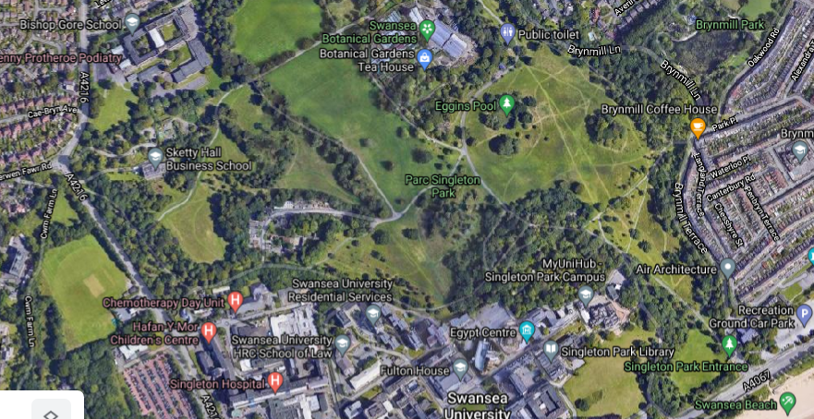
Figure 1: Singleton Park
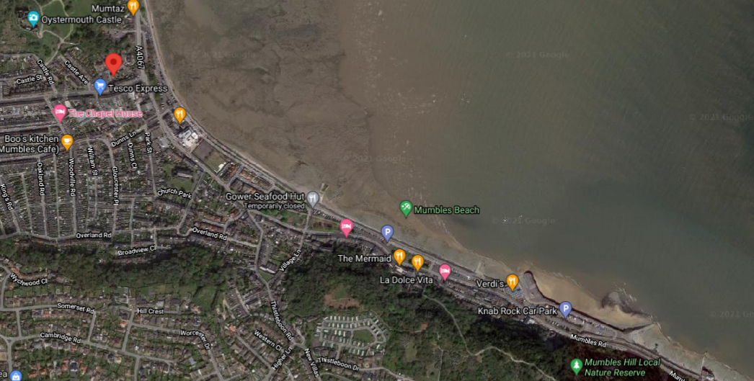
Figure 2: Mumbles Beach

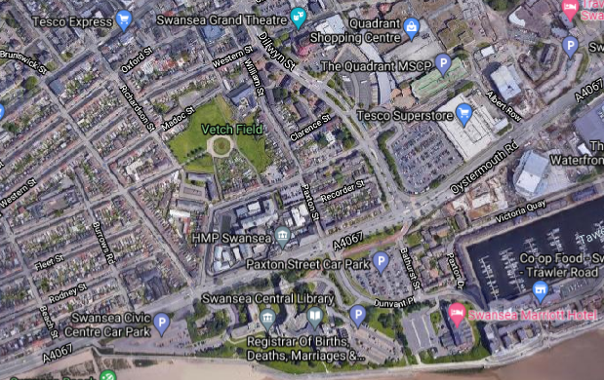
Figure 3: Vetch Field
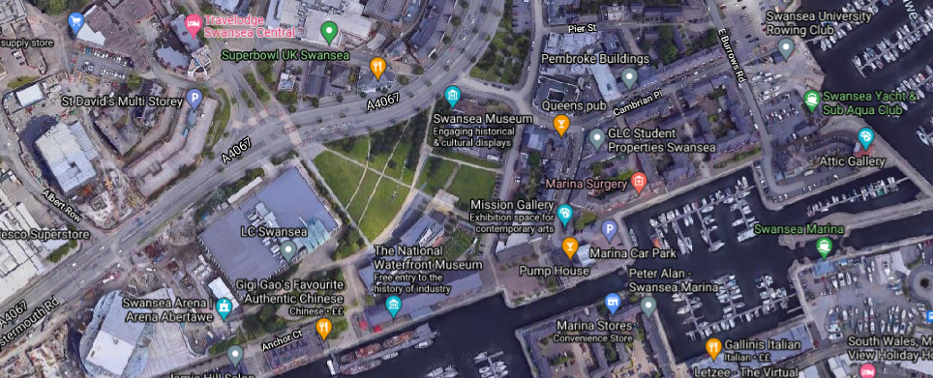
Figure 4: Museum Park

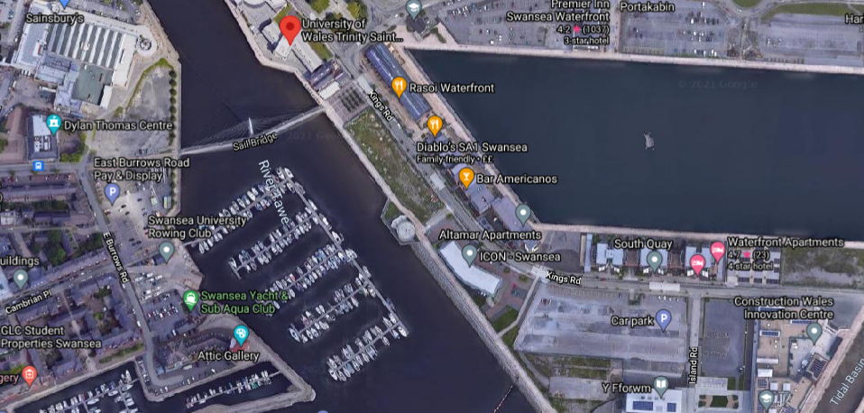
Figure 5: Dylan Thomas Centre

4.2 Appendix 2
4.2.1 Appendix 2a: Strategic Marketing Overview Figures
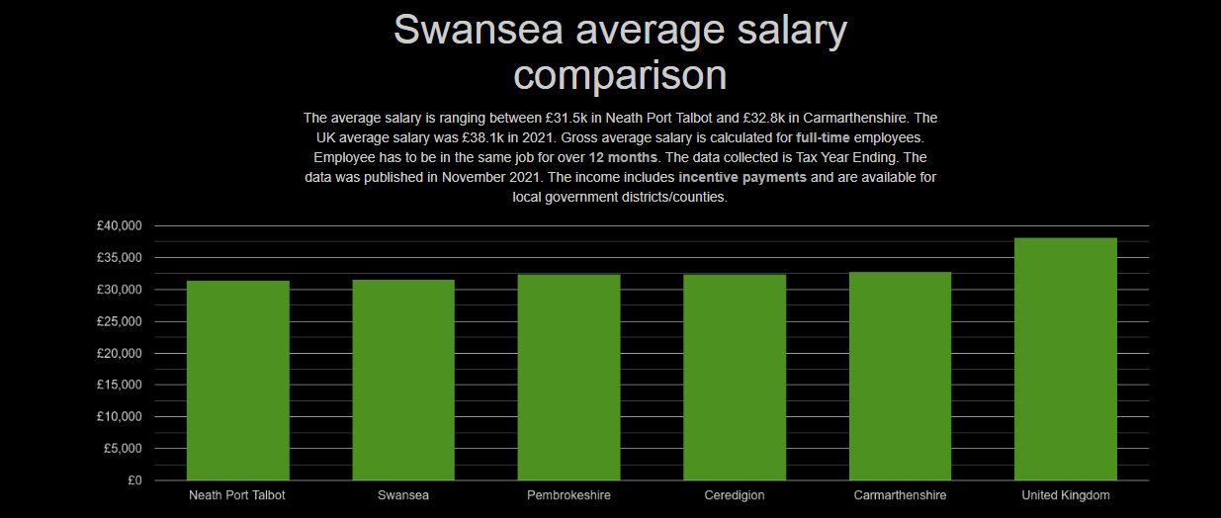
Figure 6 – Swansea Average Salary Comparison

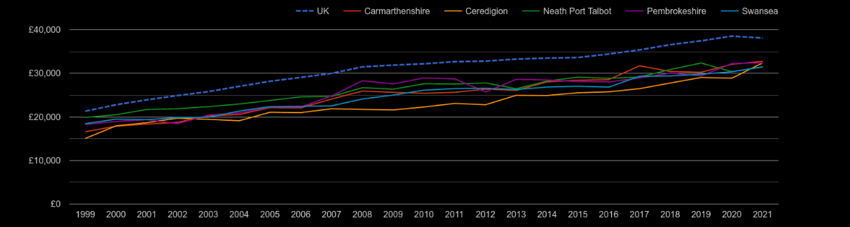
Figure 7 - Average Salary Comparison of Swansea and Surrounding Areas from 1999-2021.
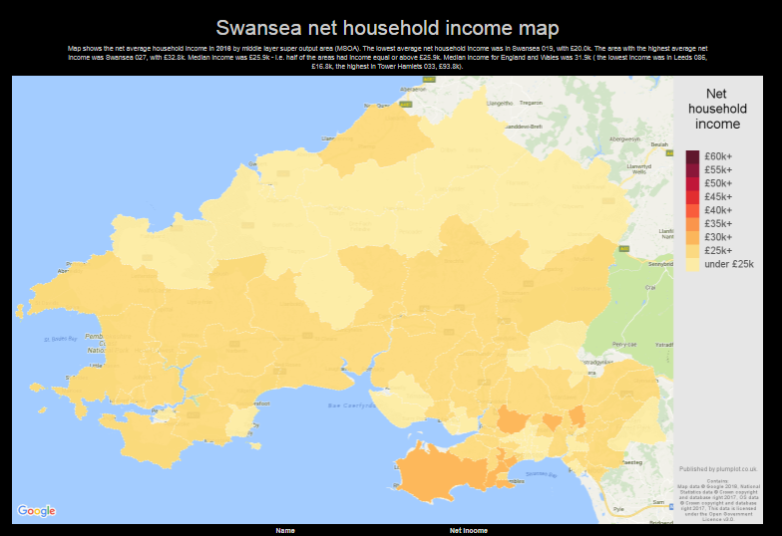
Figure 8 – Net House Income Map of Swansea and Surrounding Areas

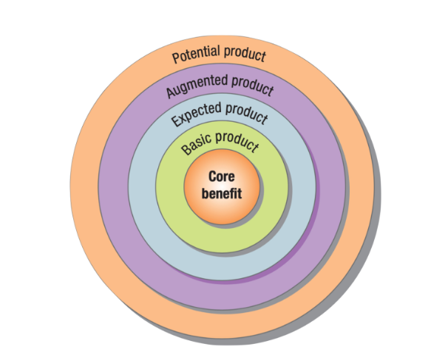
Figure 9 – Kolter and Keller (2012, p.326) Different product levels

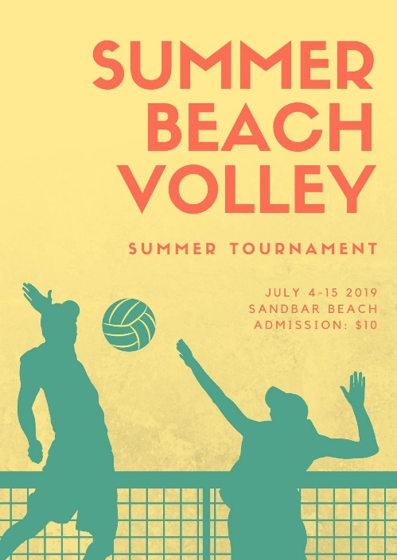
Figure 10 – Example of Promotion Poster

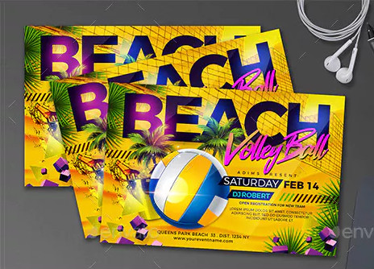
Figure 11 – Example of Promotion Leaflets

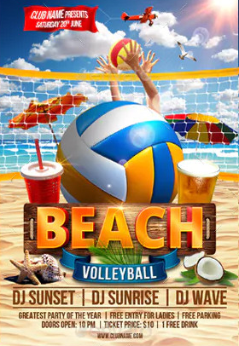
Figure 12 – Example of Promotion Poster for Students
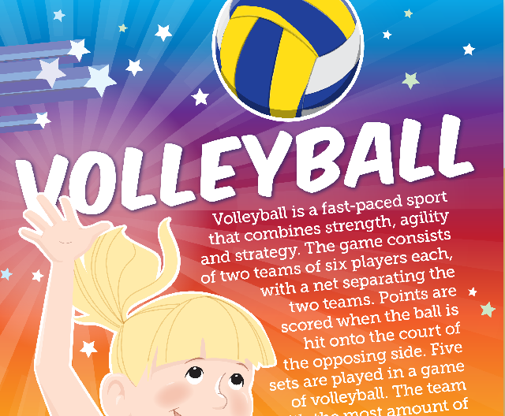
Figure 13 – Example Promotion Poster for Children

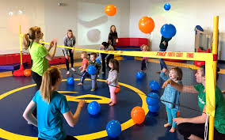
Figure 14 – Example of Toddler Volleyball Activity
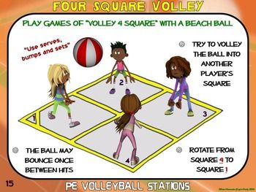
Figure 15 Example of Children’s Volleyball Activity
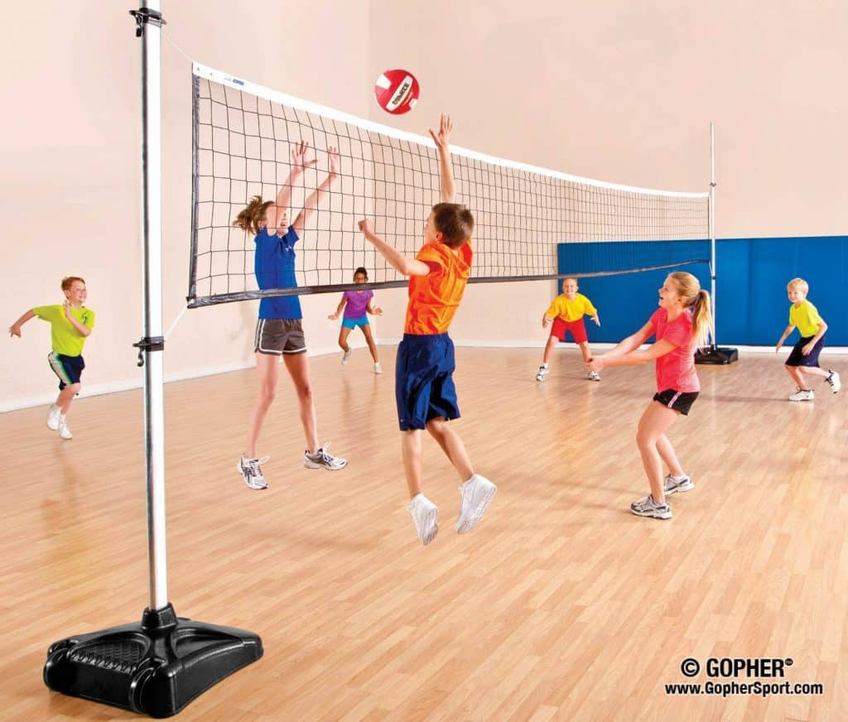
Figure 16– Example of Children’s Volleyball Game

4.2.2 Appendix 2b: Swansea Local Vision Definition
“People in Swansea will have access to modern health and social care services which enable them to lead fulfilled lives with a sense of wellbeing within supportive families and resilient communities. We will help people to keep safe and protected from harm and give opportunities for them to feel empowered to exercise voice, choice, and control in all aspects of their lives. Our services will focus on prevention, early intervention and enablement and we will deliver better support for people making best use of the resources available supported by our highly skilled and valued workforce”. – Local Vision, City & County of Swansea Mental Health Commissioning Strategy, p.9, 2017.

