Object Oriented Programming Report
Link to the game’s demo: https://www.youtube.com/watch?v=R0xedOGaZZU

Table of Contents
Introduction 2
How does the game work? 2
Conclusion 2
Testing 3
Code 7

Introduction
For my object-oriented programming object, I have decided to create a game of noughts and crosses. I have used a series of classes, inheritance, polymorphism and methods, in order to create a fully functioning game.

How does the game work?
At the beginning, the program displays a splash screen of the name of the game. It does so with an object created from the ‘Splash’ class. The next stage of the game involves the program asking one of the users for their name and whether they prefer playing as the noughts or crosses. The program then stores their name in a private attribute of the player class, by using the setter method, in order to be able to recall the player’s name later in the code, using the getter method. Based on the symbol chosen by the player, the program will also store that information, giving the players the option to choose. After the first player provides their name and preference in shapes, the second player is also prompted with an input for their name, however, because the first player already chose a shape, the second player is simply assigned the second option for the choice. Both players have a corresponding player object, which allows the program to differentiate between the two users.
The next segment of the program is essentially the main game. This is the section where players will take turns typing in X and Y coordinates and the program will determine where on the game board, should a shape be placed. The game grid works by utilising a 2D array. After each turn in placing a symbol on the grid, the program scans for any matching lines, whether they would be horizontal, vertical or diagonal, in order to determine if any of the payers have managed to win the game. If a player has managed to get three in a row, the program will recognise that as a win and will end the match. On the other hand, if the code runs through both player’s turns, a specific number of times and the win condition has not been achieved, it can then deduct that it must have come to a draw, in which case none of the players get a point, the match ends and the players are prompted with a menu, just as they would be if a win condition was achieved.
After every match, players are prompted with a menu, where they can choose if they would like to play another game, or if they would like to exit the program. In the case of choosing to play again, the program will simply run the game function endlessly until the players choose to exit at the end of every match. However, in the case of a player wanting to quit the game, the program will attempt to check if any of the players scored higher than the other. If one of the players managed to win more times than the other, the users will be prompted with text which will state, who won overall, however, if both players had the same number of points, the program would recognise that as a draw once again. Whether one of the players won, or if the end result was a draw, after announcing the potential winners, the program will end.

Conclusion
Overall, this program is relatively straight forward even though it makes use of some object-oriented programming principles like classes, inheritance, polymorphism and methods. Even though there is room for some improvement and new features in order to make the game smoother and more fun to play, this noughts and crosses program runs smoothly and is quite efficient with the tasks it performs.

Testing
Test | Expected Result | Actual Result | Screenshot of the Output
Ask for player names | The program asks for a player’s name and saves it | The player’s name is saved using the setter method | 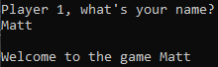
Ask for first player’s preferred symbol | After the player’s name is established, the player can choose if they prefer to play with a naught or a cross | If the player chooses ‘x’ they will play with a cross and in the case of an ‘o’, they will play with a naught | 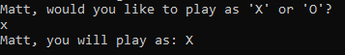
Assign the opposite sign to the second player automatically based on the first player’s decision | After the second player sets their name, they will play with a naught or a cross, based on the first player’s decision | If player 1 chose a naught, player 2 will play with a cross and vice versa | 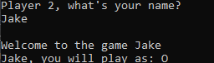
Display the game board and splash screen in the correct format | At the beginning, an ascii art of ‘Tic-Tac-Toe’ is displayed and the noughts and crosses board are displayed along with the current score | The ascii art appears before a user is asked for their name and the noughts and crosses board is displayed with both the user’s names and scores | 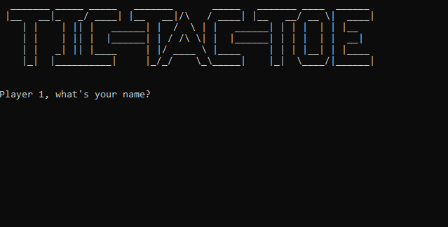
Places a naught or cross based on input coordinates | A naught or cross will be placed in the correct space that is determined using coordinates | A player’s symbol is placed in the appropriate space on the board | 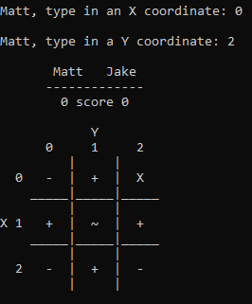
Check if a space is occupied | If a player tries to place a symbol in an occupied space the program will prevent it | The player is stopped from replacing an already placed symbol and is asked to type in the coordinates again | 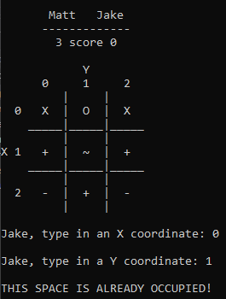
Check for symbols aligning horizontally | Actively check each row of the game board to see if there’s a 3 in a line | If three noughts or crosses align in a horizontal line, the player that aligned them wins | 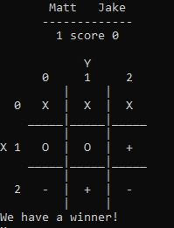
Check for symbols aligning vertically | Actively check each column of the game board to see if there’s a 3 in a line | If three noughts or crosses align in a vertical line, the player that aligned them wins | 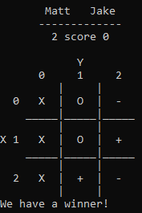
Check for symbols aligning diagonally | Actively check both diagonal lines of the game board to see if there’s a 3 in line | If three noughts or crosses align in a diagonal line, the player that aligned them wins | 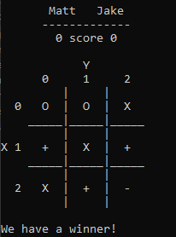
Check for a draw | If the players have taken all their turns and nobody won, it will declare a draw | If both players can’t win, the game will declare a draw | 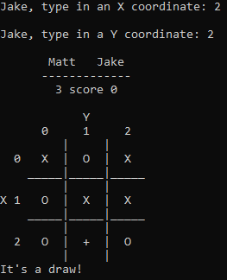
Update the wins for every player based on if somebody won or if there was a draw | After a player wins, their score is raised by one | After and if a winner is declared, their score is updated and displayed upon the start of the next game
Prompt the user with a menu | After each game, a menu is displayed | After a game is concluded, a menu is displayed | 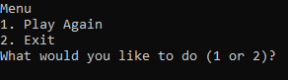
Play Again menu option | If the user wants to play again, update the score, clear the board and display it again | Displays the cleared game board with the updated scores | 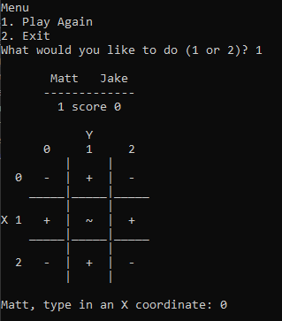
Exit menu option | If the player choses to exit, the program will stop. Upon the exit request, a player is declared a winner if there is one | Just before the program stops, it determines who’s the overall winner, if there is one. Then, the program stops | 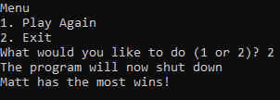
Invalid menu option | If the user inputs an option that is invalid the program will assume to stop | If the input is invalid, the program stops | 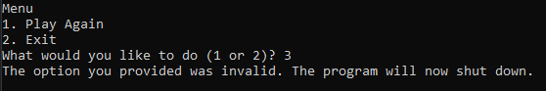

Code
#include<iostream>
#include<string>

using namespace std;

int x, y, j, k, Score, tScore1, tScore2, turn, menuOption = 1;
string Name, Sym;
bool choiceCheck = false, tileCheck = true, win = false, draw;

//symbol class that holds the game grid and the symbol variable
class Symbol {
public:
string symbol;
string pB[3][3] = { {"-","+","-"},
{"+","~","+"},
{"-","+","-"} };
};

//defiines a player class to hold the player's names for thew whole duration of the game
//Also inherits from the symbol class in order to make a naught or cross personal to each player object
class Player : public Symbol {
private:
string name;
public:

//setter
void setName(string Name) {
name = Name;
}

//getter
string getName() const {
return name;
}

Player(string pName, string pSymbol) {
name = pName;
symbol = pSymbol;
}

};

//splash screen
class Splash {
public:
Splash() {
cout << " _______ _____ _____ _______ _____ _______ ____ ______" << endl;
cout << " |__ __|_ _/ ____| |__ __|/\\ / ____| |__ __/ __ \\| ____|" << endl;
cout << " | | | || | ______| | / \\ | | ______| | | | | | |__ " << endl;
cout << " | | | || | |______| | / /\\ \\| | |______| | | | | | __| " << endl;
cout << " | | _| || |____ | |/ ____ \\ |____ | | | |__| | |____ " << endl;
cout << " |_| |_____\_____| |_/_/ \\_\\_____| |_| \\____/|______|" << endl << endl << endl;
}
};

//board function that prints the layout of the game grid in the correct format and determines if a player has won or if the game is a draw
int board(Player player1, Player player2, Symbol playingBoard, int j) {

//-----------------------------------------------------------------|Playing Board|-----------------------------------------------------------------------------------------------
cout << endl << " " << player1.getName() << " " << player2.getName() << endl;
cout << " -------------" << endl;
cout << " " << tScore1 << " score " << tScore2 << endl << endl;
cout << " Y" << endl;
cout << " 0 1 2 " << endl;
cout << " | | " << endl;
cout << " 0 " << playingBoard.pB[0][0] << " | " << playingBoard.pB[0][1] << " | " << playingBoard.pB[0][2] << " " << endl;
cout << " _____|_____|_____ " << endl;
cout << " | | " << endl;
cout << "X 1 " << playingBoard.pB[1][0] << " | " << playingBoard.pB[1][1] << " | " << playingBoard.pB[1][2] << " " << endl;
cout << " _____|_____|_____ " << endl;
cout << " | | " << endl;
cout << " 2 " << playingBoard.pB[2][0] << " | " << playingBoard.pB[2][1] << " | " << playingBoard.pB[2][2] << " " << endl;
cout << " | | " << endl;
//-------------------------------------------------------------------------------------------------------------------------------------------------------------------------------

for (k = 0; k < 3; k++) {
if (playingBoard.pB[k][0] == playingBoard.pB[k][1] && playingBoard.pB[k][0] == playingBoard.pB[k][2] || playingBoard.pB[0][k] == playingBoard.pB[1][k] && playingBoard.pB[0][k] == playingBoard.pB[2][k]) {
cout << "We have a winner!" << endl;
win = true;
}
}

//checking the win for both diagonal
if (playingBoard.pB[0][0] == playingBoard.pB[1][1] && playingBoard.pB[0][0] == playingBoard.pB[2][2] || playingBoard.pB[0][2] == playingBoard.pB[1][1] && playingBoard.pB[0][2] == playingBoard.pB[2][0]) {
cout << endl << "We have a winner!" << endl;
win = true;
}

if (j == 4 && win == false) {
cout << "It's a draw!" << endl;
draw = true;
}

return 0;
}

//game function allows players to take turns placing noughts and crosses on the grid, and also lets them know if a space is occupied or if coordinates that were provided were invalid
int game(Player player1, Player player2, Symbol playingBoard) {
while (win == false && draw == false) {

//-------------------------------------------------------|Player 1's Turn|------------------------------------------------------------------------------------
board(player1, player2, playingBoard, j);

while (tileCheck == true && win == false && draw == false) {
cout << endl << player1.getName() << ", type in an X coordinate: ";
cin >> x;
cout << endl << player1.getName() << ", type in a Y coordinate: ";
cin >> y;
if (x >= 0 && x <= 2 && y >= 0 && y <= 2) { //if the coordinates provided are valid
if (playingBoard.pB[x][y] == "X" || playingBoard.pB[x][y] == "O") {
cout << endl << "THIS SPACE IS ALREADY OCCUPIED!" << endl;
}
else {
turn = 1;
playingBoard.pB[x][y] = player1.symbol;
break;
}
}
else {
cout << "THESE COORDINATES ARE INVALID!" << endl;
}
}

//-------------------------------------------------------|Player 2's Turn|------------------------------------------------------------------------------------
board(player1, player2, playingBoard, j);

while (tileCheck == true && win == false && draw == false) {
cout << endl << player2.getName() << ", type in an X coordinate: ";
cin >> x;
cout << endl << player2.getName() << ", type in a Y coordinate: ";
cin >> y;
if (x >= 0 && x <= 2 && y >= 0 && y <= 2) { //if the coordinates provided are valid
if (playingBoard.pB[x][y] == "X" || playingBoard.pB[x][y] == "O") {
cout << endl << "THIS SPACE IS ALREADY OCCUPIED!" << endl;
}
else {
turn = 2;
playingBoard.pB[x][y] = player2.symbol;
break;
}
}
else {
cout << "THESE COORDINATES ARE INVALID!" << endl;
}
}
j++;

//updates the player scores after every match depending on if a win was achieved and who's turn it was last
if (win == true && turn == 1) {
tScore1 += 1;
}
else if (win == true && turn == 2) {
tScore2 += 1;
}
}

return 0;
}

//main function allows the players to input their names and choices in shapes for the rest of the game as well as running the main game code
int main() {

Splash splash;

//create two player objects
Player player1(Name, Sym);
Player player2(Name, Sym);
Symbol playingBoard;

cout << "Player 1, what's your name?" << endl;
cin >> Name;
player1.setName(Name); //sets the name value for the player1 object using the user input
cout << endl << "Welcome to the game " << Name << endl;
while (choiceCheck == false) {
cout << player1.getName() << ", would you like to play as 'X' or 'O'?" << endl;
cin >> Sym;
if (Sym == "X" || Sym == "x") {
player1.symbol = 'X';
player2.symbol = 'O';
choiceCheck = true;
}
else if (Sym == "O" || Sym == "o") {
player1.symbol = 'O';
player2.symbol = 'X';
choiceCheck = true;
}
else {
cout << "Please enter a valid option" << endl;
}
}
cout << player1.getName() << ", you will play as: " << player1.symbol << endl;

//asks the second player for their name and saves the value in the private 'name' attribute using a setter
cout << endl << "Player 2, what's your name?" << endl;
cin >> Name;
player2.setName(Name); //sets the name value for the player2 object
cout << endl << "Welcome to the game " << Name << endl;
cout << player2.getName() << ", you will play as: " << player2.symbol << endl;

//while the players want to play again, the win and draw conditions are reset and they are prompted to choose if they indeed want to keep playing or if the users would like to exit the code
while (menuOption == 1) {
game(player1, player2, playingBoard);
win = false;
draw = false;
j = 0;
cout << "Menu" << endl;
cout << "1. Play Again" << endl;
cout << "2. Exit" << endl;
cout << "What would you like to do (1 or 2)? ";
cin >> menuOption;

}
if (menuOption == 2) {
cout << "The program will now shut down" << endl;
if (tScore1 > tScore2) {
cout << player1.getName() << " has the most wins!" << endl;
}
else if (tScore1 < tScore2) {
cout << player2.getName() << " has the most wins!" << endl;
}
else {
cout << "It's a draw!" << endl;
}
exit;
}
else {
cout << "The option you provided was invalid. The program will now shut down." << endl;
exit;
}

return 0;
}

