ELECTRONICS 1 – EXAM SUBMISSION – MICHAEL HOWELLS
Q1a.
IC1 is an op amp configured as a direct integrator. The voltage across C1 is an integral of the current produced by the photodiode by the photo diode. This is proportional to the sunlight and so is used to integrate the total sunlight over time. The output of IC1 is the integral of the sunlight detected.
The reset button will short the terminals of the capacitor C1 together. This will discharge any power that is held within its static field.
Q1b.
IC2 is an op amp configured as a Schmitt trigger. The input of IC1 is connected to the non-inverting input of IC2. When the input reached the threshold value the output will go low and trigger the speaker. Alerting the user of the device that they have had enough sunlight.
The Resistor network R1, R2 and R3 are used to configure the positive feedback of the circuit. R3 however is a variable resistor that is used to manually adjust the feedback network. This will adjust the limit of the Schmitt trigger so that more or less sunlight is required to trigger the speaker. Schmitt triggers utilise hysteresis to ensure that there is no high/low oscillations near the boundary of its high and low. See image showing general hysteresis window. For the device to change state from high to low, a threshold must be met.
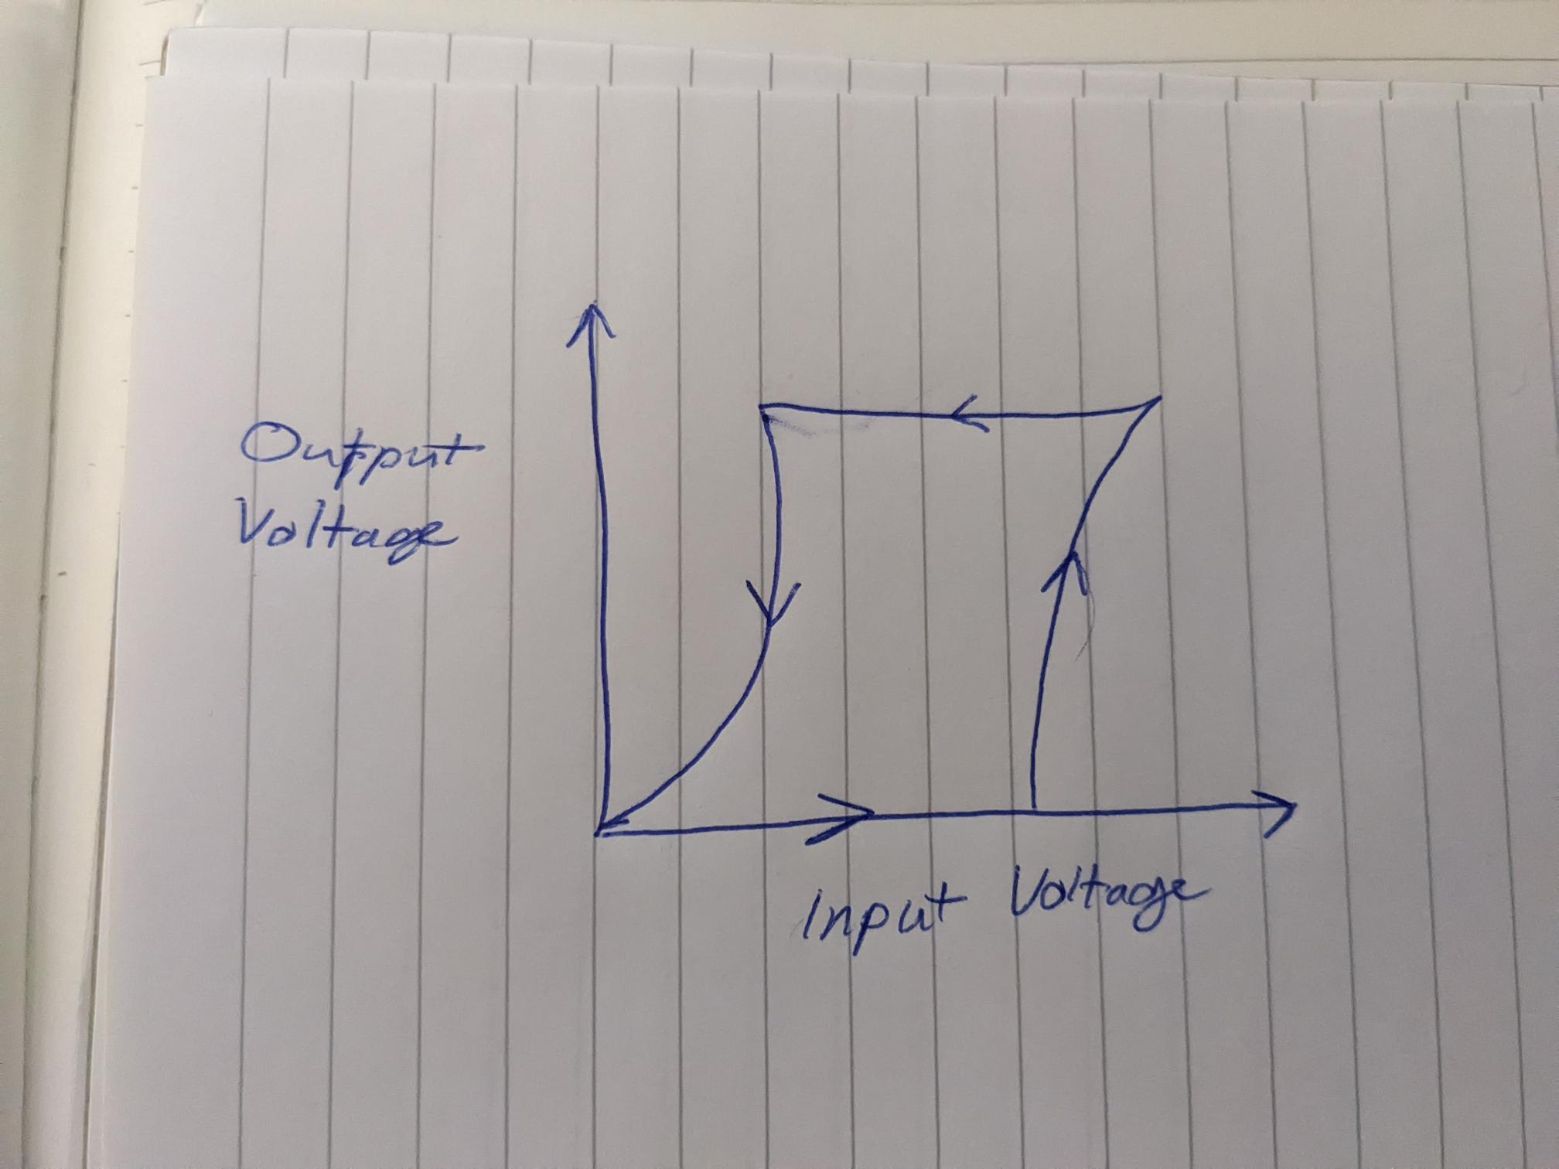

Q1c.
The device is a photo diode. When a photodiode is exposed to light, a current is induced and is integrated by the IC1 op amp setup. In this setup it operates in reverse bias mode. This integral is proportional to the total amount of sunlight. In the suntan circuit, The UV filter is used to ensure that it is only triggered by ultra violet wavelengths of light as this is the type that is dangerous for human skin. All other types are filtered out.
Q1d.
The method of using a filter is not preferable if it is added separately. A device that is specifically designed to detect UV light is preferrable as it has been designed and tested for this function.
There is no off switch on this setup. This device is always running and so will waste current even if it is not running. (Even if it is low). Solution: Add a switch to battery.

Q2a.
CPU-(Central Processor Unit)This is the “brains” of the device. The micro processor is an integrated circuit that implements logic based on a program that has been for it and it can access. It performs the majority of computation for the devcice and is responsible to controlling what data goes to what address. It requires additional hardware in order for it to operate. Operations are carried out at a rate defined by its clocking frequency.
8k RAM- (random access memory). It is a form of non volatile memory which means that the data stored here is not kept after it has power cycled. It is used for storing data that is required for the device operation. For example, variables that are used in the program.
EPROM- (Electrically Programmable Read only Memory) This is a type of volatile memory so the data stored here remains after a power cycle. The program for the device would be stored here.
ACD- (Analog to digital converter) These devices are used to convert an analog signal into a digital waveform. This is called quantisation. The analog waveform is sampled at intervals. Nyquist–Shannon sampling theorem can be used to ensure that the integrity of the ac waveform is not lost during conversion. IT states that the signal must be samples at twice the highest frequency component of the signal. In the circuit they are used to sample the temperator sensor. The register on the device that stores this data can be read back as specified by the program and used to in calculations for the carbon dioxide sensor.
8bit COUNTER- In this device, two 8 bit counters have been added together to become a 16 bit counter as this device was not available. A single one can count 2^8(256) but together they can count up to 2^16(65536) which is much higher. It is used here to count the time it takes for the sound to pass the cavity.

3-8 DECODER-The 3-8 decoder is used to enable only the chips that are required to communicate to the CPU at one time. This decoder has been setup to use the most significant bits of the address signal so only enable the correct device. It inputs 3 of these bits and then it will only enable one of its outputs. The outputs are connected to enable pins of the device. Output pins cannot be connected together, the enable pin is used to ensure that only device is on at once. As they use tri state outputs, they can be turned on and off as required. See image. It shows how S can be used to disable the output. This principle is used with the devices with enable pins.
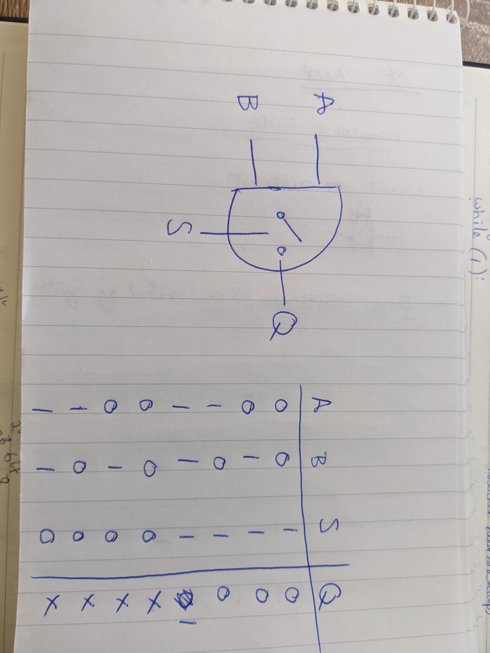
6522 VIA (Versatile interface adaptor)- Versatile interface adaptor. This device contains digital IO pins that can be configured and read in software. It also has pins that can be used to iic interfacing. This has been used in this context for adding an additional EEPROM.
WATCHDOG TIMER-The watchdog timer is used to monitor the device and reset it is there are malfunctions such as brown outs.
IIC EEPROM- This is an additional EEPROM device that has been added. It uses the IIC protocol which uses 2 lines, clock and data (gnd/power also). This allows for peripherals to be easily added.
In this device is could be used to store the calibration data of each unit. Each unit must be calibrated before it is sold to ensure its accuracy. This needs to be done because there are minor differences in build/component spec/ distance of cavity etc. Calibration will help ensure that the reading between units is consistent.
DISP-The display is used to show the carbon dioxide reading of the device. Most likely on a seven segment display. This allows for the user to get a value from the device.
TX-This transfers the audio from the speaker.
TEMP SENSOR- This temperature sensor is connected to the ADC(1) and its value is used in the CO2 detector calculation. Its output is proportional to the current temperature in the cavity.
RX- This receives the audio from the speaker.
CLOCK GATE LOGIC-This logic is used to start and stop the counter. When the TX sound has been triggered, the logic will start the counter. When the RX has received the sound, the count will stop.
OSC – The oscillator in this circuit is used to both clock the CPU externally and also to clock the counter. External clocks are often more accurate than the internal clocks of the CPU.
AND GATE-The clock is only triggered is both the oscillator and logic circuit are high.
2b.8
2c.8
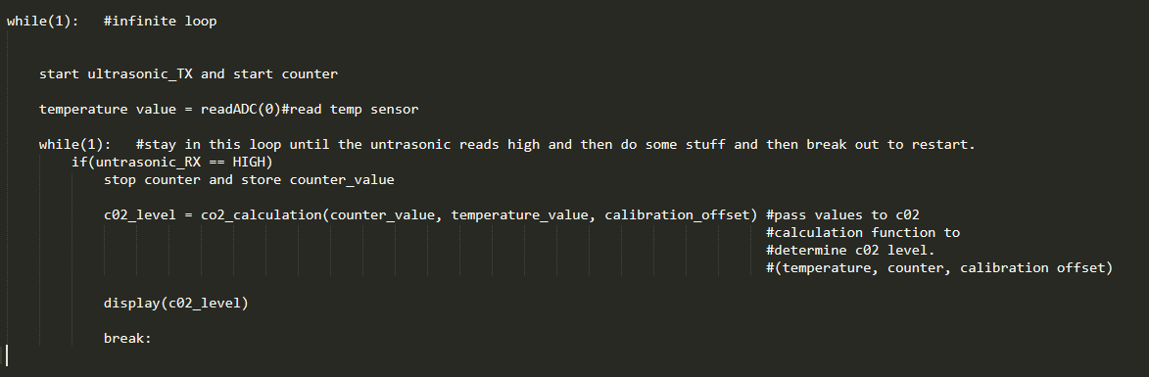
2d.PSEUDO CODE

2e. The three most important thing I think you would need to consider for this design are:
System Speed – This is a particularly important parameter for a device to be used in this context. The requirement of the device specifies that is required a 16MHz clock to drive the measurement circuit. So the micro must either have a 16MHz clock or capable of using one.
COST - The microcontroller must be a reasonable cost in order to keep the price of the c02 sensor unit down as it may be sold to the market. There is no point in getting a high end device that can do everything required but also have features that are not utilised as it is overkill on both hardware and price.
NVM – The microcontroller must have NVM somewhere to store its calibration data. Or capability to add it somewhere. Perhaps an IIC interface like the one in the current setup could be duplicated with a microcontroller.

3a. A Thyristor is a type of 3 terminal diode that conducts only when a gate line is high a latching current is met. See diagram
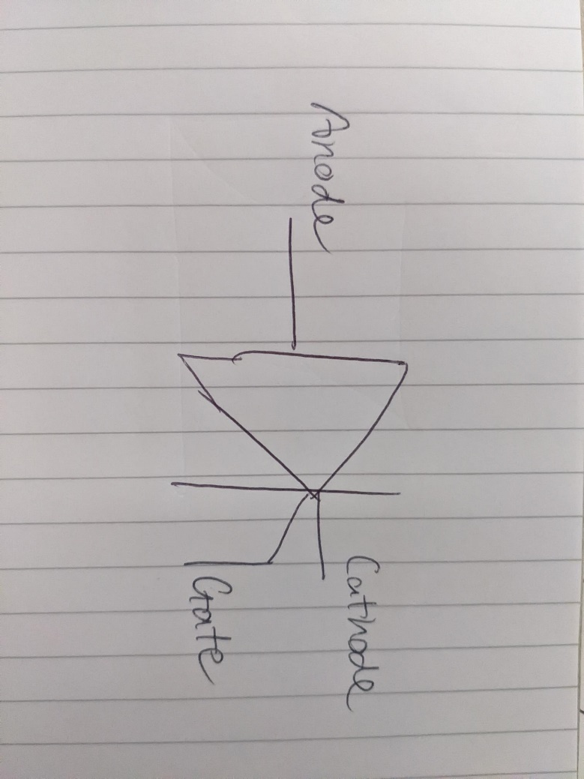
To turn off the thyristor, the current flow from anode to cathode must be interrupted. A standard thyristor only conducts in one direction so is not really suitable for AC power control as it will rectify the full waveform.
A triac is type of thyristor that can conduct in both directions so is suitable to AC power control. A triac contains two thyristors that are connected in opposite directions.
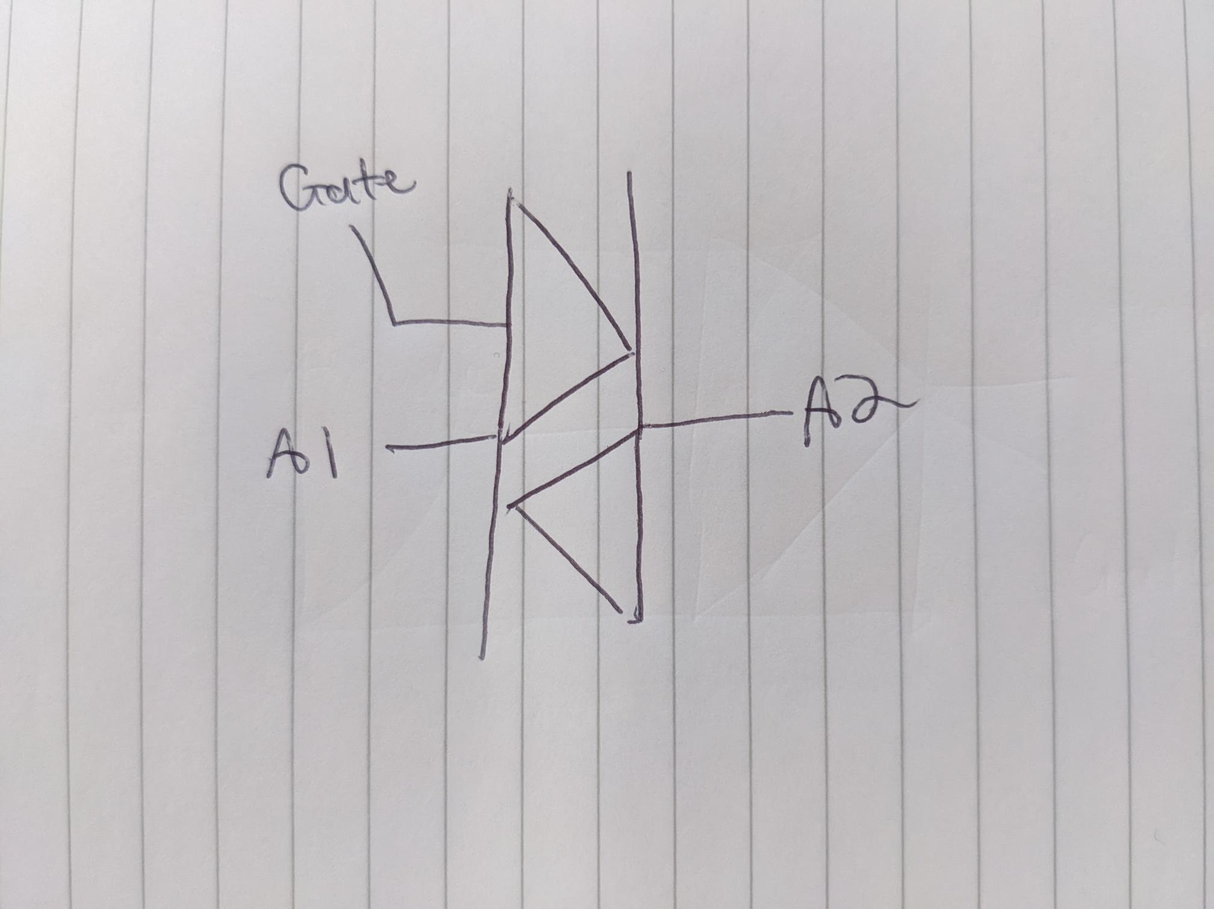
To control the phase angle of the AC waveform with an TRIAC, the zero cross point must be detected. This is the point at which the waveform crossed the 0 point. See diagram.
The thyristor stops turns off when the signal reaches the zero cross point as no current will flow.
Some method must be used to detect the zero cross point. This could be done by a op amp in a certain configuration or even a microcontroller with a dedicated zero cross point detection input.
When it has been detected, the gate can be triggered after a set amount of time. Changing this time delay will control how much power gets to the device. For example a high delay would cause an AC bulb to go dim the opposite will happen if the delay is low.
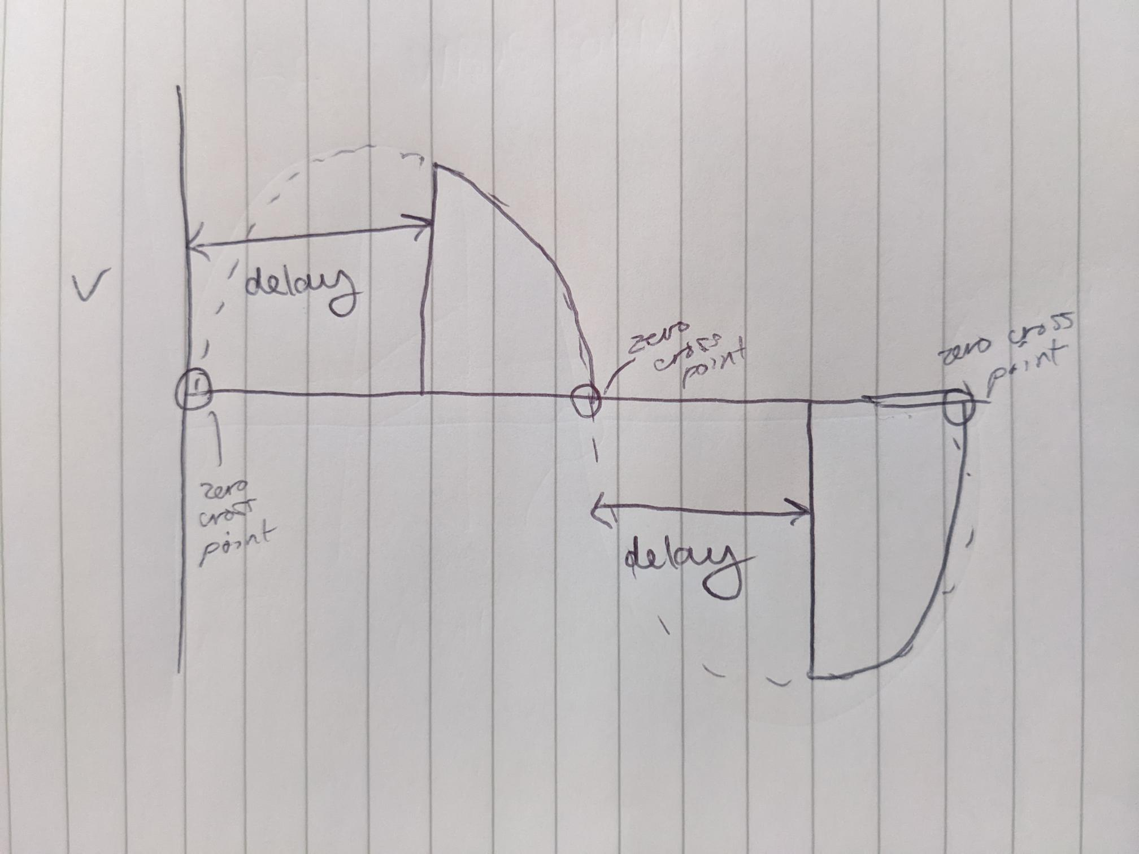
The same method could be used for a standard triac but half the waveform would be rectified.
3b. The zero crossing point is when the AC waveform crosses the 0v point. It is the transition from +v to -V. It happens at 0°, 180° and 360° of the waveform. See diagram.
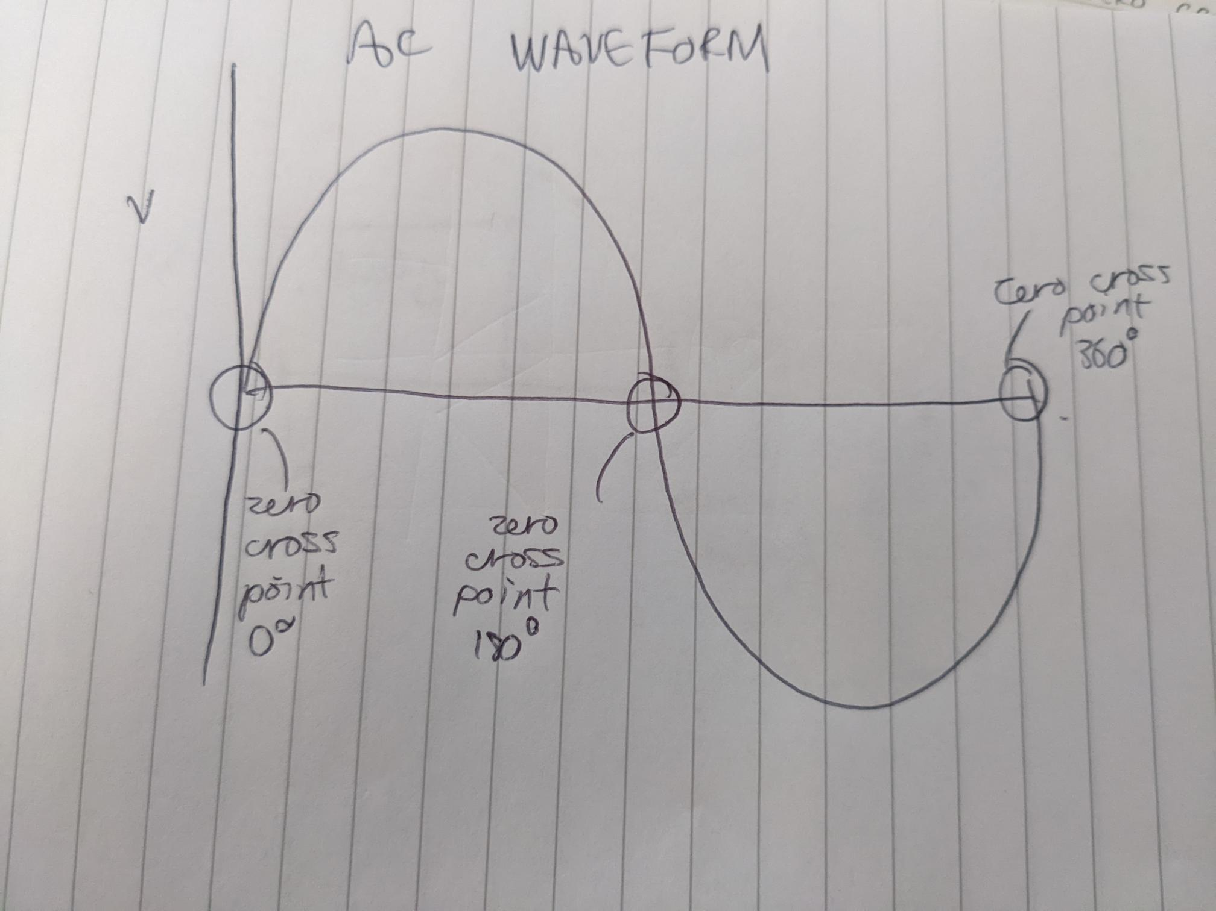
3c.The two components are TRIAC and DIAC. The Gate of the triac is triggered only when the threshold voltage of the diac has been met. This occurs when the capacitor has charged to reach the threshold. This charge speed is adjusted by the variable resistor.
The variable resistor is used to adjust the phase angle at which the diac activates as it adjusts the speed of charge.
When the AC waveform reached its zero cross point, the diac and triac will turn off and the cycle will start again.
The fuse is also used for over current protection and will break and open circuit in such an event.

3d. The diagram below shows the op amp configuration required for cross point detection.
The op amp is setup as a comparator. This means that if the input is above zero2, the op amp output will saturate to +v and if it is below zero it will saturate to -v. These sharp changes in voltage can pass through the capacitor as a voltage spike. This shows the cross point. In my diagram a diode is used to rectify the output so that only the positive outputs are available at the output. The RC network shown is used to adjust the charging and discharging waveform.


