- Module code: BMSW4005
- Lecture name: Olubukola Adegbite

Portfolio of work

Gina Oprean 1918859
2021
Job advertisement
ITALY HAS NEVER BEEN SO CLOSE…
Opening early 2021, Eataly London will become the first UK store for the global brand.
Founded in 2007, Eataly is the world’s largest artisanal food and beverage marketplace.
London will house 3 restaurants, 5 bars, a gourmet grocery market, fresh counters, bakery, quick service restaurants and much more! The London store will host around 300 employees.
#EAT a meal in our restaurants or quick-service counters.
#SHOP a selection of quality Italian and local produce.
#LEARN through our masterclasses and team’s product knowledge.
As a Waiter/Waitress you will coordinate the service station and communicate with front of the house and back of the house personnel to provide a dining experience that exceeds guest expectations. Always wearing a smile and ensuring product knowledge is high, our Waiters/Waitresses are key to any successful guest experience in one of our restaurants.
Eataly London compromises 3 restaurants, a traditional Italian grill restaurant – Terra. A classic casual Italian – Pasta + Pizza. And a marketplace restaurant, complete with fresh food counters. We are currently recruiting across restaurants and if successful, your application will be matched according to your experience.
THE PERKS OF BEING AN ‘EATALIAN’…
- Food on shift
- Lifestyle and culture discounts through our benefit supplier
- Cycle to work scheme
- 22 days holiday allowance that increases with length of service + 8 days bank holiday allowance
- Technology and gym benefit available
- Healthcare cash plan scheme
- Employee assistance program
- And much more!
But mostly, the chance to be a part of this incredible opening which will provide a true Italian cultural experience, with a huge respect for biodiversity, to every guest - without needing to step on a plane. Italy is Eataly.
WE’RE LOOKING FOR
- Significant experience as a Waiter/Waitress at a premium at a high volume, fresh produce restaurant
- Willingness to learn vast amounts of product knowledge
- Ability to be flexible and work evenings, weekends, and bank holidays
- A passion for food and beverage and the Italian culture
- Willingness to support multiple teams
- Right to work in the UK
- Fluent in English
- Italian language is an advantage but not mandatory

Cover Letter
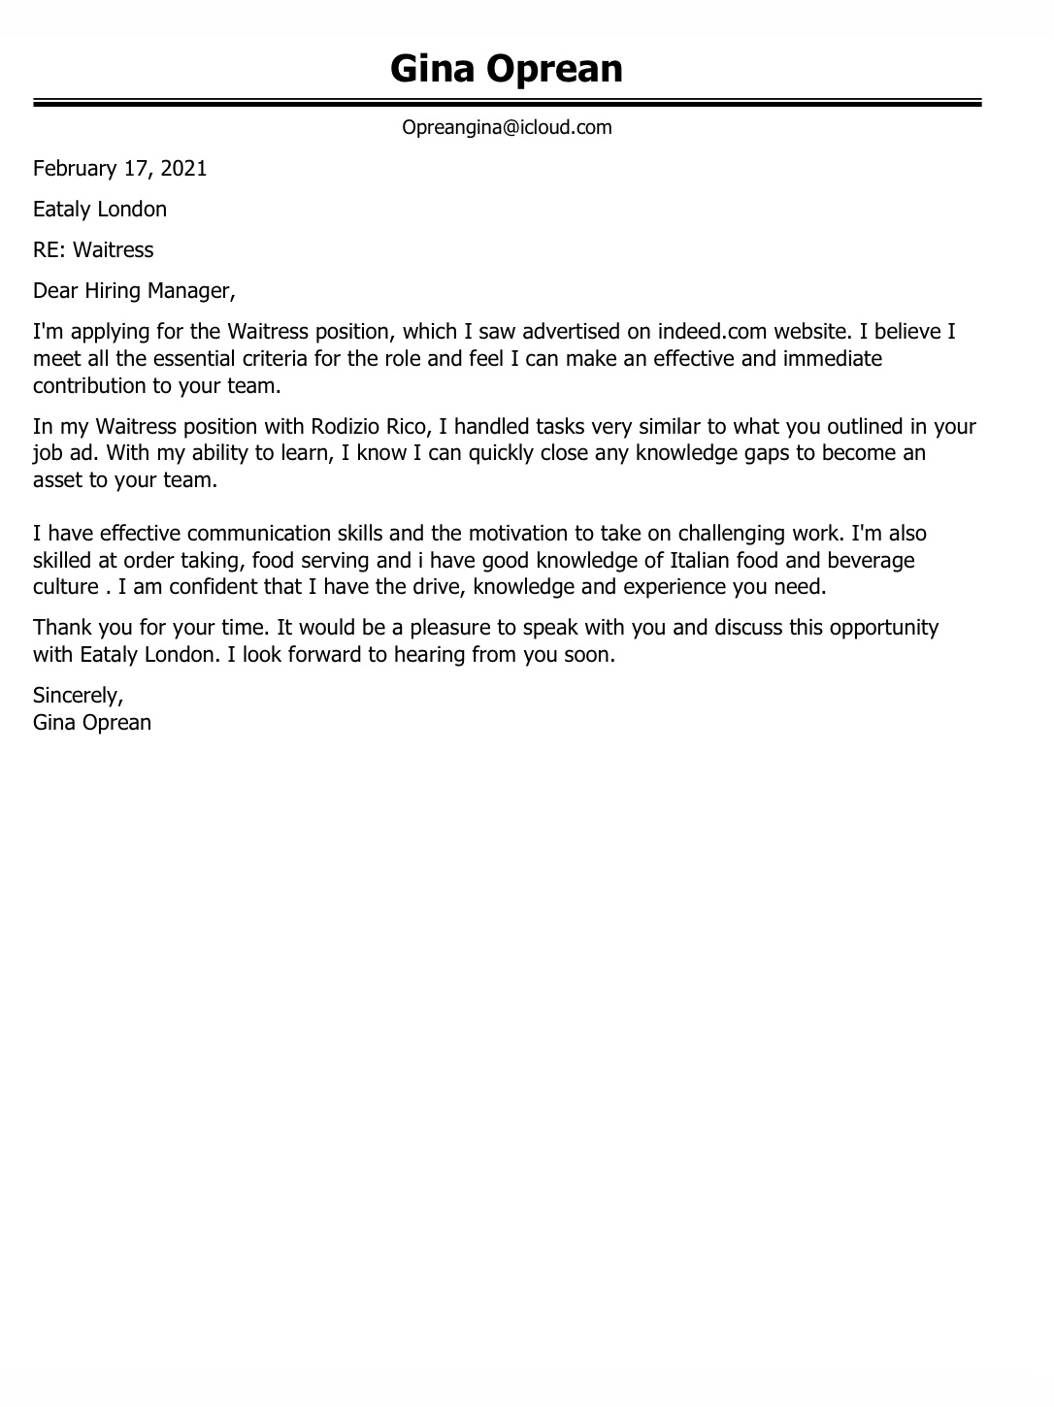
CV


