Academic and Employability Skills

Mohammed Jahirul Islam
Student Number: 1706006
Tutor Name: Anita Term 2
Module: BMSK4001

Table of Contents
Introduction 3
Employability Skills 3
Advantages of having effective employability skills 8
Conclusions 8
Reference List 10

Introduction
According to my assumption, Employability skills in the simplest terms identify the skills that are useful for the employees for securing a particular job in the particular sector. The horizon pertaining to the employability skills are indeed huge. The employability skills that are mostly in use incorporate a combination of both soft skills as well as technical skills. In most of the cases it is estimated that possessing these skills will be effective enough for an aspirant to be placed in any reputed organisations
For having a clear analysis as to what the technical skills actually are and how it affects the selection criteria the case study of Tesco have been chosen for the purpose. I think, the particular assignment will emphasize on the concepts of employability along with the skills that are needed for being employable in the organisations. The skills that are needed for the purpose are indeed plenty in number. The theories, models as well as the concepts that have been pertaining to it have also been discussed in the below sections.

Employability Skills
As discussed by Bensonet al.(2014) the employability skills in not a concept that can be understood and explained in simple words. The boundary is indeed huge and so are the skills that are pertaining to it.According to my point of view, it can be depicted thatthe employability skills identify all types of skills that are needed for making some one employable in the current competitive market. Though the skills vary greatly from one industry to other, but the basic fundamental skills remain the same. The skills if possessed by an individual appropriately turn out to be basic advantage for securing some safe and secured jobs in the market. Some of the basic employability skills that need to be possessed by any aspirant for being recruited at Tesco may include the soft skills, communication skills along with effective technical skills.According to my assumption, in case of all organisations (not particularly Tesco) the soft skills are among the most significant skills that will make an individual easily employable in the organisations. Soft skills cannot be defined in simple terms as any particular skill. The soft skill identifies the conglomeration of all the skills that allows an individual to interact effectively within the particular environment that he is working (El Mansour and Dean, 2016). The soft skills identifies the conglomerations of skills that can make an aspirant an effective team player, In most cases , communication is considered as one of the most effective employability skills. I think,there is a common English proverb that words can do all what swords cannot and this is the exact reason of the incorporation of communication skills within the soft skills. The methods that are used by the individual to communicate in the different situations actually tell a lot about him. An effective communication often turns out to be the solution to a whole lot of problems. In accordance with this the individuals who are active participants in the debates, talk shows as well as public speeches are often preferred over the others. It is expected that these individuals have a better control over communications than others. These individuals actually know how to express themselves in all types of adverse situations possible (Messumet al., 2017).
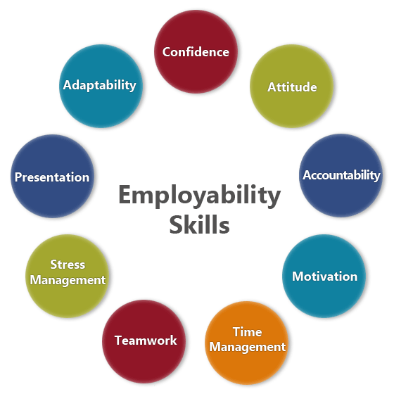
Figure: Employability Skills
(Source: Messumet al., 2017)
However, having only communication skills along with other allied soft skills is not the only one that makes the individual “hot cake” in the market. I think the technical skills are also one of the vital factors that play a pivotal role in the entire process. In the current competitive world when machines are replacing humans in all four tiers possible technical skills are something that tops the list of all the skills that can be possessed by the individuals under all the possible situations . The technical skills involve basic knowledge of computers along with an effectiveknowledge of the Microsoft office packages. However the criteria and the requirement for the technical education varies in accordance with the positional hierarchy in the organisations. Almost all of the organisations including Tesco, the authorities organise a particular technical round for checking the skills of the individuals. At times proper training sessions are also organised by the institutions to impart effective technical knowledge among the employees.
According to my point of view, it can be depicted that since the competitions have changed or rather increased, the basic criteria for getting employed have also changed to a great extent. In the previous times communication and technical skills were effective enough for getting someone placed in the esteemed organisations like Tesco. But now more expertise, specialisation as well as other skills are needed for being recruited in the organisations of repute. As put forward by Colletet al.(2016) the additional skills that are required for the purpose can be strictly bifurcated into motivation skills, working effectively under pressure, problem solving skills, negotiation skills and last but not the least the organisational skills.
The concepts pertaining to motivational skills are something that needs a proper discussion. Motivational skills do not only identify the ways, that are used by the individual to motivate himself in the complex situations (Messumet al., 2016). It also identifies the ways that are used for motivating the other individuals or rather his own co workers to perform their work more effectively. In business terms there is a common saying that motivation does it for all and this is exactly what an utterly motivated individual does in the organisation. An individual who thinks about each and everything around him positively will always bring about positive results for the organisation as a whole. According to my assumption, problems turn out to be the pebbles in the entire work life and hence skills should be and must be possessed by the individuals to solve them with much efficacy possible. The problem solving skills also form an important chapter in the overall employability skills that needs to be possessed by the individual under all circumstances if they want to be employed in Tesco.
Tan(2016) have however emphasized much on the organisational skills. If reports are to be believed then in most cases the demand of organisational skills have increased rapidly in the past years by more than 35%. Big tycoons and business giants like Tesco currently prefer the organisational skills overt the soft skills and they considered as the most effective skills that may help an individual to be easily employed in the organisations. The organisational skills identifies ways in which the individual maintains his discipline-it is basically the scale that identifies that whether an individual is methodical or not. The organisational skills in a nutshell is an advancement over the soft skills that are possessed by the individual. () has identified the organisational skills as the soft skills that are and can be applied in case of the business world. The ability to meet the deadlines , be on track as well as monitor the overall progress are some of the vital factors that helps an aspirant to secure a safe job in the organisation and be easily employable at the organisation (Collet et al., 2015).
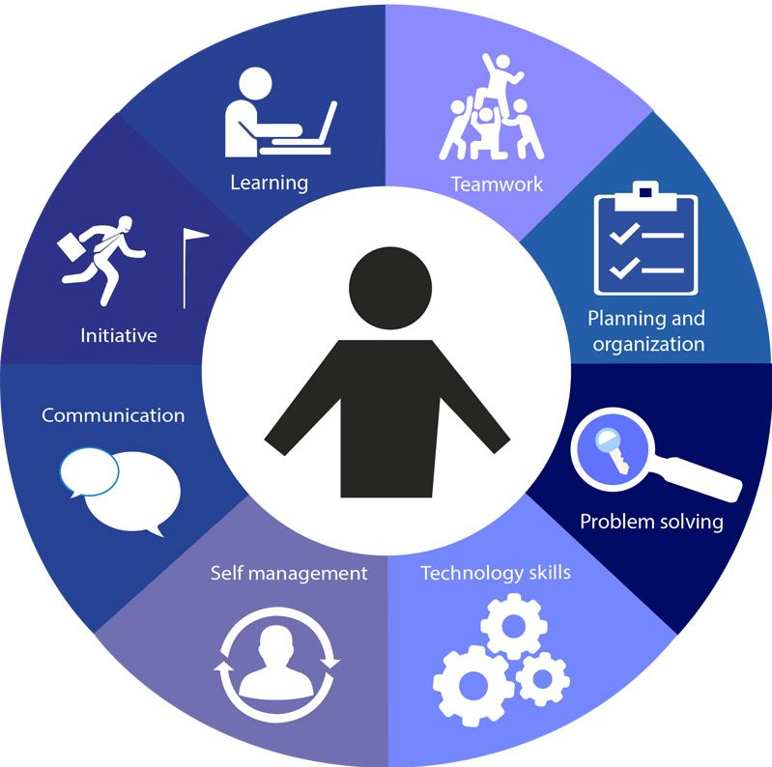
Figure: Employability Skill Management
(Source: Collet et al., 2015)
I think, overall there are not some hard and first rules pertaining to employability in the organisations. It is completely in the hands of the recruiting team of Tesco as to who they will employ and who they will not. The above section has hardly pointed out towards a few guidelines or rather the skill sets that can be possessed by the individuals to secure a good position in the employee market. But it can never be strictly said that these are the only skills that can help him to secure a job. The final decisions pertaining to his employability always pertains in the hands of the employer and there is no rule or statistics that can determine as to who they will employ and who they will not.

Advantages of having effective employability skills
It is quite evident from the above discussions that the advantages of having effective employability skills are indeed huge. The most significant among the advantages is that it helps an individual to secure a good position in the market. As put forward by Jackson(2014) the competitions have increased by a total of 45% since the past years. Peoples need along with their demand and aspirations have also changed and evolved greatly in the passing years. Instead of appointing two or three individuals, most of the organisations prefer appointing the individuals who can do the work of two to three people. According to my assumption, in a situation like this the incorporation of more number of effective employability skills turns out to be a competitive advantage in the market for the particular employer. Securing a good stable and steady job becomes a cakewalk for that particular individual. The organisational skills as well as the technical skills are some of the most effective skills that help an individual. In an age when the machines have started replacing almost each and every possible activity having an effective technical skill is by far the most important thing that can be possessed by an individual for being employable. Having effective technical skills increases the chances of employability by more than 45%.

Conclusions
The above sections I believe have proved to be effective in identifying what employability skills actually is and how it impacts the overall recruitment process. I have identified that employability skills are the combination of a whole lot of skills that are needed by an individual for being recruited in a particular organisation particularly Tesco in this case.
I think, the Concepts as well as the skills pertaining to employability have changed and modified to great extent in the passing years and a whole lot of new skills have been incorporated in the traditional employability skill set. However, I believe the soft skills as well as the technical skills are also some of the major skills that need to be possessed. I have discussed in the above sections the importance of organisational skills along with the soft skills. It has been noted that effective communication skills are also some of the vital employability skills that needs to be mentioned. I reflected that in most case it is believed that any individual who is capable of expressing himself in all possible situations thrown at him will always be able to perform his work effectively in the organisations. However, it can never be said that possessing the skills is the only criteria for getting employed in any reputed organisation.

a

Reference List
Benson, V., Morgan, S. and Filippaios, F., 2014.Social career management: Social media and employability skills gap. Computers in Human Behavior, 30, pp.519-525.
Collet, C. and Hine, D., 2015.Employability skills for knowledge intensive industries: Employers’ perspectives.
Collet, C., Hine, D. and du Plessis, K., 2015.Employability skills: perspectives from a knowledge-intensive industry. Education+ Training, 57(5), pp.532-559.
El Mansour, B. and Dean, J.C., 2016. Employability skills as perceived by employers and university faculty in the fields of human resource development (HRD) for entry level graduate jobs. Journal of Human Resource and Sustainability Studies, 4(01), p.39.
Jackson, D., 2014. Testing a model of undergraduate competence in employability skills and its implications for stakeholders. Journal of Education and Work, 27(2), pp.220-242.
Messum, D., Wilkes, L., Peters, C. and Jackson, D., 2017. Senior Managers' and Recent Graduates' Perceptions of Employability Skills for Health Services Management. Asia-Pacific Journal of Cooperative Education, 18(2), pp.115-128.
Messum, D., Wilkes, L., Peters, K. and Jackson, D., 2016. Content analysis of vacancy advertisements for employability skills: Challenges and opportunities for informing curriculum development. Journal of Teaching and Learning for Graduate Employability, 7(1), p.72.
Tan, L.M., 2016. Employability skills required of accountants.

