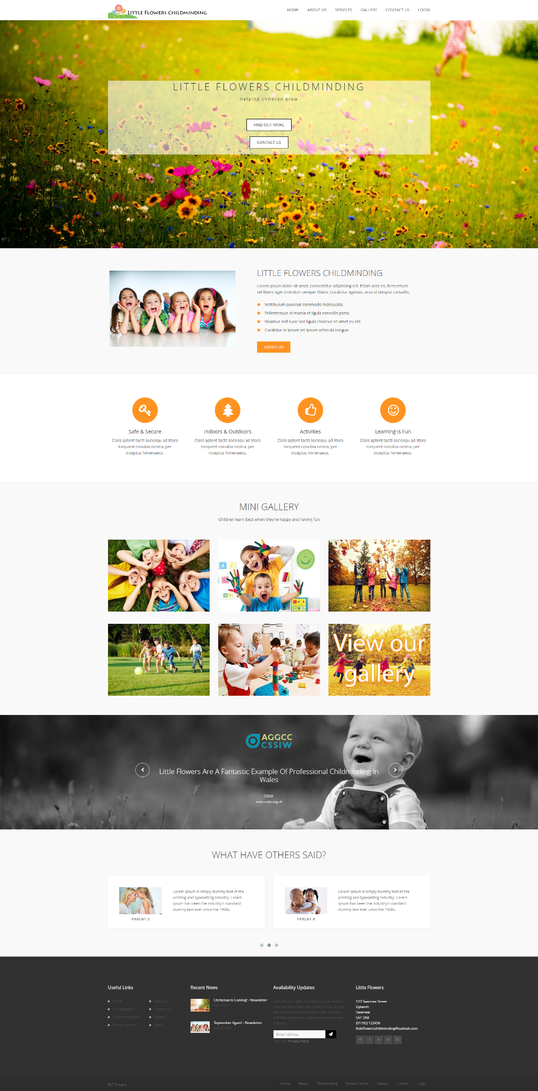
Figure 1 - Full view of Little Flowers home page (Index.php).
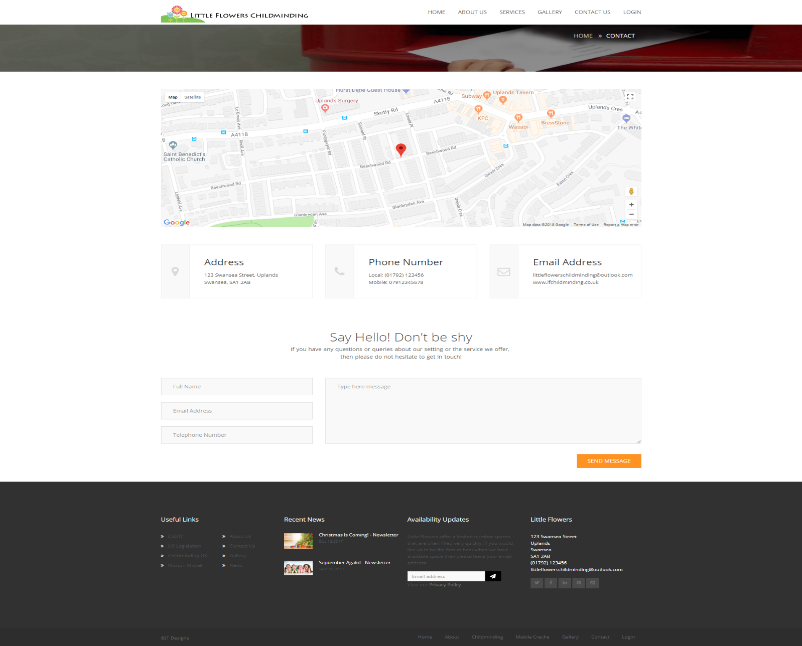
Figure 2 - Full view of Contact Us page featuring interactive Google Maps and contact form.
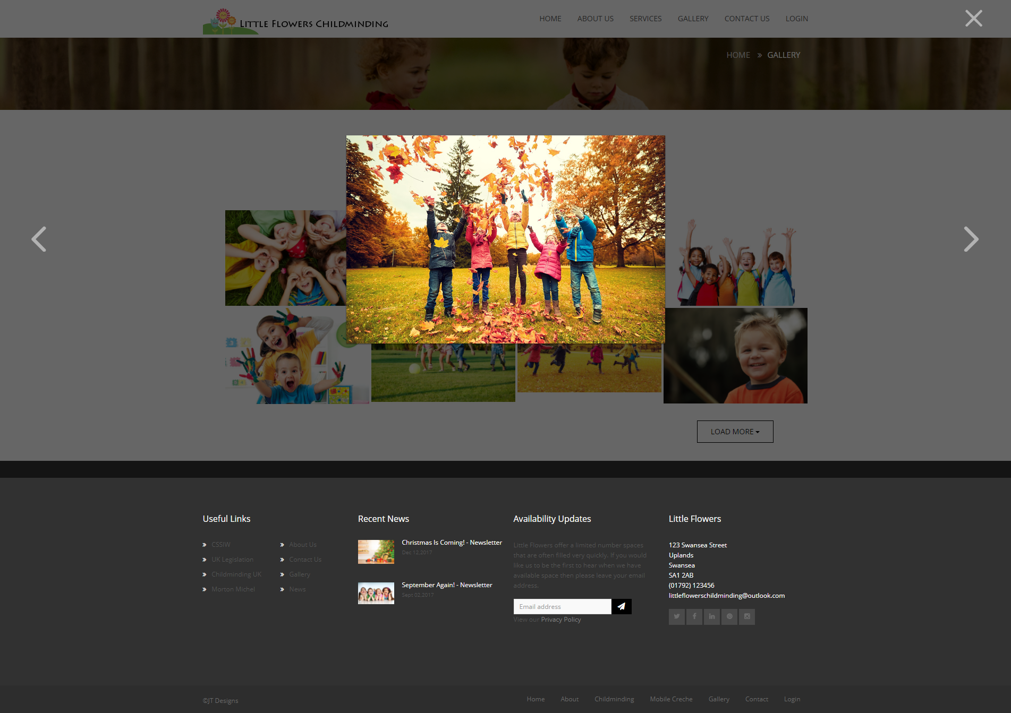
Figure 3 - Full view of Gallery page featuring interactive gallery using Lightbox.
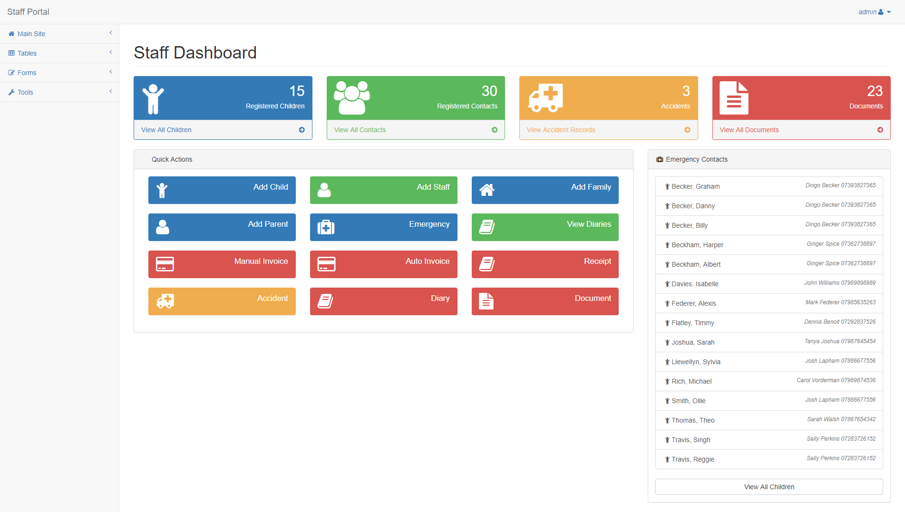
Figure 4 - Staff Dashboard featuring Quick Views panel, Quick Actions panel and Emergency Contacts table.
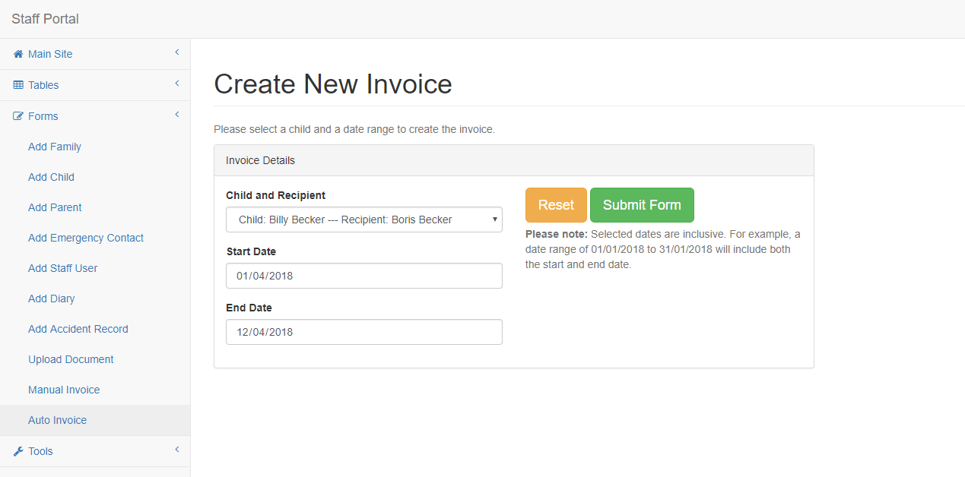
Figure 5 - Auto Invoice creation form.
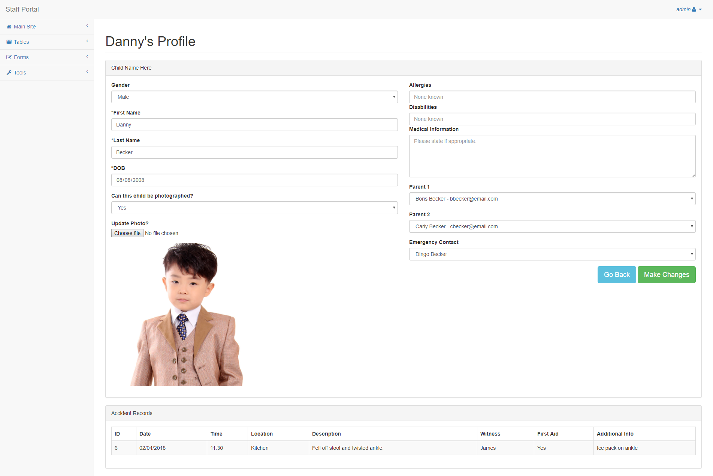
Figure 7 - Staff view of child profile and related accident records.
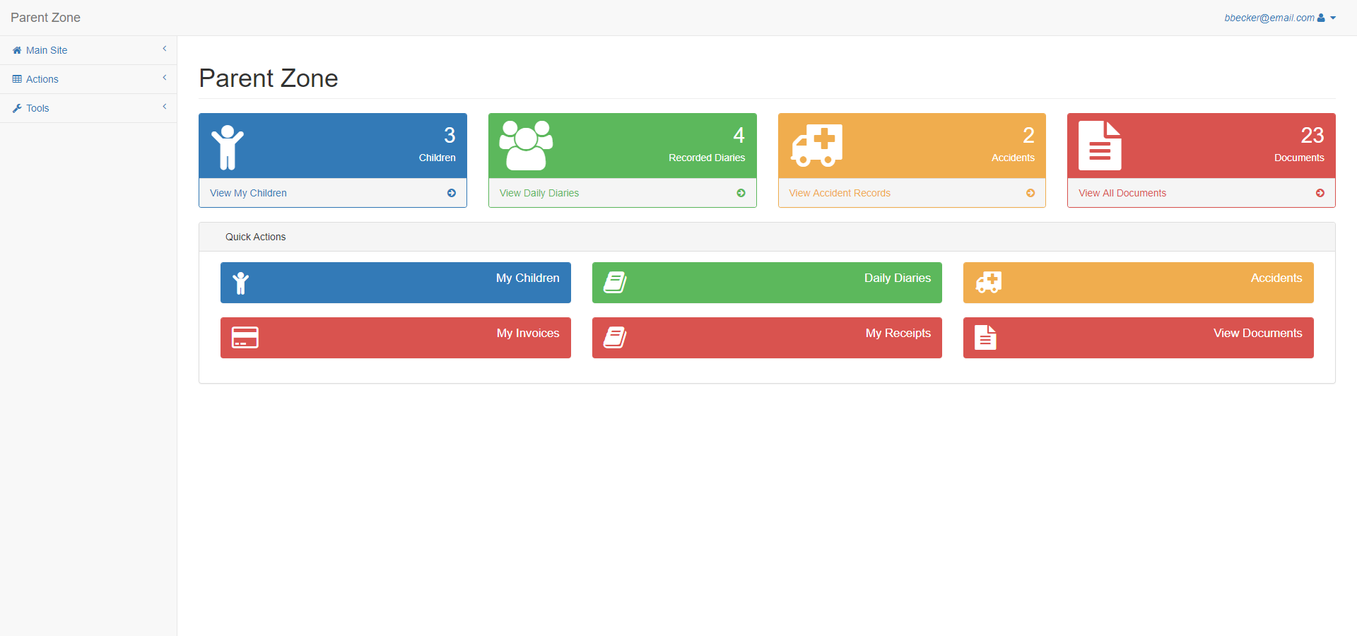
Figure 8 - Parent Zone featuring Quick Views and Quick Actions panels.
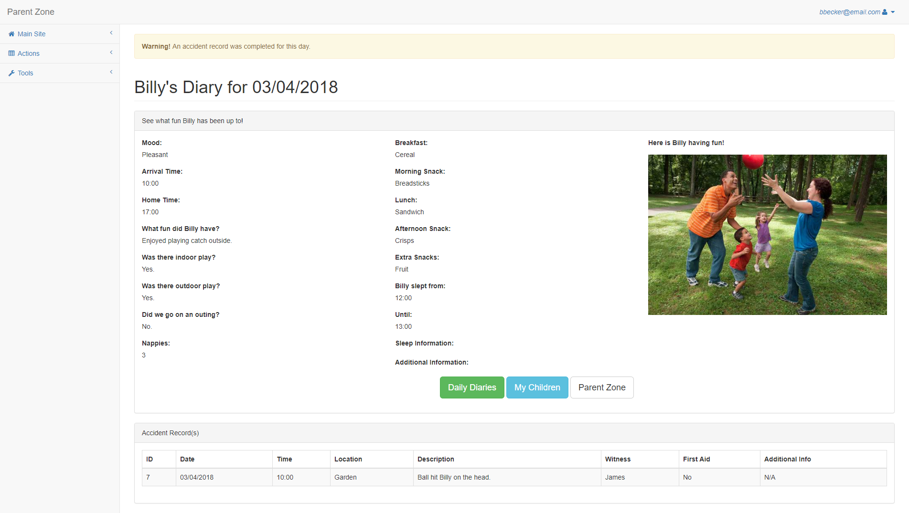
Figure 9 - Parent view of daily diary featuring accident record warning and details.
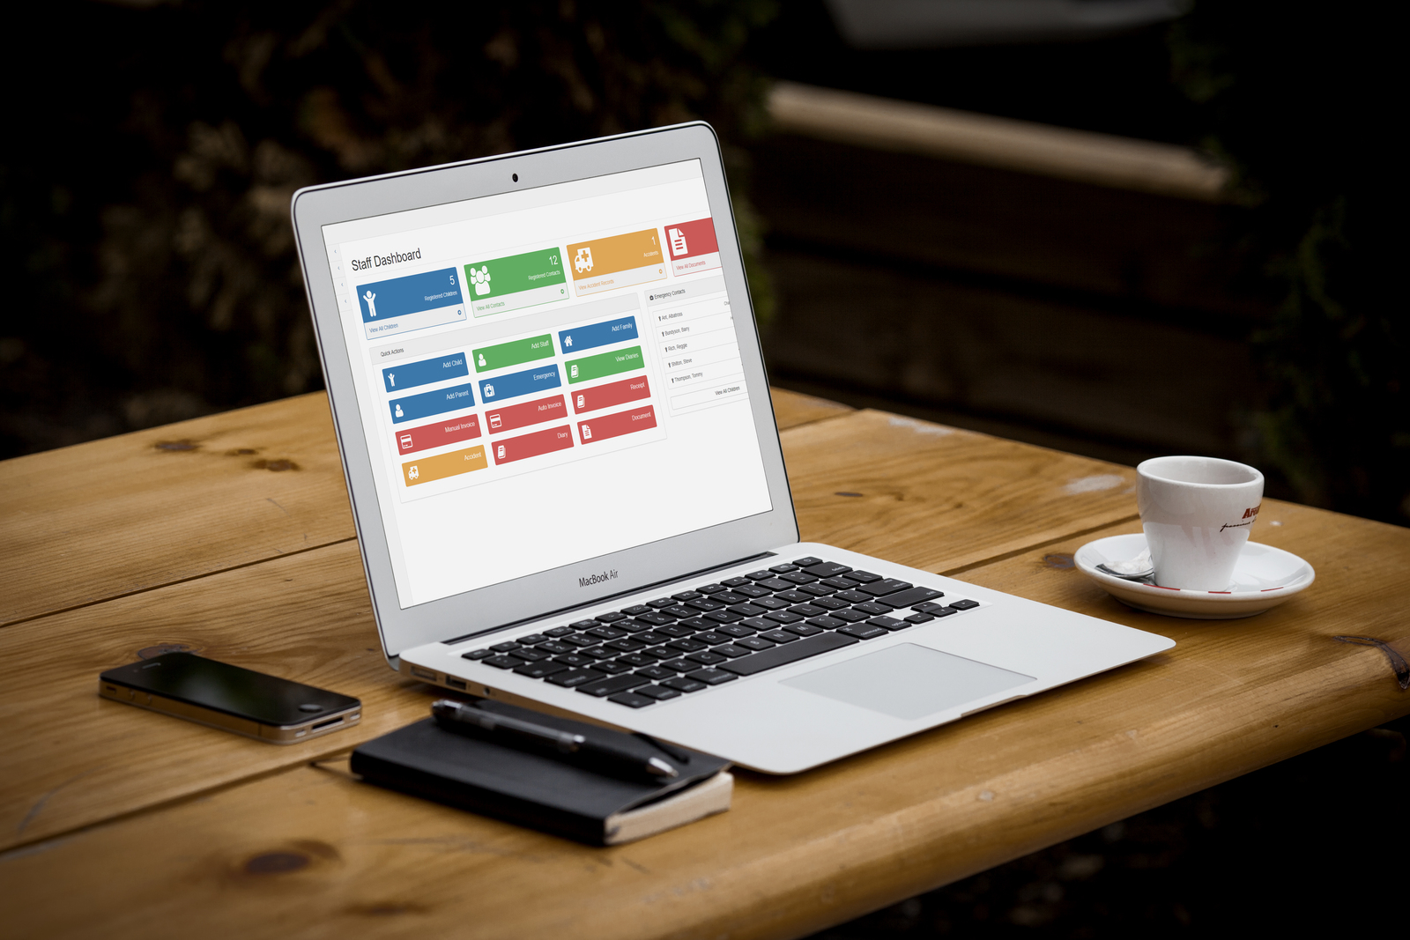
Figure 10 - Responsive design. Staff Dashboard as viewed on laptop device.
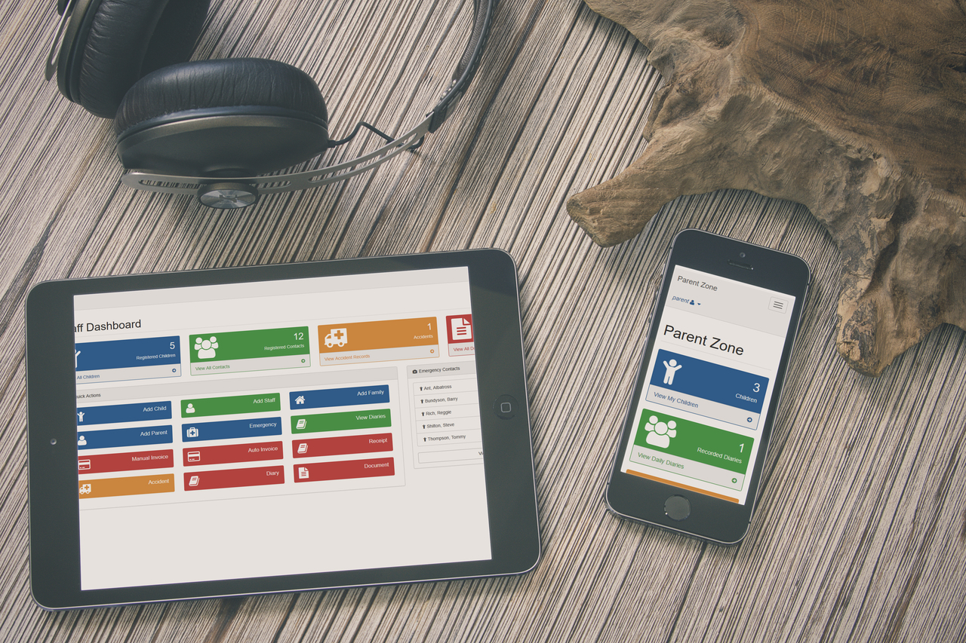
Figure 11 - Responsive design. Staff Dashboard viewed on tablet device. Parent Zone viewed on mobile phone.

Figure List
Figure 1 - Full view of Little Flowers home page (Index.php).
Figure 2 - Full view of Contact Us page featuring interactive Google Maps and contact form.
Figure 3 - Full view of Gallery page featuring interactive gallery using Lightbox.
Figure 4 - Staff Dashboard featuring Quick Views panel, Quick Actions panel and Emergency Contacts table.
Figure 5 - Auto Invoice creation form.
Figure 6 - Invoice generated in PDF format for print or digital distribution.
Figure 7 - Staff view of child profile and related accident records.
Figure 8 - Parent Zone featuring Quick Views and Quick Actions panels.
Figure 9 - Parent view of daily diary featuring accident record warning and details.
Figure 10 - Responsive design. Staff Dashboard as viewed on laptop device.
Figure 11 - Responsive design. Staff Dashboard viewed on tablet device. Parent Zone viewed on mobile phone.

