

Methods and Search Strategy Academic Poster

Student name: Shaukat Sultan
Student ID: 2309243

Module name: Independent Project (BMHP6020_BIRM) Element 2

Burnout Among UK Healthcare Professionals: A Critical Evaluation of Its Impact on Patient Safety, Workforce Retention and NHS System Sustainability
- Introduction and Research Aim :  To critically evaluate burnout among UK healthcare professionals as a systemic occupational phenomenon, examining its prevalence, structural determinants and consequences for patient safety and workforce retention, and to formulate evidence-informed recommendations that address both organisational culture and national workforce policy within the NHS. | 02 Search Strategy  For this dissertation, a structured search strategy was used to locate high-quality academic and policy-based evidence related to burnout in UK healthcare professionals. The search focused on three main concepts: Burnout, occupational stress and moral injury. Healthcare professionals, including doctors, nurses and allied health professionals. Patient safety, workforce retention and NHS sustainability. The following databases and sources were selected: PubMed. CINAHL. PsycINFO. NHS England workforce datasets. General Medical Council reports. Example Search Terms “burnout” AND “UK healthcare professionals” “clinician burnout” AND “patient safety” “NHS staff burnout” AND “retention” “moral injury” AND “healthcare workforce” “burnout” AND “doctors OR nurses OR allied health professionals” AND “United Kingdom” Boolean Operators Used AND narrows the search by combining concepts. OR broadens the search by including synonyms. NOT excludes irrelevant concepts where necessary
03 Searching for Information  Step-by-Step Search Process Step 1: Identify Key Concepts Burnout. UK healthcare professionals. Patient safety. Workforce retention. NHS system sustainability. Step 2: Select Appropriate Databases PubMed for medical and public health studies. CINAHL for nursing and allied health literature. PsycINFO for psychological theories and occupational stress evidence. Step 3: Develop Search Terms Burnout. Emotional exhaustion. Depersonalisation. Occupational stress. Moral injury. NHS workforce. Retention. Staff turnover. Patient safety. Medical errors. Step 4: Apply Boolean Operators AND to combine key concepts. OR to include similar terms. Truncation or phrase searching where available, for example “healthcare professional*”. Step 5: Screen Titles and Abstracts 03 Searching for Information Non-healthcare settings. Studies focused only on student burnout. Non-UK evidence where not transferable to the NHS context. Step 6: Access Full Texts Only studies that were fully accessible online and sufficiently relevant were retained for full review. Step 7: Search Grey Literature and Policy Sources NHS England reports. GMC workforce surveys. Royal College and workforce policy documents. Relevant government and professional body publications. Step 8: Organise References Accurate Harvard referencing. Efficient source organisation. Reduced risk of citation errors. | 04 Picture / Graph / Visual Aid / Statistics  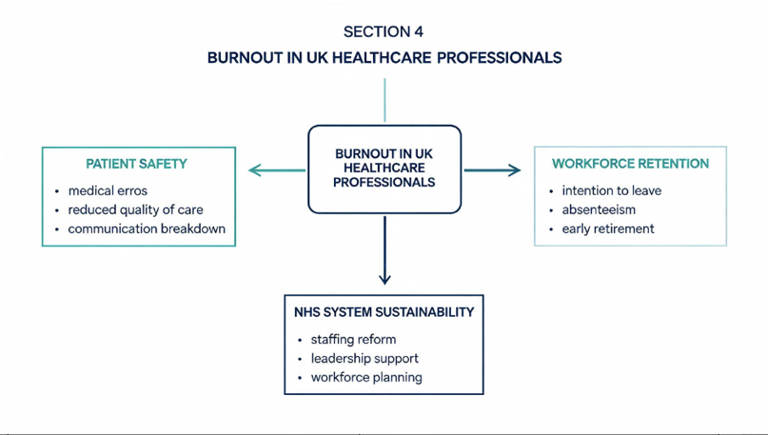
05 Research Validation and Analysis
To validate the evidence used in this dissertation, sources were selected based on: Peer-review status. Study design quality, such as systematic reviews, meta-analyses and large cohort studies. Sample size and representativeness. Relevance to the UK healthcare and NHS context. Publication recency. Transparency of methods and limitations. Use of established data sources, such as NHS England and the GMC. Themes Likely to Be Drawn from the Literature Structural and organisational determinants of burnout, including workload, staffing shortages, shi intensity, leadership and moral injury. Burnout and patient safety, including medical errors, reduced quality of care, safety culture and communication breakdown. 04 Picture / Graph / Visual Aid / Statistics 05 Research Validation and Analysis Burnout and workforce retention, including intention to leave, reduced hours, absenteeism, presenteeism and early retirement. Critique of individualised resilience narratives, including the limitations of wellbeing-only interventions and the tension between personal coping and systemic accountability. System-level recommendations for NHS sustainability, including workforce planning, supportive leadership, staffing reform and cultural change. This dissertation will use a thematic synthesis approach, informed by Braun and Clarke, to identify key themes across the literature.
06 Inclusion Criteria  Included Sources Peer-reviewed journal articles. Systematic reviews and meta-analyses. Large-scale cohort or cross-sectional studies. UK-specific workforce reports and policy documents. Sources published within the last 10 years, approximately 2016–2026 where possible. Seminal older sources included where theoretically necessary, such as Maslach and Jackson (1981). Studies Focused On Doctors. Nurses. Allied health professionals. NHS staff and the UK healthcare workforce. Articles Examining Burnout prevalence. Occupational determinants. Patient safety outcomes. Retention, turnover and intention to leave. Full-text sources accessible online. English-language publications | 07 Exclusion Criteria  Excluded Sources Articles published more than 10 years ago, unless they were key theoretical texts. Studies conducted outside the UK where findings were not transferable to NHS systems. Research focused solely on students. Research focused on non-clinical professions. General workplace stress without burnout-specific analysis. Sources without full-text access. Opinion pieces, blogs or non-academic commentary lacking robust evidence. Studies With Small, unrepresentative samples. Poor methodological transparency. Limited relevance to patient safety or workforce outcomes. Duplicate studies across databases. Sources that did not address healthcare settings or professional practice.
08 Ethical Considerations
Ethics in Secondary Research Because this project uses secondary data only, formal ethical approval is generally not required. However, several ethical principles still apply: 1. Academic Integrity All ideas, data and findings from published sources will be accurately cited using Harvard referencing to avoid plagiarism and maintain scholarly honesty. 2. Accurate Representation of Evidence Findings will be reported fairly and without selective distortion. Contradictory evidence will be included where relevant to avoid bias and support balanced critical discussion. 3. Use of Credible Sources Only reputable academic databases and recognised UK policy sources, such as NHS England and the GMC, will be used. 4. Avoidance of Harm Through Misinterpretation The dissertation will avoid reinforcing harmful narratives that overemphasise personal resilience while ignoring structural causes. 5. Reflexivity As a healthcare student with personal proximity to the topic, reflexivity is important. Personal experiences may create insight, but they may also introduce bias. 07 Exclusion Criteria 08 Ethical Considerations 6. Respect for Original Data Context Data and findings from reports or studies will be interpreted within their original context to avoid misrepresentation

References
Bakker, A.B. and Demerouti, E., 2007. The Job Demands-Resources model: state of the art. Journal of Managerial Psychology, 22(3), pp.309-328.
Chew-Graham, C.A., Rogers, A. and Yassin, N., 2003. ‘I wouldn’t want it on my CV or their records’: medical students’ experiences of help-seeking for mental health problems. Medical Education, 37(10), pp.873-880.
Cooper, C.L., Rout, U. and Faragher, B., 1989. Mental health, job satisfaction, and job stress among general practitioners. British Medical Journal, 298(6670), pp.366-370.
Dall’Ora, C., Ball, J., Reinius, M. and Griffiths, P., 2020. Burnout in nursing: a theoretical review. Human Resources for Health, 18, article 41.
Dimou, F.M., Eckelbarger, D. and Riall, T.S., 2016. Surgeon burnout: a systematic review. Journal of the American College of Surgeons, 222(6), pp.1230-1239.
Maslach, C., Schaufeli, W.B. and Leiter, M.P., 2001. Job burnout. Annual Review of Psychology, 52, pp.397-422.
NHS England, 2022. NHS staff survey 2022: national results briefing. London: NHS England.
Royal College of Physicians, 2022. Burnout and wellbeing in the medical workforce. London: Royal College of Physicians.
Royal College of Nursing, 2023. On the frontline of the UK’s nursing crisis. London: Royal College of Nursing.
World Health Organization, 2019. International classification of diseases for mortality and morbidity statistics (11th Revision). Geneva: World Health Organization
General Medical Council, 2022. The state of medical education and practice in the UK: workplace experiences 2022. London: General Medical Council.
Hall, L.H., Johnson, J., Watt, I., Tsipa, A. and O’Connor, D.B., 2016. Healthcare staff wellbeing, burnout, and patient safety: a systematic review. PLOS ONE, 11(7), e0159015.
Maslach, C. and Jackson, S.E., 1981. The measurement of experienced burnout. Journal of Occupational Behaviour, 2(2), pp.99-113.
Panagioti, M., Geraghty, K., Johnson, J., Zhou, A., Panagopoulou, E., Chew-Graham, C., Peters, D., Hodkinson, A., Riley, R. and Esmail, A., 2018. Association between physician burnout and patient safety, professionalism, and patient satisfaction: a systematic review and meta-analysis. JAMA Internal Medicine, 178(10), pp.1317-1331.
West, C.P., Dyrbye, L.N. and Shanafelt, T.D., 2018. Physician burnout: contributors, consequences and solutions. Journal of Internal Medicine, 283(6), pp.516-529.

