

Effectiveness of Social Media Marketing on Customer Engagement in the UK: A Case Study of Nike UK

Name: Ronok Ahmed Shihab
ID: 2506432

Declaration
This work has not previously been accepted in substance for any degree and is not being concurrently submitted in candidature for any degree.

Signed ...........: Ronok Ahmed Shihab...........................................................
Date .....25/09/2026...................................................................

STATEMENT 1

This work is the result of my own investigations, except where otherwise stated.

Other sources are acknowledged by footnotes giving explicit references. A bibliography is appended.

Signed .......: Ronok Ahmed Shihab..............................................................

Date ..................25/09/2026......................................................

STATEMENT 2

I hereby give consent for my work, if accepted, to be available for photocopying and for inter-library loan, and for the title and summary to be made available to outside organisations.

Signed ........: Ronok Ahmed Shihab.............................................................

Date ....................25/09/2026....................................................

Abstract
This dissertation evaluates the effectiveness of Nike's social media marketing strategy and its direct and indirect links with customer engagement, purchase behavior and brand loyalty as perceived by its customers. The study is positivist, deductive and quantitative, with an explanatory-correlational study design, guided by the models of Customer Engagement Theory, Relationship Marketing Theory, the Technology Acceptance Model and the AIDA heuristic. The data were obtained through an online questionnaire from 154 valid respondents and analysed with reliability analysis, descriptive statistics, Pearson correlations, multiple regression, and bootstrapped mediation analysis. The internal consistency of all the measures was satisfactory to good, with Cronbach's alpha values ranging from 0.716 to 0.873. Multiple regression analysis revealed that perceived Social Media Marketing Effectiveness was a significant predictor of Customer Engagement (β=.230, p=.004) and Brand Loyalty (β=.244, p=.002). Customer Engagement did not significantly predict Purchase Behaviour (β=.121, p=.135) or Brand Loyalty (β=.094, p=.227), while Technology Acceptance did not significantly predict Customer Engagement (β=.106, p=.183). The PROCESS Model 4 with 5,000 bootstrap samples did not find significant indirect results between Social Media Marketing Effectiveness and Purchase Behaviour via Customer Engagement (effect=.0367, 95% CI [-.0030, .0941]) or between Social Media Marketing Effectiveness and Brand Loyalty via Customer Engagement (effect=.0358, 95% CI [-.0075, .0873]). Based on the results, it can therefore be concluded that there is a positive relationship between Nike's social media marketing and customer engagement and loyalty, while customer engagement does not function as the proposed mediator between the perception of social media marketing and the results of customer outcomes. The study found that, in terms of social-media effectiveness, the direct, indirect and broader customer influences must be measured, not just engagement metrics.
Keywords: Social Media Marketing; Customer Engagement; Purchase Behaviour; Brand Loyalty; Technology Acceptance Model; Nike UK; UK Retail Industry

Acknowledgement
I would like to thank Ka Po Chong, my supervisor, for the guidance and constructive feedback, as well as ongoing support, provided during the completion of this dissertation. Their contribution in establishing critical insight, notably in suggesting a more rigorous interpretation of the statistical results and their transparency, was very instrumental in the quality and integrity of this research.
I would like to express my gratitude to the University of Wales Trinity Saint David for providing the resources and support needed to conduct this research and to the 154 individuals who participated in this study, who gave their time generously.
I would like to express my gratitude to my family and friends for their patience, encouragement and support throughout my studies.

Contents
Declaration ii
Abstract iii
Acknowledgement iv
1. Introduction 1
1.1 Background of the Study 2
1.2 Problem Statement 3
1.3 Research Aim and Objectives 4
1.3.1 Research Aim 4
1.3.2 Research Objectives 4
1.4 Research Questions 5
1.4.1 Primary Research Question 5
1.4.2 Sub-Questions 5
1.5 Structure of the Dissertation 6
1.6 Chapter Summary 6
2. Literature Review 7
2.1 Introduction 8
2.2 Social Media Marketing and Customer Engagement in the UK Retail Industry 8
2.2.1 Engagement Drivers and Their Limitations 8
2.2.2 Platform, Privacy and Measurement Challenges 10
2.2.3 Implications for Effective and Responsible Engagement 12
2.3 Assessment of Nike UK’s Social-Media Marketing Strategy 14
2.4 Impact of social media marketing on customer interaction, purchasing behaviour and brand loyalty 17
2.4.1 Factors affecting brand loyalty through social media marketing 17
2.4.2 Challenges faced for implementing effective social media marketing 17
2.4.3 Probable solutions of the problems 18
2.5 Digital marketing activities 19
2.5.1 Ways of implementing digital marketing strategies 19
2.5.2 Theoretical Framework 21
2.6 Literature Gap 22
2.7 Conceptual Framework 24
3. Research Methodology 25
3.1 Introduction 26
3.2 Research Philosophy 27
3.3 Research Approach 27
3.4 The research design 28
3.5 Research strategy 28
3.6 Data Collection Method 28
3.7 Data Collection Technique 29
3.8 Population and Sample 29
3.9 Hypothesis Development 29
3.10 Data Analysis 31
3.11 Ethical Considerations 31
3.12 Gantt Chart and Time Frame 32
4. Findings 35
4.1 Data Coding, Transformation and Demographic Profile of Respondents 36
4.1.1 Data Coding and Preparation Process 36
4.1.2 Coding of Likert Scale Measurement Items 36
4.1.3 Construction of Composite Variables 37
4.1.4 Demographic Profile of Respondents 38
4.2 Frequency Analysis of Survey Responses 43
4.3 Reliability Analysis of Measurement Constructs 43
4.4 Descriptive Statistics 44
4.5 Pearson Correlation Analysis 44
4.6 Multiple Regression, Mediation and Hypothesis Testing 45
5. Discussion of Findings 49
5.1 Discussion 50
6. Conclusion and Recommendation 55
6.1 Conclusion 56
6.2 Recommendations 59
6.3 Limitations and Future Research 61
References 63
Appendices 85
Appendix A: Survey Questionnaire 85
Appendix B: Dataset 92
Appendix C: SPSS Output 92
Appendix D: Ethics Form 121

1. Introduction

1.1 Background of the Study
Digital technologies have transformed consumers' way of searching for information, communicating with brands and making purchase decisions (Kutnjak, Gregurec and Lucija Tomašek, 2022). Social media has become very significant due to its ability to integrate communication, entertainment, product discovery and customer interaction in one digital platform. This is a very mature environment in the United Kingdom. Ofcom (2025) found that UK adults spend an average of four and a half hours online a day in 2025, which is approximately 10 minutes more than in 2024. With so much activity taking place online, there is significant potential for retailers to engage with their audience multiple times via social media, digital advertising, branded content and interactive communication.
Digital channels are also growing in significance in the UK retail market. The percentage of electronic sales (internet sales) of total retail sales in Great Britain has increased from 19.2% in 2019 to 27.4% in 2025, according to the data from the Office for National Statistics (ONS) (2026). This shift means that online has moved beyond its role as a pandemic time filler and is now a permanent way of getting products into consumers' hands. Social media is no longer just a marketing vehicle for retailers; it's a part of the customer journey as well, and customers might find a product, learn about the options, engage in social interaction with a brand, and be pushed towards buying a product (Siregar et al., 2023).
Customer engagement is a key part of this digital world. According to Lim and Rasul (2022), Social media has further heightened the need for customer engagement as customers can interact with brands at any time and with other customers. Engagement can consist of cognitive attention, emotional resonance and active behaviours, including commenting, sharing, recommending or participating in branded activity. In addition, Kulikovskaja et al. (2023) illustrate that the type of social media content can elicit distinct engagement, and that engagement can impact broader marketing results, such as customer loyalty and word-of-mouth. Thus, the efficacy of social media marketing should not only be measured by the amount of content shared or followers gained but also by the quality of customer interaction and outcomes in terms of behaviour (Shahid, 2019).
The retail environment demonstrates that these are not guaranteed. Dolega, Rowe and Branagan (2021) determined that there is a positive correlation between social media activity and traffic to retail websites, but the correlation between traffic and orders or sales is not necessarily linear. Likewise, a study by Gutierrez et al. (2023) on 541 respondents in the United Kingdom revealed that positive consumer-brand interactions on social media boost purchase intention and that privacy concerns can reduce the impact of positive interactions. This indicates that retailers should consider the social media practices they could implement that stimulate meaningful engagement, and how engagement relates to purchase behaviour and long-term loyalty.
The Nike brand offers a timely organisation to examine these questions as the company has developed an integrated approach of retail, eCommerce, mobile apps, social media messaging, athlete partnerships and brand communities. NIKE, Inc. (2026) achieved full-year revenue of US$46.4 billion for the financial year ended 31 May 2026 at the global level. NIKE Direct reported US$17.7 billion, a 12% drop in NIKE Brand Digital revenue for the year. While not UK-specific, these are indicative of the strategic significance of Nike's direct and digital performance and how it's evolving. The relevance of Nike's social media marketing strategies and tactics in a competitive UK sportswear market is therefore applicable in the aspects of content, personalisation, influencer activity, customer interaction and digital engagement.
Based on this backdrop, the current study emphasises social media marketing and customer engagement with regard to Nike UK. It identifies the factors that may affect engagement, assesses customers' perceptions of Nike's social media marketing strategies, and explores the relationship between engagement and buying behaviour/brand loyalty. The study also takes into account the use of digital marketing that can be able to assist the company Nike in improving the interaction of its customers in the UK retail sector.

1.2 Problem Statement
While social media provides retailers with a direct way to reach large numbers of online consumers, a central managerial and academic challenge is that there is no direct link between visible engagement and the commercial and/or relationship outcomes (Wang, 2023). Likes, comments, shares, and site visits are just a handful of metrics that indicate that customers have seen or interacted with content, but don't necessarily indicate purchase intent, repeat purchase or brand loyalty. For instance, Dolega, Rowe and Branagan (2021) determined that social media presence boosted the number of visitors to retail websites, but did not always correspond to higher order rates or sales. As a result, retailers must have proof that there is some type of social media activity that helps to build and drive engagement, and not just a quick head pay.
Consumers are highly engaged online, and online retail makes up a considerable proportion of retail sales; this is a significant issue in the UK market. Meanwhile, engagement isn't just about the promotion. Gutierrez et al. (2023) demonstrate that consumer-brand interaction can enhance purchase intention, whereas privacy concerns have the potential to disrupt this relationship. Despite a promising online presence, these factors can all diminish the impact of social media marketing.
The existing literature provides a general connection between social media marketing, engagement, and consumers' behaviour. However, three questions have not been addressed in this context. First, studies often examine engagement as an outcome, but not as a mediator between marketing perceptions and purchase behaviour and loyalty. Second, although traffic and engagement might not lead to sales, it is assumed to be a sign of commercial effectiveness (Dolega, Rowe and Branagan, 2021). Thirdly, there is a lack of evidence specific to the Nike customer base in the UK. The presented study therefore explores direct as well as indirect links between perceived social media marketing effectiveness, customer engagement, purchase behaviour and brand loyalty, keeping in mind that the design of the study is cross-sectional and thus cannot claim causality.

1.3 Research Aim and Objectives

1.3.1 Research Aim
The aim of this research is to evaluate customers' perceptions of Nike UK's social media marketing effectiveness and to examine the direct and indirect associations between social media marketing, customer engagement, purchasing behaviour and brand loyalty among the surveyed UK customers.

1.3.2 Research Objectives
The research objectives are:
1. To determine how social media marketing can be used to improve customer engagement in the UK retail industry.
2. To assess customers' perceptions of the social media marketing tactics used by Nike UK across Instagram, TikTok, Facebook and X.
3. To analyse the direct relationships among Nike UK's perceived social media marketing effectiveness, customer engagement, purchasing behaviour and brand loyalty, and to test whether customer engagement mediates the relationship between social media marketing effectiveness and customer outcomes.
4. To examine whether technology acceptance provides additional explanatory value for customer engagement and customer outcomes beyond perceived social media marketing effectiveness.
5. To provide recommendations for enhancing social media marketing techniques at Nike UK and, where relevant, within the wider UK retail sector.

1.4 Research Questions

1.4.1 Primary Research Question
How effective is Nike UK's social media marketing as perceived by the surveyed customers, and to what extent are its associations with purchase behaviour and brand loyalty direct or statistically mediated through customer engagement?

1.4.2 Sub-Questions
The study addresses the following sub-questions:
1. How can social media marketing be used to improve customer engagement in the UK retail industry?
2. How do customers perceive the effectiveness of Nike UK's social media marketing tactics across Instagram, TikTok, Facebook and X?
3. What direct and indirect relationships exist between perceived Nike social media marketing effectiveness, customer engagement, purchasing behaviour and brand loyalty?
4. Does technology acceptance of Nike's digital platforms explain additional variation in customer engagement or customer outcomes?
5. What recommendations could enhance social media marketing techniques at Nike UK and support customer engagement in the wider UK retail sector?

1.5 Structure of the Dissertation
The dissertation has six chapters. Chapter 1 gives an overview of the study, including the background, problem statement, research aim and objectives, research questions and structure of the dissertation.
The literature review in Chapter 2 critically examines the research on social media marketing, customer engagement, purchasing behaviour and brand loyalty. It discusses alternative explanations, specifies the extent of measurement and causal constraints in previous research, analyses the context of Nike UK and constructs a theoretical, conceptual and hypothesis framework. Chapter 3 details and justifies the methodology, including positivist philosophy, deductive approach, cross-sectional explanatory correlational design, quantitative survey, sampling, measurement, multiple regression, mediation analysis and diagnostic requirements. The empirical results of the 154 valid questionnaires are presented in Chapter 4. It presents information on data preparation, demographics, reliability, descriptive statistics, correlations, multiple regression models, and archived SPSS output, diagnostics, mediation tests and hypothesis decisions. In Chapter 5, the results of the study are discussed critically in relation to the research questions, theoretical framework and previous literature. The dissertation ends with Chapter 6, which offers recommendations based on evidence, the main restrictions and future research priorities.

1.6 Chapter Summary
This chapter has laid the groundwork and direction for the research. However, the value of digital channels is clear in the UK with the increase in daily online activity and online retailing, and previous research has identified that social media engagement does not necessarily result in purchase or loyalty results. The relevance of Nike is the fact that it has a strong digital footprint and its direct and digital channels are strategically relevant. In this regard, the chapter has clarified the research problem, aim, objectives and questions under which the research is conducted. The literature review in the next chapter critically investigates the literature regarding social media marketing, customers' engagement, purchasing behaviour and brand loyalty, after which the theoretical and conceptual background for the research is built.

2. Literature Review

2.1 Introduction
The potential benefits of social media marketing are often touted as a path to customer engagement, purchase behaviour and brand loyalty (Pathak, 2025). This relationship, however, is not automatic and is not the same for all customers, platforms and outcomes. A critical review needs, therefore, to be able to separate out what is communicated in the name of the brand, what is visible on the platforms, what generates psychological engagement, and what is commercial downstream. Likes, views, or website visits can mean attention, but it doesn't mean that they are the same as relational commitment, repeat purchase or loyalty. For instance, Dolega, Rowe and Branagan (2021) discovered that social-media activity can drive up retail web traffic while driving down the order or sales figures. This is crucial to the present study as it eliminates any potential inferences of the effectiveness of Nike UK's social media marketing strategy based on visibility alone.
There are alternative explanations in the literature. From this point of view, the relevant content, interaction and personalisation are considered as the factors that bring about engagement, as it makes communication more useful and socially meaningful (Oualid, Selma and Soufyane, 2024). Another interpretation focuses on current brand attitudes: If customers like a brand, they are more likely to follow it, interact with it and report loyalty towards it. A cross-sectional study cannot prove that these constructs are associated with each other, but it can estimate such associations (Elwahab et al., 2025). A third view is on platform and privacy conditions. What some customers may find to be relevant is the same personalised communication that could be experienced as intrusive by others, particularly if data practices are unclear. The review thus assesses the proposed relationships and clarifies their boundaries and the circumstances in which they can change.

2.2 Social Media Marketing and Customer Engagement in the UK Retail Industry

2.2.1 Engagement Drivers and Their Limitations
Customer engagement is a multi-faceted phenomenon comprising customers' cognitive attention, emotional involvement and behavioural involvement in brand interactions (Brodie et al., 2011). This is a more comprehensive definition than typical social media metrics, including likes, views, numbers of followers or shares. For instance, a customer may “like” a Nike post within seconds and without much thought, while a customer who posts user-generated content, joins a fit challenge, comments on a product issue, or asks a question of the brand may show “more substantive behavioural engagement” (Neupane, 2022). So don't assume that any platform activity is a sign of great customer–brand relationships.
In social media environments, B Mohamed, B Jamil and Mohamed (2025) list some of the possible factors affecting engagement. Well-written, entertaining, informative, and visually appealing content that is relevant to the interests of the customer can capture attention and interaction. Two-way communication could also be beneficial for engagement as it enables customers to ask questions, communicate opinions and receive answers from the brand (Etuk, 2018). In addition, when recommendations, advertising, or content are based upon a customer's interests and interactions, personalisation can also enhance perceived relevance (Zhu and Chang, 2016). Furthermore, user-generated content and influencer partnerships can help build the credibility of brand messaging, as consumers can see what happens to athletes, creators and other consumers and hear their thoughts rather than just the brand's own messaging.
But what is found in the literature doesn't necessarily mean that all engagement activities are equally effective. The success of engagement efforts might depend on the platform, kind of engagement, the consumer's prior experience with the brand, and the kind of engagement. Meta-analytic data provided by Blut et al. (2023) reveal that engagement programs are not equally effective on all engagement platforms, nor with all types of initiatives. This implies that social-media marketing should not be considered as a single entity. Each of the above examples may encourage engagement of varying kinds and intensities (Rahman, 2024).
The content, athlete alliance, brand story, community engagement, product promotion, and the integration of digital platforms in Nike UK's social media marketing campaign are crucial aspects of this issue (Li and Chen, 2023). Inspirational athlete content can resonate with the same person who otherwise doesn't like to see product promotions, and product-information content can be of interest mainly to another person who is more focused on practical fitness. Therefore, a composite index of perceived effectiveness of social media marketing can serve as a meaningful summarisation of customer perceptions, but it may mask differences in value of the content, credibility of the influencers, and engagement with the community and social media platforms, as well as responsiveness of social media platforms (Gayathri and Anwar, 2024). The study's social-media metric is thus defined as a perception of marketing effectiveness, and not as direct evidence of the impact of any specific Nike campaign on engagement.
Moreover, there can be factors in engagement besides social-media marketing. Those who already have positive attitudes towards Nike could be more inclined to follow Nike accounts, engage with the content, and report high levels of loyalty (Rabbanee, Roy and Spence, 2020). Engagement can also be influenced by a variety of factors, including Nike's brand identity, frequency of purchases, personal interest in sport, and previous satisfaction with the product. Thus, the link between perceived social-media marketing and engagement should be considered as an association only and not as a causal link. The study will still predict that there will be a positive relationship, as there are opportunities for customers to listen to, engage with and become more connected to Nike UK as a result of the relevant, interactive, credible communication.

2.2.2 Platform, Privacy and Measurement Challenges
Social media presents opportunities for Nike UK to directly engage with customers, but significant challenges exist with regard to platform, privacy and measurement (Chai, 2024). Social media varies and has different types of posts, expectations and algorithms. Instagram and TikTok focus on video and image content, including short-form video content, while Facebook supports more content for the community and X supports faster public communication and customer-service replies (Sha, Dolan and Rashidirad, 2020). A platform presence, however, is not necessarily a guarantee that content will reach and impact the targeted audience. The distribution of messages is influenced by algorithms, competition for paid advertising, posting timing, content saturation, and customers' online behaviour, as these factors determine which messages will be viewed and responded to. (Ade Apriansyah, Muji Gunarto and Sulaiman Helmi, 2025).
A challenge for Nike UK is that a message for one platform can be different for another. The reuse of the same content across all platforms could be efficient, but the content might not be relevant if it is not specific to the conventions and the expectations of the platforms (Gilbert, Shilton and Vitak, 2023). Meanwhile, with the constant adaptation to trends, content fatigue can occur, or brand consistency may be lost. Nike, therefore, has to take care to ensure that it balances its creativity with a unified brand. Although increasing the number of posts can lead to increased engagement, the relevance, timing, authenticity and responsiveness of posts can be more important than the number of posts, according to La Ragione and Risitano (2025).
There's a related challenge in personalisation. Personalised ads and suggestions can save customers from searching and make the content more useful. Nike could better relate to their customers when getting them information about their previous interests, browsing and product preferences, as they can now see that Nike communication is relevant. Consumers can, however, sense a lack of transparency and control when personalisation is used without their awareness. Gutierrez et al. (2023) identified that customer–brand relationships on social media can positively influence purchase intention, but the negative effect of privacy concerns cannot be ignored. So, the notion that more data-driven targeting will equal more engagement isn't necessarily true.
Therefore, Nike UK must see privacy as a component of customer experience rather than a legal gimmick. The customer should be able to understand why he/she is being offered certain recommendations, adjust his/her communication preferences and feel confident that his/her personal data is being handled responsibly (Zhao, Fu and Bai, 2025). Transparency in data practices can build trust, and the opposite can reduce engagement and brand relationships. Instead, the strategic objective should be relevant and proportionate personalisation, but one that customers believe is helpful and fair (Casaca and Miguel, 2024).
Another difficulty is measurement. Details of likes, comments, shares, video views and follower counts are readily accessible, but insufficient metrics of the marketing's success. High engagement metrics may be indicative of temporary entertainment, controversy, or paid visibility (reach) through algorithms, not lasting customer engagement (Kumar and Sarkar, 2025). At the same time, a customer could form positive attitudes toward Nike without public contact with content. Social media marketing can boost traffic to retail websites without the commensurate rise in orders or sales, according to Dolega, Rowe and Branagan (2021). This is to show that engagement numbers and commercial results should not be considered interchangeable.
This study tackles this by looking at the perceived social media marketing effectiveness and customer engagement with it, purchase behaviour and brand loyalty. However, the survey results are based on what respondents thought they encountered in the campaign and not on what they actually saw or heard, nor on whether they purchased the product, or on the amount of time spent on the digital platforms, so respondents' perceptions should be taken with a pinch of salt. The analysis can show whether the Nike brand has improved specific social media metrics, like engagement and positive customer outcomes, among those who are more positive about its social-media marketing, but it cannot prove whether any campaign, platform algorithm, marketing activity or any other factor caused those outcomes.

2.2.3 Implications for Effective and Responsible Engagement
Kumar & Sarkar (2025) suggest that Nike UK can go beyond the metrics of reach, likes, and follower growth on social media to better engage its audiences. Relevant content, use of the platform appropriately, credible communication, interaction with customers and responsible handling of data are all needed to effectively engage. But Bashar, Ahmad and Wasiq (2012) also show that there is no one-size-fits-all approach to social media tactics. The effectiveness of engagement efforts relies on platform features, intent of the audience, engagement content type, and customers' previous interactions with Nike and the competitive landscape. Nike UK, therefore, needs to experiment and assess its activities instead of taking the fact that it is highly visible for granted as an indicator of the presence of customer relationships and commercial value.
Nike UK first has to develop content strategies that focus on value to the audience rather than regular product promotion. Content may include practical advice on fitness, athlete and customer stories, product use, simple wellbeing tips, challenges in the community, and behind-the-scenes looks (Abed, Izadi and Do Young, 2025). Not only do they deliver information, motivation, or connection with other people, but they can also encourage participation in a way that is not purely an advertisement for products. However, the content must be optimised for the platform. Brief, trendy, and interactive videos may fit better for TikTok, whereas visual storytelling, product discovery, and community-based content may align more with Instagram (Manic, 2024). It doesn't mean Nike needs to do everything, but it does mean that content needs to be perceived as genuine and not too commercial/ promotional and align with the brand's values.
Secondly, treat customers as a way of building relationships. When Nike responds to questions, complaints, and customer-generated content in a timely and constructive manner, it can indicate that they value their customers' opinions (Johnen and Schnittka, 2019). Engaging the community through fitness challenges, user-generated content campaigns, and athlete-led discussions can enhance participation and social connection (Shah Baig, Elahib and Hashmi, 2023). The volume of feedback, however, is not the sole indicator of customer interaction. Nike UK should ask if interactions are beneficial, if problems have been addressed, if customers are feeling more positive about the brand and if interactions create desirable customer behaviour such as visiting its website, exploring its products or purchasing again.
Thirdly, personalisation should be transparent, controllable and proportionate. These insights can be used to craft content that resonates more with customers, but only when Nike UK has their consent and they are clearly informed on what data are being collected (Samanta, 2025). These are important as personalisation can be the boon of value, but the bane of trust when perceived as an invasive method of advertising. Privacy protection and ethical data use should then be seen as part of a social-media strategy, not an additional administrative challenge.
Lastly, Nike UK needs to adopt a more comprehensive measurement system. In addition to reach and visible engagement, performance can be measured with other metrics like meaningful comments, saves, click-through rates, product-page visits, customer-service response times, sentiment, conversion rates and repeat purchase rates (where data is available) (Nica et al., 2021). This would help to separate the short-term attention from the engagement that results in customer experience and longer-term customer relationships. It would also validate the theoretical model of this research that suggests that perceived social-media marketing effectiveness can be linked to purchase behaviour and brand loyalty partly via customer engagement. While there is general consensus in the literature that engagement is a multidimensional construct and not merely a metric, there is disagreement among authors on what factors influence engagement. Brodie et al. (2011) conceptualise engagement as cognitive, emotional and behavioural, which is echoed by Lim and Rasul (2022) who emphasise the interactive and platform-embedded nature of engagement. But the findings of a meta-analysis by Blut et al. (2023) counter this consensus: while there is some variability by engagement platform, there is also variability by initiative type, suggesting that none of these tactics is consistently effective at driving engagement. While Brodie et al. conceptualise their content through five key engagement dimensions, Kulikovskaja et al. present a more mechanistic consideration of different content forms and their corresponding engagement responses, with both forms having a distinct influence on outcome variables such as loyalty and word-of-mouth. These findings are further echoed by Krowinska and Dineva (2025), who also highlight how the form of branded content influences active engagement behaviours, building on Kulikovskaja et al., but with a nuance in relation to content typology. The common ground between these studies lies in the fact that they all argue that reach-based metrics cannot be considered a good proxy for engagement; the difference is in the explanatory driver, which is either platform characteristics (Blut et al.) or platform content (Kulikovskaja et al.; Krowinska and Dineva) or psychological state (Brodie et al.). This tension provides a justification for using perceived effectiveness as the predictor used in this study instead of one specific tactic.

2.3 Assessment of Nike UK’s Social-Media Marketing Strategy
Nike's social-media marketing ought to be viewed as an extension of the company's direct-to-consumer and DTC marketing and digital presence (Constantinides, 2014). Social-media content can link to e-commerce, mobile apps, athlete partnerships, product launches, membership benefits and brand communities. Many touchpoints are not necessarily effective, but integration provides opportunities to take consumers from attention to information search, community participation to purchase. For the year ended 31 May 2026, NIKE, Inc. generated full-year revenue of US$46.4 billion, of which US$17.7 billion was from NIKE Direct revenue, and US$12.2 billion was from NIKE Brand Digital revenue, which fell by 12%. These are global, not UK-specific, results, but they highlight the need to separate out digital presence from customer outcomes.
Athlete-centred storytelling, sport, motivation, identity and performance are some of the themes that are always connected to Nike's brand communication (Fadillah, Hao and Long, 2021). This positioning can be furthered through social media platforms, where consumers can watch short videos, athlete content, product demos, event-related content and content from the consumers themselves. The strategic potential of this kind of communication is its ability not only to highlight the features of the product, but also to make the brand culturally and emotionally relevant, which is quite important (Fenias and Miguel, 2024). This is in line with studies on customer involvement that indicate that when customers perceive that the communication between the brand and them is relevant, credible, and meaningful, emotional, cognitive and behavioural engagement can occur. But emotional storytelling doesn't equate to loyalty. Purchasing more affordable products, preferring competitor products, viewing and sharing content without making a purchase, or appreciating inspirational Nike content while purchasing a lower-priced product are all examples of when a customer may prefer to buy something less expensive.
The adaptation of the platform is significant for Nike UK. Instagram and TikTok can be helpful for visual storytelling, athlete relationships, short-form video, and user-generated fitness content, while X can be helpful for quick messages and public engagement and customer service visibility (Triwidyati and Pangastuti, 2021). But not every campaign that's duplicated in another format for each platform is an activity that takes place there. There are distinct sets of relationship norms, algorithmic requirements and norms of authenticity for each platform. Content that performs well on TikTok may not perform well on Instagram, and high levels of engagement could be related to the entertainment and/or trending of content, instead of its content being of interest in terms of Nike products (Li, 2025). So, it is important to assess the effectiveness of Nike's strategy by considering reach, meaningful interaction, sentiment, click-throughs, product page visits, customer service outcomes and, where possible, indicators of conversion or repeat purchases.
Partnering with influencers, athletes, and creators can help Nike reach wider audiences and build trust through social proof, tying the brand to specific sports, fitness, or lifestyle communities (Wang, 2025). However, an influencer's influence is not as much based on the number of followers as on whether the person seems authentic and whether it's a trusted relationship with the audience. This could reduce trust if the partnership seems more business-like or if there are discrepancies between the creator's ideals and Nike's. Thus, Nike UK needs to invest more in longer-term and more credible collaborations with players and creators whose fanbase aligns better with the brand's target audience, and assess their outcomes not just by impressions or engagement metrics, but by tangible results (Peggiani and Lamberti, 2026).
User-generated content and involvement in the community could also boost Nike's social-media efforts. Promoting training experiences, sporting success or how to use a product by customers can help to drive more engagement and build social proof of value from peers (Thakur, Mehta and Mathew, 2021). However, user-generated content is not necessarily good or manageable. Can reveal complaints, criticism and dissatisfaction publicly, especially when customers think a brand is unresponsive. The problem is not simply to get customers to share content, but to manage the community's interactions effectively, understand their concerns and act on them with respect and level up their customer experience with feedback (Rane, Achari and Choudhary, 2023).
There is an additional opportunity and risk of personalisation. The Nike digital ecosystem can be used to provide more relevant content, product suggestions, and communication with member information (Rajeswari and Kannan, 2010). These practices can lower the effort required to search and enhance the perceived usefulness, especially when the customers willingly provide preferences. But privacy issues may arise when the customers are not aware of how and why their data is collected. Nike UK should thus ensure that it is relevant but at the same time transparent, with clear preference controls and use of customer information proportionate. However, more targeting doesn't always mean more effective targeting when it comes to a loss of trust (Bandi, Cohen and Ray, 2024).
The studies confirming the influence of celebrities in brand communication are mixed on the effect, but they are quite divided on how this happens. While influencer marketing does seem to work on average, as identified in the Barari, Eisend and Jain's (2026) meta-analysis, the study noted that there are various factors to consider, including the type of audience and platform, so care should be taken to avoid making generalised claims. Ahmed, Islam and Ghaffar (2024) tighten this to a specific pathway by highlighting follower engagement and social attractiveness as mediators between the influencer and the loyalty relationship. According to Sporl-Wang et al., (2025), the most important factors for success aren't necessarily reach or followers; it's authenticity and audience-creator congruence. In contrast, Gu and Duan (2024) propose a theoretical perspective that is different from brand credibility theory. Gu and Duan (2024) suggest that the source of engagement is not directly connected to brand credibility, but rather the need for autonomy and relatedness. They go further than this into virtual influencers and discover similar engagement impacts to human creators, casting doubt on the importance of authenticity (Sporl-Wang et al., 2025). All these sources concur that the use of influencer/athlete content can contribute towards engagement, but differ in their understanding of how this happens, specifically authenticity, psychological need fulfilment or mediated social attractiveness, which means it is not possible to evaluate the strategy of Nike UK in a uniform manner without breaking down these paths. In general, Nike UK's social media strategy can help them engage customers by telling stories, engaging communities, creating content for platforms, leveraging influencer credibility, and integrating digital media. Due to the nature of Nike as a globally known brand, the strategy should be considered as a collection of practices which are context-sensitive and not just because it seems effective in general (Hou, 2023). This research study does not evaluate Nike's actual campaign performance nor gain access to internal platform analytics. Instead, it has focused on respondents' perceptions of the effectiveness of Nike's social-media marketing and how these perceptions relate to engagement, purchase behaviour and brand loyalty. This distinction is crucial in order to prevent casual and company-wide claims that are not substantiated with the cross-sectional survey data.

2.4 Impact of social media marketing on customer interaction, purchasing behaviour and brand loyalty

2.4.1 Factors affecting brand loyalty through social media marketing
Customer engagement is frequently suggested as a stepping stone between communication and behaviour as it fosters attentive, emotional and participative responses to a brand encounter and the resulting personal significance (Brodie et al., 2011; Lim and Rasul, 2022). However, this mechanism ought not to be taken for granted. The meta-analytic and review evidence shows a high level of heterogeneity between platforms, types of initiatives and customer contexts (Blut et al., 2023; Sporl-Wang, Krause and Henkel, 2025). It's not so much if social media ‘works' in general, but rather if perceived Nike social media effectiveness accounts for unique variation in engagement and downstream outcomes after accounting for overlapping constructs.
Conceptually, the purchase behaviour and loyalty should be distinguished from each other. Purchase intention or a visit to a product page is a more proximal behavioural response, whereas loyalty reflects a longer-term preference, recommendation tendency or repurchase willingness. Dolega, Rowe and Branagan demonstrate this point (2021): Digital activity can be responsible for traffic growth, but not for the orders or sales in proportion. Similarly, Majeed, Owusu-Ansah and Ashmond (2021) and Hanaysha (2022) have found some mediating mechanisms that account for the effects of social media beyond a direct effect, including brand equity and/or trust. In the Nike context, a consumer may value athlete storytelling, or engage with a post, but still decide to buy a competitor due to price, fit, product availability or prior experience. Therefore, the statistical significance of the results is not enough; the ability of the models to explain the phenomena and plausible influences left out of the analysis should be assessed.

2.4.2 Challenges faced for implementing effective social media marketing
There are three challenges in the interpretation of this literature. First, cross-sectional self-reported studies do not allow for temporal ordering: loyal Nike customers could rate Nike social media more positively, thus running the risk of reverse causality (Penney, 2017). Second, common method measurement can overestimate associations when both the predictor and outcome measures are measured in the same questionnaire at the same time. Thirdly, engagement measures are composed of qualitatively different behaviours. A ‘like' isn't a big deal, but ongoing engagement or emotional connection could be more significant. Another boundary condition is privacy concerns, as data-driven relevance can help provide convenience, but also erode trust if it is seen as intrusive (Gutierrez et al., 2023). It is a limitation of these restrictions that the present dissertation understands the coefficients as associations, and that multivariable models are used to determine if there are relationships when conceptually related predictors are introduced in the model together.

2.4.3 Probable solutions of the problems
The strongest implication from the literature is that social media is a relationship and evidence system and not a broadcasting system (Kakembo, Annet and II, 2024). For each platform, it should be assessed for the outcomes that are clearly defined, such as meaningful interactions, product exploration, conversion and repeat purchase, rather than just for follower growth. Authenticity and audience fit are more defensible than raw reach for influencer and athlete partnerships, as in the case of credibility (Ahmed, Islam and Ghaffar, 2024; Sporl-Wang, Krause and Henkel, 2025). Similarly, the amount of participation in community activities should not be measured by the number of campaigns, but by the quality of the participation and retention of those involved.
The second implication has to do with transparency and measurement. While personalisation can enhance its relevance, it needs to be tailored to the right level, made clear and understandable, and under consumer control, as consumer-brand interaction effects can be undermined by privacy concerns (Gutierrez et al., 2023). Nike UK should thus use a mix of behaviour-based metrics and customer-reported metrics of trust, engagement and loyalty. In this dissertation, these arguments are sufficient to test direct paths and mediation. In the conceptual model, the indirect effect of the perceived social media marketing effectiveness on purchase behaviour and loyalty should be statistically significant from zero; otherwise, the recommendations should not be based on the model of indirect causality, as the indirect effect is not statistically significant from zero because of the pairwise correlation test results (Eslami, Ghasemaghaei and Hassanein, 2022).
The link between marketing and purchasing is both in the direction of the relationship and in the strength and mechanism of the relationship. The findings of Dolega, Rowe and Branagan (2021) are not as positive as others; they did not find that social media led to an increase in sales from the website proportionate to the increase in traffic. Majeed et al. (2021) and Owusu-Ansah and Ashmond (2021) also suggest that social media has a significant effect on purchase intention via brand equity and brand trust, respectively (both proposing psychological mediators which were missing in Dolega’s traffic-based analysis). Ibrahim's (2022) meta-analysis finds a positive social media–to–loyalty connection, but also reports that research findings differ significantly. Dolega, Rowe and Branagan (2021) also question the uniformity of the effects. This is because the relationship between marketing and loyalty is not always linear and consistent across customer segments, as presented by Ali et al. (2025) using both symmetrical and asymmetrical modelling. Although there is general agreement, Jai, Tong and Chen (2022) synthesise the antecedents of social-media brand loyalty generally, but recognise that there is no consensus regarding causal ordering. These sources together warrant discussing engagement, purchase behaviour and loyalty as conceptually distinct and empirically testable relationships instead of as one uniform one that is universally accepted.

2.5 Digital marketing activities

2.5.1 Ways of implementing digital marketing strategies
Digital marketing efforts should be considered a portfolio, not a series of tactics. Social media posts, creator collaborations, user-generated content, apps, e-commerce, and personalisation can complement each other, but can each elicit different responses from customers (Beyari and Bahaaudeen, 2025). Studies on engagement initiatives reveal that the characteristics of the platform and initiative have a moderating effect on engagement (Blut et al. 2023), and research on influencers highlights the importance of authenticity, congruence and motivational fit, instead of just exposure (Gu and Duan 2024; Sporl-Wang, Krause and Henkel 2025). This shifts the focus away from simply more posts, more influencers or more targeting being better.
Social media should, therefore, be integrated with the broader digital customer journey for Nike UK. While content can generate attention and interest in a product, usability and quality of information, along with friction in websites and applications, are also critical to the transition to product exploration and purchase (Guoqiang and Bhaumik, 2024). Relevance of the Technology Acceptance Model (TAM): Perceived usefulness and ease of use can influence the willingness to use digital systems (Davis, 1989). But TAM does not guarantee that a user-friendly website will automatically result in emotional attachment and loyalty. This is crucial for the empirical model, where technology acceptance is examined as an extra predictor and not as an equivalent of customer engagement.
There should also be a link of marketing activity to outcomes at various points (Ambler and Kokkinaki, 2000). Reach and impressions are signs of exposure; saves, comments and participation are signs of engagement; product-page visits and purchase intentions are signs of movement towards transaction; repeat purchase and recommendation are signs of longer-term outcomes. However, Dolega, Rowe and Branagan (2021) show that transitions are not guaranteed to occur between the stages. In this case, a merit-level evaluation should consider incremental explanatory power and indirect mechanisms, as well as positive mean scores.
Studies of digital-journey mechanisms reveal an emerging consensus on multi-stage customer movement, but not so much on what drives it. However, while the role of eWOM is found to have significant impacts on purchase intention, as presented by Leong, Loi and Woon (2022), the TAM as presented by Davis (1989) instead provides a system-level explanation of platform-level behaviour instead of a social explanation. Wan et al. (2025) fill the gap that exists between these perspectives, as social media engagement influences purchase intent in a way that goes beyond eWOM and usability and is mediated by self-disclosure, a behavioural mechanism. On the other hand, Kothari et al. (2025) build on the idea that “credentials” and “perceived authenticity and sustainability” are key factors affecting consumers' reactions to social ads, which implies that content quality may be more influential than platform usability. By proposing a contingent curvilinear relationship between engagement and sharing behaviour, Taylor et al. (2023) complicate the above by suggesting that for some people, more engagement might not imply better sharing, undermining linear assumptions in linear TAM-based models and eWOM-based models. This body of work has concurred that digital marketing is a phenomenon that works on multiple parallel mechanisms (usability, peer communication, self-disclosure, credibility) and the relative contribution of those mechanisms is a matter of debate; for this reason, technology acceptance is used here as a separate mechanism, added to the others.

2.5.2 Theoretical Framework
The theoretical framework brings together complementary theories, but does not assume that each of these theories is equally supported by the data. The central mechanism comes from Customer Engagement Theory, longer-term outcomes of relations from Relationship Marketing Theory, the enabling quality of digital platforms from the Technology Acceptance Model, and AIDA as a heuristic for communication stages only. This separation is crucial because the theories are not at the same level and should not be combined and presented as a single undifferentiated causal statement.
The Customer Engagement Theory suggests that engagement is a state that consists of three components: cognitive, emotional and behavioural, and depends on the context (Brodie et al., 2011). In a similar vein, Lim and Rasul (2022) highlight the active process of engagement in a social media context. In this theory, attention and interest, interaction and participation, emotional connection and relationship strength are directly related to the study's mediator, which is the questionnaire used in the study. Its downside is the measurement breadth, as a composite score can miss the identification of which of the three aspects of the cognitive, behavioural or emotional relationship to the product is associated with purchase or loyalty. The cross-sectional design also fails to show that marketing exposure is followed by engagement over time.
The AIDA model is one that goes from attention to interest, desire and action. It can be helpful here as a heuristic to illustrate the reasons behind product exploration or purchase that can be preceded by a process of engaging communication as described by Tristanto et al. (2021). But digital journeys are not linear: customers may be at different points in the process, come back to products again and again, have access to peer content and algorithms, or have robust product preferences. The model is thus not given the status of causality. However, it does offer the purchase-behaviour path as a simple and interpretable lens through which to examine the observed data, whereas the regression and mediation analyses assess whether this pathway is supported by the observed data.
Relationship Marketing Theory takes a different focus from the one of transactional interactions to trusting relationships, commitment and the creation of value through the relationship over time. Successful relational exchanges depend on commitment and trust, as Morgan and Hunt (1994) state. This approach is relevant to brand loyalty, as it is the more long term measures, such as recommendation, future purchase and competitive preference, are more enduring than the one-off social media interactions. Concurrently, product quality, price, service, and brand history outside of the survey model can create loyalty (Haq et al., 2025). Thus, a low or moderate R² would be theoretically possible and not indicative of an invalid regression (Chicco, Warrens and Jurman, 2021).
Davis (1989) hypothesised in TAM that perceived usefulness and perceived ease of use are factors that affect technology acceptance. It applies to Nike's website, app, and digital touchpoints, but its explanation is limited to customer engagement or customer relationship marketing. A digitised environment can be used to enable interaction, but not necessarily affect the emotional bond, while loyal customers could accept a less than ideal technology due to their attachment to the brand (None Zhang ZILONG et al., 2024). Therefore, the study examines technology acceptance as an independent variable, and returns a non-significant coefficient as an indication that digital usability cannot be assumed to be social-media engagement.

2.6 Literature Gap
The findings obtained from the literature reviewed in this chapter show a strong individual component, and each of the literature sources contains an explicit or implicit gap which motivates the present study.
Although well-established, the theory of foundation engagement has yet to be tested on an empirical level in the context of a particular brand. Brodie et al. (2011) define customer engagement as a multidimensional phenomenon but do not go so far as to measure it or discuss the implications of customer engagement on downstream outcomes. The field of engagement and social media research is lacking a one-stop, rigorous representation of the ways in which engagement manifests as outcomes across contexts, as identified by Lim and Rasul (2022) in their PRISMA-based systematic review of this field. In an explicit call for a future "way forward" for the field, the researchers Lim and Rasul (2022) conclude their PRISMA-based systematic review of engagement and social media research by stating that there is a need in the field for a one-stop, rigorous representation of how engagement outcomes are realised across contexts, which this dissertation is able to provide for Nike UK, in particular. Further, despite the engagement strategies' effectiveness on social media platforms shown by the meta-analysis of Blut et al. (2023), the researchers did not test the nature of the mediation between engagement and the achievement of marketing outcomes (which is the focus of this dissertation but was not tested by Blut et al. (2023) in their meta-analysis).
In the case of commercial-outcome studies, there is a parallel drop in engagement and conversion. Although Dolega, Rowe and Branagan (2021) show that social media activity can lead to increased traffic to the website, without a corresponding increase in orders or sales, their study does not investigate what psychological mechanism (engagement) may explain this relationship. Gutierrez et al. (2023) partially tackle this issue by demonstrating that the relationship between social media and purchase intention goes through privacy management, with privacy being portrayed as an 'Achilles heel' of engagement, but do not test the relationship between engagement and brand loyalty, nor use engagement as a formal mediator in their model. Both Majeed, Owusu-Ansah and Ashmond (2021) and Hanaysha (2022) have only a single mediator each, for brand equity and brand trust respectively, in just one product category each, and neither make claims on whether customer engagement as a mediator has an effect, nor generalise the finding beyond their specific sectors into sportswear retail.
Studies on engagement through influencers and content reach similar conclusions, with a focus on strategy without ever going through the purchase and loyalty stages. Influencer-to-follower engagement has been found to lie between the influencer and the loyalty construct by Ahmed, Islam and Ghaffar (2024) but has not been linked to a social-media-marketing-effectiveness construct. As a review, Sporl-Wang, Krause and Henkel (2025) do not empirically test mediation in one dataset, but they do synthesise predictors of the effectiveness of influencer marketing. Gu and Duan (2024) offer an explanation of engagement based on their theory of self-determination, but do not apply their theory to commercial measures like purchase behaviour or loyalty.
Lastly, the theoretical bases that were borrowed for this study come with their own sets of limitations. The TAM developed by Davis (1989) was designed to account for the phenomenon of technology adoption in the workplace, not brand engagement, and is not directly predictive of any emotional or relational consequences. The commitment-trust theory, which preceded the era of social media, was established by Morgan and Hunt (1994), and they extrapolate this theory's concepts to digital engagement.

2.7 Conceptual Framework
Conceptual model establishes direct, indirect and supporting relationships between the study variables. Perceived Social Media Marketing Effectiveness is used as the main predictor, while Customer Engagement is used as the mediator between Perceived Social Media Marketing Effectiveness and Purchase Behaviour and Brand Loyalty. Technology Acceptance is an additional predictor of Customer Engagement to determine if perceived usefulness, ease of use and digital convenience explain any variance beyond that accounted for by perceptions of social media marketing effectiveness.
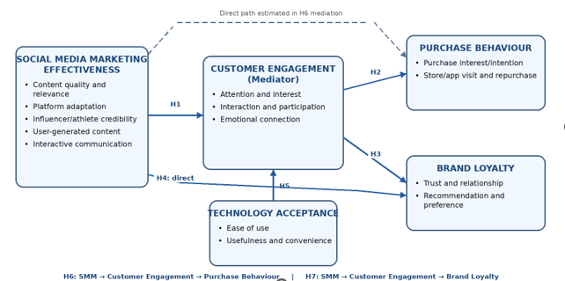
Figure 1: Conceptual framework. Source: Author’s Design
The framework suggests that perceived Social Media Marketing Effectiveness positively influences Customer Engagement (H1); Customer Engagement positively influences Purchase Behaviour (H2) and Brand Loyalty (H3); perceived Social Media Marketing Effectiveness positively influences Brand Loyalty (H4); and Technology Acceptance positively influences Customer Engagement (H5). Also, the framework suggests two indirect relationships: Customer Engagement is a mediator between Social Media Marketing Effectiveness and Purchase Behaviour (H6), and Customer Engagement is a mediator between Social Media Marketing Effectiveness and Brand Loyalty (H7). These mediation hypotheses enable indirect pathways in the conceptual framework to be tested statistically, instead of assumed from separate direct pathways.

3. Research Methodology

3.1 Introduction
Research methodology can be regarded as a framework showing the logic between the research questions and the evidence and analytical procedures (Rayshan, 2025). The Research Onion is adopted as an organising framework since it is layered and entails a set of philosophical, design, strategy, time-horizon and analytical choices that need to be consistent with one another (Saunders, Lewis and Thornhill, 2023). The study uses positivism, a deductive, quantitative mono method, an online survey and a cross-sectional time horizon. Importantly, this design is classified as an explanatory-correlational design, as the study has tested hypotheses, estimated multiple regression models, and evaluated indirect effects (Putri, Rezani and Hermina, 2025). The use of the word 'explanatory' does not mean 'experimental causality'. Statistical explanation of association.
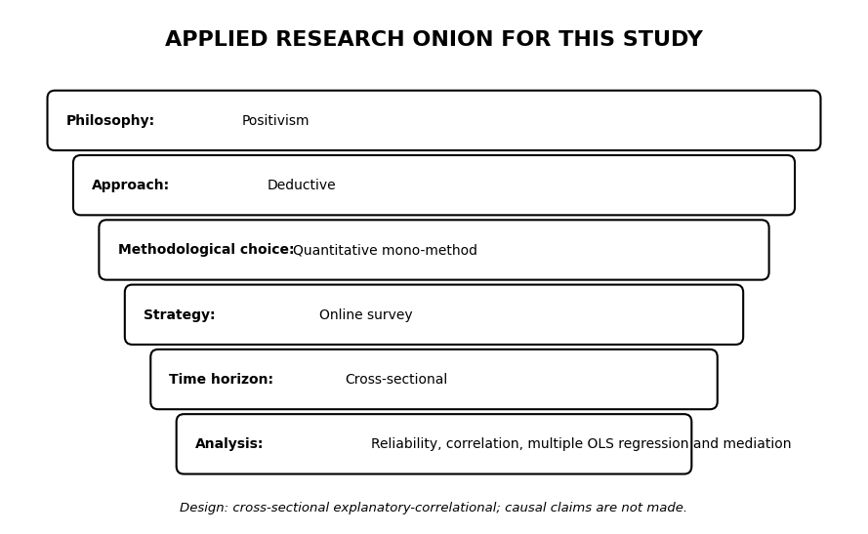
Figure 3: Research Onion Model
Source: Adapted from Saunders, Lewis and Thornhill (2023).
The methodological choices are derived from the aim of research. Standardised survey items yield numerical construct scores, the deductive hypotheses are tested by correlational analysis and ordinary least-squares regression, and customer engagement is analysed as a statistical intervening variable. All observations were made at a single point in time and without experimental manipulation or temporal sequencing, so it is interpreted as associations across cross-sections. This distinction continues in the findings, discussion and conclusion.

3.2 Research Philosophy
Research philosophy has to do with assumptions about what is credible knowledge and how that knowledge may be studied (Mwita, 2025). The study follows a positivist philosophy since the research operationalises theoretical constructs into measurable variables and analyses their connections through the use of statistical analysis (Saunders, Lewis and Thornhill, 2023). Structured Likert-scale items measure Perceived Social Media Marketing Effectiveness, Customer Engagement, Purchase Behaviour, Brand Loyalty and Technology Acceptance, but inferential statistical procedures are used to test predefined hypotheses.
Positivism is suitable since the study aims to determine observable patterns and statistical relationships between the study constructs based on standardised quantitative data (Maksimović and Evtimov, 2023). However, the application of survey measures does not mean that complex consumer experiences can be fully reflected using numerical scores. Possible measurement error, self-report bias and contextual effects are thus acknowledged in the interpretation of the findings.

3.3 Research Approach
The research methodology employed was deductive due to the fact that it starts with known theories and prior empirical studies, builds hypotheses based on those theoretical anticipations, and then tests those hypotheses with quantitative data (Creswell and Creswell, 2023). The theoretical foundation of the proposed relationships among the study constructs is Customer Engagement Theory, Relationship Marketing Theory, the Technology Acceptance Model and the AIDA heuristic.
The deductive method is suitable since the relationships to be analysed were predefined prior to statistical analysis (Mohammed, 2024). Direct hypotheses examine the relationships between Social Media Marketing Effectiveness, Customer Engagement, Purchase Behaviour, Brand Loyalty and Technology Acceptance, and mediation hypotheses examine whether Customer Engagement offers an indirect linkage between Social Media Marketing Effectiveness and each of the two customer outcomes.

3.4 The research design
The research design is a cross-sectional explanatory-correlational study (Setia, 2016). The descriptive part serves to describe the features of the respondents and the distribution of the study variables, and the primary analytical task is inferential: to estimate correlations between constructs, determine the independent contribution of predictors with the help of multiple regression, and test the indirect correlations with the help of the mediation analysis.
It is a non-experimental study where all variables were measured at one point and not manipulated or sequenced over time. Thus, the statistical associations revealed by regression and mediation are viewed as relationships, but not as causes. The cross-sectional design also implies that reverse relationships are not to be dismissed. Customers who have higher existing brand loyalty might rate Nike social-media activities more favourably (Espuela, Reina and Sevilla, 2023). This means that no causal statements are made in the findings, discussion and conclusion.

3.5 Research strategy
An empirical method is one that is quantitative and conducted via the internet. When it comes to quantitative survey research, it is suitable for gathering standardised responses from a relatively large sample of people and measuring relationships between constructs that have been measured (Creswell and Creswell, 2023). Secondary academic and corporate sources are only used to create context and theory, and do not make the design mixed methods. The strategy is advantageous for replicable coding and statistical comparisons but also focuses on common-method risks, as predictors and outcomes are self-reported in the same instrument.

3.6 Data Collection Method
The primary data source was the structured questionnaire, and the secondary data source for the context was peer-reviewed literature, official UK statistics and NIKE corporate reporting (Kolev, 2019). Primary and secondary sources should not be mixed up with mixed-method integration. The empirical statements in chapters 4-6 derive from the responses to the questionnaire; secondary sources are used to interpret the consistency or challenge to existing knowledge of the associations made in the questionnaire.

3.7 Data Collection Technique
A questionnaire of eligibility questions, demographics and five-point Likert items was administered via Google Forms online. Participants had to be between 18 and 30 years old, based in the UK, users of social media and be a current or former Nike customer. Constructs of social media marketing effectiveness, customer engagement, purchase behaviour, brand loyalty and technology acceptance were assessed using multi-item constructs. Future-improvement items were considered as a preference only for recommendation, as statements like ‘Nike should provide more personalised content' are meant to measure desired improvements, not an experienced construct (Singh, Sethuraman and Lam, 2017).

3.8 Population and Sample
The study targeted UK-based consumers aged 18-30 who use social media and are current or former Nike customers. These eligibility criteria were chosen because the study will examine only young adult consumers who have been exposed to Nike's digital and social media efforts. A complete sampling frame of UK Nike customers was not available, so a combination of convenience and purposive sampling was used.
https://docs.google.com/forms/d/e/1FAIpQLScfyjtsfWxoIKdDePVtYFRp34TY8_N4-JIWsKyd5tCdFKUUiw/viewform?usp=header
After screening, 154 valid responses were retained for statistical analysis. Responses that did not meet eligibility conditions and did not include usable data regarding the study variables were excluded. The sampling method used was non-probability, and the sample obtained is therefore not necessarily statistically representative of the total population of Nike customers in the UK. Demographic details of the final sample are given in a separate chapter (Chapter 4).

3.9 Hypothesis Development
The hypotheses are drawn from the conceptual model and are presented before the interpretation of the model. If the theory in the literature suggests a positive relationship, a positive directional hypothesis is used, while mediation hypotheses are used to determine whether the indirect effect via customer engagement is different from zero.
H1: Perceived Social Media Marketing Effectiveness is positively associated with Customer Engagement among surveyed Nike UK customers.
Rationale: When producing relevant, interactive and credible communication, participation and emotional connection should increase (Brodie et al., 2011; Blut et al., 2023).
H2: Customer engagement has a positive relationship with purchase behaviour, once the effect of perceived social media marketing effectiveness and technology acceptance is controlled. Rationale: engagement can help to shift customers from attention and interest to exploring products and taking action towards purchase, but is likely to be partial rather than deterministic.
H3: Customer Engagement is positively associated with Brand Loyalty after controlling for Social Media Marketing Effectiveness, Purchase Behaviour and Technology Acceptance.
Rationale: Relationship theory implies that continued interaction can contribute to trust and commitment. However, loyalty can be the result of product or service attributes that are not in the social media arena (Morgan and Hunt, 1994).
H4: Perceived effectiveness of social media marketing positively correlates with brand loyalty, after controlling for customer engagement, purchase behaviour and technology acceptance. Rationale: Social-media communication can have a direct effect on brand meaning and relational value, apart from its indirect effect on both through engagement (Ibrahim, 2022).
H5: Nike's digital platforms' technology acceptance is positively related to Nike's customer engagement, given the effect of perceived effectiveness of social media marketing. Rationale: Davis (1989) proposed that TAM is more of an explanation of technology usage, and useful and easy-to-use digital touchpoints can enable interaction.
H6: Customer engagement will mediate the positive relationship between perceived social media marketing effectiveness and purchase behaviour. Rationale: This hypothesis does not assume mediation from individual significant regressions, but rather tests the central mechanism suggested by the conceptual framework.
H7: Customer engagement mediates the positive association between perceived social media marketing effectiveness and brand loyalty. Rationale: The product of the social media-to-engagement path and the engagement-to-loyalty path should be statistically significant from zero when engagement is the mechanism that connects favourable perceptions from social media to loyalty (Hayes, 2022).

3.10 Data Analysis
Responses from the questionnaire were transferred to MS Excel for preliminary screening, coding and data preparation. The cleaned dataset was then imported into IBM SPSS Statistics for statistical analysis. For each construct, the corresponding items on a Likert scale were averaged together to form composite scores. The built constructs were Social Media Marketing Effectiveness, Customer Engagement, Purchase Behaviour, Brand Loyalty and Technology Acceptance. Future Improvement items were not included in the main regression models; they were analysed separately for description and recommendation purposes.
The internal consistency of the multi-item constructs was evaluated using Cronbach's alpha. Data were analyzed using descriptive statistics, including frequencies and percentages for demographic characteristics and means, standard deviations, minimum and maximum for principal constructs. Pearson correlation is then used to find out the direction and strength of the bivariate relationships among the study variables.
The direct hypotheses were tested using multiple ordinary least-squares regression analysis. Three models were fit. Model 1 tested the effect of Social Media Marketing Effectiveness and Technology Acceptance as predictors of Customer Engagement. Model 2 investigated Purchase Behaviour through Social Media Marketing Effectiveness, Customer Engagement and Technology Acceptance. Model 3 investigated the relationship between Social Media Marketing Effectiveness, Customer Engagement, Purchase Behaviour and Technology Acceptance with the construct of Brand Loyalty.
Multicollinearity was evaluated from tolerance and VIF values; independence of residuals from the Durbin–Watson statistic; normality of residuals based on histograms and normal P–P plots; linearity and homoscedasticity from residual-versus-predicted-value plots; and influential values from Cook's Distance.
The mediation analysis was performed with Hayes' PROCESS macro for SPSS, Model 4. Two mediation models were estimated, Customer Engagement as a mediator between Social Media Marketing Effectiveness and Purchase Behaviour, and Customer Engagement as a mediator between Social Media Marketing Effectiveness and Brand Loyalty. They calculated the indirect effects using 5,000 bootstrap samples and 95% confidence intervals. Indirect effects were deemed statistically significant when the 95% bootstrap confidence interval excluded zero. All other inferential tests used a significance level of p < .05. Since the study was cross-sectional and non-experimental, the study results were considered associations rather than causal relationships.

3.11 Ethical Considerations
Ethical issues are applied to the research process, and the rights, privacy and wellbeing of participants are protected. The data collection in this study will only commence once necessary ethical approval for UWTSD has been obtained. The research will follow the UWTSD Research Ethics and Integrity Policy, the UWTSD Research Data Management Policy, relevant Open Access requirements, the UK General Data Protection Regulation (UK GDPR) and the Data Protection Act 2018. The participants will be adults aged 18- 30 years, and the study will not intentionally recruit vulnerable participants.
All potential participants will be given a Participant Information Sheet prior to participation that will outline the purpose of the research, what participation entails, how the data will be used, the expected survey procedure and participants ' rights. Next, informed consent will be documented by a written consent statement in electronic format prior to providing access to the questionnaire. Participation will be voluntary, and someone can refuse to answer a question and can withdraw from the questionnaire at any stage before submission without penalty. No tricks will be employed. The participant is allowed to withdraw his/her response to the survey within 14 days from the survey completion until a decision is made, by contacting the researcher using the information provided in the Participant Information Sheet and Consent Form (Al Habsi, 2024).
Once the withdrawal period has ended, the responses will be anonymised and added to the data set, and it will no longer be possible to identify and remove a response. Data minimisation will be carried out throughout the study. Participants will not have to write their name, and the data collected will consist of variables that are important for the research, like age class, gender, nationality or education. The study will not aim to gather data of any special category, such as opinions on politics, religious beliefs, health information, sexual orientation, etc. If a volunteer provides this information in an email message, it will be kept in a different database from the questionnaire answers and will be deleted after the questionnaire data collection and withdrawal periods.
The questionnaire will not knowingly gather or retain unnecessary digital identifiers, including information that could be used for location tracking purposes. Google Forms will be used to create a survey that will be downloaded and stored on secure, university-approved, password-protected devices, and only accessible to the researcher and supervisor. Data will be anonymised for analysis and analysed in summary format, without attributing to any individual participants. Anonymised research data will be kept securely for 5 years in accordance with the requirements of research data management in the university and will be securely deleted after that. These procedures are intended to maintain informed consent, confidentiality, anonymity, data protection and participant control throughout the study.

3.12 Gantt Chart and Time Frame
A Gantt chart is a type of project management tool that is useful to researchers for organising and tracking research in a particular period of time. It illustrates the flow of activities, the length of the tasks, and how tasks are related to each other in the project. A Gantt chart is a visual schedule that makes scheduling the research activities easier than a simple calendar or milestone plan that may not include enough detail, and can be useful to ensure that the research activities are completed in time (Palombarini, and Martinez, 2022). It also enables the researcher to track progress and pinpoint any slowdowns that could impact the project.
The study period was from May to September 2026. After gaining approval of the topics and literature development, the questionnaire was prepared and then made available online and was followed by screening of responses, coding and analysis of the data, reliability analysis, descriptive statistics, correlation analysis, multiple regression analysis and mediation testing. The last stage involved critical discussion, conclusion and recommendations, and reporting and revising the documents. The programme is thus descriptive and inferential analysis and not just descriptive statistics only.

Gantt Chart (05 May 2026 – 25 September 2026)
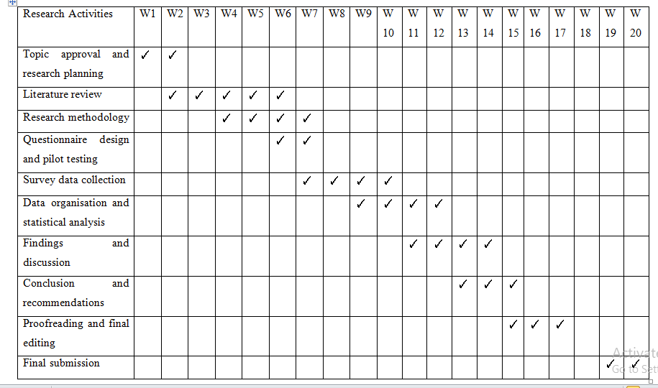

4. Findings

4.1 Data Coding, Transformation and Demographic Profile of Respondents

4.1.1 Data Coding and Preparation Process
The data from the survey were downloaded to Microsoft Excel and then analysed in IBM SPSS Statistics. The answers to the questionnaires were systematically coded into numerical data that can be analysed quantitatively. In order to achieve uniformity, the coding procedure was used for the demographic variables, categorical questions, and Likert scale measurement items. Each question in the demographic and screening questions was given a number. Questions related to eligibility and consent were recoded as binary coded variables: “Yes” = 1 and “No” = 0.
Categorical responses to demographic variables were coded numerically. Age groups were coded according to the predefined survey categories: 18–20 = 1, 21–24 = 2, 25–27 = 3, and 28–30 = 4. Gender was dichotomised (Female = 0, Male = 1), allowing for differences in gender to be incorporated into any analyses performed as needed. Education was also coded to numerical categories, maintaining the original meaning, as the other categories were frequency of using social media and frequency of purchasing Nike. The question "Which social media platforms have you encountered Nike content on?" was a multiple-response question that the respondent could check off if they had seen Nike content on the platform. So, this variable was broken down into dummy variables for each platform. Instagram, TikTok, Facebook, X, YouTube and Other were each individually coded with 1 as the answer to the question of whether this platform was selected and 0 as the answer to the question of whether this platform was not selected. This change enabled the usage patterns on the platform to be statistically analysed.

4.1.2 Coding of Likert Scale Measurement Items
A 5-point Likert scale was used to measure the main constructs of the study. All attitudinal statements about the Social Media Marketing Effectiveness, Customer Engagement, Purchase Behaviour, Brand Loyalty, Technology Acceptance and Future Improvement Recommendations were coded consistently. The coding of the Likert scale questions was in the following way:
Table 1: Coding of Likert Scale
Response Category | Numerical Code
Strongly Disagree | 1
Disagree | 2
Neither Agree nor Disagree | 3
Agree | 4
Strongly Agree | 5

4.1.3 Construction of Composite Variables
After coding, composite variables were created by calculating the arithmetic mean of the items belonging to each construct. Because the 1-5 metric is the same as the original, and different numbers of items can be represented on the same metric to better compare constructs, mean scores were used instead of sums. Future Improvement items were also averaged for descriptive purposes only and were not treated as a predictor of brand loyalty, as the items measure desired changes, not experienced interactions.
Construct Mean= $\frac{\sum{of}individualitemscores}{Numberofitems}$
The mean transformation method was selected because it maintains the original 1–5 Likert scale interpretation while providing a single representative score for each theoretical construct.
Table 2: Composite Variable Table
Construct | SPSS Computation | Analysis Use
Social Media Marketing Effectiveness | Mean(SM1-SM7) | Reliability, descriptive, correlation, regression and mediation
Customer Engagement | Mean(CE1-CE6) | Reliability, descriptive, correlation, regression and mediation
Purchase Behaviour | Mean(PB1-PB5) | Reliability, descriptive, correlation and regression outcome
Brand Loyalty | Mean(BL1-BL5) | Reliability, descriptive, correlation and regression outcome
Technology Acceptance | Mean(TA1-TA4) | Reliability, descriptive, correlation and additional predictor
Future Improvement Preferences | Mean(FI1-FI3) | Reliability and descriptive recommendation evidence only

4.1.4 Demographic Profile of Respondents
The total number of responses collected was 154. The achieved sample represented all four age groups in the intended target group of 18 to 30 years old, and respondents varied in their experience buying Nike products and in their social media usage.
Table 3: Age Distribution of Respondents
Age Group | Frequency (n) | Percentage (%)
18–20 | 22 | 14.3
21–24 | 11 | 7.1
25–27 | 66 | 42.9
28–30 | 55 | 35.7
Total | 154 | 100.0

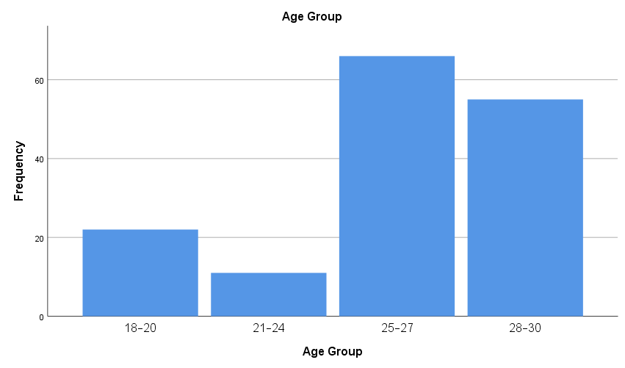
Figure 4: Age Group

The largest age group was 25–27, representing 42.9% (n=66), followed by 28–30 with 35.7% (n=55). Respondents aged 18–20 represented 14.3% (n=22), while 7.1% (n=11) were aged 21–24. The sample is still clustered around people aged 25-30.
Table 4: Gender Distribution of Respondents
Gender | Frequency (n) | Percentage (%)
Male | 86 | 55.8
Female | 68 | 44.2
Total | 154 | 100.0

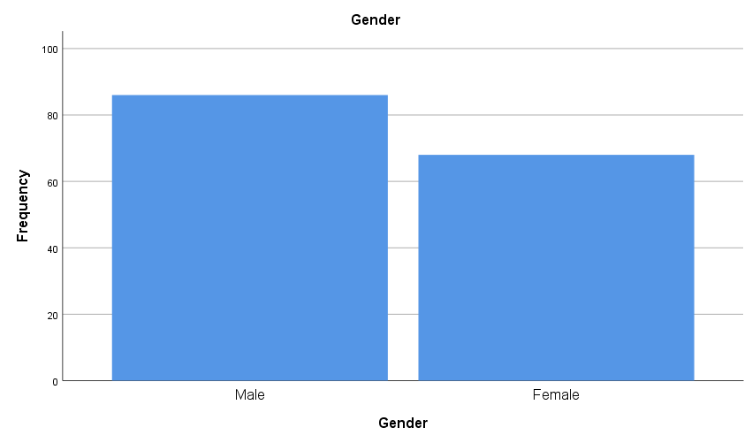
Figure 5: Gender Distribution

The sample comprised 86 men (55.8%) and 68 women (44.2%). There were therefore representatives of both sexes, though there were more males. Gender is used descriptively rather than as a basis for claiming the percentages observed reflect the larger population of Nike UK customers.
Table 5: Nationality Distribution of Respondents
Nationality | Frequency (n) | Percentage (%)
British | 18 | 11.7
UK | 28 | 18.2
Other | 108 | 70.1
Total | 154 | 100.0

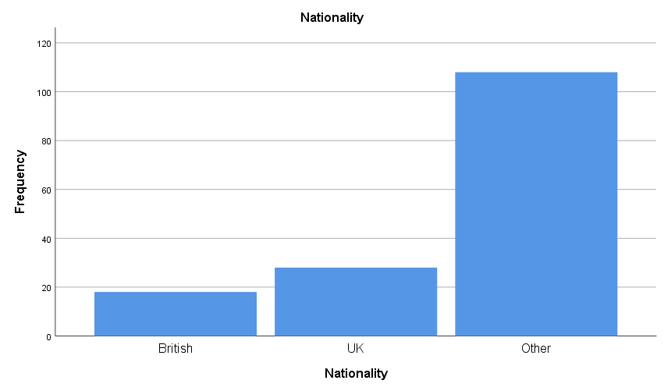
Figure 6: Nationality Distribution
The majority of respondents (70.1%, n=108) were recorded in the Other category of nationality, followed by UK (18.2%, n=28) and British (11.7%, n=18). The sample is thus a mix of nationality backgrounds although there were categories in the original questionnaire for British and UK nationalities.
Table 6: Education Level of Respondents
Education | Frequency (n) | Percentage (%)
Secondary school | 7 | 4.5
College or A-Level | 20 | 13.0
Undergraduate | 13 | 8.4
Postgraduate | 114 | 74.0
Total | 154 | 100.0

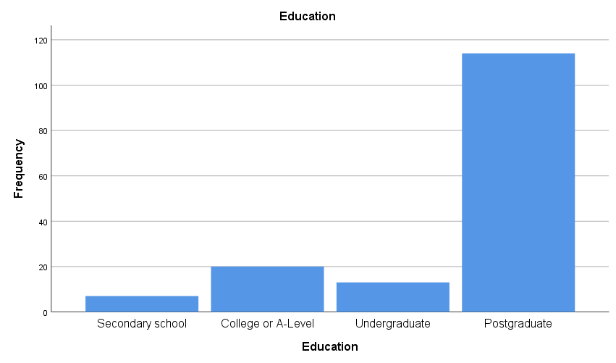
Figure 7: Education Level Distribution
The sample was highly skewed towards the postgraduate level, as 114 respondents (74.0%) had a postgraduate qualification. 13.0% were in college or at A-level, 8.4% in undergrad and 4.5% in secondary school. The findings show that this sample includes more highly educated people than might be expected in a random sample.
Table 7: Daily Social Media Usage of Respondents
Daily Social Media Usage | Frequency (n) | Percentage (%)
Less than 1 hour | 13 | 8.4
1–2 hours | 25 | 16.2
2–4 hours | 22 | 14.3
More than 4 hours | 94 | 61.0
Total | 154 | 100.0

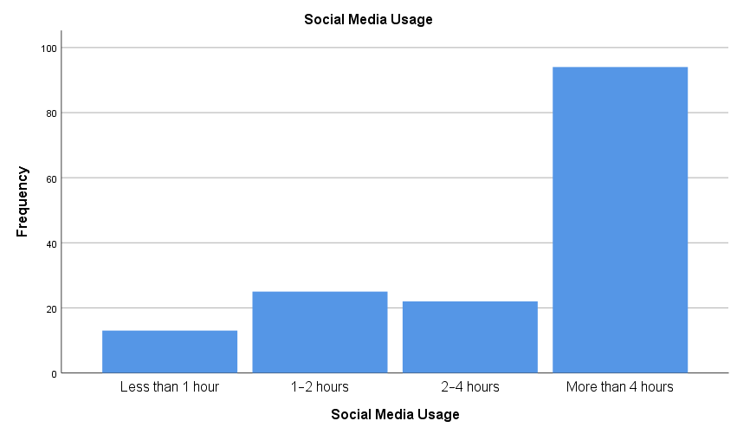
Figure 8: Social Media Usage Distribution
There was a moderate level of social media use: 94 respondents (61.0%) used it for over 4 hours a day, and 22 (14.3%) used it for 2-4 hours a day. Twenty-five (16.2%) respondents used social media for one to two hours, and 13 (8.4%) for less than one hour. The sample is therefore relevant for digital marketing exposure research.
Table 8: Nike Purchase Frequency of Respondents
Nike Purchase Frequency | Frequency (n) | Percentage (%)
None in last 12 months but purchased previously | 10 | 6.5
Once | 54 | 35.1
2–3 times | 82 | 53.2
4–5 times | 4 | 2.6
More than 5 times | 4 | 2.6
Total | 154 | 100.0

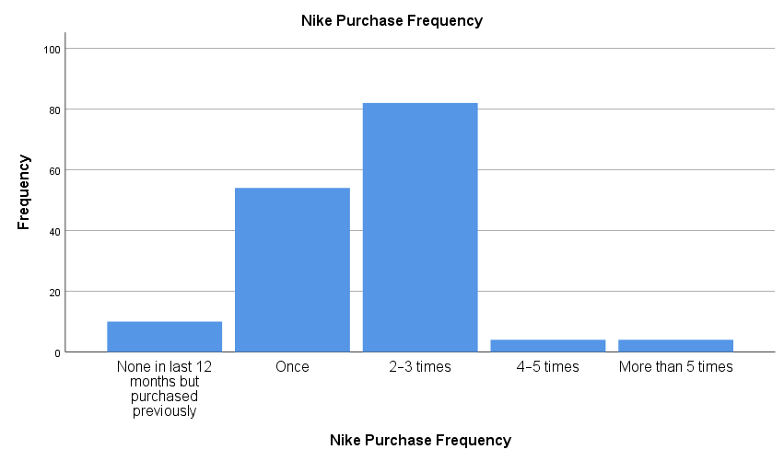
Figure 9: Nike Purchase Frequency Distribution

Nike purchases were relatively common: 82 respondents (53.2%) bought two to three times in the past year, and 54 (35.1%) bought once. Ten respondents indicated that they had bought before, but not in the past year (6.5%) and eight respondents had purchased four or more times (5.2%). This meant that most respondents had their own experience of buying Nike products within the last few years.

4.2 Frequency Analysis of Survey Responses
Items on Likert scale were analysed by frequency and descriptive analysis. A total of 154 valid responses were received. A summary of how the overall responses were distributed for each construct is presented below..
Table 9: Summary of Likert-Scale Response Patterns
The overall feedback was favourable, but not all the endorsement for any individual item of feedback necessarily reflects explanatory links between constructs. This is why the frequency analysis is performed descriptively, and the relationships suggested are tested by correlation, regression and mediation.

4.3 Reliability Analysis of Measurement Constructs
Table 10: Cronbach’s Alpha Reliability Statistics for Measurement Constructs
Construct | Number of Items | Cronbach’s Alpha (α) | Reliability Level
Social Media Marketing Effectiveness | 7 | 0.862 | Good
Customer Engagement | 6 | 0.873 | Good
Purchase Behaviour | 5 | 0.813 | Good
Brand Loyalty | 5 | 0.833 | Good
Technology Acceptance | 4 | 0.772 | Acceptable
Future Improvement Preferences | 3 | 0.716 | Acceptable

The Cronbach's alpha scores for the six multi-item scales ranged from 0.716 to 0.873, all above 0.700. The internal consistency in the constructs is acceptable to good. The results indicate acceptable to good internal consistency across all constructs, supporting the use of the corresponding composite scores in subsequent analyses.

4.4 Descriptive Statistics
Table 11: Descriptive Statistics of Measurement Constructs
Construct | N | Minimum | Maximum | Mean | Std. Deviation
Social Media Marketing Effectiveness | 154 | 2.14 | 5.00 | 3.86 | 0.63
Customer Engagement | 154 | 1.67 | 4.83 | 3.52 | 0.72
Purchase Behaviour | 154 | 1.00 | 5.00 | 3.65 | 0.72
Brand Loyalty | 154 | 1.80 | 5.00 | 3.60 | 0.69
Technology Acceptance | 154 | 1.75 | 5.00 | 3.78 | 0.69
Future Improvement Preferences | 154 | 1.33 | 5.00 | 3.59 | 0.70

Social Media Marketing Effectiveness was rated highest (M=3.86, SD=0.63), followed by Technology Acceptance (M=3.78, SD=0.69) and Purchase Behaviour (M=3.65, SD=0.72). The average results were 3.60 for Brand Loyalty, 3.59 for Future Improvement Preferences and 3.52 for Customer Engagement. Generally, positive means describe respondents' attitudes but do not show explanatory relationships among constructs.

4.5 Pearson Correlation Analysis
Table 12: Pearson Correlation Matrix of Study Constructs
Relationship | Correlation (r) | Significance
SMM Effectiveness – Customer Engagement | 0.244 | p=0.002
SMM Effectiveness – Purchase Behaviour | 0.270 | p=0.001
SMM Effectiveness – Brand Loyalty | 0.331 | p<0.001
Customer Engagement – Purchase Behaviour | 0.190 | p=0.018
Customer Engagement – Brand Loyalty | 0.206 | p=0.011
Purchase Behaviour – Brand Loyalty | 0.255 | p=0.001
Technology Acceptance – Customer Engagement | 0.137 | p=0.089
Technology Acceptance – Brand Loyalty | 0.248 | p=0.002
Brand Loyalty – Future Improvement Preferences | 0.353 | p<0.001

Note: ** p < .01; * p < .05 (two-tailed).
Correlations were generally positive and small to moderate. Social Media Marketing Effectiveness correlated significantly with Customer Engagement (r=.244, p=.002), Purchase Behaviour (r=.270, p=.001) and Brand Loyalty (r=.331, p<.001). Customer Engagement also showed significant association with Purchase Behaviour and Brand Loyalty. Technology Acceptance was not significantly related to Customer Engagement, whereas it was positively related to Brand Loyalty.

4.6 Multiple Regression, Mediation and Hypothesis Testing
Table 13: Regression Diagnostic Review
Diagnostic results were not suggestive of serious violations of the regression assumptions. The VIF values were near to 1, and the Durbin-Watson values were near to 2. For the three models, Maximum Cook's Distance was 0.071, 0.042 and 0.051, respectively, indicating that no observation had undue influence over the regression estimates.
Table 14: Multiple Regression Results
Outcome / Model | Predictor | β | p | VIF | R² (Adj. R²) | Model F (p)
Customer Engagement | SMM Effectiveness | .230 | .004 | 1.02 | .071 (.058) | 5.736 (.004)
 | Technology Acceptance | .106 | .183 | 1.02
Purchase Behaviour | SMM Effectiveness | .226 | .006 | 1.08 | .100 (.082) | 5.562 (.001)
 | Customer Engagement | .121 | .135 | 1.08
 | Technology Acceptance | .105 | .184 | 1.03
Brand Loyalty | SMM Effectiveness | .244 | .002 | 1.13 | .181 (.159) | 8.245 (<.001)
 | Customer Engagement | .094 | .227 | 1.09
 | Purchase Behaviour | .144 | .068 | 1.11
 | Technology Acceptance | .179 | .019 | 1.04

Model 1 – Customer Engagement
$$ZCE=0.230\left(ZSMM\right)+0.106\left(ZTA\right)$$Social Media Marketing Effectiveness was more influential and Technology Acceptance was less influential.
Model 2 – Purchase Behaviour
$$ZPB=0.226\left(ZSMM\right)+0.121\left(ZCE\right)+0.105\left(ZTA\right)$$In the Purchase Behaviour model, Social Media Marketing Effectiveness was the highest standardised coefficient, followed by Customer Engagement and Technology Acceptance.
Model 3 – Brand Loyalty
$$ZBL=0.244\left(ZSMM\right)+0.094\left(ZCE\right)+0.144\left(ZPB\right)+0.179\left(ZTA\right)$$
The highest standardised coefficient for Brand Loyalty was found for Social Media Marketing Effectiveness, followed by Technology Acceptance, Purchase Behaviour and Customer Engagement.
Where:
- ZSMM = Social Media Marketing Effectiveness (standardised)
- ZCE = Customer Engagement (standardised)
- ZPB = Purchase Behaviour (standardised)
- ZBL = Brand Loyalty (standardised)
- ZTA = Technology Acceptance (standardised)
The results of the multivariable analysis indicated that Social Media Marketing Effectiveness significantly predicted Customer Engagement (β=.230, p=.004), but Technology Acceptance was not significant. The model accounted for 7.1% of the variance in engagement. In the Purchase Behaviour model, Social Media Marketing Effectiveness was significant (β=.226, p=.006), and Customer Engagement and Technology Acceptance were not. The model accounted for 10.0% variance. For the Brand Loyalty model, Social Media Marketing Effectiveness (β=.244, p=.002), and Technology Acceptance (β=.179, p=.019) were significant, while Customer Engagement and Purchase Behaviour were not. The model explained 18.1% of the variance in Brand Loyalty. The models offer some important relations, but leave a lot of variation unaccounted for.
Table 15: Mediation Analysis Through Customer Engagement
After specifying Customer Engagement as a mediator, PROCESS Model 4 with 5000 bootstrap samples demonstrated no significant mediation effect. The indirect effect for Purchase Behaviour was 0.0367 (95% bootstrap CI: [-.0030, .0941]). For Brand Loyalty, the indirect effect was 0.0358, with an interval of [-.0075, .0873]. The intervals included 0, so neither mediation hypothesis was supported.
Table 16: Hypothesis Testing Summary
Hypothesis | Tested Relationship | Result | Decision
H1 | SMM Effectiveness → Customer Engagement | β=.230, p=.004 | Supported
H2 | Customer Engagement → Purchase Behaviour | β=.121, p=.135 | Not supported
H3 | Customer Engagement → Brand Loyalty | β=.094, p=.227 | Not supported
H4 | SMM Effectiveness → Brand Loyalty | β=.244, p=.002 | Supported
H5 | Technology Acceptance → Customer Engagement | β=.106, p=.183 | Not supported
H6 | CE mediates SMM → Purchase Behaviour | Effect=.0367, CI [-.0030, .0941] | Not supported
H7 | CE mediates SMM → Brand Loyalty | Effect=.0358, CI [-.0075, .0873] | Not supported

Two hypotheses, H1 and H4, were supported. Neither H2, H3, nor H5 was supported statistically after adjusting for the other predictors, and the bootstrapped confidence intervals for H6 and H7 contained zero. The results also indicate significant direct relationships between perceived Social Media Marketing Effectiveness and both Customer Engagement and Brand Loyalty, but do not confirm the mediation hypothesis through Customer Engagement.

5. Discussion of Findings

5.1 Discussion
This study aimed to assess customers' perceptions of the effectiveness of Nike UK's social media marketing strategies and to investigate direct and indirect relationships between Social Media Marketing Effectiveness, Customer Engagement, Purchase Behaviour and Brand Loyalty. The findings offer a differentiated response to this purpose. Overall, the respondents rated Nike's social-media marketing favourably, with Social Media Marketing Effectiveness having the highest mean score across the entire construct. The regression models, however, accounted for only 7.1% of the variation in Customer Engagement, 10.0% in Purchase Behaviour, and 18.1% in Brand Loyalty. The separation between positive perceptions and explanatory power is significant because positive perceptions of social-media activity do not always directly correspond with improved commercial or relational outcomes. Consequently, the results confirm that social-media marketing has an impact on customer outcomes, yet there are other influences at play.
H1 was supported by the significant association of Customer Engagement with Social Media Marketing Effectiveness when Technology Acceptance was controlled (β=.230, p=.004). This discovery resolves the first research goal on the subject of social-media marketing and its ability to help customers. It also aligns with the Customer Engagement Theory, which describes engagement as having a cognitive, emotional and behavioural component (Brodie et al., 2011). Lim and Rasul (2022) also highlight interaction and participation in social-media settings. Thus, the finding helps to affirm that relevant, interactive and credible communication is linked to higher customer attention, participation and emotional response. This reading is also supported by literature that highlights content relevance, personalisation, two-way communication, user-generated content, and influencer credibility as potential engagement factors. The R² value of .071, however, shows that Social Media Marketing Effectiveness only accounts for a portion of the variation in engagement. This indicates that other factors, such as prior attitudes towards Nike, sporting identity, satisfaction, peer influence and platform preference, could also play a role in engagement. H1 thus confirms the importance of social-media marketing but fails to make it the most probable explanation for customer engagement.
The second research goal was to understand customers' perceptions of Nike UK's approach to social media. The descriptive findings were largely positive, suggesting that Nike's digital and social-media campaigns were received well by its audiences. It aligns with literature that talks about Nike leveraging athlete storytelling, influencers, UGC, and platform-specific communication. However, positive perceptions should not be interpreted as a sign that all social-media strategies will yield the same behavioural result. However, engagement can differ across platform and initiative type, as demonstrated in Blut et al. (2023), and isn't just about exposure – it's about authenticity and audience–creator fit, as noted by Sporl-Wang, Krause and Henkel (2025). So the second research question, which was what is the perception of customers toward the tactics, was answered with the descriptive findings; however, it was not shown that all tactics create equal purchase and loyalty.
H2 not supported. Customer Engagement had a significant bivariate correlation with Purchase Behaviour (r=.190, p=.018) and became non-significant when controlling for Social Media Marketing Effectiveness and Technology Acceptance (β=.121, p=.135). This undermines the engagement-to-purchase pathway and weakens the logic of the AIDA heuristic. AIDA suggests a series of steps from attention to interest, desire and action, but today's digital customer journey doesn't always follow that sequence. Customers can interact with Nike content for entertainment, inspiration, information or community involvement without purchasing. Price, product need, availability, income, fit, and past experience can also influence purchase behaviour. This is in line with Dolega, Rowe and Branagan (2021), who raise doubts about whether digital engagement leads to proportional digital commercial outcomes. Importantly, Social Media Marketing Effectiveness remained a significant predictor of Purchase Behaviour (β=.226, p=.006), suggesting that there may be a more direct relationship with purchasing than the path proposed in the study.
Therefore, there was no support for H3. Customer Engagement was statistically correlated with Brand Loyalty (r=.206, p=.011) and was found to have a bivariate positive correlation with Brand Loyalty when controlling for social media marketing effectiveness and purchase behaviour and statistical significance was not achieved with technology acceptance (β=.094, p=.227). This questions the theory that increasing engagement equates with increased loyalty. Morgan and Hunt (1994) emphasise the concepts of trust, commitment and relational value in the theory of Relationship Marketing. The construct of Customer Engagement that was measured in this study, however, primarily reflects attention, interaction, participation and emotional connection. The non-significant H3 result might, therefore, indicate that engagement is not a complete representation of the relational mechanism that results in the development of loyalty. More appropriate for long-term loyalty indicators such as repurchase and recommendation are satisfaction, perceived quality, service experience, value and prior brand experience. Therefore, there is no rejection of Relationship Marketing Theory in the case of H3, but it does mean that engagement is not enough to explain loyalty.
On the other hand, H4 was supported. The effect of Social Media Marketing Effectiveness on Brand Loyalty was still significant even after the researchers accounted for Customer Engagement, Purchase Behaviour and Technology Acceptance (β=.244, p=.002). This will reinforce the direct relationship suggested by the conceptual framework and is consistent with Ibrahim's (2022) meta-analysis, which found a positive relationship between social media and loyalty. The authors of the literature also doubt the order of events. As pointed out by Jai, Tong and Chen (2022), it might be difficult to determine whether positive social media experiences affect a customer's loyalty or whether loyal customers evaluate branded communication in a more favourable way. This is a cross-sectional study and therefore, reverse directionality cannot be ruled out. Furthermore, the Brand Loyalty model explained 18.1% of the total variance, indicating that there was still a significant variance not explained. H4 is not a causal statement, though, just a statistically significant association.
H5 was not supported because Social Media Marketing Effectiveness did not significantly predict Customer Engagement when Technology Acceptance was controlled (β=.106, p=.183). Theoretically, this finding is important since the Technology Acceptance Model emphasizes perceived usefulness and ease of use, whereas the Customer Engagement Theory emphasizes cognitive, emotional and behavioural involvement. While a digital platform might be convenient and easy to use, it doesn't necessarily create a stronger emotional or participative response. Technology Acceptance did not significantly affect Purchase Behaviour in the Purchase Behaviour model (β=.105, p=.184); however, Technology Acceptance was significantly related to Brand Loyalty (β=.179, p=.019). The mixed pattern indicates that digital usability can be a part of the broader customer relationship but it will not fully explain engagement. It also aligns with the theoretical principle that digital outcomes can emerge from parallel processes such as usability, content, credibility, and relational experience.
The mediation analysis was the most direct test of the conceptual framework. H6 and H7 were not operational. The indirect effect of Social Media Marketing Effectiveness on Purchase Behaviour via Customer Engagement was .0367, which was not significantly different from zero given the 95% bootstrap confidence interval [-.0030, .0941]. The indirect effect on the outcome of Brand Loyalty was .0358 with a 95% bootstrap confidence interval of [-.0075, .0873]. Both mediation effects were not statistically significant because both confidence intervals contained a zero. The results of the findings showed that Customer Engagement did not act as the proposed statistical mechanism between Social Media Marketing Effectiveness and Purchase Behaviour, or between Social Media Marketing Effectiveness and Brand Loyalty. This is a critical contribution because it shows that mediation is not assumed merely because of the relationship between Customer Engagement and Social Media Marketing Effectiveness. The result also helps to close the literature gap, which was cited in the dissertation. Engagement is generally explored as an outcome and rarely tested as a formal mediator between marketing perceptions and downstream customer outcomes.
There was no strong mediation, indicating that other psychological or relational mechanisms might play a more significant role. The literature review highlighted prior research that has suggested some variables that might be mediators, including brand trust, brand equity, satisfaction, authenticity and perceived value. There can be mediation of social media effects, however, on brand-related relational mechanisms, not merely engagement, as proposed by Majeed et al. (2021) and Hanaysha (2022). So the results of the current study do not imply that Customer Engagement is not significant. Customer engagement is clearly correlated with the effectiveness of SMM for H1. The data, on the other hand, suggest that there is no significant transmission of the association to purchase or loyalty in this sample.
When combined, the results refine, and do not simply confirm the theoretical model. While there is support from the Social Media Marketing Effectiveness and Engagement from the Customer Engagement Theory, this isn't a complete pathway to Purchase Behaviour or Brand Loyalty. The importance of RMT is that loyalty can be based on trust and commitment, relational values, which can be sustained over a longer period than engagement. TAM does not provide a direct explanation of Customer Engagement as stated, but rather provides a complementary usability point of view. AIDA is still a very good reminder model of the various stages of customer response, but the outcomes are not necessarily definitive evidence of a linear journey from “attention” to “engagement” to “purchase” to “loyalty”.
The low R² values are also of theoretical importance. They argue that statistically significant relationships only account for a partial explanation of the outcome of the customer's experience. Other factors are uncovered in the literature search including product quality, price, privacy concerns, platform features, prior brand attitudes, satisfaction and previous experiences. This unexplained variance is thus in line with the multi-causal approach to customer behaviour. Positive mean scores or individual coefficients alone should not be used to judge statistical significance but along with the explanatory power and plausible alternative explanations.
Overall, the results give a nuanced response to the research questions. H1 and H4 provide direct relationships between Social Media Marketing Effectiveness and Customer Engagement and Brand Loyalty, respectively. After controlling for shared variance among predictors, H2, H3, and H5 were not supported. Indirect effects for H6 and H7 were also not supported as their bootstrap confidence intervals overlapped zero. The study therefore argues that Nike UK's social-media marketing efforts are pertinent to customer engagement and loyalty, but that the impact of stronger social-media marketing on the level of engagement and the impact of engagement on the purchase and loyalty do not constitute a linear progression in which increasing the former inevitably leads to increasing the latter. Instead, the evidence suggests that direct, indirect and parallel customer processes should be taken into account when evaluating social-media marketing effectiveness.

6. Conclusion and Recommendation

6.1 Conclusion
This dissertation measured the effectiveness of Nike UK's social media marketing and its direct and indirect links with Customer Engagement, Purchase Behaviour, and Brand Loyalty. The study also examined whether Technology Acceptance added value in these relationships. A quantitative, cross-sectional, explanatory-correlational design was used, and 154 valid responses were analysed. The results offer a nuanced view of Nike UK social media marketing, rather than an indication that positive perceptions of social media marketing necessarily lead to engagement, buying and loyalty.
Respondents generally had positive views of Nike's social-media marketing and digital environment. The inferential analysis, however, showed that these positive evaluations should be separated from the strength of the relationships among the study variables. After controlling for Technology Acceptance, there was a significant relationship between Social Media Marketing Effectiveness and Customer Engagement (β=.230, p=.004), which supported H1. This suggests that when customers found Nike's social-marketing efforts more positive, they also reported higher engagement. However, only 7.1% of the variance in engagement was explained by the Customer Engagement model, indicating that there are many other factors contributing to engagement beyond those measured in this study.
Purchase Behaviour results were narrower. There was a positive bivariate correlation between Purchase Behaviour and Customer Engagement, but the latter was not a significant independent predictor after the other variables were controlled (β=.121, p=.135). Therefore, H2 was not supported. The overall model accounted for 10.0% of the variance, while Social Media Marketing Effectiveness continued to be significantly related to Purchase Behaviour. The results indicate that positive perceptions of social media are related to purchasing outcomes, yet social media engagement does not adequately explain purchasing behaviour.
Customer Engagement was not a statistically significant independent predictor after the other variables were controlled (β=.094, p=.227), and thus H3 was not supported. However, Social Media Marketing Effectiveness remained significantly associated with Brand Loyalty (β=.244, p=.002), which supported H4. Technology Acceptance was also a significant factor of the model, but it was not significant in predicting Customer Engagement. The model of Brand Loyalty had the highest explanatory power among the three models, accounting for 18.1% of the variance, while most of the variation in loyalty was not captured by the variables used in this study.
One of the main strengths of this study was the direct statistical analysis of the mediation relationships presented in the conceptual model. The indirect effect of Social Media Marketing Effectiveness on Purchase Behaviour via Customer Engagement was found to be .0367, and the 95% confidence interval for the effect was [-.0030, .0941] using PROCESS Model 4 with 5,000 bootstrap samples. The indirect effect on Brand Loyalty was .0358, with a 95% confidence interval (CI) of [-.0075, .0873]. Since both intervals included zero, H6 and H7 were not supported. These data are therefore insufficient to identify Customer Engagement as the statistical mechanism that links favourable perceptions of social-media marketing with Purchase Behaviour or Brand Loyalty.
All of these together, only H1 and H4 were supported; H2, H3, H5, H6 and H7 were not supported. These findings extend the conceptual model by showing that the relationships between digital marketing perceptions and customer outcomes are not linear, from social-media marketing to engagement to purchase to loyalty. Rather, the results indicate that direct and parallel relationships are better suited to explain the observed pattern. Although Customer Engagement is associated with Social Media Marketing Effectiveness, it was not substantiated as the proposed bridge to downstream customer outcomes.
The study thus addresses the primary research question, stating that Nike UK's social-media marketing is viewed positively and has a significant correlation with the most significant customer outcomes, namely Customer Engagement and Brand Loyalty. But its explanatory power is limited, and the associations it found should not be taken as proof that social media marketing is the sole driver of purchasing or loyalty. The wider explanation likely will include aspects of product quality, price, satisfaction, customer trust, service experiences, brand identification and prior service experiences.
Causal direction cannot be drawn from the study because it used non-probability sampling and self-reported measures, and population generalisation is not warranted because it was a cross-sectional survey. The problems are discussed further in Section 6.3. The study helps within these limits by clarifying the difference between perceptions of the positive and explanations of power, between direct relationships and indirect mechanisms, and between statistical associations and causality. It thus offers a scientific basis for generating more specific recommendations for Nike UK's social media strategy.

6.2 Recommendations
The following recommendations are linked to the observed evidence, the study's limitations and specific, measurable actions.
Recommendation 1: Develop a platform-specific engagement-to-outcome measurement framework
Nike UK needs to measure social-media campaigns in a structured way, separating exposure from engagement and customer outcomes. Reach, impressions, and video completion are indicators of exposure, and saves, shares, meaningful comments, and direct interactions are examples of engagement (Tan and Lim, 2020). These measures should then be linked, if consented customer data allow, to product page visits, app sessions, conversions, repeat purchases, and loyalty indicators. This is crucial because Social Media Marketing Effectiveness was found to be significantly related to Customer Engagement and Brand Loyalty, but the overall explanatory ability of the regression models was modest. Moreover, Customer Engagement did not play a significant role as a mediator between Social Media Marketing Effectiveness and either Purchase Behaviour or Brand Loyalty. Nike UK should therefore not consider likes, views or comments as a direct replacement for commercial or relational results (Ariestya, 2018). A dashboard accessible to campaign managers on platforms could be created for Instagram, TikTok, Facebook and X, so they can compare exposure, engagement and downstream customer outcomes by each platform. This would allow Nike UK to determine which activities are seen, which are interacted with and which activities are most associated with buying and loyalty behaviour.
Recommendation 2: Focus on content relevance, authenticity and interaction quality with ongoing testing
Social Media Marketing Effectiveness was seen as highly correlated with Customer Engagement; Nike UK should continue to invest in social media content which is relevant, credible and interactive. However, the extent of this information is not sufficient, given the abated explanatory power of the Customer Engagement model.
Content features, including storytelling format, content relevance, suitability of the athlete/creator, calls to action, and interactive features should be compared using structured A/B testing by the campaign team (Mohammad et al., 2024). Evaluation should be determined in advance of a campaign to ensure that, at the end of a campaign, the campaign is evaluated on the basis of meaningful outcomes rather than measures of engagement.
Reach isn't the only metric to consider when assessing partnerships with influencers or athletes — content is important, too, as is authenticity and audience fit. Nike UK also needs to keep an eye on the quality of the interactions, the type of feedback comments that the customers have and whether the customer's question or concern has been answered or not (Zahara, 2025). That would imply that social media communication can be "tested" and be a "proven" marketing instrument, not just that more content means more good relationships with customers.
Recommendation 3: Digital usability as an enabling condition rather than engagement
When the effect of Social Media Marketing Effectiveness is controlled, there is no significant association between Customer Engagement and Technology Acceptance. Yet, it was strongly related to Brand Loyalty in the loyalty model. Nike UK should therefore keep improving the usability and convenience of its digital offering, but should also bear in mind that usability is not the same as engagement (Su and Wang, 2024).
Nike's app and checkout process should be flawless and build up from social media content to product information (Aade, 2025). This may include stats such as task completion, checkout abandonment rates, navigation problems, app usability, and conversion rates to identify areas where users may be stumbling.
The goal of usability should be to improve the customer experience, rather than replace good content, customer service, or the value customers are expecting to get out of their purchase (Nwokedi and Nwafor, 2024). A convenient digital solution can remove the obstacles of interaction and purchase, but should be treated as a facilitator and not engagement and/or loyalty.
Recommendation 4: Improve personalisation, but ensure transparency and that customers have control
Customers also want more personalised content and increased transparency about how their personal data is used (Shaikh and Bansal, 2024). Therefore, Nike UK should continue to advance personalised communication, but also make sure personalisation is transparent, proportionate, and under the customer's control.
Clear preference settings and understandable information about how personalised content, recommendations or advertisements are created should be provided to the customers (Gough et al., 2025). Nike UK should also not retarget so much that it upsets customers or diminishes their confidence in the brand.
Personalisation does not have to be judged by response or conversion rates (Abbas, 2024). Other factors like opt-out behaviour, complaints, customer trust and satisfaction need to be taken into account as well. This would help to ensure Nike UK is not overly intrusive, while still remaining relevant.
Recommendation 5: Strengthen customer segmentation and the evidence base for future campaign decisions
Nike UK shouldn't take the attitude that everyone under the age of 30 will react to social media in the same way (Rasmussen et al., 2021). Future campaign analysis should consider the differences between customer segments, including age group, social media usage levels, purchasing frequency, and other important behaviours.
Differences may occur at the segment level that are not apparent if the person who responds is looked at as a single homogeneous group. For instance, customers who use social media more or less frequently, or who have varying experience with shopping online, can respond differently to influencer marketing, customised content, or interactive campaigns (Gregoric, Nowik and Schorn, 2024).

6.3 Limitations and Future Research
This study has some limitations. Firstly, convenience sampling and purposive sampling were employed, so the results are not generalisable to all Nike UK customers (Etikan, Musa and Alkassim, 2016). Respondents aged 25-30 were more numerous, but all intended age groups were represented. The study was also based on self-reported responses to questionnaires, potentially subject to recall bias, social-desirability bias, and common-method variance. Further, the cross-sectional design precludes conclusions regarding causation between the identified relationships.
The models of regression also presented a moderate level of explanatory power, suggesting that additional factors, including trust, satisfaction, product quality, perceived value and brand identification, might affect engagement, purchase and loyalty. The diagnostic tests, however, did not show any serious violations of the regression assumptions.
Future studies should consider larger, more balanced samples, longitudinal or experimental designs, and alternative mediators (including trust, satisfaction, and brand identification). It could explore cognitive, emotional and behavioural engagement separately and include objective behavioural markers if available.

References
Aade, L. (2025). The regulation of social media commerce under the DSA: A consumer protection perspective. Computer Law & Security Review, [online] 59, p.106181. doi:10.1016/j.clsr.2025.106181.
Abbas, Q. (2024). The impact of personalization strategies on consumer engagement and conversion rates in digital marketing. [online] ResearchGate. Available at: https://www.researchgate.net/publication/377538425_The_Impact_of_Personalization_Strategies_on_Consumer_Engagement_and_Conversion_Rates_in_Digital_Marketing [Accessed 25 Sept. 2026].
Abed, M., Izadi, B. and Do Young, P. (2025). What content do fans like? Identifying key elements of elite athletes’ Instagram posts from the fans perspective. Qualitative Market Research: An International Journal, [online] 29(1), pp.1–22. doi:10.1108/QMR-10-2024-0217.
Ade Apriansyah, Muji Gunarto and Sulaiman Helmi (2025). The influence of algorithm-based advertising on social media on millennial consumer behavior. Asian Journal of Management Analytics, [online] 4(1), pp.291–300. doi:10.55927/ajma.v4i1.13394.
Ahmed, S., Islam, T. and Ghaffar, A. (2024) 'Shaping brand loyalty through social media influencers: The mediating role of follower engagement and social attractiveness', SAGE Open. https://doi.org/10.1177/21582440241242928.
Akhtaruzzaman Khan, Sanjida Akter Sarna and Md.Abul Kalam Azad (2020). Personalization and consumer privacy: Balancing targeted marketing with trust. Journal of Business and Management Studies, [online] 2(1), pp.68–86. doi:10.32996/jbms.2020.2.1.7.
Akin, M.S. (2024). Enhancing e-commerce competitiveness: A comprehensive analysis of customer experiences and strategies in the Turkish market. Journal of Open Innovation: Technology, Market, and Complexity, 10(1), pp.1–16. doi:https://doi.org/10.1016/j.joitmc.2024.100222.
Al Habsi, S.S. (2024). Ethical considerations in obtaining informed consent in research participation. International Journal of Educational Contemporary Explorations, 1(1), pp.22–32. doi:10.69481/divl1152.
Ali, F., Suveatwatanakul, C., Nanu, L., Ali, M. and Terrah, A. (2025) 'Social media marketing and brand loyalty: exploring interrelationships through symmetrical and asymmetrical modeling', Spanish Journal of Marketing - ESIC, 29(1), pp. 114-135. https://doi.org/10.1108/SJME-08-2023-0219.
Ambler, T. and Kokkinaki, F. (2000). Marketing performance measurement: Which way is up? International Journal of Business Performance Management, [online] 2(1/2/3), p.72. doi:10.1504/ijbpm.2000.000065.
Amegbe, H., Acquah, I.S.K. and Hanu, C. (2025). Exploring social media branded customer experience and engagement. Strategy & Leadership. doi:10.1108/sl-04-2025-0085.
Ariestya, S.A. (2018). Analisis Wacana Penerjemahan Iklan Nike. Jurnal Penerjemahan, [online] 5(1). doi:10.64571/ojp.v5i1.44.
Ashrafuzzaman, Md., Rishat, A.S.M.A.H., Hossain, Md.S. and Alam, M.T. (2022). The impact of social media and digital marketing on consumer behavior. Advances in Marketing, Customer Relationship Management, and E-Services, [online] pp.275–294. doi:10.4018/978-1-6684-4168-8.ch012.
B Mohamed, M.H., B Jamil, N.K.H. and Mohamed, H. (2025). Influence of engagement social media and customer satisfaction: Evidence from small business growth in UNITAR. International Journal of Academic Research in Business and Social Sciences, [online] 15(12). doi:10.6007/ijarbss/v15-i12/27153.
Bandi, N., Cohen, M.C. and Ray, S. (2024). Behavioral retail operations: Tactics to win customers. Foundations and Trends in Technology, Information and Operations Management, [online] 18(3–4), pp.214–420. doi:10.1561/0200000111.
Barari, M., Eisend, M. and Jain, S.P. (2026) 'A meta-analysis of the effectiveness of social media influencers: mechanisms and moderation', Journal of the Academy of Marketing Science, 54(1), pp. 28-48. https://doi.org/10.1007/s11747-025-01107-3.
Barseghian, A. (2019). How Nike is using analytics to personalize their customer experience. Forbes. [online] Available at: https://www.forbes.com/councils/forbestechcouncil/2019/10/07/how-nike-is-using-analytics-to-personalize-their-customer-experience/ [Accessed 23 Sept. 2026].
Bashar, A., Ahmad, I. and Wasiq, M. (2012). Effectiveness of social media as a marketing tool: An empirical study. [online] ResearchGate. Available at: https://www.researchgate.net/publication/281676030_EFFECTIVENESS_OF_SOCIAL_MEDIA_AS_A_MARKETING_TOOL_AN_EMPIRICAL_STUDY [Accessed 23 Sept. 2026].
Bataineh, M.F., Koodakkadavath, S., Hassan, A., Al Marzooqi, H.M., Afifi, H.S., Shehata, M.G. and Ali, H.I. (2025). Strength of association between smartphone and social media screen time with dietary behaviour and physical activity in United Arab Emirates adults: A cross-sectional study. Nutrients, 18(1), p.67. doi:10.3390/nu18010067.
Beyari, H. and Bahaaudeen, A. (2025). Social commerce merges e-commerce with social media, creating seamless in-app shopping, leveraging user-generated content (UGC), peer reviews, and influencer marketing for direct selling, enhanced customer engagement, and efficient customer acquisition, t. Journal of Posthumanism, 6(1), pp.31–55. doi:10.63332/joph.v6i1.3839.
Bhatiasevi, V. (2024). The uses and gratifications of social media and their impact on social relationships and psychological well-being. Frontiers in psychiatry, 15. doi:10.3389/fpsyt.2024.1260565.
Blut, M., Kulikovskaja, V., Hubert, M., Brock, C. and Grewal, D. (2023). Effectiveness of engagement initiatives across engagement platforms: A meta-analysis. Journal of the Academy of Marketing Science, 51, pp.941–965. doi:10.1007/s11747-023-00925-7.
Bonfanti, R.C., Melchiori, F., Teti, A., Albano, G., Raffard, S., Rodgers, R. and Lo Coco, G. (2024). The association between social comparison in social media, body image concerns and eating disorder symptoms: A systematic review and meta-analysis. Body Image, [online] 52(101841), p.101841. doi:10.1016/j.bodyim.2024.101841.
Brodie, R.J., Hollebeek, L.D., Juric, B. and Ilic, A. (2011) 'Customer engagement: Conceptual domain, fundamental propositions, and implications for research', Journal of Service Research, 14(3), pp. 252-271. https://doi.org/10.1177/1094670511411703.
Caferra, R., Schirone, D.A., Tiranzoni, P. and Morone, A. (2025). Exploring the impact of targeted communication on customer experience: A natural experiment. Journal of Retailing and Consumer Services, 84, p.104240. doi:10.1016/j.jretconser.2025.104240.
Carla, J. (2024). Effectiveness of social media marketing strategy, customer engagement, and loyalty at selected small and... ResearchGate. [online] doi:10.13140/RG.2.2.30380.88961.
Casaca, J.A. and Miguel, L.P. (2024). The influence of personalization on consumer satisfaction. Advances in marketing, Customer Relationship management, and e-services Book Series, pp.256–292. doi:10.4018/979-8-3693-3455-3.ch010.
Chai, G. (2024). Optimizing social media for marketing and customer relationship management: A case study of Nike. Advances in Economics Management and Political Sciences, [online] 110(1), pp.167–171. Available at: https://www.ewadirect.com/proceedings/aemps/article/view/14560 [Accessed 23 Sept. 2026].
Chandra, S., Verma, S., Lim, W.M. and Donthu, N. (2022). Personalization in personalized marketing: Trends and ways forward. [online] ResearchGate. Available at: https://www.researchgate.net/publication/359921784_Personalization_in_Personalized_Marketing_Trends_and_Ways_Forward [Accessed 23 Sept. 2026].
Chen, T. (2024). A study on nike’s digital marketing strategy based on the 4PS theory and analysis of competitiveness maintenance methods. SHS Web of Conferences, [online] 207(01007). doi:10.1051/shsconf/202420701007.
Chicco, D., Warrens, M.J. and Jurman, G. (2021). The coefficient of determination R-squared is more informative than smape, Mae, MAPE, MSE and RMSE in regression analysis evaluation. PeerJ Computer Science, [online] 7(5), p.e623. doi:10.7717/peerj-cs.623.
Chowdhury, R.H. (2025). Digital engagement and customer experience leadership: Strategies for the modern enterprise. [online] doi:10.70593/978-93-7185-445-0.
Constantinides, E. (2014). Foundations of Social Media Marketing. 2nd International Conference on Strategic Innovative Marketing, [online] 148, pp.40–57. doi:10.1016/j.sbspro.2014.07.016.
Creswell, J.W. and Creswell, J.D. (2023) Research Design: Qualitative, Quantitative, and Mixed Methods Approaches. 6th edn. Thousand Oaks, CA: SAGE.
Damaj, A. and Nofal, R. (2026). Influencers’ persuasive power and parasocial relationships in digital consumption: Insights from Instagram and TikTok. Journal of Theoretical and Applied Electronic Commerce Research, [online] 21(4), p.112. doi:10.3390/jtaer21040112.
Davis, F.D. (1989) 'Perceived usefulness, perceived ease of use, and user acceptance of information technology', MIS Quarterly, 13(3), pp. 319-340. https://doi.org/10.2307/249008.
Dolega, L., Rowe, F. and Branagan, E. (2021) 'Going digital? The impact of social media marketing on retail website traffic, orders and sales', Journal of Retailing and Consumer Services, 60, 102501. https://doi.org/10.1016/j.jretconser.2021.102501.
Doyle, J.P., Su, Y. and Kunkel, T. (2020). Athlete branding via social media: Examining the factors influencing consumer engagement on Instagram. European Sport Management Quarterly, 22(4), pp.1–21. doi:https://doi.org/10.1080/16184742.2020.1806897.
Elwahab, M.A., Badawi, M., Nur Syafiqah and Abdalqader, M.A. (2025). A cross-sectional study on social media addiction and its relationship with stress and loneliness. Malaysian Journal of Public Health Medicine, [online] 24(2), pp.223–230. Available at: https://www.researchgate.net/publication/390545695_A_CROSS-SECTIONAL_STUDY_ON_SOCIAL_MEDIA_ADDICTION_AND_ITS_RELATIONSHIP_WITH_STRESS_AND_LONELINESS [Accessed 23 Sept. 2026].
Eslami, S.P., Ghasemaghaei, M. and Hassanein, K. (2022). Understanding consumer engagement in social media: The role of product lifecycle. Decision Support Systems, [online] 162(0167–9236), p.113707. doi:https://doi.org/10.1016/j.dss.2021.113707.
Espuela, N.D., Reina, D. and Sevilla, C. (2023). Social Networks and customer loyalty: Review of loyalty keys and main social networks publications’ characteristics. Frontiers in Psychology, 14. doi:10.3389/fpsyg.2023.1286445.
Etikan, I., Musa, S.A. and Alkassim, R.S. (2016). Comparison of convenience sampling and purposive sampling. American Journal of Theoretical and Applied Statistics, 5(1), pp.1–4. doi:10.11648/j.ajtas.20160501.11.
Etuk, S.G. (2018). Two-way communication and customer loyalty. Journal of Economics and Management Sciences, 1(3), p.p75. doi:10.30560/jems.v1n3p75.
Expert Panel (2024). Council post: How to better understand customers’ communication preferences. Forbes. [online] 12 Aug. Available at: https://www.forbes.com/councils/forbescommunicationscouncil/2022/01/04/how-to-better-understand-customers-communication-preferences/ [Accessed 23 Sept. 2026].
Fadillah, D., Hao, D. and Long, B. (2021). The new strategy of Nike Corporate Communication in efforts to build a new corporate image. Jurnal Komunikasi Ikatan Sarjana Komunikasi Indonesia, 6(2), pp.344–352. doi:10.25008/jkiski.v6i2.549.
Fatima, A., Akhter, M.S., Amar Kanekar, Roy, S., Mitra, R., Blessing Imade and Sharma, M. (2025). A scoping review of the use and determinants of social media among college students. Healthcare, 13(17), pp.2234–2234. doi:10.3390/healthcare13172234.
Fenias, C. and Miguel, B. (2024). The strategic role of integrated marketing communication in building brand value. Insight - News Media, [online] 7(1), pp.669–669. doi:10.18282/inm669.
Field, A. (2024) Discovering Statistics Using IBM SPSS Statistics. 6th edn. London: SAGE.
Figueiredo, N., Ferreira, B.M., Abrantes, J.L. and Martinez, L.F. (2025). The role of Digital Marketing in online shopping: A bibliometric analysis for decoding consumer behavior. Journal of theoretical and applied electronic commerce research, [online] 20(1), pp.25–25. doi:10.3390/jtaer20010025.
Gao, L.X., Melero-Polo, I. and Sese, F.J. (2025). The role of customer experience dimensions in expanding customer–firm relationships: A customer expansion journey approach. Journal of Retailing, 101(3), pp.493–517. doi:10.1016/j.jretai.2025.05.004.
Gayathri, A.S. and Anwar, H. (2024). Consumers” perception of the credibility of social media influencers and its impact on purchase intention. [online] 8(10), pp.1–8. Available at: https://www.researchgate.net/publication/380457892_Consumers [Accessed 23 Sept. 2026].
Gilbert, S., Shilton, K. and Vitak, J. (2023). When research is the context: Cross-platform user expectations for social media data reuse. Big Data & Society, 10(1), p.205395172311641. doi:10.1177/20539517231164108.
Gough, M., Odemwald, H., Abiodun Okunola and Scott, W. (2025). Consumer preferences for generic vs. highly personalized content. [online] ResearchGate. Available at: https://www.researchgate.net/publication/388493177_Consumer_Preferences_for_Generic_vs_Highly_Personalized_Content [Accessed 25 Sept. 2026].
Gregoric, M., Nowik, S. and Schorn, P. (2024). The influence of social media platforms on online shopping behaviour and consumer decision-making process. 115th International Scientific Conference on Economic and Social Development, Brazil. [online] Available at: https://www.researchgate.net/publication/384970794_The_influence_of_social_media_platforms_on_online_shopping_behaviour_and_consumer_decision-making_process [Accessed 25 Sept. 2026].
Gu, C. and Duan, Q. (2024) 'Exploring the dynamics of consumer engagement in social media influencer marketing: from the self-determination theory perspective', Humanities and Social Sciences Communications, 11, 587. https://doi.org/10.1057/s41599-024-03127-w.
Guoqiang, Z. and Bhaumik, A. (2024). The influence of social media on consumer behavior and digital marketing strategies: A comprehensive review. Advancement in Management and Technology (AMT), [online] 5(2), pp.30–38. doi:10.46977/amt.2024.v05i02.004.
Gutierrez, A., Punjaisri, K., Desai, B., Syed Alwi, S.F., O'Leary, S., Chaiyasoonthorn, W. and Chaveesuk, S. (2023) 'Retailers, don't ignore me on social media! The importance of consumer-brand interactions in raising purchase intention - Privacy the Achilles heel', Journal of Retailing and Consumer Services, 72, 103272. https://doi.org/10.1016/j.jretconser.2023.103272.
Hair, J.F., Black, W.C., Babin, B.J. and Anderson, R.E. (2019) Multivariate Data Analysis. 8th edn. Andover: Cengage.
Hanaysha, J.R. (2022) 'Impact of social media marketing features on consumer's purchase decision in the fast-food industry: Brand trust as a mediator', International Journal of Information Management Data Insights, 2(2), 100102. https://doi.org/10.1016/j.jjimei.2022.100102.
Haq, M.I., Adrian, M., Cintiasari, K., Fahrezi, F.H. and MS, M. (2025). AIDA (attention, interest, desire, action) as a social media marketing strategy towards customer loyalty of pelakor laundry business. Journal Of Community Service for Economics and Business, [online] 1(1), pp.29–39. doi:10.66016/jcseb.v1i1.12.
Hayes, A.F. (2022) Introduction to Mediation, Moderation, and Conditional Process Analysis: A Regression-Based Approach. 3rd edn. New York: Guilford Press.
Hödl, T. and Myrach, T. (2023). Content creators between platform control and user autonomy. Content Creators Between Platform Control and User Autonomy, 65(5). doi:10.1007/s12599-023-00808-9.
Hou, Q. (2023). Analysis of Nike brand operation and marketing strategy in different business periods based on 4P... [online] ResearchGate. Available at: https://www.researchgate.net/publication/377707072_Analysis_Of_Nike_Brand_Operation_and_Marketing_Strategy_in_Different_Business_Periods_Based_On_4P_Marketing_Theory [Accessed 23 Sept. 2026].
Ibrahim, B. (2022) 'Social media marketing activities and brand loyalty: A meta-analysis examination', Journal of Promotion Management, 28(1), pp. 60-90. https://doi.org/10.1080/10496491.2021.1955080.
Igor and Jurišová, V. (2022). Community management on Facebook: How to solve problems with negative reactions and comments from groundswell? European Conference on Social Media, [online] 9(1), pp.74–81. doi:10.34190/ecsm.9.1.332.
Jai, T.C., Tong, X. and Chen, H.S. (2022) 'Building brand loyalty on social media: theories, measurements, antecedents, and consequences', Journal of Brand Management, 29(1), pp. 35-57.
Jamil, K., Dunnan, L., Gul, R.F., Shehzad, M.U., Gillani, S.H.M. and Awan, F.H. (2022). Role of social media marketing activities in influencing customer intentions: A perspective of a new emerging era. Frontiers in Psychology, [online] 12(1), pp.1–12. doi:10.3389/fpsyg.2021.808525.
Johnen, M. and Schnittka, O. (2019). When pushing back is good: The effectiveness of brand responses to social media complaints. Journal of the Academy of Marketing Science, [online] 47(5), pp.858–878. doi:10.1007/s11747-019-00661-x.
Kakembo, A., Annet and II, U. (2024). The impact of social media on modern relationships. The Impact of Social Media on Modern Relationships, [online] 5(3), pp.66–70. Available at: https://www.researchgate.net/publication/385379322_The_Impact_of_Social_Media_on_Modern_Relationships [Accessed 23 Sept. 2026].
Kang, Y. (2026). Emotional configurations and brand positioning in fashion startups. Asia Pacific Journal of Marketing and Logistics, [online] pp.1–20. doi:10.1108/apjml-02-2026-0381.
Kassa, B.Y. and Worku, E.K. (2025). The impact of artificial intelligence on organizational performance: The mediating role of employee productivity. Journal of Open Innovation: Technology, Market, and Complexity, 11(1), p.100474. doi:10.1016/j.joitmc.2025.100474.
Khan, S., Aslam, M.J. and Hashim, M. (2022). The influence of social media in sports marketing. Human Nature Journal of Social Sciences, [online] 3(4), pp.373–387. doi:10.71016/hnjss/sm2x2441.
Koç, B. (2023). The role of user interactions in social media on recommendation algorithms: Evaluation of TikTok’s... [online] ResearchGate. Available at: https://www.researchgate.net/publication/375775130_The_Role_of_User_Interactions_in_Social_Media_on_Recommendation_Algorithms_Evaluation_of_TikTok [Accessed 23 Sept. 2026].
Kock, N. (2018). Should bootstrapping be used in PLS-sem? Toward stable P-value calculation methods. Journal of Applied Structural Equation Modeling, 2(1), pp.1–12. doi:10.47263/jasem.2(1)02.
Kolev, S.V. (2019). Human resource management practices and how that is perceived from the part of consumers within the UK: A case study on “Nike” Department of Business Management. [online] Research Gate. Available at: https://www.researchgate.net/publication/377570802_Human_resource_management_practices_and_how_that_is_perceived_from_the_part_of_consumers_within_the_UK_A_case_study_on_Nike_Department_of_Business_Management [Accessed 23 Sept. 2026].
Kothari, H., Choudhary, A., Jain, A., Singh, S., Prasad, K.D.V. and Vani, U.K. (2025) 'Impact of social media advertising on consumer behavior: role of credibility, perceived authenticity, and sustainability', Frontiers in Communication, 10, 1595796. https://doi.org/10.3389/fcomm.2025.1595796.
Krowinska, A. and Dineva, D. (2025) 'The role and forms of social media branded content driving active customer engagement behaviours', Journal of Marketing Management, 41(9-10), pp. 1030-1060. https://doi.org/10.1080/0267257X.2025.2544808.
Kulikovskaja, V., Hubert, M., Grunert, K.G. and Zhao, H. (2023) 'Driving marketing outcomes through social media-based customer engagement', Journal of Retailing and Consumer Services, 74, 103445. https://doi.org/10.1016/j.jretconser.2023.103445.
Kumar, S. and Hsieh, J.-K. (2024). How social media marketing activities affect brand loyalty? Mediating role of brand experience. Asia Pacific journal of marketing and logistics, 36(10). doi:10.1108/apjml-09-2023-0900.
Kumar, S. and Sarkar, P.A.K. (2025). Role of social media engagement (likes, shares, comments) in FMCG brand preference in western Uttar Pradesh. International Scientific Journal of Engineering and Management, [online] 04(07), pp.1–9. doi:10.55041/isjem04795.
Kutnjak, A., Gregurec, I. and Lucija Tomašek (2022). How digital technologies influences consumer decision making process – literature review. 11th International Scientific Symposium Region Entrepreneurship Development. [online] Available at: https://www.researchgate.net/publication/370599578_How_Digital_Technologies_Influences_Consumer_Decision_Making_Process_-_Literature_Review [Accessed 23 Sept. 2026].
La Ragione, G. and Risitano, M. (2025). Rethinking consumer behaviour in a green digital marketing landscape. Journal of Business Research, [online] 202, p.115755. doi:10.1016/j.jbusres.2025.115755.
Leong, C.M., Loi, A.M.W. and Woon, S. (2022) 'The influence of social media eWOM information on purchase intention', Journal of Marketing Analytics, 10(2), pp. 145-157. https://doi.org/10.1057/s41270-021-00132-9.
Li, Du (2025). How short video platforms influence the purchasing habits of young consumers: Mechanisms, challenges, and emerging trends. Advances in Economics, Management and Political Sciences, 164(1), pp.86–95. doi:10.54254/2754-1169/2025.20732.
Li, W., Ding, H., Xu, G. and Yang, J. (2023). The impact of fitness influencers on a social media platform on exercise intention during the COVID-19 pandemic: The role of parasocial relationships. International Journal of Environmental Research and Public Health, [online] 20(2), p.1113. Available at: https://pmc.ncbi.nlm.nih.gov/articles/PMC9858650/ [Accessed 23 Sept. 2026].
Li, Z. and Chen, Y. (2023). The impact of Nike’s social media marketing strategy on consumer demand. Advances in Economics Management and Political Sciences, [online] 38(1), pp.172–178. Available at: https://www.researchgate.net/publication/375551990_The_Impact_of_Nike’s_Social_Media_Marketing_Strategy_on_Consumer_Demand [Accessed 23 Sept. 2026].
Lim, W.M. and Rasul, T. (2022) 'Customer engagement and social media: Revisiting the past to inform the future', Journal of Business Research, 148, pp. 325-342. https://doi.org/10.1016/j.jbusres.2022.04.068.
Liu, Y. (2025). Characteristics of sports brand content on social media and their effects on consumers. Frontiers in Sports and Active Living, [online] 7. doi:10.3389/fspor.2025.1721424.
Lohneiss, A. and Hill, B. (2013). The impact of processing athlete transgressions on brand image and purchase intent. European Sport Management Quarterly, 14(2), pp.171–193. doi:10.1080/16184742.2013.838282.
Majeed, M., Owusu-Ansah, M. and Ashmond, A.A. (2021) 'The influence of social media on purchase intention: The mediating role of brand equity', Cogent Business & Management, 8(1), 1944008. https://doi.org/10.1080/23311975.2021.1944008.
Maksimović, J. and Evtimov, J. (2023). Positivism and post-positivism as the Basis of Quantitative Research in Pedagogy. Research in Pedagogy, 13(1), pp.208–218. doi:10.5937/istrped2301208m.
Manafe, L.A. and Pramita, K. (2022). Personal selling implementation and AIDA model; attention, interest, desire, action. IJEBD (International Journal of Entrepreneurship and Business Development), [online] 5(3), pp.487–494. doi:10.29138/ijebd.v5i3.1846.
Mandal, P.C. (2023). Engaging customers and managing customer relationships. Journal of Business Ecosystems, 4(1), pp.1–14. doi:10.4018/jbe.322405.
Manic, M. (2024). Short-form video content and consumer engagement in digital landscapes. Bulletin of the Transilvania University of Brasov Series V Economic Sciences, [online] 17(66), pp.45–52. doi:10.31926/but.es.2024.17.66.1.4.
Mero, J. (2018). The effects of two-way communication and chat service usage on consumer attitudes in the e-commerce retailing sector. Electronic Markets, 28(2), pp.205–217. doi:10.1007/s12525-017-0281-2.
Mohammad, Daoud, A., Daoud, A., Tariq Ali Samarah, Vasudevan, A. and Li, M. (2024). Content marketing optimization: A/B testing and conjoint analysis for engagement strategies in Jordan. Journal of Ecohumanism, [online] 3(7). doi:10.62754/joe.v3i8.5066.
Mohammed, S.S. (2024). Deductive and Inductive Research. [online] ResearchGate. Available at: https://www.researchgate.net/publication/384971734_deductive_and_inductive_research [Accessed 25 Sept. 2026].
Morgan, R.M. and Hunt, S.D. (1994) 'The commitment-trust theory of relationship marketing', Journal of Marketing, 58(3), pp. 20-38. https://doi.org/10.1177/002224299405800302.
Muliyati, M. and Rahmat Jaya (2025). Customer satisfaction as a mediator of service quality and perceived value in building customer trust. Jurnal Ilmiah Manajemen Kesatuan, 13(3), pp.1871–1880. doi:10.37641/jimkes.v13i3.3333.
Mustak, M., Hallikainen, H., Laukkanen, T., Plé, L., Hollebeek, L. D and Aleem, M. (2024). Using machine learning to develop customer insights from user-generated content. Journal of Retailing and Consumer Services, 81, pp.104034–104034. doi:10.1016/j.jretconser.2024.104034.
Mwita, K. (2025). Understanding research philosophies and designs: A guide for early-career researchers. Eminent Journal of Social Sciences, 1(1), pp.43–52. doi:10.70582/28z5p186.
Naeem, M., Ozuem, W., Ranfagni, S. and Howell (2025). Decoding digital consumerism of fashion brands: Exploring the role of electronic semiotics and symbolic interactionism on Instagram. Computers in Human Behavior, 168, p.108642. doi:10.1016/j.chb.2025.108642.
Naresh Babu Ks and Kumar, M. (2025). Social media’s role in the new consumer journey -a deep dive into buying behaviour. International Journal of Research in Marketing Management and Sales, [online] 7(1), pp.213–221. Available at: https://www.researchgate.net/publication/390239999_Social_media [Accessed 23 Sept. 2026].
Neupane, R. (2022). Analysis of the impact of public relations strategies on customer-based brand equity: A study of Nike customers in the UK. International Journal of Research -GRANTHAALAYAH, 10(4), pp.125–160. doi:10.29121/granthaalayah.v10.i4.2022.4562.
NGO, T.T.A., AN, G.K., DANG, N.Y., Trong Tin, D. and Hoang, N.V.M. (2026). The psychological impact of social media marketing on consumer willingness to pay for tech gadgets: A study on brand perception and decision-making. Acta Psychologica, [online] 262, p.106130. doi:10.1016/j.actpsy.2025.106130.
Ngo, T.T.A., Nguyen, H.L.T., Mai, H.T.A. and Nguyen, H.P. (2025). Key determinants of online impulse buying behavior: A study from TikTok shop users in Vietnam. Acta Psychologica, [online] 260, p.105593. doi:10.1016/j.actpsy.2025.105593.
Nica, I., Chirita, N. and Ionescu, S. (2021). Using of KPIs and dashboard in the analysis of Nike Company’s performance management. [online] ResearchGate. Available at: https://www.researchgate.net/publication/351123152_Using_of_KPIs_and_Dashboard_in_the_analysis_of_Nike_company [Accessed 23 Sept. 2026].
NIKE, Inc. (2026) 'NIKE, Inc. Reports Fiscal 2026 Fourth Quarter and Full Year Results', 30 June. Available at: https://investors.nike.com/ (Accessed: 9 August 2026).
None Zhang ZILONG, None Oyyappan DURAIPANDI, None Liu XIAOTONG, SHA, N.R. and None Shi XIAOFAN (2024). The impact of digital marketing on consumer preferences and brand loyalty. International Journal of Computational and Experimental Science and Engineering, 10(4). doi:10.22399/ijcesen.3752.
Nwokedi, C.C. and Nwafor, C.A. (2024). Enhancing customer service and user experience through the use of machine learning powered intelligent chatbots. World Journal of Advanced Research and Reviews, [online] 23(2), pp.181–191. doi:10.30574/wjarr.2024.23.2.2307.
Ofcom (2025) Online Nation 2025. London: Ofcom. Available at: https://www.ofcom.org.uk/media-use-and-attitudes/online-habits/online-nation (Accessed: 9 August 2026).
Office for National Statistics (2026) 'Internet sales as a percentage of total retail sales (ratio) (%)', Retail Sales Index time series, Series J4MC. Available at: https://www.ons.gov.uk/businessindustryandtrade/retailindustry/timeseries/j4mc/drsi (Accessed: 9 August 2026).
Oualid, C., Selma, D. and Soufyane, B. (2024). The impact of content personalization on customer engagement and market risks of e-stores. Financial Markets Institutions and Risks, 8(3), pp.37–56. doi:10.61093/fmir.8(3).37-56.2024.
P Vikrant Kumar (2025). Decoding digital authenticity: Consumer perceptions of Nike’s brand identity on social media. European Economic Letters (EEL), [online] 15(2), pp.5034–5042. doi:10.52783/eel.v15i2.3351.
Paintsil, A. and Kim, H.-S. (2021). Sharing personal experiences and online consumer engagement: A case study of glossier. Journal of Global Fashion Marketing, [online] 13(1), pp.1–15. doi:10.1080/20932685.2021.1947150.
Pathak, M. (2025). The impact of social media marketing on brand loyalty and customer engagement. International Scientific Journal of Engineering and Management, 04(03), pp.1–7. doi:10.55041/isjem02531.
Peggiani, G. and Lamberti, L. (2026). Beyond the post: Crafting influencer marketing strategies across the funnel. Journal of Business Research, [online] 207, p.116037. doi:10.1016/j.jbusres.2026.116037.
Penney, J. (2017). The historical lineage of the citizen marketer. [online] Oxford University Press. Available at: https://www.researchgate.net/publication/271759302_Historical_Analysis_of_Apparel_Marketer [Accessed 23 Sept. 2026].
Pereira, Schmitt, B., Cordeiro, B.A., Schmitt, B., Gabriela, M., Eugenia, S. and Gonçalves, M.C. (2025). Factors of customer loyalty and retention in the digital environment. Journal of Theoretical and Applied Electronic Commerce Research, [online] 20(2), p.71. Available at: https://www.mdpi.com/0718-1876/20/2/71 [Accessed 23 Sept. 2026].
Pires, P.B., Santos, J.D., Brito, P.Q. de and Marques, D.N. (2022). Connecting Digital channels to consumers’ purchase decision-making process in online stores. Sustainability, [online] 14(21), p.14392. doi:10.3390/su142114392.
Podsakoff, P.M., MacKenzie, S.B., Lee, J.-Y. and Podsakoff, N.P. (2003) 'Common method biases in behavioral research: A critical review of the literature and recommended remedies', Journal of Applied Psychology, 88(5), pp. 879-903. https://doi.org/10.1037/0021-9010.88.5.879.
Popek, A. (2024). The role of social media in increasing interest in sport and physical activity. Zenodo. [online] doi:10.5281/zenodo.14184500.
Putri, L., Rezani, M.R. and Hermina, D. (2025). Correlational Research Design. Jurnal Riset Multidisiplin Edukasi, 2(6), pp.306–317. doi:10.71282/jurmie.v2i6.456.
Rabbanee, F.K., Roy, R. and Spence, M.T. (2020). Factors affecting consumer engagement on online social networks: Self-congruity, brand attachment, and self-extension tendency. European Journal of Marketing, 54(6), pp.1407–1431. doi:10.1108/ejm-03-2018-0221.
Rahman, M.A. Al (2024). Buildup content marketing and its role in B2C and B2B strategies. [online] ResearchGate. Available at: https://www.researchgate.net/publication/381697872_Content_marketing_is_a_strategic_marketing_approach_focused_on_creating_and_distributing_valuable_relevant_and_consistent_content_to_attract_and_retain_a_clearly_defined_audience_ultimately_aiming_to_ [Accessed 23 Sept. 2026].
Rahman, W.N.A., Mutum, D.S. and Ghazali, E.M. (2022). Consumer engagement with visual content on instagram. International Journal of E-Services and Mobile Applications, 14(1), pp.1–21. doi:10.4018/ijesma.295960.
Rajeswari, P.s. and Kannan, B. (2010). “Nike, Nike, who can do the Nike?.” Recess Battles, [online] pp.63–76. doi:10.2307/j.ctt12f61k.9.
Rane, N., Achari, A. and Choudhary, S.P. (2023). Enhancing customer loyalty through quality of service: Effective strategies to improve customer satisfaction, experience, relationship, and engagement. [online] ResearchGate. Available at: https://www.researchgate.net/publication/370561455_Enhancing_customer_loyalty_through_quality_of_service_Effective_strategies_to_improve_customer_satisfaction_experience_relationship_and_engagement [Accessed 23 Sept. 2026].
Rasmussen, K., Dufur, M.J., Cope, M.R. and Pierce, H. (2021). Gender marginalization in sports participation through advertising: The case of Nike. International Journal of Environmental Research and Public Health, [online] 18(15), pp.1–22. doi:10.3390/ijerph18157759.
Rayshan, A. (2025). Research methodology. [online] Available at: https://www.researchgate.net/publication/388494650_Research_Methodology [Accessed 23 Sept. 2026].
Richa Raghuvanshi (2026). Digital and social media influence on modern consumer behavior in competitive brand markets. ResearchGate, [online] Volume: 10(4). Available at: https://www.researchgate.net/publication/404731913_Digital_and_Social_Media_Influence_on_Modern_Consumer_Behavior_in_Competitive_Brand_Markets [Accessed 23 Sept. 2026].
Roggeveen, A.L., Grewal, D., Karsberg, J., Noble, S.M., Nordfält, J., Patrick, V.M., Schweiger, E., Soysal, G., Dillard, A., Cooper, N. and Olson, R. (2021). Forging meaningful consumer-brand relationships through creative merchandise offerings and innovative merchandising strategies. Journal of Retailing, [online] 97(1), pp.81–98. doi:https://doi.org/10.1016/j.jretai.2020.11.006.
S, S. and T, M. (2025). Mediation analysis in structural equation modeling (SEM): Theoretical foundations, statistical methods and practical implications. Asian Journal of Economics, Business and Accounting, 25(3), pp.19–37. doi:10.9734/ajeba/2025/v25i31692.
Saeedi, K. (2025). Emotional branding: Using feelings as a catalyst for brand loyalty. 3rd International Conference On Recent Advices in Engineering, Innovation & Technology. [online] Available at: https://www.researchgate.net/publication/390582727_Emotional_Branding_Using_Feelings_as_a_Catalyst_for_Brand_Loyalty [Accessed 23 Sept. 2026].
Samanta, P. (2025). A critical review of influencer marketing’s influence on brand perception and consumer buying decisions. Journal of Information Systems Engineering & Management, 10(29s), pp.822–838. doi:10.52783/jisem.v10i29s.4594.
Saunders, M.N.K., Lewis, P. and Thornhill, A. (2023) Research Methods for Business Students. 9th edn. Harlow: Pearson.
Setia, M.S. (2016). Methodology series module 3: Cross-sectional studies. Indian Journal of Dermatology, 61(3), pp.261–264. doi:10.4103/0019-5154.182410.
Sha, H., Dolan, R. and Rashidirad, M. (2020). The role of social media content format and platform in users” engagement behavior. [online] ResearchGate. Available at: https://www.researchgate.net/publication/344368990_The_Role_of_Social_Media_Content_Format_and_Platform_in_Users [Accessed 23 Sept. 2026].
Shah Baig, W., Elahib, H. and Hashmi, N.U. (2023). Impact of social media fitness contents on health and fitness motivation of the users. Fall 2023, [online] VI(IV), pp.60–60. doi:10.31703/gdpmr.2023(vi-iv).05.
Shahid, H. (2019). (PDF) effectiveness of social media marketing. [online] ResearchGate. Available at: https://www.researchgate.net/publication/335714818_Effectiveness_of_Social_media_marketing [Accessed 23 Sept. 2026].
Shaikh, Z. and Bansal, H.O. (2024). Consumer perception towards data privacy and usage in personalized marketing strategies. [online] Available at: https://www.researchgate.net/publication/398520386_CONSUMER_PERCEPTION_TOWARDS_DATA_PRIVACY_AND_USAGE_IN_PERSONALIZED_MARKETING_STRATEGIES [Accessed 25 Sept. 2026].
Shamim, K. and Azam, M. (2024) 'The power of social media influencers: unveiling the impact on consumers' impulse buying behaviour', Humanities and Social Sciences Communications, 11, 1461. https://doi.org/10.1057/s41599-024-03796-7.
Sharma, P., Ueno, A., Dennis, C. and Turan, C.P. (2023). Emerging digital technologies and consumer decision-making in retail sector: Towards an integrative conceptual framework. Computers in Human Behavior, [online] 148, pp.107913–107913. doi:10.1016/j.chb.2023.107913.
Si, C., Wu, Y., Deng, F. and Zhi, K. (2023). How does ad relevance affect consumers” attitudes toward personalized advertisements and social media platforms? The role of information co-ownership, vulnerability, and privacy cynicism. Journal of Retailing and Consumer Services, [online] 73, p.103336. doi:10.1016/j.jretconser.2023.103336.
Singh, P., Sethuraman, K. and Lam, J. (2017). Impact of corporate social responsibility dimensions on firm value: Some evidence from Hong Kong and China. Sustainability, 9(9), p.1532. doi:10.3390/su9091532.
Siregar, N., Nursyamsi, S.E., Angellia, F., Hamboer, M.J.E. and Riyantie, M. (2023). The role of social media in increasing customer interaction and brand loyalty. Jurnal Minfo Polgan, [online] 12(2), pp.1865–1873. doi:10.33395/jmp.v12i2.13058.
Sporl-Wang, K., Krause, F. and Henkel, S. (2025) 'Predictors of social media influencer marketing effectiveness: A comprehensive literature review and meta-analysis', Journal of Business Research, 186, 114991. https://doi.org/10.1016/j.jbusres.2024.114991.
Su, S. and Wang, B. (2024). The impact of Integrated Digital Marketing on brand growth: Nike. Finance & Economics, 1(10). doi:10.61173/3j4b6v91.
Sychrová, L. (2013). Measuring the effectiveness of marketing activities use in relation to company size. Acta Universitatis Agriculturae et Silviculturae Mendelianae Brunensis, 61(2), pp.493–500. doi:10.11118/actaun201361020493.
Syed, W. and Basil A. Al-Rawi, M. (2023). Assessment of awareness, perceptions, and opinions towards artificial intelligence among healthcare students in Riyadh, Saudi Arabia. Medicina, 59(5), p.828. doi:10.3390/medicina59050828.
Tamanna and Bansal, R. (2022). Customer engagement in social media: Drivers and strategies. [online] 3(2), pp.28–36. Available at: https://www.researchgate.net/publication/362127277_Customer_Engagement_in_Social_Media_Drivers_and_Strategies [Accessed 23 Sept. 2026].
Tan, W.B. and Lim, T.M. (2020). A critical review on engagement rate and pattern on social media sites. A Critical Review on Engagement Rate and Pattern on Social Media Sites. doi:10.56453/icdxa.2020.1002.
Tay, R. (2017). Correlation, variance inflation and multicollinearity in regression model. Journal of the Eastern Asia Society for Transportation Studies, [online] 12, pp.2006–2015. doi:10.11175/easts.12.2006.
Taylor, A., Carlson, J., Liao, Y.-C. and Rahman, M.M. (2023) 'Customer engagement and sharing behaviors: Toward a contingent curvilinear perspective', Journal of Business Research, 154.
Thakur, N.M., Mehta, S.R. and Mathew, J. (2021). Leveraging social proof strategies to grow your business organically without relying on expensive advertising or brand partnerships. [online] Available at: https://www.researchgate.net/publication/394436220_Leveraging_Social_Proof_Strategies_To_Grow_Your_Business_Organically_Without_Relying_On_Expensive_Advertising_Or_Brand_Partnerships [Accessed 23 Sept. 2026].
Tristanto, T.A., Hurriyati, R., Dirgantari, P.D. and Elyusufi, A.M. (2021). AIDA model as a marketing strategy to influence consumer buying interest in the digital age. Budapest International Research and Critics Institute (BIRCI-Journal): Humanities and Social Sciences, 4(4), pp.12575–12586. doi:10.33258/birci.v4i4.3319.
Triwidyati, E. and Pangastuti, R.L. (2021). Storytelling through the tik tok application affects followers’ behaviour changes. Jurnal Ekonomi & Bisnis JAGADITHA, 8(2), pp.127–135. doi:10.22225/jj.8.2.2021.127-135.
Tuti, M. and Sulistia, V. (2022). The customer engagement effect on customer satisfaction and Brand Trust and its impact on brand loyalty. [online] ResearchGate. Available at: https://www.researchgate.net/publication/358969398_The_Customer_Engagement_Effect_on_Customer_Satisfaction_and_Brand_Trust_and_Its_Impact_on_Brand_Loyalty [Accessed 23 Sept. 2026].
Vo, T.-H., Tan, G.W.-H., Pham, N.T., Truong, T.H.-D. and Ooi, K.-B. (2025) 'Promoting customer engagement and brand loyalty on social media: The role of virtual influencers', International Journal of Consumer Studies, 49, e70028. https://doi.org/10.1111/ijcs.70028.
Wan, L., Lan, Y., Jian, J. and Liu, K. (2025) 'How social media involvement affects consumer purchase intention on online social networking sites: examining the mediating role of self-disclosure', Frontiers in Communication, 10, 1604727. https://doi.org/10.3389/fcomm.2025.1604727.
Wang, K. (2023). The impact of social media on consumer behavior. Highlights in business, economics and management, [online] 23, pp.1198–1205. doi:10.54097/1ys3cj95.
Wang, K.S., Krause, F. and Henkel, S. (2024). Predictors of social media influencer marketing effectiveness: A comprehensive literature review and meta-analysis. Journal of Business Research, [online] 186, pp.114991–114991. doi:10.1016/j.jbusres.2024.114991.
Wang, L., Li, X., Wang, D. and Zhu, J. (2024). Influence of social media fitness influencers’ credibility on users’ physical activity intentions. DIGITAL HEALTH, 10. doi:10.1177/20552076241302016.
Wang, Y. (2025a). Technological innovation and emotional resonance: A case study of nikes brand strategy and consumer experience design. Communications in Humanities Research, [online] 92(1), pp.175–182. doi:10.54254/2753-7064/2025.km30450.
Wang, Z. (2025b). The marketing strategy of Nike: Analysis and future outlook. Highlights in Business, Economics and Management, [online] 60, pp.54–58. doi:10.54097/8x66c346.
Weidig, J., Weippert, M. and Kuehnl, C. (2024). Personalized touchpoints and customer experience: A conceptual synthesis. Journal of business research, 177, p.114641.
Wijayanto, G., Risdwiyanto, A., Imawati, R. and Siagian, A.O. (2025). Social media marketing strategies and customer engagement effects on purchase intention in online business. International Journal of Business, Law, and Education, [online] 6(2), pp.1565–1572. doi:10.56442/ijble.v6i2.1320.
Wu, G. (2022). The brand analysis of Nike based on its emotional branding and marketing strategies. [online] ResearchGate. Available at: https://www.researchgate.net/publication/361839396_The_brand_analysis_of_Nike_based_on_its_emotional_branding_and_marketing_strategies [Accessed 23 Sept. 2026].
Yan, C., Brown, C. and Greenleaf, A. (2022). Just do it: Analysis of Nike’s marketing strategies and growth recommendations. Journal of Student Research, 11(4).
Yuan, R., Chen, Y. and Timo, M. (2024). It takes two to tango: The role of interactivity in enhancing customer engagement on sharing economy platforms. Journal of Business Research, [online] 178, p.114658. doi:10.1016/j.jbusres.2024.114658.
Yurder, Y. and Akdöl, B. (2021). Social media as a communication channel. Research Anthology on Strategies for Using Social Media as a Service and Tool in Business. [online] doi:10.4018/978-1-5225-9416-1.CH007.
Zahara, M. (2025). Enhancing customer experience with AI-Powered marketing. Business Science Reference.
Zhao, L., Fu, B. and Bai, S. (2025). Understanding the influence of personalized recommendation on purchase intentions from a self-determination perspective: Contingent upon product categories. Journal of Theoretical and Applied Electronic Commerce Research, 20(1), p.32. doi:10.3390/jtaer20010032.
Zhao, Y., Wen, L., Feng, X., Li, R. and Lin, X. (2020). How managerial responses to online reviews affect customer satisfaction: An empirical study based on additional reviews. Journal of Retailing and Consumer Services, 57, p.102205. doi:10.1016/j.jretconser.2020.102205.
Zheng, K. (2022). The analysis of Nike’s marketing strategy from social media and consumer psychology & behavior. [online] ResearchGate. Available at: https://www.researchgate.net/publication/366296144_The_Analysis_of_Nike [Accessed 23 Sept. 2026].
Zhu, Y.-Q. and Chang, J.-H. (2016). The key role of relevance in personalized advertisement: Examining its impact on perceptions of privacy invasion, self-awareness, and continuous use intentions. Computers in Human Behavior, 65, pp.442–447. doi:10.1016/j.chb.2016.08.048.

Appendices

Appendix A: Survey Questionnaire
For all Likert-scale statements, use: 1 = Strongly Disagree, 2 = Disagree, 3 = Neither Agree nor Disagree, 4 = Agree, 5 = Strongly Agree.
Section | Question / Statement | Variable Code | Measurement / Coding
Consent & Eligibility | I confirm that I have read the Participant Information Sheet, understand the purpose of the study and voluntarily agree to participate. | Consent | 1 = Yes, 0 = No
 | Are you aged between 18 and 30 years? | AgeEligibility | 1 = Yes, 0 = No
 | Are you currently living in the United Kingdom? | UKResident | 1 = Yes, 0 = No
 | Do you currently use at least one social media platform such as Instagram, TikTok, Facebook or X? | SocialMediaUser | 1 = Yes, 0 = No
 | Are you a current or previous Nike customer/user? | NikeCustomer | 1 = Yes, 0 = No
Demographic Information | What is your age group? | AgeGroup | 1 = 18–20, 2 = 21–24, 3 = 25–27, 4 = 28–30
 | What is your gender? | Gender | 1 = Male, 2 = Female
 | What is your nationality? | Nationality | 1 = British, 2 = UK, 3 = Other
 | What is your highest level of education? | Education | 1 = Secondary school, 2 = College/A-Level, 3 = Undergraduate, 4 = Postgraduate, 5 = Other
 | Approximately how much time do you spend on social media each day? | SocialMediaUsage | 1 = Less than 1 hour, 2 = 1–2 hours, 3 = 2–4 hours, 4 = More than 4 hours
 | On which social media platforms have you seen Nike content? (Select all that apply) | Platform | Multiple response
 | Instagram | Instagram | 1 = Selected, 0 = Not selected
 | TikTok | TikTok | 1 = Selected, 0 = Not selected
 | Facebook | Facebook | 1 = Selected, 0 = Not selected
 | X | X | 1 = Selected, 0 = Not selected
 | YouTube | YouTube | 1 = Selected, 0 = Not selected
 | Other | Other | 1 = Selected, 0 = Not selected
 | How often have you purchased Nike products during the last 12 months? | NikePurchaseFrequency | 1 = None in last 12 months but purchased previously, 2 = Once, 3 = 2–3 times, 4 = 4–5 times, 5 = More than 5 times
Social Media Marketing Effectiveness (Independent Variable) | Nike's social media content is visually attractive and catches my attention. | SM1_Visual_attractiveness | 1–5 Likert scale
 | Nike publishes social media content that is relevant to my interests. | SM2_Content_relevance | 1–5 Likert scale
 | Nike's social media content provides useful information about its products and activities. | SM3_Information_usefulness | 1–5 Likert scale
 | Nike adapts its content effectively for different platforms such as Instagram, TikTok, Facebook and X. | SM4_Platform_adaptation | 1–5 Likert scale
 | Nike's collaborations with athletes and influencers make its social media content more engaging. | SM5_Influencer_collaboration | 1–5 Likert scale
 | Content created or shared by Nike customers makes the brand appear more authentic. | SM6_User_generated_content | 1–5 Likert scale
 | Overall, I consider Nike's social media marketing to be effective. | SM7_Overall_effectiveness | 1–5 Likert scale
Customer Engagement (Mediator) | I pay attention when Nike content appears on my social media feed. | CE1_Attention | 1–5 Likert scale
 | Nike's social media content makes me interested in learning more about its products or activities. | CE2_Interest | 1–5 Likert scale
 | I interact with Nike's social media content by liking, commenting, sharing or saving posts. | CE3_Interaction | 1–5 Likert scale
 | Nike's social media activities encourage me to participate in polls, challenges, discussions or similar activities. | CE4_Participation | 1–5 Likert scale
 | I feel emotionally connected to Nike through its social media communication. | CE5_Emotional_connection | 1–5 Likert scale
 | My interaction with Nike on social media strengthens my overall relationship with the brand. | CE6_Relationship_strength | 1–5 Likert scale
Purchasing Behaviour | Nike's social media content increases my interest in purchasing Nike products. | PB1_Purchase_interest | 1–5 Likert scale
 | Seeing Nike products on social media increases my intention to purchase them. | PB2_Purchase_intentionon | 1–5 Likert scale
 | Nike's social media posts encourage me to visit its website, app or physical store for more information. | PB3_Store_app_visit | 1–5 Likert scale
 | Athlete, influencer or customer recommendations on social media increase my confidence in purchasing Nike products. | PB4_Recommendation_influence | 1–5 Likert scale
 | Positive experiences with Nike's social media increase my likelihood of purchasing Nike products again. | PB5_Repurchase_intention | 1–5 Likert scale
Brand Loyalty | Nike's social media communication increases my trust in the brand. | BL1_Trust | 1–5 Likert scale
 | Regular interaction with Nike through social media strengthens my relationship with the brand. | BL2_Relationship | 1–5 Likert scale
 | I would recommend Nike to other people based partly on my experience with the brand online. | BL3_Recommendation | 1–5 Likert scale
 | I intend to continue purchasing Nike products in the future. | BL4_Future_purchase | 1–5 Likert scale
 | I would choose Nike over similar competing brands when the products meet my needs. | BL5_Competitive_preference | 1–5 Likert scale
Technology Acceptance | Nike's website and digital platforms are easy to use. | TA1_Ease_of_use | 1–5 Likert scale
 | Nike's digital platforms are useful for obtaining product and brand information. | TA2_Usefulness | 1–5 Likert scale
 | Nike's online channels make it convenient for me to browse or purchase products. | TA3_Convenience | 1–5 Likert scale
 | Nike's digital services encourage me to interact with the brand more frequently. | TA4_Digital_interaction | 1–5 Likert scale
Future Improvement Preferences | Nike should provide more personalised social media content based on customer interests. | FI1_Personalised_content | 1–5 Likert scale
 | Nike should increase direct interaction with customers through comments, polls, questions and live sessions. | FI2_Direct_interaction | 1–5 Likert scale
 | Nike should provide clearer information about how customer data are used for personalised digital marketing. | FI3_Data_transparency | 1–5 Likert scale

Appendix B: Dataset

Appendix C: SPSS Output
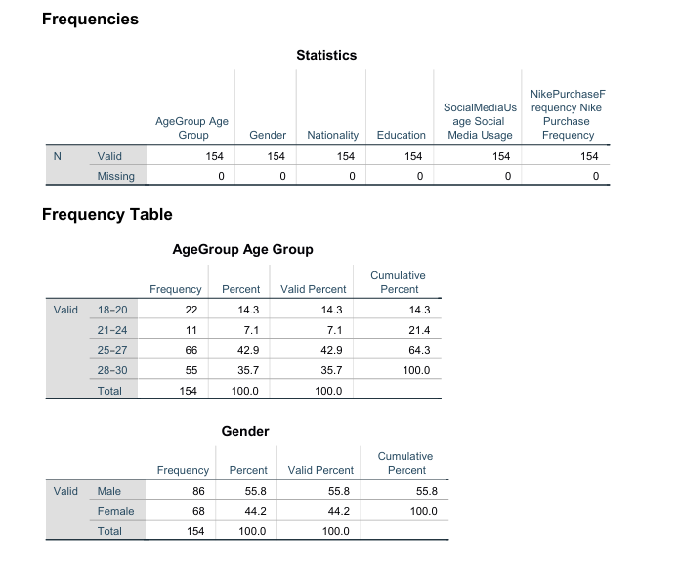
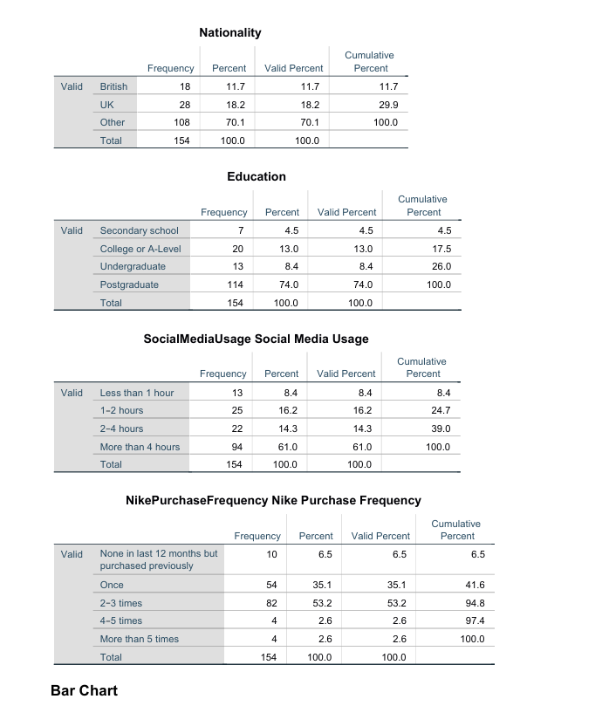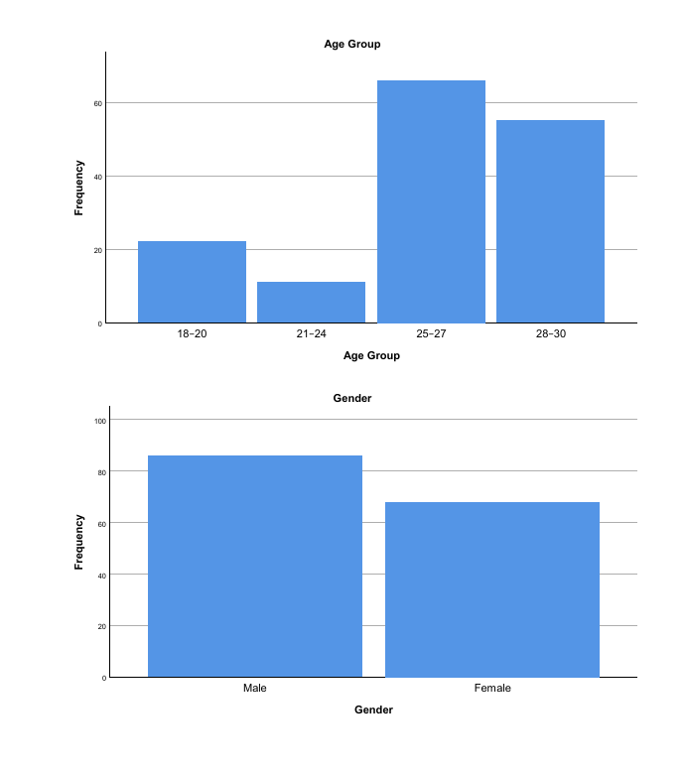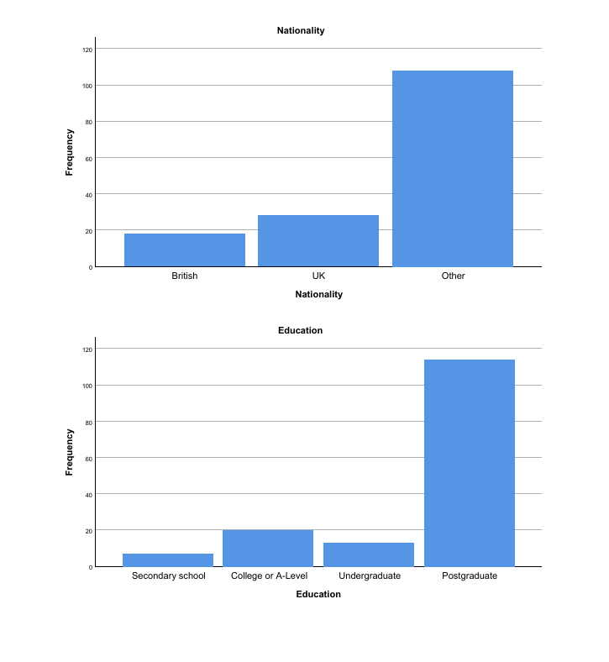
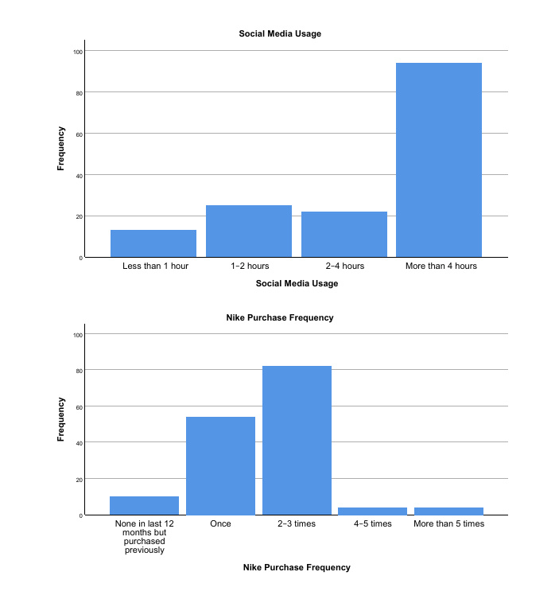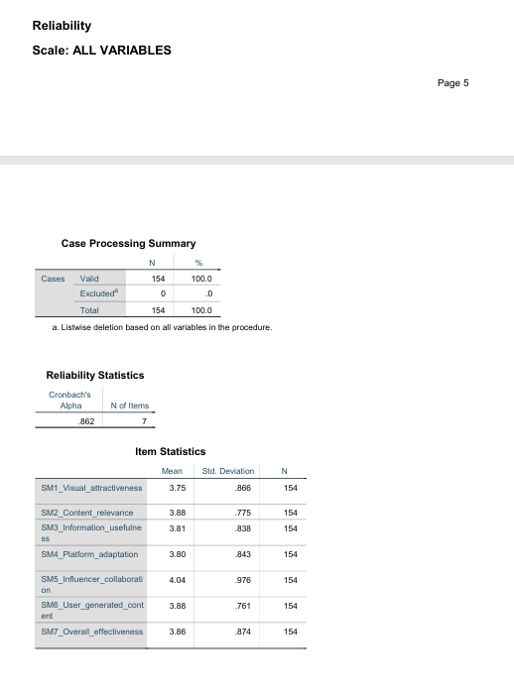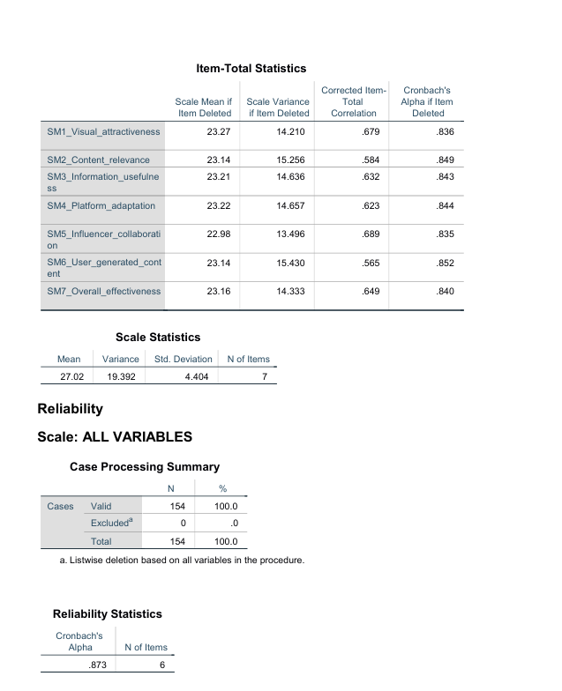
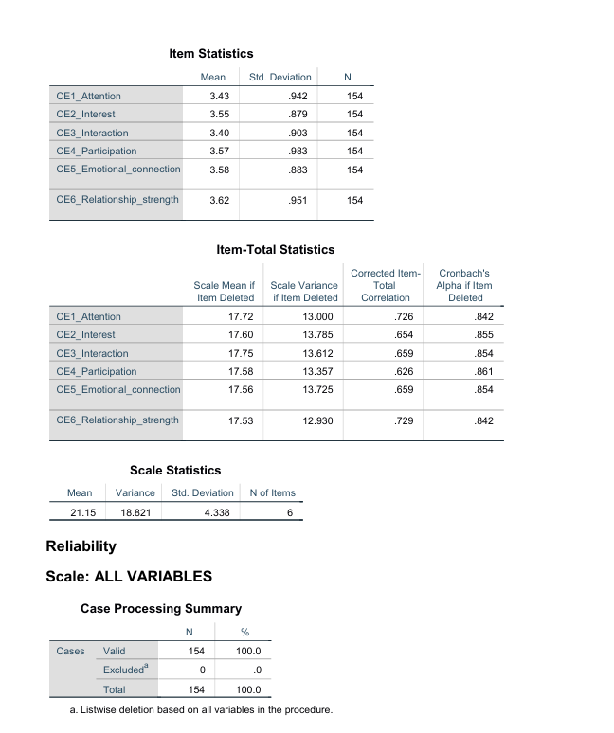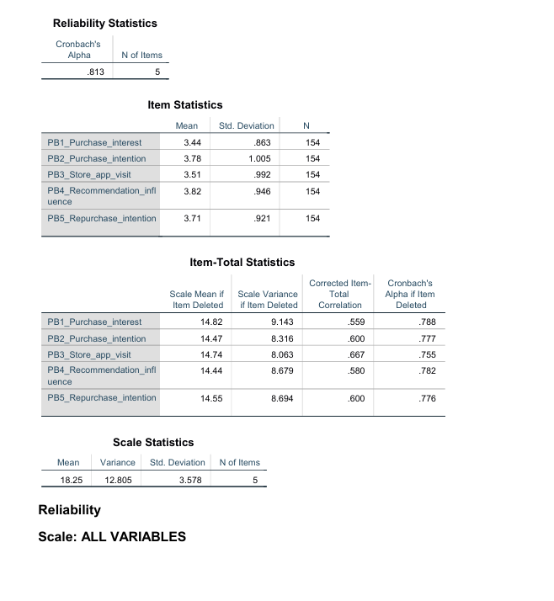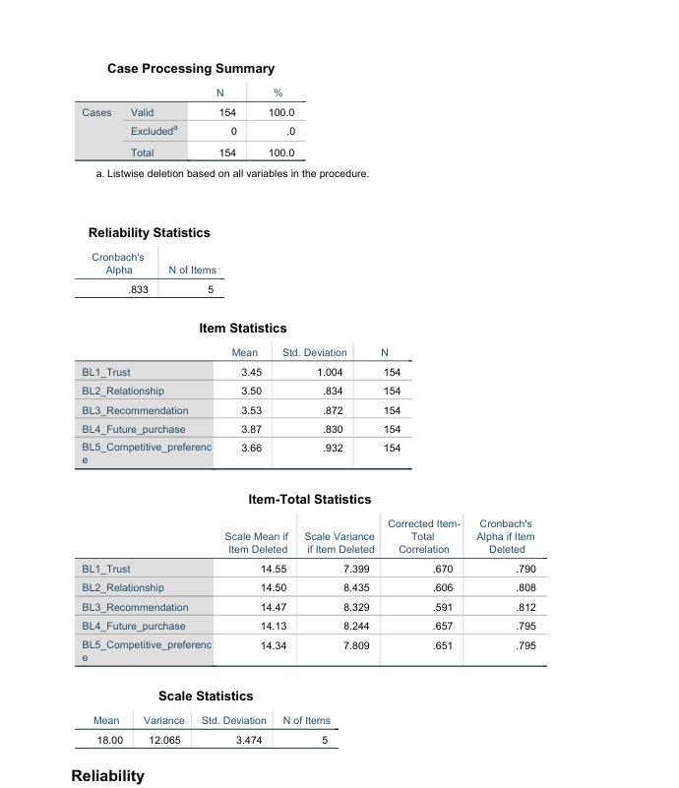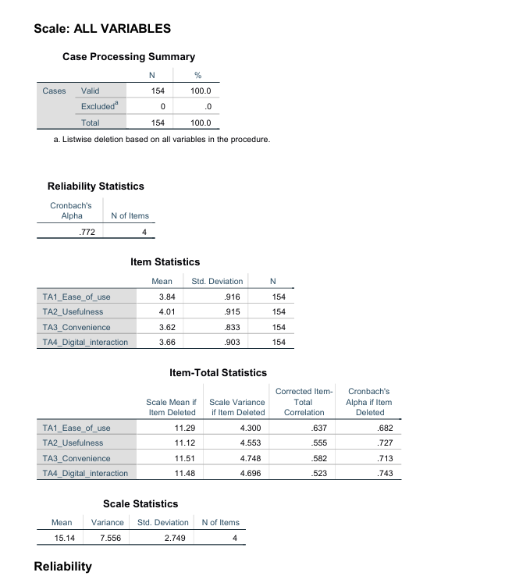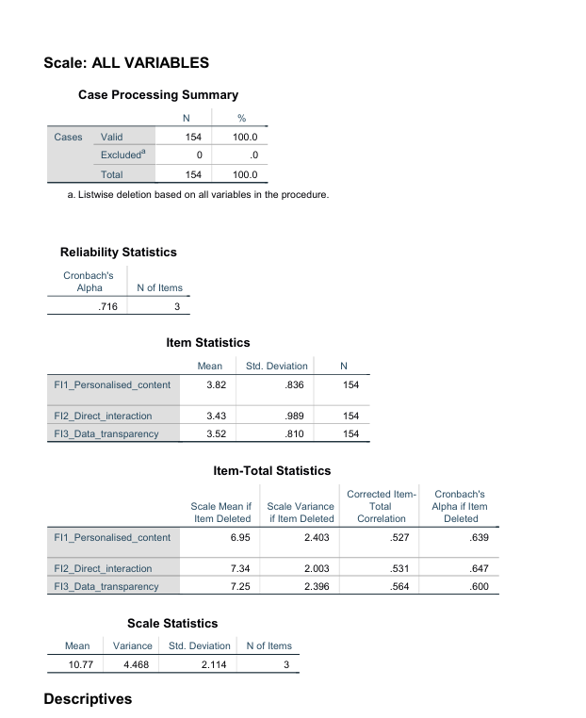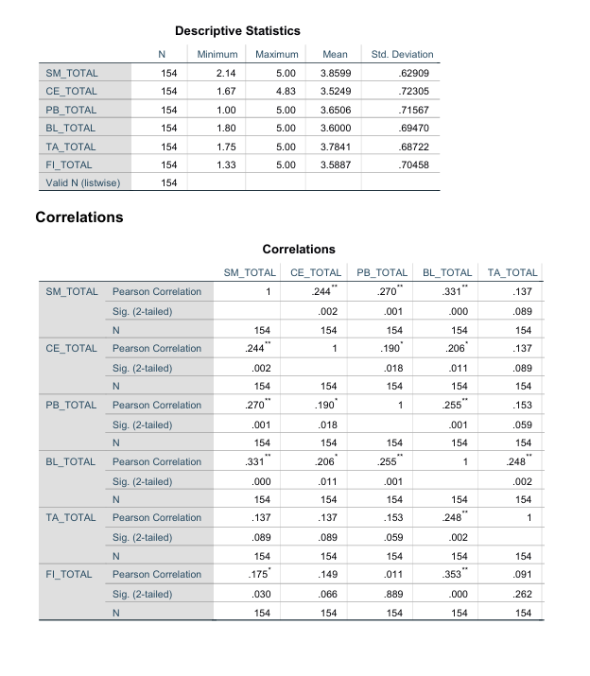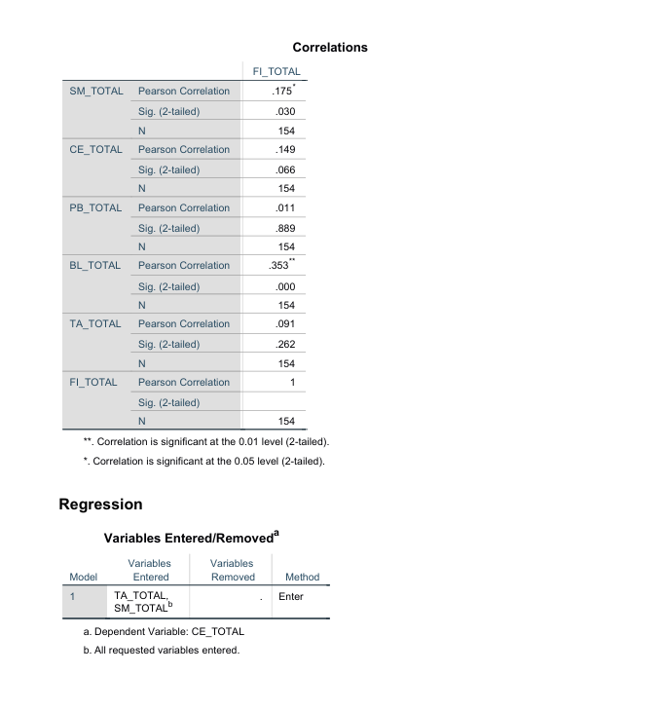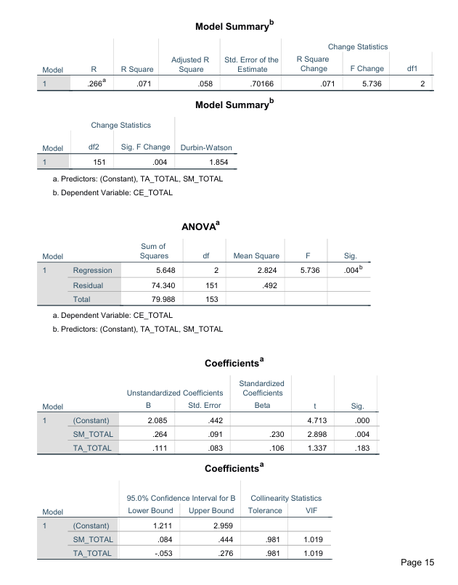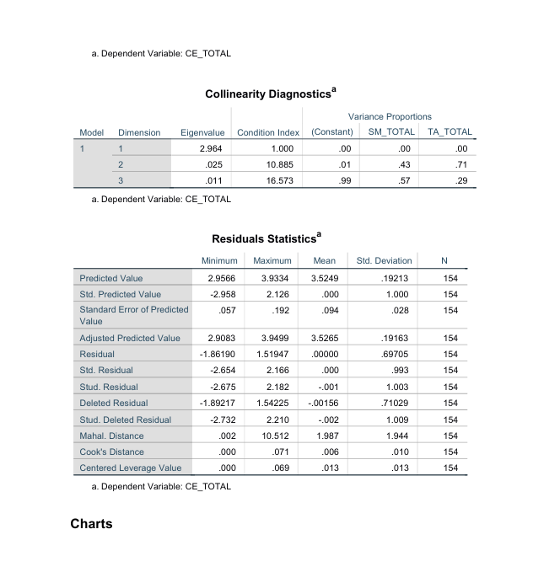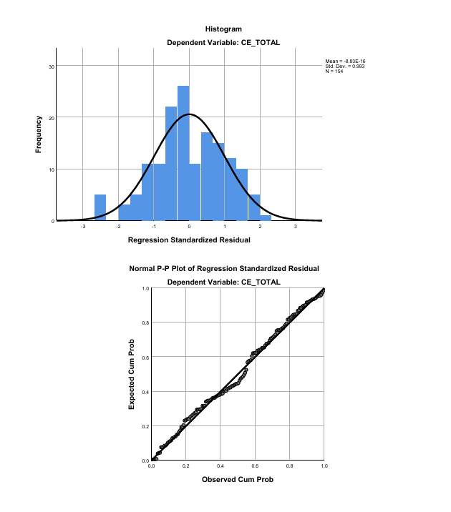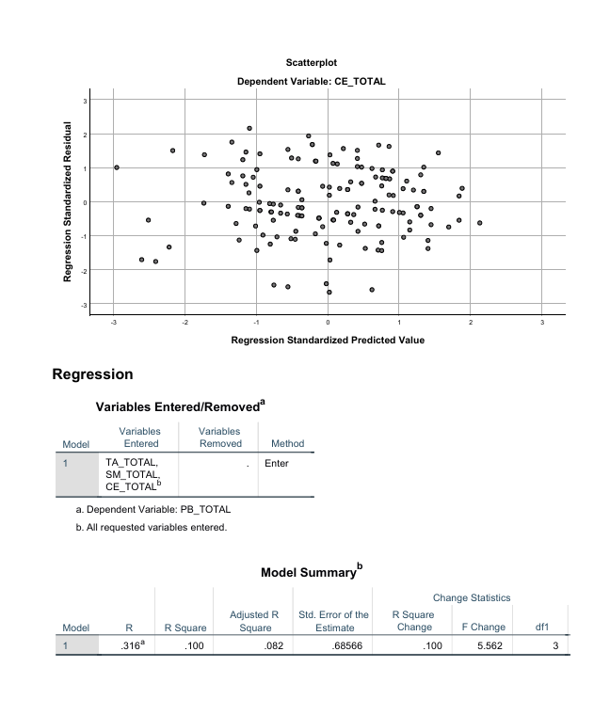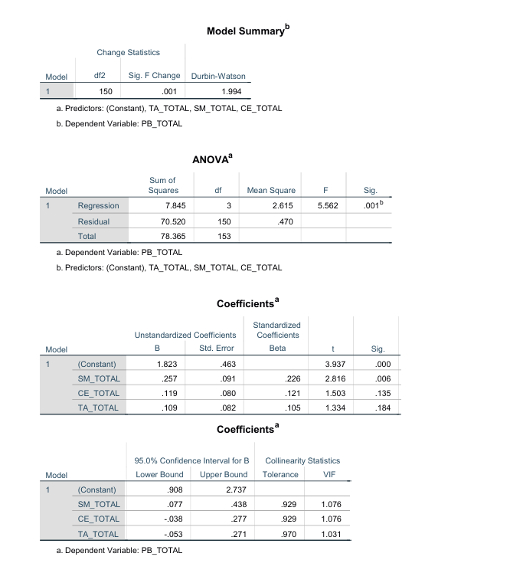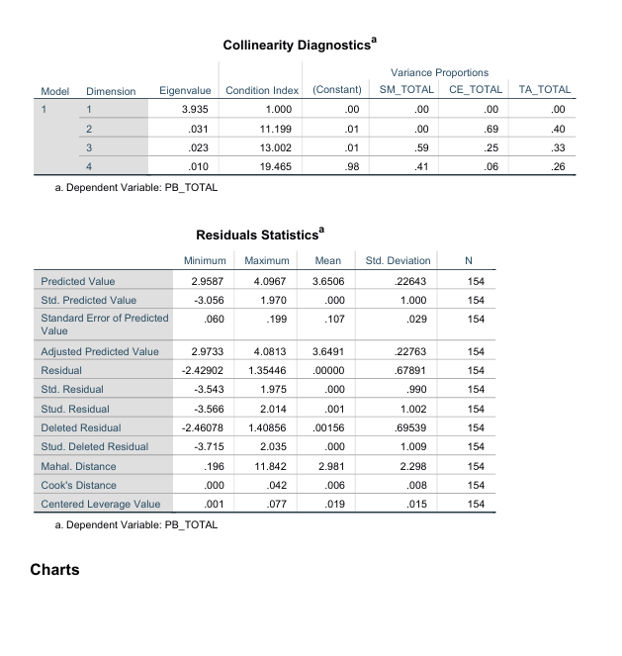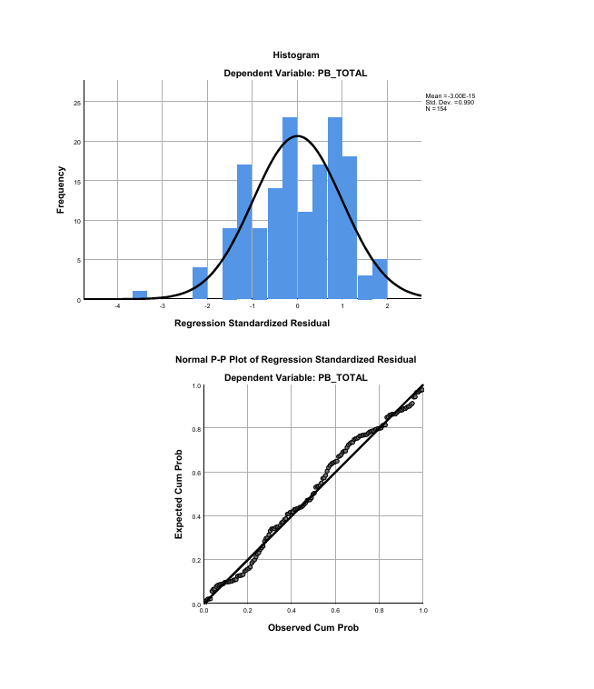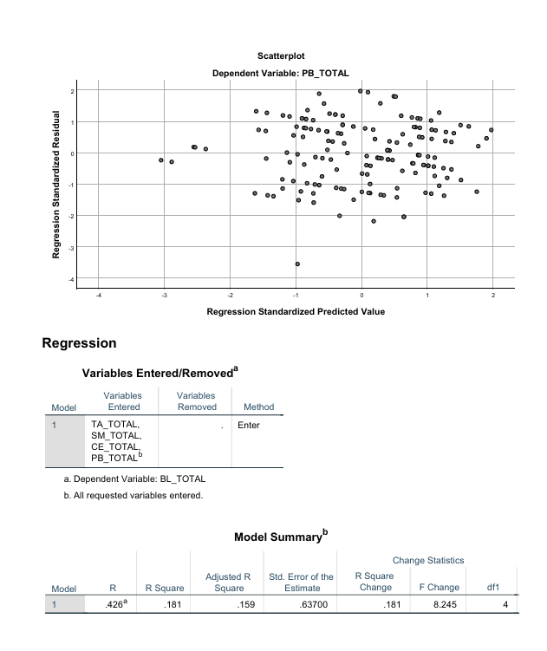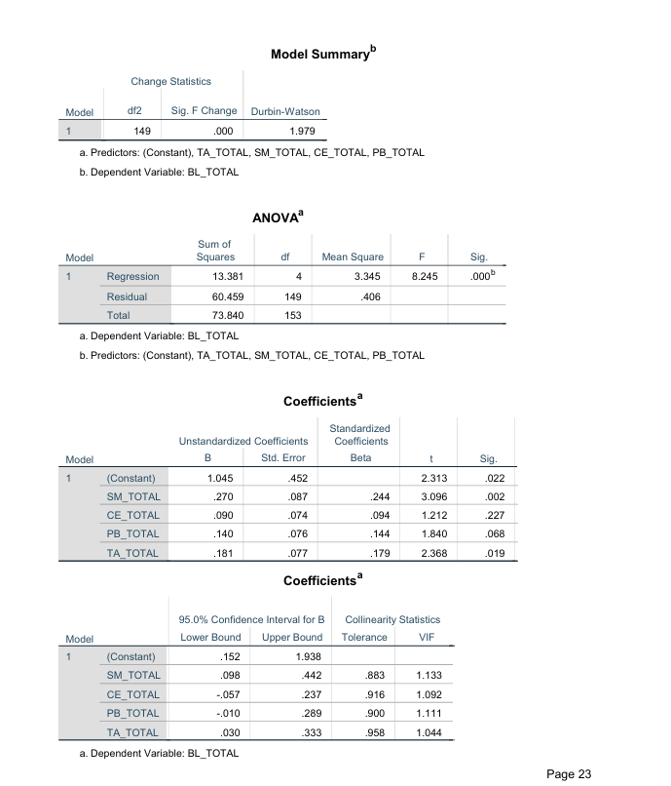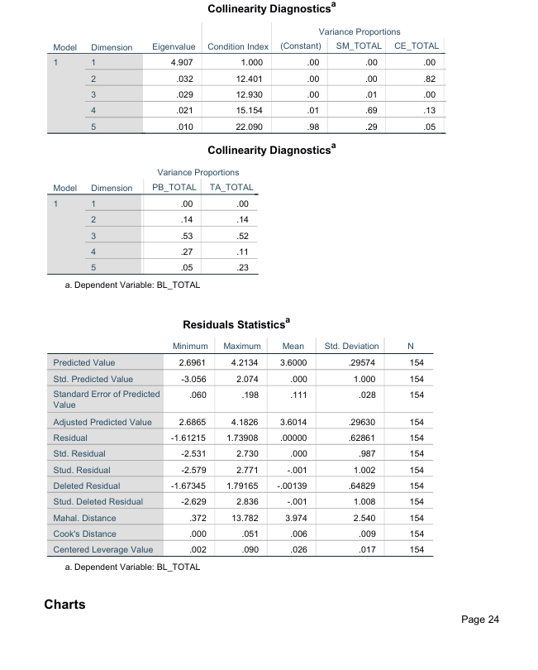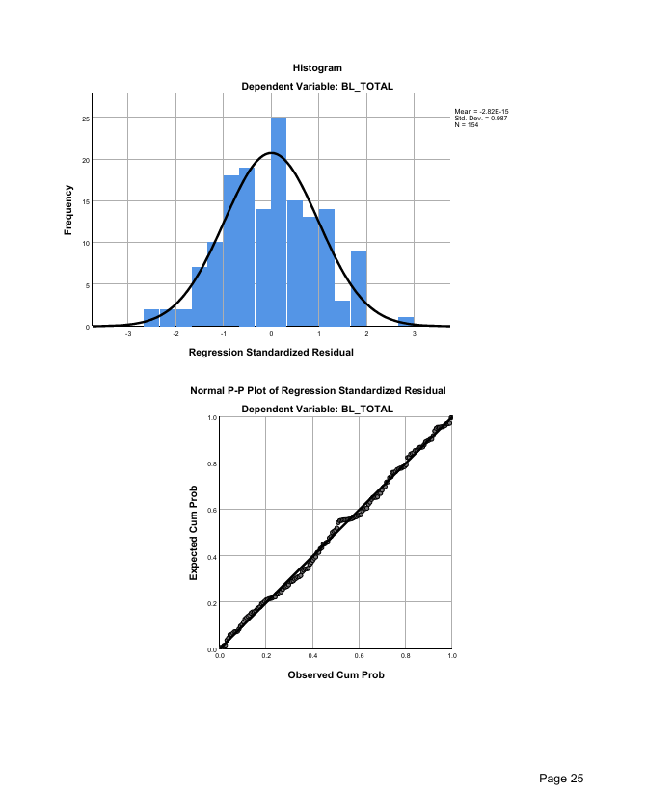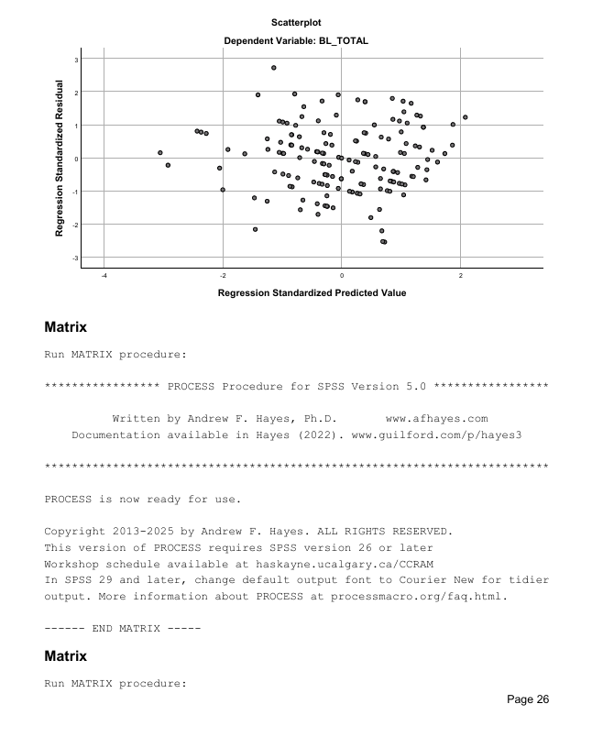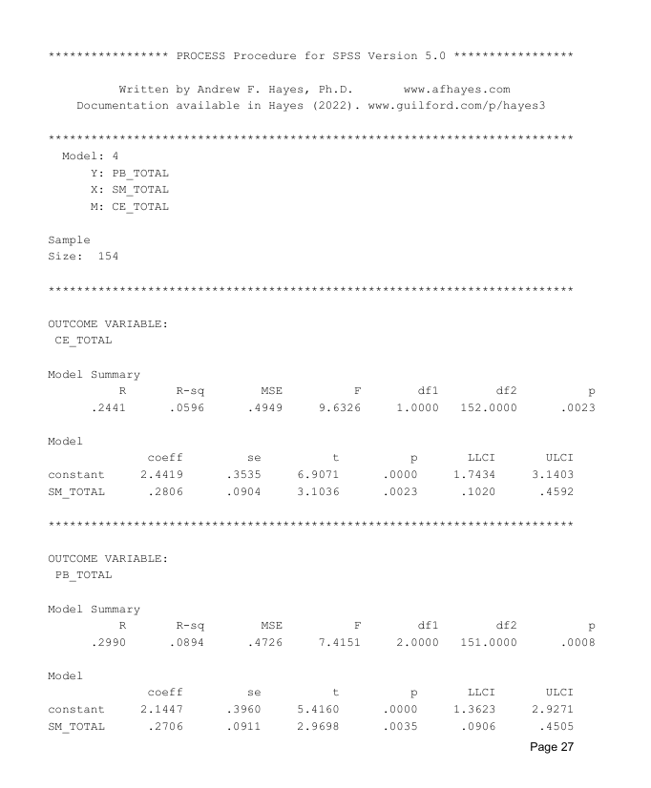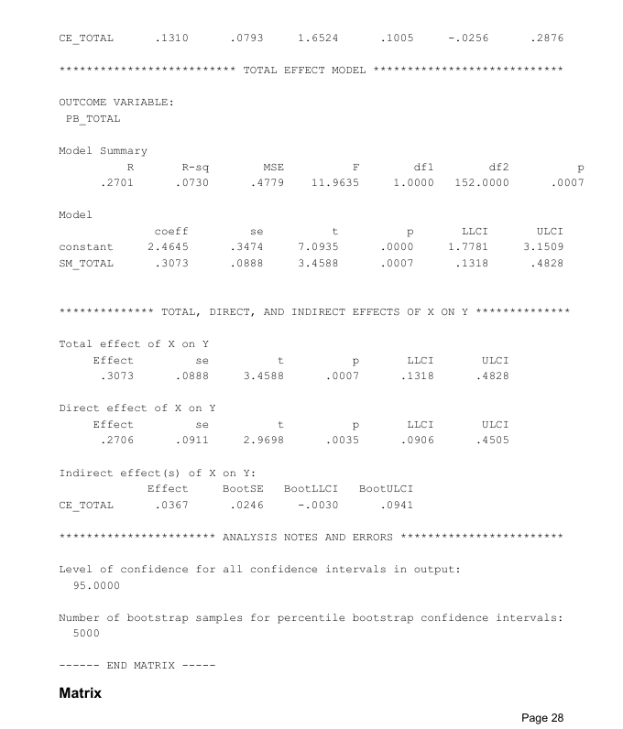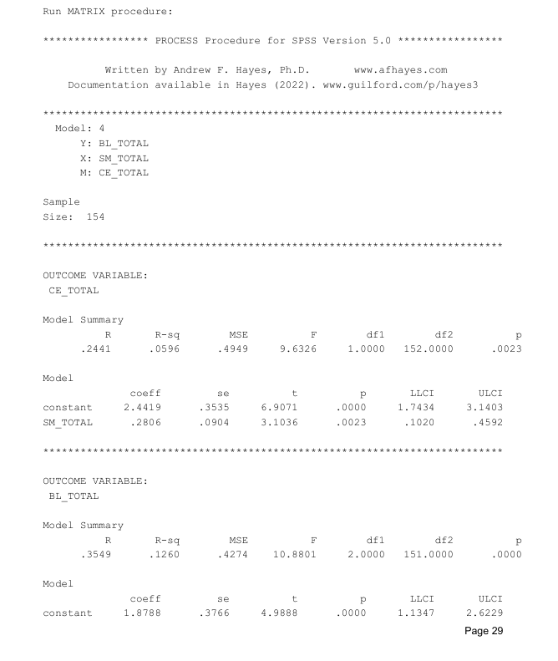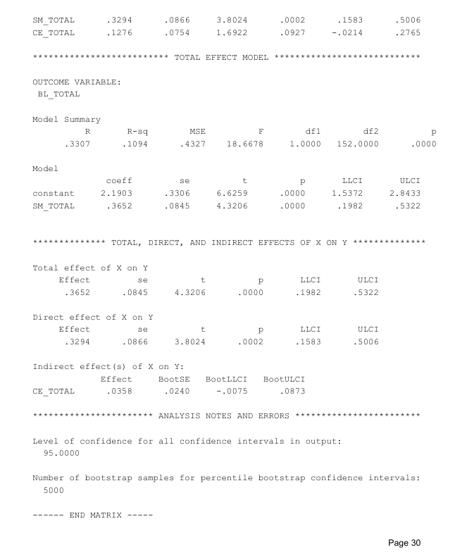

Appendix D: Ethics Form

