Three Keywords: Pattern, Process, Product
Student Number: 2103221
BA Course Title: Surface Pattern and Textiles
Word Count: 2,306
Tutor’s name: Julia Lockheart
Proposed Question for independent Project: How has industrialisation and technology developments impacted contemporary pattern design?

My three keywords are Pattern, Process and Product, which have an intertwining relationship, because whilst you are doing one, you are forced to consider the other. For example, you cannot make a pattern, without first considering the process. Furthermore, you cannot think about the process without thinking about the product or final outcome. My research will consider the importance of these words within the design process. Key artists and designers in this analysis include William Morris, Tord Boontje and Gabriel Schama.

Pattern
Psychologist, Garratt (2009) states, ‘patterns bring beauty into everyday life’. This suggests that the addition of pattern to a surface or product only serves to improve our experience of it. “A shared awareness and understanding of pattern will positively shape the future” (Murray, 2009, Pg.7). This quotation from ‘Patternity’ shows the importance of pattern for both the designer and their target audience.

Furthermore, a pattern is ‘a repeated decorative design’ (Murray, 1998). The word decorative has connotations with beauty and ornament, suggesting the purpose of pattern is solely to be beautiful, for the viewer to appreciate. William Morris ‘defined art and beauty together as integral to life itself; beauty, which is what is meant by art’ (Morris, 1880). Morris further preaches that pattern is ‘made by the people for the people as a joy for the maker and the user’ (Morris, 1880). This agrees with ‘patternity’, suggesting that patterns hold equal significance to the designer as it does to their target audience. More evidence to support this is socialist, Justema. According to Justema (1982) ‘Every pattern is a pretty thing… evoking joy in those who create patterns and who view it’.

Moreover, two key pattern designers I have analysed are William Morris and Tord Boontje. They both create pattern using different processes, discussing the impact the Industrial Revolution has had on society, through their patterns. ‘William Morris held industrial production responsible for the ugliness of the cities. Yet, Boontje does not see any conflict between stylised forms of nature and mechanical production. Quite the contrary; it is only the application of innovative technologies that has enabled him to produce’. (Coleman,1990). Boontje’s process revolves around Laser cutting: a modern innovate technology. Whereas Morris’ main processes included ‘reviving medical craft techniques’ to create patterns (Coleman, 1990).

However, it could be argued that Boontje is not a ‘pattern designer’ as his art does not appear to repeat seamlessly, like Morris’ clearly does. Yet, in Fig 2. Is an artwork entitled ‘Midsummer’ by Boontje, which he describes as a ‘floral pattern’ (Boontje, 2004). This evidence clearly argues that he must be a pattern designer. Although Morris is more well known for his seamless repeat patterns (See fig 1.), Boontje’s appear more abstract, with the repeat being less obvious. Due to the process Boontje uses he is able to use his patterns on more applications compared to Morris’ artworks. It is also important to note that William Morris’ popularity was in the 1870’s (Mason, 2021). This suggests that although Morris’ art is beautiful, it could be considered outdated an irrelevant in regard to contemporary society. Whereas Boontje is a more contemporary pattern designer, who is still creating patterns within the 21st century, suggesting he holds more relevance. This leads me to question the future for pattern designers? Will pattern designers use innovate technologies or medical craft techniques to create patterns in the 21st century?

In addition, Boontje’s work suggests that perhaps the future for pattern designers includes exploration with different processes using innovative technologies. It further suggests that we may see an increase in technology to help create patterns. For example, Adobe photoshop now has ‘50% of creative businesses’ using their software (Linder, 2024). This clearly shows that the use of technology within the design process is steadily increasing. Another statistic that supports this is ‘90% of the world’s creative professionals currently use Adobe Photoshop (Warnock, 2024).

On the contrary, according to the Victoria and Albert Museum in London, Morris ‘provided a model for other to follow’ (Parry, 1990). This suggests that old processes may ‘revive’ as Morris’s patterns are defined as ‘timeless’ (Parry, 1990). Yet, throughout my research I struggled to find a contemporary book to support this. This therefore further supports the idea that pattern may become heavily supported with technology. Thus, leading me to further question will designers become dependent on technology to create contemporary patterns?
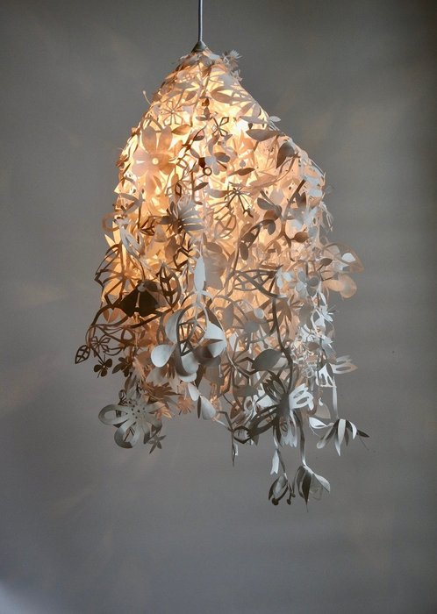
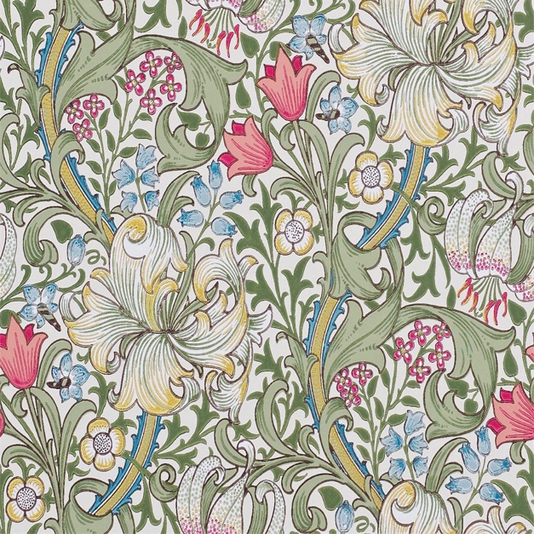
Fig. 1, Morris, W. (1986). ‘Arts and Crafts repeat’. Fig.2, Boontje, T. (2004) ‘Midsummer”.

Process
Process is defined by the Oxford English Dictionary as ‘a series of actions or steps taken in order to achieve a particular end’ (Murray, 1998) This suggests that to create specific patterns you may need to use specific or ‘particular’ processes in predefined orders. For example, laser cutting can be used with ‘a wide variety of materials and… for a wide variety of applications and industries.’ (Xometry, 2022). This therefore suggests that it is fast and efficient, providing you with the opportunity to use different materials. Another artist similar to Tord Boontje is Gabriel Schama (See Fig. 3). This image is described as ‘a laser-cut relief sculpture embedded with beautifully intricate geometric patterns’ (Barry, 2017). He intertwines pattern and process beautifully to create outstanding final products.

Moreover, he ‘cuts pieces from a variety of different plywood, which he layers to create varying images of the human form, architectural studies, and mandala- like patterns’ (Mothes, 2023). They ‘twist, intersect and overlap’. ‘Each piece begins as a vector illustration which is fed into his laser cutter, and glued and finished by hand’ (Mothes, 2023). This shows how his process is elaborate, detailed, and thorough. It is interesting how his work uses a mix of machinery (laser cutter) and human touch. ‘Finishes by hand’ suggests that human touch holds equal importance as technology within the design process. His work beautifully explains the relationship between process, product, and pattern. In Fig 3. You can clearly see how elaborate and delicate his process is.

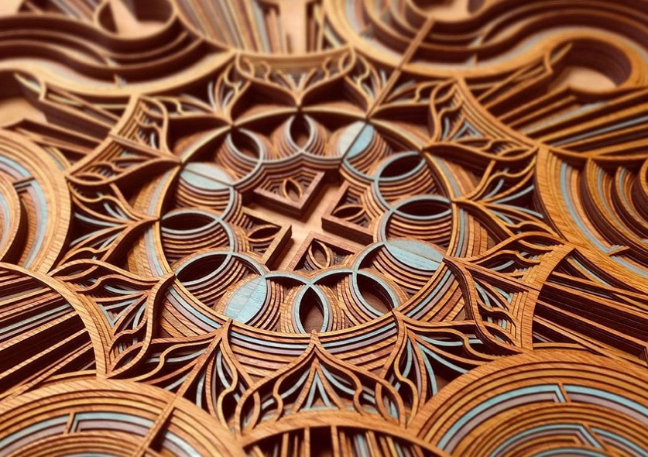
Fig. 3, Schama, G. (2017). ‘Laser Cut Wooden Sculpture’.

Furthermore, the process a designer goes through whilst creating ‘products’ or ‘patterns’ could be considered just as crucial to the design process as the final outcome. For example, ‘conversational patterns’ are becoming increasingly popular ‘with consumers being 72% more likely to purchase a product with a conversational pattern, compared to one without’ (Savoir, 2007). A conversational pattern refers to a ‘statement pattern that tells a story through recognisable motifs’ (Kuhlhorn, 2014). The best example for this is ‘mini moderns’ (See Fig. 4). They are a design company that create ‘pattern with a story’ (Stephenson, 2024). Their process involves travelling to gather inspiration from ‘holidays and field trips, both at home in the UK and abroad’ (Stephenson, 2024)’. An example of this is their wallpaper ‘Porcellana’. This wallpaper was inspired by their visit to the ‘stylish Italian hotel Maison La Minervetta, perched on a cliff top overlooking Sorrento harbour… the result is this full-colour trompe I’oeil explosion of hand-painted ceramic plates depicting nautical scenes and culinary treats’. (Hampshire, 2024). Thus, according to Davies this wallpaper would be more successful than an average wallpaper, due to the narrative. This supports the idea that process plays an important role in the success of a pattern or product, with a consumer being 72% more likely to purchase a product from mini-moderns due to its conversational pattern (Kuhlhorn, 2014).
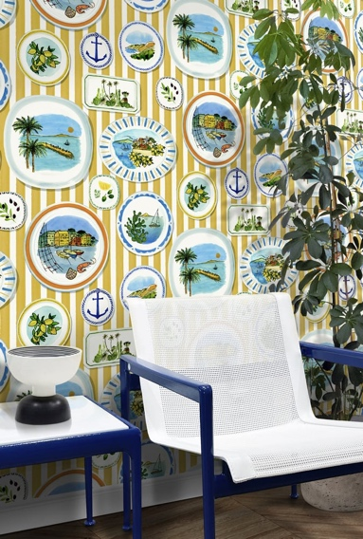
Fig. 4, Mark Hampshire & Keith Stephenson (2023). ‘Porcellana-Mustard’.

Additionally, a conversational pattern, suggests the designer has gone through a very articulate process in order to create the pattern or product. An example of this is the ‘Pewter Stool’ (See Fig. 5.). The artist and designer ‘Max Lamb’ went through an elaborate process to create a stool using the natural elements of ‘Caerhays beach in Cornwall’. His process was elaborate because of the numerous steps within his process. Some of these include, carving out the stencil within the sand, burying a portable gas cooker in a pit with the pewter ingots (molten copper) and continuously spraying the sand to prevent it from crumbling. He further had to pour the molten pewter into the mould, let it harden and excavate it gently (Hudson, 2008). This process was thoroughly researched and the placement of the pattern on top adds a quality finish. In addition, the beach held personal significance to Lamb. This is due to the fact that Caerhays beach was where he grew up and used to play. This leads me to question whether the process is more important than the product? However, he created a functional product suggesting they hold equal importance.

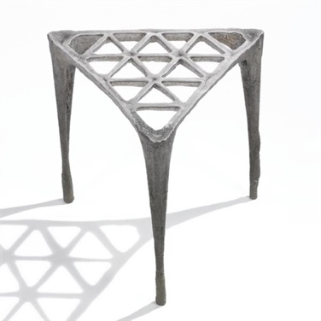
Fig. 5, Lamb, M. (2011) ‘Pewter Stool’
More evidence to support the process being of equal importance if not more than the product is Land Art. ‘Land art is made directly in the landscape by sculpting the land itself or by making structures in the landscape with natural materials’ (Kastner, 2010). The idea behind land art is ‘the notion of impermanence’ and the ‘subsequent interactions with nature’ (Malpas, 2007). Thus, Land art’s main focus is the process because it ‘has no permanent physical attributes’ (Malpas, 2007). Land Artists do not create ‘products’ they create ‘patterns’. Land Art thus suggests that product holds no importance. This is because Land Art creates a pattern and then allows nature to overcome it, which often involves nature disturbing or destroying a beautiful pattern. Thus, questioning the importance of a product in regard to art.

Product
This leads me to my final keyword: Product. I have chosen this word as I feel you have to consider the final product, to determine what type of pattern and process is required. ‘The designer must know the product’s demand and what the customers require from the product’. (Hatte, 2024). Schama has done this beautifully throughout his work, consistently considering his process, pattern and product throughout. I have looked at these three keywords in depth throughout, considering the interconnections between them all.

A product refers to ‘a thing that is grown or produced, usually for sale’ (Murray, 1998). Products are items that are sold to consumers; thus, they are heavily commercialised and tailored to specific audiences.’ ‘Commercialisation can be attributed to various factors, including the growth of consumer culture, advances in marketing and advertising, and the increasing role of corporations in shaping societal norms.’ Also, ‘globalisation and technology advancements have contributed to the widespread commercialisation of goods and services (i.e. products)’ (Muroyama, 2022). This links to Boontje and Morris, who explore the Industrial Revolution within their work. Thus, designers must consider their audience whilst creating a pattern, in order for it to sell. However, does this hinder the design process?

Product consideration is crucial when constructing a pattern. This is because depending on what product you desire; your process will vary. Context must be considered, for different processes are more suitable for different outcomes. ‘Today’s generation of makers are fluent in product design’ they hold ‘knowledge of more than just one material and are building bridges between fashion, lifestyle, media and craft’ (Jackson, 2011). This explains how contemporary society has become over-commercialised, with the importance of the viewer being at the forefront of teaching pattern design.

However, there is a significant increase with consumers buying products without patterns. According to a social study conducted by Kumar (2004), ‘Consumers are 63.5% more likely to buy a product because of the brand name, over the pattern design’. Yet, ‘Pattern is engaged as a process, rather than a means to an end...there is a palpable sense of attachment to the materials and methods that are employed.’ (Magliaro, 2008). This supports Lamb’s Pewter Stool, because he took careful consideration using a method that would allow him to create a piece that would hold meaning and resonance with the beach he used to play on in his youth. In the book, ‘By Hand’ Magliaro and Shu Hung discuss how designers ‘are happy to leave fingerprints on their work… letting a bit of themselves show through in their final products’. This suggests that people are aware that patterns must hold a purpose to perform as or on a product, but the best patterns make us feel something, or feel a part of the world the artist/designer has created. Vincent Van Gogh (1870) once said ‘every artist dips his brush in his own soul and paints his own nature into his pictures’. This explains how beautiful the process of creating a pattern is, allowing an audience to be ‘let into your world’, even if only for a moment.

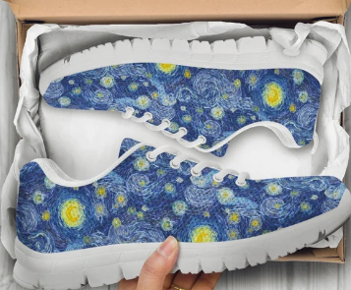
Fig. 6, Unicornshoesshop, Amy. (2024) ‘StarryNightShoes’

Furthermore, within contemporary society it has become a trend to take famous art and make it more functional. Thus, it has become increasingly important to consider pattern in relation to products (See Fig.6 above). An example of this is Unicornshoesshop, the artist Amy inspiration from famous artworks and repaints/prints them onto footwear. This clearly shows how products are becoming more important than the process. Another example to support this is the local clothing brand Primark. Primark has recently dropped a new clothing collection entitled the Basquiat collection. Jean Michael Basquiat was an artist very well-known for his expressionist paintings in the late 1970’s. Primark is ‘blending his iconic work with modern laid-back styles’ (Lasek, 2023). This suggests the future of pattern design will consist of upholding legacy, commercialising pattern and attempting to make it more functional, considering pattern within the use of products.

To conclude, after extensive research I have decided my question for my independent research task is ‘How has industrialisation and technology developments impacted contemporary pattern design?’. ‘Languages and technologies change fast; therefore, design will eventually become irrelevant.’ (Harvey,2017). Therefore, for my independent project, I am going to discuss the relationship between industry and design, considering both the positive and negative impacts. Furthermore, looking into contemporary pattern designers and what processes they use, considering their use of technology within their design.

Bibliography
Barry, K. (2017). Gabriel Schama-Artist Bio. Available at:Gabriel Schama - KBAA (kevinbarry.com) (Accessed: 28th March 2024)
Boontje, T. (2004). Tord Boontje. Available at: Midsummer · Tord Boontje. (Accessed: 24th April 2024)
Coleman, R. (1990) ‘Design and Technology in Nowhere'. Oxford: Oxford University Press.
Garratt, K. (2009) ‘Introducing Postmodernism: A Graphic Guide’. United Kingdom: Icon Books.
Gogh, Vincent. (1870). ‘Vincent Van Gogh Quotes...Vol.28: Motivational and Inspirational Life Quotes by Vincent Van Gogh’. United Kingdom: CreateSpace Independent Publishing Platform.
Hampshire, M. (2024). Porcellena. Available at: Mini Moderns — Porcellana - Washed Denim (Accessed: 25th March 2024)
Harvey, R. (2017). Are Design patterns really essential nowadays? Available at:Are design patterns really essential nowadays? - Software Engineering Stack Exchange/ (Accessed: 29th April 2024)
Hatte, W. (2024). Essential Factors of Product Design. Available at: Essential Factors of Product Design (mitaoe.ac.in) (Accessed: 25th April).
Hudson, J. (2008). ‘Process: 50 Product designs from concept to manufacture’. USA: Laurence King Publishing.
Jackson, L. (2011). ‘20th Century Pattern Design Textile & Wallpaper Pioneers’. London: Princeton Architectural Press.
Justema, W. (1982) ‘The Pleasures of Pattern'. New York: Van Nostrand Reinhold.
Kastner, J. (2010) ‘Land and Environmental art’. California: Phaidon Press
Kuhlhorn, L. (2014). ‘Designing Patterns for Decoration, Fashion and Graphics’. Russia: Gestalten.
Kumar, A. (2004). ‘Consumer Behaviour’. New Delhi: Atlantic Publishers and distributors.
Lasek, S. (2023). The Basquait Collection. Available at:Primark X Basquiat Collection | Primark. (Accessed: 3rd May 2024)
Linder, Jannik. (2024). Adobe Photoshop Statistics: Latest Data & Summary. Available at:Adobe Photoshop Statistics: Latest Data & Summary - WiFiTalents (Accessed: 3rd March 2024)
Magliaro, J. Hung, S. (2008). ‘By hand:The use of craft in contemporary art’. New York: Princeton Architectural Press.
Mason, A. (2021). ‘William Morris’. United Kingdom: W.W. Norton & Company
Malpas, W. (2007). ‘Land Art in the U.K.: A Complete Guide to Landscape, Environmental, Earthworks, Nature, Sculpture and Installation Art in the United Kingdom’. United Kingdom: Crescent moon publishing.
Muroyama, J. (2022). ‘Globalisation of technologies: International perspectives’. United Kingdom: National Academies press.
Murray, A. (2009) ‘Patternity. A new way of seeing: The inspirational power of pattern.’ United Kingdom: Conran publishing.
Murray, Sir James Augustus Henry. (1998) ‘Pattern’. Oxford English dictionary. First edition. Oxford: Oxford University Press.
Murray, Sir James Augustus Henry. (1998) ‘Process’. Oxford English dictionary. First edition. Oxford: Oxford University Press.
Morris, W. (1880) ‘The beauty of life: William Morris & the art of design’. Birmingham: Kelmscott Press.
Mothes, K. (2023) In Fantastical Laser-Cut Plywood Reliefs, Gabriel Schama Revels in Elaborate Details. Available at:In Fantastical Laser-Cut Plywood Reliefs, Gabriel Schama Revels in Elaborate Details — Colossal (thisiscolossal.com) (Accessed: 16th March 2024)
Parry, L. (1990) ‘V&A Pattern: William Morris’. London: V&A Publications.
Savoir, L.A. (2007). ‘Pattern Design: Applications and Variations’. United States of America: maomao publications.
Schmidt, P. Teitenberg, A. Wollheim, A. (2006) ‘Patterns in design, Art and Architecture’. USA: Birkhauser Basel Publications.
Stephenson, K. (2024). About Keith & Mark (Mini Moderns). Available at: Mini Moderns — About Us. (Accessed: 24th March 2024)
Warnock, J. (2024). Adobe Fast Facts. Available at:Adobe fast facts (Accessed: 13th February 2024)
Xometry, T. (2022). Advantages and disadvantages of Laser Cutting. Available at:Advantages and Disadvantages of Laser Cutting | Xometry (Accessed: 12th April 2024)

List of figures
Fig. 1: Morris, W. (1986) Arts and Crafts Repeat. [Artwork]. Victoria and Albert Museum: London.
Fig. 2: Boontje, T. (2004) Midsummer. [Laser cut paper] Victoria and Albert Museum: London.
Fig. 3: Schama, G. (2017) Laser cut wooden sculpture. [Laser cut plywood].
Fig, 4: Hampshire, M. Stephenson, K. (2023). Porcellana. [Wallpaper]
Fig. 5: Lamb, M. (2011). Pewter Stool. [Molten Copper]
Fig. 6: Amy, S. (2024). Starrynightshoes. [Shoes printed]

