The Global tourism experience
Travel Review

Jasmin Begum - 1806359

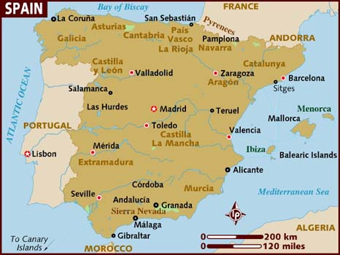

Hola y bienvenidos a España
Spain is the largest country in Southern Europe and a popular holiday destination for many visitors, with many wonderful places to visit it is suitable for everyone. There are many regions within Spain with so much to offer from the diversity of culture, amazing food, incredible views and the all-round sun. Spain is perfect for a first-time holiday as well as a returning holiday for visitors all around the globe. The currency used in Spain is Euros which is used in many parts of Europe. In 2018 Spain received a record number of 82.8 million foreign tourists, spending up to a total of 89.856 billion euros. (xinhuanet,2019) There are many ways tourists can come and visit Spain such as using airlines, boats, trains and roads. It is mostly common to travel by airlines and roads, these methods are used within Spain too and can transport around the country hiring a car, motorcycle or quadbike.
It is ranked second on the World Tourism Organization’s list of most visited countries in the world, United Kingdom to be the main source market for tourists visiting Spain with over 18 million visitors in 2019 followed by Germany and France with over 11 million visitors. (statista,2020) Spain’s number of foreign visitors dropped by 1.4 percent year on year to 4.1 million in January 2020.
Travel and tourism have become one of the biggest growths for the Spanish economy with an increase in the GDP contribution to reach approximately 178 billion euros in 2018, it boosts the Spanish employment market which had a downfall since the 2007 financial crisis which jeopardized and ruined many jobs across the country. (tradingeconomics,2020)

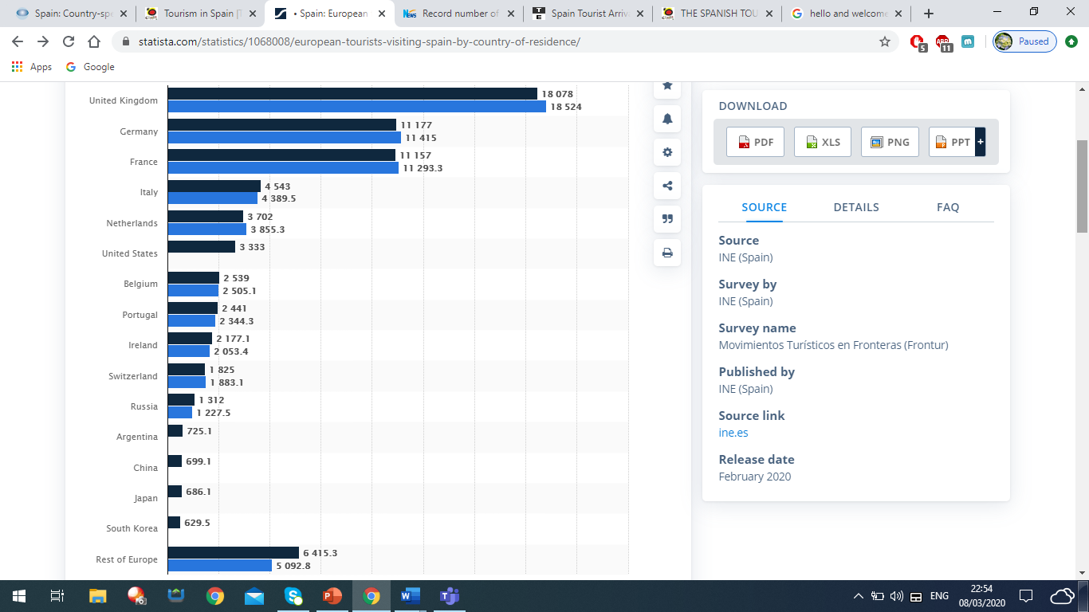

Dark blue – 2019
Light blue – 2018

Figure 1 – Number of European tourists arriving in Spain. (statista,2020)
Spain tourism involves a variety of different markets, suitable for everyone. It is mostly known for family holidays where you can relax in the sun on the beautiful beaches but now it involves a lot of visitors coming to embrace the culture and gastro tourism. The culture is very authentic, and their language Spanish is ranked at 4th in the most spoken languages in the world with 527 million speakers. (Julian and Julian, 2020) The Spanish food is very popular cuisine globally and is known for their tapas, cheeses and wine. Spain have investigated growing their tourism by celebrating big anniversaries on the Ibiza Island, Holding sporting event UEFA 202 in Bilbao and opening doors of the Palace of Liria to the public for the first time. (socialnewsroom.spain,2020) Growing the tourism in Spain has had a significantly great impact on Spain as more people are buying accommodation and settling down there, it has given Spain a big boost to on their social, economy and environment. There is also a negative to this as Spain are losing their culture in parts of their country and are becoming more British, such as the style of their houses, bars and restaurants but this is to make people feel more at home while visiting.
The positive social impacts that tourism have on Spain is that more people are willing to learn about the culture and respect them, also that they have catered to our standards and culture too. This helps others understand more and makes them feel comfortable but also is a commercialisation of culture removing traditional meanings and values. Ibiza is a very known popular island for visitors, from January to September 2019, more than 3.54 million visitors came to Ibiza by air 871,000 of them travellers from British airports. Juan Miguel Costa, director of the Ibiza Island Council, said: “Ibiza depends largely on British tourism and despite Brexit uncertainties, they forward to warmly welcoming many more British visitors in the forthcoming months”. (traveldailymedia,2019) This helps create more jobs for the economy only during the summer months and promotes anti-social behaviour but in a controlled environment.
The tourism does good for the economy by profiting enough money that there are no leakages this then allows the country to improve on the infrastructure. Spain has always had a good tourism industry that it is possible to spend little and in return gain a big profit, this allows residents or visitors to open businesses and migrate to Spain, this also creating more jobs. The negative effect that this has is that it is seasonal and low pay during this period.
The impacts of tourism on the environment helps regenerate areas and the reuse of buildings and landscapes. Many historic and grade listed building are still in use today for this reason and many more are getting built. The buildings today is more modern and not like original Spanish build, the new architectural styles are allowing people to have choice in their own taste and needs. There is a risk of over development as more people from overseas are purchasing new houses and only getting used in peak season.
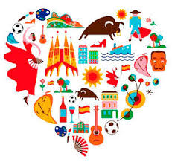
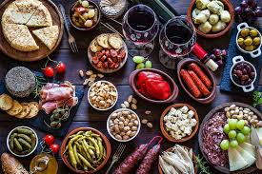

Spain is a fantastic place to visit and will meet all your needs and expectations. Looking at Maslow’s Hierarchy of needs it is built up of five tiers, the top tier being self-actualisation. Tourism is the practice of traveling for pleasure, education or business, it incorporates new experience, meeting people, places, traditions, cultures. This psychologically gives a person motivation to travel and meet individual needs and satisfactions. (Šimková and Holzner,2014) This Spanish country allows you to build yourself up each step to the top of the hierarchy with all the needs and wants fulfilled.
Depending on what part of Spain that interests each individual then it would determine what travellers there are on Cohen’s Classification of Tourists. There are many people who would fit the category of ‘The Organised Mass Tourist’ which is why Spain has catered for this by creating a very homely place for the British travellers as they are the biggest target market, tourists can feel at home while enjoying the sun. These areas include Alicante (69,289), Malaga (47,193), Almeria (14,931), Balearics (14,870) and Barcelona (14,284) latest ﬁgures by province are for January 2019. (aplaceinthesun,2019) Many Party areas include Benidorm, Ibiza, Magaluf which are favourite Brit destinations and these types of travellers are called ‘The Explorer’ and ‘The Drifter’. Travellers can freely go around exploring creating their own itinerary as they go along, safely and making many friends with locals or other travellers. (Cohen, E. 1972).
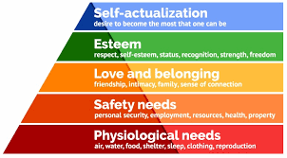

There are many tourist attractions to visit in Spain, number one being in Granada the Alhambra, Part fortress, part palace and part garden. The Nasrid Sultans constructed this in the 14th century overlooking the city.(touropia,2018) There are many more historic buildings and monuments worth visiting such as The Mesquita, El Escorial, Sagrada Familia and Aqueduct of Segovia.
It is worth going to visit all the blue water beaches in Balearic Islands, partying the nights away. Going to visit the Retiro Park for a quiet, relaxed day out or going to visit the many vineyards, the best being the La Rioja Vineyards where tourist can try Spanish wine during harvesting time. (theculturetrip,2020) Many eateries serve tapas style food but get served a 5* meal in the Gatsby in Barcelona where one can get entertained while dining, don’t forget to dress to impress!
Tourism can be one of the biggest employments for a country as it is for Spain, to be known as an international tourist destination. The earnings from tourism has represented an important source of compensation for the Spanish current account and for its trade imbalances in the last three-four decades. This creating a multiplier effect and leakage, tourism profits give Spain a boost into enhancing machinery and technology which were needed. This was taken for granted as enough attention was not paid to the tourist developments and Spain’s economic development didn’t stimulate from this. (Balaguer and Cantavella-Jordá, 2002)
There are many other hurdles that Spain has overcome in the past years such as Spanish flu (influenza) in 1918 which killed from 20 million to 100 million people, wiping them out one by one like the plague. Mostly young adults aged 20-40 years old, elderly and children under 5. Tourism was not as big as it is now but still having an impact on the number of visitors, this was overcome by having vaccines and precautions before going out. (Edition.cnn.1999).
Today we have risks globally about terrorism and Coronavirus disease (COVID-19) this has got on impact on the tourism industry and Spain have got safe measures to avoid any incidents. Keeping security levels on high alert through both airports and streets, as well as having patients in quarantine to be thoroughly checked.
Butlers Lifecycle shows how the tourism in Spain has impacted the economy and whether it has been good or bad. Looking at each stage from the start Spain had got off to a good start by having a good tourism market and visitors in most parts. This is when Spain had developed and started to create more jobs, had a range of activities to do and more markets had arrived for business. The tourism market had expanded to more regions of Spain, this helping creates a wider target market with so much to do. The development went on with many visitors buying accommodation and setting up their own businesses. Social media has also had a massive impact on this by promoting destinations in Spain bringing in a different target market, as everyone is keeping up with the trends. (Garay and Cànoves, 2011) Spain’s tourism is at a high peak during seasons and are trying to get travellers in all year round, by using the upcoming ideas it hopes to be success in the future.
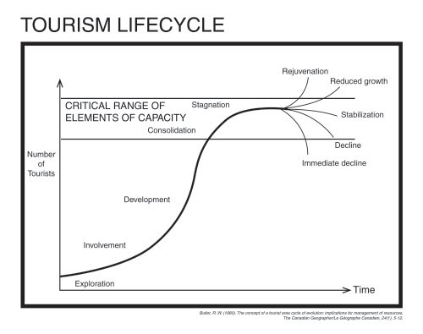

Statista. (2020). Spain: European tourist arrivals by country 2019 | Statista. [online] Available at: https://www.statista.com/statistics/1068008/european-tourists-visiting-spain-by-country-of-residence/ [Accessed 1 Mar. 2020].
Xinhuanet.com. (2019). Record number of tourists visits Spain in 2018 - Xinhua | English.news.cn. [online] Available at: http://www.xinhuanet.com/english/2019-02/02/c_137793067.htm [Accessed 1 Mar. 2020].
Tradingeconomics.com. (2020). Spain Tourist Arrivals | 1995-2020 Data | 2021-2022 Forecast | Calendar | Historical. [online] Available at: https://tradingeconomics.com/spain/tourist-arrivals [Accessed 1 Mar. 2020].
Julian, G. and Julian, V. (2020). The 10 most spoken languages in the world. [online] Fluent in 3 months - Language Hacking and Travel Tips. Available at: https://www.fluentin3months.com/most-spoken-languages/ [Accessed 3 Mar. 2020].
THE SPANISH TOURIST OFFICE REVEALS LASTEST TOURISM DEVELOPMENTS AT WORLD TRAVEL MARKET 2019. (2020). THE SPANISH TOURIST OFFICE REVEALS LASTEST TOURISM DEVELOPMENTS AT WORLD TRAVEL MARKET 2019. [online] Available at: http://socialnewsroom.spain.info/the-spanish-tourist-office-reveals-lastest-tourism-developments-at-world-travel-market-2019/ [Accessed 3 Mar. 2020].
Travel Daily. (2019). UK delivers highest number of overseas visitors to Ibiza. [online] Available at: https://www.traveldailymedia.com/uk-visitors-to-ibiza/ [Accessed 6 Mar. 2020].
Šimková, E. and Holzner, J. (2014). Motivation of Tourism Participants. Procedia - Social and Behavioral Sciences, 159, pp.660-664.
Page, H., Spain, H. and Sun, A. (2020). Here's where the British are buying property and living in Spain - A Place in the Sun. [online] Aplaceinthesun.com. Available at: https://www.aplaceinthesun.com/articles/2019/10/heres-where-british-nationals-are-buying-property-and-living-in-spain [Accessed 6 Mar. 2020].
Cohen, E. (1972). TOWARD A SOCIOLOGY OF INTERNATIONAL TOURISM. Social Research, 39, pp.164-182.
smith, t. (2018). 10 Top Tourist Attractions in Spain. [online] Touropia. Available at: https://www.touropia.com/tourist-attractions-in-spain/ [Accessed 6 Mar. 2020].
Jones, J. (2020). 20 Must-Visit Attractions in Spain. [online] Culture Trip. Available at: https://theculturetrip.com/europe/spain/articles/20-must-visit-attractions-in-spain/ [Accessed 6 Mar. 2020].
Balaguer, J. and Cantavella-Jordá, M. (2002). Tourism as a long-run economic growth factor: the Spanish case. Applied Economics, 34(7), pp.877-884.
Edition.cnn.com. (1999). CNN - 'Flu: The Story of the Great Influenza Pandemic of 1918' - November 19, 1999. [online] Available at: http://edition.cnn.com/books/beginnings/9911/flu/index.html [Accessed 8 Mar. 2020].
Garay, L. and Cànoves, G. (2011). Life cycles, stages and tourism history. Annals of Tourism Research, 38(2), pp.651-671.

