Food Waste and Sustainability in the Hospitality Sector: An Evaluation and Effectiveness

Name: Victoria Prodan
Student ID number: 2245322
The module title: Contemporary Themes in the Hotel and Hospitality Sector
Module code: BMIH6001
Lecture’s name: Dr Ernest Balutie Wavei
Contemporary theme: Sustainability in terms of Food waste and its efficacy

Abstract
The task applies a theme which includes considering sustainable choices within hotels and hospitality businesses. In addition to this, it applied the concept in a chosen company within the industry. Sustainability is meeting the needs of a business and reducing its overall impact on the environment. The theme highlights the role of sustainability within the industry as it demands a reduction in food waste. The chosen company is Welbeck Hotel, which is a boutique hotel in the UK and might not have the necessary resources to implement the waste reduction techniques. The Welbeck hotel already has an eco-friendly image, which can be used by the company to enhance its output. In addition to this, it can deploy waste management analytics by companies such as Winnow and can use targeted social media advertising to reach more consumers.
Introduction
The chosen theme highlights the role of sustainability within the hospitality industry as it demands a reduction in food waste. This can be possible with the help of proper inventory management and local sourcing. However, this might be taxing on the smaller businesses where profitability margins are lower. This can cause issues for the smaller businesses rather than facilitate their growth. Objectives of the study:
- To highlight the role of waste management in sustainability implementation.
- To understand the impact of technology on waste management.
- To understand how profitability can be balanced with transparency practices aligned with guest expectations.
The implementation of business sustainability can help in making sure that the environmental impacts associated with the hospitality industry are reduced. This can help in improving the brand image of the business, and at the same time, can help the business in preventing regulatory scrutiny. On the other hand, ensuring sustainability through proper management of resources might require additional costs.
In the UK, the Waste and Resource Action Program identified that there was a total food waste of 10.7 million tonnes in 2021. The major contributor to the food waste in the UK was households consisting of 60% and the hotel and hospitality involved 10% of the total amount. The hospitality industry is one of the leading contributors within the UK economy, as the industry raised an estimated £54 billion in tax receipts in 2022 (Ukhospitality.org.uk, 2026). In contrast to this, food waste is a contemporary issue in the sector due to regulations associated with net-zero targets and added regulatory pressure.

2. Literature Review

2.1 Relationship between sustainability and waste management
In the hospitality sector, waste management can be viewed as a valuable tool which can help align business operations with sustainability requirements. As per the studies of Cooper and Hall (2023), sustainability has shifted from a marketing tool towards a core operational requirement within a business, linking itself with business development. Contrary to this, the findings of Costa and Costa (2022) have argued that waste management is a core concept within sustainable management that must be given priority. It can also be noted that effective waste management can help in maintaining the sustainability value of the business. However, at the same time, waste management can be critical in ensuring that the business can reduce the losses incurred due to food waste.
In 2025, it is estimated that over 1.1 million tonnes of food waste will have been generated by the hotel and hospitality industry (Wrap.ngo, 2026). This can be mitigated with the help of effective waste management strategies adopted within the industry. On the other hand, as per the findings of Goffi, Masiero and Pencarelli (2022), it has been observed that global tourism and hospitality companies are now heavily focused towards using sustainability to improve their strategic positioning. Based on the findings as presented by the sources, waste management and sustainability can be supported with the help of an effective management system.

2.2 Impact of technology usage in waste management monitoring
Multiple advanced technological tools can be used to ensure that effective waste monitoring is implemented. As per the findings of Chkoniya (2021), technologies such as Artificial Intelligence can be a driver of waste management, especially in the hospitality sector of Small and Medium-Sized Enterprises (SMEs). This could play a crucial role in making sure that the overall food wastage can be reduced. The findings presented by the authors highlight the use of technology that can help in automating the processes and minimise the scope of manual human mistakes.
Additionally, as per the findings of Nyoni (2025), data analytics can be used in implementing advanced predictions as well. This contradicts the observations made in the previous case, which highlights the need for technology. The presence of advanced analytics in this case could also play a significant role in waste monitoring and management. It can produce the future needs within the kitchen that can help chefs in planning in advance and minimising wastage. Contrary to this, the findings of Xu, Shirowzhan and Sepasgozar (2023) indicate the presence of real-time dashboards. The findings suggested by the authors highlight that technology adoption could be beneficial, as human users can monitor it. This, in turn, could help inform the management about any observed anomalies related to food consumption or wastage.

2.3 Managing guest expectations with waste management initiatives.
The findings of Socaci (2020) indicate the presence of waste management as a strategic challenge being faced by the hospitality industry. It can be a crucial driver in making sure that a given business can meet the expectations of the boarders and guests. This could help a business in generating income by maintaining an eco-friendly image. On the other hand, Wavei, Lo and Gedecho (2025) have noted the role of Customer Relationship Management (CRM) software in handling guest expectations. This can be coupled with sustainability considerations that, in turn, can be aligned with the guest experiences. As per the paper published by Alexander Danzer (2025), the presence of food waste can be viewed as an economic loss for a business. The findings of the authors correlate with the presence of guest expectations associated with sustainability within the hotel businesses that can be managed more effectively.
In addition to this, Lvov and Konu (2025) have observed that the presence of guest satisfaction within a hotel is dependent on a number of intangible factors. Effective implementation of sustainable attributes and efficient waste management could be some of those factors as well. On the other hand, as pointed out by Khatter (2023), sustainability management is important in managing waste and ensuring that effective quality controls are in place. The findings indicate that sustainability could be enhanced further with the help of guest engagement as well, which can implement a comprehensive and well-rounded approach towards adding sustainability within the hotel.

2.4 Theoretical underpinnings
The triple bottom line theory is a sustainability framework that could ensure that the success of a business is measured in terms of economic development, social equity, and environmental stewardship.
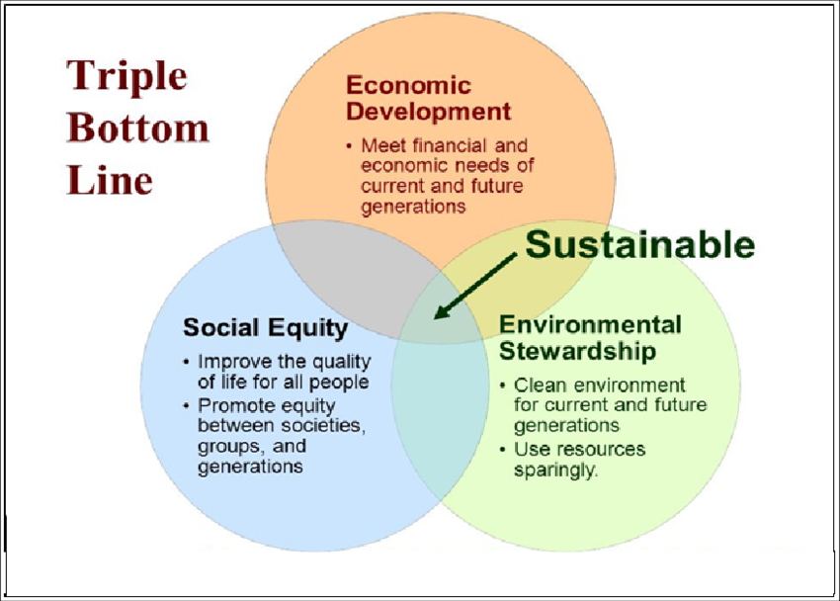
Figure 2: Triple Bottom Line Theory
(Source: Bogale, 2023)
As per the above figure, it can be observed that the presence of the Triple bottom line theory can help in highlighting the sustainability efforts by a business. This can be correlated to the chosen theme, where sustainability is the priority. This includes crucial considerations that must be aligned by hotel and hospitality businesses within the UK.

3. Method

3.1 Research data collection procedures
The data collection process involved in the given case is a secondary data collection process that will include accessing an already published source of information. In this case, it can be noted that the study will be using already published reports, government data, company websites, and peer-reviewed articles. On the other hand, secondary data possesses the risk of including outdated data. It can contain bias of the author, which can impact the quality of the insights obtained.

3.2 Analytical techniques
The analytical techniques to be used in the given case include a secondary thematic analysis that will include developing themes based on the objectives of the research (Gregory and Williamson, 2022). Socaci (2020) also stated that this would be useful in determining meaningful insights. With the help of thematic analysis, it would be possible to derive insight associated with implementing sustainability (Nyoni, 2025). It is also helpful for waste management in the hotel business (Alexander Danzer, 2025).

3.3 Any tools or frameworks used.
In this case, a PEST framework has been used that includes four distinct factors, namely ‘Political,’ ‘Economic,’ ‘Social’ and ‘Technology’ (Mwogosi and Mambile, 2025). The PEST framework is an effective tool for identifying the macro environmental factors associated with the Welbeck Hotel. The findings can help align the data with the findings of Alexander Danzer (2025) and highlight how food waste can incur losses for the business. This aligns with the objectives of the presence of sustainable processes in the case of the hospitality industry, which can further fine-tune the processes. This could be crucial in providing a strategic direction for the business in managing its risks and capitalising on its potential opportunities.

4. Theme impact analysis

4.1 PEST analysis
Factors | Details
Political | - The political stability index within the UK is low, with the latest value being 0.51, indicating a volatile political situation which can affect policies and funding (Theglobaleconomy.com, 2026).  - Post-Brexit legislation has resulted in increased prices of labour and other operational costs within the UK, leading to inflated operational prices for the Welbeck hotel (Portes and Springford, 2023).
Economic | - The rate of inflation within the UK is 4.1%, which can lead to an increase in operational costs and reduce overall profitability (ONS.gov.uk, 2026).  - The presence of financial savings due to green adoption within the operations at Welbeck hotel can help in effective waste disposal processes.
Social | - Within the UK hospitality industry, boarders and guests prefer eco-friendly and sustainable services within the business.  - The Building Research Establishment Environmental Assessment Method (BREEAM) certification obtained by the Welbeck hotel places it at a competitive advantage due to its eco-friendly image (Welbeckhotel.com, 2026).
Technology | - The hotel industry is adopting tools that include digital tracking systems that can be critical in tracking waste generated in the business.  - Collaborating with a third-party service provider such as Veolia can ensure that the hotel can manage its waste effectively (Veolia.co.uk, 2026).
Table 1: PEST analysis of Welbeck hotel
The above table highlights the PEST analysis framework being applied in the case of the Welbeck hotel. On the other hand, it can be observed that while political and economic elements might pose significant risks which can be leveraged by the business in achieving operational excellence. Hence, as per the table, it can be agreed upon that the presence of a competent brand image associated with the sustainability of the brand could be effectively leveraged. At the same time, it can be used to highlight the operational excellence associated with the brand.

4.2 Industry examples
The hotel and hospitality industry within the UK has been developing strategies which include the inclusion of a circular economy within its operations. Multiple leading brands, such as Whitbread PLC, have implemented strategies that can initiate waste reduction within their operations (Cdn.whitbread.co.uk, 2026). This includes diversion of waste from landfills and meals donated to charity to ensure minimal wastage. Apart from this, the government has been implementing regulations that include an initiative named ‘Waste Prevention Programme for England’ (Consult.defra.gov.uk, 2026). This initiative proposes actions which could be helpful towards managing the resources and waste as per the waste management hierarchy. This also includes prevention of waste, among other aspects.
The initiative has been aimed towards an increase in the reuse, repair, and remanufacturing of existing products. This can be applied in the case of the hospitality industry of the UK, which can follow up on the implemented guidelines. In addition to this, the industry has been auditioning food waste tracking software as well. Companies such as Winnow have been developing solutions that fuse AI with food waste tracking (Winnowsolutions.com, 2026). This would be helpful for companies such as Welbeck in tracing their food waste and identifying points at which it could be prevented.

4.3 Levels of impact (strengths and weaknesses)

4.3.1 Strengths
One of the strengths in this case includes that the provisions made in the government initiatives could help the hotels in following a blueprint. With this, it will be possible to make sure that the operators are briefed based on these guidelines to align their work accordingly. With technology such as Analytics being used, smaller hotel operators such as Welbeck can use the same to enhance their food tracking capabilities.

4.3.2 Weaknesses
While some companies, such as Whitbread, have taken active steps in ensuring that the circular economy is maintained, there is no joint consensus on what is to be done to align the operations with the circular economy. In addition to this, the government has not passed any concrete legislation associated with food wastage within hotels.

4.4 Theoretical application
A circular economy is a concept focused on reducing waste and recycling elements that includes operational waste and aims to generate the highest economic value possible (Balaram, 2024). In this case, it can be used in making sure that the hotels can recycle their waste and ensure that the business is maximally profitable.
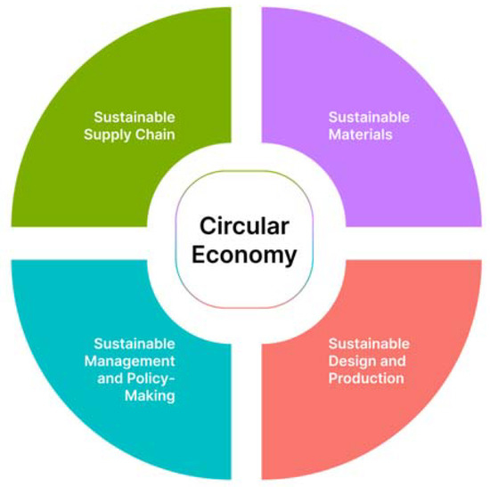
Figure 3: Circular economy considerations
(Source: Kazakova and Lee, 2022)
Considering the circular economy within the UK, boutique hotels are crucial in making sure that the business maintains the three important aspects of sustainability. By adopting sustainability and maintaining the value for its stakeholders as well. Based on these findings, it could be noted that the presence of a circular economy can effectively manage waste within the business (Kazakova and Lee, 2022). This could be helpful for the hotel management in achieving a balance between profitability and sustainability. Welbeck can focus on sustainable design and production, and in turn could be used in expanding the same towards the supply chain as well.

5. Conclusion
Sustainability is the concept of meeting the present needs of a business by reducing its overall impact on the environment. With the help of waste management, it is possible to implement social equity, economic development, and environmental stewardship. The hospitality industry within the UK has been in dire need of controlling its waste generation, as it would be useful in controlling the overall costs. On the other hand, implementing sustainable initiatives cannot ensure that the overall operational costs are reduced. This can be ensured by adopting strategies which are feasible and easier to implement on a smaller scale. In this case, insights would be obtained based on the use of secondary qualitative data. This can assist in highlighting the role of waste management in sustainability implementation.

6. Recommendations

6.1 Implementing advanced analytics software.
Welbeck hotel management can consult with companies such as Winnow and Veolia in developing robust, customised solutions which could be implemented within the property. The presence of these solutions can help in examining the waste generated from functional areas such as the kitchen by tracking the lifecycle of the waste, which is generated (Khan and Ahmad, 2022). Analytics-based functionality of software such as Winnow can be used, which could provide periodic reminders. These reminders can be generated in the form of reports, which can be produced for the managers to make decisions based on actionable insights. The solutions can also provide dashboards, which can include data visualisation tools such as pie charts, which can provide real-time updates to the management team (Winnowsolutions.com, 2026). The ‘Winnow action’ feature could be critical in making sure that the past historical data of the waste generation can be used in generating plans for avoiding food waste.

6.2 Follow up on government guidelines.
The implementation of sustainability within the business operations can be made possible by following up on the provisions. These can be included in programmes such as the Waste Prevention Programme for England. Based on the findings associated with the study, this could be critical in guiding the use of resources within the property and determining the best viable option for the implementation of waste management (Gov.uk, 2026).
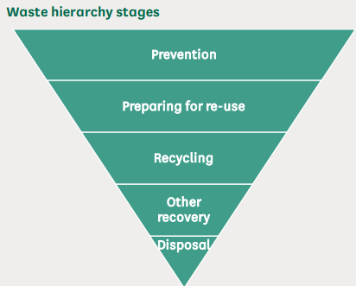
Figure 4: Waste Hierarchical Framework
(Source: Researchbriefings.files.parliament.uk, 2026)
Currently, the government in the UK uses a 'Waste Hierarchy Framework' to fight against the food waste challenge all over the nation. It involves five distinct stages, such as 'Prevention', 'Preparing for Re-use', 'Recycling', 'Other Recovery' and 'Disposal' (Researchbriefings.files.parliament.uk, 2026). This can be pivotal in reducing the generation of waste and can guide the line managers effectively in implementing circular economy concepts at the ground level.

6.3 Implementing sustainability centric campaigns.
Within the UK, various hospitality companies such as Whitbread and Premier Inn have been found to be adopting a sustainable approach as part of their business strategy. It has been noted that most of the sales and taxes within the industry are generated from these campaigns. Welbeck hotel can take insights and develop advertising campaigns for both online and offline consumers, and can highlight its existing commitment towards sustainable cities, such as the BREEAM certification. This can be helpful for the company in generating maximised revenues with the help of attracting more consumers. Targeted advertising campaigns can be developed on popular social media websites within the UK, such as Facebook and Instagram (Boulianne, Hoffmann and Bossetta, 2025). This can offer more specifications for the customers to be targeted by the company.

7. References
- Balaram, V., (2024) ‘Sustainable recovery of rare earth elements by recycling of E-waste for a circular economy: perspectives and recent advances. Environmental Materials and Waste, pp.499-544. DOI: https://doi.org/10.1016/B978-0-443-22069-2.00023-1
- Boulianne, S., Hoffmann, C.P. and Bossetta, M., (2025) ‘Social media platforms for politics: A comparison of Facebook, Instagram, Twitter, YouTube, reddit, snapchat, and WhatsApp’. New Media & Society, 27(11), pp.6006-6037. DOI: https://doi.org/10.1177/14614448241262415
- Cdn.whitbread.co.uk (2026) Enabling people to live and work well. Available at: https://cdn.whitbread.co.uk/media/2025/05/Whitbread-PLC-Environmental-Social-and-Governance-Report-2024-25.pdf#:~:text=These%20are%3A%20climate%20change%2C,and%20quality%2C%20and%20corporate%20culture. (Accessed: 07 February 2026).
- Chkoniya, V. (ed.) (2021) Handbook of research on applied data science and artificial intelligence in business and industry. Hershey, Pennsylvania: IGI Global.
- Clegg. S.R, Skyttermoen. T. Vaagaasar. A.L, (2021) Project Management: A Value Creation Approach. Sage, London.
- Consult.defra.gov.uk (2026) Consultation on the Waste Prevention Programme for England: Towards a Resource-Efficient Economy. Available at: https://consult.defra.gov.uk/waste-and-recycling/waste-prevention-programme-for-england-2021/ (Accessed: 02 February 2026).
- Cooper, C. and Hall, C.M. (2023) Contemporary tourism: an international approach. 5th ed. Oxford: Goodfellow Publishers Limited.
- Goffi, G., Masiero, L. and Pencarelli, T., (2022) ‘Corporate social responsibility and performances of firms operating in the tourism and hospitality industry’. The TQM Journal, 34(6), pp.1626-1647. DOI: http://doi.org/10.1108/TQM-06-2021-0166
- Gov.uk (2026) The waste prevention programme for England: Maximising Resources, Minimising Waste. Available at: https://www.gov.uk/government/publications/waste-prevention-programme-for-england-maximising-resources-minimising-waste/the-waste-prevention-programme-for-england-maximising-resources-minimising-waste (Accessed: 05 February 2026).
- Gregory, A. and Williamson, E., (2022) ‘I think it just made everything very much more intense: a qualitative secondary analysis exploring the role of friends and family providing support to survivors of domestic abuse during the COVID-19 pandemic’. Journal of Family Violence, 37(6), pp.991-1004. DOI: https://doi.org/10.1007/s10896-021-00292-3
- Khan, A.U.R. and Ahmad, R.W., (2022) ‘A blockchain-based IoT-enabled E-waste tracking and tracing system for smart cities. IEEE Access, 10, pp.86256-86269. DOI: https://doi.org/10.1109/ACCESS.2022.3198973
- Khatter, A., (2023) ‘Challenges and solutions for environmental sustainability in the hospitality sector’. Sustainability, 15(15), p.11491. DOI: https://doi.org/10.3390/su151511491
- Mwogosi, A. and Mambile, C., (2025) ‘Applying PEST analysis to evaluate the adoption of electronic health records in Tanzanian healthcare: A scoping review’. Digital Health, 11, p.20552076251334029. DOI: 10.1177/20552076251334029
- Nyoni, R., (2025) ‘Harnessing Data Analytics for Predictive Insights: Advancing Decision-Making with Big Data Innovations’. Int. J. Res. Publ. Rev, 6, pp.2915-2936. Available at: https://www.researchgate.net/profile/Rumbidzai-Nyoni/publication/388384621_Harnessing_Data_Analytics_for_Predictive_Insights_Advancing_Decision-_Making_with_Big_Data_Innovations/links/67951f43207c0c20fa5a6680/Harnessing-Data-Analytics-for-Predictive-Insights-Advancing-Decision-Making-with-Big-Data-Innovations.pdf
- ONS.gov.uk (2026) Consumer price inflation, UK: August 2025. Available at: https://www.ons.gov.uk/economy/inflationandpriceindices/bulletins/consumerpriceinflation/august2025 (Accessed: 27 January 2026).
- Portes, J. and Springford, J., (2023) ‘The impact of the post-Brexit migration system on the UK labour market’. Contemporary Social Science, 18(2), pp.132-149’. DOI: https://doi.org/10.1080/21582041.2023.2192516
- Researchbriefings.files.parliament.uk (2026) Food waste in the UK. Available at: https://researchbriefings.files.parliament.uk/documents/CBP-7552/CBP-7552.pdf (Accessed: 10 February 2026).
- Socaci, S.A. (ed.) (2020) Food preservation and waste exploitation. London, England: IntechOpen.
- Theglobaleconomy.com (2026) United Kingdom: Political stability. Available at: https://www.theglobaleconomy.com/United-Kingdom/wb_political_stability/ (Accessed: 27 January 2026).
- Ukhospitality.org.uk (2026) Economic contribution of hospitality. Available at: http://ukhospitality.org.uk/insight/economic-contribution-of-hospitality/ (Accessed: 02 February 2026).
- Veolia.co.uk (2026). Waste Management. Available at: https://www.veolia.co.uk/services/waste-management?utm_source=google+ads&utm_medium=cpc&utm_campaign=waste+management+p-max&utm_id=waste+25&gad_source=1&gad_campaignid=23256185418&gbraid=0AAAAACXkBoeApHhjxjyftL6rl9vOiT3yb&gclid=CjwKCAiAssfLBhBDEiwAcLpwfl8QdJG4cfb7UbH4UBCkwD_ldrXv9A2R3MC3yX3hoaFilx5qRBJV8hoCDjkQAvD_BwE (Accessed: 03 February 2026).
- Wavei, E. B., Lo, A., and Gedecho, E. K. (2025) ‘Understanding Frontline Employees Knowledge Management in Key Aspects of Customer Relationship Management: Insights from Contemporary Hotels’. International Journal of Hospitality & Tourism Administration, 1-29.
- Welbeckhotel.com (2026) Sustainability. Available at: https://thewelbeckhotel.com/sustainability/ (Accessed: 19 January 2026).
- Winnowsolutions.com (2026) Food waste tracking analytics for commercial kitchens. Available at: https://www.winnowsolutions.com/product/food-waste-tracking-system (Accessed: 28 January 2026).
- Wrap.ngo (2026). WRAP urges hospitality and food service CEOs and leaders to take a stand against food waste. Available at: https://www.wrap.ngo/media-centre/press-releases/wrap-urges-hospitality-and-food-service-ceos-and-leaders-take-stand (Accessed: 30 January 2026).
- Xu, S., Shirowzhan, S. and Sepasgozar, S.M., (2023) 'Urban waste management and prediction through socio-economic values and visualising the spatiotemporal relationship on an advanced GIS-based dashboard'. Sustainability, 15(16), p.12208. DOI: https://doi.org/10.3390/su151612208

