Student Name: Adji Makangila
Student ID: 2126238
Module Title: MSc Public Health and Social Care in Practice
Module code: LCHS7009
Lecturer: Dr Besty Jose
Assignment Title: Digital Health Technologies Poster

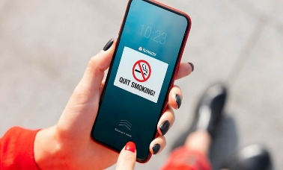
NHS Quit Smoking App: A Digital Health Intervention to Address Smoking Cessation Inequalities in the UK

Introduction
Smoking remains one of the leading causes of preventable illness, death, and health inequalities in the UK, accounting for around 74,600 deaths annually and costing the NHS approximately £1.9 billion per year. Current prevalence among adults is 12.9%, with marked disparities in rates among socio-economically disadvantaged populations and those with mental health conditions. Existing smoking cessation interventions include pharmacotherapy, NHS Stop Smoking Services (SSS), and recent digital initiatives such as apps and online support. The NHS Quit Smoking app offers free 24/7 digital support, daily coaching, motivation, and progress tracking through a tailored 28-day programme. It aims to reach users who may be unable or reluctant to access traditional services, especially those affected by digital health inequality or social barriers.


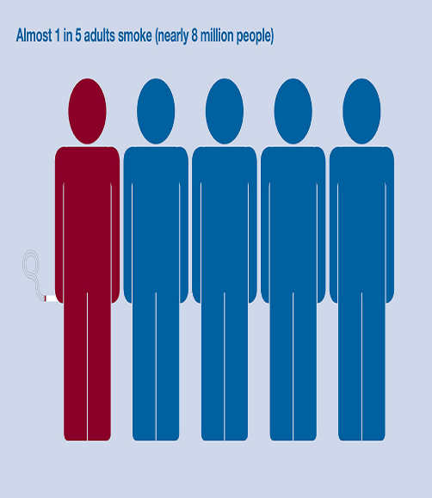

Health Promotion Principles and Values
Effective health promotion prioritises values such as equity, empowerment, cultural sensitivity, accountability, and safety. The NHS Quit Smoking app aligns with these principles by providing free, confidential, and personalised cessation support to all, reducing health inequalities. Empowerment is central, as users maintain control over their quit journey and receive tailored advice that respects cultural and individual differences. Accountability is ensured through compliance with NICE guidelines and integration of current best practices. The app also supports sustainability by promoting long-term behavioural change and is designed for continuous improvement based on user feedback and research.

Behavioural Change Theory

Expected Outcome
The use of robust behaviour change theory within the NHS Quit Smoking app is expected to increase quit attempts and success rates while enhancing user satisfaction. Personalised feedback and motivational tools support ongoing engagement, making relapse less likely and promoting continuous abstinence. Studies show increased self-efficacy and empowerment among app users, with positive outcomes seen across diverse population groups. Through its focus on accessibility and tailored interventions, the app helps bridge digital health inequalities, ensuring more equitable outcomes. Genuine improvement depends on ongoing evaluation and responsiveness to user needs and feedback.


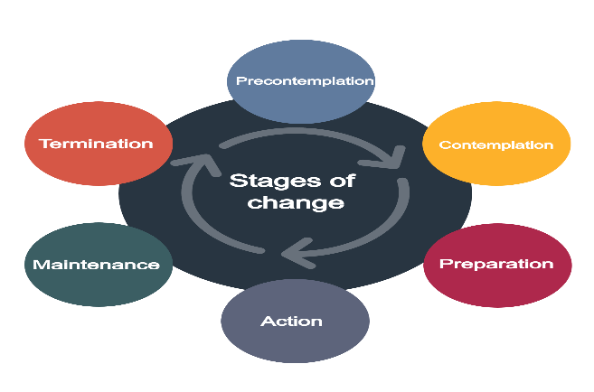
The NHS Quit Smoking app is shaped by the Behaviour Change Wheel (BCW) and Persuasive System Design (PSD) frameworks to increase capability, opportunity, and motivation. The BCW helps identify barriers such as lack of knowledge, opportunity, or motivation and select effective interventions like goal setting, reminders, and feedback. PSD provides motivational features such as gamified rewards, tracking, and social support, known to reinforce changes and sustain engagement. The app uses self-monitoring, progress visualisation, and adaptive messaging to address the diverse needs and readiness levels of users. Real-time feedback and digital nudges create a supportive environment, reducing relapse risks and promoting long-term cessation. Evidence shows that digital interventions with strong theoretical bases are more effective in fostering sustained behavioural change, particularly when personalised for each user.

Conclusion
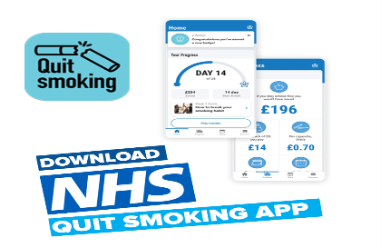

Digital health interventions, such as the NHS Quit Smoking app, reshape the way public health challenges are addressed and have significant implications for policy, education, and research. Policymakers must prioritise digital equity and ensure safe, ethical deployment of these tools. Educational programs should integrate digital literacy and empower service users with the skills to access and make the most of digital interventions. Ongoing research is needed to evaluate effectiveness, uncover best practices, and develop innovative solutions in digital health. Ultimately, such interventions play a crucial role in reducing health inequalities and promoting population-level well-being.

References
Agrawal S. (2024). NHS treatments for smoking cessation. Available at : https://www.england.nhs.uk/author/professor-sanjay-agrawal/( Accessed on: 25 October 2025).
Bilal S. et al. (2020). User-Centric Adaptive Intervention model. Available at : http://uclab.khu.ac.kr/resources/publication/J_279.pdf (Accessed on: 26 October 2025).
BMJ Open (2023). Digital health interventions: theoretical frameworks. https://doi.org/10.1136/bmjopen-2020-037643
Ferretti A. (2024). Digital tools for youth health promotion: principles, policies, and regulatory frameworks. Health Promotion International, 39(2). https://doi.org/10.1093/heapro/daae030
Frontiers in Psychology (2023). Potential associations between behaviour change techniques and intervention outcomes. https://doi.org/10.3389/fpsyg.2023.1227443
Khan S. (2019). Smoke Free App Smoking Cessation Study. NHS Health Research Authority. Available at: https://www.hra.nhs.uk/planning-and-improving-research/application-summaries/research-summaries/smokefree/ Accessed on: 26 October 2025).
Merino M. et al. (2024). Value-based digital health: A systematic literature review. PMC. https://doi.org/10.1177/20552076241277438
Michie S., Oinas-Kukkonen H., Harjumaa M. et al. (2011). Behaviour Change Wheel and Persuasive System Design. https://doi.org/10.17705/1CAIS.02428
NHS (2025). Quit smoking – Better Health – NHS. Available at : https://www.nhs.uk/better-health/quit-smoking/ ( Accessed on: 25 October 2025).
NIH (2024). Effectiveness of the Smoke Free Smartphone App. PMC. https://doi.org/10.2196/50963
Stark AL. et al. (2022). Digital health promotion and prevention in settings. PMC. https://doi.org/10.2196/21063
Winters N. (2020). Prioritarian principles for digital health in low-resource settings. BMJ Medical Ethics. https://doi.org/10.1136/medethics-2019-105468.
Amanda Koh, De Wet Swanepoel, Annie Ling, Beverly Lorraine Ho, Si Ying Tan, Jeremy Lim. (2021). Digital health promotion: promise and peril. Oxford Academic. https://doi.org/10.1093/heapro/daab134
Jarvis S. (2024). Evidence-based NHS stop smoking app. GOV.UK. Available at: https://www.gov.uk/government/publications/smoking-and-tobacco-applying-all-our-health/smoking-and-tobacco-applying-all-our-health ( Accessed on: 25 October 2025)
Oyebode, O., Ndulue, C., Alhasani, M., Orji, R. (2020). Persuasive Mobile Apps for Health and Wellness: A Comparative Systematic Review. In: Gram-Hansen, S., Jonasen, T., Midden, C. (eds) Persuasive Technology. Designing for Future Change. PERSUASIVE 2020. Lecture Notes in Computer Science(), vol 12064. Springer, Cham. https://doi.org/10.1007/978-3-030-45712-9_13.

