Student Name: Callum Cross
Student Number: 1705149
Lecturer Name: John Rees & Mabrouka Abuhmida
Module Name: Smart and Connected Devices 2
Internet of Things – Smart Cities Applications
Module Code: ACDA6005

Table of Contents
Abstract 1
Introduction 2
The Effects of Pollution 3
The Solutions to Pollution 3.1
The Effects of Greenhouse Gasses 4
The Solution to Greenhouse Gasses 4.1
Conclusion 5
Device and Web Server Design 6
The Idea 6.1
Arduino Nano V3 6.2
ESP-8266 Wi-Fi Module 6.3
DHT-11 Temperature and Humidity Sensor 6.4
MQ-2 Emissions Sensor 6.5
Web Server ASP.Net MVC 6.6
Implementation 7
Arduino Implementation 7.1
DHT-11 Sensor Implementation 7.2
MQ-2 Sensor Implementation 7.3
HTTPS Post Request 7.4
Web Server Implementation 7.5
Improvements 8
Conclusion 9
List of Figures and Tables 10
References 11

Abstract (1)
This report will show the understanding of both pollution and the greenhouse effect and how cities are leveraging the benefits of technology and digitization to combat these harmful effects, the report will also show the effects that these create and the consequences that follow these types of problems within countries and cities across the globe.
Finally, this report will document a design and implementation of an application that could be deployed to monitor cities pollution growth and greenhouse gasses and could be a solution to keeping track of the current progress to combating the problem. The student will conclude by showing the improvements that the project could have, to be more feasible in a real-world scenario and the conclusion of the project.

Introduction (2)
Pollution is the introduction of contaminants into the environment that can cause adverse change. Pollution can form in many components of chemical substances and energy, some examples of these chemicals and energy include heat, noise and light. Air Pollution can naturally kill up to 40,000 people a year at the current exposure. [1]
The greenhouse effect is the process in which the radiation within the earth’s atmosphere naturally and slowly warms the planet’s surface and oceans above what it normally would be without an atmosphere. Gases created by this effect are called “greenhouse gasses” which radiate energy in all directions. The radiation that is kept within the planet’s atmosphere depends on two factors, one the intensity of the downward radiation that is, the strength of the greenhouse effect and two the amount of current greenhouse gasses that the atmosphere contains. [2]
Keeping control over pollution and the greenhouse effect is both hard to monitor and maintain, this is mainly because of the way we can’t clearly see the effects over a short period of time but only over longer terms as the elements that it changes are miniscule when looked over shorter periods. If we look at the problem and changes over longer periods you will start to understand the actual effects that it can create and the devastating destruction it can cause to a planet if not monitored/controlled.

The Effects of Pollution (3)
The air is the first to be affected when there is an increase in pollution whether this would be in the air or water. The increase in the amount of Carbon Dioxide in the atmosphere can lead to a mixture of fog and smoke which can in turn start to create “Smog”, when exposed to smog over long periods of months or years can cause severe health problems e.g. difficulty breathing/lung problems, asthma and chest irritation. [3]
Land is most likely to be affected next especially acreage where the creation of pollution is being created. This is mainly because as pollution is being created and released into the air these particles can start forming clouds, once these clouds have fully formed these clouds can start collecting water vapor that will turn to rain but when mixed with a cloud that has been exposed to pollution this rain can affect the plants, fruits, vegetables, rivers and animals that live below.[3]
Noise pollution can cause anxiety, headaches, hearing loss and loss of sleep which could possibly result in decreased productivity, especially in areas that contain large equipment which in turn produce noise pollution.
Light pollution can also cause strain on eyes effecting the quality of life, light pollution can also affect mammals, insects, birds and reptiles, light can interfere with natural behaviours such as movement, mating and growth therefore can cause a decrease in wildlife population.

The Solutions to Pollution (3.1)
Over the last several years, climate activists and scientists have expressed and urged the need for support on pollution management in order to stop and control the damaging effects before it gets out of our control. Responding to pollution is a challenge that could possibly save lives in the near future and unlock economic opportunity through action at a local and global scale.
Some cities are starting to use advanced techniques to increase efforts for cleaner air. Each approach varies: Chicago in the United States of America has started to implement sensors across their city using a sophisticated network of both Temperature and Gas Sensors built around the city that will allow government officials to make decisions based on data collected in real-time. Louisville, which is also in the United States, has adopted a different strategy and has started giving citizens inhalers that can measure the pollution in the current vicinity and relay that information back to the city. [4]
Pollution overall needs to be dramatically reduced as it is destroying the natural environment that we thrive and live in. It is the responsibility of every living person to protect this environment, and with the ever increase of population the quicker we can control and manage this problem the better off we will be in the future.

Firstly, a sensor that would be beneficial to this problem would be an Air Pollution sensor that can detect the current pollution floating across within the atmosphere. This will allow governments to find the exact pollution spread across cities or even countries, therefore will allow governments to produce data that will allow them to see which cities and areas contribute to pollution the most and can take action.
Finally, the sensor that would be advantageous to reducing pollution would be a temperature and humidity sensor that can detect the current aridity of the air in the vicinity and be able to detect the heat being trapped by pollution. This kind of data would allow professionals to pinpoint which parts of their cities and countries are suffering the most from pollution and how they reduce the temperature to a more reasonable level.

The Effects of Greenhouse Gasses (4)
The main effect of greenhouse gasses is the increase of surface and air temperatures as these gasses become more populated in the atmosphere the steadily increase of temperature will start to rapidly degrade the glaciers which in turn will lead to a steady global rise of sea level which will create disasters for towns and cities that are at low levels of altitude by creating floods. [5]
The second impact from these gasses is on the weather itself, in the last 10-15 years hurricanes and weather patterns have become larger and more unpredictable which have been creating greater cause of concern for countries that frequently suffer from weather disasters which could lead to destroying small islands to large cities which could affect economical funds and growth. [5]
As greenhouse gases get trapped within the atmosphere the steadily increase of temperature on earth will lead to colder environments especially the continents similarly to North and the South pole where animals that thrive there might have their natural habitat destroyed by the ever increasing temperature this could inevitably lead to a lot of creatures becoming distinct.

The Solutions to Greenhouse Gasses (4.1)
Cities are using more sentimental approaches to producing energy by using Nuclear Power Plants and Hydroelectricity to produce energy in a much cleaner environments without the consequences of producing these harmful gasses. Cities have also started putting more resources into creating more solar farms to produce energy from natural winds and weather. [6]
Large cities are starting to move towards electrical transport systems as these will decrease the amount of carbon emissions being created by early creations of these transport systems that would use the typical internal combustion engine which is now considered one of the most pollutant sources. Electrical energy is reusable and produces little to no gasses compared to the traditional use. [7]

By increasing the need for recycling the materials that cities use, will decrease waste that we use every year by a significant amount. Developing safe renewable energy will allow cities to decrease the amount of greenhouse gasses that is put into the atmosphere as most pollution currently being put into the environment is from energy creation.

A sensor that could possibly be beneficial to greenhouse gasses would be an infrared sensor that can detect radiation in its surrounding environment this would allow for temperature readings from the light produced from this radiation which could lead to readings from both ground and air temperatures.

Conclusion (5)
Overall the advancements and solutions that are being created to control/maintain and maybe even reduce the greenhouse gasses and pollution that is being created and at the speed it is being formed are not being used enough across the globe, this is mainly because only larger more successful countries that have the finance backing to both develop and deploy these kinds of techniques are doing so.
This shows that less fortunate countries must rely on using these old-fashioned techniques to produce the energy and resources needed for their country whilst at the same time contributing to the large pollution and greenhouse gas problems.
The next part of the report will show the design and implementation of a monitoring system that countries and cities could use to display and combat this problem in a more meaningful way.

Device and Web Server Design (6)
This part of the report will explain a solution that was designed and implemented to combat both pollution and greenhouse gasses we will look at what tools and services were used to create the solution and what decisions were made to create the final product. This section will also look at what the student changes would have been if they could have restarted the project and how they felt the outcome that they had could have been any different.

The Idea (6.1)
The student came up with an idea of a monitoring system that used a small Arduino device that could be placed anywhere around the world with an external source of electricity and be able to send data to a monitoring system through a network that could be displayed on a webpage where the data can be seen in an intuitive graph. The Arduino would keep track of data in the vicinity for the following, temperature, humidity, heat index, dewpoint and natural gasses that are the main causes of pollution and greenhouse gasses.
With this information governments and the public people would be able to keep track of the current measures of pollution and gasses and be able to keep track on which locations and cities would need the most help to reduce these effects.

Arduino Nano V3 (6,2)
The main piece of hardware more commonly known for being the brain of the operation is an Arduino Nano V3 that can allow multiple sensors to be attached at one time and be able to easily send data using its built in Wi-Fi Module. Arduino allows us to programmatically create a device that can act as a monitoring device when attached to practical sensors.
This device will allow the student to receive data from the sensors attached and be able to process that data onwards to their monitoring system that would keep track of the data over long periods of time.

ESP-8266 Wi-Fi Module (6.3)
A built-in module with the Arduino Nano V3 is Wi-Fi that allows communication to the World Wide Web and this module will be primarily used for sending data from the device to the monitoring system that is being hosted on a Web Server via an API.
The Wi-Fi module allows both HTTP(Hyper Text Transfer Protocol) and HTTPS communication but the student decided to choose HTTPS as its communication with the web server is secure and the data being sent back and forth will be encrypted at all times stopping intruders from easily getting data from the packets currently in transit or on arrival, opposed to HTTP that simply sends plain text to the server allowing hackers to steal valuable information from both the server and client.

DHT-11 Temperature and Humidity Sensor (6.4)
The second module to be attached to the device was a DHT-11 Temperature and Humidity sensor that can detect the current heat in the air around the device and can also detect how dry the air around the device is currently. With both these values of data being collected by the sensor we can then use simple calculations to create both the Dew Point and Heat Index which gives us a better insight into the change of weather over a long period of time.
This sensor overall allows us to keep track of the current greenhouse pollutions by keeping track of the current sensors in a certain area and seeing from the data that is being sent to the monitoring system if there is still a steady increase of temperature.

MQ-2 Emissions Sensor (6.5)
The final module that would be attached and thought about was an MQ-2 sensor, which is extremely sensitive and picks up certain chemicals in the atmosphere and will give a reading of how much a certain chemical has been traced and the strength of the chemical. This allows the device to read data from the following gasses: LPG (Liquified Petroleum Gas), CO2 (Carbon Dioxide) and finally the sensor can detect particles of smoke.

By allowing these sorts of gasses to be detected we can create a graph chart based on this data and will be able to clearly see the presence of Pollution either increase or decrease over a prolonged period as these gasses especially Carbon Dioxide are the main contributions that create the pollution that gets put into our atmosphere.

Web Server ASP.NET MVC (6.6)
The web server will be the main control of all the devices currently in use as all the data will be sent to the web server for processing and displaying the data to the end-users who would like to see it. ASP.NET is the core framework built into the web server that allows use of other frameworks built inside as which one of the examples would be the MVC (Model, View, Controller) Framework.
By using this framework which was developed by Microsoft it allows us to take use of the C# 8.0 language which is also developed by the same corporation and allows the student to take advantage of the latest web technologies currently in both the Web and Technology Sectors. [8]

Implementation (7)
The student felt that with the research that they had completed on the sensors and hardware it was a straightforward implementation process because there were many libraries and documentation on the products that were picked. The implementation process will show how the device was constructed and how the device was correlated to the web server and is able to send data.

Arduino Implementation (7.1)
Arduino the main hardware was able to attach directly to a solderless breadboard which allows the device to power the modules connected to it via USB. This can be seen in Figure 1.0 as this shows both the breadboard and Arduino device implemented and running.

DHT-11 Sensor Implementation (7.2)
DHT-11 sensor was implemented by connecting it via male & female jumper cables that were used for the communication of data and both the voltage and ground connection between the board and device as seen in Figure 1.1.
To produce the data needed to be sent to the Web Server the student used a built-in Library for the device that was created by the manufacturing developers that allowed the student to call simple functions as shown in Figure 2.1 to retrieve the data from the sensor.

MQ-2 Sensor Implementation (7.3)
Just as the DHT-11 sensor the same applied to the MQ-2 sensor as they had similar connections and requirements for use, the only difference was that the MQ-2 sensor received data from the AO Port on the Arduino device.
Sensor data was retrieved the same way with a built Library that was produced by the developers of the sensor and was just as easily received with a few simple function calls as shown in Figure 1.2.

HTTPS Post Request (7.4)
To be able to post data from the device to the web server a HTTPS Post request had to be created for the server to both identify the device and the data it was sending. This post request was created by creating a “HTTPClient” object and passing both a host to send the data to and the fingerprint it would require for the HTTPS request to be accepted by the server. You can see the JSON Data being created and sent in Figure 1.3.

Web Server Implementation (7.5)
The web server was implemented by using ASP.Net MVC Framework, this allowed the student to be able to quickly get data from the database and put them into organised data classes shown in Figure 1.4. [8]
Once the web server received the data it would search through the database to find the device linked with the API-Key received and upload the data retrieved and send it to a table so it can be attached to the device owner. This implementation can be seen in Figure 1.5
Finally, once the data had been sorted to its device owner the end-user can look at that data via a navigable home and details page that would show the current devices currently running and the data they have collected. These pages are shown in Figure 1.6 and Figure 1.7, 1.8.

Improvements (8)
There were little improvements the student would have done as most of the specification they had designed was in place and functioning the way they wanted it to. The student overall felt there could have been slight improvements as talked about below.
The student felt they could have broadened the range of how devices can be searched on the device index page as show in Figure 1.8. They overall felt that there was currently too little information that the end-user could type in and search for the correlating device in the database.
Finally the student felt the final improvement could have been with the chart implementation that they had chosen and used had become harder to distinguish the data being shown the longer that data had been there for especially over longer periods of time as shown in Figure 1.9.

Conclusion (9)
In conclusion the student felt that the monitoring system that they had developed and built had gone extremely well and there wasn’t much they would have changed with the overall project. Finally, the scholar felt that they had gained a lot of insight knowledge into how the Internet of Things communication procedures and protocols worked and that it would help them in their future endeavours.

List of Figures and Tables (10)
Figure 1.0 - Arduino Device Implementation
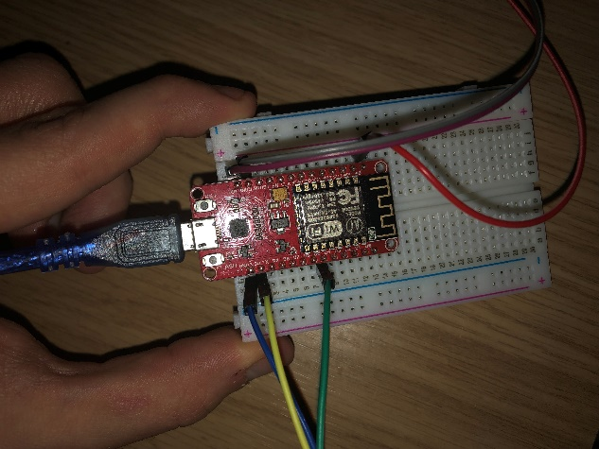
Figure 1.1 - DHT-11 Sensor Implemented
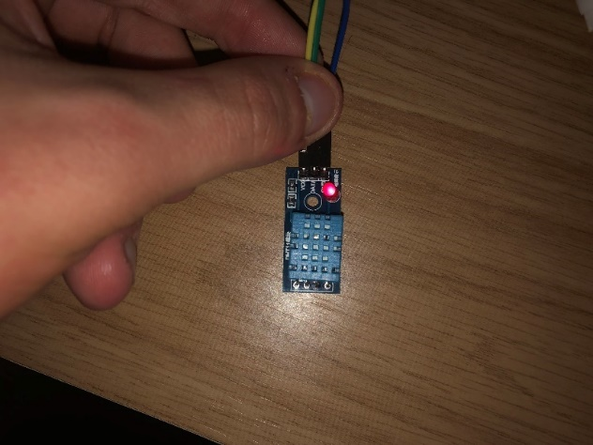

Figure 1.2 – MQ-2 Sensor Implementation
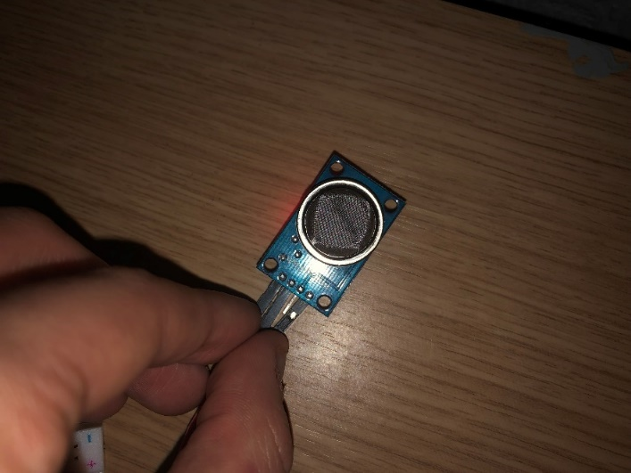
Figure 1.3 – HTTPS Post Arduino Code
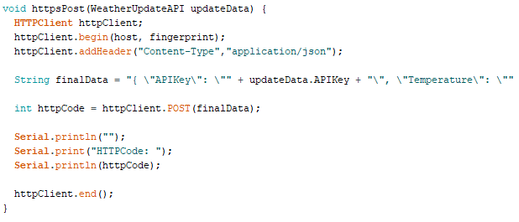
Figure 1.4 – Data Model Class Web Server C#
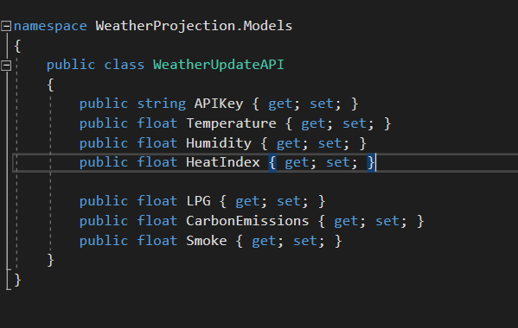

Figure 1.5 – Web Server API Response
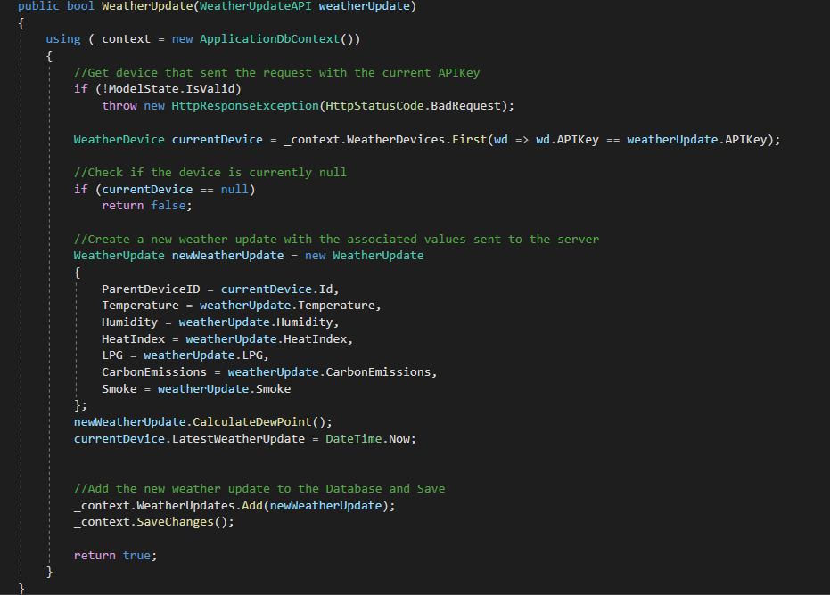
Figure 1.6 – Home Page with Devices Running
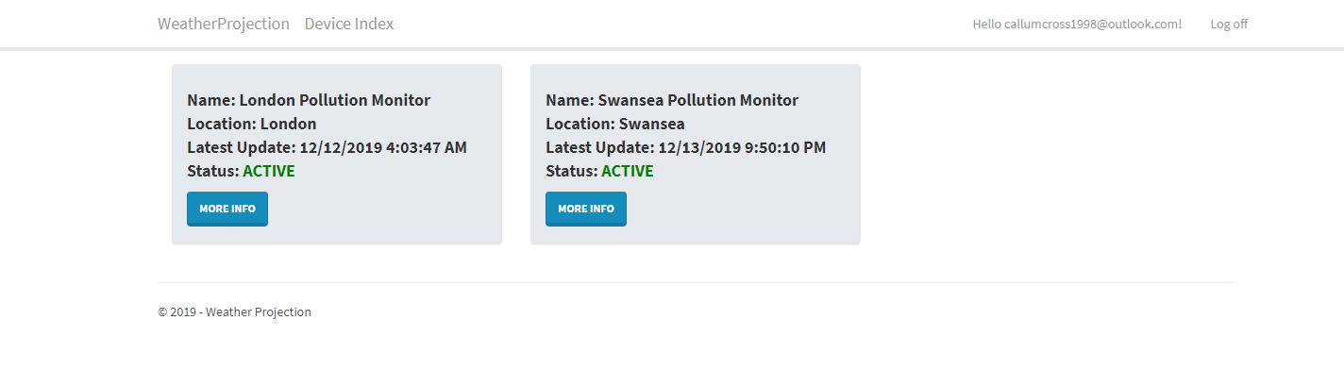
Figure 1.7 – Device Details Page with Graphs
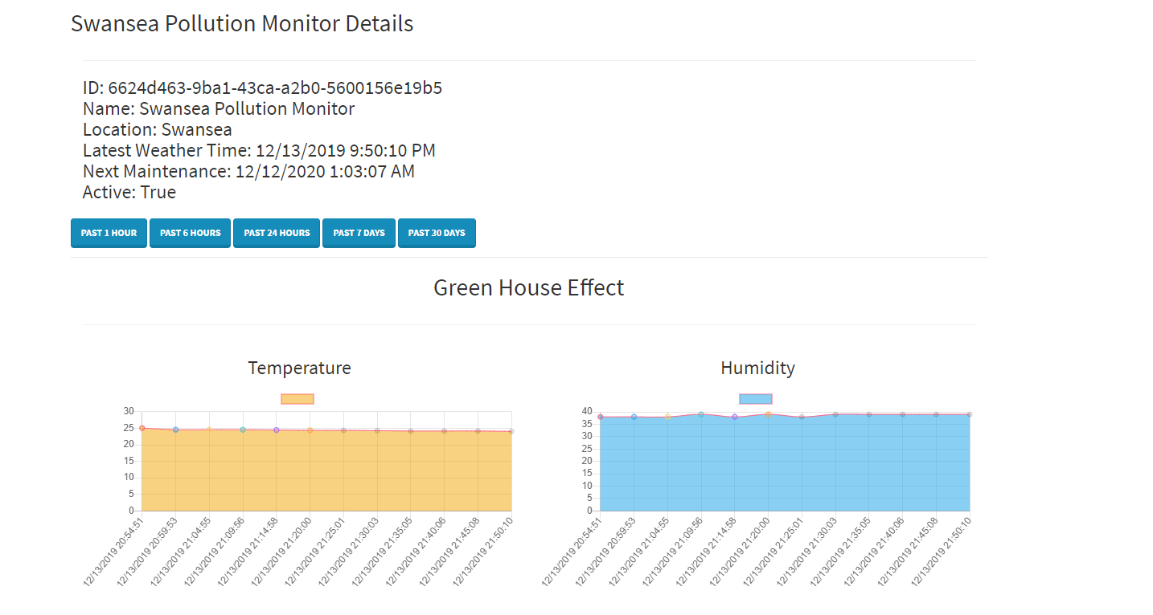
Figure 1.8 – Device Details with Graphs Part 2
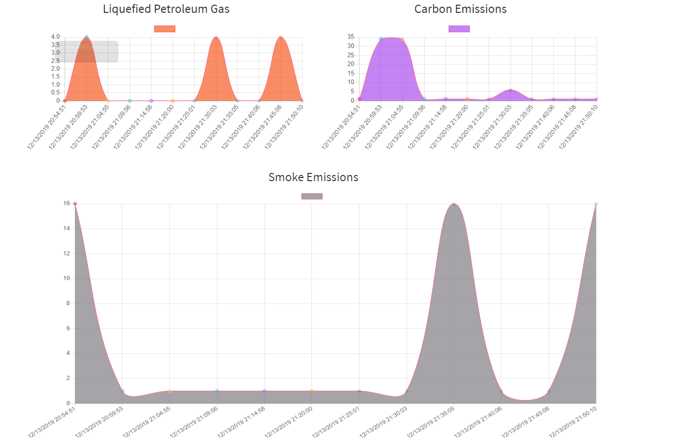
Figure 1.9 – Device Index Page for Searching
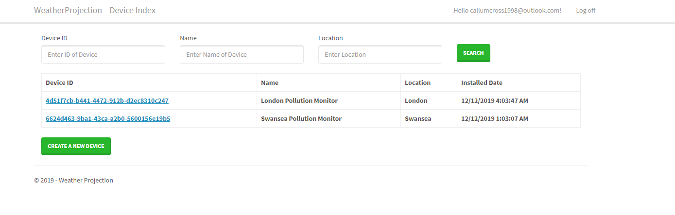

References (11)
[1] NHS.co.uk. (2016, February. 2016). “Air pollution kills 40,000 a year in the UK” [Online]. Available: https://www.nhs.uk/news/heart-and-lungs/air-pollution-kills-40000-a-year-in-the-uk-says-report/
[2] M. Denchak. (2019, July. 16). “Greenhouse Effect 101” [Online]. Available: https://www.nrdc.org/stories/greenhouse-effect-101

[3] C. Gillespie. (2018, June. 11). “Negative Effects of Pollution” [Online]. Available: https://sciencing.com/negative-effects-pollution-5268664.html

[4] C. Bousquet. (2017, April. 19). “How Cities are using the Internet of Things to Map Air Quality” [Online]. Available: https://datasmart.ash.harvard.edu/news/article/how-cities-are-using-the-internet-of-things-to-map-air-quality-1025

[5] M. Lallanila. (2018, March. 8). “What is the Greenhouse Effect?” [Online]. Available: https://www.livescience.com/37743-greenhouse-effect.html

[6] M. Chalmers. (2019, September. 13). “Cities Driving to 100% Renewable Energy” [Online]. Available: https://www.geotab.com/blog/renewable-energy/

[7] L. Wagstaffe. (2019, June. 8). “Four European Cities Leading the way in Eco-Friendly Transport” [Online]. Available: https://www.euronews.com/living/2019/06/07/four-european-cities-leading-the-way-in-eco-friendly-transport

[8] S. Smith. (2019, July. 11). “Overview of ASP.NET Core MVC” [Online]. Available: https://docs.microsoft.com/en-us/aspnet/core/mvc/overview?view=aspnetcore-3.1

