Name | Student Number | Date | Lecturer’s Name | Your score
Shanayah Wellington | 2436522 | 27/06/25 | Ellie | To be filled by the marker  ___/40
You will have 75 minutes to complete this assessment. It is divided into three sections: note-taking, paraphrasing and writing a paragraph.
---------------------------------------------------------------------------------------------------------------------
1. Take diagrammatic notes from the passage below using the space provided:

As a student you've got a lot on your plate - academic work, social life, work commitments, career plans, relationships and finances - sometimes stress can get in the way of this juggling act. When you recognise that you have become overwhelmed with stress, adopt a few strategies to help you manage your triggers more effectively. Those strategies could include exercising; you simply need to get your heart racing, for example by going for a brisk walk or a bike ride. Another suggestion is to try mindfulness, a relaxation technique originating in Buddhism. It is used by clinicians to improve patients' physical and mental health as it can significantly lower stress levels. Thirdly, why not speak to your friends and family - they know you best and care about you the most. What's more, studies suggest that socialising with a friend just once a week can reduce your stress levels and improve your mood as much as therapy or counselling. Simple time management techniques can also help you to feel more relaxed and focused. Try creating a written schedule, breaking your tasks down into manageable chunks, planning accordingly and allocating yourself time every day to relax or socialise. Finally, an obvious but often overlooked solution: get enough sleep, as no one functions at 100% when they're tired.
Adapted from: https://www.prospects.ac.uk/applying-for-university/university-life/5-ways-to-manage-student-stress

Space for your notes (max 12 marks):
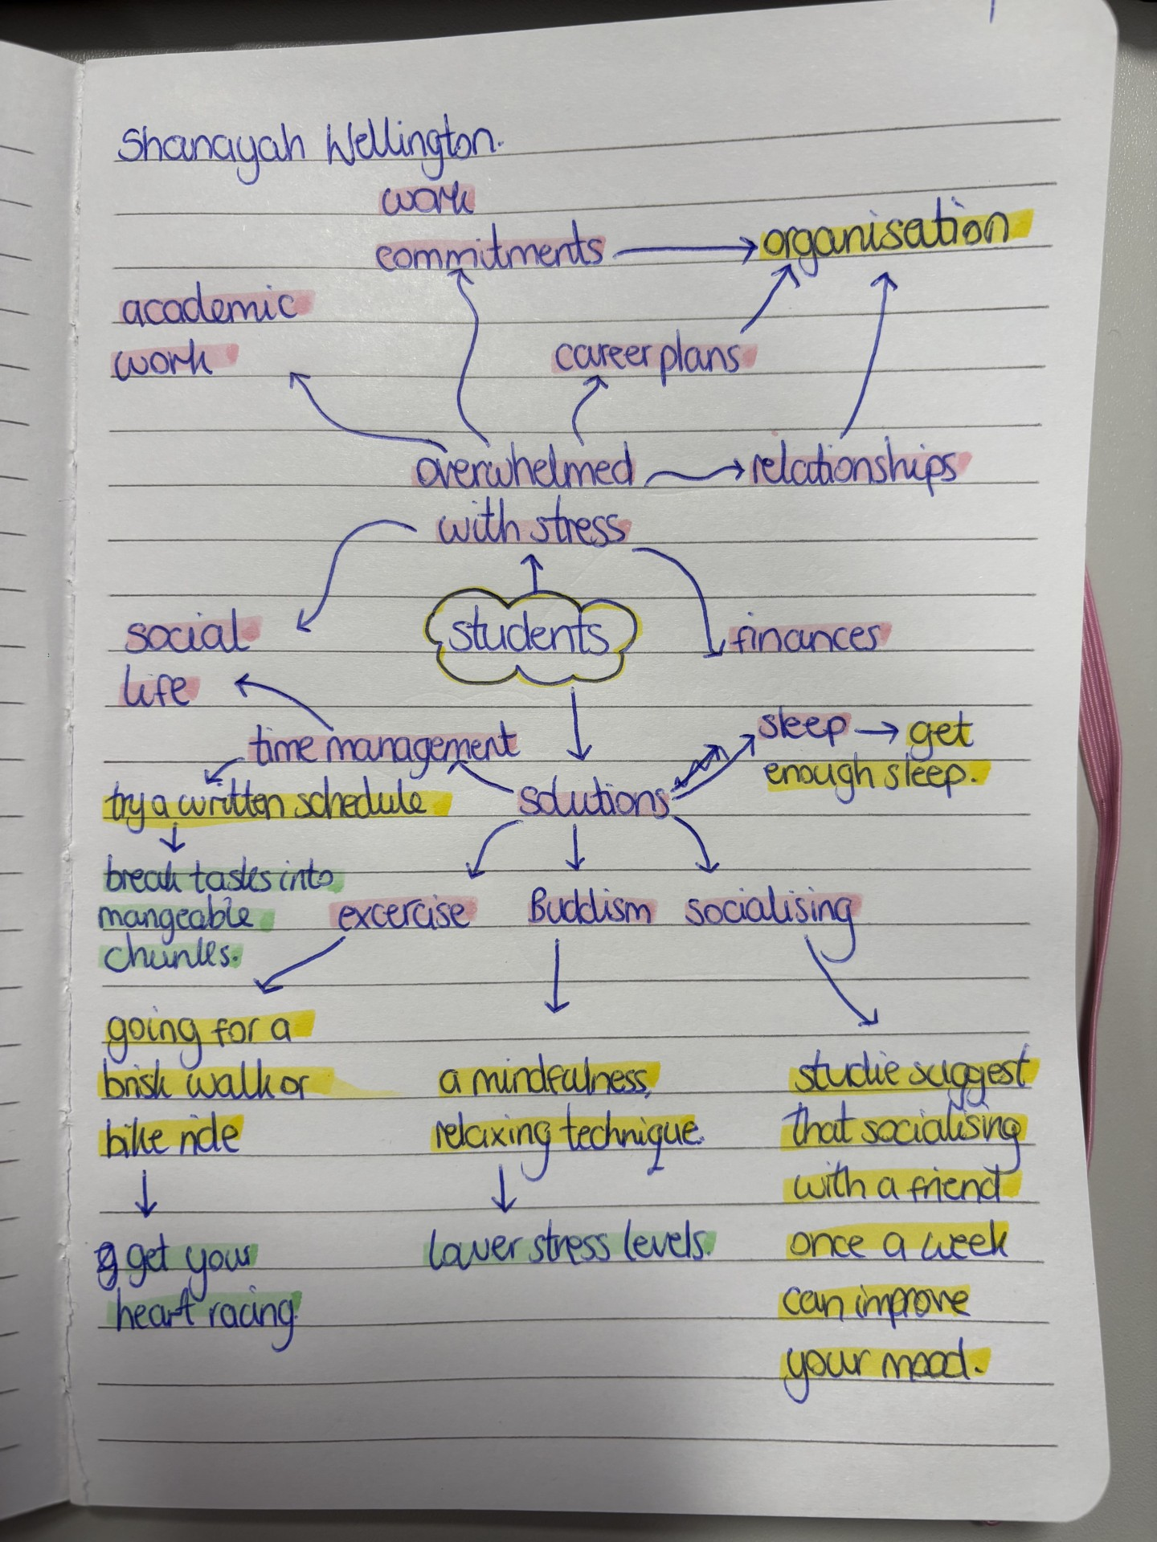

2. Paraphrase the following sentences (max 3 marks for each, max 12 marks in total):

a) Good time management techniques can help you feel more relaxed and focused.

If you are hoping to feel more relaxed and focused, developing excellent time management strategies can help.

b) Speaking to your friends and family can significantly lower stress levels.
Communicating and socialising with friends and family play a great role in lowering your stress levels.

c) University life offers numerous opportunities for personal growth and development.
Personal growth and personal development are both very important factors to becoming a better person within ourselves and to others. University life offers many opportunities to do so.

d) Attending lectures regularly is crucial for understanding course material.

To understand course material, it is crucial to attend lectures frequently.

3. Write a well-structured paragraph (8 sentences) on the following topic:

Strategies for managing a student budget and reducing costs while at university.

Your paragraph must be written in full sentences (no bullet points) and in an academic style.

(max 16 marks in total)

As a student you struggle to manage your finances – transport to and from University, social life, academic materials and basic living essentials – sometimes it can be extremely overwhelming trying to keep up with it all. When you recognise that you are finding it hard to manage these finances you can adopt a few techniques to find a healthy relationship with money. Those techniques could include organisation skills; you need to organise your finances, for example identifying what spendings are important and which spendings are not. When you do identify the difference write them down, so you know how much money you are left with after your mandatory bills have been paid for. Another suggestion is to try and budget, you can do this by cutting out unnecessary spending or even quitting bad habits that cost you money such as cigarettes, vapes, unhealthy takeaways and alcoholic drinks. These items are not necessities and affect your physical health and possibly your mental health too, removing these habits from your life will not only save you money but can also improve your physical and mental state. Thirdly, it is crucial to have a balanced lifestyle between academic work and your social life but find activities to do with your friends that are affordable. You can do nice activities like picnics, museums, a nice walk and etc that will still ensure you are enjoying your social life away from education and will save you an enormous amount of money.

