Anisah Khan (1808794)
Lecturer: Mumtaz Goolam
INTRODUCTION TO PHYSIOLOGY
BMHP5003_BIRM

The Digestive system

University of wales Trinty saint david

There are three main pairs of salivary gland; Parotid glands, Submandibular glands and Sublingual glands.
The salivary glands secret saliva which moisten the food during mastication and help to dissolve the bolus. Approximately 1.5 lites of saliva is produced on a daily basis and it is composed of water, mineral salts, mucus, immunoglobulins (antibodies) and salivary amylase. The functions of saliva include, lubrication of food, cleaning of the mouth and teeth, producing antibodies to invade microbes and chemical digestion. The enzyme amylase aids the chemical digestion of carbohydrates (Ellis and Mahadevan, 2013).

The process of digestion actually first occurs in the oral cavity and it is from here that food enters the gastrointestinal (GI) tract by ingestion (Waugh and Grant, 2018).
Food is initially broken down in the mouth by the teeth through a process known as mastication. The skeletal muscle known as the tongue helps to manipulate the food around the mouth. This mechanical digestion is aided by the salivary glands which secrete saliva and mix up the food which eventually becomes a moist lump called bolus which makes it easier for passage along the pharynx (Netter, 2014).

THE DIGESTIVE SYSTEM

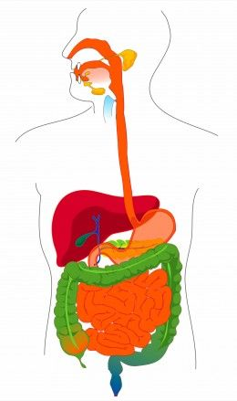
The small intestine is about 2.5cm in diameter, 5 metres long and is comprised of three parts; duodenum, jejunum and ileum. It continues on from the stomach and is located in the abdomen cavity. It is surrounded by the large intestine and it is here where the chemical digestion of food is completed and where nutrients are absorbed. Absorption occurs mostly with the ileum due to its larger surface area and the presence of villi which are tiny finger shaped structures that increase surface area (Peate and Nair, 2011). The large intestine in about 1.5 metres long, 6.5 com in diameter. It accepts anything the small intestine does not absorb, recovers water and electrolytes from waste matter and propels faeces towards the rectum for elimination (Azzouz and Sharma, 2018).
Image source: Biologydictionary.net (2021)
Although the liver, gall bladder and pancreas are not part of the GI tract, they are crucial for the digestion process. They store and secrete substances needed for digestion and such they are known as the accessory organs (Grewal and Wakim, 2021).

The oesophagus is a muscular tube that connects the pharynx to the stomach. It is approximately 25 cm long, 2cm in diameter and it runs behind the trachea and heart and in front of the vertebral column (Hoffman, 2020). The oesophagus passes through the diaphragm before entering the stomach where it curves upwards sharply preventing regurgitation. It is in the oesophagus that peristalsis occurs. Peristalsis is the wavelike movement or contractions that occur from the pharynx to the rectum (Encyclopaedia Britannica, 2021) . It allows the GI tract to push the food particles towards the anus. Peristalsis is essential to providing the body with nutrients (Patel and Thavamani, 2021). There are two types of peristaltic contractions, primary and secondary. The primary peristaltic wave helps to move food forward. The secondary wave initiates if the primary wave does not work and food is not able to pass, stimulating stretch receptors which clears the bolus (Furness et al. 2014).

Ileum
Small
Intestine:
Duodenum
Stomach
Oesophagus
Pharynx
Appendix
Anus
Sigmoid
Colon
Descending Colon
Caecum
Ascending Colon
Transverse Colon
Teeth
Large
Intestine:
Rectum
Jejunum
Pancreas
Gall Bladder
Liver
Tongue
Salivary Glands
THE ALIMENTARY CANAL
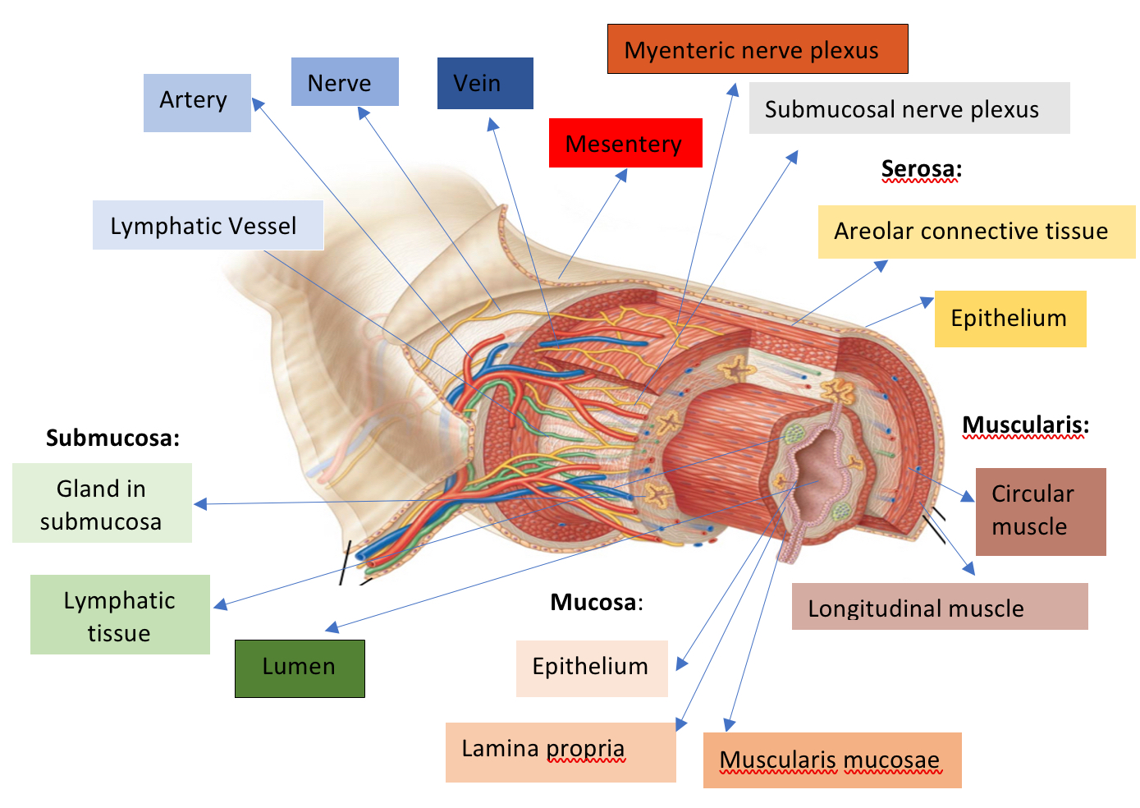
Image source: news-medical.net (2019)

Coeliac Disease
The digestive system is made up of a number of organs that convert food into energy and essential nutrients in order for the body to function. The pathway by which the food enters the body and solid waste is expelled, is known as the elementary canal after referred to as the gastrointestinal tract all the digestive tract (National Cancer Institute, 2021).
There are many pathophysiological disorders of the digestive system which can have serious implications on a persons health. Coeliac disease is a serious condition that occurs due to an abnormal, genetically determined autoimmune reaction to the protein gluten (NHS, 2019). It is a leading cause of malabsorption in developed countries (Waugh and Grant 2018). When people with coeliac disease ingest gluten, even in the tiniest amounts, it initiates an immune response that attacks the small intestine causing serious damage to the villi. Villi are fingerlike projections that line the small intestine to increase surface area for the purpose of absorbing nutrients. This villus atrophy, which occurs particularly in the jejunum, can lead to malabsorption, malnutrition, spleen atrophy and in some rare cases even cancer (Coeliac UK, 2021). Common symptoms also include diarrhoea, weight loss, fatigue, dermatitis herpetiformis bloating constipation and anaemia.
Recommendations: Coeliac patients can achieve remission from their symptoms when gluten is excluded completely from their diet, even through cross contamination. Consultation with a dietician is important to ensure patients are taking the right vitamins and supplements due to the change in diet to prevent deficiencies such as anaemia.

The alimentary canal includes the oral cavity, the pharynx, the oesophagus, stomach and the small and large intestines. The walls of the alimentary canal are made up of four basic layers with different functions and tissues:

Mucosa: this is the innermost layer and its functions include absorption and secretion. It surrounds the lumen through which food, mucus and digestive juices pass through. The mucosa comes into direct contact with digested food (chyme).
Submucosa: A thick layer of loose connective tissue overlying the mucosa, containing blood vessels, lymphatic vessels, nerves and submucosal glands that release digestive secretions.
Muscularis: Responsible for segmental contractions and peristaltic movement .
Serosa: The superficial layer of the canal present only in the abdominal cavity. In the oesophagus the serosa is replaced by adventitia. Serosa comprises of a secretory epithelial layer and a thin connective tissue layer that reduces the friction from muscle movements.

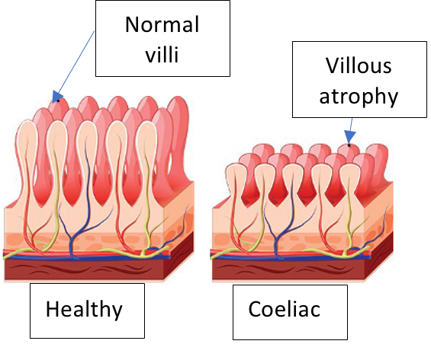
References

Azzouz, L.L. and Sharma, S. (2018) Physiology, large intestine. StatPearls (online) Available at:https://scholar.google.com/scholar?hl=en&as_sdt=0%2C5&q=azouzz+and+sharma&btnG=
(Accessed: 8 July 2021)

Biology Dictionary (2021) Digestive system fun facts. Available at:
https://biologydictionary.net/digestive-system-fun-facts/ (Accessed: 8 July 2021)

Coeliac UK (2021) About Coeliac Disease. Available at: https://www.coeliac.org.uk/information-and-support/coeliac-disease/about-coeliac-disease/
(Accessed: 8 July 2021)

Ellis, H. and Mahadevan, V. (2013) Clinical anatomy: applied anatomy for students and junior doctors. 13th Edition. London: John Wiley & Sons.

Encyclopaedia Britannica (2021) Peristalsis:Physiology. Available at:
https://www.britannica.com/science/peristalsis (Accessed: 8 July 2021)

Furness, J.B. et al. (2014) The enteric nervous system and gastrointestinal innervation: integrated local and central control. Microbial endocrinology: The microbiota-gut-brain axis in health and disease, pp.39-71.
DOI.org/10.1007/978-1-4939-0897-4_3

Grewal, M. and Wakim, S. (2021) Biology Libretexts ‘Accessory Organs of Digestion.’ Available at: https://bio.libretexts.org/Bookshelves/Human_Biology/Book%3A_Human_Biology_(Wakim_and_Grewal)/18%3A_Digestive_System/18.6%3A_Accessory_Organs_of_Digestion
(Accessed: 8 July 2021)

Hoffman, M. (2020) WebMD ‘Picture of the esophagus: Human Anatomy.’ Available at: https://www.webmd.com/digestive-disorders/picture-of-the-esophagus#1
(Accessed: 8 July 2021)

National Cancer Institute (2021) Alimentary Tract. Available at: https://www.cancer.gov/publications/dictionaries/cancer-terms/def/alimentary-tract
(Accessed: 8 July 2021)

National Health Service (2019) Coeliac Disease. Available at: https://www.nhs.uk/conditions/coeliac-disease/
(Accessed: 8 July 2021)

Netter, F.H. (2014) Atlas of human anatomy. 7th Edition. Philadelphia: Elsevier Inc

Patel, K.S. and Thavamani, A. (2021) Physiology, Peristalsis. StatPearls (online)
Available at: https://www.ncbi.nlm.nih.gov/books/NBK556137/
(Accessed: 8 July 2021)

Peate. I, and Nair, M. (2011) Fundamentals of Anatomy and Physiology for Student
Nurses. Chichester: Wiley Blackwell

Waugh, A. And Grant, A. (2018) Ross and Wilson Anatomy and Physiology in Health and Illness: 13th Edition. London: Elsevier Ltd

