Examining Trust, Perceived Benefit, Subjective Norm, eWOM, and Website Design Influencing Consumer Purchase Intention:
A Case Study of Online Clothing Shopping in Hong Kong

Table of Contents
List of Tables
List of Figures
Chapter 1: Introduction
  - Background of the study
  - Importance of the study
  - Research questions and hypotheses
  - Research objectives
  - Research process
Chapter 2: Literature Review
2.1 Trust
2.2 Perceived Benefit
2.3 Subjective Norm
2.4 Electronic Word-of-Mouth (eWOM)
2.5 Website Design
Chapter 3: Research Methodology
3.1 Research model with hypotheses
3.2 Quantitative research
3.3 Questionnaire survey method
3.4 Final survey
3.4.1 Target population
3.4.2 Sampling method
3.4.3 Sampling size
3.5 Data Analysis Techniques
3.6 Research Ethics
Refences
Appendices

Chapter 1: Introduction
  - Research background
The global retail landscape has undergone significant transformations in recent years, largely driven by the rise of e-commerce. With the advancement of technology and increased internet penetration, online shopping has become increasingly popular among consumers worldwide. This shift in consumer behavior has also been observed in Hong Kong, where the online retail market has experienced remarkable growth.

  - Importance of the study
Examining the factors influencing consumer purchase intention in online clothing shopping in Hong Kong holds great significance for several reasons. Firstly, the Hong Kong market is known for its strong fashion industry and consumer preferences. Understanding the factors that influence online clothing purchase intention can provide valuable insights into consumer behavior and preferences in this specific market.

  - Research questions and hypotheses
This study aims to examine the factors influencing consumer purchase intention of online clothing shopping in Hong Kong. The specific research questions to be addressed are as follows:

- What is the influence of trust on consumer purchase intention in online clothing shopping in Hong Kong?
- How does perceived benefit affect consumer purchase intention in online clothing shopping in Hong Kong?
- To what extent does subjective norm influence consumer purchase intention in online clothing shopping in Hong Kong?
- What is the impact of eWOM on consumer purchase intention in online clothing shopping in Hong Kong?
- How does website design influence consumer purchase intention in online clothing shopping in Hong Kong?
  - Research objectives
The objective of this study is to examine the factors influencing consumer purchase intention in the context of online clothing shopping in Hong Kong. Specifically, the research aims to investigate the impact of trust, perceived benefit, subjective norm, electronic word-of-mouth (eWOM), and website design on consumer purchase intention. By exploring the relationships and interactions between these variables, the study seeks to provide valuable insights into the underlying mechanisms that drive consumers' decision-making processes in online clothing shopping.

  - Research process
The research will adopt a quantitative research design to investigate the factors influencing consumer purchase intention in online clothing shopping in Hong Kong. This design allows for the collection of numerical data that can be analyzed using statistical techniques to establish relationships between variables and test hypotheses.

Figure x: Flowchart of the thesis
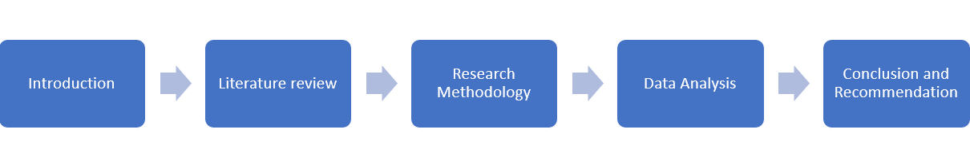
Source: Created by author

2. Literature Review
In recent years, the popularity of online shopping has witnessed a significant surge, transforming the retail landscape. This trend is particularly evident in the context of online clothing shopping, where consumers have increasingly turned to the internet to purchase apparel and accessories. Hong Kong, with its vibrant fashion industry and tech-savvy population, serves as an interesting case to study the factors influencing consumer purchase intention in the realm of online clothing shopping. This literature review aims to explore and synthesize existing research on the key factors that influence consumer purchase intention in this context, with a specific focus on trust, perceived benefit, subjective norm, electronic word-of-mouth (eWOM), and website design.

2.1 Construct and measurement of Trust:
Trust plays a vital role in shaping consumers' decision-making processes when it comes to online shopping, including the specific context of online clothing purchases. Research has consistently demonstrated that trust positively influences consumer purchase intention (Bhattacherjee, 2002) (Wang & Emurian, 2005) (Eastlick & Lotz, 2011) (Hong & Kim, 2012) (Hsu, Chuang, & Hsu, 2014) (Jadil, Rana & Dwivedi, 2022). Building trust involves several factors, such as perceiving the online retailer as competent and trustworthy, which can be determined by tangible indicators like the reputation and size of the company (Singh and Srivastava, 2018). Additionally, trust is crucial for consumers who find themselves in potentially risky situations, as they rely on the internet as a means to communicate their needs, share personal information, and complete transactions. In these cases, consumers expect the online platform to be reliable and secure, while also anticipating honest and professional behavior from the vendor throughout the purchase process (Qalati et al., 2021). Overall, trust is a fundamental factor that influences consumers' online shopping decisions, and understanding its dynamics can help businesses establish credibility and foster positive consumer attitudes and intentions.

Table 1: Definition of Trust
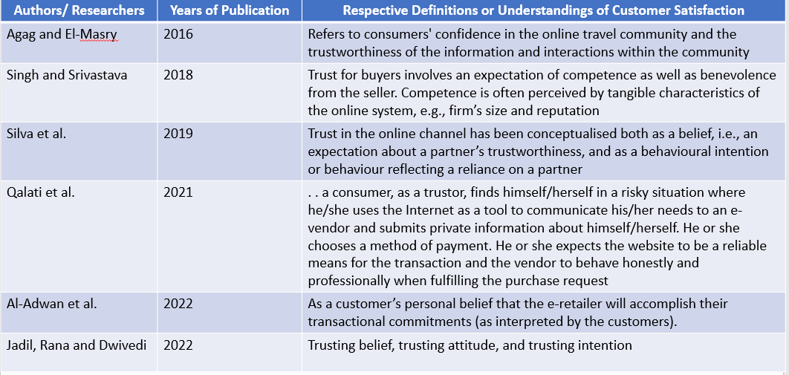
Source: Created by author

2.2 Construct and measurement of Perceived Benefit:
Perceived benefit refers to how consumers perceive the positive outcomes and advantages they expect to derive from engaging in online clothing shopping. It encompasses factors such as the value and functionality that customers believe they can gain from using the products or services offered (Zhao et al., 2020). Perceived benefit is closely related to convenience, cost-effectiveness, variety, as well as factors like perceived risks and trust in the online shopping environment (Silva et al., 2019). Extensive research has consistently demonstrated that perceived benefit significantly influences consumers' purchase intention in online shopping contexts (Kim, Ferrin & Rao, 2008) (Bhatti & Rehman, 2019). When consumers perceive that online clothing shopping provides greater convenience, lower prices, and a wider range of options compared to traditional brick-and-mortar stores, they are more inclined to engage in online shopping activities.

Table 2: Definition of Perceived Benefit
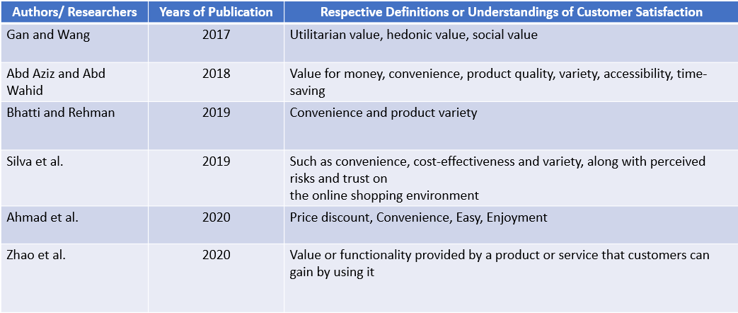
Source: Created by author

2.3 Construct and measurement of Subjective Norm:
Subjective norm refers to the perceived social pressure or influence that consumers experience in relation to their online shopping behavior. It represents the extent to which individuals perceive social connections and their expectations regarding the use of online shopping (Singh & Srivastava, 2018). Research has consistently shown that subjective norm significantly influences consumer purchase intention in the context of online clothing shopping (Lim et al., 2016) (Aslan, 2023). Positive recommendations and word-of-mouth from family and friends can enhance consumers' confidence and trust in online clothing shopping, thereby positively impacting their purchase intention. Subjective norm is based on an individual's perception of what actions they should or should not undertake, considering the potential rewards or punishments associated with such behavior (Peña-García et al., 2020).

Table 3: Definition of Subjective Norm
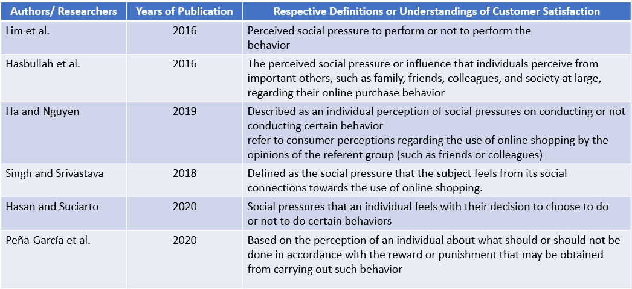
Source: Created by author

2.4 Construct and measurement of Electronic Word-of-Mouth (eWOM):
Electronic Word-of-Mouth (eWOM) refers to the sharing of positive or negative opinions, experiences, or recommendations about a brand or organization by prospective, existing, or previous customers through online channels. These communications have the potential to reach millions of individuals and organizations via the internet (Kala & Chaubey, 2018). eWOM can be found on various platforms, including social media, review websites, and online forums. Extensive research consistently demonstrates the significant impact of eWOM on consumer purchase intention (Cheung & Thadani, 2012) (Kudeshia & Kumar, 2017) (Farzin & Fattahi, 2018). eWOM is primarily driven by informal consumer communications conducted through different online media platforms, where individuals discuss the positive or negative characteristics of goods or services, as well as the producers or sellers involved (Nuseir, 2019).

Table 4: Definition of Electronic Word-of-Mouth
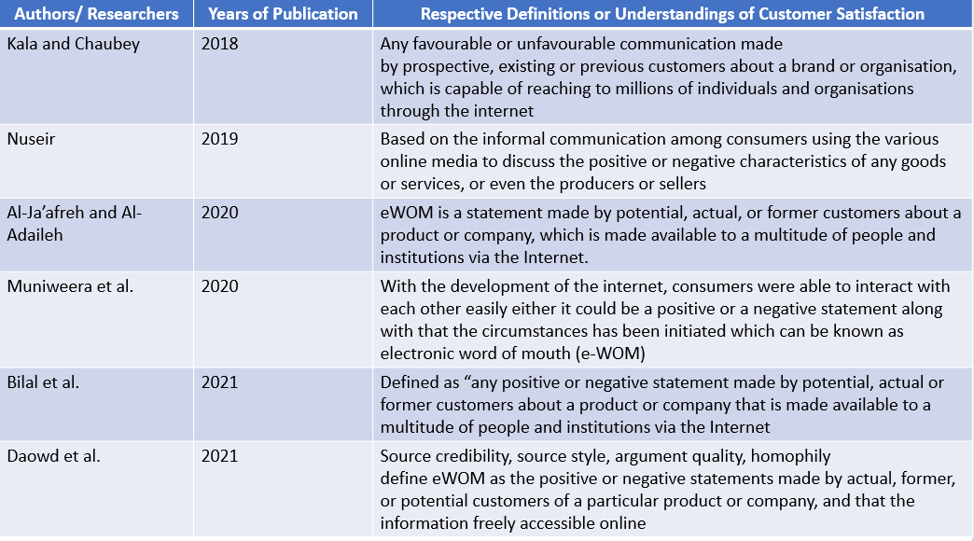
Source: Created by author

2.5 Construct and measurement of Website Design:
The design of a website plays a crucial role in shaping consumers' perceptions and experiences when engaging in online shopping. Website design encompasses various aspects, including ensuring a seamless and efficient transaction process, personalization options, understanding the needs and wants of online buyers, and providing a comfortable browsing experience (Lee et al., 2016). Extensive research indicates that factors such as website usability, visual appeal, navigation, and information presentation significantly influence consumers' purchase intention in the context of online clothing shopping (Mohd Sam and Tahir, 2009) (Wen, I., 2012). A well-designed website not only enhances consumers' trust in the online retailer but also facilitates the search and evaluation of products, leading to improved shopping satisfaction. The quality of website information and overall design elements, such as appropriate use of colors, images/graphics, and layout, contribute to creating an engaging and user-friendly online shopping environment (Rashid et al., 2023).

Table 5: Definition of Website Design
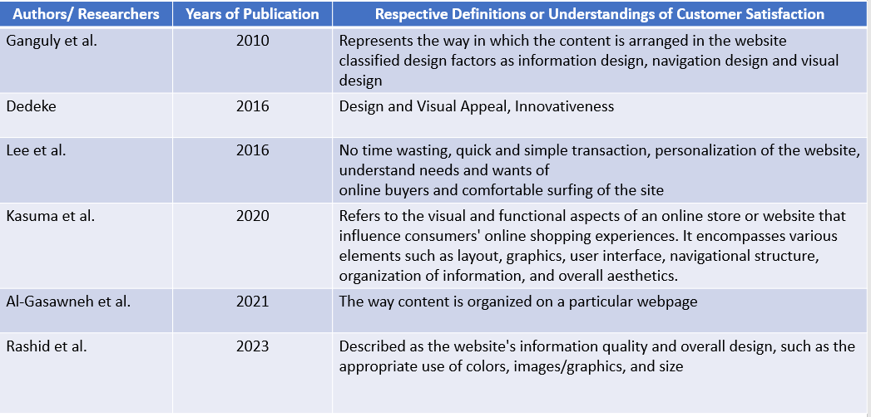
Source: Created by author

Chapter 3: Research Methodology
The research methodology section of the dissertation presents a comprehensive overview of the strategies, procedures, and tools employed to conduct the study. This section outlines the research design, data collection methods, sample selection, data analysis techniques, and ethical considerations. By elucidating the chosen methodology, the reader gains insights into how the research objectives will be achieved and the validity of the findings. This dissertation will employ a quantitative research approach to analyze the consumer purchase intention of online shopping for clothing in Hong Kong. The following sections provide a detailed description of each component of the research methodology.

3.1 Research model with hypotheses
In this section, the research model will be presented, outlining the variables (trust, perceived benefit, subjective norm, eWOM, website design) and their hypothesized relationships. By establishing a clear research model, the study aims to provide a conceptual framework for investigating the factors influencing consumer purchase intention in online shopping for clothing in Hong Kong.

Figure x: Research model
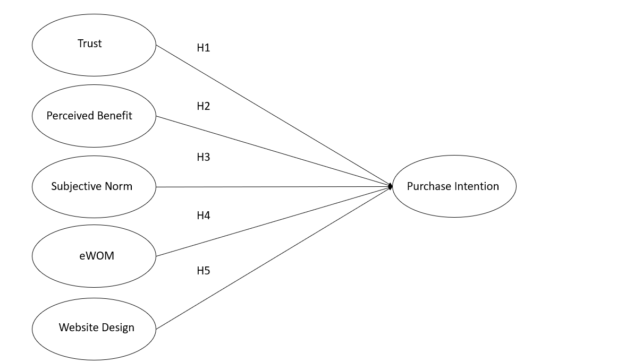
Source: Created by author

Hypotheses:
Based on the research questions, the following hypotheses are proposed for further investigation:

Hypothesis 1: Trust positively influences consumer purchase intention in online clothing shopping in Hong Kong

Hypothesis 2: Perceived benefit positively influences consumer purchase intention in online clothing shopping in Hong Kong

Hypothesis 3: Subjective norm positively influences consumer purchase intention in online clothing shopping in Hong Kong

Hypothesis 4: eWOM positively influences consumer purchase intention in online clothing shopping in Hong Kong

Hypothesis 5: Website design positively influences consumer purchase intention in online clothing shopping in Hong Kong

3.2 Quantitative research
The chosen research approach for this study is quantitative research that focuses on the objective measurement and analysis of numerical data (Bloomfield & Fisher, 2019). This section will discuss the advantages of using a quantitative research design in exploring the research questions and testing the proposed hypotheses. By collecting numerical data from a large sample size, the study aims to provide statistically significant findings that contribute to a deeper understanding of consumer purchase intention in the context of online clothing shopping. The use of a survey allows for the collection of standardized data from a larger sample size, ensuring the reliability and generalizability of the findings (Hair et al., 2019).

3.3 Questionnaire survey method
This refers to the data collection technique used to gather information from respondents. A questionnaire is a structured set of questions designed to obtain specific information from participants. It can be administered through various mediums such as paper-based forms, online surveys, or face-to-face interviews. The questionnaire survey method focuses on the design and administration of the survey instrument to collect data on variables of interest.

3.4 Final survey
3.4.1 Target population
The target population refers to the entire group of individuals, elements, or entities that is interested in studying and drawing conclusions about. It represents the larger group to which the research findings will be generalized. The target population should be clearly defined and relevant to the research objectives.

For the Geographic Scope, the target population consists of individuals residing around 7,333,200 people in Hong Kong (Census and Statistics Department, 2023). This means that the research focuses on consumers located within the geographical boundaries of Hong Kong. The geographic scope is essential for contextualizing the findings within the specific market of interest.

3.4.2 Sampling method
This refers to the technique used to select a subset of individuals or elements from a larger population for inclusion in a research study. Sampling is necessary when it is not feasible or practical to survey the entire population. The sampling method determines how participants are chosen to represent the larger population and plays a crucial role in the generalizability of research findings. Different sampling techniques, such as random sampling, stratified sampling, convenience sampling, or purposive sampling, can be employed depending on the research objectives, population characteristics, and available resources.

3.4.3 Sampling size
According to Krejcie and Morgan's (1970) guidelines for determining sample size, a sample of 385 respondents is recommended for achieving a desired level of precision and confidence. Given the estimated adult population of 6,409,200 in Hong Kong (Census and Statistics Department, 2023), this sample size is deemed appropriate for this study. Therefore, 385 sets of questionnaires were distributed among Hong Kong residents who could potentially be shopping clothing in online. By targeting this specific population, which serves as a representative sample of the broader population in Hong Kong, the research aims to draw meaningful conclusions regarding the factors influencing customers' purchase intention of health insurance. This approach allows for generalizability and enhances the study's relevance to the wider population (Babbie, 2020).

Figure x: Formula for the sample size calculation
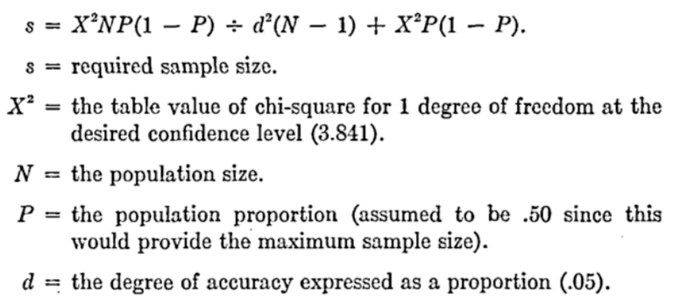
Source: Krejcie & Morgan 1970

3.5 Data Analysis Techniques
Here are 5 data analysis techniques included Descriptive Statistics, Regression Analysis, Cross Tabulation, Compute Variable, Reliability analysis will be applicable to the research:

Descriptive statistics involves summarizing and describing the main characteristics of a dataset. It provides a clear and concise summary of the data through measures such as measures of central tendency (mean, median, mode) and measures of variability (standard deviation, range). Descriptive statistics can help understanding the distribution, patterns, and basic characteristics of the variables. In this study, using descriptive statistics to calculate the mean and standard deviation of variables such as consumer age, purchase intention, and perceived benefit. This will give an overview of the central tendency and variability of these variables within the sample (Field, 2013).

3.6 Research Ethics

Obtaining informed consent is fundamental in research. Participants will be provided with clear and comprehensive information about the study, including its purpose, procedures, potential risks and benefits, and their rights as participants. Informed consent will be sought from each participant before their participation in the study. They will have the freedom to decline participation or withdraw from the study at any time without facing any consequences (Nijhawan et al.,2013)

References:

Abd Aziz, N. N., & Abd Wahid, N. (2018). Factors influencing online purchase intention among university students. International journal of academic research in business and social sciences, 8(7), 702-717.

Agag, G., & El-Masry, A. A. (2016). Understanding consumer intention to participate in online travel community and effects on consumer intention to purchase travel online and WOM: An integration of innovation diffusion theory and TAM with trust. Computers in human behavior, 60, 97-111.

Agresti, A. (2012). Categorical data analysis (Vol. 792). John Wiley & Sons.

Ahmad, A. H., Fauzi, R. U. A., Ditta, A. S. A., Idris, I., & Yazid, M. F. M. (2020). The Role of Perceived Benefits and Perceived Risks Towards the Consumers’ Purchase Intention Via ECommerce: An Evidence from Indonesia. Solid State Technology, 63(2s), 3257-3274.

Al-Adwan, A. S., Alrousan, M. K., Yaseen, H., Alkufahy, A. M., & Alsoud, M. (2022). Boosting Online Purchase Intention in High-Uncertainty-Avoidance Societies: A Signaling Theory Approach. Journal of Open Innovation: Technology, Market, and Complexity, 8(3), 136.

Al-Gasawneh, J. A., Al-Adamat, A. M., Al-Qeed, M. A., Nusairat, N. M., Ahmedd, A. E., Ngah, A. H., & Judeh, M. (2021). Moderator-moderator: Digital coupon sales promotion, online reviews, website design, and the online shopping intention of consumers in Jordan.

Al-Ja’afreh, A. L. I., & Al-Adaileh, R. A. I. D. (2020). The impact of electronic word of mouth on consumers purchasing intention. Journal of Theoretical and Applied Information Technology, 98(02).

Aslan, H. (2023). The influence of halal awareness, halal certificate, subjective norms, perceived behavioral control, attitude and trust on purchase intention of culinary products among Muslim costumers in Turkey. International Journal of Gastronomy and Food Science, 32, 100726.

Babbie, E. R. (2020). The practice of social research. Cengage learning.

Bhattacherjee, A. (2002). Individual trust in online firms: Scale development and initial test. Journal of Management Information Systems, 19(1), 211-241.

Bhatti, A., & Rehman, S. U. (2019). Perceived benefits and perceived risks effect on online shopping behavior with the mediating role of consumer purchase intention in Pakistan. International Journal of Management Studies, 26(1), 33-54.

Biernacki, P., & Waldorf, D. (1981). Snowball sampling: Problems and techniques of chain referral sampling. Sociological methods & research, 10(2), 141-163.

Bilal, M., Jianqiu, Z., Dukhaykh, S., Fan, M., & Trunk, A. (2021). Understanding the effects of eWOM antecedents on online purchase intention in China. Information, 12(5), 192.

Bloomfield, J., & Fisher, M. J. (2019). Quantitative research design. Journal of the Australasian Rehabilitation Nurses Association, 22(2), 27-30.

Census and Statistics Department (2023) Table 110-01002 : Population by Sex and Age Available at: https://www.censtatd.gov.hk/en/web_table.html?id=110-01002 (Accessed: 20 April 2023).

Census and Statistics Department. (2023). Thematic Report: Household Income Distribution in Hong Kong 2021 Available at: https://www.censtatd.gov.hk/en/data/stat_report/product/B1120108/att/B11201082021XXXXB0100.pdf (Accessed: 2 July 2023).

Census and Statistics Department (2023) Report on Monthly Survey of Retail Sales Available at: https://www.censtatd.gov.hk/en/data/stat_report/product/B1080003/att/B10800032023MM02B0100.pdf (Accessed: 20 April 2023).

Cheung, C. M., & Thadani, D. R. (2012). The impact of electronic word-of-mouth communication: A literature analysis and integrative model. Decision support systems, 54(1), 461-470.

Daowd, A., Hasan, R., Eldabi, T., Rafi-ul-Shan, P. M., Cao, D., & Kasemsarn, N. (2021). Factors affecting eWOM credibility, information adoption and purchase intention on Generation Y: a case from Thailand. Journal of enterprise information management, 34(3), 838-859.

Dedeke, A. N. (2016). Travel web-site design: Information task-fit, service quality and purchase intention. Tourism management, 54, 541-554.

Dillman, D. A., Smyth, J. D., & Christian, L. M. (2014). Internet, phone, mail, and mixed-mode surveys: The tailored design method. John Wiley & Sons.

Dinev, T., & Hart, P. (2006). An extended privacy calculus model for e-commerce transactions. Information systems research, 17(1), 61-80.

Flicker, S., Travers, R., Guta, A., McDonald, S., & Meagher, A. (2007). Ethical dilemmas in community-based participatory research: recommendations for institutional review boards. Journal of Urban Health, 84, 478-493.

Gan, C., & Wang, W. (2017). The influence of perceived value on purchase intention in social commerce context. Internet research, 27(4), 772-785

Goodman, L. A. (1961). Snowball sampling. The annals of mathematical statistics, 148-170.

Lee, T. S., Ariff, M. S. M., Zakuan, N., Sulaiman, Z., & Saman, M. Z. M. (2016, May). Online sellers’ website quality influencing online buyers’ purchase intention. In IOP Conference Series: Materials Science and Engineering (Vol. 131, No. 1, p. 012014). IOP Publishing.

Lim, Y. J., Osman, A., Salahuddin, S. N., Romle, A. R., & Abdullah, S. (2016). Factors influencing online shopping behavior: the mediating role of purchase intention. Procedia economics and finance, 35, 401-410.

Mohd Sam, M. F., & Tahir, M. N. H. (2009). Website quality and consumer online purchase intention of air ticket. International Journal of Basic & Applied Sciences, 9(10).

Norušis, M. J. (2011). IBM SPSS statistics 19 guide to data analysis

Muniweera, C. D. W., Balawardhana, K. P. I. A., Rajapaksha, M. S. N., Chamara, M. A. D. S., & Jayasuriya, N. A. (2020). The Importance of Factors Influencing on e-WOM Engagement towards Consumer Purchase Intention in Clothing Retailers, Sri Lanka. International Journal of Academic Research in Business and Social Sciences, 10(5), 349-360.

Nuseir, M. T. (2019). The impact of electronic word of mouth (e-WOM) on the online purchase intention of consumers in the Islamic countries–a case of (UAE). Journal of Islamic Marketing.

Eastlick, M. A., & Lotz, S. (2011). Cognitive and institutional predictors of initial trust toward an online retailer. International Journal of Retail & Distribution Management, 39(4), 234-255.

Fan, W., & Yan, Z. (2010). Factors affecting response rates of the web survey: A systematic review. Computers in human behavior, 26(2), 132-139.

Farzin, M., & Fattahi, M. (2018). eWOM through social networking sites and impact on purchase intention and brand image in Iran. Journal of Advances in Management Research, 15(2), 161-183.

Field, A. (2013). Discovering statistics using IBM SPSS statistics. sage.

Ha, N., & Nguyen, T. (2019). The effect of trust on consumers’ online purchase intention: An integration of TAM and TPB. Management Science Letters, 9(9), 1451-1460.

Hair, J. F., Anderson, R. E., Tatham, R. L., & Black, W. C. (2014). Multivariate Data Analysis. 7th USA: Ed.

Hasbullah, N. A., Osman, A., Abdullah, S., Salahuddin, S. N., Ramlee, N. F., & Soha, H. M. (2016). The relationship of attitude, subjective norm and website usability on consumer intention to purchase online: An evidence of Malaysian youth. Procedia Economics and Finance, 35, 493-502.

Hasan, H. N., & Suciarto, S. (2020). The influence of attitude, subjective norm and perceived behavioral control towards organic food purchase intention. Journal of Management and Business Environment (JMBE), 1(2), 132.

Hair, J. F., Black, W. C., Babin, B. J., & Anderson, R. E. (2019). Multivariate data analysis . Cengage Learning. Hampshire, United Kingdom.

Hong, I. B., & Cha, H. S. (2013). The mediating role of consumer trust in an online merchant in predicting purchase intention. International Journal of Information Management, 33(6), 927-939.

Hong, T., & Kim, E. (2012). Segmenting customers in online stores based on factors that affect the customer’s intention to purchase. Expert Systems with Applications, 39(2), 2127-2131.

Hsu, M. H., Chuang, L. W., & Hsu, C. S. (2014). Understanding online shopping intention: the roles of four types of trust and their antecedents. Internet research, 24(3), 332-352.

Jadil, Y., Rana, N. P., & Dwivedi, Y. K. (2022). Understanding the drivers of online trust and intention to buy on a website: An emerging market perspective. International Journal of Information Management Data Insights, 2(1), 100065.

Kala, D., & Chaubey, D. S. (2018). The effect of eWOM communication on brand image and purchase intention towards lifestyle products in India. International Journal of Services, Economics and Management, 9(2), 143-157.

Kasuma, J., Kanyan, A., Khairol, M., Sa'ait, N., & Panit, G. (2020). Factors influencing customers intention for online shopping. International Journal of Modern Trends in Business Research, 3(11), 31-41.

Kim, D. J., Ferrin, D. L., & Rao, H. R. (2008). A trust-based consumer decision-making model in electronic commerce: The role of trust, perceived risk, and their antecedents. Decision support systems, 44(2), 544-564.

Krejcie, R. V., & Morgan, D. W. (1970). Determining sample size for research activities. Educational and Psychological Measurement, 30(3), 607–610.

Kudeshia, C., & Kumar, A. (2017). Social eWOM: does it affect the brand attitude and purchase intention of brands?. Management Research Review, 40(3), 310-330.

McNamee, M. J., Olivier, S., & Wainwright, P. (2006). Research ethics in exercise, health and sports sciences. Routledge.

Neter, J., Kutner, M. H., Nachtsheim, C. J., & Wasserman, W. (1996). Applied linear statistical models.

Nijhawan, L. P., Janodia, M. D., Muddukrishna, B. S., Bhat, K. M., Bairy, K. L., Udupa, N., & Musmade, P. B. (2013). Informed consent: Issues and challenges. Journal of advanced pharmaceutical technology & research, 4(3), 134.

Nulty, D. D. (2008). The adequacy of response rates to online and paper surveys: what can be done?. Assessment & evaluation in higher education, 33(3), 301-314.

Nuseir, M. T. (2019). The impact of electronic word of mouth (e-WOM) on the online purchase intention of consumers in the Islamic countries–a case of (UAE). Journal of Islamic Marketing.

Parker, C., Scott, S., & Geddes, A. (2019). Snowball sampling. SAGE research methods foundations.

Peña-García, N., Gil-Saura, I., Rodríguez-Orejuela, A., & Siqueira-Junior, J. R. (2020). Purchase intention and purchase behavior online: A cross-cultural approach. Heliyon, 6(6), e04284.

Qalati, S. A., Vela, E. G., Li, W., Dakhan, S. A., Hong Thuy, T. T., & Merani, S. H. (2021). Effects of perceived service quality, website quality, and reputation on purchase intention: The mediating and moderating roles of trust and perceived risk in online shopping. Cogent Business & Management, 8(1), 1869363.

Statista (2021) Retail e-commerce sales worldwide from 2014 to 2026 Available at: https://www.statista.com/statistics/379046/worldwide-retail-e-commerce-sales/ (Accessed: 20 April 2023).

Statista (2021) Share of consumers who increased their online shopping frequency and amount during coronavirus COVID-19 in Hong Kong in 2020, by category Available at: https://www.statista.com/statistics/1222612/hong-kong-change-in-frequency-and-amount-of-online-shopping-during-covid/ (Accessed: 20 April 2023).

Statista (2023) eCommerce - Hong Kong Available at: https://www.statista.com/outlook/dmo/ecommerce/hong-kong (Accessed: 20 April 2023).

Silva, J., Pinho, J. C., Soares, A., & Sá, E. (2019). Antecedents of online purchase intention and behaviour: Uncovering unobserved heterogeneity. Journal of Business Economics and Management, 20(1), 131-148.

Singh, S., & Srivastava, S. (2018). Moderating effect of product type on online shopping behaviour and purchase intention: An Indian perspective. Cogent Arts & Humanities, 5(1), 1495043.

The Government of the Hong Kong Special Administrative Region Press Releases. (2023) Provisional statistics of retail sales for December 2022 and for the whole year of 2022 Available at: https://www.info.gov.hk/gia/general/202302/03/P2023020300321.htm?fontSize=1 (Accessed: 20 April 2023).

Wang, Y., & Emurian, H. H. (2005). An overview of online trust: Concepts, elements, and implications. Computers in Human Behavior, 21(1), 105-125.

Wen, I. (2012). An empirical study of an online travel purchase intention model. Journal of Travel & Tourism Marketing, 29(1), 18-39.

Wiles, R., Crow, G., Heath, S., & Charles, V. (2008). Anonymity and confidentiality.

Zhao, S., Fang, Y., Zhang, W., & Jiang, H. (2020). Trust, perceived benefit, and purchase intention in C2C e-commerce: An empirical examination in China. Journal of Global Information Management (JGIM), 28(1), 121-141.

Appendices
Final Survey
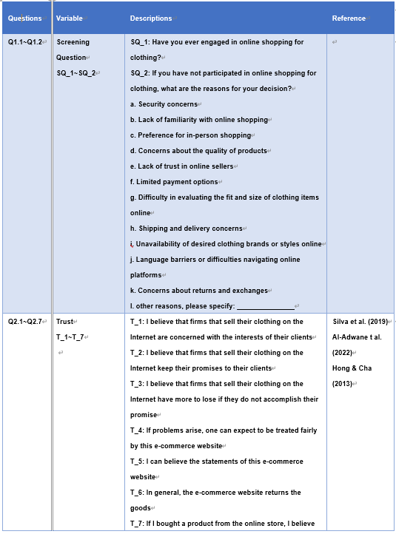
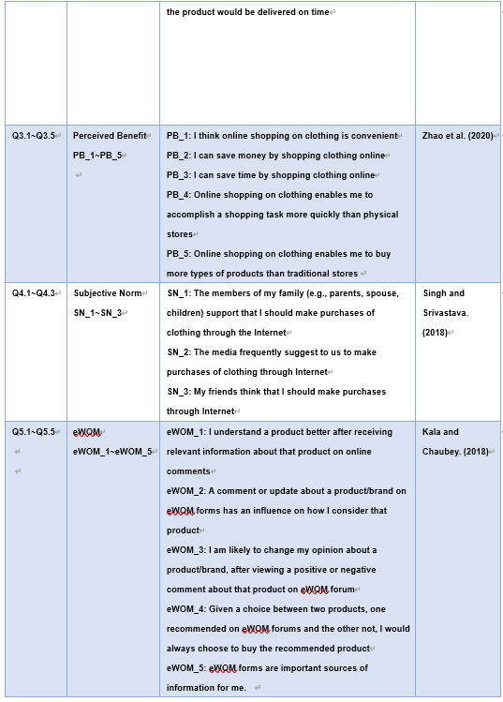

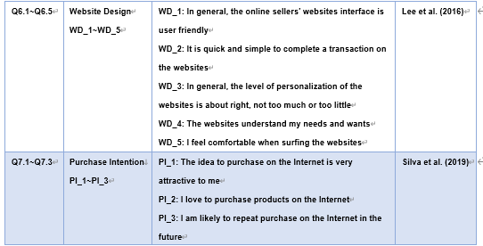

APPLICATION FOR ETHICAL APPROVAL

RESEARCH STUDENTS
This form is to be completed by the student within SIX months for full-time students and TWELVE months for part time students, after the commencement of the research degree or following progression to Part Two of your course.
Once complete, submit this form via the MyTSD Doctoral College Portal at (https://mytsd.uwtsd.ac.uk). This document is also available in Welsh.
RESEARCH STAFF ONLY
All communications relating to this application during its processing must be in writing and emailed to pgresearch@uwtsd.ac.uk , with the title ‘Ethical Approval’ followed by your name.
STUDENTS ON UNDERGRADUATE OR TAUGHT MASTERS PROGRAMMES should submit this form
(and receive the outcome) via systems explained to you by the supervisor/module leader.

In order for research to result in benefit and minimise risk of harm, it must be conducted ethically. A researcher may not be covered by the University’s insurance if ethical approval has not been obtained prior to commencement.
The University follows the OECD Frascati manual definition of research activity: “creative work undertaken on a systematic basis in order to increase the stock of knowledge, including knowledge of man, culture and society, and the use of this stock of knowledge to devise new applications”. As such this covers activities undertaken by members of staff, postgraduate research students, and both taught postgraduate and undergraduate students working on dissertations/projects.

The individual undertaking the research activity is known as the “principal researcher”.

Ethical approval is not required for routine audits, performance reviews, quality assurance studies, testing within normal educational requirements, and literary or artistic criticism.

Please read the notes for guidance before completing ALL sections of the form.

This form must be completed and approved prior to undertaking any research activity. Please see Checklist for details of process for different categories of application.

SECTION A: About You (Principal Researcher)

1 | Full Name: |  | LEUNG Hon To
2 | Tick all boxes that apply: |  | Member of staff: | ☐ | Honorary research fellow: | ☐
 | Undergraduate Student | ☐ | Taught Postgraduate Student | ☒ | Postgraduate Research Student | ☐

3 | Institute/Academic Discipline/Centre: | The University of Wales Trinity Saint David
4 | Campus: | The Hong Kong Management Association
5 | E-mail address: | 1011lht1011@gmail.com
6 | Contact Telephone Number: | +852 6740 9423
 | For students:

7 | Student Number: | 2133985
8 | Programme of Study: | Master of Business Administration (MBA) Programme
9 | Director of Studies/Supervisor: | Dr Terence Li

SECTION B: Approval for Research Activity

1 | Has the research activity received approval in principle? (please check the Guidance Notes as to the appropriate approval process for different levels of research by different  categories of individual) |  | YES | ☒ | NO | ☐
 |  |  |  |  | Date
2 | If Yes, please indicate source of approval (and date where known): Approval in principle must be obtained from the relevant source prior to seeking ethical approval | Research Degrees Committee |  | ☐
2 |  | Institute Research Committee |  | ☒ | 22 March 2023
2 |  | Other (write in) |  | ☐

SECTION C: Internal and External Ethical Guidance Materials

Please list the core ethical guidance documents that have been referred to during the completion of this form (including any discipline-specific codes of research ethics, location-specific codes of research ethics, and also any specific ethical guidance relating to the proposed methodology).
Please tick to confirm that your research proposal adheres to these codes and guidelines. You may add rows to this table if needed.
1 | UWTSD Research Ethics & Integrity Code of Practice | ☒
2 | UWTSD Research Data Management Policy | ☒
3 | [List any other relevant documents here] | ☐

SECTION D: External Collaborative Research Activity
If there are external collaborators then you should gain consent from the contact persons to share their personal data with the university. If there are no external collaborators then leave this section blank and continue to section E.

1 | Institution
2 | Contact person name
3 | Contact person e-mail address
4 | Is your research externally funded? |  | YES | ☐ | NO | ☐
5 | Are you in receipt of a KESS scholarship? |  | YES | ☐ | NO | ☐
6 | Are you specifically employed to undertake this research in either a paid or voluntary capacity? | Voluntary | YES | ☐ | NO | ☐
7 |  | Employed | YES | ☐ | NO | ☐
8 | Is the research being undertaken within an existing UWTSD Athrofa Professional Learning Partnership  (APLP)? | If YES then the permission question below does not need  to be answered. | YES | ☐ | NO | ☐

9 | Has permission to undertake the research has been provided by the  partner organisation? | (If YES attach copy) If NO the application  cannot continue | YES | ☐ | NO | ☐

Where research activity is carried out in collaboration with an external organisation

10 | Does this organisation have its own ethics approval system? | YES | ☐ | NO | ☐
 | If Yes, please attach a copy of any final approval (or interim approval) from the organisation (this may be a copy of an email if appropriate).

SECTION E: Details of Research Activity

1 | Indicative title: | Examining Trust, Perceived Benefit, Subjective Norm, eWOM, and Website Design Influencing Consumer Purchase Intention:  A Case Study of Online Clothing Shopping in Hong Kong
2 | Proposed start date: | 22 March 2023 | Proposed end date: | 13 Nov 2023
Introduction to the Research (maximum 300 words per section)
Ensure that you write for a Non-Specialist Audience when outlining your response to the points below:
Purpose of Research Activity Proposed Research Question Aims of Research Activity Objectives of Research Activity

Demonstrate, briefly, how Existing Research has informed the proposed activity and explain
What the research activity will add to the body of knowledge How it addresses an area of importance.
3 | Purpose of Research Activity  Examining the factors influencing consumer purchase intention in online clothing shopping in Hong Kong holds great significance for several reasons. Firstly, the Hong Kong market is known for its strong fashion industry and consumer preferences. Understanding the factors that influence online clothing purchase intention can provide valuable insights into consumer behavior and preferences in this specific market.  (this box should expand as you type)
4 | Research Question  - What is the influence of trust on consumer purchase intention in online clothing shopping in Hong Kong?  - How does perceived benefit affect consumer purchase intention in online clothing shopping in Hong Kong?  - To what extent does subjective norm influence consumer purchase intention in online clothing shopping in Hong Kong?  - What is the impact of eWOM on consumer purchase intention in online clothing shopping in Hong Kong?  - How does website design influence consumer purchase intention in online clothing shopping in Hong Kong?  (this box should expand as you type)
5 | Aims of Research Activity  Through a comprehensive analysis of these factors, this study aims to contribute to the existing body of knowledge by providing a deeper understanding of the determinants that influence consumer purchase intention in the online clothing shopping context. The findings of this research can be utilized by online clothing retailers in Hong Kong to develop effective strategies and enhance the overall shopping experience, ultimately leading to increased customer satisfaction, loyalty, and business success.

 | (this box should expand as you type)
6 | Objectives of Research Activity  The objective of this study is to examine the factors influencing consumer purchase intention in the context of online clothing shopping in Hong Kong. Specifically, the research aims to investigate the impact of trust, perceived benefit, subjective norm, electronic word-of-mouth (eWOM), and website design on consumer purchase intention. By exploring the relationships and interactions between these variables, the study seeks to provide valuable insights into the underlying mechanisms that drive consumers' decision-making processes in online clothing shopping.  (this box should expand as you type)
Proposed methods (maximum 600 words)
Provide a brief summary of all the methods that may be used in the research activity, making it clear what specific techniques may be used. If methods other than those listed in this section are deemed appropriate later, additional ethical approval for those methods will be needed. You do not need to justify the methods here, but should instead describe how you intend to collect the data necessary for you to complete your project.
7 | This refers to the data collection technique used to gather information from respondents. A questionnaire is a structured set of questions designed to obtain specific information from participants. It can be administered through various mediums such as paper-based forms, online surveys, or face-to-face interviews. The questionnaire survey method focuses on the design and administration of the survey instrument to collect data on variables of interest.  The questionnaire survey method involves the use of online surveys to collect data from participants. Online surveys are a popular and convenient method for administering questionnaires, as they offer several advantages such as cost-effectiveness, ease of distribution, and efficient data collection and analysis.  According to Dillman, Smyth, and Christian (2014), online surveys provide a convenient and cost- effective way to reach a large number of respondents. They highlight the benefits of using online surveys, including increased response rates, reduced administrative costs, and the ability to collect data quickly and efficiently.  To implement online surveys, Google Forms is the online survey platforms. Online survey platforms such as Google Forms, SurveyMonkey, or Qualtrics offer user-friendly interfaces, customizable survey designs, and data management features (Fan & Yan, 2010).  The process of conducting online surveys starts with designing a comprehensive and well-structured questionnaire. The questionnaire should align with the research objectives and variables of interest. It is important to consider the appropriate question types (multiple choice, Likert scale, open-ended, etc.) and arrange the questions in a logical sequence (Hair, Black, Babin, & Anderson, 2014).  Once the questionnaire is designed, it can be implemented using the chosen online survey platform. The platform provides features to create the survey, set up the survey title, introduction, and instructions for participants, and input the designed questions (Nulty, 2008).  To ensure the validity and reliability of the survey instrument, pilot testing will be conducted with a small group of individuals similar to the target population. This helps identify any issues with the survey design, question clarity, or technical glitches that need to be addressed (Fan & Yan, 2010).  Distribution of the online survey can be done through various channels such as email invitations, social media platforms, online communities. With providing clear instructions on how to access and complete the survey to ensure a higher response rate (Dillman et al., 2014).

As participants respond to the online survey, the data is automatically collected and stored within the online survey platform. The survey response rate can monitored and make necessary adjustments to the distribution strategy if needed (Nulty, 2008).

After the survey collection period is complete, download the survey responses from the online platform into a suitable data analysis software such as Excel or SPSS. The data should be cleaned and organized for analysis, and appropriate statistical techniques or qualitative analysis methods can be applied to derive meaningful insights (Hair et al., 2014).

Finally, the survey results can be interpreted and reported in the dissertation or research study. Presenting the findings using appropriate tables, charts, and narratives to support the research objectives and provide a clear understanding of the survey outcomes (Dillman et al., 2014).

Using online surveys as a questionnaire survey method offers flexibility, accessibility, and ease of data collection. It allows for efficient administration, data management, and analysis, making it a popular choice for researchers conducting studies in various fields (Fan & Yan, 2010).

(this box should expand as you type)
Location of research activity
Identify all locations where research activity will take place.
8 | Hong Kong  (this box should expand as you type)
Research activity outside of the UK
If research activity will take place overseas, you are responsible for ensuring that local ethical considerations are complied with and that the relevant permissions are sought. Specify any local guidelines (e.g. from local professional associations/learned societies/universities) that exist and whether these involve any ethical stipulations beyond those usual in the UK (provide details of any licenses or permissions required). Also specify whether there are any specific ethical issues raised by the local context in which the research activity is taking place, for example, particular cultural and/or legal sensitivities or vulnerabilities of participants. If you live in the country where you will do the research then please state this.
9 | This research takes place in Hong Kong and this is where I live.  (this box should expand as you type)

10 | Use of documentation not in the public domain: Are any documents NOT  publicly available? | NO | ☒
10 |  | YES | ☐
11 | If Yes, please provide details here of how you will gain access to specific documentation that is not in the public domain and that this is in accordance with the current data protection law of the country in question and that of England and Wales.  (this box should expand as you type)

 | Does your research relate to one or more of the seven aims of the Well-being of Future Generations (Wales) Act 2015? | YES | NO
12 | A prosperous Wales | ☐ | ☒
13 | A resilient Wales | ☐ | ☒

14 | A healthier Wales | ☐ | ☒
15 | A more equal Wales | ☐ | ☒
16 | A Wales of cohesive communities | ☐ | ☒
17 | A Wales of vibrant culture and thriving Welsh language | ☐ | ☒
18 | A globally responsible Wales | ☐ | ☒
19 | If YES to any of the above, please give details:
 | (this box should expand as you type)

SECTION F: Scope of Research Activity

 | Will the research activity include: | YES | NO
1 | Use of a questionnaire or similar research instrument? | ☒ | ☐
2 | Use of interviews? | ☐ | ☒
3 | Use of focus groups? | ☐ | ☒
4 | Use of participant diaries? | ☐ | ☒
5 | Use of video or audio recording? | ☐ | ☒
6 | Use of computer-generated log files? | ☐ | ☒
7 | Participant observation with their knowledge? | ☐ | ☒
8 | Participant observation without their knowledge? | ☐ | ☒
9 | Access to personal or confidential information without the participants’ specific consent? | ☐ | ☒
10 | Administration of any questions, test stimuli, presentation that may be experienced as physically, mentally or emotionally harmful / offensive? | ☐ | ☒
11 | Performance of any acts which may cause embarrassment or affect self-esteem? | ☐ | ☒
12 | Investigation of participants involved in illegal activities? | ☐ | ☒
13 | Use of procedures that involve deception? | ☐ | ☒
14 | Administration of any substance, agent or placebo? | ☐ | ☒
15 | Working with live vertebrate animals? | ☐ | ☒
16 | Procedures that may have a negative impact on the environment? | ☐ | ☒
17 | Other primary data collection methods. Please indicate the type of data collection method(s) below. | ☐ | ☒
 | Details of any other primary data collection method:  (this box should expand as you type) | ☐ | ☒
If NO to every question, then the research activity is (ethically) low risk and may be exempt from some of the following sections (please refer to Guidance Notes).

If YES to any question, then no research activity should be undertaken until full ethical approval has been obtained.

SECTION G: Intended Participants

If there are no participants then do not complete this section, but go directly to section H.

 | Who are the intended participants: | YES | NO
1 | Students or staff at the University? | ☐ | ☒
2 | Adults (over the age of 18 and competent to give consent)? | ☒ | ☐
3 | Vulnerable adults? | ☐ | ☒
4 | Children and Young People under the age of 18? (Consent from Parent, Carer or Guardian will be required) | ☐ | ☒
5 | Prisoners? | ☐ | ☒
6 | Young offenders? | ☐ | ☒
7 | Those who could be considered to have a particularly dependent relationship with the investigator or a gatekeeper? | ☐ | ☒
8 | People engaged in illegal activities? | ☐ | ☒
9 | Others. Please indicate the participants below, and specifically any group who may be unable to give consent. | ☐ | ☒
 | Details of any other participant groups:  (this box should expand as you type) | ☐ | ☒

Participant numbers and source
Provide an estimate of the expected number of participants. How will you identify participants and how will they be recruited?
10 | How many participants are expected? | 385  (this box should expand as you type)
11 | Who will the participants be? | Hong Kong residents who are 18 years old or above  (this box should expand as you type)
12 | How will you identify the participants? | Through my social group  (this box should expand as you type)

 | Information for participants: | YES | NO | N/A
13 | Will you describe the main research procedures to participants in advance, so that they are informed about what to expect? | ☒ | ☐ | ☐
14 | Will you tell participants that their participation is voluntary? | ☒ | ☐ | ☐
15 | Will you obtain written consent for participation? | ☐ | ☐ | ☒
16 | Will you explain to participants that refusal to participate in the research will not affect their treatment or education (if relevant)? | ☒ | ☐ | ☐

17 | If the research is observational, will you ask participants for their consent to being observed? | ☐ | ☐ | ☒
18 | Will you tell participants that they may withdraw from the research at any time and for any reason? | ☒ | ☐ | ☐
19 | With questionnaires, will you give participants the option of omitting questions they do not want to answer? | ☐ | ☐ | ☒
20 | Will you tell participants that their data will be treated with full confidentiality and that, if published, it will not be identifiable as theirs? | ☒ | ☐ | ☐
21 | Will you debrief participants at the end of their participation, in a way appropriate to the type of research undertaken? | ☒ | ☐ | ☐
22 | If NO to any of above questions, please give an explanation
 | (this box should expand as you type)

 | Information for participants: | YES | NO | N/A
24 | Will participants be paid? | ☐ | ☒ | ☐
25 | Is specialist electrical or other equipment to be used with participants? | ☐ | ☒ | ☐
26 | Are there any financial or other interests to the investigator or University arising from this study? | ☐ | ☒ | ☐
27 | Will the research activity involve deliberately misleading participants in any way, or the partial or full concealment of the specific study aims? | ☐ | ☒ | ☐
28 | If YES to any question, please provide full details
 | (this box should expand as you type)

SECTION H: Anticipated Risks

Outline any anticipated risks that may adversely affect any of the participants, the researchers and/or the University, and the steps that will be taken to address them.
If you have completed a full risk assessment (for example as required by a laboratory, or external research collaborator) you may append that to this form.
1 | Full risk assessment completed and appended? |  | Yes | ☐
1 |  |  | No | ☐
2 | Risks to participants  For example: sector-specific health & safety, emotional distress, financial disclosure, physical harm, transfer of personal data, sensitive organisational information
 | Risk to participants:  (this box should expand as you type) | How you will mitigate the risk to participants:  (this box should expand as you type)
3 | If research activity may include sensitive, embarrassing or upsetting topics (e.g. sexual activity, drug use) or issues likely to disclose information requiring further action (e.g. criminal activity), give details of the procedures to deal with these issues, including any support/advice (e.g. helpline numbers) to be offered to participants. Note that where applicable, consent procedures should  make it clear that if something potentially or actually illegal is discovered in the course of a project, it may need to be disclosed to the proper authorities

 | (this box should expand as you type)
4 | Risks to the investigator  For example: personal health & safety, physical harm, emotional distress, risk of accusation of harm/impropriety, conflict of interest
 | Risk to the investigator:  (this box should expand as you type) | How you will mitigate the risk to the investigator:  (this box should expand as you type)
5 | University/institutional risks  For example: adverse publicity, financial loss, data protection
 | Risk to the University:  (this box should expand as you type) | How you will mitigate the risk to the University:  (this box should expand as you type)
6 | Environmental risks  For example: accidental spillage of pollutants, damage to local ecosystems
 | Risk to the environment:  (this box should expand as you type) | How you will mitigate the risk to environment:  (this box should expand as you type)

 | Disclosure and Barring Service
 | If the research activity involves children or vulnerable adults, a Disclosure and Barring Service (DBS) certificate must be obtained before any  contact with such participants. | YES | NO | N/A
7 | Does your research require you to hold a current DBS Certificate? | ☐ | ☐ | ☐
8 | If YES, please give the certificate number. If the certificate number is not  available please write “Pending”; in this case any ethical approval will be subject to providing the appropriate certificate number.

SECTION I: Feedback, Consent and Confidentiality

1 | Feedback  What de-briefing and feedback will be provided to participants, how will this be done and when?
Participants in this research study will be provided with a debriefing and feedback session at the conclusion of the study. The purpose of the debriefing is to provide participants with a comprehensive understanding of the study's objectives, procedures, and findings.

(this box should expand as you type)
2 | Informed consent  Describe the arrangements to inform potential participants, before providing consent, of what is involved in participating. Describe the arrangements for participants to provide full consent before  data collection begins. If gaining consent in this way is inappropriate, explain how consent will be obtained and recorded in accordance with prevailing data protection legislation.
In this research study, informed consent is of utmost importance to ensure ethical practices and protect the rights of participants. The arrangements for informing potential participants and obtaining their full consent will be carefully implemented in accordance with prevailing data protection legislation.

(this box should expand as you type)

3 | Confidentiality / Anonymity  Set out how anonymity of participants and confidentiality will be ensured in any outputs. If anonymity is not being offered, explain why this is the case.
Confidentiality and anonymity are crucial aspects of this research study to protect the privacy and identity of participants. The arrangements for ensuring confidentiality and anonymity will be carefully implemented to uphold ethical standards and maintain the trust of participants.

(this box should expand as you type)

SECTION J: Data Protection and Storage

 | Does the research activity involve personal data (as defined by the General  Data Protection Regulation 2016 “GDPR” and the Data Protection Act 2018 “DPA”)? | YES | NO
1 | “Personal data” means any information relating to an identified or identifiable natural person (‘data subject’). An identifiable natural person is one who can be identified, directly or indirectly, in particular by reference to an identifier such as a name, an identification number, location data, an online identifier or to one or more factors specific to the physical, physiological, genetic, mental, economic, cultural or social identity of that natural person. Any video or audio  recordings of participants is considered to be personal data. | ☐ | ☒
 | If YES, provide a description of the data and explain why this data needs to be collected:
2 | (this box should expand as you type)
 | Does it involve special category data (as defined by the GDPR)? | YES | NO
3 | “Special category data” means sensitive personal data consisting of information as to the data subjects’ –  - racial or ethnic origin,  - political opinions,  (c ) religious beliefs or other beliefs of a similar nature,  - membership of a trade union (within the meaning of the Trade Union and Labour Relations (Consolidation) Act 1992),  - physical or mental health or condition,  - sexual life,  - genetics,  - biometric data (as used for ID purposes), | ☐ | ☒
 | If YES, provide a description of the special category data and explain why this data needs to be collected:
4 | (this box should expand as you type)

 | Will data from the research activity (collected data, drafts of the thesis, or materials for publication) be stored in any of the following ways? | YES | NO
5 | Manual files (i.e. in paper form)? | ☐ | ☒
6 | University computers? | ☐ | ☒
7 | Private company computers? | ☐ | ☒
8 | Home or other personal computers? | ☒ | ☐
9 | Laptop computers/ CDs/ Portable disk-drives/ memory sticks? | ☐ | ☒
10 | “Cloud” storage or websites? | ☐ | ☒

11 | Other – specify: | ☐ | ☒
12 | For all stored data, explain the measures in place to ensure the security of the data collected, data confidentiality, including details of backup procedures, password protection, encryption,  anonymisation and pseudonymisation:
To ensure the security and confidentiality of the collected data, multiple measures will be implemented. This includes storing data on password-protected devices and secure servers, regular data backups, password protection, encryption of sensitive information, anonymization or pseudonymization of participant data, and restricted access for authorized team members. Physical data will be stored in locked cabinets. All team members will sign confidentiality agreements, and ethical guidelines and data protection regulations will be followed. These measures aim to safeguard the data, maintain participant anonymity, and comply with data protection laws.

(this box should expand as you type)

 | Data Protection
 | Will the research activity involve any of the following activities: | YES | NO
13 | Electronic transfer of data in any form? | ☐ | ☒
14 | Sharing of data with others at the University outside of the immediate research team? | ☐ | ☒
15 | Sharing of data with other organisations? | ☐ | ☒
16 | Export of data outside the UK or importing of data from outside the UK? | ☐ | ☒
17 | Use of personal addresses, postcodes, faxes, emails or telephone numbers? | ☐ | ☒
18 | Publication of data that might allow identification of individuals? | ☐ | ☒
19 | Use of data management system? | ☐ | ☒
20 | Data archiving? | ☐ | ☒
21 | If YES to any question, please provide full details, explaining how this will be conducted in accordance with the GDPR and Data Protection Act (2018) (and any international equivalents, where appropriate):
 | (this box should expand as you type)
22 | List all who will have access to the data generated by the research activity:
 | (this box should expand as you type)
23 | List who will have control of, and act as custodian(s) for, data generated by the research activity:
 | (this box should expand as you type)
24 | Give details of data storage arrangements, including security measures in place to protect the data, where data will be stored, how long for, and in what form. Will data be archived – if so how and if not why not.

 | (this box should expand as you type)
25 | Please indicate if your data will be stored in the UWTSD Research Data Repository (see https://researchdata.uwtsd.ac.uk/ ). If so please explain. (Most relevant to academic staff)
 | (this box should expand as you type)
26 | Confirm that you have read the UWTSD guidance on data management (see https://www.uwtsd.ac.uk/library/research-data-management/) | YES | ☐
27 | Confirm that you are aware that you need to keep all data until after your research has completed or the end of your funding | YES | ☐

SECTION K: Declaration

The information which I have provided is correct and complete to the best of my knowledge. I have attempted to identify any risks and issues related to the research activity and acknowledge my obligations and the rights of the participants.

In submitting this application I hereby confirm that I undertake to ensure that the above named research activity will meet the University’s Research Ethics and Integrity Code of Practice which is published on the website: https://www.uwtsd.ac.uk/research/research-ethics/
1 | Signature of applicant: |  | Date:  15 July 2023

For STUDENT Submissions:
2 | Director of Studies/Supervisor: | Dr Terence Li | Date:  15 July 2023
3 | Signature: |  | Date:  15 July 2023

For STAFF Submissions:
4 | Academic Director/ Assistant Dean: |  | Date:
5 | Signature: |  | Date:

Checklist: Please complete the checklist below to ensure that you have completed the form according to the guidelines and attached any required documentation:

☒ | I have read the guidance notes supplied before completing the form.
☒ | I have completed ALL RELEVANT sections of the form in full.
☒ | I confirm that the research activity has received approval in principle
☐ | I have attached a copy of final/interim approval from external organisation (where appropriate)
☐ | I have attached a full risk assessment (where appropriate) ONLY TICK IF YOU HAVE  ATTACHED A FULL RISK ASSESSMENT
☒ | I understand that it is my responsibility to ensure that the above named research activity will meet the University’s Research Ethics and Integrity Code of Practice.
☒ | I understand that before commencing data collection all documents aimed at respondents (including information sheets, consent forms, questionnaires, interview schedules etc.) must be confirmed by the DoS/Supervisor, module tutor or Academic Director.

RESEARCH STUDENTS ONLY
Once complete, submit this form via the MyTSD Doctoral College Portal at (https://mytsd.uwtsd.ac.uk).
RESEARCH STAFF ONLY
All communications relating to this application during its processing must be in writing and emailed to pgresearch@uwtsd.ac.uk , with the title ‘Ethical Approval’ followed by your name.
STUDENTS ON UNDERGRADUATE OR TAUGHT MASTERS PROGRAMMES should submit this form
(and receive the outcome) via systems explained to you by the supervisor/module leader.

