Title: Self-reflective Report
Name: Liam Coghlin
P number: 144508
University name: University of Wales Trinity Saint David
Word count: 2615 without appendices and bibliography
2997 with appendices and bibliography

Contents

Introduction…………………………………………………………………………………………………………….….3
Character anatomy………………………………………………………………………………………………….3-4
Character clothing…...…………………………………………………………………………………………………4
Facial modelling ……………………………………………………………………………………………………......5
Prop modelling ………………………………………………………………………………………………………….6
Environment modelling………………………………………………………………………………………………6
Creature modelling……………………………………………………………………………………………………..7
Conclusion…………………………………………………………………………………………………………………..7
Appendices………………………………………………………………………………………………………………….8
Bibliography………………………………………………………………………………………………………………...9

After spending 3 years in university on the 3D computer animation course, I have decided to focus my specialties into 3D modelling, this is because I have taken a liking to modelling, it is something I both enjoy and feel like I can be the most creative with compared to other areas of computer animation such as texturing or rigging which after prior experience with both areas don’t feel as thou I have an affinity towards them, they are two area’s I don’t enjoy doing and don’t have the technically know how to do them well enough to a professional standard. Hence why I have chosen modelling as my preferred speciality and intend to explain in more detail later on.

Character anatomy
Understanding the anatomical structure of a humanoid character. Anatomical modelling is one of the hardest forms of modelling due to the extensive knowledge of the human body needed in order to model an accurate humanoid character, learning how the each muscle functions and how and where in the body it connects is vital when approaching anatomical modelling.
Ben Knapp, a 3D character artist from Hi-Rez Studios said in a video interview (see appendix A for the quote)
This is something I completely agree with because I think it shows both determination and passion to continue working on your craft even after lesson and speaking from personal experience it’s when you learn the most about something, through trial and error and discover new tools or ways to do things all while learning a work flow that works best for you.

My first attempt at anatomical modelling was in the second semester of my second year, where during my art direction module I had to model the anatomy of 7-9 year old girl for the story I was trying to tell about finding your own place to belong in the world. Example below

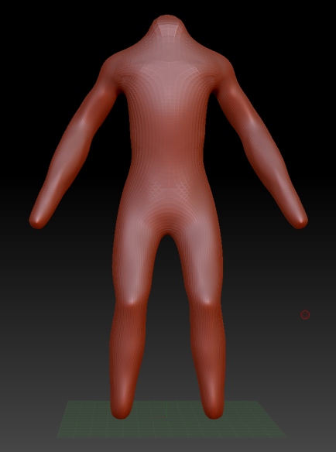 | 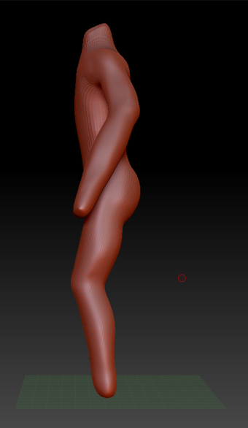

From the example above, many anatomical problems stand out right from the get go, one being the lack of muscle formation, despite the character being 7-9 year old girl the model lacks any signs of any muscle formation and instead opts for general shape over anatomical correctness.
This was caused by my lack of understanding for both muscle placement and importance of defining the muscle mass of the character, Signs of body shape are present however as shown best by the legs and how they have a more natural shape to them, I intend to prioritise more time towards this aspect of modelling in the future as I feel it will be a vital part to learn when modelling future characters.
In the future I’d like to model a lot of passion project characters to see how they look in 3D model form and for me to get a better idea of the character when writing about them in their respective stories. There’s also a lot of one shot characters I’d like to create from one of idea’s that never made it into an actual story or my own take on a concept like a character class from a game or character from other stories, I also want to learn to model in a variety of styles to help diversify my skills and options I could bring to a company.

Character clothing
Approach to realism in apparel design. Clothing is a key part to any character design, it’s what helps bring out your characters personality, it’s like the old saying “clothing makes the man” which means that clothing can change everything about a character from their personality to the way people see them to how they fit into the world they are made for.
Rashad Foux, a 3D character artist from Hi-Rez Studios said during a video interview (see appendix B for the quote)
I think what this means is that you only as good as your worst piece on your show reel, which makes a lot of sense since nobody will be at the top of their game all the time so they need to know that even on an off or bad day your work will still be to the level needed for the project at the time.

Clothing modelling is an aspect of modelling I enjoy quite a bit due to the near limitless possibilities in which you can design a characters attire. My first attempt at modelling clothing was back in the first year for computer animation, where we were tasked with modelling, rigging and animating a character based on a theme “cyborg” as shown below
1st year | 2nd year | 3rd year
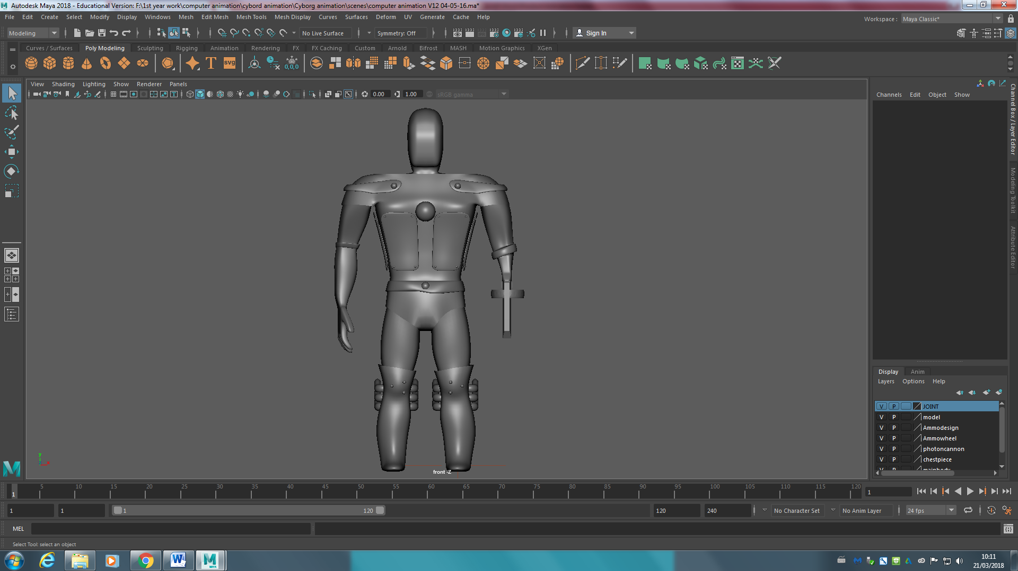 | 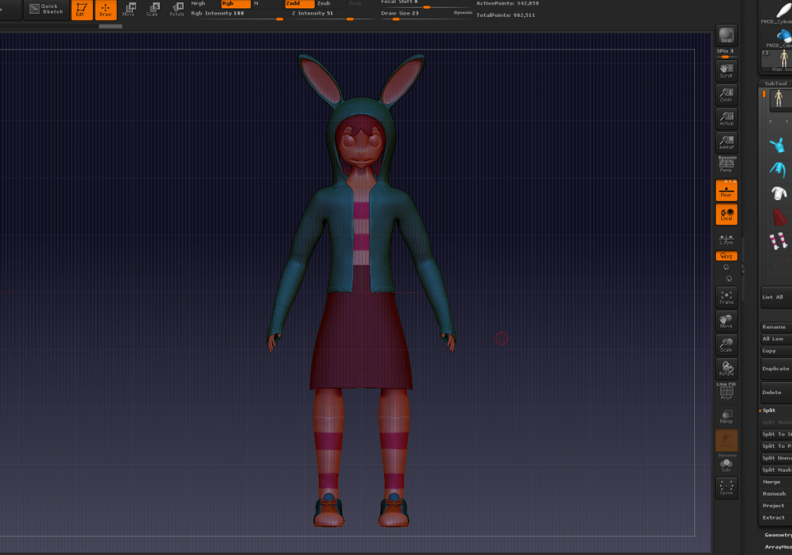 | 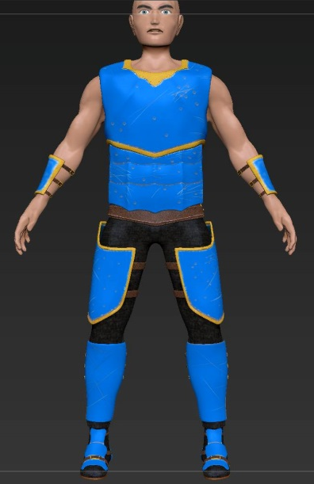
As shown by the examples above, as the years have increased so too has my skills and confidence in clothing modelling. I also think that the fact that I’ve modelling both soft fabric and hard material has both helped me greatly understand how various material look and are structure when applied to the human form. Since I’ve had to tackle both extremes of clothing, it has thus expanded my knowledge in both area’s and allowed me to challenge myself when swapping between the two.
In the future I’d like to try tackle a costume with a mixture of materials both hard and soft material, I’d also like to try and tackle animal or creature clothing as well since I think that would be both a good learning point and grant me a new level of freedom I currently haven’t experience with modelling cloths for humans, I feel like it will force me to get both creative and really dive into how that character lives, think and works in the world it is placed in.

Facial Modelling
Understanding the facial structure of a humanoid character. Facial modelling is right up there in terms of difficulty as anatomical modelling. It’s hard to get right but easy to mess up. Even if the slightest thing is off in a characters face, the audience will pick up on it and could break the immersion.

A head sculpt was done by John Asaro (see appendix C for image) and was made to help people who struggled with head sculpting learn what the bare minimum is needed in order to then move on to creating a character from the basic shape.
This was something shown to me by one of my lecturers and I intended to learn from this in more detail when given the chance as I think I can learn a lot by learning the placement of the plates and might help me understand the human facial structure better.

Over the course of 3 years, I feel as thou my facial modelling has drastically improved, when I first started out character modelling I’d often leave the characters face blank because I wasn’t confident in my modelling ability or knowledge of the facial structure to model I normal looking face but as I’ve tackled facial modelling with each new year, I feel as thou my skills and confidence has increased.
1st year | 2nd year | 3rd year
 |  | 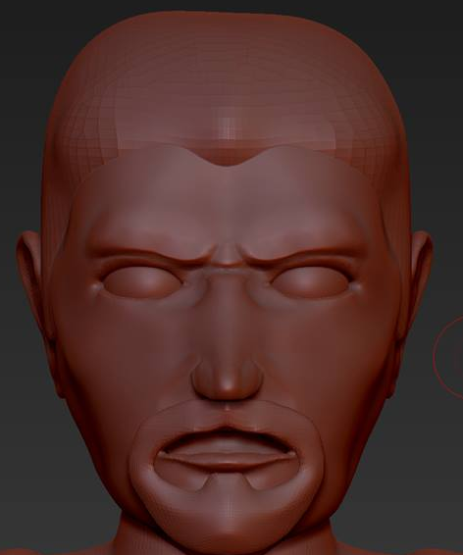
As shown above, I’ve gone from having no facial features in the first year to full facial features in the third year. I am really happy with this level of progress since I feel as thou I’ve come a long way since first year. As shown by my second year art direction project, my knowledge back then still wasn’t all that great since there are many errors in terms of the anatomy of the face such as the eye’s being too big and far apart from each other, less defined nose and a mouth too large for the face compared to the 3rd-year example that fixes many of these problems.
In the future I hope to tackle a much wider range of faces and facial features such as hair, blemishes, imperfections, accessories and body injures.

Prop modelling
Prop modelling is one of the first forms of modelling I had to tackle when first starting the course. When I first started prop modelling, I mainly stuck to simple and easy props such as tables, doors, wardrobes, etc., props that generally had a boxy shape to them, this was my first environment model I was ever tasked with creating for an assignment, where I was told to pick an environment and both model and texture it, that assignment ended rather poorly for me due to bad time management as I prioritised other models over it and trying to take the easy way out by modelling the closest environment to be at the time.
As the years and projects went by so too did the need for more and more complex or weird shaped props such as lamps, picture frames of various shapes and sizes, this forced me to step out of my comfort zone and got me into tackling more and more complex props and with each new prop came a new form of enjoyment for me since I’d have to think about how to tackle the new prop, which would often require me to think outside the box when props got difficult.
One of the most fun and creative props I’ve ever had to work on is the various picture frames from second year group project “Adar”, which was themed around welsh culture and involved a bird looking at varies picture frames with past images of itself and its own.
since it required me to model all kinds of shapes and even go into detail work that required me to etch a design into the prop as shown by the shield frame and sunflower frames that required me to etch on a dragon and Celtic design respectively, I really enjoyed etching the Celtic symbols since it required me to do research into the various Celtic symbols in order to figure out there meaning and apply them to the picture frame designs.
In the future I’d like to tackle even more etching work since I found that the most fun when working on props as well as dive more into the whole Celtic symbols and art more since I got hooked on the culture after working on the picture frames.

Environment modelling
10% modelling, 90% placement. When it comes to environment modelling, it’s more to do with how well you can utilise prop models to help build a realistic and convincing environment. The environment can tell a compelling story just as much as a character can.

Environment modelling wasn’t something I tackled much in the first year, it’s only in the second year that I found myself really working on an environment. Every environment is basically a collection of props all placed in such a way to imply reason and a story to what is seen.
Ümit Singil, a 3D modeller for taleworld entertainment said in an interview Q&A (see appendix D for quotes) This goes back to what I said at the beginning that environment are 10% modelling and 90% placement because it’s all in how you place the props that determine how something is taken from something being up right vs knocking over, from a clock being in one piece or in bits, it’s how the props are places that determines the outlook on what’s happened in the environment.
For me I very much like to construct an environment piece by piece or brick by brick in some instances and shown by my second year where I actually built a wall brick by brick because I wanted to get that actually built by hand look to it.
There was many pieces to the second year environment and even an entire section I cut out due to time constraints which would be the bridge shown above, just like the wall I also built the brick bit by bit and really enjoyed building the environment up bit by bit, despite enjoying this way, I also know it’s not the fastest or best method to use when constructing a massive environment so it’s a bad habit I’ll have to keep an eye on in the future as to not overload the environment with tiny bits that might never be seen.
In the future I’d like to try and tackle a wider range of environments from a packed city to a murky swamp or tribal village or gangster hideout or alien planet, etc.

Creature modelling
Understanding the anatomical structure of a creature character. The anatomical structure of a humanoid character is difficult to begin with but trying to model a creature that is completely different is even harder, at least with humanoid characters you have a rough idea with how the body works but creatures are much harder to get a grasp on.

(See appendix E for image)
this image does a good job of explaining just how different creatures are to humanoid characters, anatomical studies of animals is vital in both modelling a realistic animal and when reference creatures that are made up because animals are often used as reference when creating made up creatures because of how much can be taken from an animal and applied to a made-up creature since many fictional creatures would have actually been animals that people in the past didn’t know much about.

First year was the first and only time I’ve tackled trying to model a creature, this is mostly due to the stories and projects I have worked on have been mainly involved humanoid characters. In first 2 there was two instances of me modelling a creature character, one was a giraffe which I modelled and animated myself and the other creature was a giant floating hand I modelled and animated while working with the games development course.
Back then it was my first time tackling a creature and so when I first started modelling both creatures I started by blocking out the silhouettes and slowly began adding curves to the model once I was happy with the block out, this did result in my creatures looking boxy from start to finish, which wasn’t my intention but as a starting point to creature modelling I was quite happy with the end result.
In the future I’d like to try modelling all forms of creatures from animals to monsters from mythology to alien creatures to even creatures of my own design once I feel I have the experience needed to try out my own designs.

In conclusion, after three years in university studying 3D computer animation, I believe I have made considerable progress since starting three years ago knowing next to nothing about 3D animation.
Both my technical skills and artistic skills have steadily improved over the three years, the process/order in which I tackle a project has been refined after tackling numerous projects such as time management with knowing what I should prioritise first before moving on as well as collaborating with others in teams, which has allowed me to find which area’s and job’s I feel competent in and has allowed me to find the aspect of 3D animation I’d like to continue to develop and specialise in, in the foreseeable future.
In the future I’d like to work for a game company such as CD project red, tales world, Bethesda or blizzard but I’d be fine with working for any game company I could find and work on personal projects in the background whilst also looking for people to help me on the personal projects.
In terms of what type of projects, I want to work on I’d say mainly games but I wouldn’t mind working in TV series or movies if given the chance, I would also like to work on a project that tackles the Celtic culture in some way in the future as I’ve taken an interesting in it after the second year “Adar” project.

Appendices
Appendix A - “if you go to school for this kind of stuff, what you do for homework is like entry level that’s the base, what you need to be doing is, like when you’re at home after classes you need to be like studying all the things that they don’t teach you in class”.
Appendix B - “if you have a dozen pieces that are just mediocre and one really good one, we’re going to, be take into account that good one but those mediocre ones like kind of drawn to question like well what is your style like what is it that people bring to the table”
Appendix C - 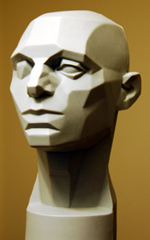
Appendix D - “Every single thing that you see when you look around in a 3D video game is a unique, painstakingly-modelled object. We are not talking only about the flashiest, most important things, such as warriors, weapons or impressive architecture: in order to be realistic, a 3D world needs to take care of its smallest details. 3D modellers do exactly that: they work like sculptors, giving shape to their imagination to create and populate the worlds we will “live” in when we play.”
Who then went on to say “I mostly use existing scene object models for reference to create the polygon friendly map models.”
Appendix E - 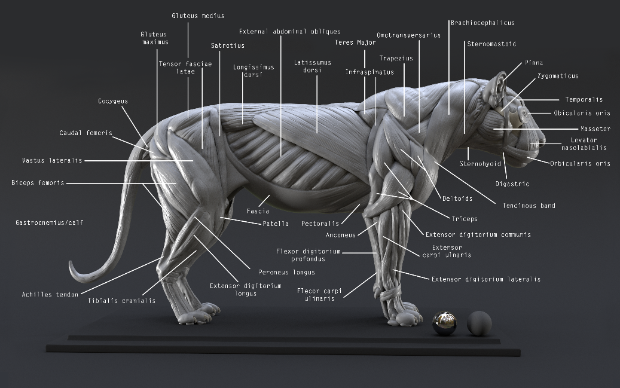
Bibliography
Source 1: SMITE by Hi-Rez Studios. (2015). Breaking into the Game Industry: 3D Character Art. [Online Video]. 2 January 2015. Available from: https://www.youtube.com/watch?v=SaPkbl5n7Pc&index=4&list=WL. [Accessed: 29 April 2018].
Source 2: SMITE by Hi-Rez Studios. (2015). Breaking into the Game Industry: 3D Character Art. [Online Video]. 2 January 2015. Available from: https://www.youtube.com/watch?v=SaPkbl5n7Pc&index=4&list=WL. [Accessed: 29 April 2018].
Source 3: John Asaro, (2008), Feeling the Form – Loomis and the Planes of the Head [ONLINE]. Available at: http://www.learning-to-see.co.uk/feeling-the-form [Accessed 29 April 2018].

Source 4: Talesworld, C. 2017. Q&A with Ümit Singil. 23rd November . Dev Blog. [Online]. [29 April 2018]. Available from: https://steamcommunity.com/games/261550/announcements?p=5
Source 5: Nicolas MOREL, (2018), Lion study n°1 : muscles [ONLINE]. Available at: http://nicolasmorel.cgsociety.org/art/anatomy-zbrush-muscles-maya-ecorche-arnold-study-lion-n1-17702605 [Accessed 29 April 2018].

