Rebecca Dingwall
2217521@student.uwtsd.ac.uk
Abstract
This report investigates how computational simulation and mathematical theorems compare for simple circuitry. The simple circuitry used within are an RCL circuit and DC resistance load circuit and the mathematical theorems used consisted of I=VR, Thevenin’s theorem and RLC circuit theory.
Electrical and Electronic system log book

Table of Contents
Introduction 1
Programs used 1
Method 1
Results 2
Task 1 Simulation results 2
Task 1 Mathematical Theoretical results 3
Task 2 simulation results 4
Task 2 Mathematical Theoretical results 6
Analysis and discussion 6
Conclusion 6
Works Cited 7

Introduction
This report focuses on how simulated circuits compare with the mathematical theory of both resonant frequency and internal resistance, to analyse the data from the simulation compared to the mathematical theory.
To find internal resistance Thevenin’s theorem has been used in both the simulation and in the mathematical calculations. It is stated that, no matter how complex, any circuit can be simplified to just one single voltage source, an overall resistance connected to a load [1].
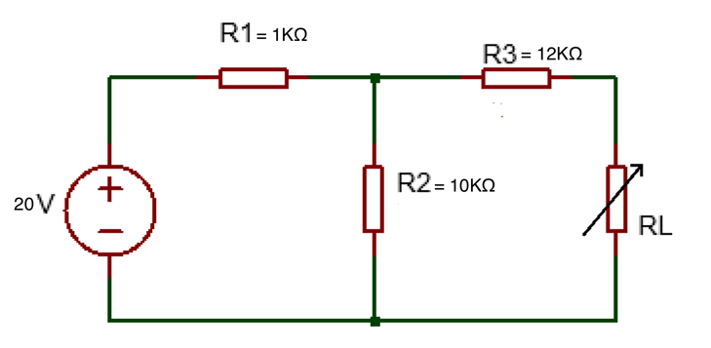
To find resonant frequency RLC circuit theory has been used. This states that, when an inductor (L), a capacitor (C) and a resistor (R) are connected in series, an equal amount of current will pass through. Resonance will only occur when the values of R,L & C have equal magnitude but a phase difference of 180°, meaning they cancel each other out [2].

Programs used
Proteus was the program used to carry out the circuit simulations during this experiment.
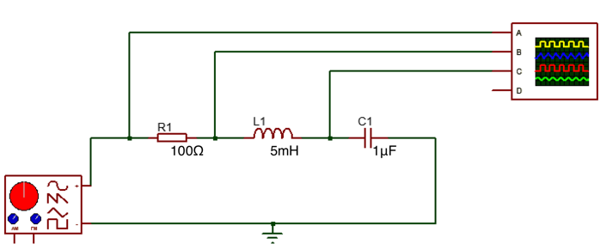
Using a simulation software to conduct this experiment is more cost effective with less errors incurred in the design phase of a circuit before moving onto more in-depth investigation of the theory vs simulation vs results. [3] There are many other simulation software packages with this capability.
Figure 1. Circuit for task 1

Method
Task 1 consisted of building a circuit with a given set of values with an unknown value for one variable resistor. See figure 1.
A circuit was then designed to follow Thevenin’s Theorem to collect the results. I=VR [4] was used to calculate the current of each
Figure 2. Circuit for task 2
of the resistance and current values collated from the simulation.
Task 2 consisted of designing and simulating the circuit found in figure 2. Setting the signal generator to a given set of values,
measuring the voltage difference in the sinusoidal wave from the peak to the trough for R1, L1 and C1.

Results

Task 1 Simulation results
Task 1 simulation results show as highlighted in yellow internal resistance on table 1 RS=RL as 12.5KΩ.
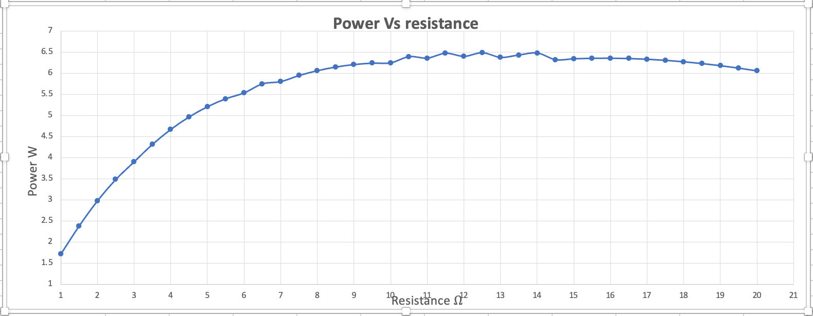
The relationship between power and resistance can be seen on the graph in Figure 4. The increase of resistance from 1KΩ to 12.5KΩ, also increases the power in Watts. After 12.5KΩ the power fluctuates slightly until 16KΩ where the power starts to slowly decrease driven by the reistance.
Figure 4. Graph showing power vs resistance

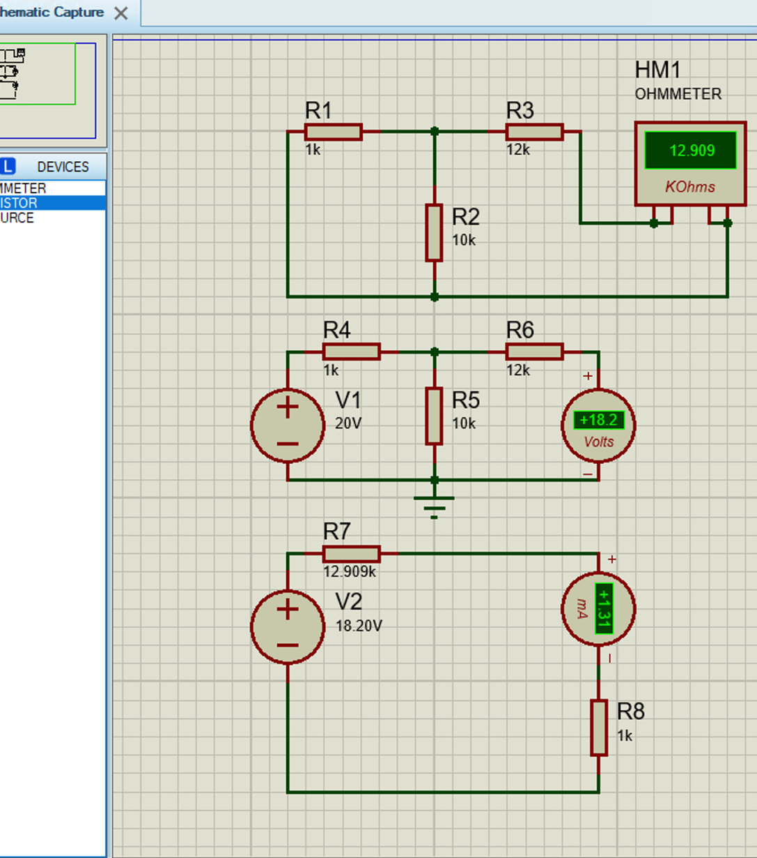

Figure 3. Simulation running to find the values in the resistance, current and power simulation table.

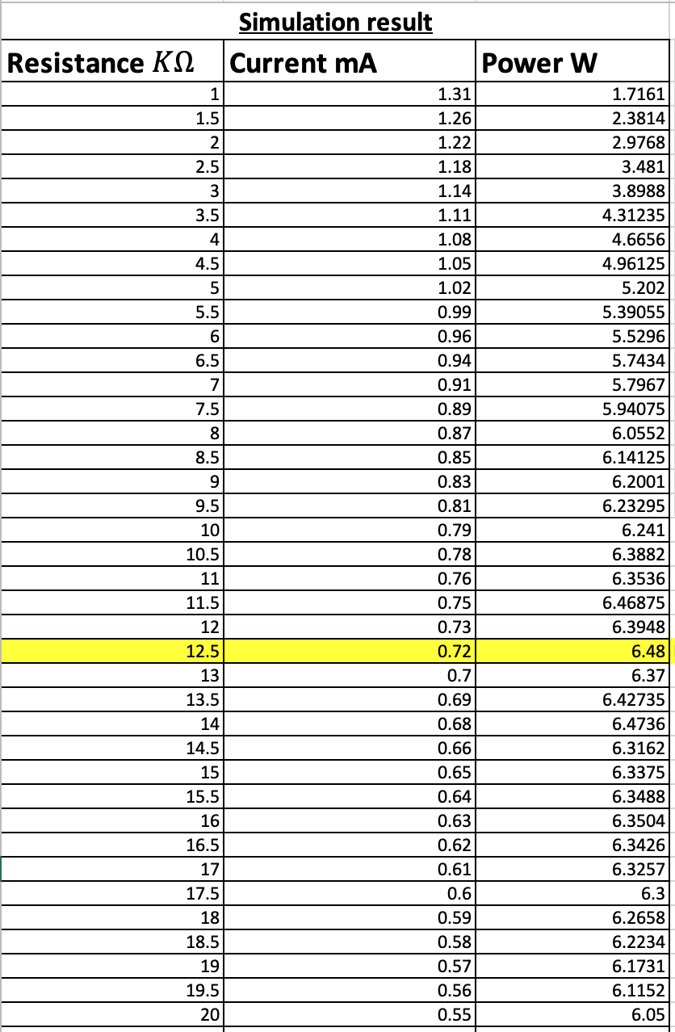

Table 1. The results of Resistance, power and resistance.

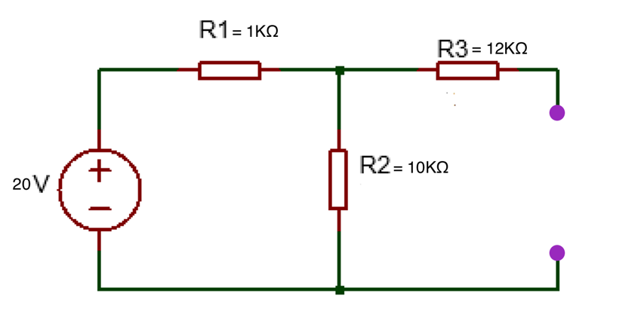
Task 1 Mathematical Theoretical results
$Rth= {\left(\frac{1}{1}+\frac{1}{10}\right)}^{-1}+12=12.090K$

$I=\frac{V}{R1+R2}$ $\frac{20}{11K}=0.0018A$

$VR2=R2I=\frac{R2 V1}{R1+R2}$ $\frac{10K 20V}{11K}=18.18V$

$I=\frac{Vth}{Rth+RL}$ $RL=\frac{Vth}{I}$ $\frac{18.18V}{0.0018A}=10100$ = 10.1KΩ

Rth= 12.090KΩ Vth=18.18V I= 1.8mA RL= 10.1KΩ

Task 2 simulation results
The resonant frequency can be seen highlighted in yellow in table 2. At 7KHz, this can be seen clearly on the graph in figure 5 as the highest point on the graph at 22 V, Voltage difference in capacitance. The voltage capacitance then continues to decrease steeply to 15KHz. From this point the voltage capacitance stays at 2V until reducing to 1V of capacitance at 20KHZ.
This is shown again in figure 6, where the cursor lines intersect the sinusoidal wave forms showing the voltage difference from the top of the peak to the trough.
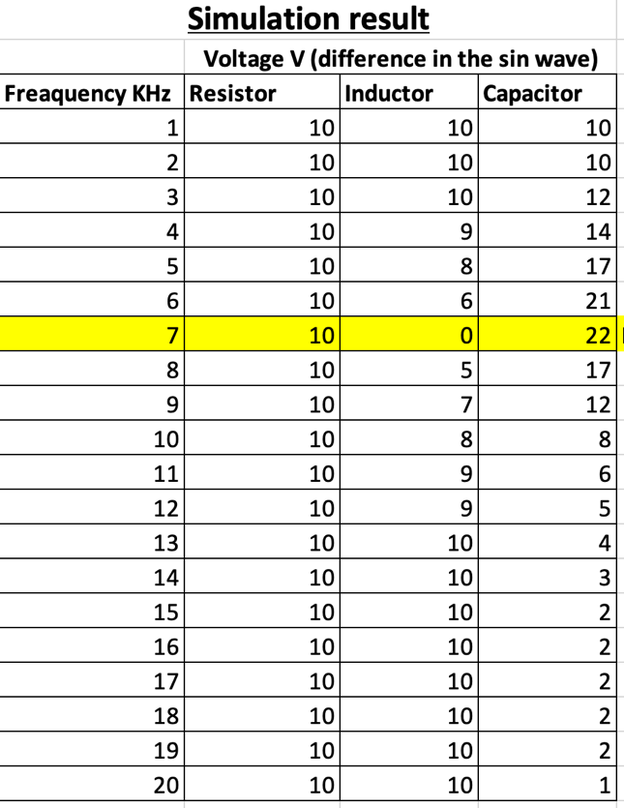

Table 2. The results from the simulation showing frequency, resistance voltage, inductance voltage and capacitance voltage.

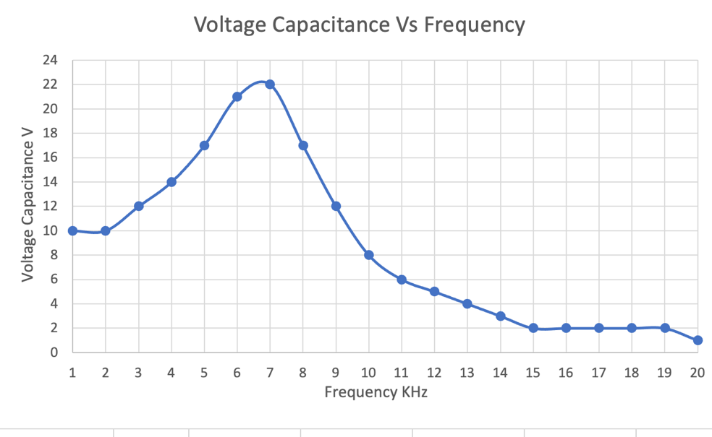

Figure 5. Graph showing voltage capacitance vs frequency
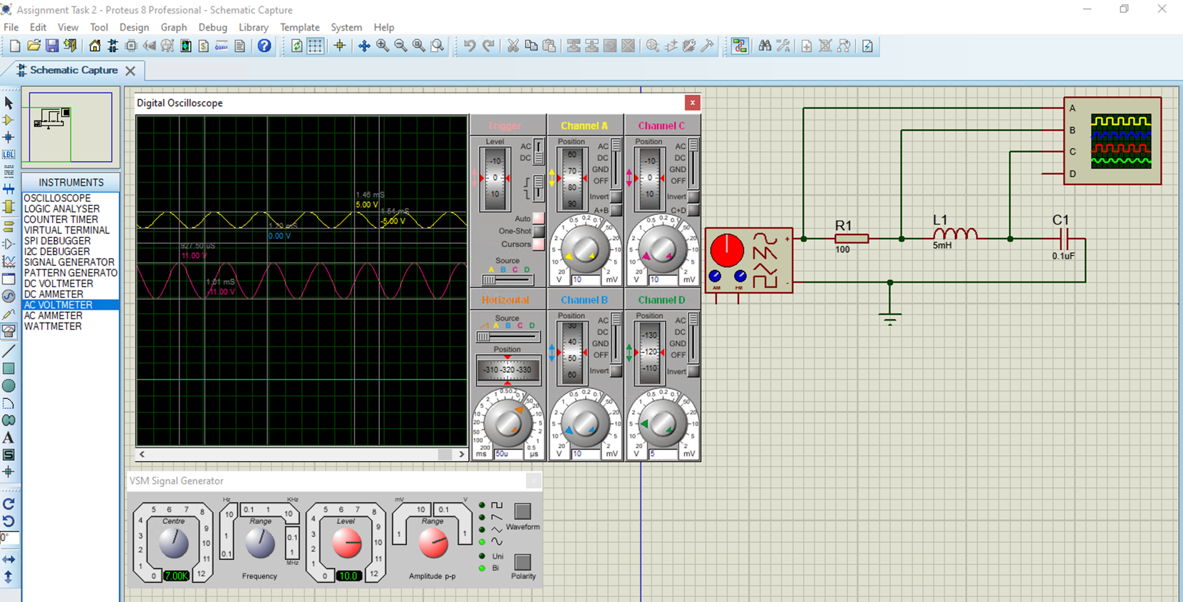
Figure 6. Simulation including the measurements of the voltage resistance, voltage inductance and voltage capacitance in yellow blue and pink respectively.

Task 2 Mathematical Theoretical results

$Fr=\frac{1}{2π\sqrt{LC}}$ L= 5mH C=0.1μF

$Fr= \frac{1}{2π\sqrt{\left(5×10-3\right)\left(0.1×10-6\right)}}=7117.63 Hz$ = 7.12KHz

Analysis and discussion
 | Simulation Result | Theory Result
Rth | 12.090KΩ | 12.090KΩ
Vth | 18.2 V | 18.18 V
I | 0.72 mA | 1.8 mA
RL | 12.5 KΩ | 10.1 KΩ

Table 3. Direct comparison of internal resistance results

As seen in table 3, showing the direct comparison of the two results of internal resistance, you can see that the Resistance Thevenin’s theorem on both the simulation and the theory are the same value. The Voltage Thevenin’s theorem has a difference in 0.02 V if rounded to 1 decimal place these results are correspondent. The current has a difference of 1.08mA between the simulation and theory results and the resistance load has a difference of 2.4KΩ.

 | Simulation Result | Theory Result
Fr | 7 KHz  Table 4. Direct comparison of Resonant frequency results | 7.12 KHz

As seen in table 4 the results from the simulation and theory are comparable, with a difference of 120 hertz.
All of the results are the same and or similar as the software uses the same theories within the programming and mathematical models that provide accurate results by accounting complex circuit elements combined with the models previously mentioned.
There are benefits of using simulation software like a reduction of cost for checking circuits will work as expected especially on more complex circuits , however there are also some drawbacks, on both the simulation and theory calculations, the resistance produced by the wires isn’t calculated, as it would be able to be recorded if building the full circuit. The software also doesn’t account for circuit leakage e.g., sound, heat, vibration, or electronic noise as it would if a data set was to be collected from a real-world circuit.
If this experiment was repeated , the use of a bread board to simply and cheaply build the circuits to get the real results to compare to the simulations and theory as this would prove beneficial to understand circuit leakage and to get a better understanding of how much resistance the wires provide, but also to validate the accuracy of the simulations.

Conclusion
To conclude, the simple circuitry within the experiment lends itself well to have the results of theory compared to simulation, however as mentioned previously a more complete data set using a real-world data from the simple circuitry would provide a more accurate and thorough investigation, as the results from the simulation and the theory are roughly the same.

Works Cited

[1] | All About Circuits, “How to Use Thevenin’s Theorem,” All About Circuits, [Online]. Available: https://www.allaboutcircuits.com/textbook/direct-current/chpt-10/thevenins-theorem/#:~:text=Thevenin%27s%20theorem%20states%20that%20any,resistance%20connected%20to%20a%20load.. [Accessed 8 July 2023].
[2] | unacadamy, “Resonance in an LCR Circuit,” [Online]. Available: https://unacademy.com/content/neet-ug/study-material/physics/resonance-in-an-lcr-circuit/. [Accessed 8 July 2023].
[3] | Proteus, “Proteus,” Lab Centre, [Online]. Available: https://www.labcenter.com/simulation/. [Accessed 9 July 2023].
[4] | Electronics Club, “Ohm's Law,” Electronics club, [Online]. Available: https://electronicsclub.info/ohmslaw.htm. [Accessed 9 July 2023].

