By Penko Nedelchev Lecturer: Anupam Mazumdar
University of wales trinity saint david
Data analysis & Visualisation
DHB

Table of Contents
Part A 3
Introduction 3
Use of Excel for Pre-processing the data 3
Use of Excel for Analysing the data 3
Use of Excel for Visualising the data 4
Determining the decline/rise in Sales and Profit 4
Analysis the profit using Pivot Table 6
Part 2 8
2.1: Number of students that like vanilla flavour of ice cream 8
2.2: The number of male and female students 8
2.3: Mean and Median of participants who like chocolate and strawberry flavour ice-cream. 9
2.4 Specific example of clustering from the data set in conjunction with SPSS 10
2.5: Explanation of common data mining and text mining methods that can be used in business 11
Data mining methods 11
Text Mining 12
2.6: Advantages and Disadvantages of using SPSS and Excel 13
Conclusion 14
References 15

Part A

Introduction
The analysis of business data is very important as it plays an important role in the decision-making process. We are provided with the data set of a superstore. The data will be used to determine the decline in sales or profits over the years. The different excel functions will be used for this purpose (Singal, 2017). The information will also be presented in graphical form to develop better understanding in visual form. The use of MS Excel by the business for pre-processing of the data, its analysis and visualization will be evaluated. This is very useful software that can be very beneficial for business.

Use of Excel for Pre-processing the data
The data collected can be in any format. It is important to make sure that the data is processed in a certain manner in order to make it useful. MS Excel is very useful software for business in this regard. The data can be processed according to the need of the business and this makes the use of Excel very effective. There are different functions that can be performed on the data that will prepare it for further processing. For example, the data of many years’ sales of a business can be collected. This will make it for the business to analyse the data in the right manner (Hrehova & Vagaska, 2017). There are different options to sort the data according to the years in order to prepare it for further processing. The formula can be applied for this purpose or the user may also benefit from the options that are already available in the software. In a similar manner, the sales of different products of a company can be collected from the sales management system. The Excel formula can be used to sort the data based on product or the filter option can be directly applied on the data set. In this manner, the data can be pre-processed and prepared for further use through excel.

Use of Excel for Analysing the data
Data is extremely important for a business. The management of the organisation is concerned with the collection of data from the different aspects of the business (Singal, 2017). The analysis of the data is critical as it will enable the management to understand the different trends, changes in values and other factors. The administration of the business can be done in a much better manner by analysing the data. MS Excel can be very useful in this regard. It has different functions that can be applied to the data for analysing the different aspects of information. Excel can be used for analysing the sales trend or the latest trends in the cost. There are different formulas that can be applied to the data. The different measures of central tendency such as mean, median, mode and range etc. can be calculated. The measure of dispersion such as correlation and standard deviation can also be calculated in a simple manner (Hrehova & Vagaska, 2017). The analysis of the data can be done to analyse the efficiency of the different task, and this helps the management in making better decisions. The management can analyse the data to establish cost controls, manage inventory and debtors etc.

Use of Excel for Visualising the data
An important aspect of managing the data of the company is getting it visualized. The understanding of the data in its tabular form can be difficult although it may be organized. The visualization of the data is helpful in different ways. It represents the data in a simple form, and anyone can understand it. The analysis of the data and the findings based on analysis can be done in a better manner when it is in a visual form. MS Excel is very useful in this area as well. It can be used to present the data visually in different ways. The pie chart can be created for visualising the data in such a manner that the analysis can be done in a better manner (Singal, 2017). The different trends in the data can be presented visually in the form of bar charts and histograms etc. For example, the company can use the line chart to visualize the data and see the changes in sales over the month. The management reports are normally given in visual form as they are comprehensible to a person who may not be able to understand the tabular data in a correct manner.

Determining the decline/rise in Sales and Profit
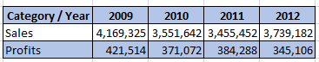
The above figures have been calculated based on the information provided in the dataset. It can clearly be seen that the sales of the superstore have been continuously declining over the years. The total sale of the business was 4169325 in 2009 which were reduced to 3551642 in 2010. The year 2011 saw a further reduction in the overall sales of the store with a figure of 3455452. There is one slight improvement in the year 2012 in which the figures were higher from the previous two years i.e., 3739182. Although, the figure in 2012 was still less than the sales that were generated by the business in 2012. The reduction in overall sales figures shows that the business is not able to generate the profits in the right manner as it used to do in previous years. The business has shown some growth in the year 2012, which is a good sign for the overall growth of the business. Excel has been useful in sorting out the random data into sales based on the year. This data has helped us to understand the overall sales of the business. The management of the organisation can use this data to further identify the increase in sales of different product categories of the business.
In a similar fashion, there is a decrease in the overall profits that are earned by the company against their sales of different products. The profit calculated for the year 2009 is 421514. The overall profit then declined to 371072 in the year 2010. The year 2011 again brought an increase to the profits and the calculate figure is 384288. The negative trend continued again for the business and the overall profits were reduced to 345106 in 2011. It should also be noted that the calculation of the profits for each year has been made possible by processing the data on a yearly basis. This helped us to calculate the profits for each year. One of the things that can be found in the data is that sales and the profit of the business are not showing a similar trend. This can be seen by the fact that the sales have decreased for 2010 and 2011 but showed a positive increase for 2012. On the other hand, the profits decreased in 2010 but increased in 2011. There was a decrease in profits once again in 2012. The analysis can also be done using Excel to identify any correlation between the changes in the figure of sales as well as profits.
It is important to analyse the different other factors in the information as they can play an important role in understanding the data in a proper manner (H.Hayslett & P.Murphy, 2017). The decrease in sales in the year 2011 but an increase in profits can be due to many factors. One of the factors that is important in this regard is that the discount offered to the customer is reduced. This has helped the superstore to increase their profits although the overall sales have decreased. The challenge with reducing the discounts is that it may help the business in the short term but may have a negative impact on attracting customers in the longer run. In a similar way, the sales revenue has been increased for the year 2012 but the overall profits have decreased. This may be due to the reason that the company has focused on offering more discounts to their customers to increase the sales. This has resulted in a decrease in the overall profitability of the business. The management of the superstore can use this information for making effective decisions about the future of the business.

Analysis the profit using Pivot Table
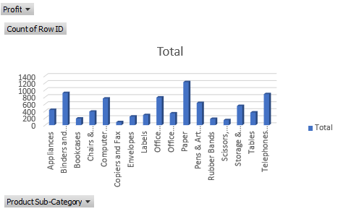
There are several ways to analyse the information in the dataset about the superstore sales. One way is to look at the profit on different product categories for each of the different categories of the customers of the business. The pivot table is a powerful feature of MS Excel that helps in analysing the information in different ways more effectively (Hrehova & Vagaska, 2017). The pivot tables have been used to compare the data about the profit for different product categories against the different nature of customers of the business. There are four different categories of customers for the superstores i.e., consumer, corporate, small business, and home office. The products that are offered by the superstores include office supplies, technology, and furniture. The above figure shows the profit for each product for each type of customer of the superstore. This is very helpful for the management of the organisation as they can easily look at and compare the different profits generated by each product based on their sales to different customers of the business. Excel has enabled the calculation of these figures in an easy manner.
The analysis of the above figure and the findings of the pivot table have shown that there are some distinct categories of business products which are more profitable for the business. There are different types of business customers and each of them has their distinct needs. This is the reason that the demand of each customer is quite different from each other as well. The furniture is the most sought-after business product category that has been demanded by most of the customers of the superstore. The next most sold item is the technology products sold by the company. Then comes the office supplies, which are also an important product of the business. The management of the organisation can use this data to understand the demand for their products by different customers of the business. This will enable them to make sure that the sales forecasts can be made in a better manner. The targeting for the sales of the business can also be done in a much better manner by doing this activity. The business can also make special offers to their existing customers in other product categories than which they demand. This will incentivize them to buy more from your business. The organisation can also use the data to make bulk purchase offers to their customers. The customers will feel more valued by such actions as they will be given special treatment. All of this has been possible by using the different features of Excel to understand the information.

Part 2
This part of the assessment comprises of the analysis of the data which is collected by carrying out a survey on 200 high school students. The data analysis will be done according to the different requirements of the company by using SPSS data mining software (Maheshwari, 2015).

2.1: Number of students that like vanilla flavour of ice cream
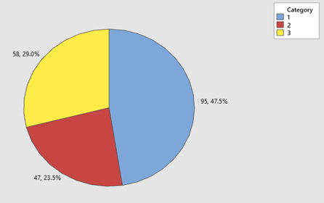
Figure - 1: Pie chart showing the liking of vanilla ice cream
The number of students that chose the vanilla flavour of ice cream as their favourite in the survey is 95. This means that 47.5% of the respondents chose vanilla ice-cream as shown in above figure - 1.

2.2: The number of male and female students
The data was analysed using SPSS and it showed that the number of male students was 91 while the number of female students was 109. This means that the percentage of male students is 45.5% while the percentage of female students is 54.5%.
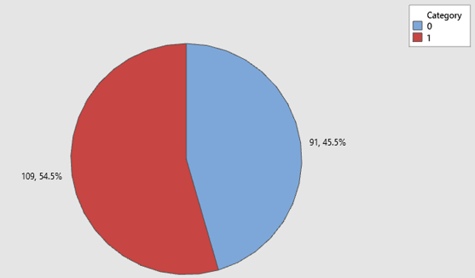
Figure - 2: Pie chart showing the number of male and female students

2.3: Mean and Median of participants who like chocolate and strawberry flavour ice-cream.
Liking of Chocolate Flavour
The mean of the students liking chocolate flavour ice-cream is 99.03 while the median figure is 98.
Liking of Strawberry Flavour
The mean of the students liking strawberry flavour ice-cream is 100.899 while the median figure is 100.5.

2.4 Specific example of clustering from the data set in conjunction with SPSS
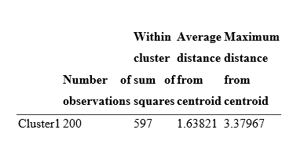

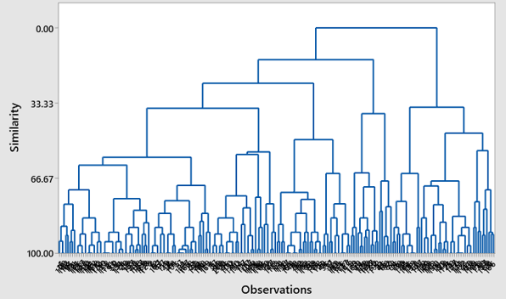

Explanation of the results
Clustering has been done for the dataset. The distance between different clusters from the centroid has been shown in the above table. The average distance from centroid is 1.68321 while the maximum distance from centroid is 3.37961. The four different clusters are the most suitable option for the ultimate division of this dataset. The dendrogram has been used for analysing the similarity between the clusters as it helps in understanding the relationship between the nodes.

2.5: Explanation of common data mining and text mining methods that can be used in business

Data mining methods
Data mining enables the business to utilise the huge amount of information that is collected for creating useful insights (Maheshwari, 2015). Some of the common methods that are used for data mining are as follows:
Clustering
One of the methods of data mining is creating clusters of data based on common characteristics (Gaskin, 2016). This method is used because it creates the subsets in the data sets which not only enable a better understanding of the information but also are very helpful in making relevant decisions. The examples of clustering used in business include the categorization of the customers into different categories such as small businesses, home offices, and large customers. The supermarket businesses use clustering for their sales data for analysing the performance of each product.
Machine Learning
Machinery learning is one of the latest technologies in which computers learn from current and past actions. This enables the machine to perform different tasks in a better manner automatically. An example of using machine learning method in data mining is the ability of the computer software to identifying different customer related trends on their own and making recommendations to the business in this regard (Maheshwari, 2015).
Data Visualisation
Data visualisation is a very common method of data mining. The findings of the day is visualized while presentation in the form of charts, diagrams, and graphs etc. For example, this method is used to show the number of walk-in customers and their purchases in the form of bar charts. The types of customers such as single or family people can be visualized by using the pie chart (Maheshwari, 2015).
Association
This is the method of data mining in which the relationship between different variables is identified and created. This helps in understanding the data in a much better manner. The analysis is done for online shopping that people that buy exercise equipment are more likely to buy protein supplements. This information is obtained by applying the association method for data mining.

Text Mining
A large part of the modern-day information comes in the form of text. For this reason, it is extremely important to use data mining techniques to extract valuable insights from the text data and use it for business decision making (Maheshwari, 2015).
Information Extraction
This is one of the most common methods of text mining that is commonly used by businesses. The data collected is in unstructured form and the information must be extracted. This information can be in the form of phrases, names, hashtags, and other such indicators.
Natural Language Processing
This is another breakthrough technology that is used for text mining. The computer systems analyse the data and intelligently identify the natural language patterns in communication. It has enabled the companies to understand the language used by users to interact with each other. Google and Facebook use this method for text mining (Maheshwari, 2015) .
Information Retrieval
This data mining method comprises of retrieving the information from the dataset to discover patterns and connections. This method is actively used by Google to retrieve the information for its users by applying an intelligent applied algorithm. In this manner, more accurate information is provided to the users (Maheshwari, 2015).

2.6: Advantages and Disadvantages of using SPSS and Excel
 | SPSS | Excel
Advantages | 1. It makes it possible to import and export data from another computer program.  2. The calculations can be done in a fast and reliable manner.  3. It is available in multiple languages and hence can be used by many people (WN write need, 2020).  4. It is an open-source program that is available for free.  5. Ability to manage qualitative and quantitative data.  6. The complex statistical analysis can be done quite easily in SPSS (WN write need, 2020). | 1. It is simple to use in terms of organising the data.  2. It helps in automatically suggesting the formula that is to be used in calculations.  3. It has a very friendly and attractive interface where the users can make different analysis with a single click (Hrehova & Vagaska, 2017).  4. It allows the multiple users to access a single file. This option is also available on cloud.  5. It is commonly used software and its files can be opened on multiple platforms.  6. Very common software and help can be sought easily (Singal, 2017).
Disadvantages | 1. The SPSS has some limitations and cannot be used for very big data sets (Grande, 2015).  2. The gap between the sample selected and the population must be small. Otherwise, the quality of the result will be compromised.  3. The SPSS requires expertise to use, and the analysis may not go well if not done correctly.  4. It is not the easiest software to use in its category (Grande, 2015).  5. It may provide simple answers while the problems are complex. | 1. MS Excel is paid software and not everyone can afford it.  This only focusses on the information that is selected by the user for calculation and this may result in wrong calculations.  3. The advanced formulas used in Excel are complex and require high level of expertise (Hrehova & Vagaska, 2017).  4. The multiple access option can sometimes result in loss of information as well as corruption of the file.  5. Its files may sometimes not open properly on new versions which may result in difficulties.

Conclusion
The analysis of the information is an important part of the business. Both MS Excel and SPSS are very useful as it allows organising and analysing the data according to the business needs (Singal, 2019). It can be used for pre-processing and visualising the data. Both MS Excel and SPSS software have helped in sorting out the relevant yearly data from the information pool and making further calculations. It has been also made a comparison in this report between Excel and SPSS, listing both their advantages and disadvantages

References
Gaskin, J., 2016. K-means cluster analysis SPSS. [Online]
Available at: https://www.youtube.com/watch?v=e27G-UCju0E&t=2s
[Accessed 28 12 22].
Grande, D. T., 2015. Sensitivity, Specificity, False Positives, and False Negatives in SPSS. [Online]
Available at: https://www.youtube.com/watch?v=XdPAjO718Fg
[Accessed 05 1 2023].
H.Hayslett & P.Murphy, 2017. Statistics MS. 2nd ed. London: Elsevier Science.
Hrehova, S. & Vagaska, A., 2017. Introduction to MS Excel advanced techniques via e-learning. New Trends and Issues Proceedings on Humanities and Social Sciences, 4(1), pp. 255-260.
Maheshwari, A., 2015. Business Intelligence and Data Mining. 1st digital ed. New York: BEP.
Singal, A., 2017. MS Excel: Let's advance to the next level. 1st ed. New York: BEP.
WN write need, 2020. What are the benefits of SPSS. [Online]
Available at: https://www.youtube.com/watch?v=gqYZoCEfMos
[Accessed 05 12 2022].

