
Skills for the Workplace
Module Assignment Submission
Student Name: | Abigail Hetherington
Student Number: | 2025084
Module No: | BMSK4005
Module Title: | Professional Career Development

Statement of Confirmation of Authenticity
By the act of making this submission, the student declares that this is the work of the student named above. The work has not, in whole or in part, been knowingly presented elsewhere for assessment, or where assessment has been built on a previous assessment, this has been identified. Where materials have been used from other sources it has been properly acknowledged. If this statement is untrue, the student acknowledges that an assessment offence has been committed.
Attention is drawn to the plagiarism and unfair practice policies of both the University and of ILM.

Table of Contents
How to identify development needs 2
1.1 Identifying the learning styles for myself and Simon 3
1.2 Identifying development needs for myself & Simon 4
1.3 Potential barriers to learning for myself and Simon. 5
1.4 How these barriers to learning can be overcome. 6
Develop myself & Simon to achieve organisational objectives 6
2.1 Learning & development options for myself & Simon. 6
2.2 Support mechanisms for the development of self & Simon 7
Development Plan 8
My Personal Analysis 8
Simon’s Analysis 9
2.4 Method used to monitor the development of self & another. 10
Preparing for the Recruitment Process 11
Reflection on the Recruitment Process 11
3.1 Description 11
3.2 Feelings 11
3.3 Evaluation and Analysis 12
3.4 Conclusion 12
3.5 Action Plan 13
References 13
Appendix A 14
Appendix B 16
Appendix C 19

How to identify development needs

Myself and my husband, Simon, run our own electrical business in Llanelli. We have wanted to grow our company for a long time. For myself and my husband to progress and achieve highly in our careers, I feel it is imperative to develop ourselves and our skillset to ensure the best possible outcome of our business and my personal life alike.
I will self-assess myself and then assess my business partner and husband to see what we can do to help us develop our business and achieve the potential that we feel it has.
The first thing I will need to do is find out what type of learners we both are.

1.1 Identifying the learning styles for myself and Simon

The best way to start my development is to assess what type of learning style suits me best and how I can utilise my strengths and manage my weaknesses the achieve the results that I want to achieve. In order to do this myself and Simon are going to complete two online learner quizzes. The first questionnaire is VARK.
VARK was originally developed in 1987 by Neil Fleming, a teacher from New Zealand, as a way to understand how people learn and how they use their own learning styles to communicate and then share the information they have just learned (2017). VARK stands for Visual, Aural, Read/ write and Kinesthetic.
If your learning style is ‘Visual’ means that the learner prefers visual aides to help with their learning such as pictures and diagrams explaining the information.
Aural means that you prefer to learn by someone explaining the topic to you, by listening to instructions and by discussions.
Read/ write is having the preference of written instructions, making notes and writing lists.
And finally Kinesthetic learning is by practically taking part in an activity or by someone showing you the correct way to undertake a task. Movements and being hands-on is what aids your learning the most.
During the questionnaire we were asked to answer a series of questions which relate to which method of explanation is best and what is your learning preference. Once all the questions are answered, your results are calculated and the type of learner you are is revealed. The questionnaire was quite simple but you had to be aware of your learning preferences, this is something that not many people are aware of, so this questionnaire might not be suited to everyone.
For myself, I came out as a VAK learner (Appendix A). This means that I am ‘multimodal’. Multimodal means that more than one learning strategy works for me and those learning strategies are visually, aurally or kinesthetically. I would agree with this result.
My husband took the same questionnaire and his results showed that he is a strong kinesthetic learner (Appendix A). This means that he prefers to learn in a practical way where possible and needs to be explained experiences from true events and shown examples that are factual or historically accurate.
The second test we took was the Honey & Mumford test. This test was a list of 80 statements that you either agree with or disagree with. These statements were broader and did not always relate to your preferred learning style but more for your preference in certain scenarios, behaviours and what type of person you are generally.
The Mumford and Honey learning styles quiz was originally developed by Alan Mumford and Peter Honey, inspired by the Kolb learning styles model, only the Mumford and Honey focussed on people’s behaviour in general rather than asking people their learning preference (2017). Mumford and Honey believed that not everyone necessarily knows their preferred learning technique as it was not something that people often thought about. That is why they developed the questionnaire, to give people more ordinary questions that would then relate to their preferred way of learning. Similar to Kolb and the VARK method, Mumford and Honey had four learning outcomes that you could be more favoured to. In this learning style quiz they were called Theorist, Activist, Pragmatist and Reflector. The way you responded to the statements is then tallied and whichever you tally the most in, that is your most dominant learning style.
When I completed this questionnaire, my highest result came back as an activist with my second highest result as a reflector (Appendix A). This shows I mainly learn by doing and have an open mind whilst learning, the reflector part of my results also show that I am keen to observe and see things from all angles before deciding the best option to take. The lowest score from my results was the theorist, I agree with this result as I do not enjoy reading over facts and having models and concepts in front of me.
These results compliment the results I had from the VARK test, so I now feel confident about the type of learner that I am and what I need to do to get the best results for myself.
The results for Simon’s questionnaire were close mixture of activist, pragmatist and reflector (Appendix A). This shows that he has a combination of learning styles. He likes to observe an instruction first and then take him time to reach a decision about how he will undertake the task, he is good at problem solving and he learns by doing. His lowest score was also theorist which means that, like me, he is not a keen reader of facts and statistics. His result from this quiz is also similar to the results of his VARK test and I know now what he needs to do to ensure that he is learning the best way for him.

1.2 Identifying development needs for myself & Simon

For our development, I must first see where our strengths and weakness lie. In order to find this out I will be completing a SWOT analysis for myself and for Simon.
According to the British Library (2021) SWOT analysis was first created by Albert Humphrey in the 1960’s as a way to document your businesses strengths and weaknesses whilst also noting the threats and opportunities in your business market.
Below is myself and Simon’s SWOT analysis.

SWOT Person 1 - Abigail

STRENGTHS  Communication Skills  Organisation  Book-keeping  Advertising & Marketing  Social Media  Patient | WEAKNESSES  IT  Time Management  Not confident practically  Lack of business contacts
OPPORTUNITIES  IT courses & training courses  Local authority contracts  Spend more time on practical jobs  Networking groups  Time management workshops | THREATS  Other businesses  Lack of available contracts  Future employees  Lack of childcare  Lack of interest in the trade

SWOT Person 2 - Simon

STRENGTHS  Good electrician  Good practically  Efficient  Works well under pressure  Problem Solving | WEAKNESSES  IT  Patience  Public Speaking  Communication skills
OPPORTUNITIES  IT courses & training courses  Local authority contracts  Practice public speaking & communicating | THREATS  Other businesses  Lack of available contracts  Future employees  Lack of childcare  Physical demand on body  Lack of interest in the trade

1.3 Potential barriers to learning for myself and Simon.

The barriers I am faced with while I am trying to develop myself and my business are similar to the barriers that Simon would be faced with. As we are married and have two small children, childcare will be an issue for us both if we both decided to enrol on a course to study. I currently work from home part-time, study full-time and work on site part-time, as our youngest son is still not in full-time school. This set-up is useful for the time being as it means I can run the business and study from our home office whilst also looking after our son. It would become a problem however if I needed to add an extra task, such as another study course.
Another barrier that would affect the ability for both myself and Simon to study is the work-life balance of our lifestyle. I believe that our relationship could be put under strain if we each take on another responsibility such a studying. So much of our time is already taken up by running our business together, raising a family and undertaking the electrical work we have booked in that I fear if anymore pressures are put on either if us, our happiness may begin to suffer. It would also mean that we would be spending a lot of time together and sometimes under stressful situations. It is a concern that we would not have enough time together as a couple which would also affect the quality of our marriage.
Simon and I do not have any savings, so if we were to enrol in a course, we would have to fund it ourselves or rely on student loans. Neither of us have had a student loan before so this is unfamiliar territory for us both. It is something that we could look in to but the idea of having another monthly outgoing is a concern as our finances are already quite stretched. It would also affect us both as we the run our household together and are finances and assets are joint.

1.4 How these barriers to learning can be overcome.

For us to overcome our issue of lack of childcare we could simply hold off on any studying for a few weeks. As our son is almost 4, he will be starting full-time school in January and I will have also finished studying for my HNC in January. This will free up a lot of our time and help us greatly with our childcare issue. We may still struggle with after school pick-ups on our busier days but as my mother is retired, she has agreed to help when we need her.
I consider my organisation skills to be one of my strengths so in order to make studying an option for both of us I will take charge of myself and my husband’s schedule, as well as the works diary and ensure that I structure our day accordingly. This will also include family time and being available for one another and our marriage. I will ensure that we take time off for family holidays, days out and enforce times where work and discussing work are not allowed.
The financial barrier that we have whilst wanting to learn is something that would have to be discussed. One solution to this problem is that we study at different times. I could enrol on a course this year and Simon could enrol on a course next year. This would help us financially to spread the cost and help to relieve the extra demand on our schedule.

Develop myself & Simon to achieve organisational objectives

2.1 Learning & development options for myself & Simon.

After completing and examining the SWOT analysis for both myself and Simon, I now have a better understanding of our educational needs, what setbacks we have while running our business and what steps we need to take to get our business ready for expansion.
Our ideal work progression is to expand our business. We want to gain a contract for regular work, whether that be local authority or a new-build housing site. Currently, we are too small to take on such large-scale work so for us to expand to a place where we can manage the bigger contracts, there are some things we need to put in place first. For us to get more contracts for our business an option would be to make more business contacts.
One of my weaknesses is my lack of confidence whilst working electrically. I qualified as an electrician in October 2013, at the time I was pregnant with my first son and shortly after I was laid off from my job as an electrician. Having to take a significant amount of time off to have my son and then being unable to get a job as a part-time electrician when I went back to work, I found myself taking a job as a maintenance supervisor in a local department store. Having spent a few years not working as an electrician it effected my confidence and my abilities to undertake electrical tasks. This is something I would like to work on and improve in the near future.
For myself and Simon, we both need help with IT. We feel this would help us be more efficient while completing digital tasks such as online invoices and quotes. I have slightly more experience than Simon, but I do feel that I would benefit from more knowledge and be tutored on the best computer software to use for our business and how to use it.
Communication is one of Simon’s weaknesses. Not only in person but his written communication is not the most professional. I usually take care of all the communication with our business but if I were to take on an extra responsibility such as studying, Simon may need to take on the communication from time to time to ensure our business standards don’t slip and we don’t lose any custom.
Another one of Simon’s weaknesses is that he isn’t a very confident public speaker. We both feel that this skill is not only beneficial for our business but also personally as well. The same also applies to Simon’s communication, if I were to study and Simon had to undertake some of my usual tasks, having the ability to communicate will be essential for our business.

2.2 Support mechanisms for the development of self & Simon

In order to support my lack of confidence whilst completing electrical tasks I feel I need to practice. Having the support of Simon, who is a more confident and more competent electrician with me while I complete small jobs and seeking his advice will help me to get better and be more confident with my own abilities. When I am feeling more confident, I will complete some jobs by myself and work on my own until I feel confident enough to lead my own team.
We are members of a BNI group so I will use the support of my team to gain more contacts by building relationships with them and their contacts. Hopefully, if I am specific with my needs and the type of contacts I want to make I will make the right connections and expand my business. Building relationships takes time so we know that this will not be a quick fix for us, but we are both prepared to invest our time into the meetings.
I currently attend the meetings for our business networking group but I feel if Simon were to attend instead of me, it will help to improve his public speaking skills and it will build his confidence while communicating. He could also take charge of our BNI representation completely, having him communicate with other members of our chapter will give him good practice to work on his emails, messaging and email communication all under my guidance until he is able to do this independently.

My Personal Analysis

Abigail: Personal Analysis
See SWOT Analysis in 1.2

Part 2: Setting Goals

What do I want to learn? | What do I have to do? | What support and resources will I need? | How will I measure success? | Target Date for Review
Gain more confidence whilst working as an electrician. | Get more practice working on the tools. | Work with Simon and gain more support from him whilst building confidence. | Taking on more jobs independently without Simon’s support. | Review in 3 months.
Improve my IT skills and gain more knowledge of my PC. | Enrol in a computer course. | Financial support, support from a teacher and support from my husband to run the business without me. | When I see my abilities increasing and gain more skills. | Review after completing the course and see if an extended course is necessary.

Part 3: Personal Objectives

Short Term Goals (next 12 months)
Enrol on to IT course – Gain more skills whilst using a computer to get more efficient while completing admin tasks for business.
Medium Term Goals (2-3 years)
Gain more confidence whilst completing electrical jobs and start to run jobs by myself.

Long Term Goals (3-5 years)
Have my own team of electricians running a new build/ council upgrade site.

Simon’s Analysis

Part 1: Simon Analysis
See SWOT Analysis in 1.2

Part 2: Setting Goals

What do I want to learn? | What do I have to do? | What support and resources will I need? | How will I measure success? | Target Date for Review
Improve his public speaking and communication skills. | Practice public speaking and my written communication in front of peers. | The support of our BNI chapter to practice standing up and speaking. Deal with all communications from BNI members and encourage them to give feedback. | The confidence he feels in himself and how ready and willing he is to speak in front of others during a presentation. | Review in 3 months and see how progression is going.
Improve IT skills. | Learn from Abigail all the things she has learned in her IT course. | Support from Abigail and ensure sufficient time is planned in the diary for the tutoring. | Have more confidence whilst using IT and being able to undertake tasks if Abigail is unable to. | Review in 3 months and see if enrolling on an IT is needed.

Part 3: Personal Objectives

Short Term Goals (next 12 months)
Run the BNI meetings for the business and take care of all admin tasks to do with BNI to increase skills and confidence. Have Abigail teach the IT skills as to avoid costs of an additional course.

Medium Term Goals (2-3 years)
Be able to take on all admin tasks and management roles as the business grows. Take on 50% of managerial tasks as all will have to be shared as Abigail will be taking on 50% of the practical work over time.

Long Term Goals (3-5 years)
Have made business contacts in new build sites through BNI and have at least two teams of electricians working for our company.

2.4 Method used to monitor the development of self & another.

For us to ensure we are progressing with our personal development I will be implementing quarterly reviews for us to go over our personal development plans. This will make sure we are on track for where we’d like to be and give us time to adjust out development accordingly if things are not going to plan. As we are a small business, these types of meetings can often be overlooked as they are not making us money, but as our growth of the business is dependable on the development of myself and Simon, I will ensure that these meeting will go ahead every quarter and our development tasks will be reviewed as necessary.

Preparing for the Recruitment Process

Reflection on the Recruitment Process


Gibbs (1988)

3.1 Description

A few months ago, before I started studying for a HNC in leadership and business management, I applied for a job as an electrician at a local company. One of the reasons I picked this job was because it was close to my home so it was convenient for me to be closer to my family. The job role was well paid and the work hours were convenient. I had all the relevant qualifications for the job and at the time I felt I did not want to have the stresses of running my own business through a pandemic. I applied for the job at RNF Property Maintenance with my curriculum vitae (Appendix B) along with my cover letter (Appendix C).
Unfortunately, the job advert was redacted, the position was no longer required and I was not called in for an interview.
In order for me to learn and develop from this situation I will be using the Gibbs reflection model to look back on the job application process and a previous interview that I have attended. The Edinburgh University (2020) writes that the Gibb’s reflection was developed to give a structured learning plan from past experiences in order to learn from them. It was developed by Graham Gibbs in 1988.

3.2 Feelings

Due to the ongoing stresses of running my own business I felt this job opportunity came at the right time. The pressures of managing a business through the covid-19 pandemic and the uncertainty of what was to come, this job advert presented itself at the right moment. I thought applying for a job would be the best option for myself and my family so we would have regular income and guaranteed work. Something that I not always promised when being self-employed.
I believe I spent sufficient time updating my CV to make sure I included all the relevant information from the job advert and I prepared my cover letter to include further details on how my skillset aligns with the job role. I made sure to include my management experience as hopefully that would set me apart from other applicants and ensure a place at interview.
Even though I did not get a chance to show more of myself at the interview for this role I feel that the reality of the outcome was much more positive. Shortly after this job role was cancelled, myself and my husband decided that we were going to invest more time into our business, that is when I enrolled on to a university course. Since then, I have gained invaluable skills that will ensure our business progresses where we want it to and give us the lifestyle we have worked for and set out to have.

3.3 Evaluation and Analysis

Even though I did not get to interview for this job role, to look back at a previous job interviews I have had, I feel I have always performed better when I worried less about the job opportunity. For example, whilst applying for my job at Debenhams, I had applied for several other roles as I just wanted to get back to work after having my son. I did not really care about working part time in a retail store, it was not something I was passionate about. When it came to the interview I was relaxed, confident and calm through the entire process. I believe this helped me secure the role.
Alternatively, when applying for a job that meant a lot more to me, I was visibly more nervous, anxious and could not concentrate on my thought process, therefore, I did not get the job. Not because I was not qualified or capable, but because I did not present myself in a way that seemed qualified and capable.
I realise that it is unlikely I will have to apply for a job in the near future but I will have to present business related presentations and hold interviews for future staff members I want to employ. For these situations I need to remember to be prepared and relaxed as possible, this will help with my anxiety and nerves as the more prepared I feel the more confident I will be.

3.4 Conclusion

In conclusion, if I were to attend an interview again, I would first make sure it is a job that is worth my time and a job I would be able to take on whilst running my business. I will try be as calm as possible as I feel that is when I am at my best.
I am still very much passionate about the expansion and development of my business so if I were to apply for a job role or attend an interview it would be most likely be to benefit my business and not for my personal career.

3.5 Action Plan

Moving forward, I will continue to invest my time into my business and into my own skillset. I will implement all of the skills I have learned while completing this assignment and ensure to enforce them into my business immediately. I will keep developing, keep reviewing and continue to reflect on decisions to see if the path I have taken is still relevant and correct for me.

References

Gibbs, G. (1988) Learning by doing; A guide to teaching and learning methods. London: FEU

McLeod, S. A. (2017, October 24). Kolb - learning styles and experiential learning cycle. Simply Psychology.
Available at: www.simplypsychology.org/learning-kolb.html
(Accessed: December 11 2021)

The University of Edinburgh (2020) Gibbs’ Reflective Cycle
Available at: https://www.ed.ac.uk/reflection/reflectors-toolkit/reflecting-on-experience/gibbs-reflective-cycle
(Accessed: December 11 2021)

The e-learning network (2017) Honey & Mumford Learning Styles
Available at: https://www.eln.co.uk/blog/honey-and-mumford-learning-styles
(Accessed: December 11 2021)

The British Library (2021) What is SWOT Analysis
Available at: https://www.bl.uk/business-and-ip-centre/articles/what-is-swot-analysis
(Accessed: December 11 2021)

Appendix A

Abigail’s VARK Results: 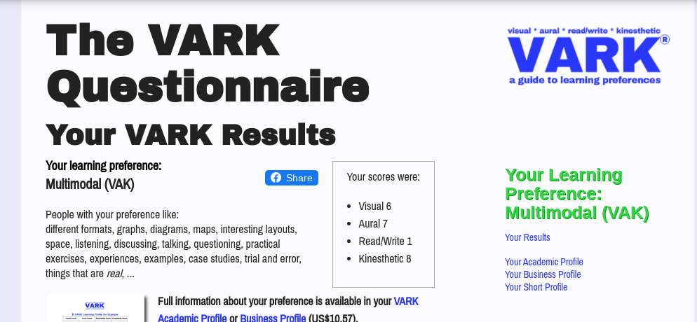

Simon’s VARK Results:
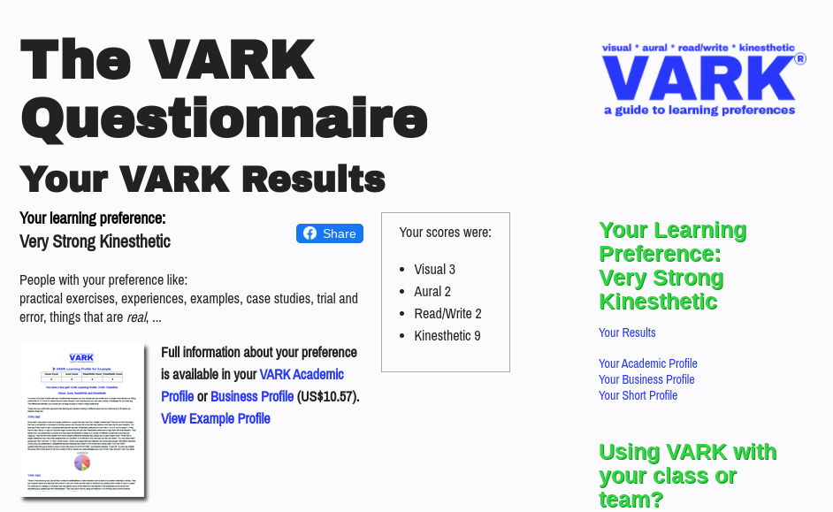

Abigail’s Mumford & Honey Results:
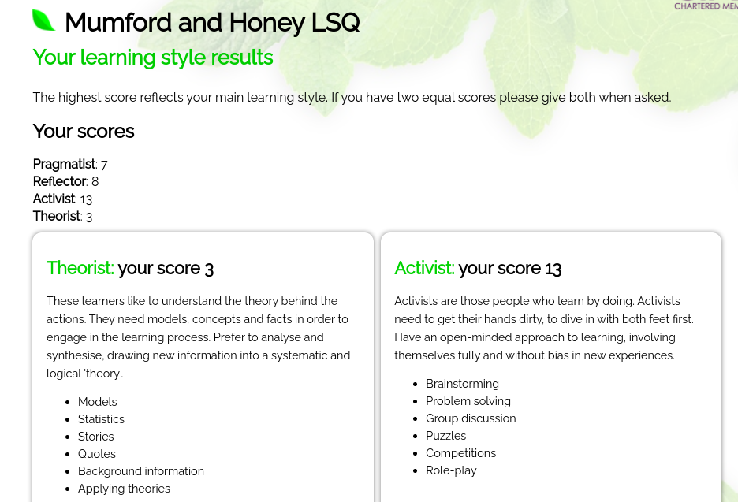
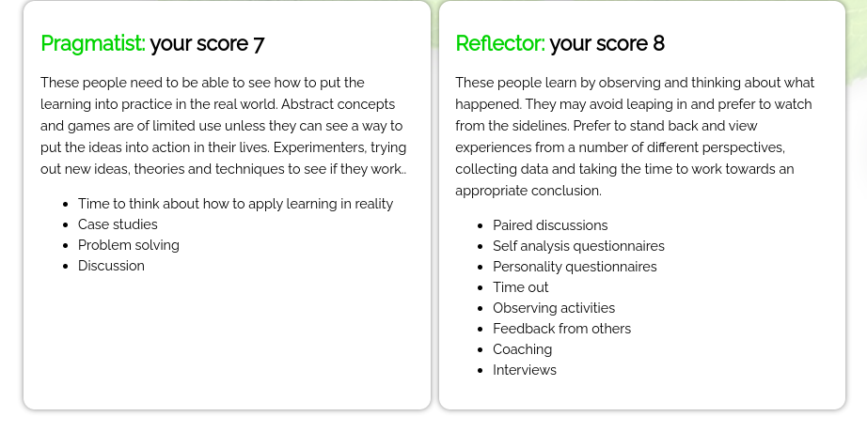

Simon’s Mumford & Honey Results:
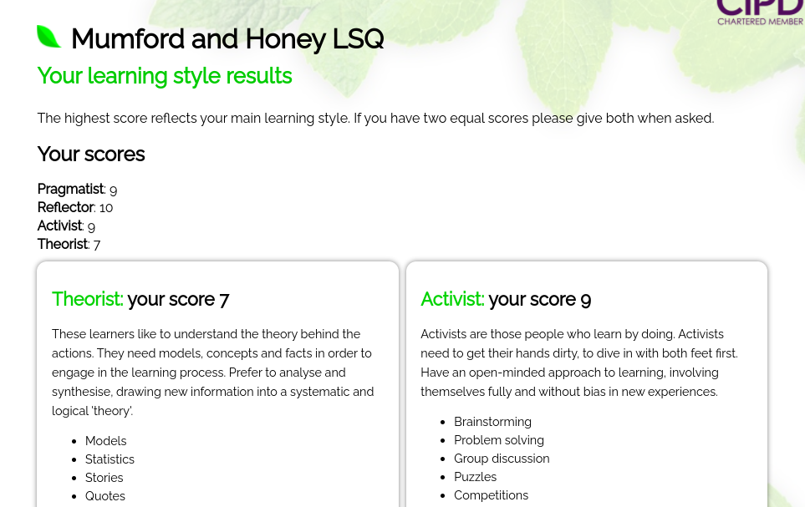
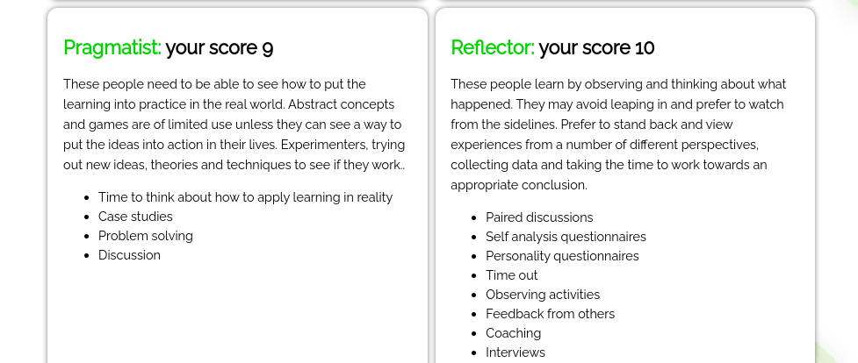

Appendix B
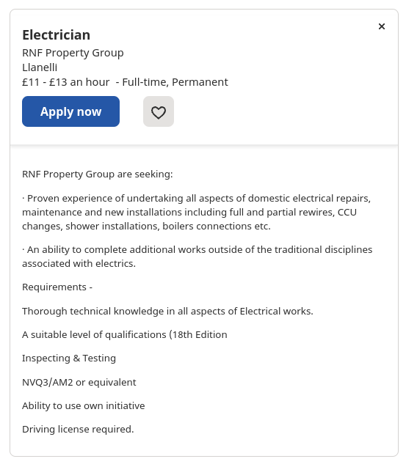

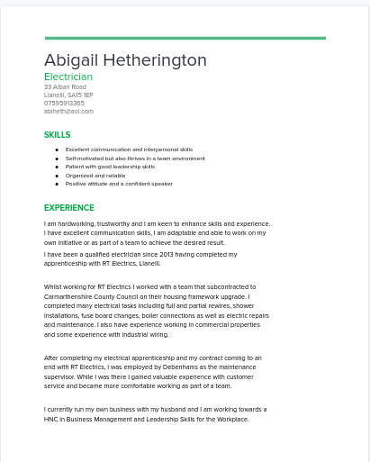

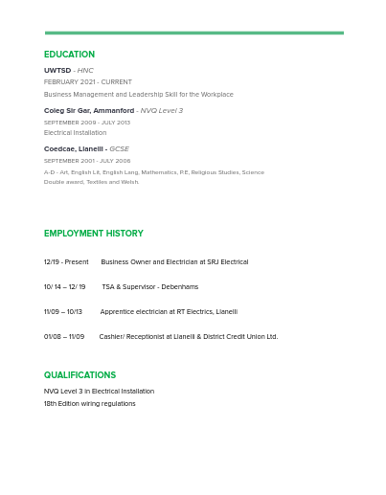

Appendix C



