

LEVEL 6

SEMESTER 1

MODULE CODE: SHSS6082
Landscape and Sustainable Recreation
aSSESSMENT TYPE: assignment
Assessment: 2

COMPONENT WEIGHTING: 50%

WORD COUNT: 2500WORDS

MODULE TUTOR: Dr Louise Emanuel

Reflective Fieldwork Journal
During this module you will visit a number of sites on fieldwork. At each site you should keep detailed notes relating to the following issues:

• Landscape Character
• Landscape Quality
• Designations
• Use
• Access
• Future Potential

These notes should subsequently be written up into a reflective and critical account of the landscape at each location, which incorporates relevant academic and policy related literature and provides suggestions sustainable approaches to recreational development at the site. Maps, sketches and photographic evidence should be used as appropriate. You should include details of two fieldwork sites in the main body of the work, and include the notes relating to the third in an appendix.

SUBMISSION DETAILS:

Submit by Turnitin on or before Friday 11th January 2019

Date feedback to be returned to student: On or before Friday 8th February 2019

School of Sport, Health & Outdoor Education

Assessment Feedback Sheet

Student No./Name: 1600979/ Lewis Hughes
Module: Landscape and Sustainable Recreation
Module Code: SHSS6082

Personal Evaluation – to support your academic progress please complete the section below BEFORE submitting your work.
What do you consider to be the best aspects of this work? |  |  | I consider the research put into Cregennan lake is the best aspect
Which aspects do you consider could have been improved in this piece of work? |  |  | Next time I would improve by writing more about landscape features
What have you found most satisfying whilst undertaking this submission? |  |  | I found it satisfying comparing Cregennan to cheddar gorge
ASSESSMENT CRITERIA | Learning  Outcomes |  | GRADE
ASSESSMENT CRITERIA |  |  | Poor  < 20% | Weak  20-29% | Unsatisfactory  30-39% |  | Satisfactory  40 – 49% | Good  50 – 59% | Very Good  60 – 69% | Excellent  70 – 84% |  | Exceptional  85– 100% | %
Your discussion of the nature of landscape within the context of the fieldwork locations | 1 |  |  |  |  |  |  |  |  |  |  |  | 20%
Your critical evaluation of external and internal influences that affect the perception, interpretation and use of landscape at the fieldwork sites. | 2 |  |  |  |  |  |  |  |  |  |  |  | 20%
Your critical discussion of the relationship between landscape and recreation and your suggestion of sustainable approaches to the interpretation and use of landscape for recreation. | 3 |  |  |  |  |  |  |  |  |  |  |  | 40%
Your identification and use of relevant academic and other material to help inform and develop your argument | 1,2,3 |  |  |  |  |  |  |  |  |  |  |  | 20%
It is expected that students will present work that is proof read, correctly referenced and adheres to the Assessment Checklist. Therefore a range of 0 – 10 marks will be deducted for non-completion of any of the points on the checklist below.
TUTOR COMMENTS:

Submission date:  via Turnitin |  | Return date:  (at least within 4 weeks) |  |  |  | Tutor: |  |  |  |  | Mark:

Assignment Checklist

- Please complete the Personal Evaluation section of the Assessment Feedback sheet, add your name and details, and paste the whole of this assignment document into the front of your assignment

- Submission is a single word file, clearly labelled with your name and module code
- Font style - Times New Roman, size -12 for text and 14 for headings
- Ink colour – black only
- Line spacing – 1.5 line spacing and 2cm- 2.5cm page margins
- Quotations more than three lines to be indented 1 line spacing
- One line space between paragraphs, paragraphs must be left aligned
- Pagination (your assignment should have page numbers)
- All tables and figures are internally referenced and have a title
- Word count checked and written at end of text (before references and any appendix)
- Assignment is within 10% of the word limit (excluding references and any appendices)
- All references in the text are included in the reference list
- Correct referencing following the Harvard style, as described in the Palgrave study skills book ‘Cite them Right’.
- Correct spelling using UK English
- Correct use of punctuation
- Grammar and syntax correct- double check anything that has a green line under it
- I have read my assignment out loud to myself and it makes sense and is easy to read
- Somebody else has read my work and it makes sense to him or her!
- I have checked and I have not plagiarised
Failure to follow these guidelines will cost you marks!
Reflective Fieldwork Journal

Introduction
Recently I have visited several locations, one of them for the first time, others I have been visiting throughout my life. I strongly believe we need to manage and conserve these landscapes of natural beauty and history. “We must consider our planet to be on loan from our children rather than being a gift from our ancestors.” G. H. Brundtland, former prime minister of Norway (Reece et al., 2015). The aim is to show that areas which are not as popular amongst tourists and visitors still have equal value to those that are considered honeypot sites. Both Cheddar Gorge and Cregennan Lakes have their own unique landscapes, both show evidence of how the last ice age shaped the Earth today. With the destruction humans cause, we are slowly erasing the evidence and are invading habitats endangering them in the process.

Cheddar Gorge
Cheddar Gorge is known to be the most iconic English landscape and the most spectacular natural sight with its weathered crags and pinnacles. It is also one of Britain's best-known limestone features. The gorge itself is a dramatic gash in the wooded landscape with grey limestone cliffs, almost vertical in places. At almost 400 feet deep and three miles long, it is England’s largest gorge. The importance of the site has been recognised as a Site of Special Scientific Interest (SSSI) with numerous caves, The National Trust owns the north side of this gorge except for any of the caves and car parks. Cheddar Gorge is in the South of England in Somerset (ST 469 540).

Formation of cheddar gorge
Cheddar Gorge would have begun forming about one million years ago during the last Ice Age. The water from the melting glacier formed a river, the flowing water over time would have started to rapidly erode the Carboniferous limestone rock eventually creating the steep cliffs that are there today. Former river sediments can be found high up on ledges on the sides of the gorge indicating that it was vertical erosion of the river bed that was responsible for its formation. The Cheddar Yeo River gradually made its way underground, creating the famous Cheddar Caves. There is evidence showing that it appears freeze thaw weathering had occurred as water entered the gaps in the limestone during the ice age, this too may also have contributed to the shaping of the huge cliffs of the gorge.(Royal Geographical Society n.d.)

Cheddar Gorge environment and habitats

Some places in the UK can attract many visitors and become very popular. They attract such large numbers of visitors that they have become known as honeypot sites. Cheddar Gorge is a major tourist honeypot site, approximately 500,000 people visit the area of Cheddar Gorge, each year up to 400,000 of them visit the show caves. Most of the Cheddar Gorge visitors are tourist who stay within 30 miles of the gorge however very few people come from the local communities. The visitor profile shows that most of the people are visiting for the first time, between the ages of 25 and 44 and may visit with their children. The peak number of visitors to the site occur during bank holidays and the summer. (Royal Geographical Society n.d.)
Cheddar Gorge spectacular and unique environments are protected by legislations. The site has become a Scheduled Ancient Monument due to the evidence of prehistoric occupation, whilst the inner caves are Sites of Special Scientific Interest (SSSI). Within the cave you will find greater and lesser Horseshoe bats living there. The horseshoe is one Britain's more endangered mammals from the result of their habitats being threatened by human activity.

Caves are not only a unique ecosystem, they can also be a very popular amongst tourists, which can lead to conflict between humans and the environment. With their own microclimate and ecology which is closely linked to the availability of light, their environment has been at risk as they have been opened up to day trippers and cavers. In natural caves the availability of light is decreased the further and more complex they are and so do the number of species, and the biodiversity. Artificial light can have a greater impact in caves than you may think with the introduction of artificial light it can encourage the growth of green algae which could alter the food chain. Different Passages may be straightened or widened to allow access and other entrances may be blocked by doors to secure sites, all this alteration will change the airflow and humidity and subsequently the environment and the ecosystem.

The sites environment also provides a number of habitats ranging from caves to cliffs and grassland each with their own species. One of the issues that Cheddar Gorge is required to manage is the ever-increasing invasive species. During the summer when the gorge is at its busiest the local populations is matched by the visitors, there are approximately 5,000 visitors who may arrive in 2,000 cars a day. Many of the visitors are seen in the lower gorge area of the gorge, however those that are exploring at the upper gorge where it is more vulnerable are those who may be responsible for footpath erosion and damage caused when parking cars. (Royal Geographical Society n.d.)

Activities at Cheddar Gorge

There are many activities for visitors at Cheddar Gorge. There are activities for those who want to be adventurous and go rock climbing, adventure caving, black cat free fall. There are also a lookout tower for people who want to enjoy the beauty of the landscape or museum for those who want to learn about the area and recently they have also included escape rooms. Base jumping is another activity there and has become increasingly popular, however it is illegal there. Base is an acronym referring to the four types of objects that jumpers can potentially leap from while taking part in the sport. These objects include Buildings, Antennas, Spans (which refers to bridges), and Earth (which includes high cliffs, mountain tops or other tall natural locations)(Friedland 2018) .BASE jumping involves extreme mentality Unlike skydiving, BASE jumpers don't use an aircraft of any kind, they climb to great heights on manmade structures or tall cliff faces. but instead choose to leap from the top of a fixed structure. This gives the jumper less time to react to shifting conditions, equipment failure, or recover from a bad jump. This can sometimes result in serious injury or even death.

Base jumping has been a problem in Cheddar Gorge that requires management. Not only does the sport have a negative impact on the local environment, but also has frightened the people who are watching and can cause misinterpretation. On March 16th, 2009 a concerned witnesses dialled 999 after seeing a man throwing himself off from the top of Cheddar Gorge. The man was illegally trespassing on the land was seen falling between High Rock and Sunset Buttress, two of the highest points in Cheddar Gorge. This misunderstanding of the highly-risky parachute jump had triggered a helicopter, police and cliff rescue teams to start the rescue operation and close the gorge road for three hours. It wasn't until later after a large search and rescue operation was launched, police officers discovered the man was in fact an illegal base jumper. The operation of the search was estimated to have cost between £30-40,000, and also a great inconvenience to all the volunteers there helping. It was also mentioned in the news that the jumpers could have been easily killed especially as there are jagged rock faces (Knapton 2009)

Future potential for Cheddar Gorge

The manages and operates of Cheddar Gorge, The Longleat Estate, want to breathe new life into Cheddar by creating new features, they are currently considering potential ways of regenerating projects. One possibility they are considering is a cable car and education centre. The aim is to create a new visitor interest to the area. The project would help support the ongoing conservation work and make the Gorge more accessible to all visitors. This would also provide better educational facilities and bring significant economic benefits to local businesses and employers. The chief executive of Longleat Estate Sai they want to be mindful that the Gorge lies within an Area of Outstanding Natural Beauty and is a Site of Special Scientific Interest, they want their team of consultants to work closely with all the advisory groups and regulatory bodies to ensure that their proposals have minimal impact on the environment (MacMahon 2012)

Cregennan lakes

Cregennan Lakes are located in the southern part of Snowdonia, situated on the northern slopes of Cader Idris above the village of Arthog (SH657143). To access the lakes, take a turning off the A493 that is half way up a steep hill on the Dolgellau side of Arthog following the signs up a hill, there will be gates along the road that will need to be opened. You can walk up a hill or just enjoy the views of the lake and mountains on the flat area. Climb up to see Barmouth town. The name Cregennan was originally Crogenan which derives from Crog-gangen’ this translates to as ‘hanging branch’. The story is thought to be that criminals convicted of crimes at Llys Bradwen were hanged from the branch of a nearby oak tree. (The Captains Guide n.d.)

Cregennan Lakes consist of two bodies of water, the large lake is 27 acres which include a small island and the smaller lake is half the size at 13 acres. These lakes are estimated to be about 785 feet above sea level. The lakes are a popular for fishing and are stocked with blue and rainbow trout and also home to wild brown trout (Studios 2018) Cregennan lakes were owned Major C.L. Lynne- Jones and was given to the national Trust in memory of his two sons who were lost in the second world war. (The Captains Guide n.d.) around Cregennan lakes you will be able to see ancient ruins scattered around the area from neolithic standing stones, bronze age hut circles and Llys Bradwen. Bradwells court has be known to belonged to Ednywain ab Bradwen who was the leader of one of the Fifteen Tribes of Gwynedd from the 7th century. (Challinor 2015)

How did the Cregennan form?

The rocks in this area were formed during the Ordovician period which was about 495 - 443 million years ago and was named after the Ordovices who the last Welsh tribes were to submit to the Romans. The area has two main kinds of rock. Firstly, sedimentary formations laid down whilst the area was a shallow sea, over time they were compressed to become hard slates and gritstones. The slate being quarried at Friog (SH620121) and Ty’n y Coed (SH652153) until the 1920’s when the slate became uneconomical to extract. (Challinor & Bates 1973)

Secondly there are the volcanic rocks which include Acid Igneous Rocks (rich in sodium and potassium) and Basic Igneous Rocks (rich in iron, magnesium and calcium). There are igneous intrusions which is molten magma pushed by pressure from the earth’s core towards the surface and between the stratified rocks and forming horizontal sills. Tectonic Plate movements resulted in the rock deposits being pushed above sea level to produce a geosyncline named the Harlech Dome and causing the rock beds to dip at an angle of 40 degrees south or south-south-east. One type of igneous intrusion is a Laccolite which is still like but in the form of a flattened dome which causes the overlying strata to become domed by the force of the magma whose presence the escarpment of Cader Idris is due. (Challinor & Bates 1973)

The Cregennan sill is about 300 meters thick and traceable for approx. five miles. Unlike most of the igneous rocks in the district the Cregennan granophyre (fine grained microgranite) forms mainly low-lying ground due to an intricate small -scale jointing which has facilitated its erosion and removal by ice and other eroding agents. The lakes are found on its western edge and covered by alluvial deposits with Cadair Idris escarpment towering above the lakes by 200 meters on the south -east side and Pared y Cefn Hir by 100 meters on the north-west side. Near the car park there is clear evidence of glacial erosion in the form of roches moutonnees. (Cox 1925)

Cregennan Environment and Habitats

Cregennan has a wide variety of habitats: scrub, mire (peat bog), heathland and crags which support a large variety of plant life such as Sphagnum moss including Sphagnum rubellum, Polytrichnum commune , Carnivorous plants (sundews) , rushes, sedges and cotton grass, Bilberry, Lichens such as Cladonia portentosa, Gorse and stunted Hawthorn and a variety of heathers on the scrub including Calluna vulgaris, Erica cinerea, and Erica tetralix. These in turn offer ground cover for birds and habitats for insects, moths and butterflies. The area is often grazed by sheep and a large area of the scrub and heathland was burnt in December by a fire which got out of control causing a lot of damage to this valuable area.

Cregennan Lakes has many uses and different attractions for people. As mentioned before it is a popular fishing site, the locations are well suited for families or to serious anglers. Fishing is permitted between 8.00 am. and 1 hour after dusk. This location also makes a great worthwhile bouldering venue, with wonderful rock texture and the setting high on the hills over the Mawddach estuary Although they are generally small and scattered. (Dexter n.d.)

Developing and managing Cregennan Lakes

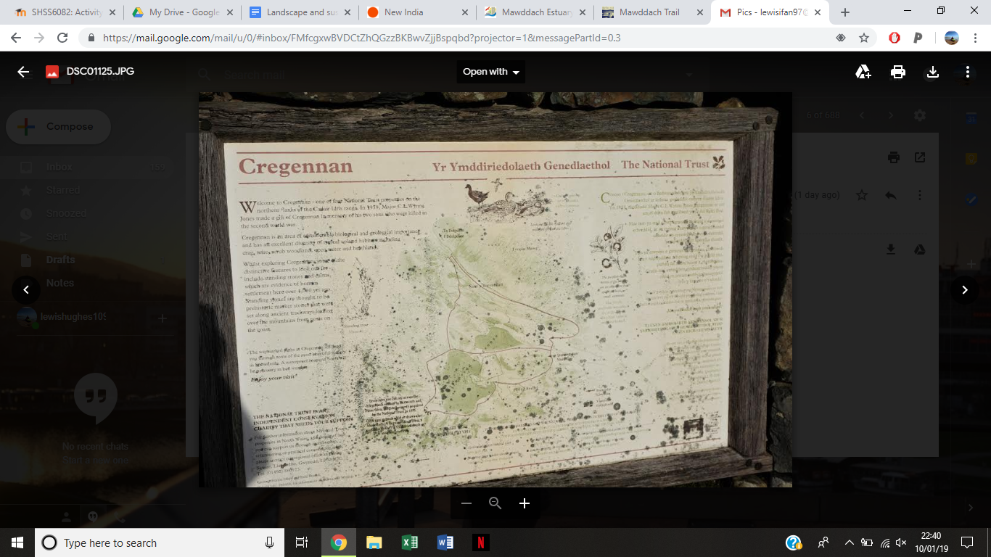
After visiting the area, I have thought of many ways for future potential uses for Cregennan lakes. I would begin with improving the car park that is already in place. The road around Cregennan lakes are in good conditions however the car park is very uneven which would make be an inconvenience to anyone who is using a wheelchair and put in marking in the car park for defined parking spaces, making it more organised during busy periods on bank holidays. Near the car park I would also suggest that a notice board to be replaced and the signs are in need of replacement as shown in figure 1 they haven't been well looked after. To preserve the natural beauty of the area I would keep signage to a minimum however, there is not much known about the area unless you have already scoured the internet. There should be some information about the history and culture of the area.
Figure 1

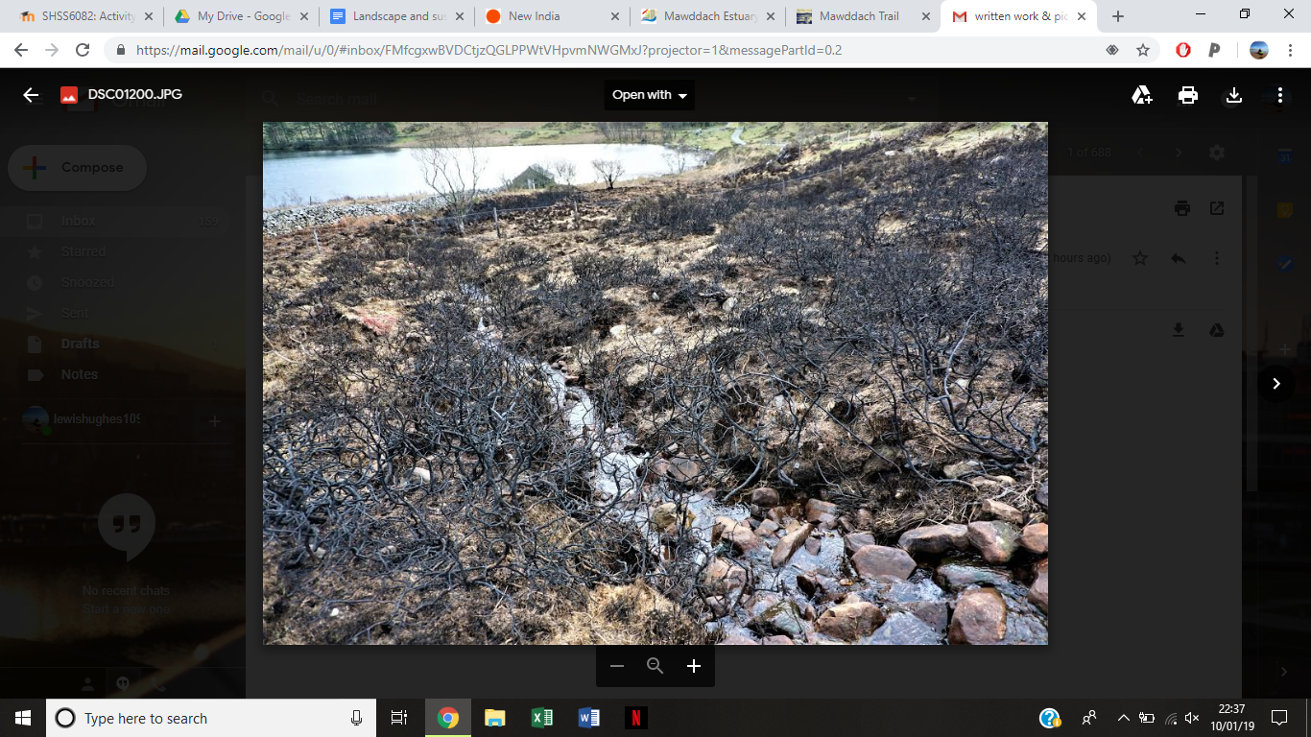
In December a local farmer set alight an area of scrub and heathland to clear the heather and gorse in the way many farmers do. Unfortunately, in this case the vegetation was very dry and it was a very windy day so the fire spread and very quickly got out of control and burnt most of the area near the lake and decimated a site of scientific importance (as seen in figure 2). This event suggests that if such burning practices are to continue, particularly in conservation areas, then those persons carrying out these methods should be trained and licenced to prevent these incidences happening.
Figure 2

To develop the area of interest further I would introduce a bird watching shelter. A bird watching shelter would be useful for everyone who has an interest in the animals around the lakes, the shelter will overlook the lake for people to watch and photograph the animals and birds without disturbing them. In the bird watching shelter there would be information displayed with the different variety of birds that live in the area and also show the different animals living in and around the lake. To help maintain the bird shelter I would suggest putting a donation box inside. If these changes create a bigger popularity for Cregennan lakes than a pay and display can be introduced to the car park.

Conclusion

In conclusion both of these spectacular landscapes have their own characteristics, they give us an opportunity to see how the Earth was shaped over millions of years from the last ice ages and volcanic eruptions. I believe both locations are in threat of being destroyed by our fascination of venturing beautiful landscapes. They should be managed better especially after the fire at Cregennan lakes destroying a huge proportion of habitats and vegetation under SSSI. perhaps I would like to see Cregennan lakes managed due to sentimental reasons while Cheddar Gorge will be better managed due to profit making the landscape value to some would be economical and to those who visit it has a historical value.

Word count 2674

Appendix

Third locations notes: Mawddach

The Mawddach estuary is where the river runs to to the sea an forms a wide and stunning sandy banks along the estuary. At the north side of the estuary is the town Barmouth and on the south side is Fairbourne village. 8 miles inland is the town Dolgellau Which is connected to the coast by the Mawddach Trail which used to be a railway line operating in 1865 and was then take apart exactly a hundred years later in 1965. (Studios 2018)

The Mawddach trail is now managed by the Snowdonia National Park Authority. The trail is a leisure route for walkers and cyclists and is part of the Sustrans Cross-Wales Cycling Route and it's the most popular walk/cycle path in the area due to its flat surface. (Visit Mid Wales n.d.)

The source of the river is in a wide area north of Dduallt in Snowdonia.
The estuary used to be the centre of ship building in the 18th century and probably for some centuries before, today there is little evidence remaining of this activity in the estuary today.

Other past industries include gold panning in the River Mawddach at Coed-y-Brenin.

Today the river sustains an important salmon and trout fishery and the countryside it flows through is some of the most spectacular and scenic in the UK

References
Challinor, J. & Bates, D.E.B., 1973. Cader Idris and Neighbouring Areas. In Geology Explained in North Wales. David & Charles, pp. 88–99. Available at: http://agris.fao.org/agris-search/search.do?recordID=US201300497560.
Challinor, P., 2015. Cregennan Lakes. Travels With My Aunt. Available at: https://paulchallinor.com/2015/04/12/cregennan-lakes/ [Accessed January 10, 2019].
Cox, A.H., 1925. The Geology of the Cader Idris Range (Merioneth). Quarterly Journal of the Geological Society of London, 81(1-4), pp.539–594. Available at: http://jgs.lyellcollection.org/content/81/1-4/539 [Accessed January 10, 2019].
Dexter, J., Guide to the bouldering at Cregennan Lake above Arthog near Dolgellau in Gwynedd. midwalesclimbing. Available at: http://www.midwalesclimbing.com/attachments/File/cregennan.pdf.
Friedland, L., 2018. Want to try BASE jumping? Here’s what you need to know before you go! TripSavvy. Available at: https://www.tripsavvy.com/what-is-base-jumping-34497 [Accessed January 8, 2019].
Knapton, B.S., 2009. Cheddar Gorge base jumper sparks £40,000 rescue operation. The Daily Telegraph. Available at: https://www.telegraph.co.uk/news/newstopics/howaboutthat/5062349/Cheddar-Gorge-base-jumper-sparks-40000-rescue-operation.html [Accessed January 10, 2019].
MacMahon, C., 2012. The future of Cheddar Gorge. Heart Somerset. Available at: https://www.heart.co.uk/somerset/news/local/future-cheddar-gorge/ [Accessed January 10, 2019].
Reece, J.B. et al., 2015. Campbell Biology Australian and New Zealand Edition, Pearson Higher Education AU. Available at: https://market.android.com/details?id=book-5t6aBQAAQBAJ.
Royal Geographical Society, Adventure Landscapes in the UK – “geography explained” fact sheet. rgs. Available at: https://www.rgs.org/CMSPages/GetFile.aspx?nodeguid=34f417d4-6c60-4ebc-9ead-93e3109a2cfe&lang=en-GB [Accessed January 9, 2019].
Studios, I.K.-M., 2018. The Town of Dolgellau in Snowdonia with Great Walks and Accommodation. Available at: http://dolgellau.wales/places/cregennen-lakes.php.
The Captains Guide, Cregennan Lakes Arthog North Wales. Available at: http://www.thecaptainsguide.co.uk/cregennan-lakes-i229.html [Accessed January 10, 2019].
Visit Mid Wales, Mawddach Estuary | River | Dolgellau|Gwynedd. visitmidwales. Available at: http://www.visitmidwales.co.uk/Dolgellau-Mawddach-Estuary/details/?dms=3&venue=1012044 [Accessed January 10, 2019].

