Q1. Evaluate the concept of evidence-based practice (EBP) and provide two examples of where Technivara could use it to ensure sound decision-making in people practice. (AC 1.1)

Evidence based practice (EBP) ensures quality decision-making is guided by reliable evidence and critical thinking (Barends, Rousseau and Briner, 2014). People professionals should consider multiple evidence sources including professional expertise and judgement, stakeholder and employee views, scientific research and organisational data (CIPD, 2025a). Evidence should be carefully examined for validity, reliability, relevance, bias and limitations before informing decisions (Barends, Rousseau and Briner, 2014). This can be realised through a six-step evaluation process: ask questions, acquire, appraise, aggregate, apply and assess outcomes (Elder and Nikodem, 2023; CIPD, 2025).

Technivara currently operates traditionally with limited data metrics, meaning decisions may rely on personal opinions, subjective judgement and trends rather than robust evidence. Introducing a rational framework to gather, critically appraise and apply evidence will allow Technivara to reduce bias and reliance on intuition (Briner, Denyer and Rousseau, 2009; Friedman, 2023). This improves decision quality whilst reducing legal and ethical risk by enabling fairness and consistency (CIPD, 2025). EBP also encourages alignment between strategic people decisions and business objectives which could help Technivara meet expansion and modernisation goals (Armstrong and Taylor, 2014).

Data quality and accessibility may be restricted by Technivara’s paper-based systems reflecting bounded rationality where decision-makers cannot consider all relevant information (Simon, 1990). It may be time and resource intensive to implement a new system and analytics to overcome this. Additionally, qualitative and quantitative data must considered for EBP to be effective. This could come from primary or secondary sources. Cultural resistance is another barrier as employees may resist change under traditional leadership (Armstrong and Taylor 2014). People practitioners are paramount to ensuring effective change management and risk mitigation.

New roles will likely be required as Technivara expands therefore EBP will aid recruitment and reduce reliance on subjective methods. For example, decision-making accuracy would improve by analysing internal turnover and skills gap data, external benchmarking, introducing validated selection methods and structured interviews (Linos and Reinhard, 2015). Schmidt and Hunter (1998), illustrate that structured recruitment and selection methods show higher validity in predicting performance than unplanned methods. Applied effectively, this will help reduce bias, enable strategic alignment of people and goals whilst improving hiring quality.

Technivara could also use EBP to inform reward and pay decisions (CIPD, 2025b). EBP would enable pay, promotions and bonuses to be issued based on appraised evidence supporting retention, morale and trust. Stakeholders would also receive valuable financial insight and performance metrics to inform decisions. An EBP approach could include reviewing internal pay data, identifying gaps, comparing external benchmarks and salary guides (Rose, 2014). This quantitative data could be combined with qualitative information gathered through employee feedback surveys and 121s. Ultimately, EBP would enable structured, objective criteria to be set for reward, pay, promotions and bonuses.

Q2. Evaluate one appropriate analysis tool and one appropriate analysis method that Technivara might apply to recognise and diagnose issues, challenges and opportunities. (AC 1.2)

SWOT provides an analysis tool for Technivara to explore internal strengths and weaknesses along with external opportunities and threats (Waite et al, 2021). It enables managers and people professionals to understand organisational position, underlying issues, challenges and strategic opportunities, for example, during expansion and modernisation (CIPD, 2025c).

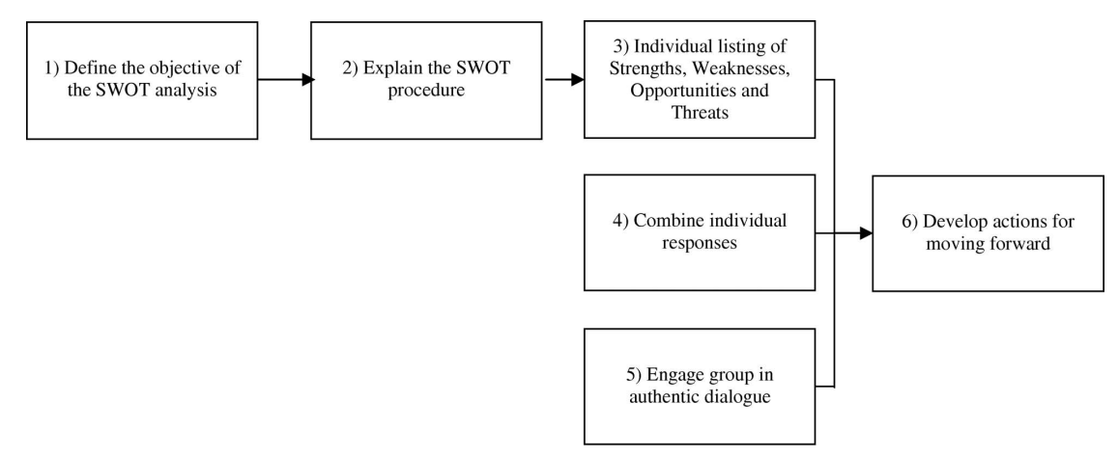

Figure 1 – SWOT process (Chermack and Kasshanna, 2007)

Recognising strengths including sustained growth and high employee and client retention enables Technivara to assess organisational stability, workforce capability and readiness for expansion. Analysing weaknesses, including outdated paper-based systems, traditional practices and limited EBP help managers identify challenges such as operational inefficiencies and cultural barriers that could hinder expansion or modernisation (CIPD, 2025c). Opportunities like market expansion, technological integration, new talent onboarding and introducing EBP could allow Technivara to identify areas for workforce development and investment. Identifying threats such as skills shortages, change resistance, competition and legal or ethical risks allows Technivara to diagnose vulnerabilities and plan mitigating strategies (Tinsager and Smith, 2022).

SWOT is a rational, simplistic tool that will provide structured insight into readiness for expansion, opportunities and risks whilst supporting decision-making at Technivara. Its effectiveness is hindered by reliance on opinion, limited input and traditional approaches rather than EBP and data-driven approaches. SWOT should integrate qualitative and quantitative evidence, reflecting the four types of data required for effective EBP (CIPD, 2025d). However, SWOT is static and can oversimplify cultural and behavioural challenges, so Technivara should use additional tools for comprehensive diagnosis.

Structured interviews is one analysis method that Technivara could use to identify issues, challenges and opportunities. Typically, the same questions would be asked in a set order to collect information on experiences, behaviours, perceptions and skills providing qualitative data (Armstrong and Taylor, 2014). Exit interviews with leavers could help Technivara understand turnover reasons including views on systems, pay, culture, leadership, growth plans, skills and training. Exit interviews offer a final opportunity to retain staff but this is often too late to make a difference (HR-Inform, 2021). Marchington et al (2025) highlight two limitations of exit interviews. Firstly, leavers may withhold honest feedback thereby restricting data quality. Secondly, leavers are often viewed uniformly rather than considering differences in demographic characteristics, service length etc. However, this data could be captured, segmented and analysed to provider deeper insight.

Technivara could introduce stay interviews to understand current employee feedback (Finnegan, 2018). Although time-consuming to plan, conduct and analyse these would provide insight into causation combining qualitative and quantitative data to enhance overall validity (CIPD, 2025e). Both exit and stay interviews would enable Technivara to identify issues, challenges and opportunities which in turn would support strategic decision making e.g. modernisation, risk mitigation and workforce planning to support growth.
Q3. Explain the main principles of critical thinking including how these might apply to your own and others’ ideas to assist objective and rational debate at Technivara (AC 1.3)

Critical thinking involves logical, objective and evidence-informed reasoning to evaluate ideas and information (CIPD, 2019). Within Technivara, strategic decisions are influenced by intuition and personal judgement resulting from traditional leadership and outdated paper-based systems. This increases the risk of bias, bounded rationality and inconsistent outcomes (Simon, 1990; Barends, Rousseau and Briner, 2014). Critical thinking would allow me, as People Practice Advisor, and others to evaluate ideas objectively whilst assisting rational debate at Technivara.

Objective reasoning, a key principle of critical thinking, involves separating emotion and personal belief from factual evidence. Ruggiero (2012) notes that people often feel as opposed to think which can hinder rational debate. Feelings are subjective and rise unconsciously whereas thinking is a conscious process to understand information, find solutions and overcome problems. I would critically assess my own thoughts and ideas before presenting them and ensure others ideas are evaluated against data rather than taken at face value. I could also ask clarifying questions and encourage them to reflect on their own assumptions. This will help ensure fairness and consistency whilst encouraging structured debate.

Critical thinking also requires questioning evidence and sources to confirm validity, reliability and relevance (Barends, Rousseau and Briner, 2014). I would use triangulation to support this by gathering and comparing data from multiple sources. For example, I could look at available internal metrics, gather employee feedback and carry out external benchmarking. This would allow correlation and validity to be assessed before presenting my ideas and findings (CIPD, 2025e).

Another principle of critical thinking is bias awareness, which is crucial when evaluating evidence, my own ideas and opinion and those of others. At Technivara, traditional leadership and reliance on personal judgement increases the risk of conscious and unconscious bias reflecting deliberate preferences and ingrained assumptions (Barends, Rousseau and Briner, 2014). As People Practice Advisor, I would actively question my own assumptions and opinions through self-reflection and check against reliable evidence sources to ensure validity and reasoned judgement. Woodhams and Perkins (2022) highlight the importance of applying critical thinking to online sources by examining bias as underlying or hidden personal or political interests may introduce bias or compromise validity. I would make informed decisions, ask questions and use triangulation to enhance validity. Applying these principles will promote objective, rational debate at Technivara whilst improving people decisions quality, supporting EBP and providing organisational insight (CIPD, 2025).

Q4. Explain two decision-making processes that Technivara could apply to ensure that effective outcomes are achieved. (AC 1.4)

Structured decision-making is essential as Technivara expands and modernises, moving away from traditional approaches and paper-based systems. De Bono (1999, cited in Serrat, 2017) outlines a Six Thinking Hats model which Technivara could apply to strengthen decision-making and people outcomes. The model promotes parallel thinking, allowing HR problems to be examined through multiple perspectives (Woodhams and Perkins, 2022). Team members metaphorically wear the same hat at the same time, focusing on one shared viewpoint, before collectively cycling through all six. This could help inform decisions in areas including recruitment, engagement, workforce planning or new system implementation. For this example, workforce planning will be explored.
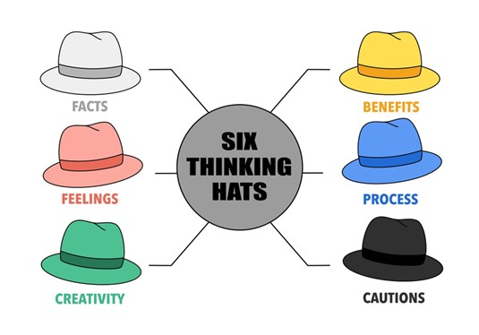
Figure 2 (Singapore Institute of Management, 2025).

The white hat signifies facts and data, and would encourage evidence-based decisions using internal metrics such as retention and turnover rates, skills gaps, headcount and projected resource requirements. The red hat allows intuition, emotion and gut feelings to be expressed openly which is important because decisions are not purely data based. For example, by enabling thought sharing on morale, role changes etc. The green hat would promote creative responses to problems and decisions, for example, the people team could brainstorm ideas for recruitment, training and upskilling or internal redeployment. The black hat would enable risk identification including skills gaps, budget restraints or morale impacts whilst encouraging evaluation and critical thinking to overcome these (Woodhams and Perkins, 2022). The yellow hat would elicit positive thinking, encouraging teams to identify benefits of proposed changes like improved engagement, training and productivity (Serrat, 2017). Finally, the blue hat represents control, allowing the group to decide which hat to use at each stage thereby maintaining structural alignment. The success of this approach may be limited by Technivara’s traditional culture and potential resistance to change and it requires strong facilitation, aided by the people team. However, by balancing evidence, emotion, risk and creativity it enables informed people decisions and effective outcomes.

Technivara could also use the Kepner-Tregoe (KT) model which offers a rational, systematic approach to problem solving and complex decisions (Parra et al., 2023). The model is grounded in critical thinking and has four steps, outlined in Figure 3.

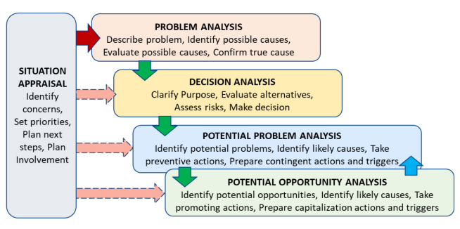
Figure 3 (Markopoulos et al., 2022).

For illustrative purposes, these steps could be applied to Technivara’s challenge of having paper-based HR processes. Situation appraisal would enable Technivara to identify and prioritise the problem which is the need for system modernisation. Problem analysis would identify the root cause such as limited data, poor record-keeping, outdated processes and inefficient manual processes (Parra et al., 2023). Decision analysis would evaluate HR system options factoring in criteria such as cost, usability, reporting tools, compliance and scalability. Potential problem analysis would anticipate risks such as resistance to change and training gaps whilst allowing mitigation strategies to be developed e.g. training and phased rollout (Markopoulos et al., 2022). Finally, opportunity analysis allows for positive outcomes to be identified, for example, improved accuracy, data-driven insights, cost-saving and improved efficiencies. The KT model would ensure systematic exploration of issues, solutions, risks, mitigation strategies and opportunities which would encourage evidence-based, informed decisions within Technivara.

Q5. Assess two different ethical perspectives including how these could be used at Technivara to inform and influence decision-making. (AC 1.5)

Deontology, often referred to as Kantian or rights-based ethics, is one ethical perspective that could be applied to decision-making at Technivara. This perspective centres on the idea that we have a moral duty to help those in need thereby emphasising equality, respect and honesty (Clark, 2015). This closely aligns with the CIPD code of conduct and can be adopted by the people team and senior leaders to ensure ethical practice when making decisions and determining actions (CIPD, 2023). Deontological approaches help safeguard employee needs and interests whilst promoting fairness and consistency.

Technivara could apply this lens to ensure equal treatment across recruitment, pay, reward and performance decisions during the proposed expansion. This would encourage a shift from traditional, informal decision-making to a more structured, fair process. A deontological approach would enable the people team and leaders to consider moral duties in every decision, shaping judgements and decisions across day-to-day actions and strategic outcomes (Clark, 2015). Decisions underpinned by fairness and consistency will also enhance legal and ethical compliance. When modernising HR systems, this approach would ensure that employee data is handled lawfully and confidentially whilst encouraging morale attentiveness (Shahzad et al., 2024). Furthermore, it would encourage transparent and fair decisions regarding recruitment and workforce planning during the expansion.

However, deontology is criticised for its rigidity as strict adherence to rules can produce morally questionable outcomes in complex scenarios (Holt, 2020). Applying the same procedure to every scenario without considering individual or situational context can slow decision-making and organisational changes. For example, thoroughly checking all pay or promotion changes for fairness and equality before implementation may reduce business efficiency and hinder morale.

Another ethical perspective, utilitarianism, could inform and influence Technivara’s decision-making by prioritising actions that achieve the greatest benefit for the largest number of people (Schumann, 2001). This approach bases morality on the consequences of decisions rather than an adherence to moral duties as seen in deontological approaches. Utilitarianism would be particularly useful for Technivara in shaping strategic decisions for growth whilst aligning with performance goals and supporting fair HR practices (Smith and Mitchell, 2022a). For example, workforce planning decisions could prioritise the development and deployment of skills needed to support growth even if this requires restructuring certain roles or brings uncertainty. Utilitarianism focuses on cost benefit analysis and closely aligns to evidence-based practice as decisions are informed by data, metrics and measurable outcomes (Smith and Mitchell, 2022a). This means that decisions are justified by ethical reasoning whilst ensuring they bring the greatest benefit to the most people. This could be applied to modernisation as introducing a HR system will have a majority benefit through increasing efficiency, compliance and data quality.
That said, it is important for people teams and leaders to ensure that the marginal voices and employee well-being are considered in decision-making. This helps mitigate the limitations of utilitarianism, which can reduce fairness, individual rights and morality. Technivara should apply ethical perspectives in a way that supports growth and modernisation whilst maintaining trust, wellbeing and professional integrity (CIPD, 2025f).

Q6. Appraise two different ways that Technivara could measure financial and non-financial performance, providing one example of each. (AC 3.1)

One financial performance measure Technivara could apply is the profit and loss (P&L) statement. As a private-sector organisation, this is a relevant tool for assessing financial health as it summarises revenue, production costs, operating expenses and overall profit or loss over a given time period (Stobierski, 2020). Additionally, net profit margin would provide a clearer picture of performance by showing the proportion of revenue remaining after all costs and deductions. This strengthens P&L analysis by highlighting Technivara’s actual profitability and how effectively the organisation manages costs relative to revenue (Marr, 2012). This would be particularly important for Technivara as they enter a period of growth and modernisation. Net profit margin would be more informative than gross profit alone and would enable Technivara to assess whether turnover growth is generating sufficient return (Stobierski, 2020).

For example, implementing a new HR system will incur costs such as software, implementation and training costs and may temporality hinder productivity. Monitoring net profitability would help Technivara to evaluate whether these initial investments have brought long-term financial benefits such as improved efficiency, reduced overtime and more informed workforce planning decisions. Sustained net profitability would indicate that investments are financially beneficial thereby reinforcing evidence based HR decisions e.g. within recruitment, training and retention.

One benefit of net profit analysis is that it allows financial performance to be compared over time. However, as it is typically reviewed monthly, this retrospective view may restrict prompt decision making (Marr, 2012). Technivara should also use non-financial measures, such as employee turnover rate, to provide a balanced understanding of performance. This involves calculating the percentage of employees who exit Technivara within a defined time period, against the total workforce (Taylor and Woodhams, 2022).

As Technivara expands, monitoring employee turnover rate is essential because high turnover levels can disrupt growth plans, hinder productivity, weaken culture and morale and create skills gaps (Al-Suraihi et al., 2021). While some turnover can be beneficial, such as removing underperforming team members and allowing for fresh perspectives via new starters, excessive turnover can create instability. Although this metric provides early warning, it is simplistic in nature and does not provide detailed insight into why employees leave. Therefore, Technivara should use qualitative methods such as exit interviews for a more complete insight and to undertake informed mitigating actions (Fukui et al., 2025).

Q7. Explain how people practices could add value at Technivara and identify two methods that might be used to measure the impact of these people practices. (AC 3.2)

Burke (2023) highlights that organisations should recognise the value of people practices in developing human capital, enhancing decision-making and supporting strategic goals. At Technivara, people practices could add value by matching workforce skills with strategic goals whilst driving productivity and culture. Robust hiring methods that assess skill and cultural alignment will enhance fit, reduce hiring time and support growth plans. Providing realistic job previews and transparent recruitment processes will increase trust and the likelihood of employees staying long-term (Smith and Mitchell, 2022b). This will be further strengthened by effective induction and onboarding processes.

People practice encompasses retention strategies that could add value at Technivara by retaining talent and skills within the business and mitigating turnover costs. The people team could identify and support the delivery of training and development opportunities, ensure transparency in pay and promotion and provide clearly defined career pathways. These initiatives will equip employees with skills and capabilities needed to support growth and modernisation. People practices that drive engagement, such as consulting and involving employees in changes, can boost morale and buy-in. Coupled with clear reward and career development structures, people practices could add value at Technivara by improving retention, performance and alignment with strategic goals.

To measure the impact of people practices, Technivara could use return on investment (ROI) analysis which is commonly used in private-sector organisations. ROI is expressed as a percentage and would measure how much value initiatives including recruitment, training, engagement and reward generate compared with their costs (Findlay et al., 2018). For example, when delivering a new training programme Technivara could use ROI to assess whether the benefits of the programme outweigh the costs of planning, delivering and supporting the programme. Tangible benefits such as cost savings, increased efficiency and revenue may be easier to quantify than intangible benefits such as reduced errors, improved retention and engagement. ROI is criticised because intangible benefits are difficult to quantify, impacting accuracy and relying on assumption. It is also calculated after the event, offering a retrospective view as opposed to cost-benefit analysis which aims to predict future results. That said, ROI would allow the people teams to demonstrate the value of HR practices in supporting strategic plans, performance and decisions.

Technivara could also implement key performance indicators (KPIs) to measure the value of people practices and to ensure alignment with organisational goals (CIPD, 2026). KPIs could provide metrics across multiple areas including recruitment (time to hire, cost per hire, quality of hire), retention (turnover and retention rates), training and development (completion rates, ROI) and engagement (absenteeism rates, employee engagement scores) (Parmenter, 2014). KPIs could enable the people team to identify issues early and implement mitigate strategies to reduce potential negative impacts (Agile HR Analytics, 2026). One limitation is that effective KPI reporting requires robust technology and reporting tools. The could be addressed by implementing the digital HR system which would facilitate data-driven decisions, improve accessibility to insights, enable benchmarking (internal and external) and strengthen the evidence of the value people practices deliver.

Q8. Table 1 shows Technivara's turnover and recruitment data for 2024. Sue has asked you to convert the data into percentage form, for each of the departments, to show: leavers as a % of the total number of employees, vacancies as % of the total number of employees, positions filled as a % of the total number of employees (AC 2.1)
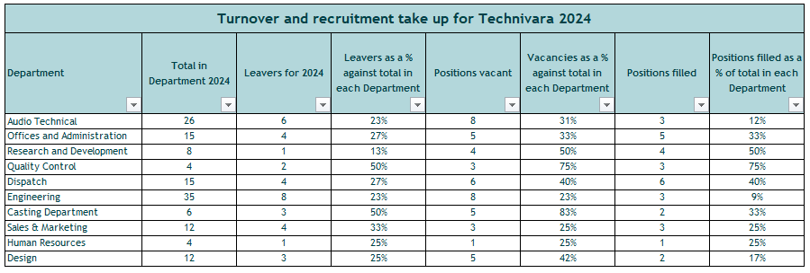

Q9. When you have completed Table 1, present your findings using a minimum of three different types of diagrammatical forms. (AC 2.2)
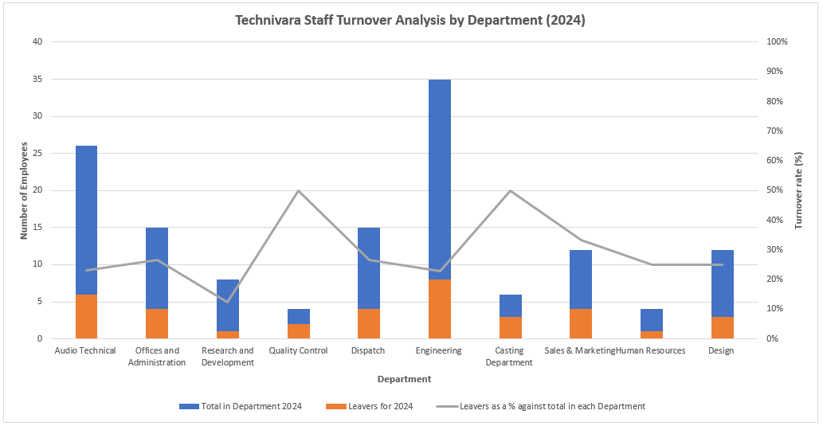
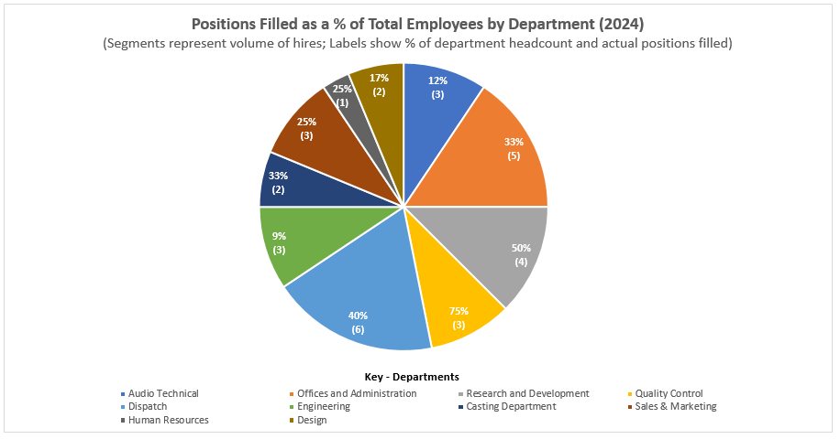
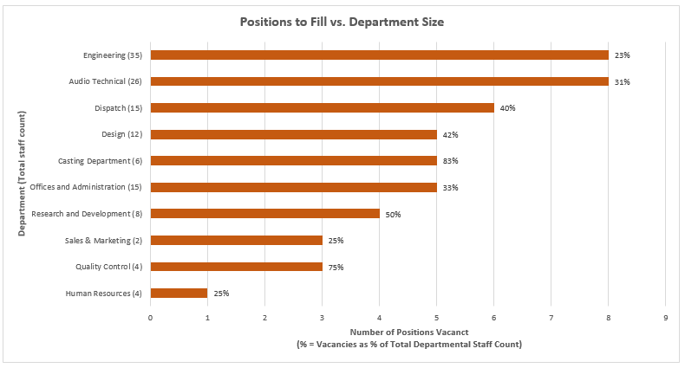

Q10. Table 2 contains evaluation feedback from 42 employees who attended a recent learning and development activity. Sue would like you to review the feedback and identify patterns, themes or trends that might be occurring and make recommendations based on your findings. (AC 2.3)

The evaluation feedback in Table 2 highlights a number of recurring patterns and themes relating to the quality of delivery, effectiveness of learning design, engagement levels and practical application of learning at Technivara.

The data shows that the facilitator demonstrated strong subject expertise and was prepared for the session as reflected in consistently high employee ratings for their knowledge and the quality of training materials. This aligns with research showing that skilled facilitators and thoughtfully prepared materials enhance perceived training quality and learner engagement (Salas et al, 2012; CIPD, 2024). However, the high level of disagreement regarding opportunities for meaningful questioning suggests the session was largely one-way with limited scope for employee input or collaborative discussion.

Bandura’s (1977) social learning theory proposes that learning occurs cognitively within a social context through observation, modelling and active interaction. Effective learning relies on four key processes including attention, retention, reproduction and motivation with learners more likely to adopt behaviours and beliefs demonstrated by people they identify with or respect (Bandura, 1977). Although employees viewed the facilitator positively, the limited interaction may have reduced engagement. This could weaken attention, retention and ultimately learning transfer which is a key factor of effective training (Wisshak, Naumann and Koch, 2025).

This concern is reinforced by the finding that whilst almost all employees agreed clear objectives were set at the start of the session the majority did not feel all learning outcomes were achieved. This demonstrates the gap between perceived satisfaction and actual learning, aligning with Kirkpatrick’s (1976, cited in Bates, 2004) four level training evaluation model. This model shows that level 1 reaction scores such as learner enjoyment do not necessarily result in level 2 learning. Applied to the data, this suggests that training resources may have been focused on creating a positive experience rather than facilitating meaningful skill development (Bates, 2004).

The data further indicates a learning transfer gap as the majority of employees were neutral or negative about their ability to apply the knowledge and behaviours gained from the training to their roles. There was also high neutrality around how the training linked to their performance targets and low agreement that the session supported individual learning needs. One criticism of Kirkpatrick’s model is that it assumes that if learning occurs through training it will lead to improved performance (CIPD, 2025g). The Brinkerhoff Success Case Method (SCM) provides broader insight by focusing on workplace application, success and non-success cases and exploring wider factors that hinder performance improvement (Brinkerhoff, 2005; CIPD 2025g). Ultimately, post-training support and reinforcement may be required to ensure effective application, retention and to combat the ‘forgetting curve’ (Murre and Dros, 2015).

The initial recommendation is to conduct a structured learning needs analysis (LNA) to ensure that future training directly addresses identified skills gaps and aligns with Technivara’s performance objectives (CIPD, 2024b). This would address the high neutrality around learning needs alignment and encourage links between training and organisational performance. A mixed-method approach could be adopted to gather quantitative and qualitative data through an electronically distributed employee survey, four facilitated focus groups and one hour interview with five managers or stakeholders (Armstrong and Taylor, 2014; Smith and Mitchell, 2022b). Existing performance data, KPIs and competency frameworks should be reviewed to support evidence-based decision making although this may be constrained by Technivara’s paper-based systems.
The LNA could reasonably be completed within two to four weeks, allowing time for design, consultation and analysis (National Training, 2022). The total People Practice Advisor time required would equate to approximately thirty-seven hours, allowing six hours for survey design, testing and distribution, ten hours for focus group preparation and delivery, five hours for manager interviews and a sixteen hours for analysis and reporting (Blue Goose, 2025; FeedLearning, 2025). Based on an estimated hourly rate of £18.62 for the People Practice Advisor, the direct total cost for HR support would be £689 (Reed, 2026).

Indirect costs would include twenty-one hours of employee survey completion time (estimated thirty minutes per survey) along with forty-two hours of employee time for participation in four one-hour focus groups with all employees split across the sessions in addition to five hours of manager interview time. These costs could be calculated with available salary information. Although this creates a short-term productivity impact, the cost is modest in relation to the anticipated benefits such as increased employee voice, more effective training spend, stronger return on investment and improved alignment with Technivara’s strategy.

The second recommendation is to redesign the delivery approach to increase interaction and improve the learning transfer within Technivara. Whilst a structured LNA will ensure that content is aligned to identified skills gaps, the feedback data shows that facilitation style must be adapted to enhance engagement, application and return of investment (CIPD, 2024). The delivery model should incorporate active learning techniques such as structured Q&A intervals during the session, reflective activities to consolidate learning and group discussions to encourage collaboration and knowledge sharing (Bandura, 1977; Tafvelin et al., 2021). Activity booklets could also be developed to support the sessions and provide a post-training reference tool (Salas et al. 2012).

From a costings perspective, redesign and delivery testing could require eight to twelve hours of time from the People Practice Advisor, equating to a maximum cost of £298. Furthermore, if the training is delivered internally by a Technivara employee it may be beneficial to provide access to an accredited train-the-trainer course to upskill the facilitator, typically costing £300-£800 (The CPD Certification Service, 2024; The Mandatory Training Group, 2026). Indirect costs could result from longer session durations and additional employee engagement time but these are outweighed by the anticipated benefits such as improved learning transfer, engagement and training effectiveness.

Bibliography:

Agile HR Analytics (2026) HR performance KPIs: key metrics to drive organisational impact. Available at: https://www.agile-hr-analytics.com/hr-performance-kpis-guide/ (Accessed: 31 January 2026).

Al-Suraihi, W.A., Samikon, S.A., Al-Suraihi, A.A. and Ibrahim, I. (2021) ‘Employee turnover: causes, importance and retention strategies’, European Journal of Business and Management Research, 6(3), pp. 1–10. Available at: https://doi.org/10.24018/ejbmr.2021.6.3.893

Armstrong, M. and Taylor, S. (2014) Armstrong’s handbook of human resource management practice. 13th edn. London: Kogan Page.

Bandura, A. (1971) Social learning theory. New York: General Learning Press. Available at: https://www.asecib.ase.ro/mps/Bandura_SocialLearningTheory.pdf (Accessed: 1 February 2026).

Barends, E., Rousseau, D.M. and Briner, R.B. (2014) Evidence-based practice: the basic principles. Centre for Evidence-Based Management (CEBMa). Available at: https://cebma.org/assets/Uploads/Evidence-Based-Practice-The-Basic-Principles.pdf (Accessed: 24 January 2026).

Bates, R. (2004) ‘A critical analysis of evaluation practice: the Kirkpatrick model and the principle of beneficence’, Evaluation and Program Planning, 27(3), pp. 341-347. Available at: https://doi.org/10.1016/j.evalprogplan.2004.04.011

Blue Goose (2025) How to write and analyse an employee engagement survey. Available at: https://bluegoose.co.uk/how-to-write-and-analyse-an-employee-engagement-survey/ (Accessed: 1 February 2026).

Briner, R.B., Denyer, D. and Rousseau, D.M. (2009) Evidence-based management: concept cleanup time? Academy of Management Perspectives, 23(4), pp. 19-32. Available at: https://cebma.org/assets/Uploads/Briner-Denyer-Rousseau-Evidence-based-management-Concept-cleanup-time.pdf (Accessed: 24 January 2026).

Brinkerhoff, R.O. (2005) ‘The success case method: a strategic evaluation approach to increasing the value and effect of training’, Advances in Developing Human Resources, 7(1), pp. 86–101. Available at: https://blogs.ubc.ca/evaluation/files/2009/02/success20case20method.pdf (Accessed: 1 February 2026).

Burke, E. (2023) People and the creation of value: why organisations need to up their game on understanding, measuring and leveraging human capital. Available at: https://www.cipd.org/globalassets/media/knowledge/knowledge-hub/reports/people-and-the-creation-of-value_tcm18-19955.pdf (Accessed: 31 January 2026).

Chermack, T.J. and Kasshanna, B.K. (2007) ‘The use and misuse of SWOT analysis and implications for HRD professionals’, Human Resource Development International, 10(4), pp. 383–399. Available at: https://chermackscenarios.com/wp-content/uploads/2020/10/The-Use-and-Misuse-of-SWOT-Analysis-and-Implications-for-HRD-Professionals.pdf (Accessed: 24 January 2026).

CIPD (2019) ‘Critical thinking’. CIPD podcast [Podcast]. Available at: https://www.cipd.org/uk/knowledge/podcasts/critical-thinking/ (Accessed: 26 January 2026).

CIPD (2023) CIPD code of conduct and ethics. London: Chartered Institute of Personnel and Development. Available at: https://www.cipd.org/globalassets/media/comms/code-of-conduct/2023-cipd-code-of-conduct-and-ethics.pdf (Accessed: 28 January 2026).

CIPD (2024) Learning methods. Factsheet. Available at: https://www.cipd.org/uk/knowledge/factsheets/learning-methods-factsheet/ (Accessed: 1 February 2026).

CIPD (2024b) Identifying learning and development needs. Factsheet. Available at: https://www.cipd.org/uk/knowledge/factsheets/learning-needs-factsheet/ (Accessed: 1 February 2026).

CIPD (2025a) Evidence-based profession. Available at: https://www.cipd.org/uk/knowledge/guides/evidence-based-profession/ (Accessed: 24 January 2026).

CIPD (2025b) Reward: an introduction. Factsheet. Available at: https://www.cipd.org/uk/knowledge/factsheets/reward-factsheet/ (Accessed: 24 January 2026).

CIPD (2025c) SWOT analysis. Factsheet. Available at: https://www.cipd.org/uk/knowledge/factsheets/swot-analysis-factsheet/ (Accessed: 24 January 2026).

CIPD (2025d) Evidence-based practice for effective decision-making. Factsheet. Available at: https://www.cipd.org/en/knowledge/factsheets/evidence-based-practice-factsheet/ (Accessed: 24 January 2026).

CIPD (2025e) People analytics. Factsheet. Available at: https://www.cipd.org/uk/knowledge/factsheets/analytics-factsheet/ (Accessed: 26 January 2026).

CIPD (2025f) Ethical practice and the role of people professionals. Available at: https://www.cipd.org/uk/knowledge/factsheets/ethics-role-hr-factsheet/ (Accessed: 28 January 2026).

CIPD (2025g) Learning evaluation, impact and transfer. Factsheet. Available at: https://www.cipd.org/uk/knowledge/factsheets/evaluating-learning-factsheet/ (Accessed: 1 February 2026).

CIPD (2026) Performance management factsheet. Available at: https://www.cipd.org/uk/knowledge/factsheets/performance-factsheet/ (Accessed: 31 January 2026).

Clark, S.J.A. (2015) Ethical decision making: eight perspectives on workplace dilemmas. London: CIPD Publishing. Available at: https://www.cipd.org/globalassets/media/comms/the-people-profession/profession-map-pdfs/ethical-decision-making-2015-eight-perspectives-on-workplace-dilemmas_tcm29-9564.pdf (Accessed: 28 January 2026).

FeedLearning (2025) How to conduct a learning needs analysis. Available at: https://www.feedlearning.com/blog/how-to-conduct-a-learning-needs-analysis (Accessed: 1 February 2026).

Findlay, P., Thompson, P., Cooper, C. and Pascoe-Deslauriers, R. (2018) Creating and capturing value at work: Who benefits? Part 2 – measurements report. Available at: https://www.cipd.org/globalassets/media/knowledge/knowledge-hub/reports/creating-and-capturing-value-at-work_2018-who-benefits-part-2_tcm18-37078.pdf (Accessed: 31 January 2026).

Finnegan, R.P. (2018) The power of stay interviews for engagement and retention. 2nd edn. Society for Human Resource Management (SHRM).

Friedman, H.H. (2023) Cognitive biases and their influence on critical thinking and scientific reasoning: a practical guide for students and teachers. SSRN Electronic Journal. Available at: https://www.researchgate.net/publication/316486755_Cognitive_Biases_and_Their_Influence_on_Critical_Thinking_and_Scientific_Reasoning_A_Practical_Guide_for_Students_and_Teachers (Accessed: 24 January 2026).

Fukui, S., Garabrant, J., Greenfield, J., Salyers, M.P., Morse, G. and Bass, E. (2025) ‘Using exit surveys to elicit turnover reasons among behavioral health employees for organizational interventions’, Psychiatric Rehabilitation Journal, 48(3), pp. 208-213. Available at: https://pmc.ncbi.nlm.nih.gov/articles/PMC12312671/ (Accessed: 31 January 2026).

Holt, D. (2020) Deontology: strengths & weaknesses. Available at: https://viva.pressbooks.pub/phi220ethics/chapter/deontology-pros-cons/ (Accessed: 28 January 2026).

HR-Inform (2021) Stay interviews – a valuable retention tool. Available at: https://www.hr-inform.co.uk/news-article/stay-interviews-a-valuable-retention-tool (Accessed: 26 January 2026).

Linos, E. and Reinhard, J. (2015) A head for hiring: the behavioural science of recruitment and selection. CIPD. Available at: https://www.cipd.org/globalassets/media/knowledge/knowledge-hub/reports/a-head-for-hiring_2015-behavioural-science-of-recruitment-and-selection_tcm18-9557.pdf (Accessed: 24 January 2026).

Marchington, M., Wilkinson, A., Donnelly, R. and Kynighou, A. (2025) Human resource management at work: the definitive guide. 8th edn. London: Kogan Page.

Markopoulos, E., Refflinghaus, J., Roell, M. and Vanharanta, H. (2022) ‘Understanding situationality using the Kepner‑Tregoe Method in the Company Democracy Model to increase employee engagement and knowledge contribution’, Creativity, Innovation and Entrepreneurship, 31, pp. 196-207. Available at: https://doi.org/10.54941/ahfe1001522

Marr, B. (2012) Key performance indicators: the 75 measures every manager needs to know. 1st edn. Harlow: Pearson.

Murre, J.M.J. and Dros, J. (2015) ‘Replication and analysis of Ebbinghaus' forgetting curve’, PLOS ONE, 10(7), article e0120644. Available at: https://doi.org/10.1371/journal.pone.0120644

National Training (2022) How to conduct learning needs analysis. Available at: https://nationaltraining.edu.au/how-to-conduct-learning-needs-analysis/ (Accessed: 1 February 2026).

Parmenter, D. (2014) Human resources key performance indicators. Available at: https://www.researchgate.net/publication/269829585_Human_Resources_Key_Performance_Indicators (Accessed: 31 January 2026).

Parra, X., Tort-Martorell, X., Alvarez-Gomez, F. and Ruiz-Viñals, C. (2023) ‘Chronological evolution of the information-driven decision-making process (1950-2020)’, Journal of the Knowledge Economy, 14(3), pp. 2363-2394. Available at: https://doi.org/10.1007/s13132-022-00917-y

Reed (2026) Salary guide 2026: human resources. London: Reed.

Reid Elder, S. and Nikodem, M. (2023) ‘Considering the application and relevance of evidence-based HR’. People Management. Available at: https://www.peoplemanagement.co.uk/article/1845833/considering-application-relevance-evidence-based-hr (Accessed: 24 January 2026).

Rose, M. (2014) Reward management. London: Kogan Page Ltd. Available at: https://nibmehub.com/opac-service/pdf/read/Reward%20Management-%20Rose-%20M..pdf (Accessed: 24 January 2026).
Ruggiero, V.R. (2012) Beyond feelings: a guide to critical thinking. 9th edn. McGraw-Hill.

Salas, E., Tannenbaum, S.I., Kraiger, K. and Smith-Jentsch, K.A. (2012) ‘The science of training and development in organizations: what matters in practice’, Psychological Science in the Public Interest, 13(2), pp. 74-101. Available at: https://doi.org/10.1177/1529100612436661

Schmidt, F.L. and Hunter, J.E. (1998) ‘The validity and utility of selection methods in personnel psychology: practical and theoretical implications of 85 years of research findings’, Psychological Bulletin, 124(2), pp.262-274. Available at: https://docslib.org/doc/4277464/the-validity-and-utility-of-selection-methods-in-personnel-psychology-practical-and-theoretical-implications-of-85-years-of-research-findings (Accessed: 24 January 2026).

Schumann, P.L. (2001) ‘A moral principles framework for human resource management ethics’, Human Resource Management Review, 11(1–2), pp. 93-111. Available at: https://doi.org/10.1016/S1053-4822(00)00042-5

Serrat, O. (2017) ‘Wearing six thinking hats’, in Knowledge solutions, Singapore: Springer, pp. 615-618. Available at: https://link.springer.com/chapter/10.1007/978-981-10-0983-9_67 (Accessed: 25 January 2026).

Shahzad, K., Hong, Y., Muller, A., DeSisto, M. and Rizvi, F. (2024) ‘An investigation of the relationship between ethics-oriented HRM systems, moral attentiveness, and deviant workplace behavior’, Journal of Business Ethics, 192(3), pp. 591–608. Available at: https://doi.org/10.1007/s10551-023-05513-x

Simon, H.A. (1990) ‘Bounded rationality’, in Eatwell, J., Milgate, M. and Newman, P. (eds) Utility and probability. London: Palgrave Macmillan, pp. 15-18. Available at: https://link.springer.com/chapter/10.1007/978-1-349-20568-4_5 (Accessed: 24 January 2026).

Singapore Institute of Management (SIM) (2025) Six thinking hats technique: boost decision making & solve workplace problems. Available at: https://www.sim.edu.sg/articles-inspirations/six-thinking-hats-technique-boost-decision-making-solve-workplace-problems (Accessed: 25 January 2026).

Smith, J. and Mitchell, J. (2022a) ‘The behaviour of the people professional’, in Taylor, S. and Woodhams, C. (eds) Studying human resource management. 3rd edn. London: Kogan Page pp. 141-172.
Smith, J. and Mitchell, J. (2022b) ‘Shaping people practice to benefit your organisation’, in Taylor, S. and Woodhams, C. (eds) Studying human resource management. London: Routledge, pp. 89-112.
Stobierski, T. (2020) 13 financial performance measures managers should monitor. Harvard Business School Online. Available at: https://online.hbs.edu/blog/post/financial-performance-measures (Accessed: 31 January 2026).

Tafvelin, S., Hasson, H., Nielsen, K. and von Thiele Schwarz, U. (2021) ‘Integrating a transfer perspective into evaluations of leadership training’, The Leadership Quarterly, 32(3), article 101524. Available at: https://doi.org/10.1108/LODJ-11-2019-0492%20

Taylor, S. and Woodhams, C. (2022) Studying human resource management. 3rd edn. London: Kogan Page.

The CPD Certification Service (2024) CPD: why take a train the trainer course? Available at: https://www.cpduk.co.uk/news/cpd-why-take-a-train-the-trainer-course (Accessed: 1 February 2026).

The Mandatory Training Group (2026) Online train the trainer courses & training. Available at: https://www.mandatorytraining.co.uk/collections/online-train-the-trainer-courses-training (Accessed: 1 February 2026).

Tinsager, A. and Smith, B. (2022) ‘Managing employee reactions to change’, in Taylor, P. and Woodhams, E. (eds) Organisational change and development. London: Routledge, pp. 41-64.
Waite, K., Beevers, K., Tomlinson, K., Small, N. and Hussain, S. (2021) People practice: a complete guide. London: Kogan Page.
Wisshak, S., Naumann, A., Koch, A. and Spener, C. (2025) ‘Trainers’ knowledge of training transfer: exploration of a crucial yet uncharted concept’, Zeitschrift für Erziehungswissenschaft. Available at: https://doi.org/10.1007/s11618-025-01318-y
Woodhams, C. and Perkins, G. (2022) ‘Research and evidence-based practice in HRM’, in Taylor, S. and Woodhams, C. (eds) Studying human resource management. 3rd edn. Kogan Page.

