10/13/2025
University of Wales Trinity Saint David
London campus
E-Portfolio Link: https://2510165.wixsite.com/semra
Module Name: Learning In the Digital Era
Module Code: ACCA 4025
Student Name: Semra Ozturk
Student ID: 2510165
Group: 2
Lecturer’s Name: Koushik Modak
Submission Deadline: 21 November 2025

LDE Assignment 1
E-Portfolio
Table of Contents
Introduction 2
Main Body 3
Task 1: Essential Academic and Employment Skills for the future career Path 3
Task 1 (a): Report on Essential Academic and Employment Skills 3
Task 1 (b): Evaluation of Task 1 (a) based on Similarity report 4
Mind Map (Collaborative) 6
Poster (Individual) 6
Task 3: Virtual Collaboration and RefWorks 8
Report on Virtual Collaboration 8
Step-by-step process of using RefWorks with visuals 9
Task 4: E-Portfolio Creation and Evaluation 12
Task 4 (a): E-Portfolio Creation 12
Task 4 (b): Illustrative Review of E-Portfolio tool Selection 12
Conclusion 12
References 12
Task 1 References: 13
Task 3 References: 13

Introduction
This e-portfolio has been created in course of the Learning in the Digital Era (ACCA 4025) module to reflect the practice of academic, digital, and professional skills that are vital in the future growth of the career. In entails activities like a written summary of information on data analytics, a Turnitin reflection, a group-driven mind map and poster, a report on virtual collaboration, and use of RefWorks to reference. The e-portfolio that was developed via Wix displays efficient application of digital tools, creativity, and organisation. Altogether, it is a kind of constant learning, teamwork, and introduction of technology in the field of study and work.

Main Body

Task 1: Essential Academic and Employment Skills for the future career Path

Task 1 (a): Report on Essential Academic and Employment Skills

Essential Skills for Study and Employment (Data Analyst Focus)
In a competitive business today, it is paramount to have a combination of both academic and professional skills in order to achieve success especially when one would like to embark the career of Data Analyst. Data Analysts work on raw data and find or build the desired information from it. Data analytics is the fuel of the business intelligence nowadays. All the business decisions are now backed with strong data analytics. Now business processes are design in a way to store things to make in format [1].
Critical thinking is one of the most useful skills that enable analysts to evaluate problems rationally and determine trends and create strategic solutions. The interpretation skills in analytical data analysis are also important since the business decisions are becoming data oriented. The ability to use such tools like Excel, Power BI, Tableau, and SQL are useful in collecting, organizing, and analysing complex data to come to conclusions. With that Python and R for data analytics programming language help the visualise billion of rows in dataset [2].
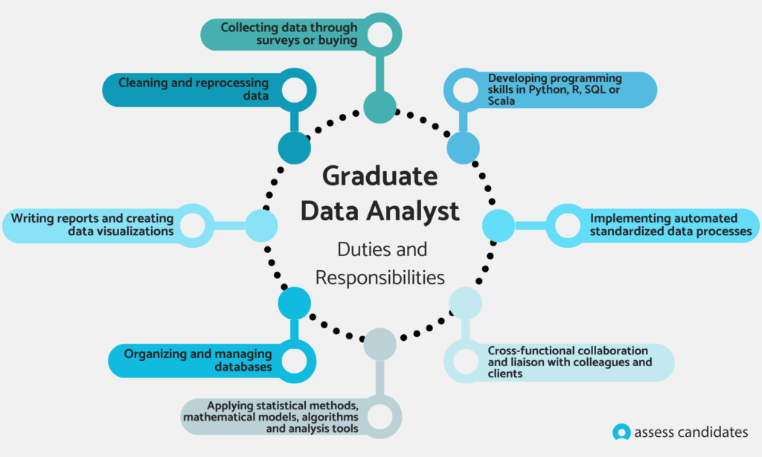
Image 1: Graduate Data Analyst [3].
Data visualisation and communication skills would allow the analysts to make technical concepts lucrative to non-technical stakeholders in a way that makes everybody aware of the business purpose. These skills also encourage group work and support in the establishment of strong interdepartmental relationships. The skills of making decisions and solving problems will also be fundamental in the assessment of the business problems and the adoption of effective solutions which can contribute to the desire value. Moreover, changeability and time management aid Data Analysts become need in quickly changing, fast business environments where priorities and needs can be extremely moving [4].
Acquiring these fundamental capabilities in the course of the studies eases one towards the employment by enhancing the capabilities. Now universities offer data courses at entry level programs. These things encourage me to become a proficient Data Analyst in my selected field because I will be able to perform efficient data analysis, convey knowledge to others, and formulate business decision that will eventually result in organizational development and prosperity [5].

Task 1 (b): Evaluation of Task 1 (a) based on Similarity report

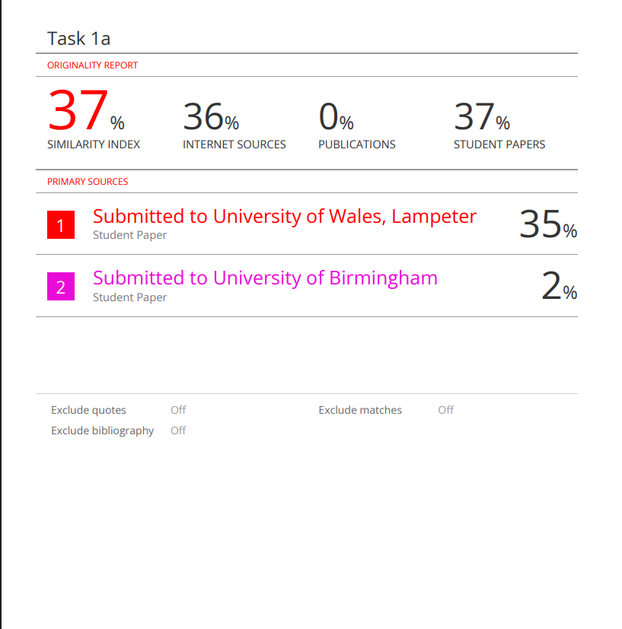
Image 2: Similarity Report
I had a score of %37 similarity, and to a large extent, it is because of using the template compulsory in the assignment, which is used by a majority of other students. With this inevitable parallelism, the remainder of work was original, though the expressions might have been encountered by the reader in learned works, as a result of the standard language. The way to improve this score in the future is to better paraphrase and make the ideas sound more person-specific, and in a better way, so that will not be a problem of excessive similarity.
Based on the Generic Assessment Criteria, I would give myself a mark of 80 out of 100 at a postoperative stage. The reason is that there is excellent engagement with literature, clarity in understanding of the topic and proper writing in academic document; however, there is still scope for improvement in the work, as this presupposes rewording of the topic and critiquing the matter. The submission of the submissions can be better in the future with more refinement and, more specifically, more developed thoughts.

Task 2: Collaborative Mind Map and Individual Poster

Mind Map (Collaborative)
Mind Map Link:
https://mm.tt/map/3845138122?t=p2sHkWYE8N
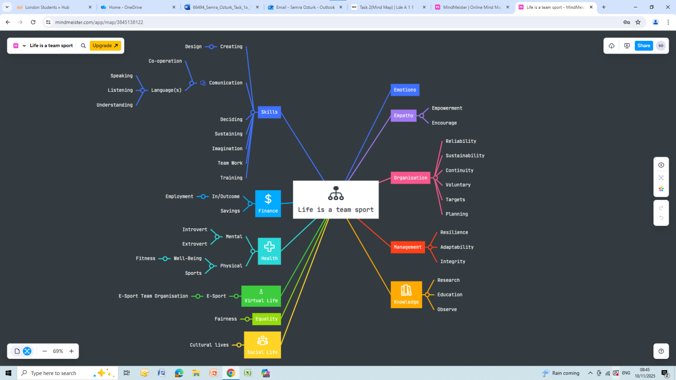
Image 3: Mind Map Life is a Team Sport (Group Work)
This mind map explains the idea behind the thesis statement of Life is a Team Sport as it illustrates how teamwork relates to any other facet of life. It also underlines such important areas of skills that are relevant in communication, creativity, decision-making, empathy, and emotional awareness. It also associates the teamwork with organisations, management, finance, health, equality, social life and knowledge. The branches symbolise the role of collaboration, flexibility, planning, and common roles in the self-development, well-being, and successful function of the virtual and real worlds.

Poster (Individual)
Poster Link:
https://www.canva.com/design/DAG37DQKtCQ/o1GxcMefGhdeQtkFhgVA3A/edit?utm_content=DAG37DQKtCQ&utm_campaign=designshare&utm_medium=link2&utm_source=sharebutton
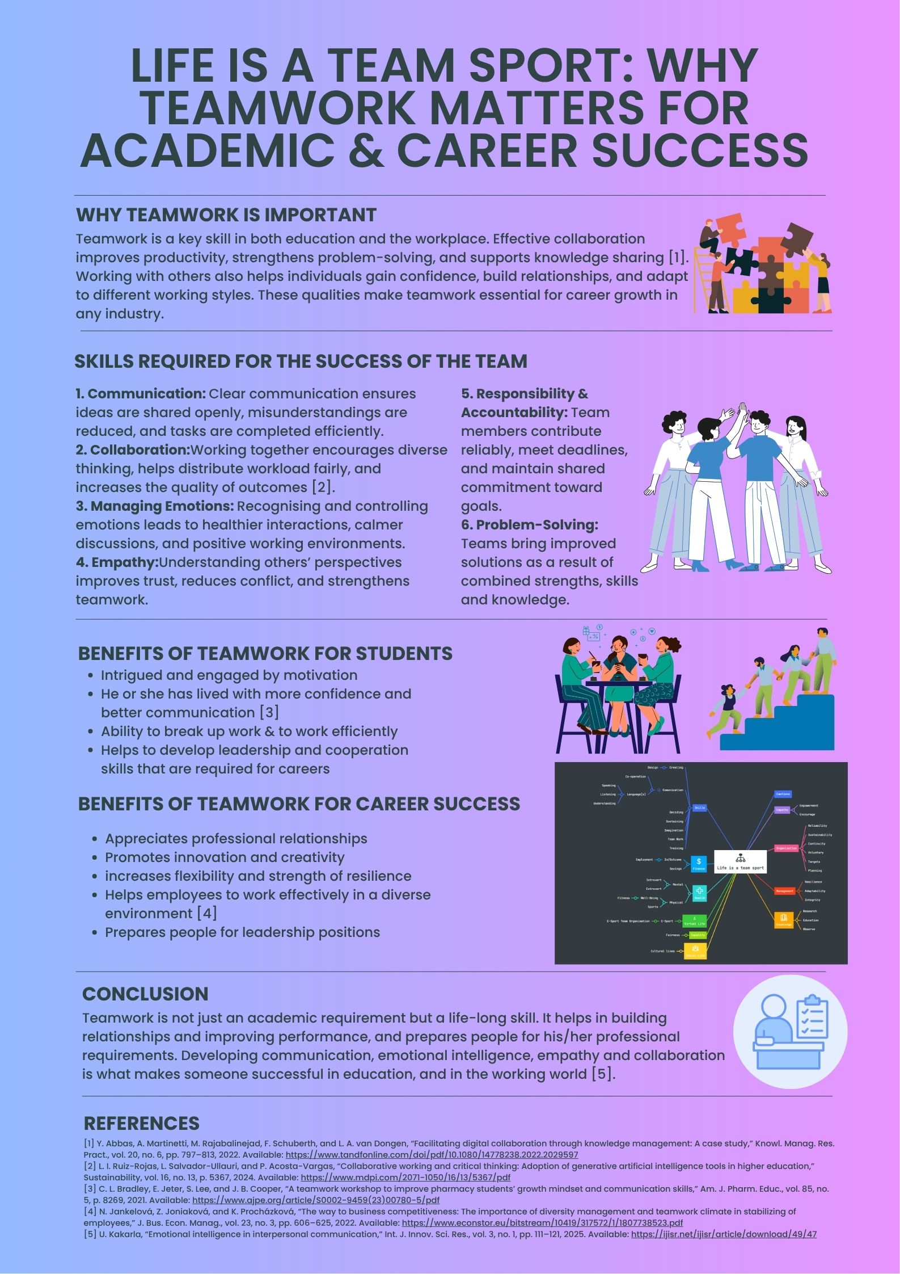
Image 4: Poster Life is a Team Sport (Individual Work)
This poster underscores the significance of collaboration towards success in academics and the workplace. It lays out some important skill sets of teamwork as communication, collaboration, emotional intelligence, empathy, and responsibility, in addition to problem-solving. It further describes the benefits of teamwork to students and professionals, such as increasing motivation, creativity, confidence, and flexibility. The poster continues to affirm that there is no way teamwork is only critical to the learning process, but it is also a lifetime-long skill that enhances education and performance at the workplace.

Task 3: Virtual Collaboration and RefWorks

Report on Virtual Collaboration
The digitalisation of workplaces has made the teams building, communication and provision of result to be totally different [1] Topic 1, Forming a Team, focuses on the importance of teamwork being one of the most important employability skills, but the way of creating and running a team has shifted considerably in the virtual world. The old-fashioned face-to-face cooperation depended on the relationship of physical proximity a great deal, on in-person dialogues and straightforward interpersonal communication. Conversely, virtual teams rely on the virtual communication applications, formal procedures and purposeful relationship development.
First of all, one of the aspects that is related to this concern is that good teamwork assumes complementary skills, an assigned role, and shared objectives. These values are also refined in the virtual environment since spontaneous communication is not offered. To create an online team, team members need to reach initial deals concerning tasks, communication style and norms [2]. This conforms with generally recognised teamwork paradigms, in those clear goals, the sharing of the work and the shared responsibility represent the key to realising efficient collaboration.
According to Tuckman, Stages of Team Development, team development takes time, and this is highly crucial in virtual collaboration, whose communication, trust-building and role clarity need to be made with more conscious effort.
The other aspect that emerged as significant out of the topic is the requirement to take into account such interpersonal skills as empathy, active listening and cultural awareness. The skills help in establishing trust, which is normally harder to achieve in the virtual environment due to the absence of non-verbal cues. The staff members will be asked to be tolerant, open, and active at all times using online platforms. This includes acknowledging the input of other people, encouraging participation, and handling any misconceptions should be handled at the earliest opportunity.
Technology is also key in the creation of an efficient virtual team. Video-conferencing, shared documents and instant messaging can be implemented as collaborative tools and help keep the interaction and coordination [3]. Nevertheless, team members must be digitally literate and adaptable to rely on technology. Learning to operate these instruments effectively will shorten waiting time, augment the working process and improve the overall experience of the team.
Finally, the issue emphasises the fact that virtual teamwork is a reflection of the current perspective of working in the contemporary world. A large number of organisations are currently working with teams spread out geographically, and virtual collaboration has become an essential skill required to work with in the future [4]. The students can acquire transferable skills of communication, self-management and problem-solving through learning how to establish, lead and engage in virtual teams.
On the whole, managing a virtual team involves intentional communication, good interpersonal skills, with the use of digital technologies. By learning these aspects, teams can work effectively even when separated by distance, and this proves why working virtually is vital in both the school and workplace contexts.
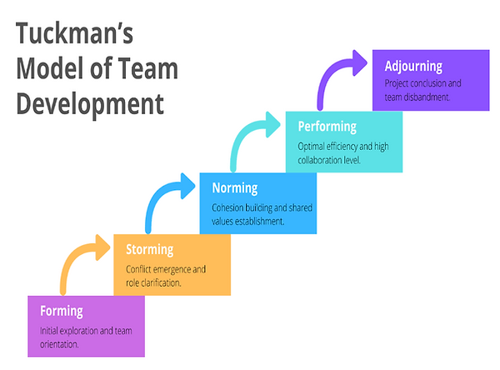
Image 5: Tuckman’s Model of Team Development [5].

Step-by-step process of using RefWorks with visuals
In order to organise and structure my referrals, I used RefWorks during this assignment. All four academic articles are uploaded into a specific folder, as seen in the screenshots named Portfolio Tasks. RefWorks was automatically performing the bibliographic details of each PDF, and then spotted the details and improved them accordingly to make them accurate. Once the references had been organised, I selected the Create Bibliography option to create the citations and reference list in IEEE format. These I then entered in my written summary. RefWorks wa more efficient, consistent, and reliable in the process of referencing the source and saved time and errors.
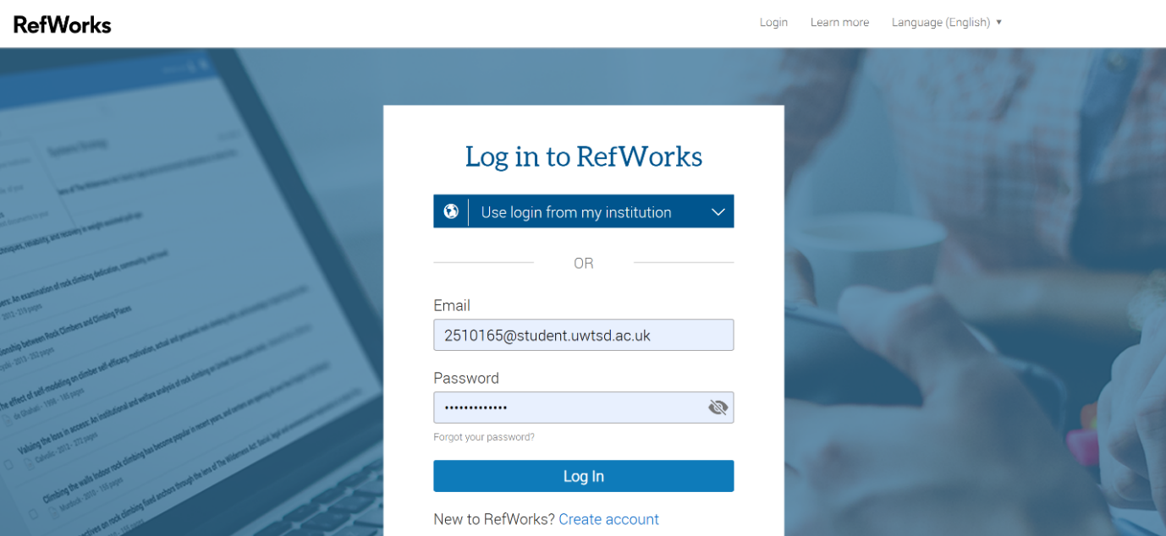
Image 6: Task 3b Step 1
Step 1 reveals the RefWorks log-in screen, where the user logs in with their university email.

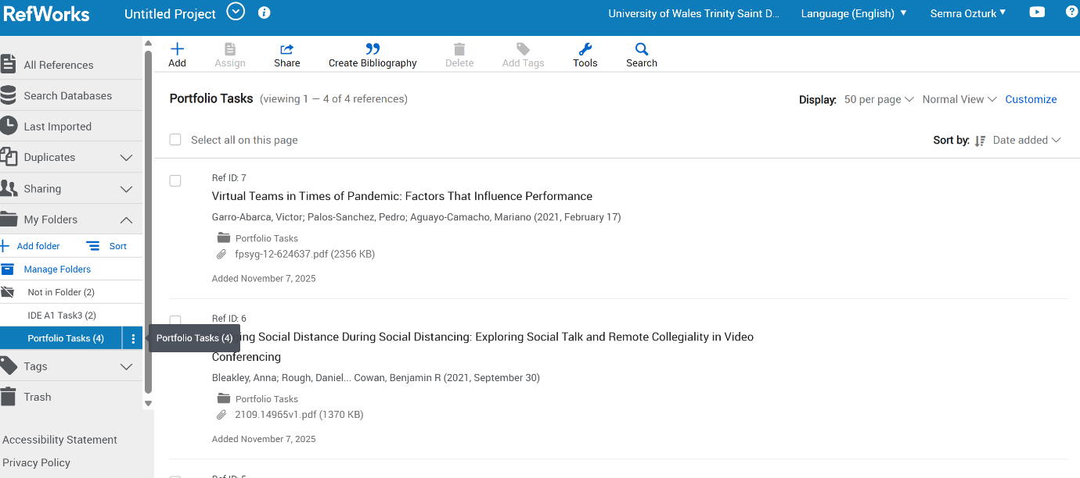
Image 7: Task 3b Step 2
Step 2 includes creating a special folder called Portfolio Tasks in RefWorks, where academic references were placed to make the e-portfolio tasks efficient.

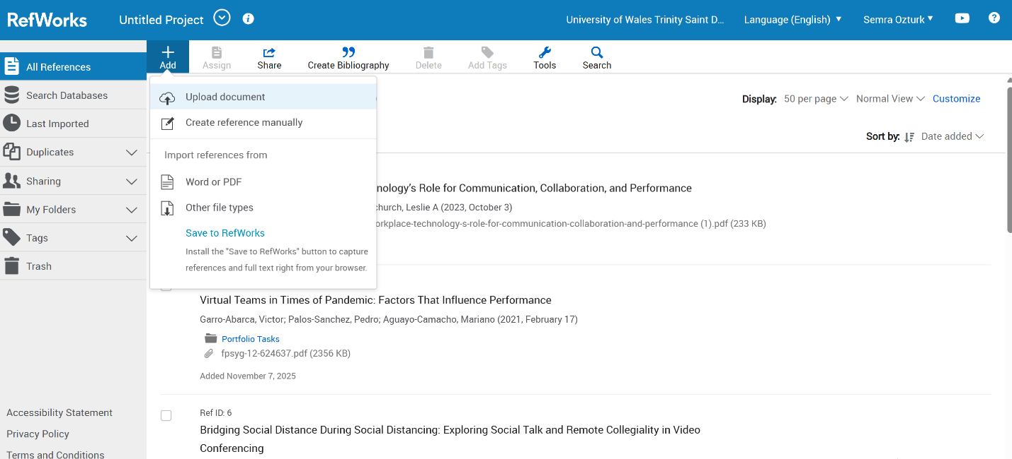

Image 8: Task 3b Step 3
Step 3 is a view of the Word document, which opens the RefWorks Citation Manager

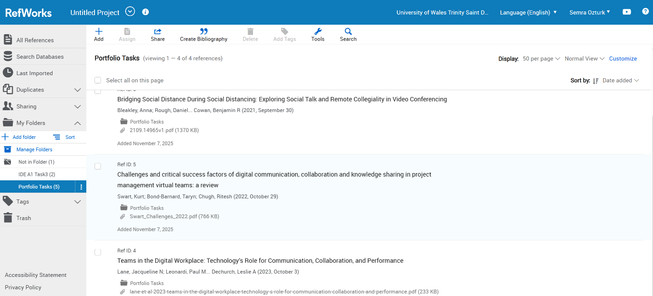
Image 9: Task 3b Step 4
Step 4 displays the manner in which the references were gathered and sorted out within the RefWorks “Portfolio Tasks” folder

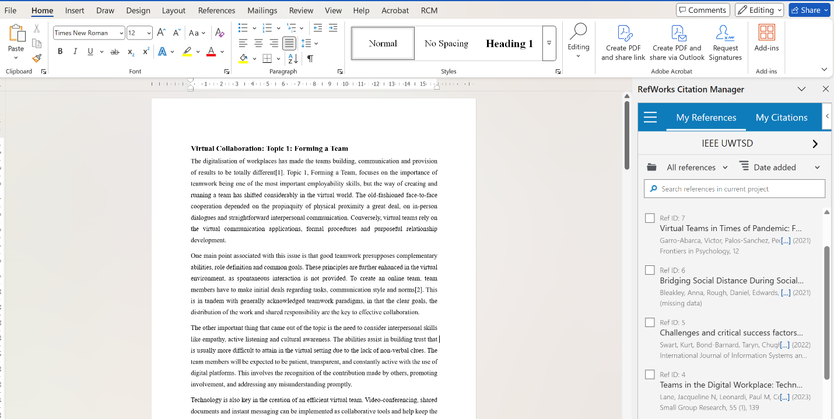
Image 10: Task 3b Step 5
Step 5 shows the process of adding new references in RefWorks by either uploading documents or creating them.
.
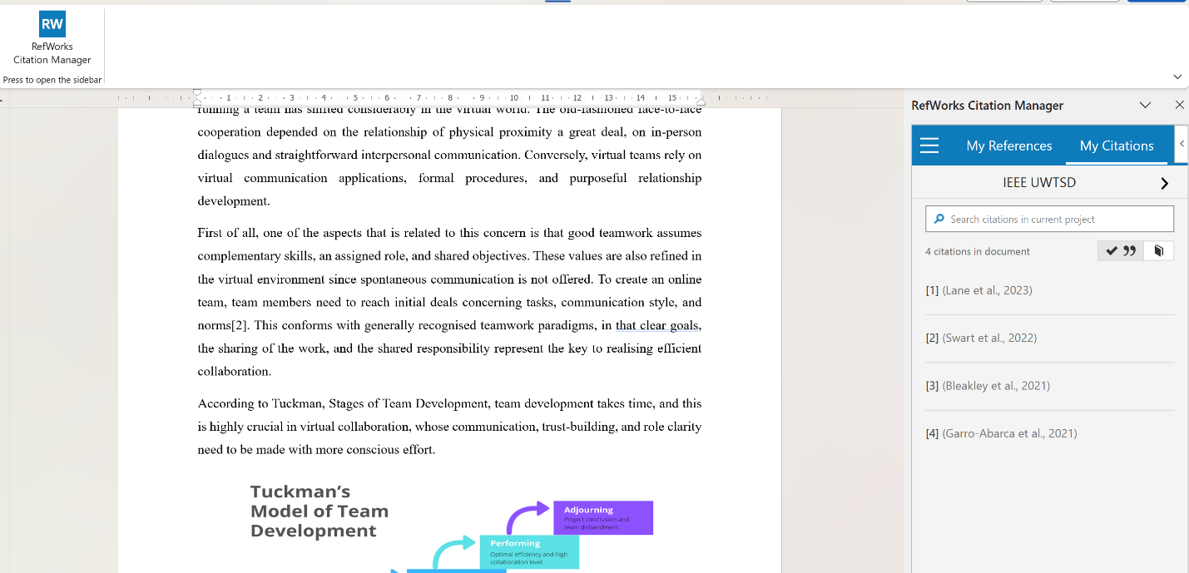
Image 11: Task 3b Step 6
Step 6 shows the list of citations successfully inserted into the Word document through the RefWorks Citation Manager.

Task 4: E-Portfolio Creation and Evaluation

Task 4 (a): E-Portfolio Creation
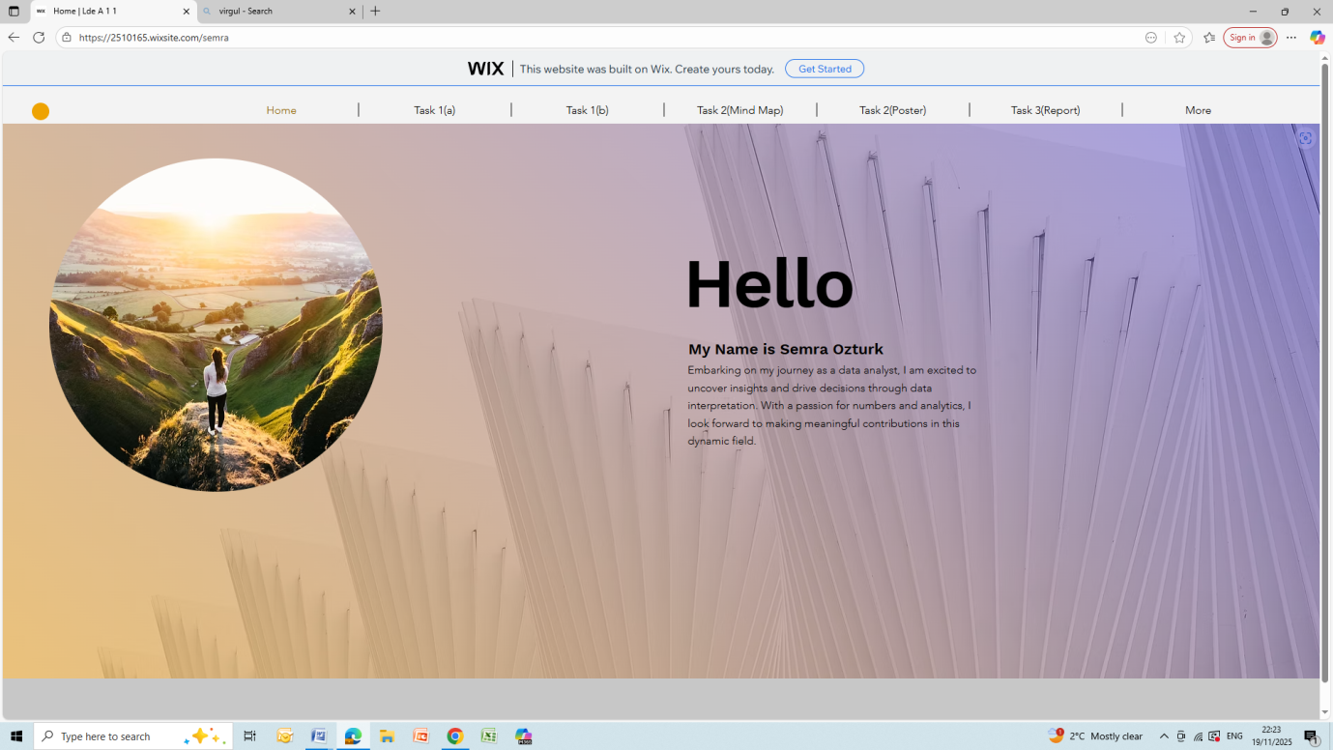
Image 12: Wix Home Page
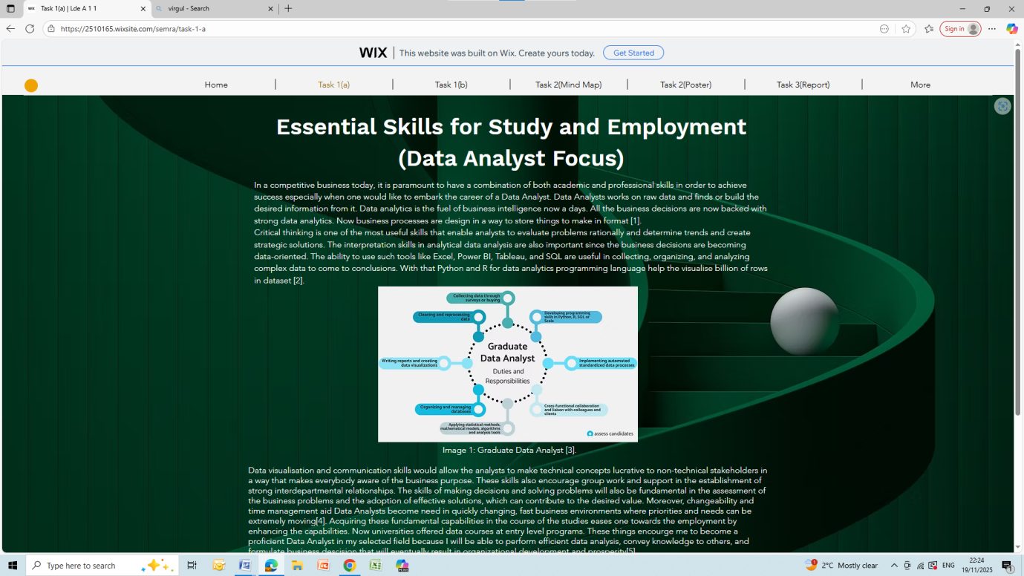
Image 13: Wix Task1(a) Screenshot

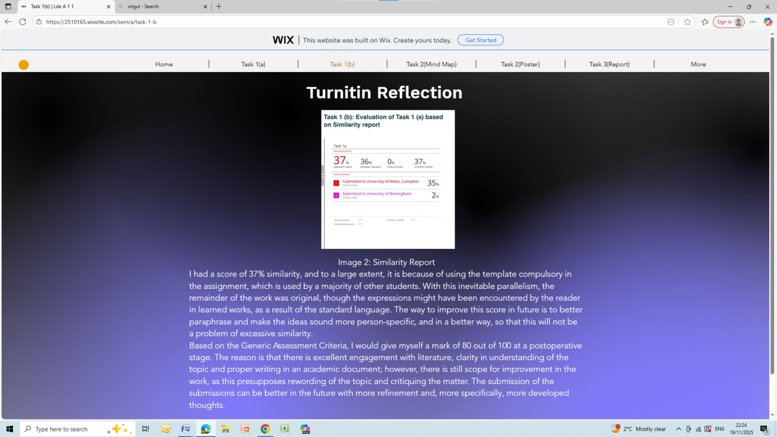
Image 14: Wix Task1(b) Screenshot

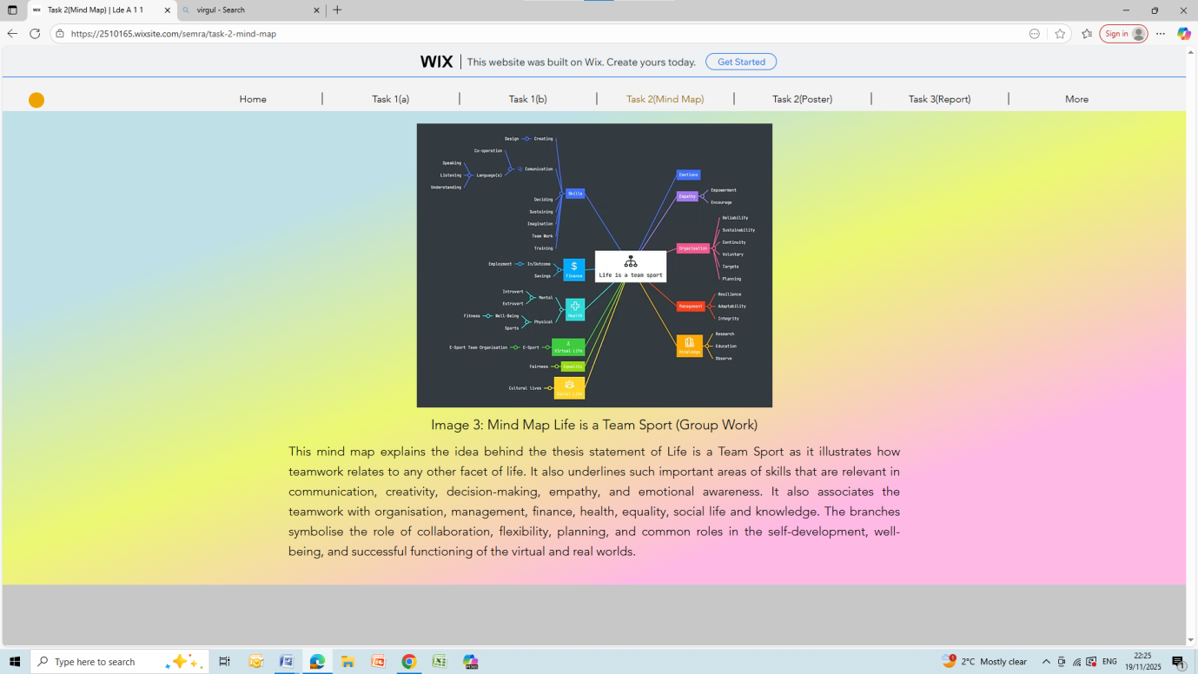
Image 15: Wix Task2(a) Screenshot

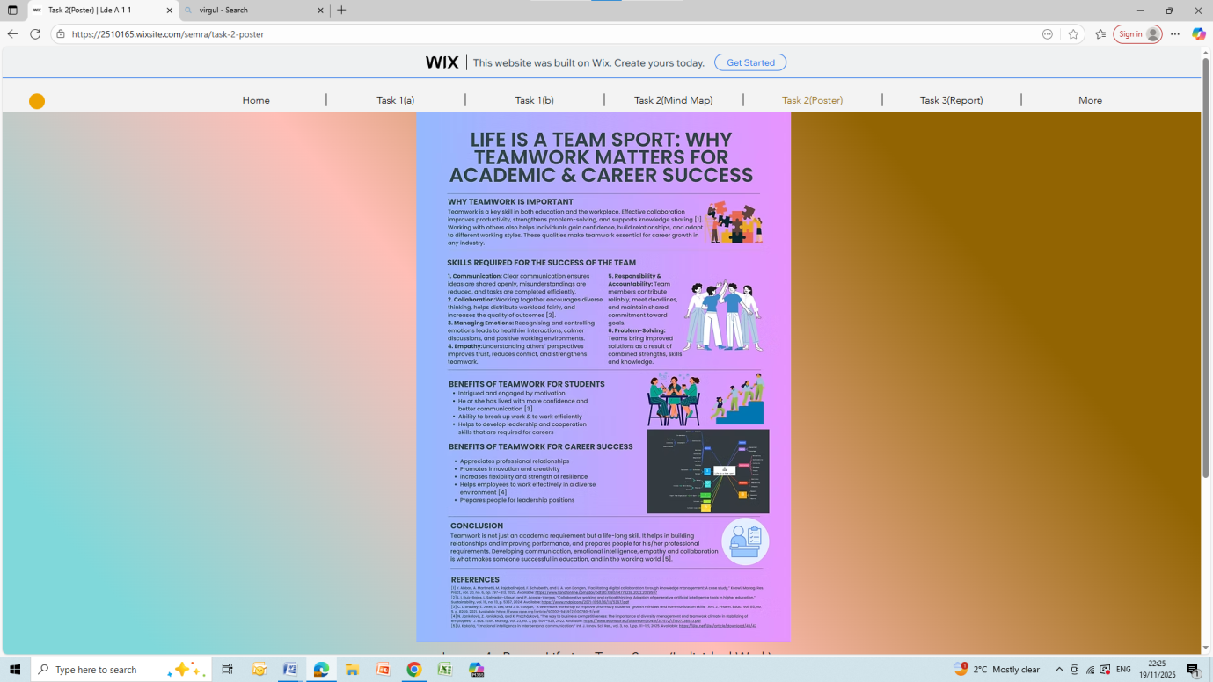
Image 16: Wix Task2(b) Screenshot
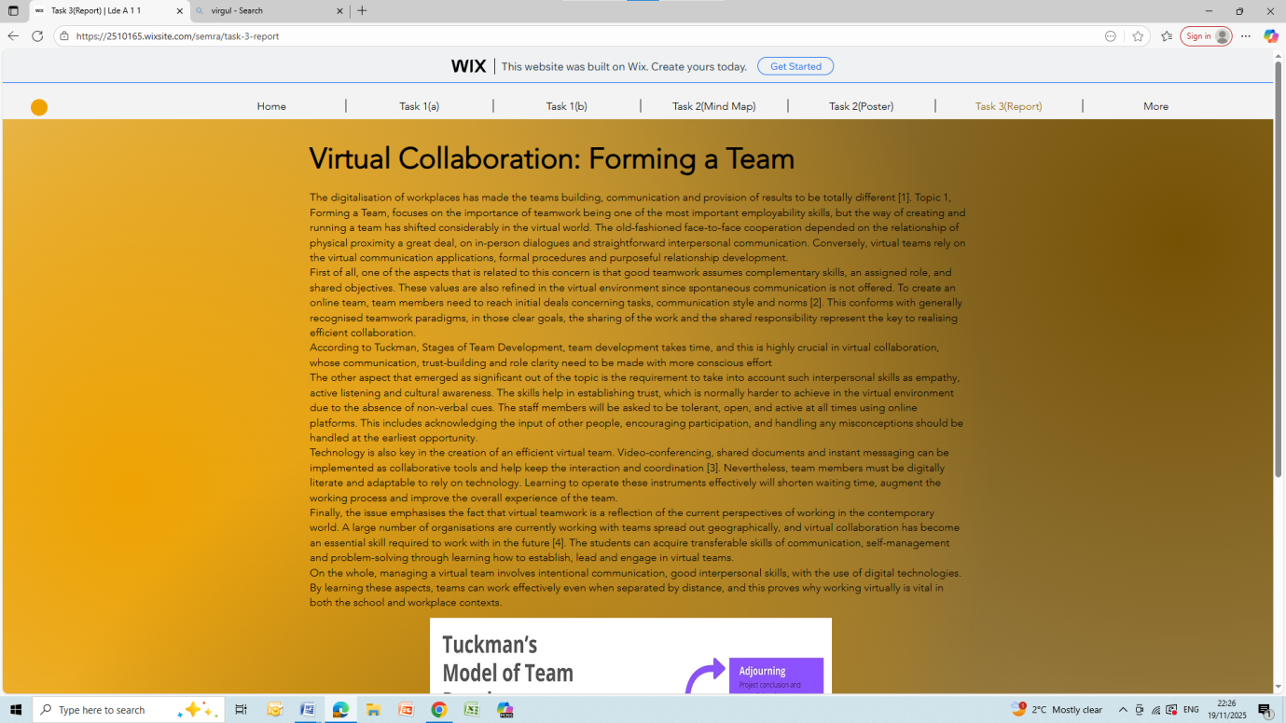
Image 17: Wix Task3(a) Screenshot

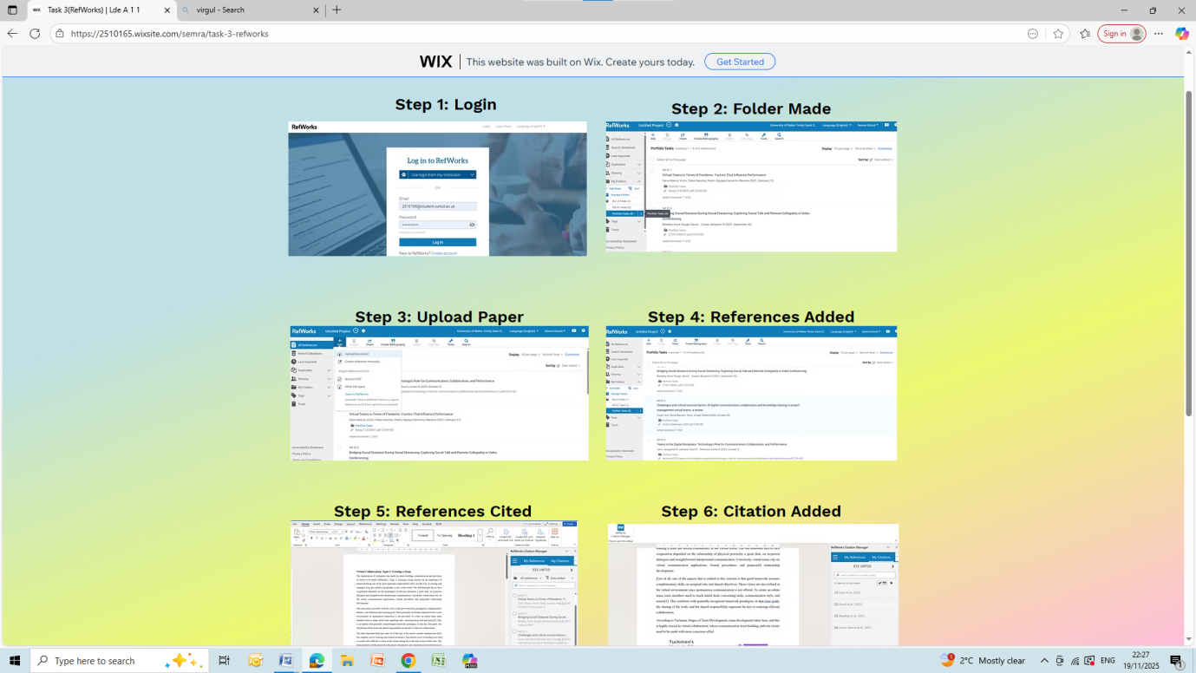
Image 18: Wix Task3(b) Screenshot

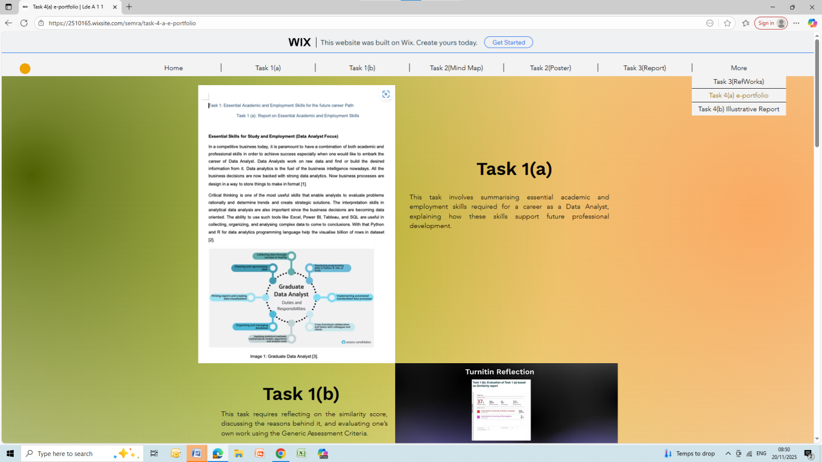
Image 19: Wix Task4(a) Screenshot

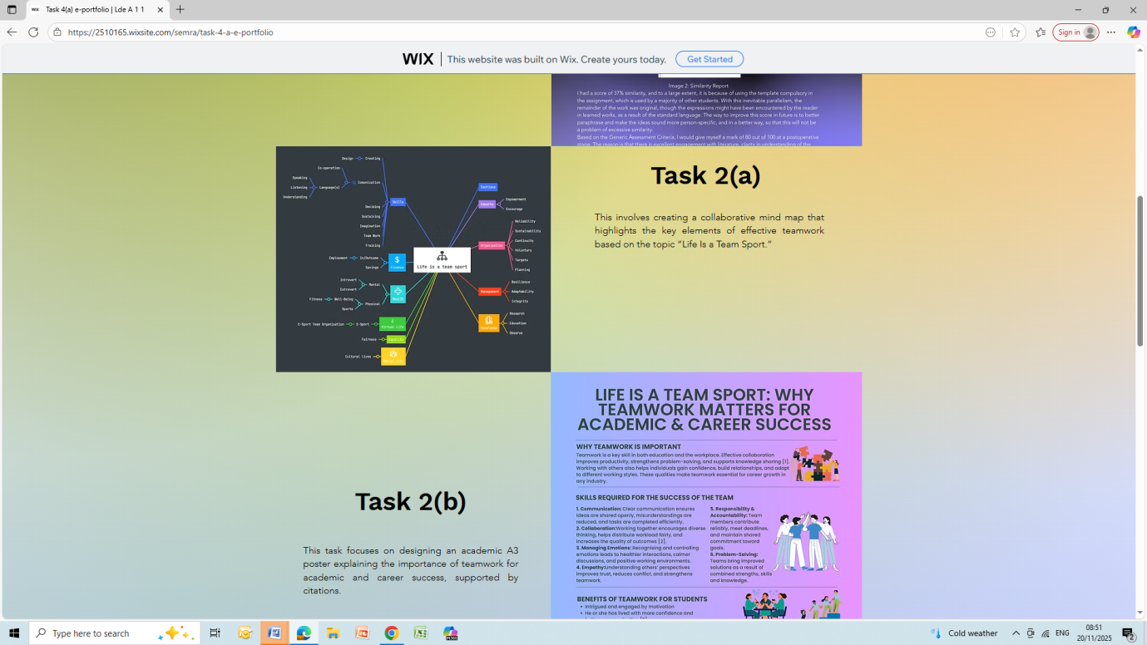
Image 20: Wix Task4(a) Screenshot
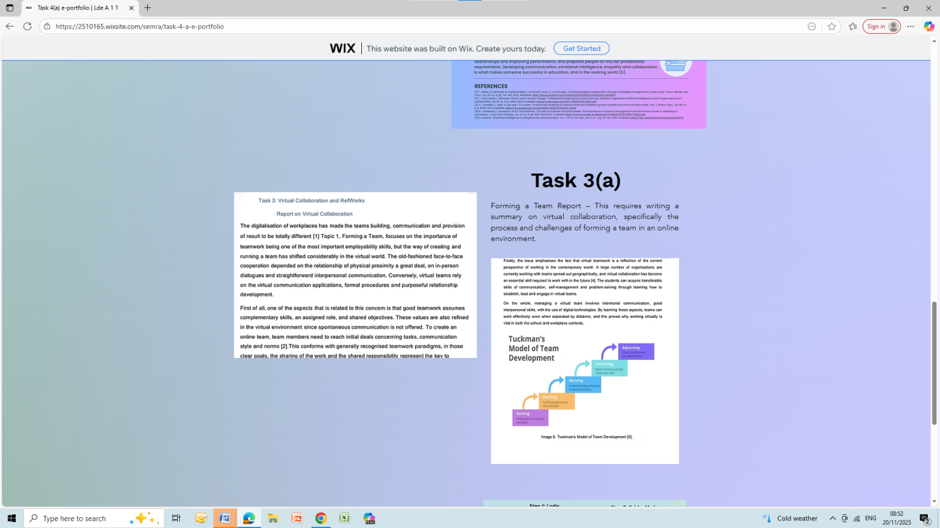
Image 21: Wix Task4(a) Screenshot

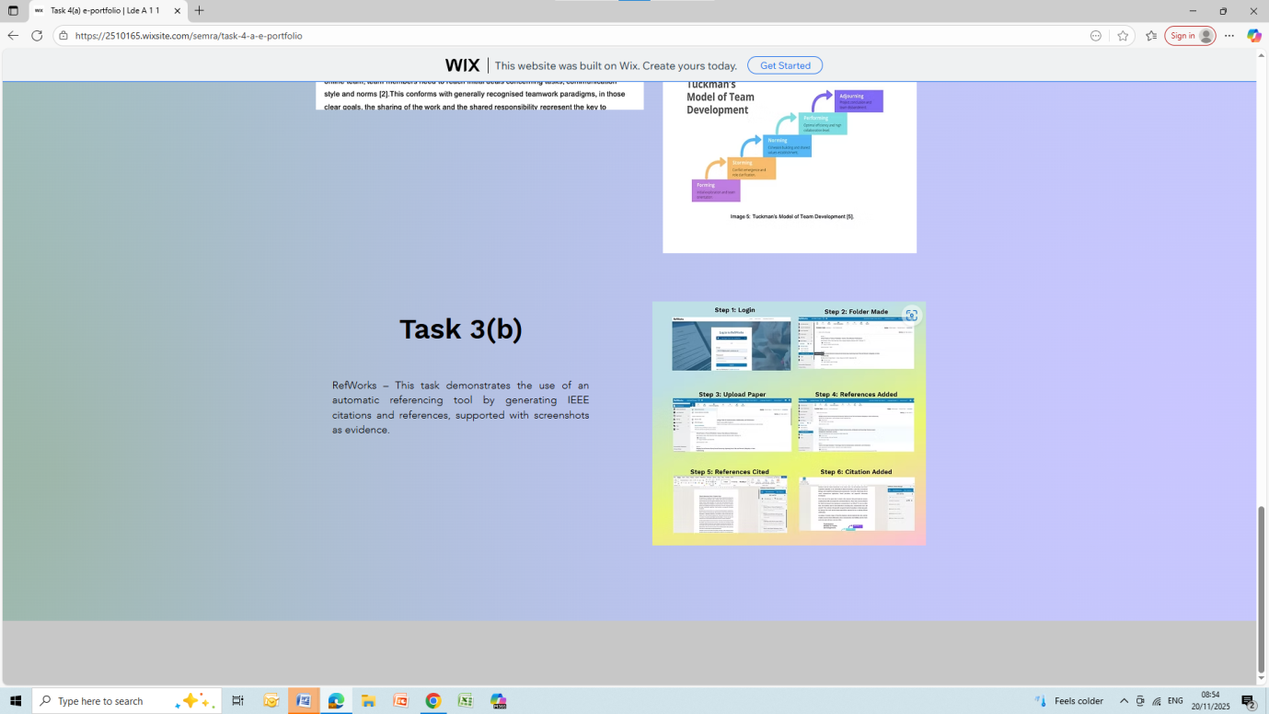
Image 22: Wix Task4(a) Screenshot

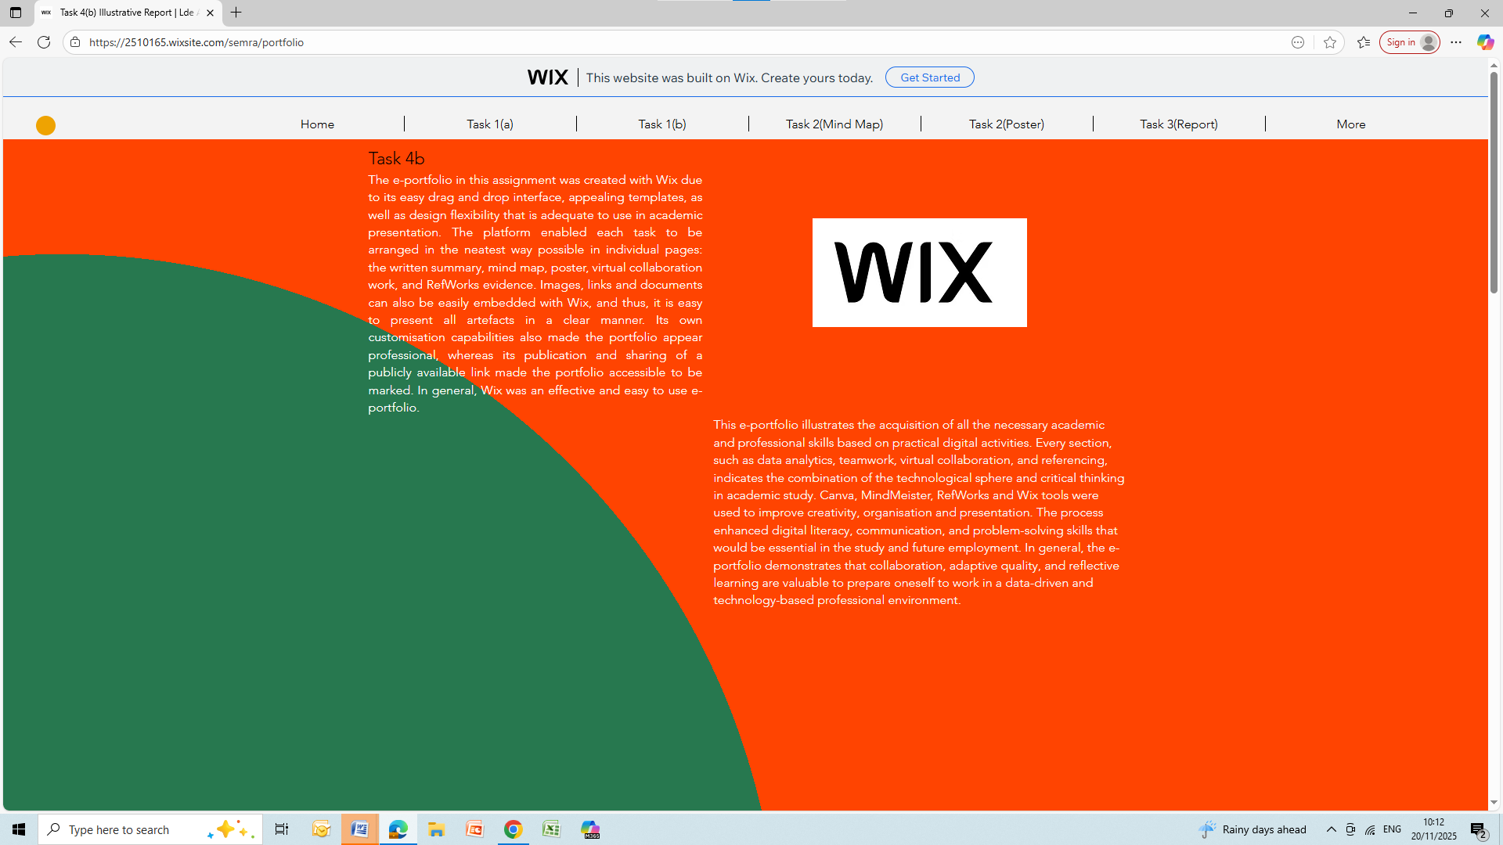
Image 22: Wix Task4(a) Screenshot

Task 4 (b): Illustrative Review of E-Portfolio tool Selection
The e-portfolio in this assignment was created with Wix due to it is easy drag and drop interface, appealing templates, as well as design flexibility that is adequate to use in an academic presentation. The platform enabled each task to be arranged in the neatest way possible in individual pages; the written summary, mind map, poster virtual collaboration work, and RefWorks evidence. Images, links, and documents can also be easily embedded with Wix, and thus it is easy to present all artefacts clearly. Its own customisation capabilities also made the portfolio appear professional, whereas its publication and sharing of a publicly available link made the portfolio accessible to be marked. In general, Wix was an effective and easy-to-use e-portfolio.

Conclusion
This e-portfolio illustrates the acquisition of all the necessary academic and professional skills based on practical digital activities. Every section, such as data analytics, teamwork, virtual collaboration, and referencing, indicates the combination of the technological sphere and critical thinking in academic study. Canva, Mind Meister, RefWorks and Wix tools were used to improve creativity, organisation and presentation. The process enhanced digital literacy, communication, and problem-solving skills that would be essential in the study and future employment. In general, the e-portfolio demonstrates that collaboration, adaptive quality, and reflective learning are valuable to prepare oneself to work in data-driven and technology-based professional environment.

References

Task 1 References:

[1] | K.Eremenko, Confident Data Skills: How to Work with Data and Future-proof Your Career, London, 2020.
[2] | R. Sikdar, Data Analytics-An Emerging Skills Gap, vol. 10, pp. 1-13, 2022.
[3] | A.Arshad, “"Hiring Graduate Data Analyst: Why you should adopt these pre-employment assessment," Assess Candidates,” 2025.
[4] | E.Stevens, What is Data Analytics?A Complete Guide for Beginners, 2023.
[5] | “The London School of Economics and Political Science,” How data skills Can Expand your career?, 2025.

Task 3 References:

[1] J. N. Lane, et al., "Teams in the digital workplace: Technology's role for communication, collaboration, and performance," Small Group Research, vol. 55, no. 1, pp.139, 03.10 2023.
[2] K. Swart, T. Bond-Barnard and R. Chugh, "Challenges and critical success factors of digital communication, collaboration and knowledge sharing in project management virtual teams: a review," vol. 10, no. 4, pp.139–183, 2022. doi: 10.12821/ijispm100404.
[3] A. Bleakley, et al., "Bridging social distance during social distancing: Exploring social talk and remote collegiality in video conferencing," vol. 37, no. 5, pp.1–39, 30.09 2021.
[4] V. Garro-Abarca, P. Palos-Sanchez and Aguayo-Camacho Mariano, "Virtual Teams in Times of Pandemic: Factors That Influence Performance," vol. 12, pp.1–14, 17.02 2021. doi: 10.3389/fpsyg.2021.624637.
[5] "Tuckman's Model Definition& Why It's Important In Agile Team Development." Holistique Traning. https://holistiquetraining.com/public/en/news/tuckmans-model

