

Programme Name: Master of Business Administration
Module Code: LCMB7024
Module Title: Marketing Management

Marketing Environment Analysis

Lecturer’s Name: Dr. Laila Maazouz

Student Name: Harsh Deep Singh
Student ID: 2436567
Date: 21.11.2025
Table of Contents
1. Introduction 2
2. Task 1: Macro Marketing Environment Analysis 2
2.1 Overview of Macro Marketing Environment 2
2.2 Technological Factors Influencing the EV Industry 3
2.3 Environmental Factors Influencing the EV Industry 6
3. Task 2: Strategic Responses by Pioneers and Followers 8
3.1 Introduction to Strategic Responses 8
3.2 Strategic Responses to Technological Factors 8
3.3 Strategic Responses to Environmental Factors 11
4. Conclusion 13
References 14

List of Figures
Figure 1: PESTLE Framework 3
Figure 2: Public Charger Stock from 2023 to 2035 4
Figure 3: Cost of Lithium-ion Battery Pack 5
Figure 4: Composition of Raw Materials 7
Figure 5: Deployments Energy Storage 9
Figure 6: Ansoff Matrix 10
Figure 7: Revenue of Volkswagen in 2024 11

1. Introduction
Electric vehicle (EV) industry is currently among the most active and dynamic areas in the global arena as a result of the rapid technological development and growing pressure on the environment. With stricter emission policies advanced by governments and more environmentally friendly mobility options sought by consumers, EV producers have both massive prospects and threats (Sathiyan et al. 2022). In this sector, the early movers, like Tesla and BYD have influenced the expectations of the early market by the advancement of battery technologies, robust innovation strengths and nascent investment in charging infrastructures. As a reaction, follower corporations, such as Volkswagen Group and Ford, have entered the EV market with a later reaction to the regulatory changes and pressure. Making sense of the macro-environmental forces affecting these organisations is crucial towards the analysis of their competitiveness, strategic decisions and sustainability in the rapidly changing market environment.

2. Task 1: Macro Marketing Environment Analysis

2.1 Overview of Macro Marketing Environment
Macro marketing environment entails external factors that shape the strategic decisions within an organisation, but they cannot be directly manipulated (Yaneva, 2020). All these determine the market opportunities, competition and the long-run performance. The technology related to the electric vehicle (EV) sector of the PESTLE model is especially significant in the industry due to the impact on innovation, regulatory transformation and changes in consumer expectations.
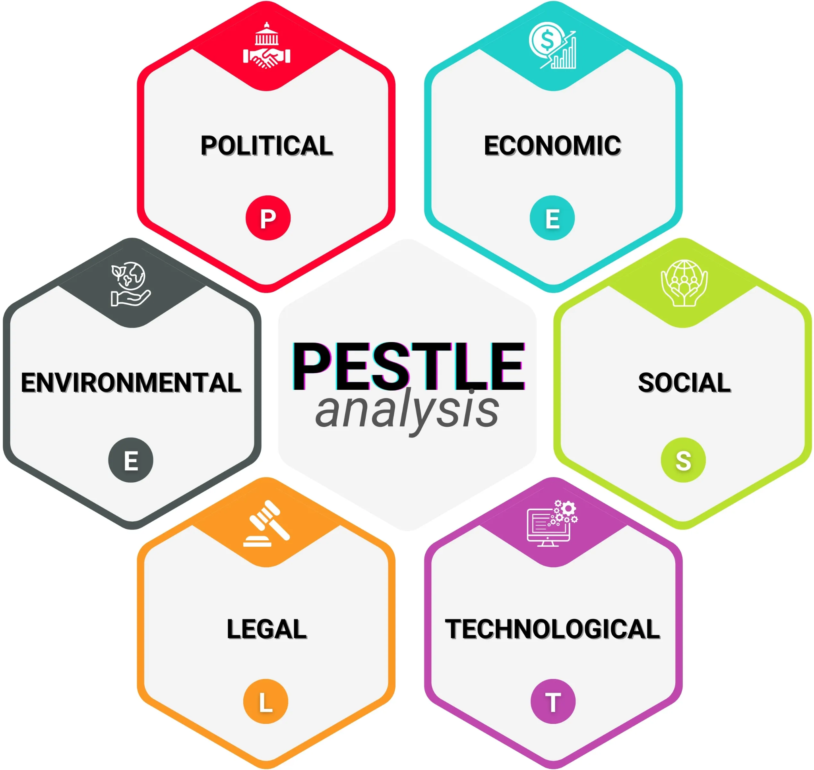

Figure 1: PESTLE Framework
(Source: Iqbal, 2025)

2.2 Technological Factors Influencing the EV Industry
Opportunities Created for Pioneers
The opportunities for the pioneer EV companies are big since there are technological innovations. First, new battery chemistries and architectures are adopted early on to step up the innovation. As an example, of all battery types, including sodium-ion, solid-state, and redox-flow, global investments increased drastically, from less than 15% to more than 25% of total battery funding (IEA, 2024b). Secondly, energy density and range can be improved continuously because of quicker R&D cycles. As an example, the world capacity of battery production in 2023 was the highest at 2.5 TWh, 780 GWh higher than in 2022, which indicates that scaling has a tremendous rate (IEA, 2024c). Lastly, the growth of charging infrastructure is growing. To illustrate, public charging ports will be estimated as four times more in 2030 than the expected amount of 4 million in 2023 (IEA, 2024a).
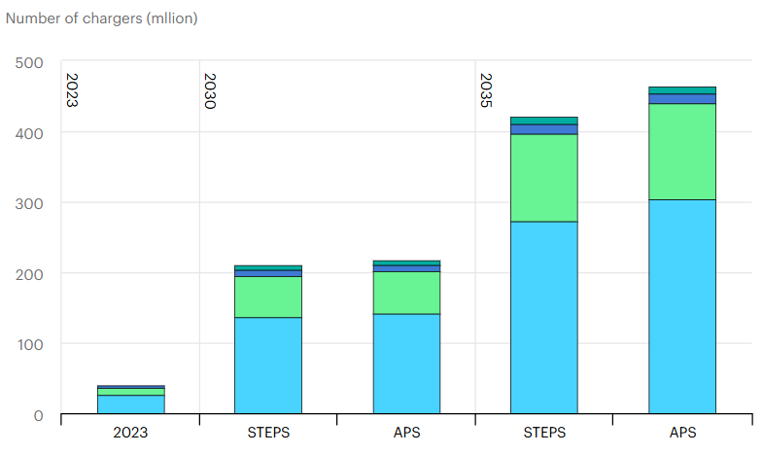

Figure 2: Public Charger Stock from 2023 to 2035
(Source: IEA, 2024a)
Threats Created for Pioneers
The rapid technological advancement is a threat to innovative companies in the EV industry. Though battery innovation, software leading and charging ecosystem deployment capabilities are beneficial in early stages, they require substantial continuous investment. As an example, in 2022, the estimated cost of the average battery pack was $153/per kWh, which indicates intense capital (Vehicle Technologies Office, 2023). The volatility of metal prices also contributed to lithium-ion packs by increasing the price by 7% in 2022, although this declined in 2023 (IEA, 2024d). With the innovation gap narrowed by competitors, differentiating will become more difficult, and returns on first-mover may weaken.
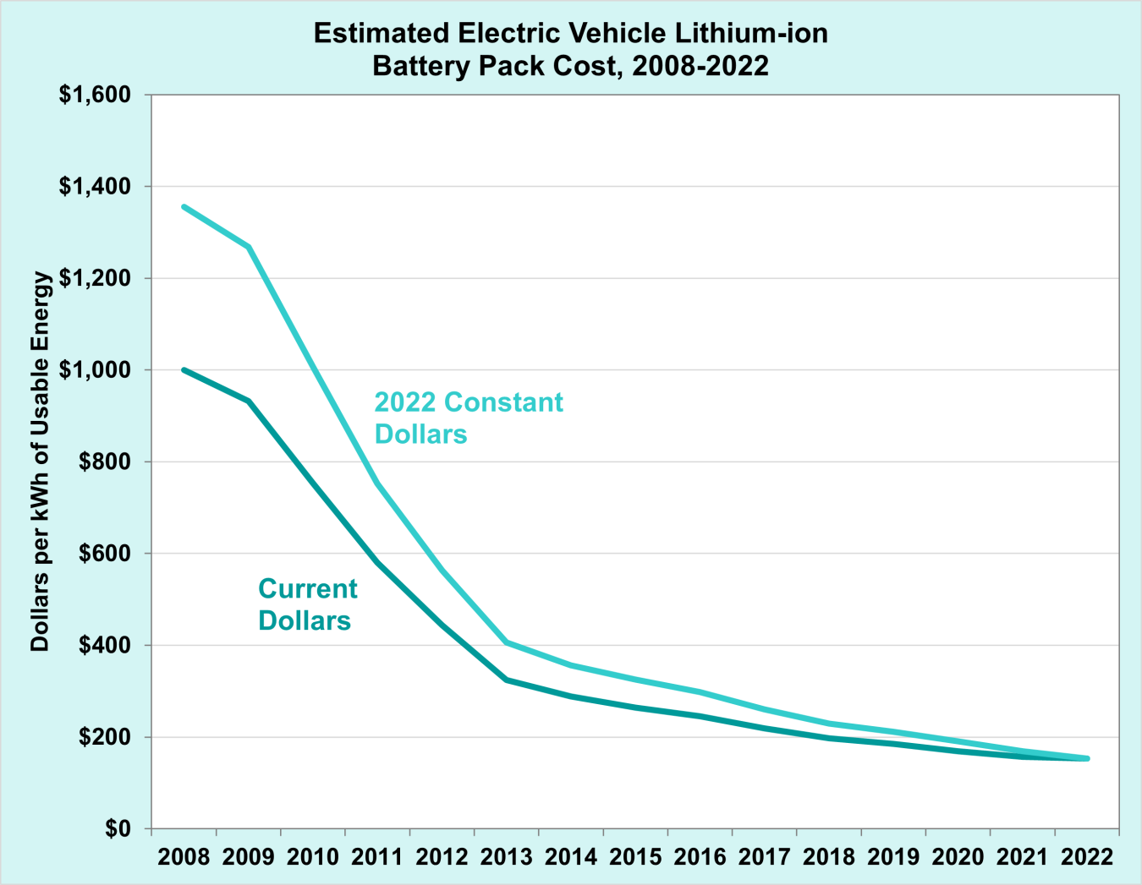

Figure 3: Cost of Lithium-ion Battery Pack
(Source: Vehicle Technologies Office, 2023)
Opportunities for Followers
Adherents of the EV industry also have the advantage of copying the successful technologies with reduced risk, which eliminates expensive risks associated with innovative breakthroughs. They enhance the innovation by forming joint ventures and partnerships, like Ford “BlueOval SK JV” with “SK On” to make batteries on a large scale (Ford, 2021). Moreover, they are using common platforms and open systems more frequently. To provide an example, The MIH Consortium encourages an open EV architecture that is modular and helps an upcoming entrant to contribute more rapidly and cheaply to vehicle development (MIH, 2021).
Threats for Followers
Due to the high reliance on imported lithium-ion cells, which constitute 35-40% of the overall cost of an EV, many of the follower automakers are vulnerable to their supply chains (Mahajan, 2024). Such dependency hinders cost management and subjects them to market volatility. Furthermore, shifting to EV production requires a heavy investment of funds, and the worldwide raw material expenses are approximately 65 percent greater than ICE ones per vehicle (Lyon et al. 2023). It also involves big R&D expenses and alliances to meet the technology standards of the pioneers.

2.3 Environmental Factors Influencing the EV Industry
Opportunities Created for Pioneers
EV pioneers are becoming increasingly popular due to the rapid global decarbonisation policies. Its sales are projected to climb to over 20 million units by 2025 due to incentive-supported markets both in Europe and China (IEA, 2025b). Major regions still have stringent standards of CO₂ emission of new cars, which forces companies to the zero-emission solutions. This wave of regulations provides an early-adopting EV company with a competitive edge (IEA, 2025b). They already meet climate-policy ambitions and mitigate the risk of compliance and can make markets where they have aggressive decarbonisation objectives more competitive.
Threats Created for Pioneers
There are a number of threats related to the environment which face pioneers because they rely on rare minerals such as cobalt and lithium. The world resources of these materials are substantially much concentrated in the geopolitically volatile regions. As an illustration, more than 60% of cobalt is found in the Democratic Republic of Congo (Dhairiyasamy et al. 2024). This kind of dependency poses a risk to firms in regard to breaking the supply chain and price fluctuations. Besides, the growing sustainability demands and the creation of more rigorous recycling laws, in particular in the EU, amplify the pressure to obtain recycled materials (Su et al. 2025). Lastly, the EV battery supply chain is also under a risk of geopolitical risks such as export policy and political instability.
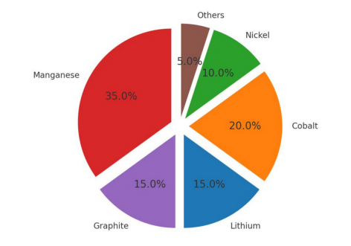

Figure 4: Composition of Raw Materials
(Source: Dhairiyasamy et al. 2024)
Opportunities for Followers
The presence of government incentives is a great boost to EV companies that started late. The amount of global spending on EV subsidies was $2.7 billion in 2024 alone (IEA, 2025a). The policies lower the financial load of the followers. Simultaneously, the governments promote the increase of the energy efficiency in EV manufacturing. More and more policies focus on production rather than sales, especially in China, as a strategy to promote clean and efficient production (IEA, 2023). Additionally, late movers can use sustainability enabled by innovations developed by first movers, including battery recycling, circular supply chains, and low-carbon production, to speed up their own process of developing green credentials and competitive advantages.
Threats for Followers
Strict pressure on climate regulation by such regions as the EU, US, and China compels follower automakers to make an aggressive change to the EV system and raise the compliance cost considerably. The EU also has a 55% CO₂ reduction target by 2030 with full fleet zero emissions by 2035 increasing significant financial risk to late movers (ICCT, 2025). The move towards EV production is expensive due to the traditional production of ICEs. Approximately half of the costs of manufacturing an EV have been invested in materials, which cost approximately 65 percent more than their ICE counterparts (Lyon et al. 2023). Furthermore, a lack of hitting the targets of environmental and supply-chain sustainability, including the problem of human rights in battery sourcing, may greatly ruin the image.

3. Task 2: Strategic Responses by Pioneers and Followers

3.1 Introduction to Strategic Responses
The electric vehicle companies need to implement effective strategic reactions to cope with rapid technological and environmental forces which define competitiveness (Sidik et al. 2024). The reaction of pioneers and followers is different, as these actors work in different positions in the market, with different sets of resources and focus on innovations. Pioneers usually work in the development of technology and reinforcement of initial market positions, whereas followers are interested in reduction of risk, efficiency and regulatory adherence. An examination of these opposing reactions is important towards the understanding of how firms remain competitive owing to their ability to adapt to the changing macro-environment.

3.2 Strategic Responses to Technological Factors
Pioneers’ Technology-Driven Responses
Tesla
Tesla has been substantially vigorous in first-mover technology whereby it dedicates a lot of resources internally in terms of R&D so as to develop battery chemistry, energy density, self-driving, and software. It has invested $3.97 billion in R&D in 2023, which is 29 percent more compared to 2022 (Tesla, 2024). It is an investment made by Tesla to create its own proprietary platforms, which facilitates a differentiated digital ecosystem. It also uses its first-mover status to influence the setting of charging standards by growing its Supercharger network in the world.
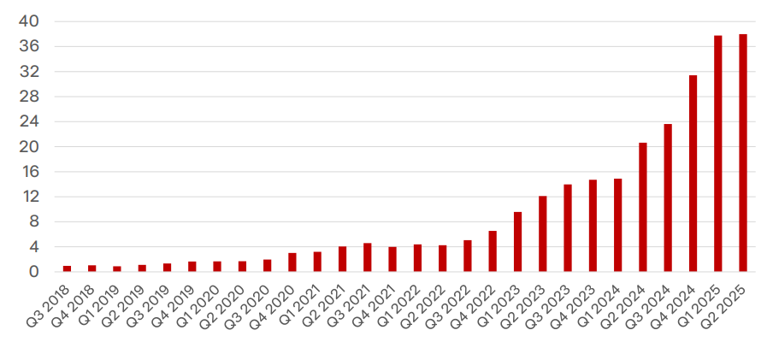

Figure 5: Deployments Energy Storage
(Source: Tesla, 2025)
During Q2 2025, Tesla has more than 2,900 new Supercharger stalls, which is 18 percent annually (Tesla, 2025). This immense infrastructure also has a lock-in effect since customers can enjoy the only fast-charging systems because this supports the technical lead of Tesla. In the meantime, there are constant cycles of innovation in the company. Consistent with the Ansoff Matrix, Tesla utilises the product development process where it enters thereby launching new, more developed EV models and software improvements into target markets to maintain growth and avoid competitors (Khajezadeh et al. 2019).
BYD
BYD is also a pioneer-orientated technological company, which has made a significant investment in internal research and development. Its R&D expenditure also increased to RMB 54.2 billion, which equals approximately $7.5 billion dollars, an increase of 36 per cent in one year (BYD, 2025). It has been historically conducting more R&D than its net profit in 13 of the last 14 years. This is financing the creation of proprietary platforms. BYD has created its own Super e-Platform that allows charging up to 400 km in the shortest possible time, five minutes, with the help of which it has created a DiSus intelligent body-control system (MT Bureau, 2024). The current R&D and platform innovation of BYD is indicative of a product development model in which it has been bringing EV technologies to its expanding markets to strengthen its technological advantage. Constant repetitions of innovation, combination, and magnitude well state that BYD will always be on the leading edge of EV development.
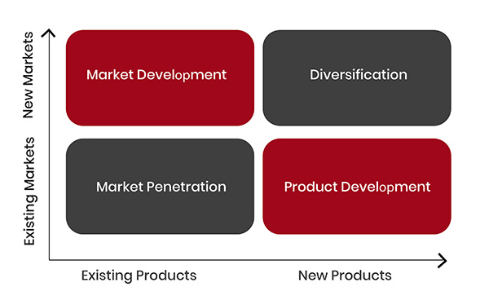

Figure 6: Ansoff Matrix
(Source: The Strategy Institute, 2024)
Followers’ Technology-Driven Responses
Volkswagen
The fast-follower and adaptive imitation strategy that Volkswagen tries to follow involves cooperation with XPeng. It invested $700 million to get a share of 4.99 percent and makes two VW EVs together with XPeng through its E/E architecture without taking much time to deliver the products to the market and reduced time to market by more than 30 percent (Volkswagen Group, 2024). In 2024, Volkswagen AG had revenue amounting to $351.31 billion, which confirms its ability to finance large-scale EV alliances and long-term electrification approaches (Macro Trends, 2025). VW is also collaborating with CATL to develop cheaper battery choices together, enhance modular systems, and share R&D risk (Opletal, 2025). Besides, its Scalable Systems Platform (SSP) standardises EV electronics architecture and saves 30% in the R&D costs (Zollino and Oemisch, 2023). This corresponds with the market development and product development strategies of the Ansoff Matrix, as it can exploit the existing technologies and relationships.
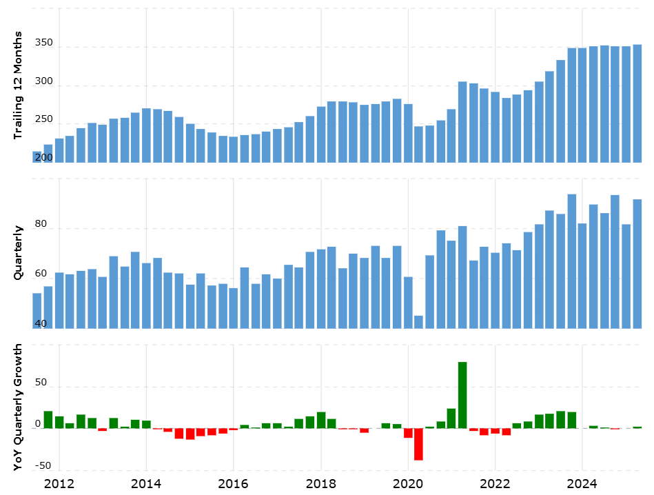

Figure 7: Revenue of Volkswagen in 2024
(Source: Macro Trends, 2025)
Ford
Through outsourced systems, Ford is attaining technology. It has secured 60 Gwh of yearly battery cell capacity with CATL, LG Energy Solution and SK On, which minimised its responsiveness to R&D (Lambert, 2022). It incorporates packs of lithium iron phosphate (LFP) battery chemistries alongside nickel-cadmium, enabling chemical combining, which lowers material expenses by approximately ten percent (Lambert, 2022). In 2026, Ford will also be entering a joint venture with LG Energy Solution and Koç Holding to construct a cell plant measuring 25-45 GWh in Turkey. Its software-defined EV platform has 20% fewer parts, and scalability of body style, which is in line with product development in the Ansoff Matrix (Uwemedimo and Blackie-Kelly, 2025).

3.3 Strategic Responses to Environmental Factors
Pioneers’ Environment-Focused Responses
Tesla
Tesla is a highly aggressive stakeholder that promotes global carbon-neutral considerations by integrating a closed-loop battery recycling approach, which utilises up to 92% of its initial battery raw material, eliminating the need to rely on virgin materials (Crider, 2022). It is working closely with recyclers and incorporating battery reuse into its manufacturing, thereby enhancing its environmental image and creating regulatory goodwill (Deepak, 2025). This plan supports the Ansoff Matrix in product development since Tesla pioneers in sustainable operations and sells to the players in the market by marketing the product on green terms to eco-sensitive buyers.
BYD
BYD aims to accomplish carbon neutrality by 2045 and aims to achieve a reduction of operational carbon intensity by half by 2030 (Jonathan, 2024). It has developed a total recycling network of closed loops of reuse of retired EV batteries and scrap aluminium, reused in the manufacturing process. The renewable energy is also incorporated at BYD through its energy-storage and solar divisions that sustain a less-polluting value chain. This in terms of the Ansoff Matrix, this would be diversification through energy storage and solar and product development through the integration of the concepts of a circular economy into its EVs.
Followers’ Environment-Focused Responses
Volkswagen
In its turn, Volkswagen, being a follower, moves at rapid speed towards becoming fully EV and transitioning to the zero-emission target of 2035 in an immediate response to the tightening of European CO₂ standards, especially in terms of a 55% cut to comply by 2030 and a total zero-emission goal by 2035 (Volkswagen Group, 2023). It is gradually retiring its internal combustion engine (ICE) models and investing in making its production processes and suppliers cleaner and screening its suppliers to make sure that the battery supply chain is clean (Volkswagen Group, 2023). VW is working towards sustainable manufacturing and circular economy by collaborating with environmental organisations and highly auditing its suppliers. This is a product development strategy whereby it is innovating its current line of vehicles by transforming them into electric versions without compromising on risk.
Ford
Ford is also responding to the regulatory pressure since it is drastically increasing expenditure on EV capital. It has already invested 5 billion dollars in an electric vehicle plant and is increasing battery manufacturing with a joint venture with SK On (Cunningham, 2025). It has promised to stop manufacturing new ICEs gradually, and in the estimated future, by 2030, 50% of its worldwide vehicle sales will be of electric types. Another aspect that Ford is strengthening to increase its sustainability in manufacturing revolves around cutting operational emissions and obtaining renewable energy in addition to conducting stringent audits of essential minerals as part of sourcing (Ford, 2023). By penetrating the markets and gaining a greater share of EVs in the current markets through the environmental alliances and certifiers, Ford promotes integrity both with the regulators and consumers.

4. Conclusion
The discussion indicates that the electric vehicle market is highly influenced by technological and environmental factors on competitive behaviour. Early innovation and good levels of R&D and investments in proactive sustainability give pioneers an advantage in being the ones who set the standards that the industry follows and who react instantly to the pressures of the external environment. Late entrants, like the followers, follow systematic approaches, including structuring strategies, including partnerships, cleaner production processes and alignment with their regulatory systems to lower the risk and speed up their transition. As pioneers are enjoying long-term benefits of innovation leadership, the followers can also establish competitiveness due to adaptive-based strategies, efficient implementation, and capital investment that is motivated by the market. The combination of these reactions indicates the dynamism and changing of the EV industry.

References
BYD (2025) BYD Ranks 91st in 2025 Fortune Global 500. Available at: https://www.byd.com/us/news-list/BYD-Ranks-91st-in-2025-Fortune-Global-500 (Accessed: 12 November 2025).
Crider, J. (2022) Tesla’s Recycled Batteries: Almost 92% Reuse Of Raw Materials. Available at: https://cleantechnica.com/2022/05/08/teslas-recycled-batteries-almost-92-reuse-of-raw-materials/ (Accessed: 12 November 2025).
Cunningham, M. (2025) Ford says it’s investing $5 billion in EV production, with a new model to start at $30,000. Available at: https://www.cbsnews.com/news/ford-electric-vehicles-ev-production-5-billion-investment-30000-model/ (Accessed: 12 November 2025).
Deepak (2025) Tesla Sustainability 2025: Circular Energy and Net Zero Goals. Available at: https://thesustainableinnovation.com/tesla-sustainability/ (Accessed: 12 November 2025).
Dhairiyasamy, R., Gabiriel, D., Bunpheng, W. and Kit, C.C. (2024) ‘A comprehensive analysis of India’s electric vehicle battery supply chain: barriers and solutions’, Discover Sustainability, 5(1), p.361. https://doi.org/10.1007/s43621-024-00595-7
Ford (2021) Ford commits to manufacturing batteries, to form new Joint Venture with SK innovation to scale North America battery deliveries. Available at: https://corporate.ford.com//articles/electrification/ford-commits-to-manufacturing-batteries/ (Accessed: 12 November 2025).
Ford (2023) Road to Better: Ford Releases 2023 Integrated Sustainability and Financial Report, Details Progress Toward Carbon Neutrality and Commitment to Responsible EV Supply Chain | China | English | Ford Media Center. Available at: https://media.ford.com/content/fordmedia/fap/cn/en/news/2023/04/03/road-to-better--ford-releases-2023-integrated-sustainability-and.html (Accessed: 12 November 2025).
ICCT (2025) The EV Transition Check: Measuring progress towards zero-emission for passenger cars in the European Union - International Council on Clean Transportation. Available at: https://theicct.org/publication/ev-transition-check-sep25/ (Accessed: 12 November 2025).
IEA (2023) Policy developments – Global EV Outlook 2023 – Analysis | IEA. Available at: https://www.iea.org/reports/global-ev-outlook-2023/policy-developments (Accessed: 12 November 2025).
IEA (2024a) Outlook for electric vehicle charging infrastructure – global EV outlook 2024 – analysis | IEA. Available at: https://www.iea.org/reports/global-ev-outlook-2024/outlook-for-electric-vehicle-charging-infrastructure (Accessed: 12 November 2025).
IEA (2024b) Trends in the electric vehicle industry | IEA. Available at: https://www.iea.org/reports/global-ev-outlook-2024/trends-in-the-electric-vehicle-industry (Accessed: 12 November 2025).
IEA (2024c) Outlook for battery and energy demand – Global EV Outlook 2024 – Analysis | IEA. Available at: https://www.iea.org/reports/global-ev-outlook-2024/outlook-for-battery-and-energy-demand (Accessed: 12 November 2025).
IEA (2024d) Trends in electric vehicle batteries – global EV outlook 2024 – analysis | IEA. Available at: https://www.iea.org/reports/global-ev-outlook-2024/trends-in-electric-vehicle-batteries (Accessed: 12 November 2025).
IEA (2025a) Trends in electric car markets – Global EV Outlook 2025 | IEA. Available at: https://www.iea.org/reports/global-ev-outlook-2025/trends-in-electric-car-markets-2 (Accessed: 12 November 2025).
IEA (2025b) Executive summary – Global EV Outlook 2025 – Analysis - IEA. Available at: https://www.iea.org/reports/global-ev-outlook-2025/executive-summary (Accessed: 12 November 2025).
Iqbal, A. (2025) PESTLE Analysis: The CEO’s Guide to Future-Proofing a Business | Medium. Available at: https://medium.com/techno-preneurship/pestle-analysis-the-ceos-guide-to-future-proofing-a-business-877e6c4e20ea (Accessed: 12 November 2025).
Jonathan, N. (2024) BYD Highlight Sustainability Efforts In 2024 ESG Report (Press Release) | V3Cars. Available at: https://www.v3cars.com/press-release/byd-highlight-sustainability-efforts-in-2024-esg-report (Accessed: 12 November 2025).
Khajezadeh, M., Niasar, M.S.F., Asli, S.A., Davari, D.D., Godarzi, M. and Asgari, Y. (2019) ‘Application of neural network in portfolio product companies: Integration of Boston consulting group matrix and Ansoff matrix’, International Journal of Economics and Management Engineering, 13(6), pp.821-825. https://www.researchgate.net/profile/Sali-Asli/publication/360928851_Application_of_neural_network_in_portfolio_product_companies_Integration_of_Boston_Consulting_Group_matrix_and_Ansoff_matrix/links/629340546886635d5cad0cbf/Application-of-neural-network-in-portfolio-product-companies-Integration-of-Boston-Consulting-Group-matrix-and-Ansoff-matrix.pdf
Lambert, F. (2022) Ford secured 60 GWh of battery supply to achieve production of 600,000 electric vehicles. Available at: https://electrek.co/2022/07/21/ford-secured-60-gwh-battery-supply-achieve-production-600000-electric-vehicles/ (Accessed: 12 November 2025).
Lyon, V., Mouëllic, M.L., Weber, T., Heller, K., Rahme, R., Spitzbart, J., Salomon, N. and Otmani, H.S.E. (2023) The High-Stakes Race to Build Affordable B-Segment EVs in Europe | BCG Global. Available at: https://www.bcg.com/publications/2023/reducing-the-electric-vehicle-manufacturing-costs (Accessed: 12 November 2025).
Macro Trends (2025) Volkswagen AG Revenue 2006-2019 | VWAGY. Available at: https://www.macrotrends.net/stocks/charts/VWAGY/volkswagen-ag/revenue (Accessed: 12 November 2025).
Mahajan, S. (2024) India’s Li-ion Battery Industry to See Over ₹75,000 Crore Investment by 2030: ICRA | Autocar Professional. Available at: https://www.autocarpro.in/news/indias-li-ion-battery-industry-to-see-over-%E2%82%B975000-crore-investment-by-2030-icra-125535 (Accessed: 12 November 2025).
MIH (2021) MIH Consortium. Available at: https://www.mih-ev.org/tw/consortium (Accessed: 12 November 2025).
MT Bureau (2024) BYD India Rolls Out 10 Millionth EV, Commits CNY 100 Billion Investment For R&D | Motoring Trends. Available at: https://www.motoring-trends.com/alternative-energy/byd-rolls-out-10-millionth-ev-commits-cny-100-billion-investment-for-rd/ (Accessed: 12 November 2025).
Opletal, J. (2025) Volkswagen announces strategic cooperation with CATL to develop batteries in China jointly. Available at: https://carnewschina.com/2025/02/21/volkswagen-announces-strategic-cooperation-with-catl-to-develop-batteries-in-china-jointly/ (Accessed: 12 November 2025).
Sathiyan, S.P., Pratap, C.B., Stonier, A.A., Peter, G., Sherine, A., Praghash, K. and Ganji, V. (2022) ‘Comprehensive assessment of electric vehicle development, deployment, and policy initiatives to reduce GHG emissions: opportunities and challenges’, IEEE Access, 10, pp.53614-53639. https://ieeexplore.ieee.org/iel7/6287639/6514899/09775727.pdf
Sidik, H.M., Raharjo, E.S. and Anggiani, S. (2024) ‘Organizational Design and Competencies as Sources of Sustainable Competitive Advantage in a Rapidly Changing Technological Environment’, Jurnal Pendidikan Indonesia, 5(12). https://www.researchgate.net/profile/Heru_Sidik/publication/395525348_Organizational_Design_and_Competencies_as_Sources_of_Sustainable_Competitive_Advantage_in_a_Rapidly_Changing_Technological_Environment/links/68c8c30b11d348252ba5b53a/Organizational-Design-and-Competencies-as-Sources-of-Sustainable-Competitive-Advantage-in-a-Rapidly-Changing-Technological-Environment.pdf
Su, D., Mei, Y., Liu, T. and Amine, K. (2025) ‘Global Regulations for Sustainable Battery Recycling: Challenges and Opportunities’, Sustainability, 17(7), p.3045. https://doi.org/10.3390/su17073045
Tesla (2024) TESLA, INC. ANNUAL REPORT ON FORM 10-K FOR THE YEAR ENDED DECEMBER 31, 2023. Available at: https://www.sec.gov/Archives/edgar/data/1318605/000162828024002390/tsla-20231231.htm (Accessed: 12 November 2025).
Tesla (2025) 2025 Q2 Quarterly Update Deck. Available at: https://www.tesla.com/sites/default/files/downloads/TSLA-Q2-2025-Update.pdf (Accessed: 12 November 2025).
The Strategy Institute (2024) The Ansoff Matrix: a Powerful Tool for Business Strategy and Growth. Available at: https://www.thestrategyinstitute.org/insights/the-ansoff-matrix-a-powerful-tool-for-business-strategy-and-growth (Accessed: 12 November 2025).
Uwemedimo, E. and Blackie-Kelly, C. (2025) Ford’s $5 billion EV platform and factory investment. Available at: https://www.automotivelogistics.media/ev-and-battery/ford-highlights-in-plant-logistics-gains-in-5-billion-rollout-of-new-ev-platform-and-production-system/651521 (Accessed: 12 November 2025).
Vehicle Technologies Office (2023) FOTW #1272, January 9, 2023: Electric Vehicle Battery Pack Costs in 2022 Are Nearly 90% Lower than in 2008, according to DOE Estimates. Available at: https://www.energy.gov/eere/vehicles/articles/fotw-1272-january-9-2023-electric-vehicle-battery-pack-costs-2022-are-nearly (Accessed: 12 November 2025).
Volkswagen Group (2023) Environmental and social risks - VW Annual Report 2023. Available at: https://annualreport2023.volkswagen-group.com/group-management-report/report-on-risks-and-opportunities/risks-and-opportunities/environmental-and-social-risks.html (Accessed: 12 November 2025).
Volkswagen Group (2024) Ready for next EV push: Volkswagen enters into agreement with XPENG for fast joint development of two smart e-cars. Available at: https://www.volkswagen-group.com/en/articles/ready-for-next-ev-push-volkswagen-enters-into-agreement-with-xpeng-for-fast-joint-development-of-two-smart-e-cars-18246 (Accessed: 12 November 2025).
Yaneva, D. (2020) ‘Importance of the marketing environment analysis in the process of Strategic Marketing Decision making’, Economics and Law, 2(2), pp.24-32. https://el.swu.bg/wp-content/uploads/2020/12/IMPORTANCE-OF-THE-MARKETING-ENVIRONMENT-ANALYSIS-IN-THE-PROCESS-OF-STRATEGIC-MARKETING-DECISION-MAKING.pdf
Zollino, P. and Oemisch, C. (2023) Volkswagen Group taps into new profit pools with sustainable mobility | Volkswagen Group. Available at: https://www.volkswagen-group.com/en/press-releases/volkswagen-group-taps-into-new-profit-pools-with-sustainable-mobility-17606 (Accessed: 12 November 2025).

