Modul Code: BMSW4002
Module Name: Effective Teamwork and Communication

Assignment: Effective Teamwork and Communication Assessment 1
Module Leader: Lloyd Beharry

Student name: Elena Porcescu
Student ID: 2123762

- Introduction
Communication skills is the most basic ability to connect people, share and exchange ideas and thoughts. Strong communication skills allow people to clearly understand the information, position and opinions, whereas poor communication tend to misguide and misunderstandings. Common forms of communication include writing, talking with friends, speaking on telephone. Communication occurs on many levels, from the simplest exchanges among friends to mass communication experienced through public speeches or news broadcasts (britannica, 2022). Communicating effectively in the workplace is important because it can improve employee engagement and productivity, team collaboration and overall satisfaction. Effective communication in the workplace helps achieve better results as individual, team, and for organizations and get fewer misunderstandings. (Page, 2022)
This essay will discuss three models of communication and evaluate some real-life cases based on the models. It will include the description of types of communication skills such as verbal and non-verbal communication and active listening skill. And will follow to discuss the advantages and disadvantages of technology in communication.

- Models of communications
This section will discuss different models to illustrate the communication process. Visual representations of communication, such as models of communication, can help simplify the process and make it easier to understand. Models can be very helpful in understanding barriers that might occur on different levels, and its various aspects of the communication, as they allow to see specific concepts and steps within the process.
2.1 Shannon and weaver
Shannon and Weaver (Schannon & Weaver, 1948) are best known for its ability to explain the commutation process and how the message can be mixed up and misunderstood during the communication process between sender and the receiver. By using this mathematical theory of communication, it would be possible to identify the points more effectively at which communication is distorted.
The Shannon Weaver model (Schannon & Weaver, 1948) begins with the information source or the sender, following the encoder, channel, noise that represents the errors in encoding or decoding messages, the decoder, and passing to the receiver. The sender has the information or the message that needs to get transferred. An information source may communicate a message in various ways, such as speaking, writing, using body language, or through music. The sender begins the process by choosing a message to send, someone to send the message to, and a channel through which to send the encoded message.
The noise is the barrier that can interfere with a message as it is being sent from one person to another. It gets its name from the fact that noise can interfere with the understanding of information, and it can be internal noise that comes at the sender or receiver step, and noise that comes from the external environment. Internal noise may happen when encoding for example, when sender misspell a word in a text message. External noise occurs when something not controlled by the sender or recipient gets in the way of a message. One of the key goals for people who use this theory is to identify the causes of noise and try to minimize them to improve the quality of the message.
The receiver is the destination of the communication process. This step of the model is where the person gets the message, full of partial. But he final step of the model is feedback, which was not originally suggested by Shannon and Weaver, but was added by Norbert Weiner to transform the model into dual communication rather than linear communication. Feedback is a signal that the receiver of the message sends to the sender as a respond to close the loop, but it does not occur in every situation.
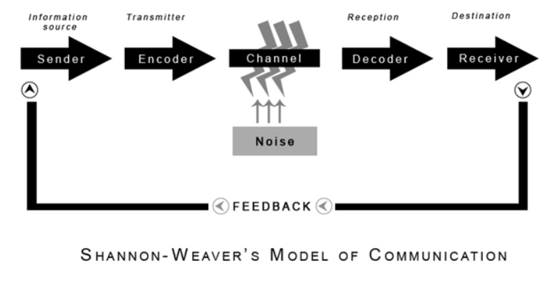
The study case describes that Maria transmitted the message to Pedro, but it got distorted because of the noise of the building site. Maria is the sender and Pedro is the receiver. Pedro heard word ‘kitchen’ instead of ‘chicken’. It was recommended to stay curious and ask questions. In case of Maria, she could have been waiting for feedback to conclude that message was understood by Pedro. On the other hand, Pedro could take in consideration the noise. He could have said what he understood or asked questions that would be the feedback and, Maria would have repeated her message to avoid confusion.
A similar example from my friend’s workplace, where the manager calls the employers every morning for a brief meeting to give instruction. Most of the employers are foreigners from different countries with different accents, including the manager. Manager speaks very quiet and sometimes can be unclear in instructions because of his strong accent. While he was talking about two different projects with a similar name, others mistakenly understood the named project with others project’ name deadline. Everyone got the instruction and did the work accordingly. Because of that it raised some complaints regarding the deadlines from the clients that were confused. Towards the end of the day somebody asked the manager about the conflicts with the clients, problem was mitigated after manager heard the wrong project name and gave the staff the correct information related to the deadlines. But this confusion could have been avoided, if during the morning meeting somebody would have asked back to confirm. As well the manager could have used written instruction as well to the employees or have spoked clearer.

2.2 Schramm (1954)
Another common model used to describe communication process is model proposed by Wilbur Schramm (Schramm, 1954). This model views the use of message of communication between sender and receiver only if it is expressed clearly in words and communicated to the receiver. Encoding is very important because it is the first step in communication, converting thoughts into content. It is the responsibility of the person receiving the information to decode ad understand what the speaker is trying to communicate. If the person receiving the information cannot understand the message, it is of no use. Thus, encoding and decoding are two of the most important factors for an effective communication. Without them, information would never be able to transit between two individuals. It also bases the process on the feedback from receiver. The message is considered incomplete until the feedback is received, as Schramm suggested that communication is a two-way process, otherwise how to understand whether communication is complete or not.
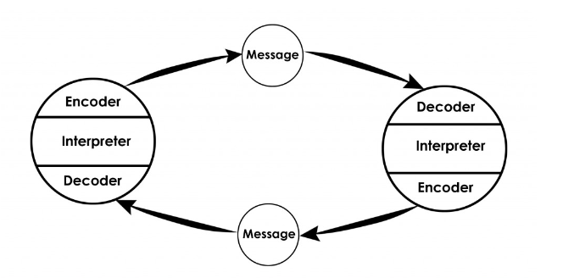
Using Schramm model to evaluate Maria and Pedro’s case, Pedro who is the receiver was responsible to ensure that message from sender was understood. Maria needed to wait for the message from Pedro to close the loop. Because he heard the noise from the building site, he could take some actions to emphasise the understanding. He should have asked Maria back if she really meant word kitchen. She would have received the feedback from Pedro and would intend to initiate another clearer message that would have an increased chance for him to understand it.
In the case from my friend’s workplace, when the manager mistakenly confused the projects name, he could have waited for everyone to respond back to him with a question or confirmation before ending the meeting. The staff should have asked back if he really mentioned that project, ask details about the second one or request an email to confirm the information. This would have made the manager to repeat the name of the project he intended to or to try to write it on the table, so it would not get confused with the other with the similar name.
2.3 Berlo’s SMCR model
David Berlo’s SMCR model (Berlo, 1960) has similar aspect as the previous ones, nut instead it represents the communication process in a linear form. The model views the process of communication with four stages: sender, message, channel, and receiver. While in the Shannon and Weaver and Schramm models represent the feedback as the sign that the receiver got the message, the Berlo’s model argued that the receiver is the last step that determines the meaning of the information received. The sender is the source who start the communication process, creates, encodes the message, chooses the channel, and sends the message. The communication channel may include hearing, sight, touching, smelling, and tasting. It assumes to use both types of communication – verbal and non-verbal.
Communication skills such as reading, listening, writing, and speaking are the factors that can influence the source. Reading and listening are important skills that are an essential set for a good communicator. It helps to understand others message to reply to their information. In addition, personal qualities and social-cultural environment are considered which may influence the participants such as attitude, knowledge, cultural and social system, and the content. An important aspect is language barrier that might occur between sender and the receiver.
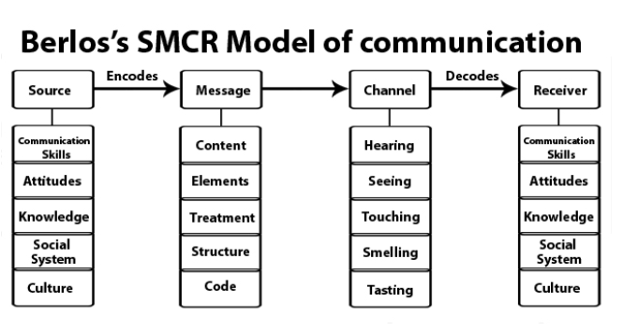
The case study describes a professor with a well-known reputation and many years of experience in high-ranking universities. He is invited to present lecture in front of an audience, but his strong accent enables the audients to understand the discussed material partially. The lecture remained misunderstood and disappoints the students. The sender is the professors who encodes through his voice the message which if the lecture. His channel of communication are the sound waves. Decoders are the ears and minds of the students, and the receivers are the students. The noise and the factors that influenced the participants and the poor understanding of the lecture was the lecturer’s accent. He could have prepared in advance a power point presentation with notes to be used during the lecture. It would have helped to avoid or decrease the level of dissatisfaction of his fellow students.
- Communication skills
Communication is about more than just exchanging information between two people or groups. It involves understanding the needs and objectives of the other party and making sure that the message is clear and concise. Communication takes a lot of effort. Gestures, tone of voice, body language, and spoken language are some of the important aspects of communication, so if the other person is unable to understand any of these factors, the process fails.
3.1 Verbal communication
Verbal communication the most understood mean of communication and the most useful instrument using the words for sharing the information between individuals. It is estimated that on average a person uses about 30,000 words daily to speak (Mehrabian, 2021). Verbal communication cand be defined as an activity of sharing information using languages and words through speaking to communicate, listening and reading are primarily the skills to understand and process the information then respond to it, and writing to deliver it on paper or digitally. The verbal communication also includes the speed of the voice, pronunciation, and grammar. A strong communication skill is a combination of skills, abilities and knowledge that influence ideas of the sender and perception of the receiver.
  - Non-Verbal communication
Non-verbal communication is the instrument that can emphasise the emotions and understanding of the message, but also can break it. It includes the gestures, body language, and mimics. Sometimes bogy language or face expressions can help to identify whether a person is telling the truth or not. Facial expression can help to find the emotional state of the person. These can show if the person feels uncomfortable to discuss specific topic, makes it nervous, or is happy.
Gestures can help to engage the listeners and make the message stronger. Sign language is one of the oldest ways to communicate and understand each other. But one must consider the socio-culture difference in ways of gestures, as in some countries moving nodding the head means an agreement whereas in countries such as Greece, Cyprus, Iran, Turkey, Bulgaria nodding represents a disagreement (Kubilius, 2019).
Proximity also sends a non-verbal message. When somebody is imposing and leaves a very small distance between the other person, it might be seen as a threat, whereas giving too much space might sent a sign that person is feeling awkward.

  - Active listening
Active listening is a key skill for effective communication, building strong professional relationships, and increasing productivity, trust, and reduce mistakes. Continuous improvement of the listening skill can influence the lifestyle and emphasise the ability to focus and gather all the information before making conclusions, decisions or giving feedback. The active listener is also about maintaining the eye contact. The conversation feels ignored if the listener does not engage his eyes.
The important key to a good conversation is asking questions. Listening actively also include responding to the message or asking questions and listening to carefully the answers to them. Another suggested idea is to mirror the speaker. When trying to repeat or paraphrase the speaker, it allows to build a connection between participants and ensure that any misunderstandings will be corrected (Rogers & Farson, 1957).

- THE ADVANTAGES and DISADVANTAGES of TECHNOLOGY in communication
The communication technologies are the electronic systems that are used as means of communication between individuals of groups. They are used to deliver the lectures and tutorials, engage with colleagues and clients at work, communicate with friends and family. Such means of communication includes telephones, radio, broadcasting, emails, videos etc.
Communication technology made the communication process easier and more efficient. It made people to be able to connect to each other from different location. Long Distance communication is easier, quicker and at a reduced cost. Technologies ensure the fastest method of communication during the emergencies. The emails and other communications can be saved using databases and inexpensive storage and can be accessed when needed in the future.
However, there are many advantages of using technologies, there are still disadvantages. Unfortunately, the older generation find harder the use of technologies. The communication made be less personal and risky with the increasing level of cyber attacks and phishing. The technologies are not always reliable, due to the weather or other circumstances the connections might get lost. The constant use of the devices, it creates a habit of checking the email and other social media which makes harder to keep an active conversation face-to-face.
- Conclusion
The study showed that three models of communication are effective ways to delegate and structure the communication in any environment. Often the receiver can get the message to exactly how sender intended to. There are many communication barriers that can occur at any level of the communication process, such as emotional barriers, lack of attention, differences in perception and point of view, physical disabilities, different languages and accents, and cultural differences. It is therefore important for the communicator to seek feedback to ensure that their message is being understood clearly. To ensure the success of proper communication, both verbal and non-verbal speaking and listening should be effective. It can facilitate an engaging work environment requires the active communication between the superiors and juniors. The company benefits from having different perspective from the employees, therefore strong communication skills are one of the essential skills an employer could seek in the applicants. Communication is the safest way to identify the issues, discover the opportunities, analyse the facts and make decisions that will only profit the company.

References
Berlo, D. K. (1960). The process of communication : an introduction to theory and practice. Holt, Rinehart And Winston.
britannica. (2022). Communication. Retrieved from https://kids.britannica.com/: https://kids.britannica.com/students/article/communication/273754
Kubilius, K. (2019, August 19). Nonverbal Communication: Yes and No in Bulgaria. Retrieved from https://www.thoughtco.com/: https://www.thoughtco.com/nodding-yes-and-no-in-bulgaria-1501211
Mehrabian, A. (2021). Attitudes inferred from non-immediacy of verbal communications. Journal of Verbal Learning and Verbal Behavior, 294–295.
Page, M. (2022). The importance of good communication in the workplace. Retrieved from michaelpage.co.uk: https://www.michaelpage.co.uk/advice/management-advice/development-and-retention/importance-good-communication-workplace
Rogers, C. R., & Farson, R. E. (1957). Active Listening. Chicago.
Schannon, C., & Weaver, W. (1948). Mathematische Grundlagen der Informationstheorie. München: R. Oldenbourg Verlag.
Schramm, W. (1954). Schramm model of communication. Westport Greenwood P.

