Canolfan Gwili Centre
INTRODUCTION
This report has been prepared to assess the critical resources required for the successful execution of the Canolfan Gwili Community Centre project in Hendy, Carmarthenshire, South Wales. The project entails constructing a multi-functional community centre equipped with an activity hall with advanced audio and lighting systems, two conference rooms, and a café.
The report aims to Identify and evaluate key resources essential to the project, discuss methods for monitoring and controlling project resources, address challenges associated with any delays the project incurs, and recommend practical solutions to manage such delays effectively.
By analysing the critical components of resource management and delay mitigation, this report provides insights into ensuring timely project completion while maintaining high standards of quality and efficiency
RESOURCES
The successful completion of the Canolfan Gwili Community Centre project requires careful planning and management of various resources. These include human resources like skilled labour, for example brick layers, knowledgeable ground workers, skilled carpenters etc. all the labour needs to be carefully selected to ensure the project gets executed to plan, only workers with experience in these types of projects should be selected, to ensure less unforeseen issues and a high standard of work. Also a comprehensive project management team is absolutely essential to a project of this nature, a dedicated team oversees multiple aspects of the job such as planning, scheduling, resource allocation, costs, coordination of subcontractors and coordination with the client and councils. A good management team will have a huge influence on the workers attitudes when coming to work on this site, they have to be easy to communicate with, a good knowledge of what they are building, but at the same time a demanding and perfectionist attitude towards hitting goals and deadlines.
Also resources like materials are obviously essential to a construction project, steel poured concrete and concrete blocks will form the frames and main structure of the building, it is important we source sustainable materials for the project like sustainably sourced timber, recycled plastics and metals for aspects like windows and cladding potentially. This is important as the client would want us as the contractor to demonstrate how this project will be progressive and sustainable in how it was constructed. It is important trades like plumber and electricians are cautious when carrying out jobs like first fixing not to waste too much material, wastage can be a big cost to the builder and could potentially effect the whole projects budget. This can be mitigated by having a competent management team that order the correct materials and ensure quantities are as close as possible.
Recourses such as equipment and machinery are just as essential, like cranes and excavators for moving materials, it is important these aspects of the job are managed and monitored, it would be impractical to have machines too big or too small for the job, for example a 200 ton mobile crane wouldn’t be needed to lift in a steel frame for this project, it could cause logistical issues like access, and cost a fortune. Also you wouldn’t want an excavator too small to dig deep enough for the footings, or move boulders in the ground. This would all add lots of undesired delays in the project as time and money are both resources related to the project.
Monitoring and controlling resources to ensure the project stays on track, a robust monitoring and control system must be implemented. Key strategies include utilizing software like Microsoft Project allows the team to track progress against the project schedule, allocate resources efficiently and monitor costs and identify potential overruns early. Alongside software like Microsoft Project paired with strategies like regular site meetings and reporting, can ensure all the team and subcontractors are working together and help workers understand exactly their aim. Weekly site meetings allow team members to review progress, address challenges, and adjust plans as needed as it gives all people involved to communicate. Also Daily reports track key performance indicators (KPIs) like work completed, materials used, and issues encountered, this helps keep all the team involved in what’s happening on site without spending too much time in the building.
Taking advantage of resources like the approved document list on GOV.UK or the NHBC Portal which would answer any questions the team or any of the workers would have in regards to building regulations and building standards if there were to be any uncertainties, it could be detrimental to the site if an aspect was installed incorrectly, subsequently having to be ripped out and re constructed, potentially causing delays to the project.
DELAY
It is essential that if a delay would to arise, which unfortunately they often do, it is imperative that it is managed and resolved quickly and efficiently, to minimise any subsequent effects on farther activities down the line. In this particular circumstance, as see In “Figure 1” below the crane was delayed a total of 9 days, causing a domino effect of major delay throughout the project. The cause of this delay was weather, on the 9th of July 2025 the crane was scheduled to arrive to install the steel frame to the multi-function hall however, strong winds have been forecast for the next 2 days so the crane could not arrive on site, in fear that the contractor would have to pay for it, while it sat there doing nothing as cranes are not allowed to operate In high winds. Unfortunately this crane company had other jobs to attend to following this particular frame install and was booked up for another 7 working days causing a total delay of this job of 9 days.
As you can see from figure 2, this delay was exaggerated by knock on effect throughout the job and ended up putting a total of nearly 3 months on the job. Provisionally estimated to finish the week before Christmas, any delay was made worse by having to leave site over the Christmas break for nearly 2 weeks.
How can we claw back delay?
The project timeline was re-evaluated, and tasks not dependent on the steel frame were accelerated. For instance, block work and brickworks activities were prioritised, Non-construction tasks, such as procurement of advanced equipment and interior design planning, were expedited to make productive use of the delay period. You could also ask contractors to come in on weekends and work Saturdays, however there is an extra cost associated with this. Efforts were made to identify alternate crane providers to minimize dependency on a single source. While the crane was unavailable, discussions with multiple providers helped secure a backup option for future tasks. For future lifts on site reliance on detailed weather forecasts helped plan lifting activities for periods of stable weather. Wind speed thresholds for safe crane operation were integrated into the scheduling software.
Lightening the blow of delays is also possible by the use of contingency days built into the project schedule allowed for some flexibility in accommodating the delay without impacting the overall completion date.

FIGURE 1

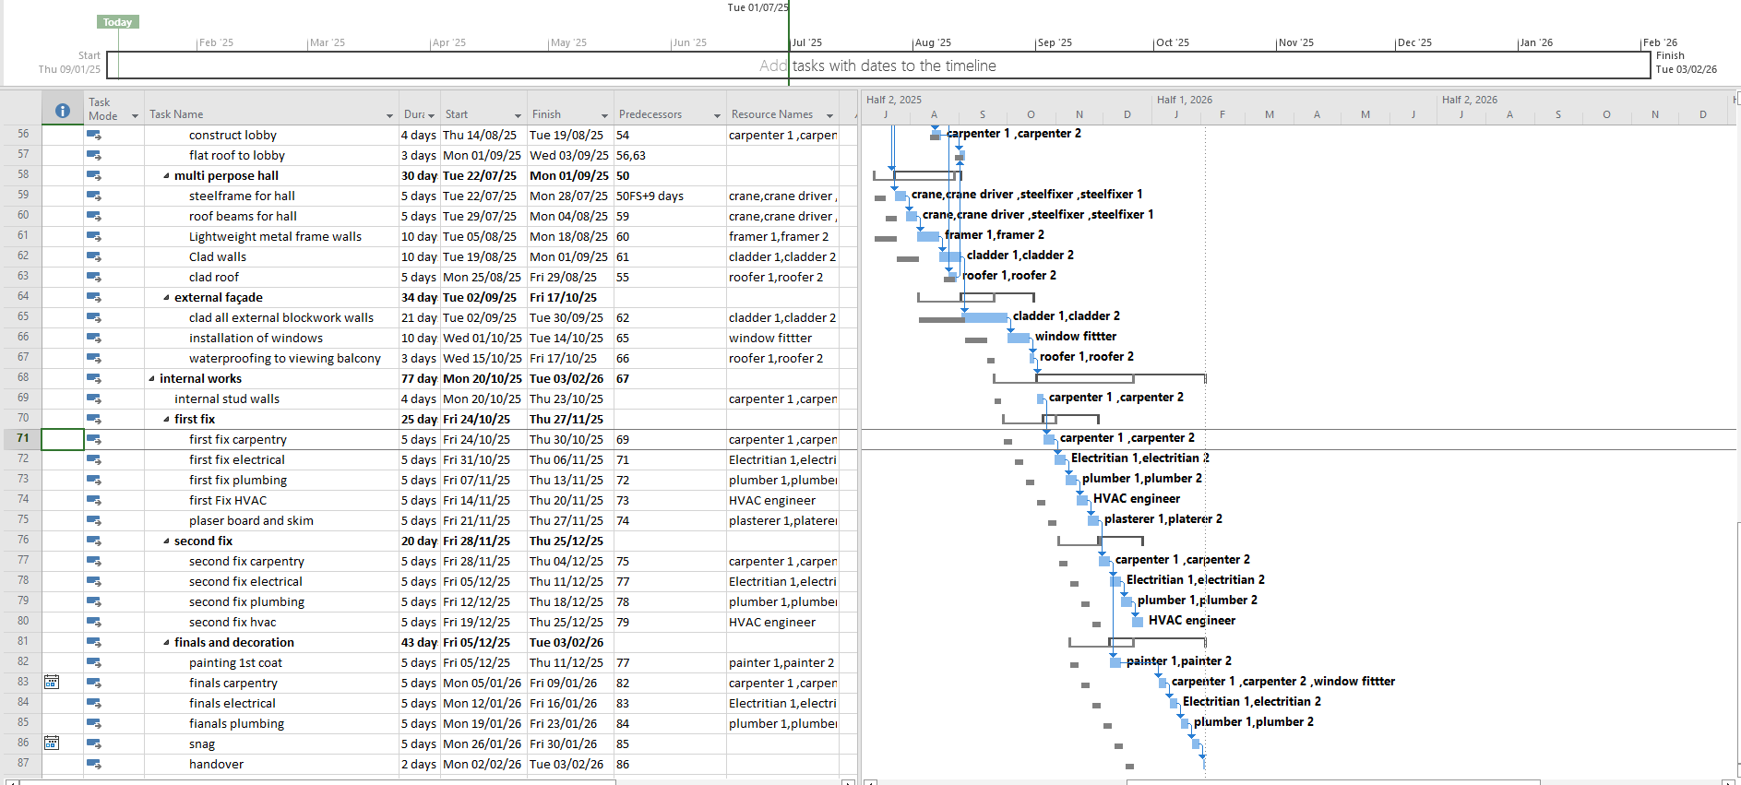
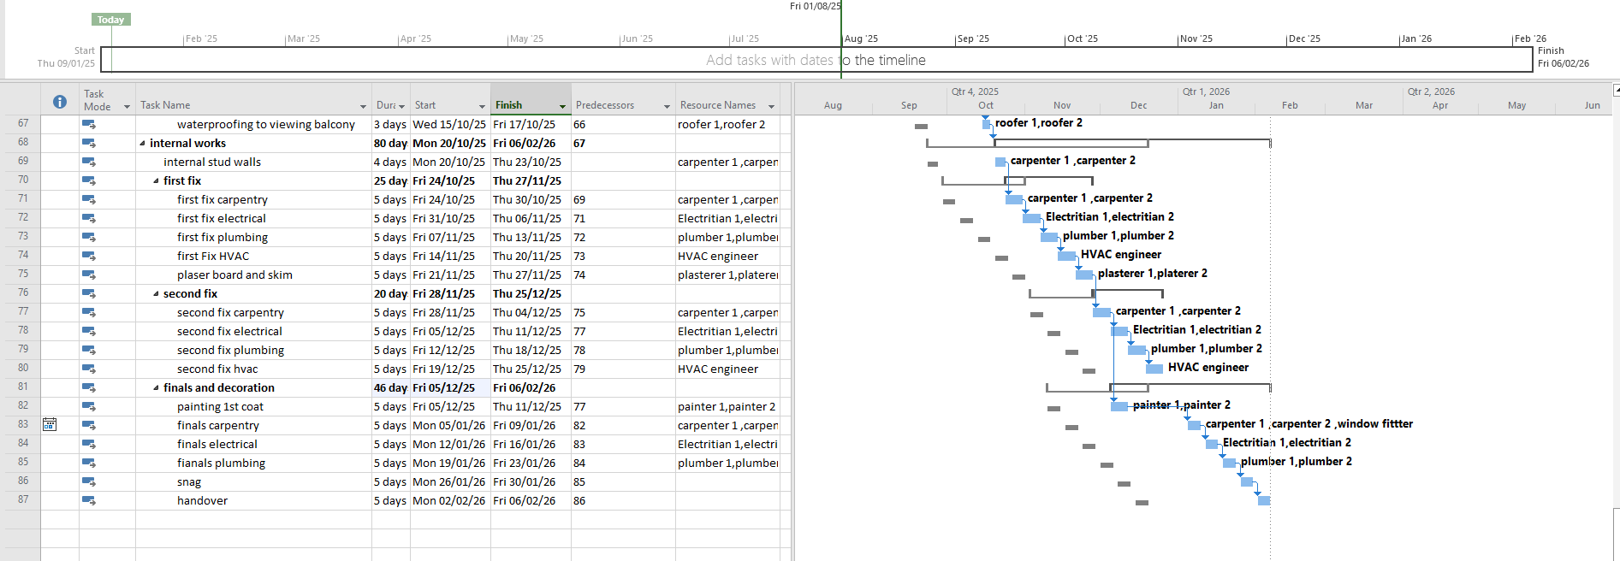
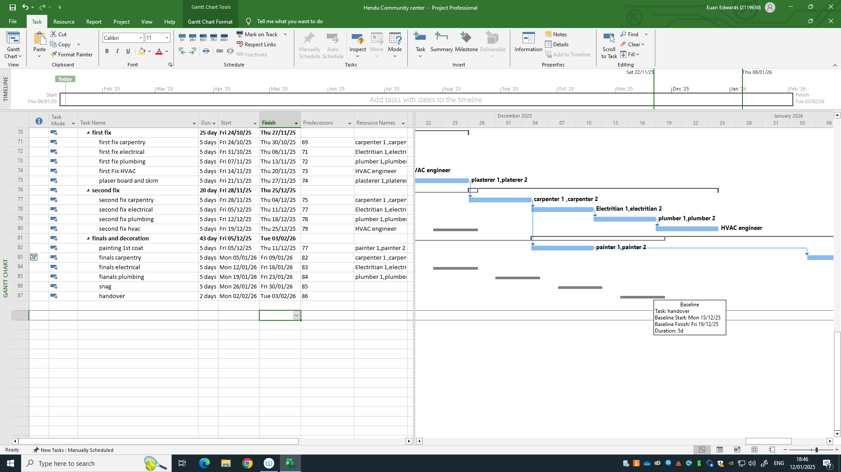

FIGURE 2

