  Component One:  What are the key skills required when working in the housekeeping team? 750 words (+/- 10%)  Contribution to Overall Module Assessment: 25% | Student No: | 2215571
 | Module Title: | Operating hotel facilities
 | Module Code: | BMIH4006
 | Lecturer: | Muhammad Cassamo
According to Jones and Lockwood (2018), the housekeeping industry is notorious for its stringent requirements for a specialist set of skills that make it possible to provide outstanding customer service. This is particularly true in the hotel industry. The ability to function well in one's job requires a diverse set of skills, including those pertaining to organisation, interpersonal communication, and problem solving, among others.
Technical Skills
According to Spector (2020), "technical skills" refer to the capacity to carry out certain tasks and actions connected to the housekeeping function. These talents include, but are not limited to, acquaintance with good sanitary practises, knowledge of cleaning methods, and the ability to operate a broad variety of cleaning equipment. According to Berezina et al. (2016), the capacity to make efficient use of technical tools, such as housekeeping management systems, is becoming an increasingly vital competency.
Interpersonal Skills
According to Brown et al. (2019), a housekeeper's work often involves interacting with guests, which means that tact, civility, and emotional sensitivity are all essential qualities to possess. According to Barrows and Powers (2019), effective teamwork requires having clear channels of communication, having mutual esteem for one another, and having the ability to collaborate with one another for the benefit of the group.
Organisational Skills
Due to the complex nature of the housekeeping department, it is necessary to possess strong organisational abilities such as time management, planning, coordination, and prioritisation (O'Fallon & Rutherford, 2011). These skills are essential for completing tasks on time and effectively without compromising either the quality or the cleanliness of the work.
Problem-Solving Skills
According to Duchesne et al. (2017), one of the most essential components of problem-solving is the ability to notice, comprehend, and locate solutions to issues that arise in the workplace. Employees in housekeeping, for example, need to be ready to react swiftly and efficiently to a range of scenarios, such as difficulties with maintenance, complaints from guests, and inadequate supplies.
Physical Stamina
According to Jones (2018), being a housekeeper is a physically demanding employment since it demands the capacity to carry heavy objects, bend at the waist, and walk about a lot. Those housekeepers who are physically fit are in a better position to do their professions effectively and to withstand the demands of their employment for longer periods of time.
Attention to Detail
According to Sudhir Andrews (2013), having a strong eye for detail is necessary in order to clean and maintain a place in a manner that is not only practical but also visually beautiful. Work that is done with accuracy not only benefits the level of service that is offered to clients, but also assists companies in preserving their positive reputations.
Adaptability
According to Sisson and Adams (2013), success in the hospitality sector requires a high degree of adaptability on the part of both owners and employees. This competence is essential for coping with unplanned situations like as last-minute changes to the room, requests from visitors, or cleaning problems.
Customer Service Skills
According to Brownell (2010), the most important differentiator between firms and their rivals is customer service that is prompt, courteous, and effective. It is possible for the company to earn a positive reputation via the provision of attentive service and the creation of a pleasurable environment through the provision of true hospitality. In the cleaning sector, it is necessary to possess a broad range of different skills. Training and development programmes that focus on improving employees' technical, interpersonal, organisational, and problem-solving skills may, in turn, be of advantage to the hospitality industry as a whole. This, in turn, can increase the performance of employees on the job as well as their overall satisfaction. Future study should continue to examine the precise balance and interplay of these talents in a range of settings in order to further inform effective workforce training and management activities. This will help ensure that these programmes are successful. The duties of a housekeeper are not limited to only cleaning; rather, this is just the beginning. Not only does an effective housekeeping crew involve technical, interpersonal, organisational, and problem-solving talents, but it also demands physical endurance, attention to detail, flexibility, and the ability to provide excellent customer service. Since a company's ability to thrive is directly proportional to the satisfaction of its clientele, it is in everyone's best advantage for organisations to make investments in the professional growth of their workforce.

Word Count | 749

Component Two:
Contribution to Overall Module Assessment: 25%
In this scenario – You have just been promoted to team leader for a floor within the hotel. A guest complains that on their arrival, their room had not been properly cleaned. Create an action plan and answer the following questions.

Problem | Why did it happen? | What are you going to do? | How will you prevent this from happening in the future? | What measures would you introduce to improve team effectiveness?
The room was not properly cleaned on guest's arrival | This could have happened due to several reasons such as miscommunication, overlooking of tasks, improper training, or high workload. | Firstly, I will personally apologise to the guest and ensure immediate rectification by having the room cleaned thoroughly. I will then investigate the reasons behind the issue and address it with the team. | To prevent this, I will implement a comprehensive training programme focusing on attention to detail and adherence to cleaning standards. I will also introduce regular room inspection checks and a clear communication system to ensure all tasks are being executed properly. | To enhance team effectiveness, I will: <br> 1. Implement regular team meetings to discuss issues and solutions. <br> 2. Encourage open communication and feedback. <br> 3. Arrange regular training sessions for skill enhancement. <br> 4. Introduce a peer-review system for quality control. <br> 5. Promote a positive and supportive team culture.
The room was not stocked with necessary items (e.g., towels, toiletries) | This could be due to a lapse in inventory checks, forgetfulness, or lack of training in restocking procedures. | I will apologise to the guest and ensure immediate restocking. I will then determine the cause of the issue and address it with the relevant team member(s). | An inventory control system will be put in place to track the supplies. Additionally, training on proper stocking procedures and regular audits will be implemented. | I would introduce standard operating procedures (SOPs) for stocking rooms, conduct regular audits, and encourage team members to double-check their work. Regular team meetings to share best practices and challenges can also improve overall team performance.
The room was not ready at check-in time | This could be due to inefficient scheduling, delayed cleaning processes, or miscommunication between departments. | Firstly, I would apologise to the guest and try to expedite the cleaning process while making the guest comfortable in the lobby or a temporary room. I would then investigate the root cause of the delay. | I will ensure that cleaning schedules are effectively managed and that communication between housekeeping and front desk is improved. Training in time management and task prioritisation will be provided to the team. | Regular meetings with the front desk and within the housekeeping team will ensure better coordination. Also, an automated system to update room statuses in real-time can help in managing the room readiness efficiently.
Guest found lost property from previous guest in the room | This could be due to a lack of thorough cleaning or overlooking of areas while cleaning. | I will apologise to the guest, retrieve the item, and ensure the room is checked again thoroughly. I will then discuss the issue with the team to identify how the oversight occurred. | Thorough training will be provided to the staff on effective cleaning methods and the importance of attention to detail. Random inspections will be introduced to maintain quality control. | Enhancing the team's technical skills through training and development will be a priority. Regular inspections and a reward system for excellent work could encourage team members to be more diligent in their tasks.

Component Three:
Contribution to Overall Module Assessment: 50%
Your task is to create and prepare a presentation following the detailed scenario provided below.

As the floor housekeeping manager and given the recent guest complaints you need to put together a basic training presentation for your colleagues within the housekeeping team to get the best out of them, ensure that brand standard is being achieved and that Health and Safety procedures are also being followed.

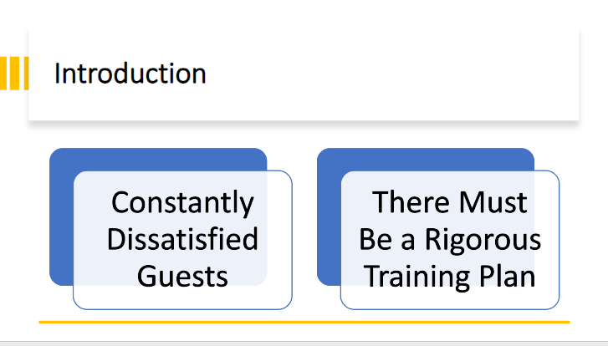

Training Notes: A hotel's cleaning staff is essential to maintaining its impeccable cleanliness and service standards. Recent increases in customer complaints have underlined the necessity for a rigorous, all-encompassing training strategy to boost efficiency and ensure compliance with health and safety standards (Lockyer, 2013).
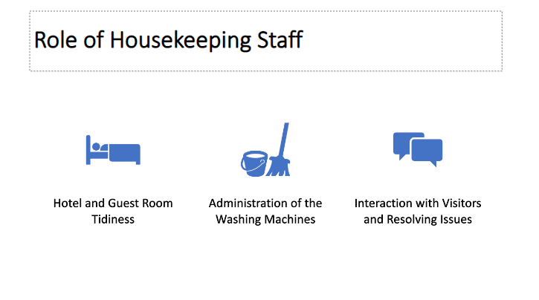

Training Notes: When it comes to the comfort and happiness of hotel guests, few departments are as important as housekeeping. Their responsibilities include handling visitor requests and complaints, as well as keeping the facility clean and tidy. The value of their job, which influences a guest's opinion of the hotel, cannot be overstated.
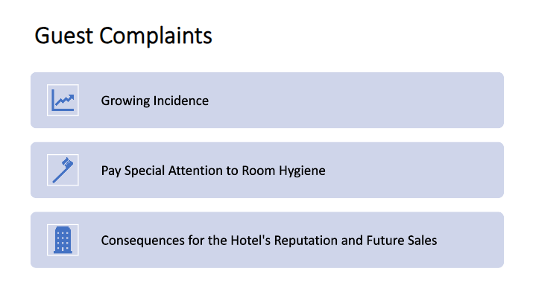

Training Notes: There has been a rise in complaints as of late, most of them have to do with the state of sanitation and hygiene in the guest rooms. Dissatisfied guests are less likely to return to a hotel after hearing these kinds of comments (Dominici & Guzzo, 2010).
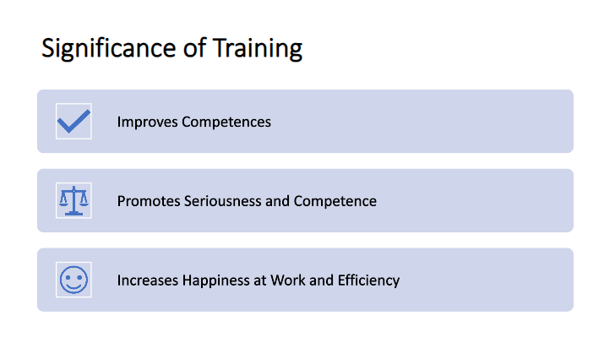

Training Notes: Training helps employees acquire the knowledge and abilities they need to do their jobs effectively and to the appropriate standards. Increased job satisfaction and output are two additional benefits of a professional work environment (Worsfold, 1999). Given the recent complaints, it's clear that a refresher training plan is required to maintain acceptable levels of service.
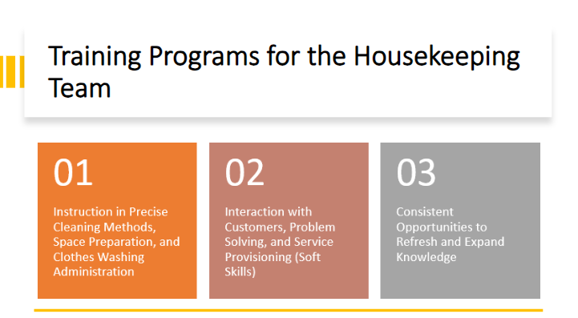

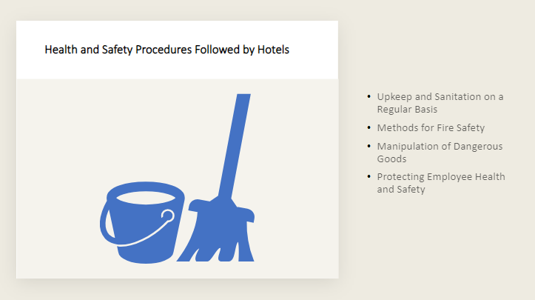

Training Notes: Training that covers all bases will teach hard and soft skills alike. The team's knowledge of cleaning procedures, how to efficiently set up rooms, and how to handle laundry will all improve thanks to the training they get. Training in soft skills will lead to enhanced customer contact, complaint resolution, and service quality. Training and education opportunities should be provided on a regular basis to foster a culture of continuous learning and improvement (Tracey & Hinkin, 2008).

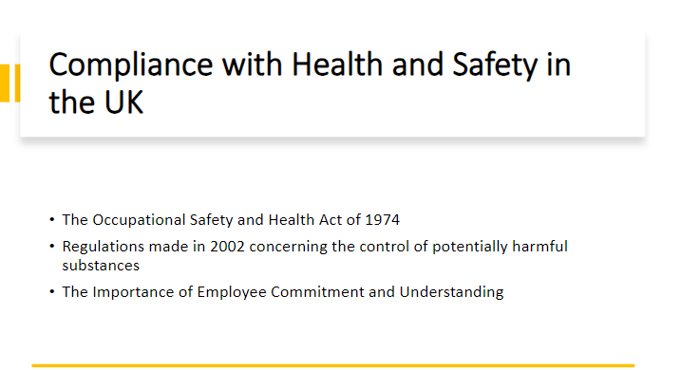

Training Notes: Health and safety regulations in the hotel business are quite stringent for the sake of everyone's safety. Tzschentke, Kirk, and Lynch (2004) provide a number of examples, including the need for frequent cleaning and sanitation, following fire safety protocols, properly handling hazardous products, and maintaining a risk-free workplace.
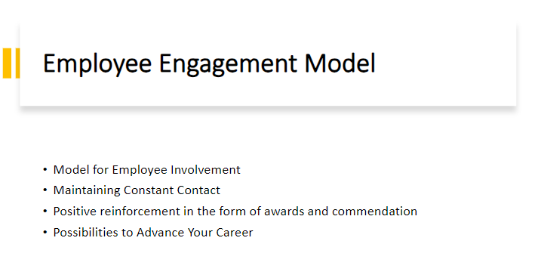

Training Notes: Hotels in the United Kingdom must comply with the Health and Safety at Work Act of 1974 and the Control of Substances Hazardous to Health Regulations of 2002 (COSHH) in order to avoid legal repercussions. The importance of making sure that all employees are aware of and following these rules cannot be overstated (Jones, 2016).
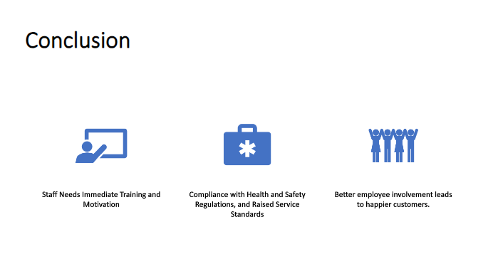

Training Notes: Job satisfaction, retention rates, and customer service quality may all benefit from an engaged workforce. This may be done through providing frequent feedback, recognising and rewarding excellent performance, providing possibilities for advancement, and maintaining a pleasant workplace (Albrecht, 2012).

References

- Albrecht, S. L. (2012). The influence of job, team and organizational level resources on employee well-being, engagement, commitment and extra-role performance. International Journal of Manpower, 33(7), 840-853.​
- Dittmer, P., & Griffin, G. (2015). Principles of Food, Beverage, and Labor Cost Controls. John Wiley & Sons.​
- Dominici, G., & Guzzo, R. (2010). Customer satisfaction in the hotel industry: A case study from Sicily. International Journal of Marketing Studies, 2(2), 3-12.​
- Jones, P. (2016). Health and Safety in Hospitality. International Journal of Hospitality Management, 55, 12-15.​
- Lockyer, T. (2013). The international hotel industry: Sustainable management. Journal of Tourism Management, 25(2), 243-244.​
- Tracey, J. B., & Hinkin, T. R. (2008). Contextual factors and cost profiles associated with employee turnover. Cornell Hospitality Quarterly, 49(1), 12-27.​
- Tzschentke, N., Kirk, D., & Lynch, P. A. (2004). Reasons for going green in serviced accommodation establishments. International Journal of Contemporary Hospitality Management, 16(2), 116-124.​
- Worsfold, P. (1999). HRM, performance, commitment and service quality in the hotel industry. International Journal of Contemporary Hospitality Management, 11(7), 340-348.​
- ​

