Juliette Turpin - 2205952
Coexistent Perspectives (ADCD7001)
MA Contemporary Dialogues: Illustration

Word Count: 3944

De/Constructing the Human: Self, Identity and Other
The influence of TikTok aesthetics on modern day women

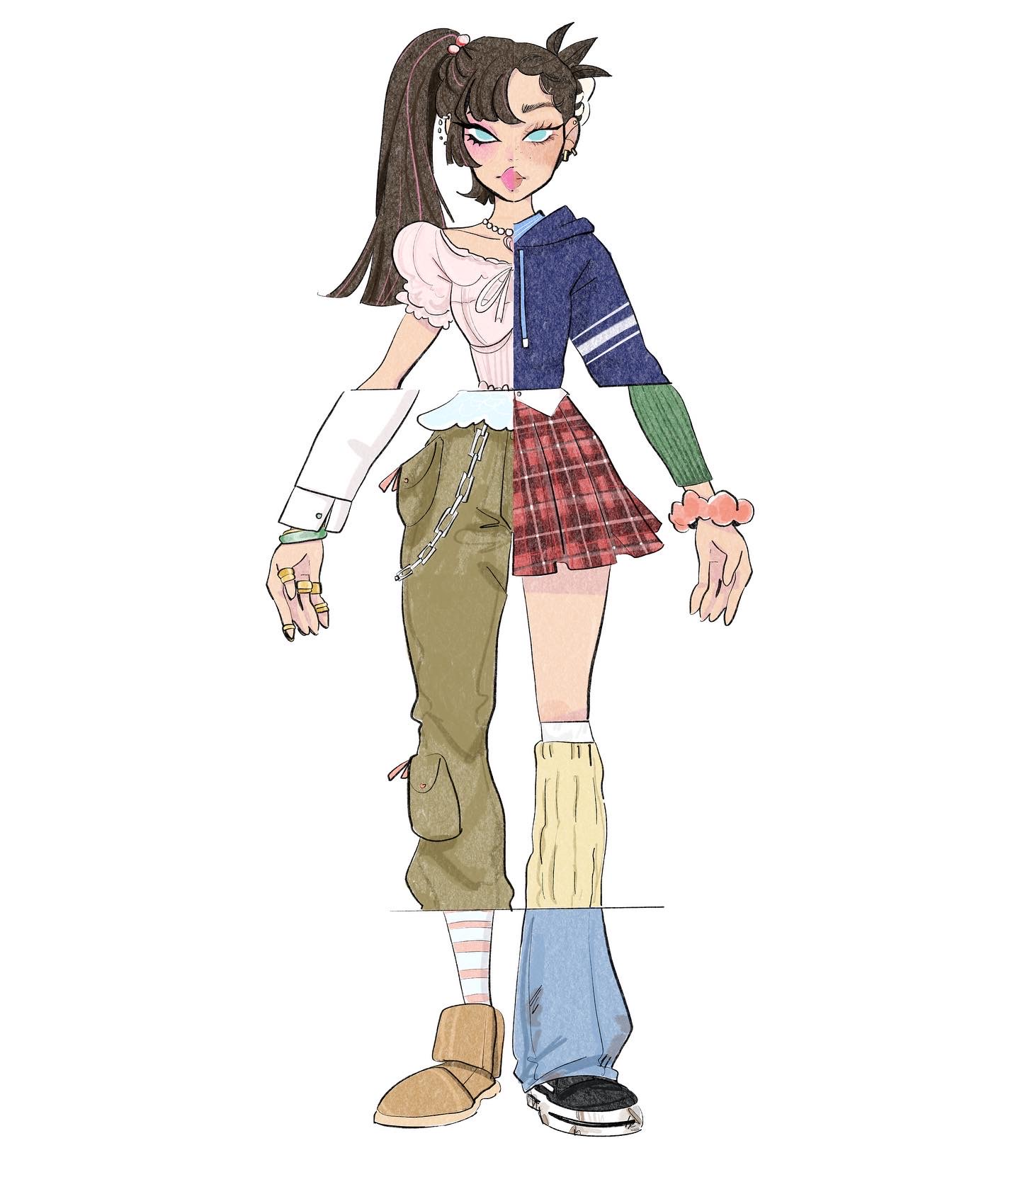

Poster illustration I created for my presentation on 9.12.2022

Introduction

There has been a rapid rise with labelling for the last couple of years. The obsession with feeling the need to identify yourself in a certain category in order to fit in certain groups has become so big, it’s taking over people’s lives. Fitting into a certain aesthetic has become so trend-able that it has exceeded the fashion and beauty industries. Trends have become such a major part of people’s lives that they are extending these aesthetics into changing their houses, their daily routines and their life dynamics, for pursuing the lifestyle they want to lead because they want to live that lifestyle. It’s not just an aesthetic now, it is a way of being. Although its true trends and micro-labels have always existed, the sudden jump in numbers expanded during the pandemic. TikTok became a global success and soon after, ‘cores’ and aesthetics became a bigger deal than they used to be. Strands of aesthetics taken from other styles and new age pop culture kept appearing and continue to be fed into their target audiences.
The French philosophers Deleuze and Guattari used the term ‘arborescent’ in order to characterise a certain type of thinking. It was epitomised by the western scientific model, where knowledge originates from a single stem and ends in predetermined fruits. The concept suggests a linear progress towards the truth, which they condemned as unrealistic and obstructing to the imagination. The term Arborescent is a contrast to the term ‘Rhizomatic’ which means there is no beginning or end. There is no central structure and is constantly changing.
Deleuze and Guattari first used the words ‘rhizome’ and ‘rhizomatic’ in their book A thousand plateaus. They used these words to describe a theory and research that allows for multiple, non-hierarchical entry and exit points in data representation and interpretation. I bring forward these theories as a case and point to back up my main subject that I stated previously, which is that TikTok cores and aesthetics all come from others. An example of an aesthetic splitting into a new one would be ‘surfer girl’. You could take the word and draw a diagram in an arborescent manner to find sub-categories that are mildly related to it. Take a small part of that aesthetic and you suddenly have ‘tomboy’, ‘VSCO girl’, ‘beach girl’, ‘mermaid core’, ‘coconut girl’, ‘island girl/core’ and so on.
Posthumanism has enabled the creation and elaboration of novel concepts such as ‘entanglements’ or ‘trans corporeality,’ thanks to the works of established scholars such as Karen Barad, Donna Haraway, Jane Bennett, and Stacy Alaimo. In this essay, I’m going to talk about the TikTok app and how labelling/micro-labelling has become a worldwide sensation and how women feel the need to identify with an aesthetic in order to fit in.

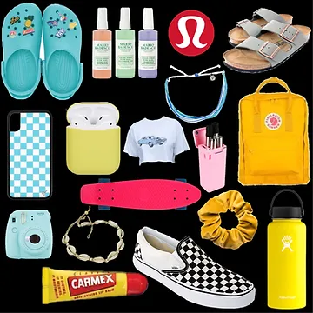

VSCO Girls board
https://www.thebelvederejournal.com/post/why-are-we-obsessed-with-aesthetics#:~:text=We%20have%20become%20so%20brainwashed,characteristics%20like%20smart%20or%20funny

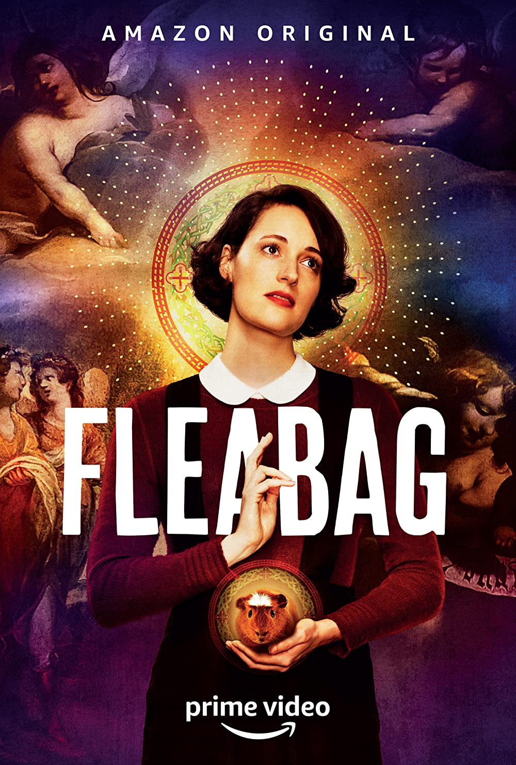

Fleabag TV series poster
https://www.imdb.com/title/tt5687612/?ref_=ttmi_tt
Theoretical research

I’ve been meaning to research TikTok aesthetics and core culture for a while now. These specific styles often appear on my TikTok ‘for you page’ - your feed, what kinds of videos may appeal to you etc. As ridiculous as some may be, deep down I too also wanted to feel included in aesthetic ‘social circles’ that I liked. However, these aesthetics became so hyper-specified that nobody could relate to them and only the person who ‘created them’ could. I chose the theme De/Constructing the human: Self, Identity and Other because I knew it related to my fascination with the obsession of aesthetics. In this essay, I will be discussing my opinions on the subject and investigate the process that goes behind these aesthetics and ‘cores’.

‘As the spectacle increasingly produces new products to maintain our attention, it simultaneously increases the banalization of life, as the limitless choice of equivalent pseudo-necessities becomes meaningless when all of these objects fail to satisfy actual necessity. The relics of the class struggle that persist to the present day are religion and family. These two institutions continue to tout the value of moral-oppression and conservatism as the solution to the spectacular excesses of our contemporary period. The result of economic abundance is both an apathetic smugness and a new spectacular rebellion that presents an image of opposition but cannot exist without the spectacle it opposes. This is because dissatisfaction has become a commodity recreated by the spectacle, as dissatisfaction is the raw material for spectacular society.’

-Guy Debord’s The Society of the Spectacle, 2021, p. 48

In the blog titled Why is our society obsessed with labels?’, blogger Valentina Vucicic states Without a doubt. Labels seem to categorise humans into groups so other people know how to behave towards them. Labelling theory suggests that self-identity and the behaviour of individuals may be determined or influenced by the terms used to describe or classify them. It is associated with the concepts of self-fulfilling prophecy and stereotyping.
Words are born in the vital flowing of thoughts, and, as the organs through which thought secures articulation and definiteness, they are an organic part of the process itself. There are the two sides, the domination of words over the mind, and the indispensable aid which they afford to the mind.

J. E. Creighton in Philosophy as the Art of Affixing Labels, 1920, Vol. 17, No. 9.

According to The Teen Mag, ‘Aestheticism’ was one of the earliest examples of aesthetics. It was an art movement that emerged during the 19th century and was centred around the aesthetic value of music, writing, and other forms of art and their socio-political functions.
Furthermore, essentially removing all rhyme or reason, rules, and regulations from the core of art and replacing it with a carefree spirit of creativity. This resulted in a more introspective style of art, which depicted the artist’s mood at the time without regard for its value or other people’s interpretations. Nowadays, the incorporation of idealistic aesthetics into our daily lives is a way to characteristically experiment and explore the different aspects of our personalities. “Aesthetics takes the idea of personality being an internal characteristic and turns it into a visual display of originality”.

Marxist philosopher Terry Eagleton once said the interpolation of aesthetics into culture is the “sort of subject that embodies all the values the bourgeoisie sought to legitimise.”
Terry Eagleton, as cited in The Teen Magazine, 2022.
To put this in current context, the bourgeois could be compared to those with the gift of beauty, influence, wealth, power, etc.., as the bourgeoisie were known for being upper middle-class people.
Furthermore, “values like autonomy” and “self-regulation” are fetishized as the perfect social model. The lust for beauty leaves behind ancient ethics of self-determination and distinctiveness.
A great amount of feminist criticism has been focused on 18th century philosophy. Many influential works on beauty, pleasure, and taste that were written at that time, and they became foundational texts for contemporary theories.
According to Jean Baudrillard in his book Simulacra and Simulation, we have all become living specimens in the spectral light of ethnology. He adds that the world has become completely catalogued and analysed.
Aesthetics make use of the phrase ‘visual personality’. It provides guidance to young people and what they should prioritise. At present, everyone has the ability to become an influencer, or a self-described influencer and it’s becoming far more difficult for cynics to stop the rapid rise with the obsession of social identity.
‘What’s important to note about the abundance of micro-cores is the greater movement in youth culture towards niche aesthetics and sub-cultures.’ - Marian Park, WGSN Strategist, 2021.

The word ‘Core’ functions as a popular qualifier for an endless number of aesthetic subgenres such as cottage core, fairy core, mermaid core, normcore, angel core and so on. These subgenres have emerged from all over the world and shared on TikTok. These ‘cores’ are all signified by the hashtag exchange of online imagery, music, and most importantly, fashion. Despite the confusing nature, the core terms have remained in the spotlight in mainstream media, with fashion and culture publications attempting their own contributions.
Cottage core, for example, has become fairly recognisable. Associating this term with yourself means you like picnics, dreams of living in a cottage in the countryside, baking all day, growing your own fruits and veg. Simple, yet a cutesy farmer style. On the other hand, ‘normcore’ is a subgenre that fetishises individuality. According to people who associate themselves with this core, the ‘coolest’ people are the ones who have evolved beyond the need to appear distinct and are embracing the universal concept of normalcy. It launched a fashion obsession with all things plain and uncool. Clothing items such as dad hats, mom jeans, crocs and Birkenstocks - items that have been cast as ‘anti-fashion’
Every day, there are more and more niche cores appearing such as cabin core and cottage hardcore.

‘Cores, aesthetics, mood boards, and vibes are all just a result of wanting to look cute on social media.’. - Alexandra Polk, Refinery29 Writer, 2021.

Kevin M. Leander, Sarah K. Burriss, authors of the British Journal of Educational Technology stated ‘The basic idea of the attention economy was that we have experienced a sociocultural shift where there is a vast sur-plus of information, such that getting individuals’ “eyeballs” on one advertisement or another, and keeping them there, is an intensified struggle.’ They hypothesised that there is perhaps an idea that the attention economy was a precursor to mass individualisation, a type of advertising shift deemed necessary within markets where attention is the most prized resource.

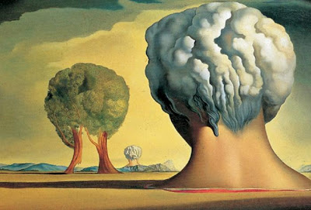

Image taken from Queen Mary University of London
https://www.qmul.ac.uk/sed/english/research/groups/literary_and_cultural_theory/

Case Study 1

The incessant and insane categorization of every single little feeling a human can have as entire personality models is entirely down to content-ifying our lives and the ‘branding’ that individuals build themselves. It all comes down to consumption.

Rayne Fisher- Quann (2022) described in her blog post Internet Princess, how women are basically fed this idea that we need to be sellable/marketable. She stated, “It’s become incredibly common for women online to express identities through an artfully curated list of the things they consume - and because young women are conditioned to believe that their identities are defined almost entirely by their neuroses, these roundups of cultural trends and authors du jour often implicitly serve to chicly signal one’s mental illnesses to the public.” You could be scrolling through TikTok, and you’ll come across a girl who might be a self-described Joan Didion/Eve Babitz/Marlboro Reds/Straight cut Levis/Fleabag girl. This means she has depression and using these terms is her way of coping.
Another will refer to herself as a baby doll/Sylvia Plath/Red Scare/Miu Miu/ Lana Del Rey girl, which is her way of showing she has an eating disorder, an additional yet similar one would be a green juice/Clean Girl/Glass skin/claw clip/Emma Chamberlain/Yoga mat/Podcast girl, which would fall under another form of eating disorder.
Fisher-Quann continues “The aesthetics of consumption have, in turn, become a conduit to make the self-more easily consumable: your existence as a ‘type of girl’ has almost nothing to do with whether you actually read Joan Didion or wear Miu Miu, and everything to do with whether you want to be seen as the type of person who would”. In short, these women feel the need to identify with a certain aesthetic despite not actually being a part of that sub-group because they want to feel included and like the look of the lifestyle without fully taking part in it. People with no established self-identity latch onto TikTok micro labels to feel as if they are included. Fisher-Quann also suggests that we consume so much nowadays that perhaps we don’t know what it means to exist as something sellable.
Why do we hide behind aesthetics and labels? I’m asking myself too because I also want to fit into a certain aesthetic. For a long time, I’ve struggled with how I want people to perceive me. What category do I fit in etc. Social media requires us to distil ourselves down to an online product, leaning into forced self-branding.
TikTok vice president of global business solutions, Blake Chanlee, who is also head of ad sales has mentioned how the service and its many tools managed to keep more than 100 million users engaged during lockdown. The platform was designed to ‘inspire creativity and spark joy’ according to Chanlee. TikTok’s popularity exploded during the pandemic. The app became a great way to pass time if there was nothing else to do. It’s curative to boredom; there is always a new challenge or dance routine to learn.
The point I’m trying to make here is people are always looking for the next best thing. We want to feel included. The fear of being left out, abbreviated as FOMO, has been prevalent in our lives for a very long time. The problem with these aesthetics is that they’re catered to a certain audience. A good example is the clean girl aesthetic. While it’s true that anyone can try it, the only ones who go viral are skinny girls with extremely clear skin. This pushes the idea that ‘clean’ girls are physically fit and healthy. Someone could have the clothes and the lifestyle of a ‘clean girl’ but if they suffer from skin conditions like acne or eczema for example, they automatically aren’t classed in that category, because acne is seen as a negative and dirty thing, thus destroying that clean girl image they want to portray.
There is a popular TikTok sound bite - background music or voice for you to add in a video - that was made to be used in tutorials to achieve the clean girl aesthetic look. It goes:

‘You know those girls that always look clean? Their skin is always glowing, their lips are always glossed, and they never ever look like they’re wearing too much makeup? You may not be them, but here’s how to get their look’.

Original sound is by TikTok user @ xolizahbeauty, 2021.

‘You may not be them’ is what stands out the most. It reinforces the idea that not anyone can be a clean girl. It’s how you want people to perceive you. Selling a false narrative in order to feel accepted and to fit in somewhere you desire. The creator of that sound responded to a comment calling it backhanded. She said `Not even a little bit. This was my script. No one is a clean girl. It’s a label. Labels aren’t real. Get a life’. As right as she is, saying ‘you may not be them’ can make someone feel even more insecure about the way they look. They can either stick with it or decide that this aesthetic isn’t for them, or they aren’t good enough for it thus gradually moving onto the ‘fleabag’ aesthetic. A look that tells people you don't care about your appearance, you’re casual and aloof. Fleabag is objectively the counterpart to clean girl. It has other subcategories such as ‘Gross girl’, ‘That Girl’, and ‘Goblin Girl’. They all mean the same thing, but it all reverts to wanting to feel unique, while in a particular group. Fitting in but also not wanting to fit in.

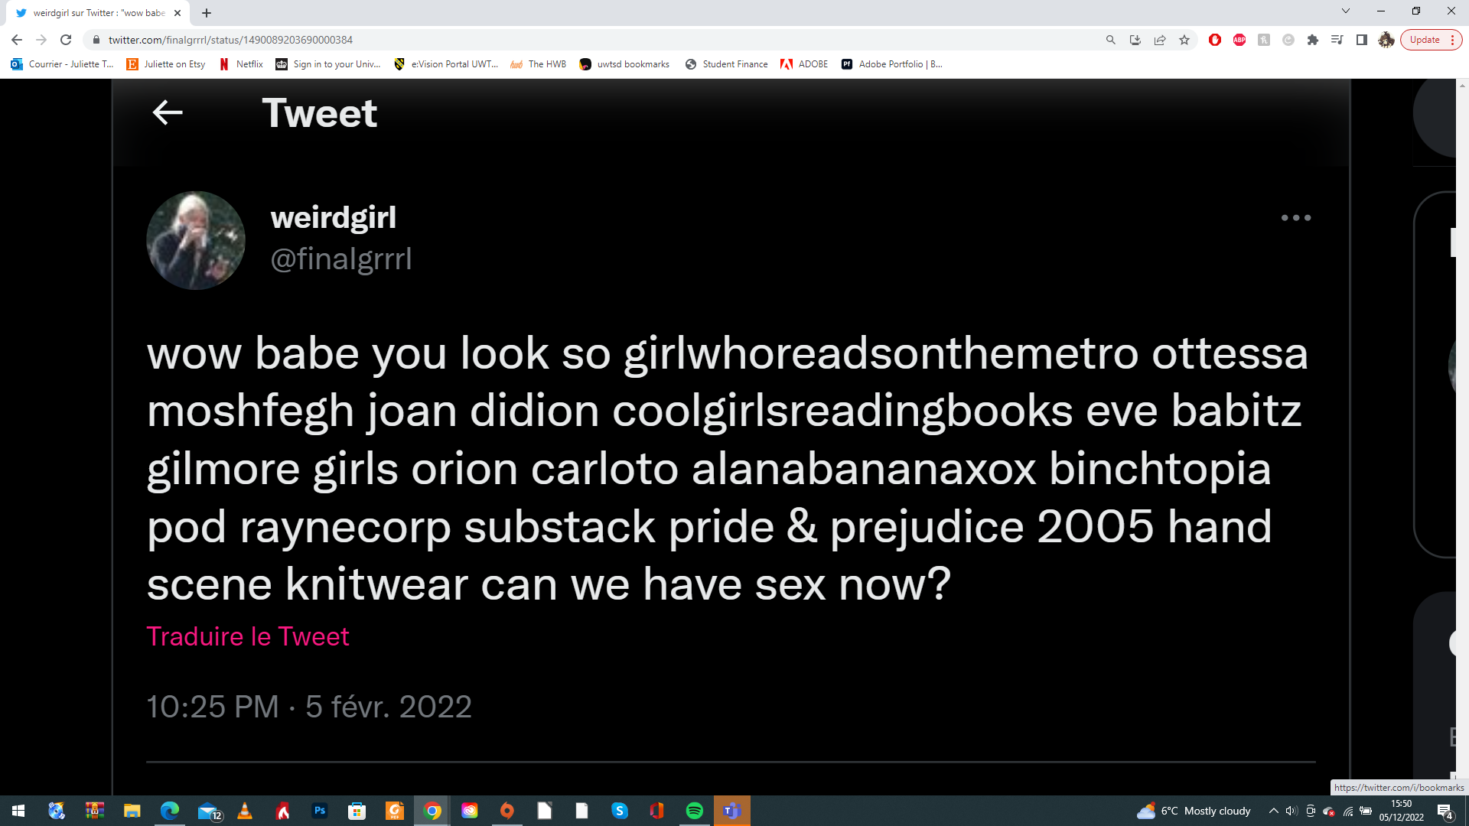

Screenshot taken on @ finalgrrrl on Twitter found here https://twitter.com/finaIgrrrI/status/1490089203690000384

Case study 2

This is a list with a few examples of the current most popular online personas.
- Coquette
- Clean Girl
- Fleabag
- Man Eater
These ‘personas’ don’t hold any authenticity to the people themselves. It’s just a reflection of whatever echo chamber TikTok has placed women in. It is basically what ‘VSCO girl’ (popularised due to the VSCO editing app) and ‘Alt girls’ were three to four years ago (2019-2020) VSCO girls are distinguished by their slightly sporty look, oversized sweaters, scrunchie hair ties and Kanken backpacks while Alt girls, short for Alternative girls, are distinguished by their edgy look. Subcultures of alt include emo, grunge and the recently popularised e-girl. There are now subgroups of that which are so hyper-specified that it applies to no one. When it comes to hyper compartmentalization like this, it hinders progress and self-exploration. For example, claiming you fit the ‘Coquette’ aesthetic while boasting about reading certain books like ‘Care of wooden floors’ or ‘My year of rest and relaxation’ despite having never read them. If you’re a ‘Clean girl’ you talk about Pilates or yoga despite never taking a class.
People take these aesthetics to such an extreme extent that it’s almost as if they fetishize themselves as this ‘character’ to the point where they start to subconsciously mould themselves as this ‘persona’, even if it conflicts with what they really want/feel.
TikTok user @ attemptedsoc says she used to identify so heavily with the term ‘Man eater’ that she found herself suppressing genuine feelings toward men simply because it didn’t suit the character she wanted to portray. If a real thought, belief or emotion existed that didn’t exactly match with her skewed self-perception, she suppressed it because she wasn’t comfortable with it. To be seen as interesting is almost like a hobby for these people and not the other way around.
I need to talk about the clean girl aesthetic again. As I said previously, it is a highly desirable aesthetic. At its core, the clean girl aesthetic is the epitome of the successful, white, millennial, rich, corporate girl boss. That is what it represents and that is why it’s so successful. It’s selling a lifestyle and not just a blazer or business attire. It’s selling a put together image. However, as nice as this aesthetic looks on Instagram, it may come across as clunky or awkward in real life because it’s almost like you’re wearing a cosplay of a more successful and more put together version of yourself.
We assume the women in this aesthetic are wealthy, have a great social life, and are hard-working. This is exactly what brands and influencers want you to think - that in order to achieve the lifestyle of these women, you must replicate their aesthetic. As if saving these images and spending money to look and dress like them will give you their lifestyle. It’s a tactic to get more traction to their account - by tricking you into believing such delusions of grandeur. In my introduction, I mentioned Deleuze and Guattari’s use of the terms ‘arborescent’ and ‘rhizomatic. The subgroups created from a number of aesthetics in order to look different all stem from wanting to be a part of whatever lifestyle you want to portray while simultaneously wanting to stand out from that aesthetic. Jean Beaudrillard, French sociologist philosopher stated in his book The Consumer Society, that “while the middle classes continue to engage in conspicuous consumption, the elites may engage in new forms of inconspicuous consumption in order to create new and more subtle differences between themselves and the rest of society”. Jean Beaudrillard, 1998, p. 6.
We have become so brainwashed to think that everything we do has to be aesthetically pleasing. And that we must place maximalism over realism.

-Grace A, The Belvedere Journal (2022)

Although it’s true that micro labelling has had a surge over the past few years, being obsessed with certain aesthetics has been around for a long time. Films during the 90’s and 2000’s popularised the idea of cliques. A group of people you associate with who often act and dress like you. Films such as Mean Girls defined 00’s culture.
Aesthetics leave us wanting more, constantly chasing what we deem as ‘self-improvement’. It’s important to note that this character mentality could also be a form of escapism. Incorporating these aesthetics into their daily lives allow them to feel confident. They could be doing it to fill a void. This brings me back to case study 1, where I first mentioned Rayne Fisher-Quann. Girls who self-describe themselves as fleabag for example, to conceal the fact that they suffer from depression. Using these aesthetic terms helps them to escape their reality and their subtle signs of wanting/needing help. It gives them an easy sense of self as all they’re doing to be this character is consuming related media, not living it and making judgements for themselves. The commodification of authenticity.
It is developmentally appropriate to try on an aesthetic and vibes until you find who you are. Although in hindsight, we should still be mindful of how newer algorithms push us into boxes and evaluate how it affects our developing identities. Hyper compartmentalisation is a side effect to dissociation. And the pandemic plus social media have amplified dissociation on a wider scale.
Christina Goulding, a professor of marketing at Birmingham Business school, suggested one viewpoint that could be used to explain the phenomena of present-day consumption. Goulding exclaimed that the current emphasis on nostalgic heritage products have been used to contextualise consumption, particularly in relation to the development of postmodern society.
Goulding, 2000, p.835-853.

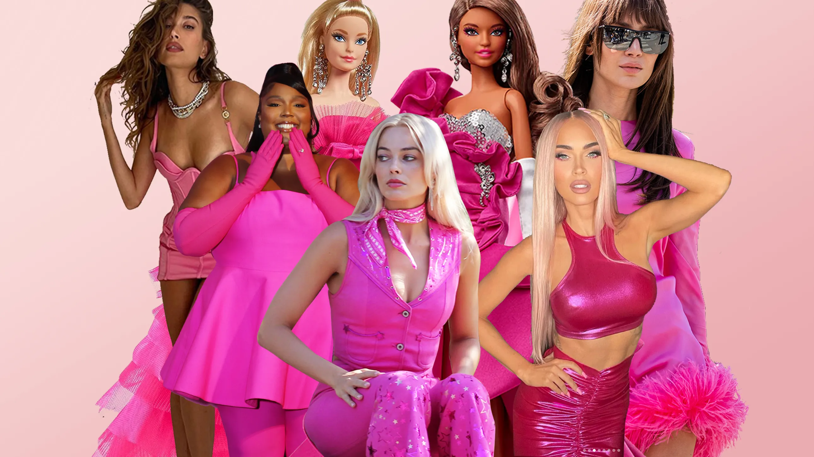

‘Barbie core’ image taken from Glamour Magazine https://www.glamourmagazine.co.uk/gallery/barbiecore-fashion-trend

Conclusion

To conclude, changing others’ perception of us doesn’t always work out. You will never be able to control what people think of you. Choosing to stick with what you think they may like will only result in a loss of your identity and sense of self. It is completely unrealistic to assume that we will ever achieve a life that is continuously Pinterest worthy/Instagram worthy/TikTok worthy. Trends change almost constantly, and life will soon get boring if we only want to stay with a certain aesthetic. It’s an interesting example of how neoliberalism causes the subject to understand themselves as a business. Neoliberals gives corporations a kind of personhood, but it also turns personhood into a corporation. Unfortunately, this algorithm that we’re stuck in is so addictive and strong, that it caters to our biases and exposes us to people that are either similar to us or that we’re comfortable with. What this does is radicalise us. This skewed perception of reality that we’re exposed to on the daily has destructive effects on our self-identity. How are we supposed to build a real sense of self when all the content we consume every single day intentionally leads us back to the same conclusion. These labels we place upon ourselves are no longer based on real life experiences and instead based on the content we consume and the content we are exposed to. Aesthetics make us think we are confined to whatever one we choose and if we take the risk to step out of that ‘aesthetic’, we are not being authentic to it. It’s about conforming to those standards and not fitting into that lifestyle will automatically make you an outcast, you will be deemed different, and that influence has a negative effect on young, impressionable women. The thought of not ‘fitting in’ has damaging effects and it’s unfortunately an issue that we are still trying to solve today. This is why social media is damaging. It makes the input of others so accessible it becomes the only thing people hear or want to hear. Curating a personal lifestyle also takes years of work. It’s based upon your idiosyncrasies. In the end, it shouldn’t be about what society thinks, it should be up to you as a person. It gets to the point where you assume you found your identity just to realise this was just a gateway to your new algorithm persona as well. Placing ourselves into an aesthetic is no longer about individuality, it’s about polarisation. Polarisation or separation will always be our downfall, both as a community and as an individual.

Bibliography

Blogs and Websites

Fisher-Quann, R. (2022). Standing on the shoulders of complex female characters Internet Princess [Blog]. 6 February. Available at: https://internetprincess.substack.com/p/standing-on-the-shoulders-of-complex?utm_campaign=post&utm_source=direct&fbclid=IwAR0RjKdXI_Z0AuZP58HeDXLppxKMGAlee2g7cGxuGAgGxhxTHCxoX4QIif4 (Accessed 24 November 2022).

Fisher-Quann, R. (2022). Manic Pixie Dream World Internet Princess [Blog]. 30 April. Available at: https://internetprincess.substack.com/p/manic-pixie-dream-world?s=r (Accessed 5 December 2022).

Littleton, C. (2021). Why TikTok’s Popularity Exploded During the Pandemic
Available at: https://variety.com/2021/digital/news/tiktok-popularity-covid-1234893740/ (Accessed 5 December).

Grace, A. (2022). Why Are We Obsessed with Aesthetics The Belvedere Journal [Blog]. 20 October. Available at: https://www.thebelvederejournal.com/post/why-are-we-obsessed-with-aesthetics#:~:text=We%20have%20become%20so%20brainwashed,characteristics%20like%20smart%20or%20funny. (Accessed 11 December 2022).

Vucicic, V. (2020). Why is our Society Obsessed with Labels? Medium [Blog]. 27 May. Available at: https://kookylovestotravel.medium.com/why-is-our-society-obsessed-with-labels-d7914e6585e8 (Accessed 12 December 2022).

Olivia, C. (2022). The Unhealthy Obsession with Aesthetic The Teen Mag [Blog]. 5 August.
Available at: https://www.theteenmagazine.com/the-unhealthy-obsession-with-aesthetic (Accessed 13 December 2022).

Stanford Encyclopedia of Philosophy (2021). Feminist Aesthetics. 12 March. Available at:
https://plato.stanford.edu/entries/feminism-aesthetics/ (Accessed 14 December 2022).

Ruane, E. (2021). From Cottage to Norm, We Breakdown Every Core Aesthetic Refinery29 [Blog]. 11 March. Available at: https://www.refinery29.com/en-gb/2021/03/10358491/core-aesthetic-fashion-trends-tiktok (Accessed 14 December 2022).

Photos

Pantony, A. (2022). Barbie core is taking over this summer - here’s how to get the look [Table]. 6 July. Available at: https://www.glamourmagazine.co.uk/gallery/barbiecore-fashion-trend (Accessed 5 December 2022).

Finalgrrrl (2022). Twitter. [Table]. 5 February. Available at:
https://twitter.com/finaIgrrrI/status/1490089203690000384 (Accessed 5 December 2022).

Grace, A. (2022). Why Are We Obsessed with Aesthetics [Table]. 20 October. Available at:
https://www.thebelvederejournal.com/post/why-are-we-obsessed-with-aesthetics#:~:text=We%20have%20become%20so%20brainwashed,characteristics%20like%20smart%20or%20funny (Accessed 11 December 2022).

IMDb (2016). Fleabag [Table]. 21 July. Available at:
https://www.imdb.com/title/tt5687612/?ref_=ttmi_tt (Accessed: 14 December 2022).

Queen Mary University of London (2022). Literary Theory, Aesthetics, Philosophy. [Table]. Available at:
https://www.qmul.ac.uk/sed/english/research/groups/literary_and_cultural_theory/ (Accessed 15 December 2022).

Books and Journals

Baudrillard, J. (1998). The Consumer Society. 2nd edition. SAGE Publications Ltd

Baudrillard, J (1981). Simulacra and Simulation. p. 8. Éditions Galilée

Debord, G (2021). The Society of the Spectacle. Illustrated edition. Unredacted Word

Creighton, J, E. (1920). Philosophy as the Art of Affixing Labels. Journal of Philosophy, inc.

Goulding, C (2000). ‘The commodification of the past, postmodern pastiche, and the search for authentic experiences at contemporary heritage attractions’ European Journal of Marketing. Vol.34 (7), p.835-853.

Leander, K. M. and Buriss, S, K. (2020). British Journal of Educational Technology. John Wiley & Sons, Ltd

Sound

Xolizahbeauty (2021) TikTok [Sound]. 13 July. Available at: https://www.tiktok.com/@xolizahbeauty/video/6984509606496062726?_r=1&_t=8YAX3Vs9QsH&is_from_webapp=v1&item_id=6984509606496062726 (Accessed: 14 December 2022).

