DS 1 Template

My Screenshots/Photos
- Please add 4–6 screenshots or photos of your digital life.
- You can use your phone or laptop.
- For each screenshot, write one or two sentences explaining what it shows.

Screenshot/Photo 1
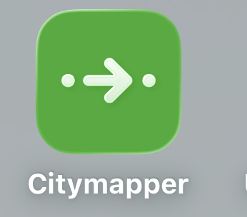
This app represents all the directions where I'm going.

Screenshot/Photo 2

In this application I try to make content to gain views and visualisations

Screenshot/Photo 3
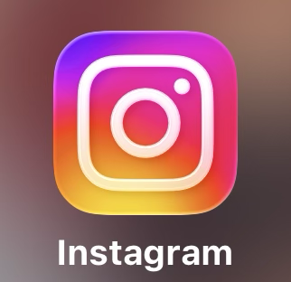
This application means a lot to me because there is a public of my best photographs.

Screenshot/Photo

This app is 10/10 here I watch all the series and movies that I love

Screenshot/Photo 5
App translation
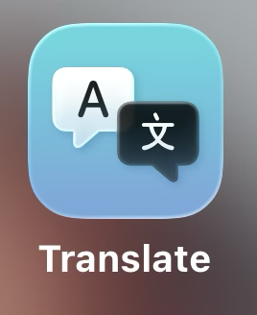
This application helps me translate into my language everything I don't understand.

Screenshot/Photo 6
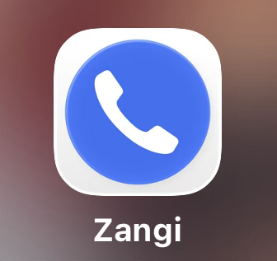
This Zangi app is the best around here. I talk to my family who are on the other side of the world.

My Short Reflection
- Write 5–8 simple sentences about your digital life.
- You can use the sentence starters below if helpful.
1.I often use these tools: Instagram, TikTok, Amazon Prime, Citymapper, and Sangjin.
2.I use digital tools to stay connected, entertained, and organized every day.
3.I feel confident when I use Instagram and TikTok to post photos and recreate videos.
4.I often use Citymapper to find directions and get around the city easily.
5.I use Sangjin to make long-distance video calls with my family.
6.I want to improve my language skills by using translation apps when I don't understand something
7.Digital skills are important for me because they help me communicate, learn, and navigate daily life.

Sentence starters
- I use digital tools to …
- I feel confident when I …
- I want to improve …
- I often use these tools: …
- I sometimes feel nervous about …
- I hope this module will help me …
- Digital skills are important for me because …
You can write more if you want.

Submission Checklist
Before you submit, please check:
​​​ ☐ I added 4–6 screenshots
☐ I wrote short sentences for each screenshot
☐ I wrote my short reflection
☐ My work is my own
☐ My file opens correctly
​​☐ My file opens correctly

