

Adam R. Foley

Design of Shaped Charges

University of Wales Trinity Saint David

Advanced Physics for OME

Supervisor: Prof. Kelvin Donne
Jan 2026

Academic integrity declaration
I declare that:
- the thesis submitted has been written by me alone.
- the thesis submitted has not been previously submitted to this university or any other.
- that all content, including primary and/or secondary data, is true to the best of my knowledge.
- that all quotations and references have been duly acknowledged according to the requirements of academic research.
I understand that to knowingly submit work in violation of the above statement will be considered by examiners as academic misconduct.

Table of Contents
Academic integrity declaration ii
List of Figures v
List of Tables vi
List of Equations vii
List of Abbreviations viii
1 Introduction 9
2 Literature Review 11
2.1 History of Shape Charges 11
2.2 Explosively Formed Projectile (EFP) 11
2.3 Jones–Wilkins–Lee (JWL) Equation of State (EOS) 14
2.4 Johnson–Cook Constitutive Model 15
2.5 Finite Element Analysis 16
2.6 Shaped Charge Ballistic Modelling 18
3 Computational Design & Modelling 20
3.1 Geometry & Materials 20
3.1.1 Design - CAD screenshots and dimensions. 21
3.2 Material models and parameters 23
3.2.1 Copper 23
3.2.2 Steel 24
3.2.3 PBX-9010 25
3.2.4 Aluminium 26
3.3 2D Model Setup (SCJ & EFP) 27
3.3.1 2D Model Set Up: 27
3.3.2 3D Model Set up. 33
4 Results 34
4.1 Test 1: Effects of Liner Material 34
4.1.1 Copper vs Steel 34
4.1.2 Velocity-Time Diagrams 37
4.2 Test 2: Effect of Charge Geometry 40
4.2.1 Explosively Formed Projectile 40
4.2.2 2D EFP Velocity Time Diagrams 43
4.2.3 SCJ vs EFP Comparison 45
4.3 Test 3: Effect of 3D modelling 46
4.3.1 Velocity Time Diagram 50
4.4 Task 4: Effects of Advanced Numerical Techniques such as Smooth Particle Hydrodynamics 52
4.5 SPH Velocity Time Graph 57
5 Conclusion 59
6 References 60
Appendices 64
Appendix A – 2D SCJ Simulation Images 64
Appendix B – 2D EFP Simulation Images 72
Appendix C – 3D SCJ Simulation Images 81
Appendix D – SPH Simulation Images 87

List of Figures
Figure 1 - Example EFP [5] 12
Figure 2 - EFP vs SCJ [6] 13
Figure 3 - Shape Charge Model 18
Figure 4 - SCJ Live Firing vs Numerical Data 19
Figure 5 - Material Manager 27
Figure 6 - Section Manager 27
Figure 7 - Step Manager 28
Figure 9 - Boundary Condition Manager 28
Figure 8 - Interaction Manager 29
Figure 10 – 2D Material Mesh 1 30
Figure 11 – 2D Material Mesh 2 31
Figure 12 - 3D Mesh. 33

List of Tables
Table 1 - EFP & SCJ CAD Drawings 22
Table 2 - Copper Material Parameters 23
Table 3 - Steel Material Parameters 24
Table 4 - PBX-9010 Material Parameters 25
Table 5 - Aluminium Material Parameters 26
Table 6 - 2D Simulation Images - SCJ 36
Table 7 - 2D Copper SCJ Simulation Velocity Time Graph 37
Table 8 - 2D Steel SCJ Simulation Velocity Time Graph 38
Table 9 - 2D EFP Simulation Images 42
Table 10 - 2D EFP Velocity Time Diagrams 43
Table 11 - 3D SCJ Simulation Images 48
Table 12 - 3D SCJ Velocity Time Graph 50
Table 13 - 3D SCJ SPH Simulation Images 55
Table 14 - 3D SCJ SPH Velocity Time Graph 57

List of Equations
Equation 1$-P=A1-ωR1ve-R1v+B1-ωR2Ve-R2v+ωe0v$ [7] 14
Equation 2 - $σ=(A+Bεn)(1+Clnε*)(1-T*m)$ [9] 15

List of Abbreviations
IT  OME  SCJ  EFP  SPH  HE  FEA  FEM  JWL  EOS  EOD  CAD  CAE  WW2  2D  3D  DP | Information Technology  Ordnance Munitions & Explosives  Shaped Charge Jet  Explosively Formed Projectile  Smooth Particle Hydrodynamics  High Explosive  Finite Element Analysis  Finite Element Method  Jones–Wilkins–Lee  Equation of State  Explosive Ordnance Disposal  Computer Aided Design  Computer Aided Engineering  World War 2  2 Dimension  3 Dimension  Detonation Products

Introduction
A Shaped Charge is an explosive device that has been designed with the intention of efficiently directing a high velocity jet, using an explosive payload pressing into a ductile angled liner, through strong targets such as thick metals. Due to this, they have been commonly associated with military use, such as armour penetration, naval applications, EOD. However, they also translate into external non-military environments through similar means including quarrying/ mining, civil engineering including demolition/ breaching and oil exploration.
This report contains a literature review into the background, design and uses of Shaped Charges before translating this knowledge into an investigation using ABAQUS CAE software to accurately model and analyse Shaped Charges to discover how well ABAQUS can be used to effectively model and simulate Shaped Charges by reviewing the results obtained from these simulations with the knowledge gained from the initial literature review. ‘Abaqus/Explicit is an explicit-dynamic finite-element solver most suitable for simulating brief transient and dynamic events such as drop tests of consumer electronics, automotive crashes, and ballistic impacts.’ [1]
This purpose of the ABAQUS simulation investigation was to analyse the impact of changes to liner material, charge geometry and modelling strategy on the behaviour of a Shape Charge Jet (SCJ) and an Explosively Formed Projectile (EFP) using ABAQUS Explicit Computational 2D and 3D simulations. This has been completed using the following Sub-Objectives, which have been used to identify the requirements for each simulation:
- Effect of Liner Material.
- Effect of Charge Geometry and Mechanisms.
- Effect of 3D Modelling.
- Effects of Advanced Numerical Techniques such as Smooth Particle Hydrodynamics (SPH).
These sub objectives have been used to model simulations, further detailed within this report to understand the effects that they have on the reliability, effectiveness and accuracy of the results gained whilst understanding the cost burden on robust explicit simulations.

Literature Review

History of Shape Charges
The earliest recognised form of what is now known as a shaped charge, defined as ‘a shaped charge is defined as a cylinder of explosive with a hollow cavity at the end opposite the initiation train’ [2] can be attributed to the discoveries made by Charles Munroe in 1888 which he rested an opened tin can on top of a steel safe, with the hollow cavity facing downwards. Both on top and surrounding the tin can, sticks of dynamite were tied and upon usage, the can performed as a liner would and perforated through the steel.
Moving into the 1940’s after years of development High Explosive Anti-Tank (HEAT) machine gun grenades, which was eventually modified to include a shoulder launcher and rocket motor and turned into what is now known as the bazooka, and artillery projectiles were manufactured and used by the USA, UK and other countries around the world. [2] Following WW2, ‘Allied researchers entered Germany near the end of World War II to study and recover German technology. They discovered flash x-rays showing the collapse and formation of shaped charges with conical and hemispherical liners.’ [2] Alongside detailed studies into the optimal explosive fill to use within Shaped Charges, all of which provided additional knowledge to improve the understanding and knowledge of shaped charges.
Shaped Charges are commonly used within Explosive Engineering for a range of applications from military use to non-military uses such as demolishing of buildings.

Explosively Formed Projectile (EFP)
EFPs are a form of shape charge, adhering to the same principles as SCJs, as a cylindrical explosive device with a liner and a hollow cavity. However, they use a conical liner, a generic EFP geometry can be seen below, with a modest angle rather than a steep cone which travels at a slower speed but uniformity throughout, so would be selected in use cases where a longer distance is travelled and when less penetration is required. The shallow angle of the liner, in comparison to a traditional Shaped Charge Jet, provides a flatter surface for the pressures released by the explosive detonation to impact upon. This in turn provides a uniform spread of pressure across the whole liner, allowing the inverting of the liner in the middle but retaining key structure around the sides of the liner in comparison to the extreme deformation seen within a typical shaped charge jet. As previously mentioned, this trade comes with a heavy sacrifice to the velocities witnessed within the formed jet/ slugs with common results of around 1500-2000 m/s [3] in comparison to the speeds of around 7000m/s and more [4].
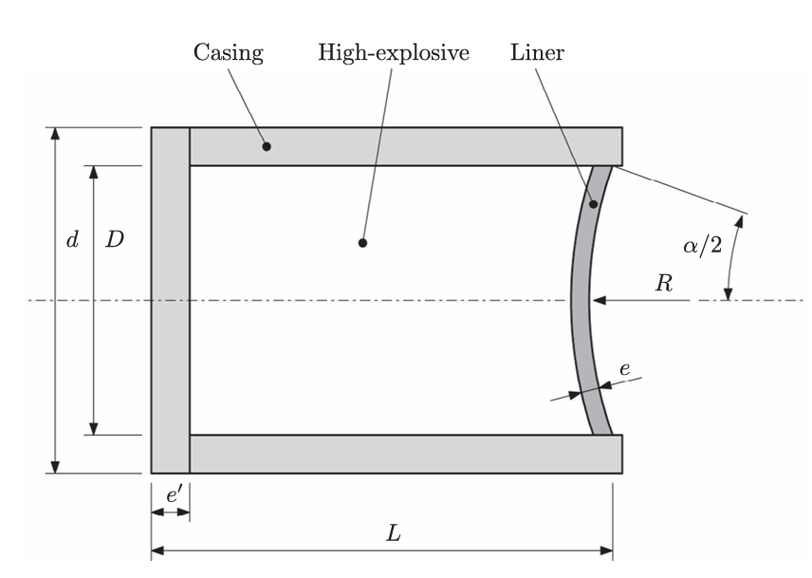
Figure 1 - Example EFP [5]
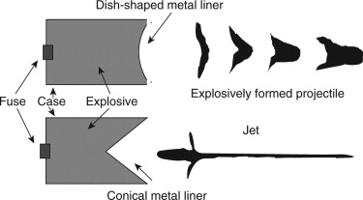
Figure 2 - EFP vs SCJ [6]
As seen in figure 2, the SCJ provides an extremely thin jet, allowing it to reach extreme velocities. However, this requires that the shaped charge is initiated as close to the target as possible due to its fragile state whereas the wide slug produced by an EFP will travel slower due to its greater surface area but can travel for longer, create a much larger whole and remain stable enough to knock away any interference arising from a larger stand-off distance.

Jones–Wilkins–Lee (JWL) Equation of State (EOS)
The Jones–Wilkins–Lee Equation of State ‘is widely used in reactive hydro simulations to describe thermodynamics of both detonation products (DP) and unreacted high explosives (HE)’ [7]. Within this report, the JWL parameters for the explosive material used, PBX-9010, are specified and their source is referenced. These parameters enable the ABAQUS/Explicit solver to accurately model the rapid energy release, pressure evolution, and expansion behaviour of the detonation products as the explosive event occurs.
The JWL EOS can be seen below:
Equation 1$-P=A\left(1-\frac{ω}{R_{1}v}\right)e^{-R_{1}v}+B\left(1-\frac{ω}{R_{2}V}\right)e^{-R_{2}v}+\frac{ωe_{0}}{v}$ [7]
Where:
- v = ρ_{e} / ρ = relative volume between the detonation products and undetonated high explosive.
- P = pressure
- ρ_{e} = The density of the explosive material
- ρ = the density of the detonation products
- e₀ = specific internal energy
- A, B, and C = linear coefficients
R₁, R₂, and ω = non-linear coefficients

Johnson–Cook Constitutive Model
The Johnson-Cook Model ‘is a function of von mises tensile flow stress, in accordance with strain hardening, strain rate hardening, and thermal softening.’ [8]. Within this report, Johnson Cook parameters are used by the ABAQUS Explicit solver to accurately model the materials used to represent each geometry; liner, HE fill and Case by understanding each materials performance under the stress, strain, temperature encountered within an explicit problem.
The Johnson-Cook Model can be seen below:
Equation 2 - $σ=(A+Bε^{n})(1+C\ln{{\dot{ε}}^{*}})(1-T^{*m})$ [9]
where:
- σ = stress
- A = initial yield stress
- B = strain hardening constant
- ε^{n} = equivalent plastic strain
- C = Strain rate hardening constant
- ε˙∗ = normalised effective plastic strain rate
- m = thermal softening coefficient
- T* = $\frac{T-T_{room}}{T^{'}-T_{room}}$
- T_{room} = room temperature
- T’ = melting temperature of the material

Finite Element Analysis
Finite Element Method (FEM) uses mathematical techniques to break down complex structures into a vast number of simple elements and subsequently uses these individual elements to make a vast array of differential calculations that are combined together and applied under Finite Element Analysis (FEA) [10]. This methodology uses computational capabilities to approximate irregular problems by turning them into thousands of small problems which come together to solve the overarching requirement.
FEA is vital for all kinds of engineering issues, notably where a live test is unrealistic or dangerous to complete. For example, if the 5 shaped charge simulations that were ran within this report couldn’t use FEA software, then 5 shaped charges would have had to have been created, tested and fired in a real-world setting, creating a massive time, resource and risk burden to all personnel involved. It allows for the fine tuning and design of complex structures and high-risk devices without any real-world material cost being wasted or risk to life being present.
However, FEA does have challenges that it struggles to overcome. This is due to everything it uses being based on assumptions, which are only as accurate as the information used to build these geometries, materials etc. For example, there is no guarantee that the material properties that have been used from online published research are completely accurate or made for this purpose and could affect the accuracy of the obtained results. Furthermore, it can ignore real world conditions, such as the weather, roughness of a geometrical surface, impurity/ condition of a real-world explosive materials – all of which would provide a big input of the accuracy and functional limitations of FEA simulations. Additionally, a massive limitation is computational capability. Unless you could use and fund an ultra-high-end machine, you can be quite limited with the amount of elements/ mesh size you can use, due to the time and resource required to calculate all the individual equations within each element.

Within FEA, you can use either 2D or 3D models which behave how one would expect them to be based on the 2D and 3D concept in real life. When creating a 2D model within FEA, it creates a component within the flat 2D plane using the X and Y axis. When creating a 3D model within FEA, it creates a component within a 3D plane, using an X, Y and Z axis. The benefit of a 2D plane is predominantly the lack of a 3rd dimension, which drastically reduces the number of elements within the mesh and subsequently drastically reduces the time taken to run a simulation with the geometry only being able to move in 2 directions. However, this ignores a big aspect of real-world testing, as all geometries are going to be 3D when used in real world scenarios, so you will require some understanding of how the geometry will move within that third axis. Due to this 2D modelling is to 3D modelling, what 3D modelling is to real life simulations – It is a useful tool which allows you to conduct testing with a dramatically lower resource requirement, but this ease of use comes with the burden of being a less accurate methodology.

Shaped Charge Ballistic Modelling

Shaped charges are commonly modelled using computational explicit simulation tools such as ABAQUS prior to conducting real life tests to reduce the likelihood of catastrophic failure due to incorrect construction, material design or to test minor tweaks and improvements to try and make the shaped charge computational perfect before trying it in real life to avoid wastage and unnecessary exposure to explosive devices. The paper referenced, conducted simulations within a CAE tool named ‘Autodyn’ before manufacturing the shaped charge designs and testing them in real life. The purpose of this testing was ‘to investigate the influence of the macroscopic mechanical properties of the materials on the jet’s performance.’ [11] This was done by the selection of 6 materials to be used as jet liners all of which were substituted into the shape charge diagram shown below.
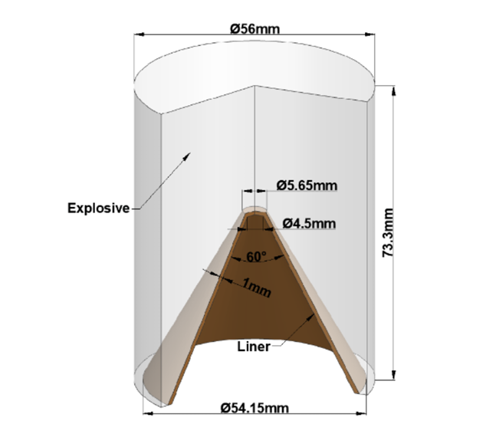
Figure 3 - Shape Charge Model
The way this was approached was by maintaining specific constants such as:
- Geometry Dimensions
- Real life apparatus
Following the results gathered after conducting both the simulation and live firings, both sets of data were collated and compared within the table below, with the ‘error’ indicating the deviation of the numerical results obtained within the CAE simulation to the corresponding live firing.
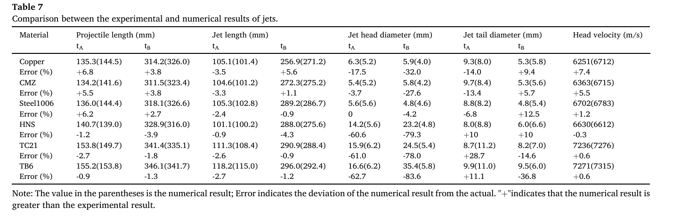
Figure 4 - SCJ Live Firing vs Numerical Data
The data gathered above, provided clear evidence that the results obtained through simulations can identified as accurate in terms of the velocities tracked up to 7%, but clear issues arise when measuring the diameter of the jet formed with the jet head diameter showing inaccuracies of up to 83.6%. This is most likely down to the meshing used within the FEA solver simplifying atomic levels of deformation into elements, which although appear to be extremely fine still aren’t accurate enough to calculate the extreme levels of deformation found within real scenarios.
This case study has been used to design the investigation completed within this report, identifying Copper and Steel 1006 as liner materials to use due to their proven reliability as jets and material data provided, the geometry as a proven SCJ. Alongside the identification of advanced techniques such as Smooth Particle Hydrodynamics to attempt to combat the liner inaccuracies found from.

Computational Design & Modelling

Geometry & Materials
The shape charge jet has been designed using open source published literature on ballistic testing of shaped charges referenced [12], with the HE Fill & Case being modelled to conform with the shape of this liner. The dimension of all components, seen within 3.1.1, remained constant throughout the investigation, using the measurements shown to ensure that the only thing that effects the results is the variable being tested within each sub task, e.g. liner material etc.
The case and HE materials used, Aluminium and PBX 9010 respectively, were unchanged throughout each experiment. This was done to avoid different results being caused by unnecessary material changes.
The Shaped Charge Models were created within ABAQUS software, in which each component was created as an individual part. These parts were then assigned to one another to form the complete SCJ and EFP seen within the simulations using the ‘ASSEMBLY’ module by creating instances of each part.

Design - CAD screenshots and dimensions.
Shaped Charge Models used for both 2D & 3D Simulations
Shape Charge Jet |  | Explosively Formed Projectile
Case | 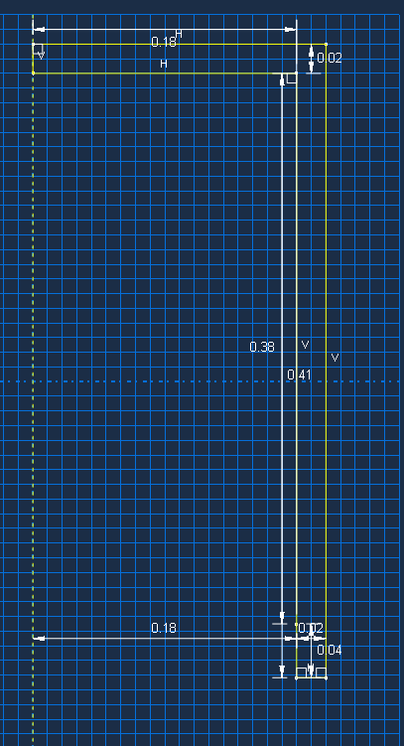 |  | 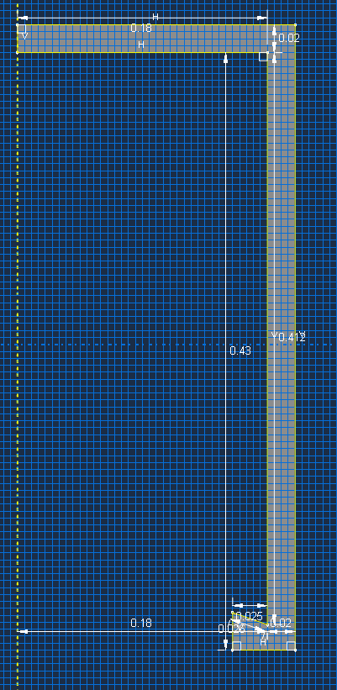
High Explosive Fill | 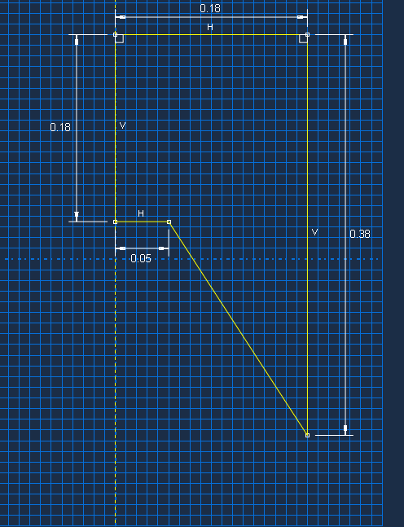 |  | 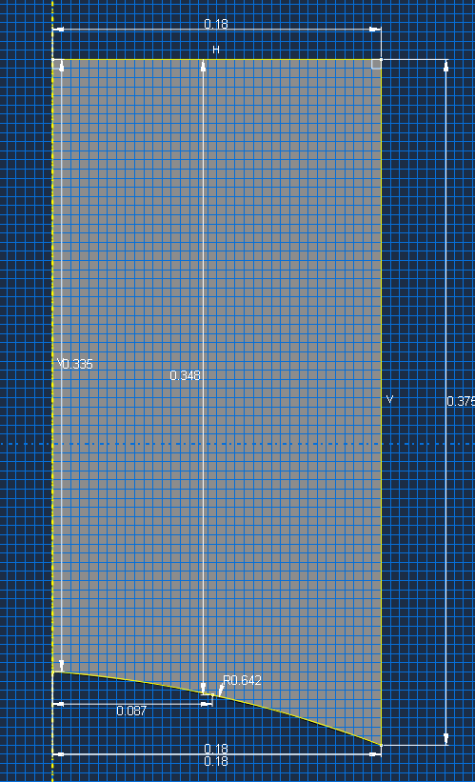
Liner | 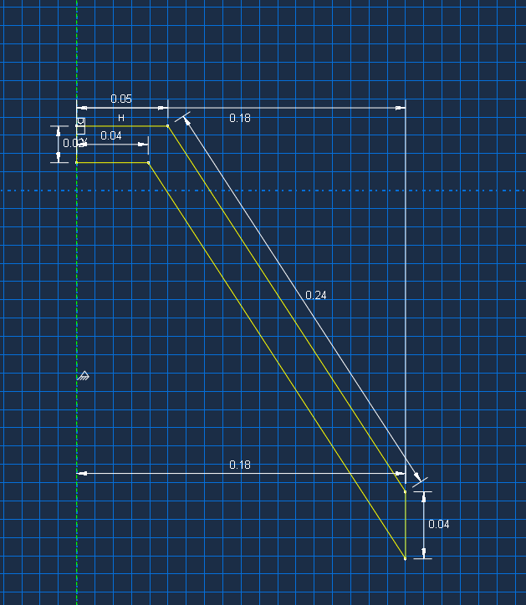 | 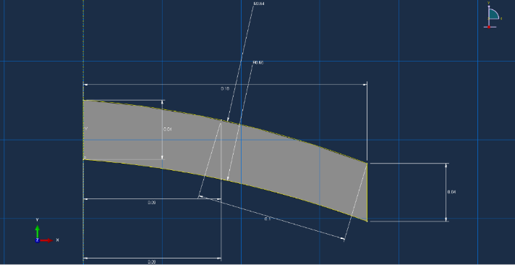
Table 1 - EFP & SCJ CAD Drawings

Material models and parameters
The following material data has been compiled from multiple reliable sources. [13] [14] [11] [15] [16] [17]:

Copper
Parameter | Symbol | Value
Mass Density [15] | ρ | 8930
Young’s Modulus | E | 110000000000
Poisson’s Ratio | v | 0.343
Johnson Cook Parameters [11]
A |  | 90000000
B |  | 292000000
n |  | 0.31
m |  | 1.09
Melting Temp |  | 1790
Transition Temp |  | 298
C |  | 0.025
Epsilon dot zero |  | 1
Table 2 - Copper Material Parameters

Steel
Parameter | Symbol | Value
Mass Density [14] | ρ | 7872
Young’s Modulus | E | 206000000000
Poisson’s Ratio | v | 0.29
Johnson Cook Parameters [11]
A |  | 350000000 Pa
B |  | 275000000 Pa
n |  | 0.36
m |  | 1.00
Melting Temp |  | 1790
Transition Temp |  | 298
C |  | 0.022
Epsilon dot zero |  | 1
Table 3 - Steel Material Parameters

PBX-9010
Parameter | Symbol | Value
Mass Density [16] |  | 1787
Jones-Wilkins-Lee Values
A | A | 581400000000 Pa
B | B | 6801000000 Pa
R1 | R1 | 4.1
R2 | R2 | 1
omega | ω | 0.35
Detonation wave speed |  | 8390
Reference energy | E0 | 5127028.5 J/m³
Table 4 - PBX-9010 Material Parameters

Aluminium
Parameter | Symbol | Value
Mass Density |  | 2770
Young’s Modulus |  | 68000000000
Poisson’s Ratio |  | 0.36
Johnson Cook Parameters [12]
A |  | 265000000
B |  | 426000000
n |  | 0.34
m |  | 1
Melting Temp |  | 933
Transition Temp |  | 293
C |  | 0.015
Epsilon dot zero |  | 1
Table 5 - Aluminium Material Parameters

2D Model Setup (SCJ & EFP)

2D Model Set Up:

Materials:
To start, the materials parameters detailed within 3.2 were inputted into separate materials within ABAQUS ‘Material Manager’ and named respectively.
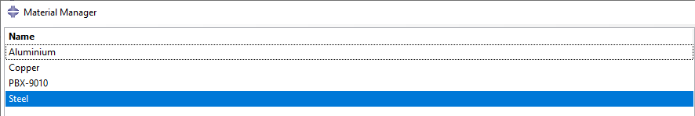
Figure 5 - Material Manager

Section Manager:
Following this, 3 sections were created with the purpose of assigning the three components their correct materials as seen below. This allows you to apply a material to the component geometry.
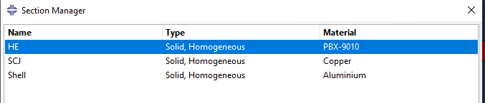
Figure 6 - Section Manager

Step Manager:
Within this section a step was created. The purpose of this was to set an explicit dynamic solve set which captured the tmax, the time at which the simulation would stop. Furthermore, within this section, the frequency of plot dumps was selected within the Field Out Request Manager, to ensure the ABAQUS simulation results would capture images of the whole deformation.
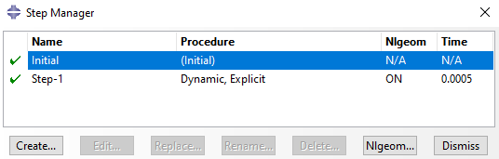
Figure 7 - Step Manager

Load:
Within this section the plane of symmetry for a 2D axisymmetric calculation was set, to ensure no point could travel along the X axis.
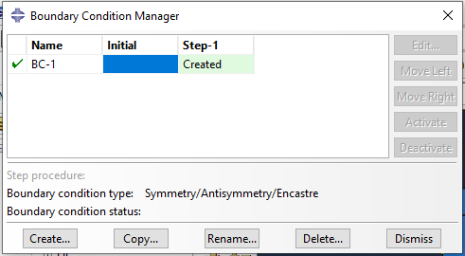
Figure 8 - Boundary Condition Manager

Interaction:
Within this section the contact between the individual models were selected to ensure that they acted as a complete shaped charge, rather than separate components. A ‘general contact’ interaction type was set, with frictionless behaviour for the mechanical tangential behaviour and hard contact for the normal behaviour.
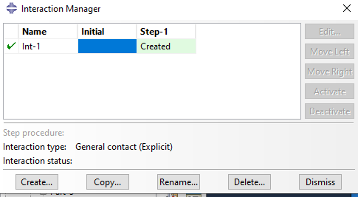
Figure 9 - Interaction Manager

Mesh:
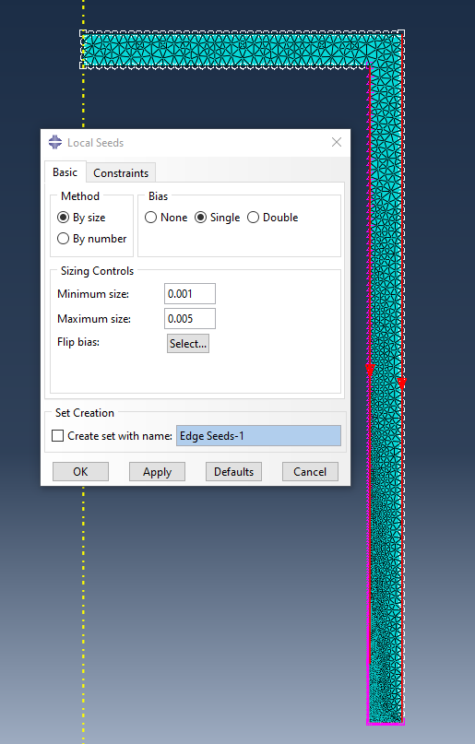
Figure 10 – 2D Material Mesh 1
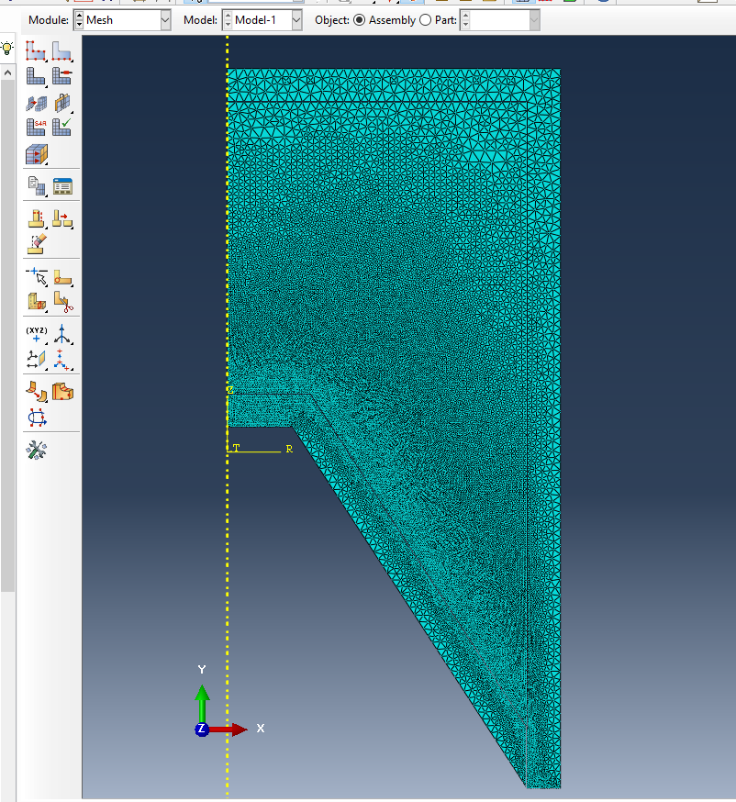
Figure 11 – 2D Material Mesh 2
Meshing is where ‘large, complex geometries are discretized into a set of simple, interconnected elements’ [18] within FEA. ABAQUS uses different shapes like triangles, to build the required geometry inputted into the software. The number of shapes used depends on how refined the mesh is, with the finer the mesh leading to a more accurate representation of the required geometry. For a shaped charge simulation, it is crucial that an extremely fine mesh is used due to the extreme pressure, strain rates and deformation the components face, requiring a large number of elements and nodes to accurately calculate rapid changes in displacement and velocity experienced at that particular point. However this increase in elements and nodes leads to a higher computational requirement due to the additional calculations and processing that occurs, so a balance between simulation accuracy and computational power must be struck depending on the time and computer available.
The mesh used was a global seed mesh of 0.005 whilst the areas that experience the most extreme rates of deformation and of most interest were assigned a single bias geometric progression mesh of 0.001. The reason for this was to have the best possible chance of seeing an accurate, liner collapse and subsequent jet formation as possible.

3D Model Set up.
To set up the 3D model simulation, the 2D model drawing was converted to a 3D geometry.
The 3D model can be seen below, with the global mesh seed being selected as 0.01 with the liner having a mesh seed of 0.0035. This was then merged with the HE and Case meshing using the single bias meshing tool which helped integrate the fine and coarse meshes to prevent failures when simulating. This mesh was selected as it was able to be simulated by the computer without a massive time and reliability burden. This mesh and model were used for all 3D simulations.
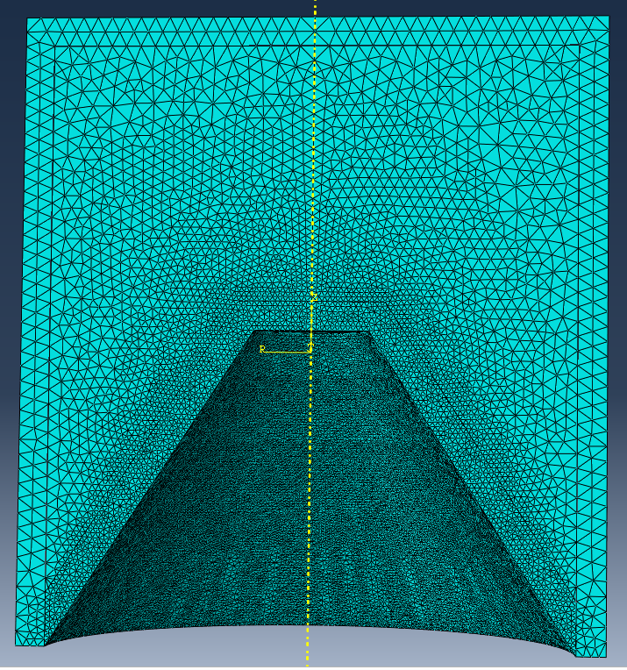
Figure 12 - 3D Mesh.

Results

Test 1: Effects of Liner Material

Copper vs Steel
The following table shows images capturing the 2D Copper vs Steel SCJ simulations at key points within the process. For enlarged images, with additional images included, please see Appendix A.
The primary purpose of this simulation, as part of the overarching investigation, was a proof of concept. This was done to ensure that the material values obtained online for the Case, HE fill and liner all performed within ABAQUS as expected, rather than creating a 3D simulation involving a lot more time and resources and seeing it fail due to incorrect material data or small errors. It was then used to identify the material that would be taken forward into the 3D simulation based on the energetic profile, visual appearance, velocities and on how well the computer handled both simulations.
 | Copper Liner | Steel Liner
Start of Detonation | 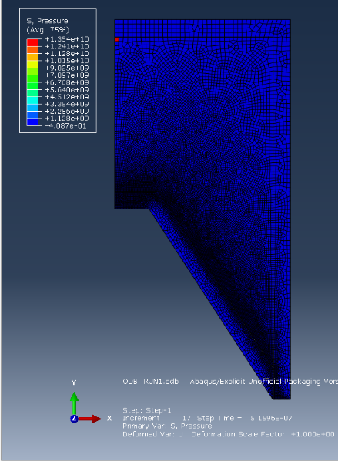 | 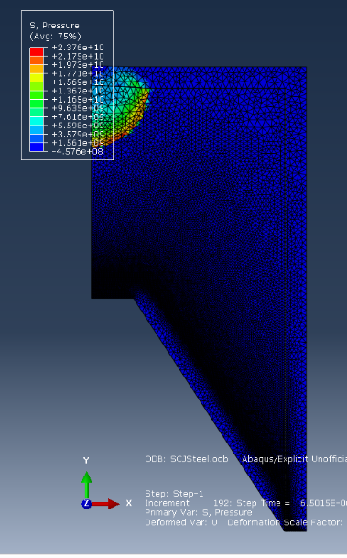
Mid Detonation | 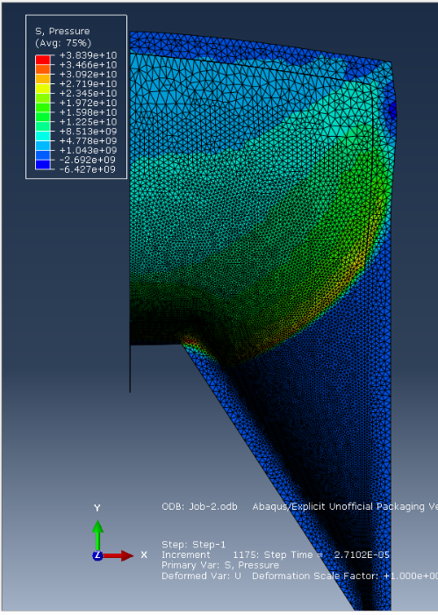 | 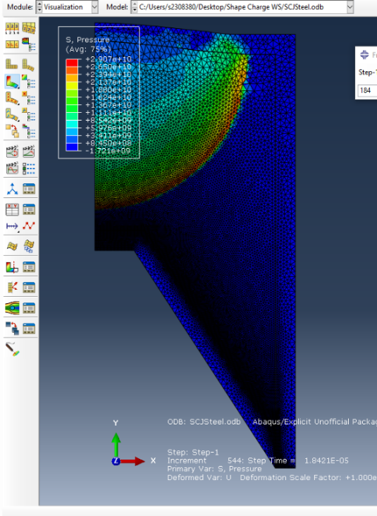
Initial Jet Formation | 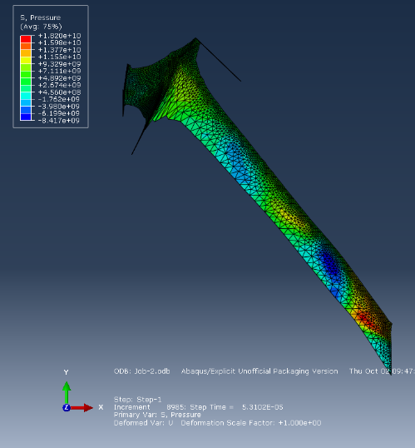 | 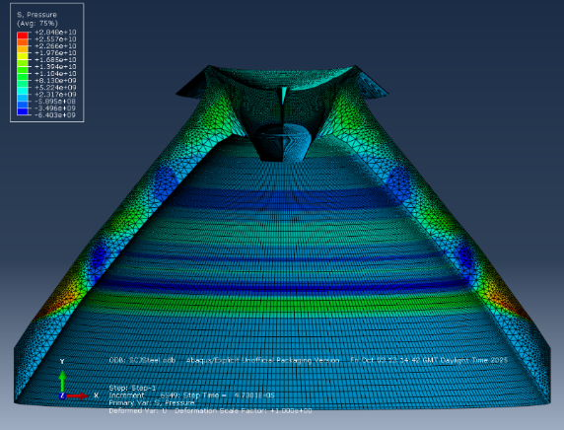
Complete Jet Formation | 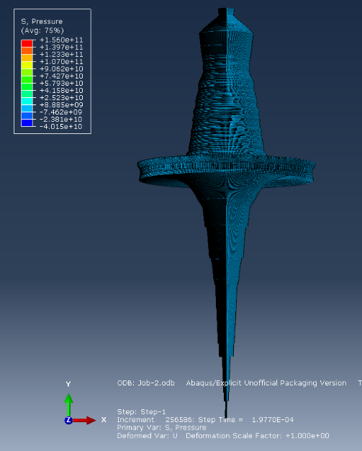 | 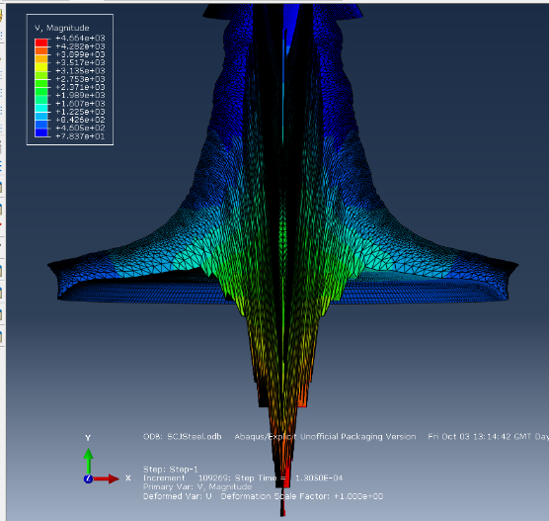
Table 6 - 2D Simulation Images - SCJ
The images above show the progression of the SCJ formation from its initiation point all through to the formation of a complete Jet for both Copper and Steel Liners. Each subheading shows a vast amount of information that can be used by the viewer:
- Start of Detonation – This shows the initiation point that has been selected to start the explosive chain (Copper Screenshot) which was identical for both simulations.
- Mid Detonation – This shows the shockwave propagating through the HE fill, from the detonation point prior to the formation of a jet.
- Initial Jet Formation – This shows the start of the Jet formation, where the flat metal is being pressed forward from the concentrated energy being released by the HE Fill. The screenshot captured within the Steel example has been extruded and revolved 180 degrees to provide a realistic view.
- Complete Jet Formation – Both screenshots show the fully formed Jet at the point of which the simulations crashed. Due to vast amount of deformation that has occurred within all aspects of the SCJ and the limited computational power that was available, both simulations crashed at their respective points. Both screenshots show a difference in view, with the Copper simulation being extruded and revolved 360 degrees to represent what the complete jet would look like in reality using the 2D calculations and the Steel simulation extruded and revolved 180 degrees to provide an inside perspective of the formed Jet.

Velocity-Time Diagrams
The following tables show the node selection and velocity diagrams for both the Copper & Steel Liner SCJ Simulations.
 | Copper Liner
Node Selection | 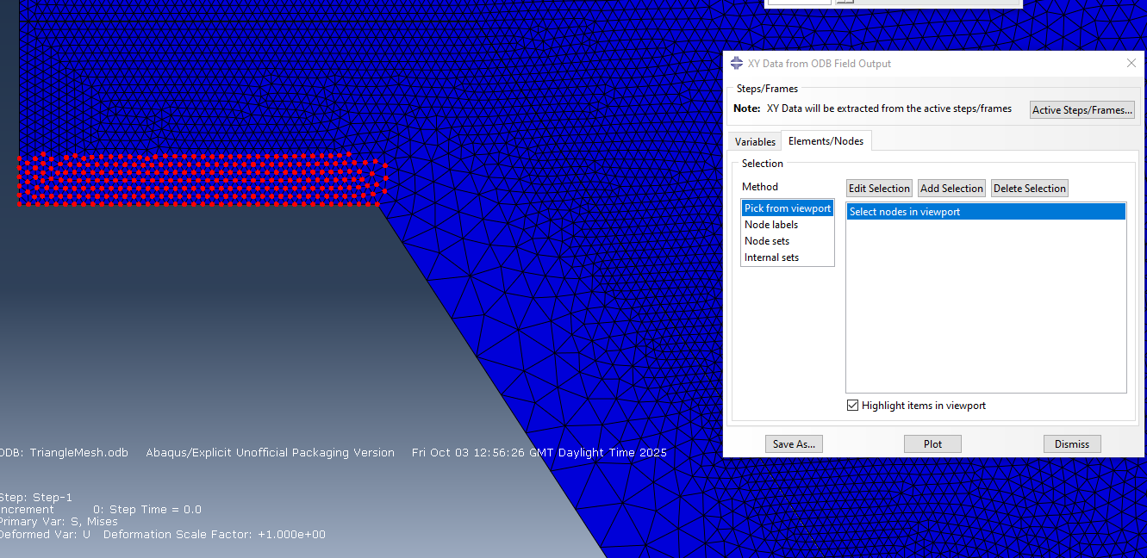
Velocity Diagram | 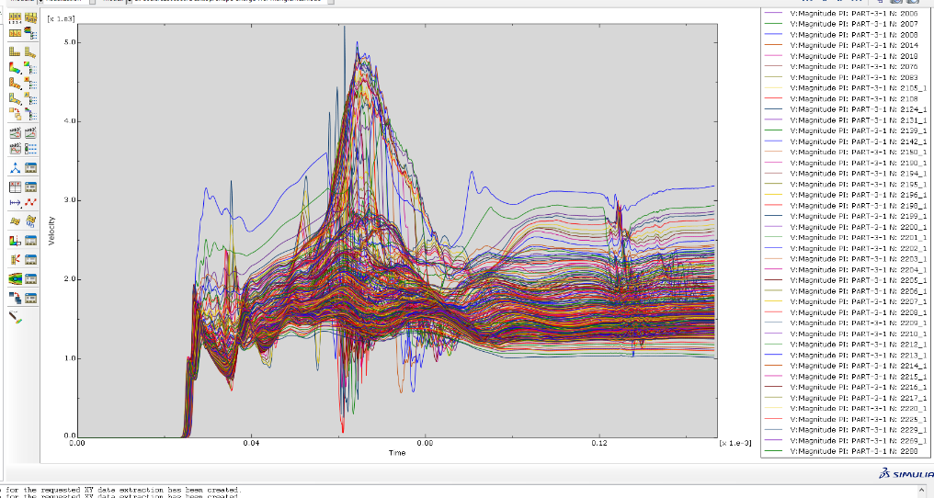
Table 7 - 2D Copper SCJ Simulation Velocity Time Graph
 | Steel Liner
Node Selection | 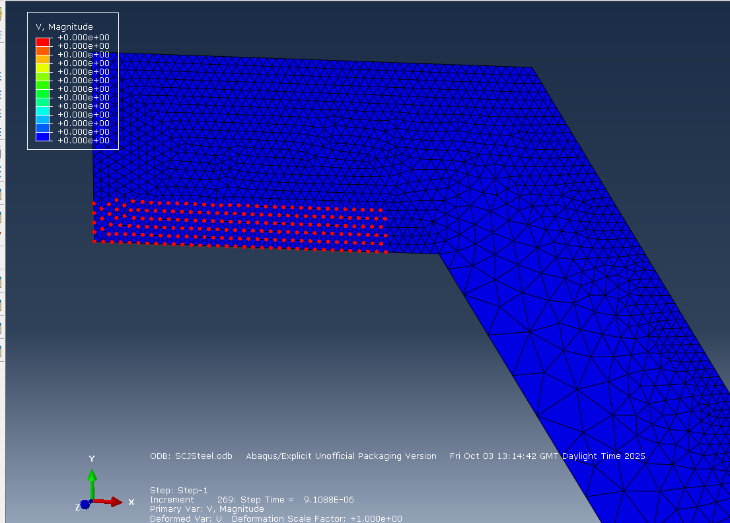
Velocity Diagram | 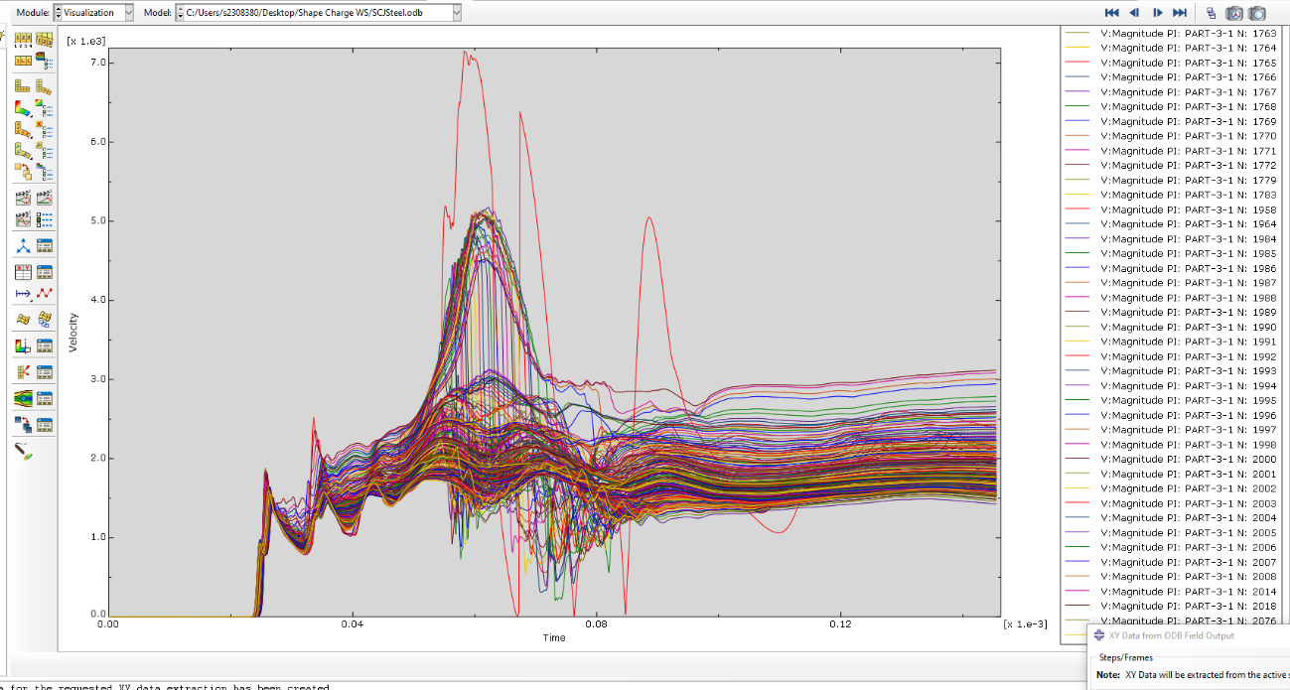
Table 8 - 2D Steel SCJ Simulation Velocity Time Graph
Upon inspection of the visual screenshots showing the simulations running from initiation to a final jet formation, as well as the velocity time diagrams for both Copper and Steel Jets, it is clear that both have performed as expected for a model SCJ both visually and graphically, showing excellent jet formations and peak speeds of 5000-7000 m/s which is comparable to real life experimental and numerical studies showing peak velocities for Copper and Steel velocities as 6712 m/s & 6783 m/s [11] respectively.
However, there are clear difference in the velocity time diagrams for both the Copper and the Steel Liners. Both diagrams show a rapid increase in velocity following the initiation of the HE, forming a peak at around 0.06ms with the Steel liner showing a much higher peak of around 7000m/s in comparison to the Copper peak of around 5000m/s. But the Copper diagram shows a much greater consistency in its nodal values throughout the simulation, notably at the peak in comparison to the Steel liner meaning that the deformation is much more uniform within the Copper liner. The Steel liner shows a high level of instability in the form of sharp spikes and abrupt drops throughout all nodes over the duration of the simulation in comparison to the smoother velocities seen within the Copper test proving its high level of ductility [19] and after the peak velocities are hit, the Copper values stabilise together into a narrow band whereas the Steel velocities diverge, showing that the Copper liner would turn into a much longer and uniform jet when compared to the Steel liner. This is backed up visually within the ‘Complete Jet Formation’ images in which the final jet formation for copper showed a much more mature and elongated Jet when compared to Steel.

Test 2: Effect of Charge Geometry

Explosively Formed Projectile
The following table shows images capturing the 2D Copper vs Steel EFP simulations at key points within the process. For enlarged images, please see Appendix B.
The purpose of this test was to understand how a change in charge geometry would affect the projectile formation and thus influence characteristics of the munition, leading to differences within the intended use cases for both shaped charges to understand design requirements. This was completed by holding the materials constant whilst changing the geometry to see how a different shaped liner, would respond to the same scenario faced by the original SCJ. Due to this, both tests were replicated and captured using the exact same methodology as Test 1, with both Copper and Steel liners being tested for further evidence.

 | Copper Liner | Steel Liner
Start of Detonation | 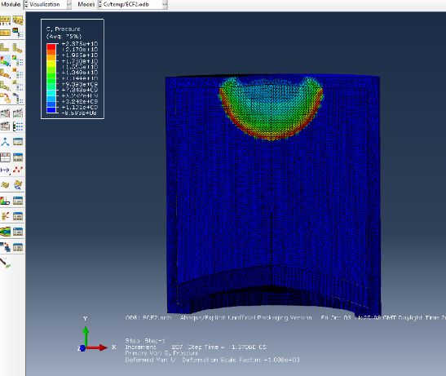 | 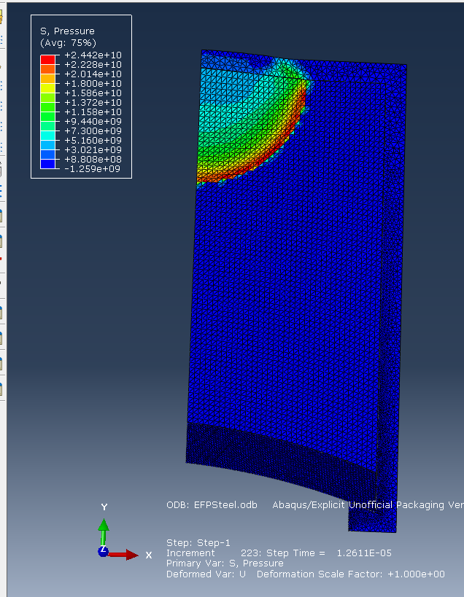
Mid Detonation | 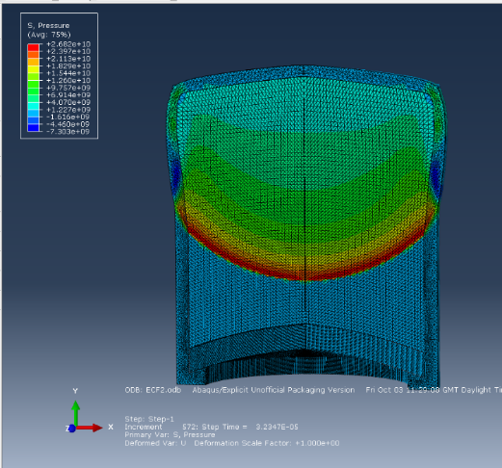 | 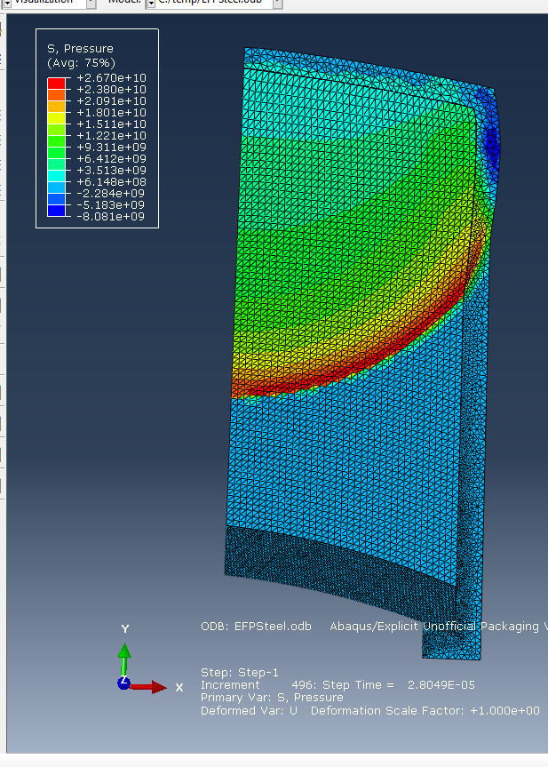
Initial Jet Formation | 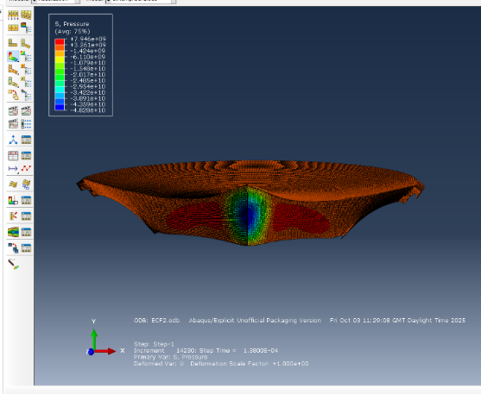 | 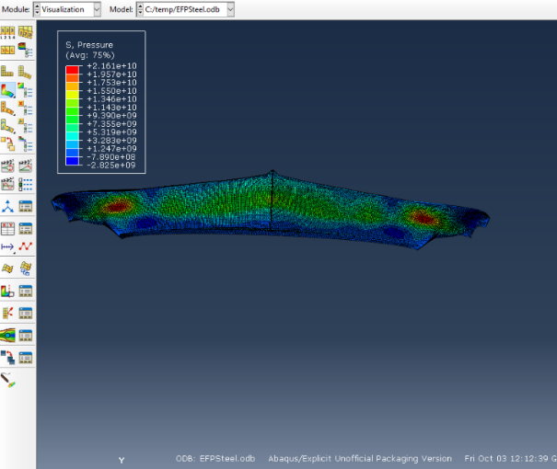
Complete Jet Formation | 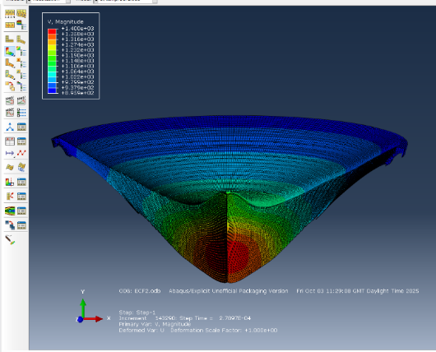 | 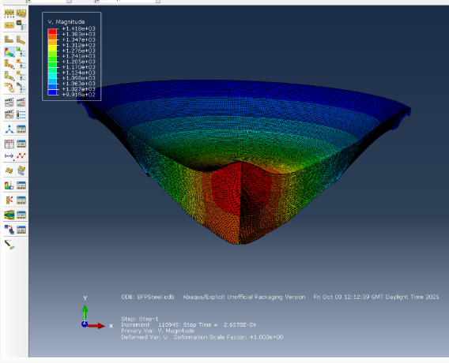
Table 9 - 2D EFP Simulation Images
The images above show the progression of the EFP formation from its initiation point all through to the formation of a complete Jet for both Copper and Steel Liners. Each subheading shows a vast amount of information that can be used by the viewer:
- Start of Detonation – This shows the start of the shockwave.
- Mid Detonation – This shows the shockwave propagating through the HE fill, from the detonation point prior to the formation of a jet, within the Copper liner, the view has been extruded and revolved 180 degrees to give a realistic insight into what a cross-sectional view of a real EFP detonation would look like. Both images show expansion to the case.
- Initial Jet Formation – This shows the start of the Jet formation for both simulations, with the copper liner being at a slightly more advanced stage. The view has been extruded and revolved 180 degrees, and the conical shape of the jet can be identified.
- Complete Jet Formation – Both screenshots show the fully formed Jet at the point of which the simulations crashed, with both simulations showing a formed conical slug comparable to existing scientific literature.

2D EFP Velocity Time Diagrams
2D EFP Velocity Time Diagrams
Copper Liner | 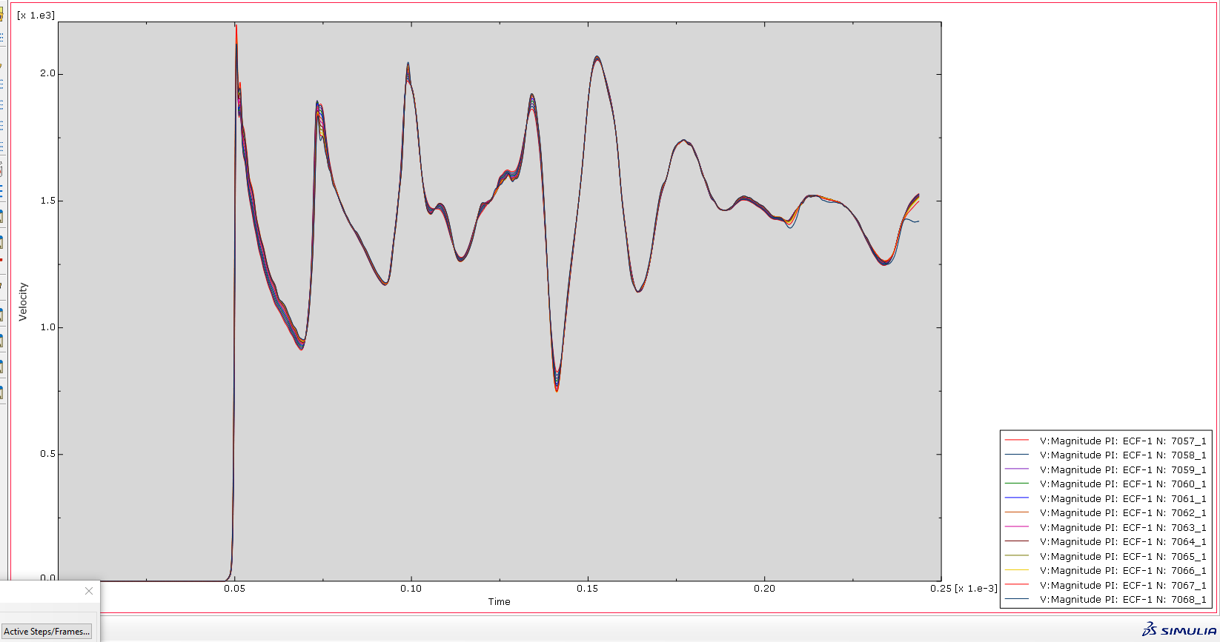
Steel Liner | 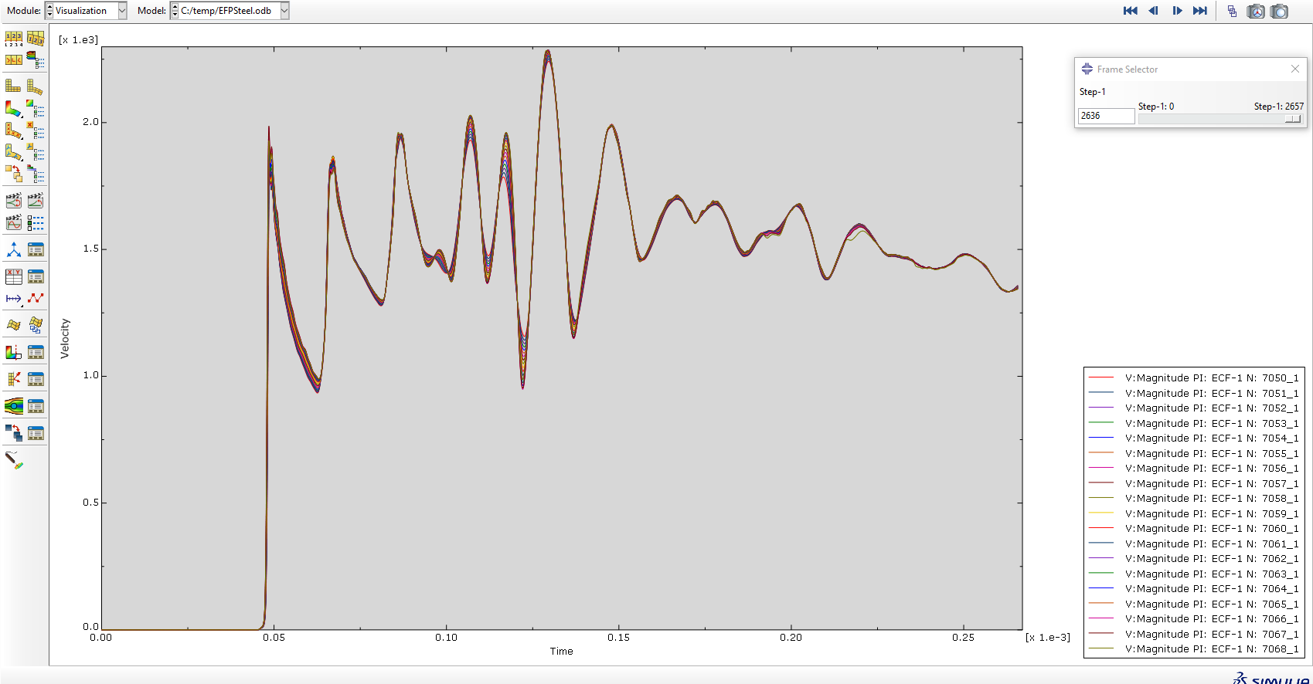
Table 10 - 2D EFP Velocity Time Diagrams
The table above provides screenshots of the velocity time graphs for both the Copper and the Steel liner simulations, using Nodes selected from the middle of the Jet. When solely comparing these two graphs they both have a similar peak of 2200m/s, however, this is hit by the copper liner in the first peak rather than the 6th peak in which the steel liner manages to reach it. Furthermore, the steel liner seems to have slightly more peaks and appears to be marginally less stable reflecting a likeness with the SCJ simulations ran previously.

SCJ vs EFP Comparison
When comparing the results found from the SCJ and EFP simulations, the key findings were the overarching stability of the velocities within the EFP results and the drastic reduction of velocity. Within the SCJ simulations, the Copper and Steel liner peak velocity were circa 5000m/s and 7000m/s respectively, showing extreme rates of deformation and a clear difference in velocity. Within the EFP simulations both materials had the same peak of circa 2200m/s. These results show that the EFP creates a more uniform jet which is much less sensitive to the liner material, due to both liner materials sharing the same peak velocity, in comparison to the SCJ which creates a much faster for deeper penetration. However, this led to the SCJ being much more sensitive to the liner material due to the extreme deformation that occurs that these high velocities, with amplification of material properties such as the clear difference of fracturing and instability with the Steel liner compared to the Copper liner. This can be seen visually, with the EFP producing a wide conical slug with minimal extreme particle deformation whereas the SCJ produced a very narrow jet, with a high level of extreme deformation.

Test 3: Effect of 3D modelling
The following table shows images capturing a 3D Copper SCJ simulation at key points within the process. For enlarged images, with additional images included, please see Appendix C.
The purpose of this test was to investigate the deformation, velocity characteristics and formation of shape charge jet that occurs when using a more complex 3D numerical model.
A graded mesh was used to ensure that the mesh was refined at the areas which saw a high level of fracture and deformation, to allow the software to accuracy model it, whilst allowing the areas of less concern such as the rear of the HE fill and case to have a coarser mesh to reduce the overall task burden placed onto the ABAQUS explicit solver to reduce the likelihood of a failure and to reduce the overall time that it would take to completely run.
Following the results of the previous test, a Copper liner SCJ was selected to be modelled. This was due to the high levels of extreme deformation, velocities and characteristics seen within the simulated 2D SCJs as well as Coppers proving to cope better than steel with its fracture velocities and rate of deformation providing a clearer velocity time graph and more optimism that the simulation would not crash.

 | 3D SCJ Simulation – Copper Liner
Start of Detonation | 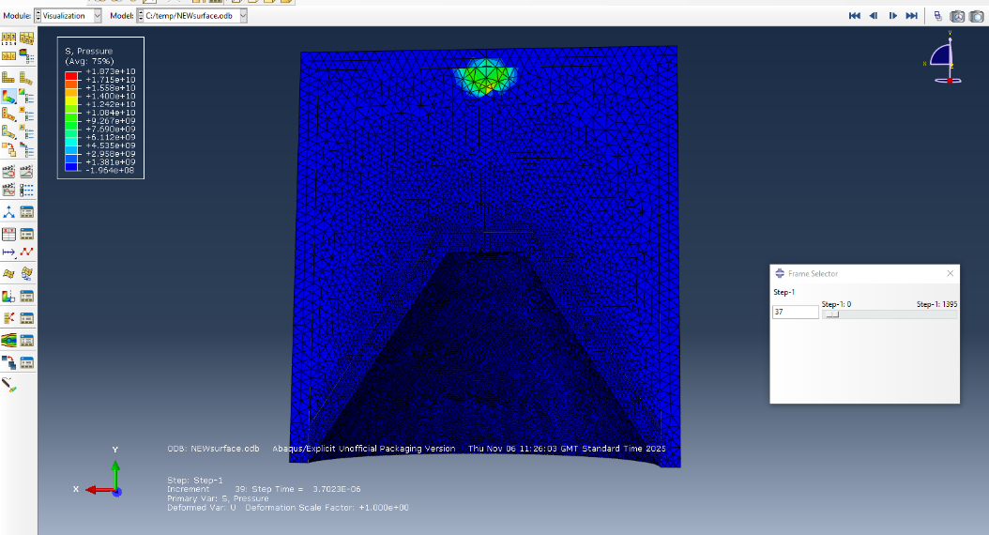
Mid Detonation | 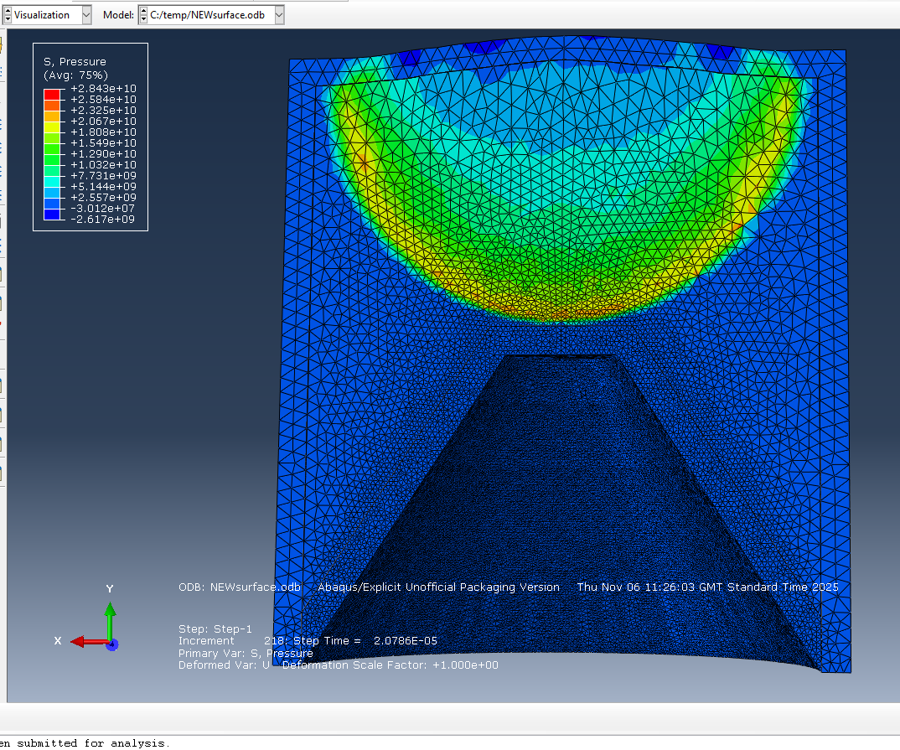
Initial Jet Formation | 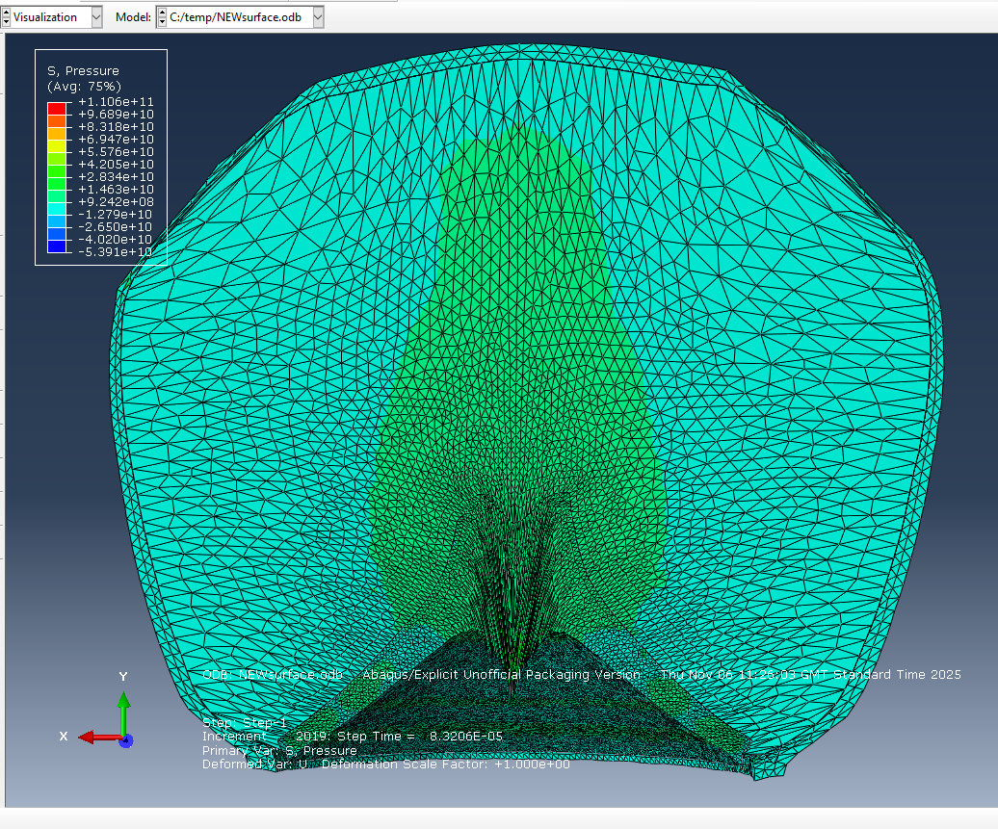
Complete Jet Formation | 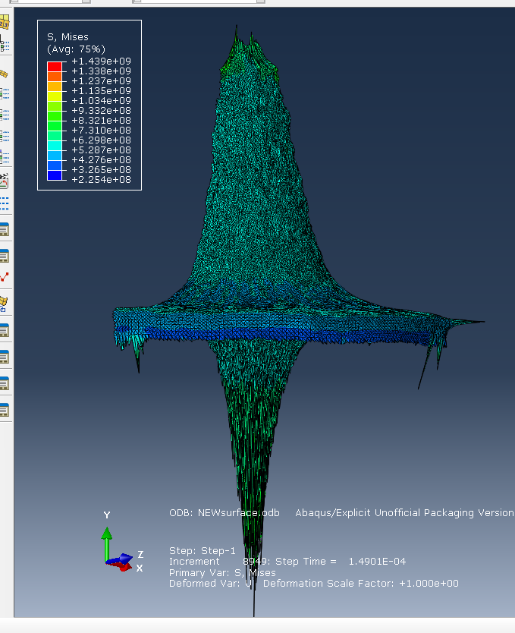

Table 11 - 3D SCJ Simulation Images

Each subheading shows a vast amount of information that can be used by the viewer:
- Start of Detonation – This shows the initiation point used to start the explosive chain with a vast amount of pressure build up represented by the green and red colour, showing how the pressure is building up through the munition.
- Mid Detonation – This shows the shockwave propagating through the HE fill prior to the formation of a jet. Within this image you can a massive pressure reaching 2.8 x 10¹⁰ Pa within the reacted HE as it promulgates towards the liner, showing how fast and powerful the explosive event is and the energy that is pressed into forming the shape charge jet.
- Initial Jet Formation – This shows the start of the Jet formation; within this it is evident that there is an extreme pressure build up being concentrated into the liner the copper being pressed into itself to begin to form a jet. Furthermore, the case has expanded to a balloon like state, with clear fracturing evident on the lips that align with the liner itself.
- Complete Jet Formation – This shows the complete jet formation at the point at which the simulation failed/ crashed. The 3D numerical model allows greater visual clarity, showing ridges, bumps and additional detail, whilst improving the realism to the 3D shape produced, rather than extruding a 2D output which mirrors the same side exactly.

Velocity Time Diagram
 | 3D Simulation
Node Selection | 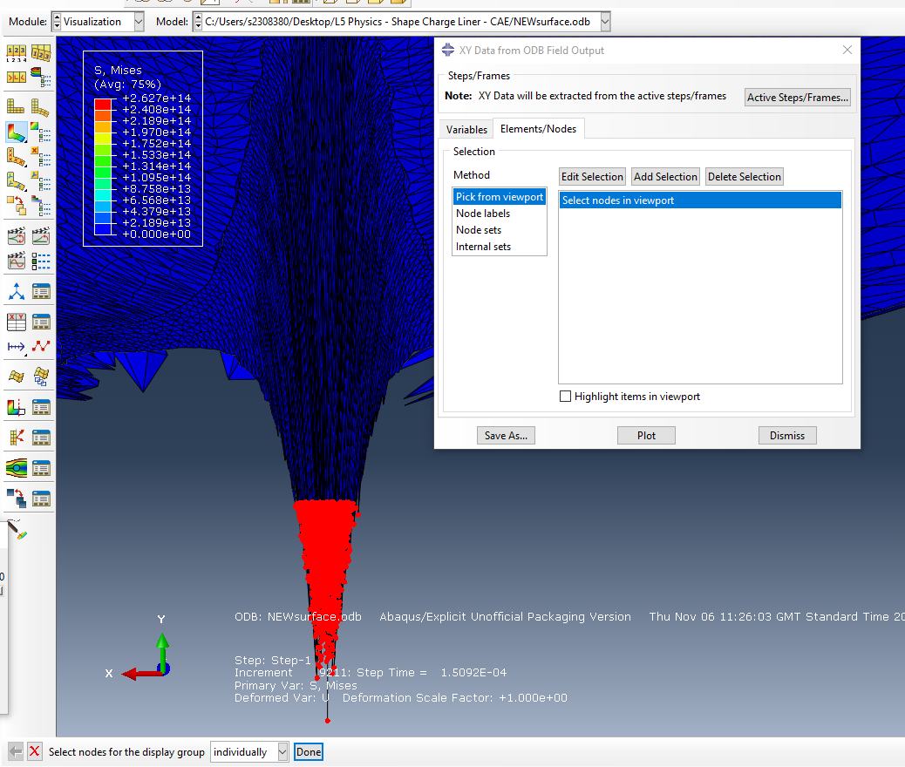
Velocity Diagram | 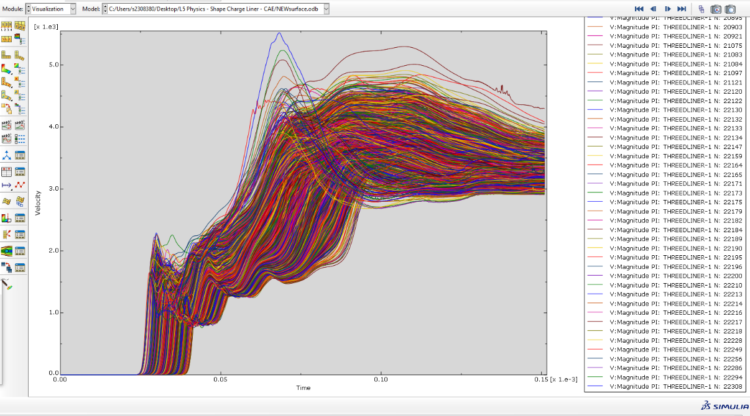
Table 12 - 3D SCJ Velocity Time Graph

The Velocity-Time diagram, tracking the velocities of circa 22000 nodes seen within table 12, shows smooth, collective transitions from peak to peak reaching around 5300 m/s, as expected from the previous copper liner 2D simulation.
When making a comparison between the results gained from this test, the 2D model performs just as well from a general metric standpoint, accurately capturing the peak velocity, general velocity trends alongside the timing of the jet formation. However, the 3D Velocity-Time graph appears much smoother and cohesive than the 2D graph, this is mainly attributed to the vast number of nodes (circa 22000) selected due to a better mesh being defined and an increased in total computational calculations. Furthermore, it provides much improved clarity and realism when watching the shaped charge evolve from initiation to the final jet formation, with improved visuals, notably off axis deformation which cannot be captured using 2D simulations, leading to unique surfaces and variation throughout the whole model.
A key flaw of the 3D is the number of nodes that undergo extreme deformation, leading to abnormally enlarged nodes, slight inaccuracies and ultimately requiring extreme processing power not available within this investigation causing a premature crash of the simulation.

Task 4: Effects of Advanced Numerical Techniques such as Smooth Particle Hydrodynamics
The following table shows images capturing a 3D Copper SCJ simulation using Smooth Particle Hydrodynamics (SPH), at key points within the process. For enlarged images, with additional images included, please see Appendix D.
The purpose of this test was to investigate the deformation, velocity characteristics and formation of shape charge jet that occurs when using a more complex 3D numerical model, identifying the improvements Smooth Particle Hydrodynamics can make to the simulation.
‘Smoothed particle hydrodynamics (SPH) is a meshless alternative to traditional Computational fluid dynamics (CFD) that foregoes the fixed mesh in favour of freely moving particles. The key difference between SPH and mesh-based methods is that the particles are free to advect with the flow according to the dynamics of the problem.’ [20] Although SPH is traditionally talked about using fluids rather than solid materials, the extreme pressure and deformation that occur within shaped charges, specifically within the liner cause it to act in a fluid state.
SPH allows for the liner to be represented as thousands of tiny particles, rather than a mesh, which represents the liner as thousands of small triangles which are stitched up into one large(r) object. Although you can have an extremely fine mesh, you still run into the limitation that the software is treating it as thousands of subcomponents (small triangles) that are stitched together as one, so when there is extreme deformation and high strain rates as found in shaped charges, the material doesn’t behave as it would in real life with severe element deformation and unrealistic material behaviours occurring.
By using SPH, you effectively remove the permanent fixation of elemental subcomponents imposed by traditional meshing, allowing all the particles to handle large scale rates of deformation with realism, displaying permanent separation and clear fragmentation.

 | 3D SCJ Simulation – SPH
Start of Detonation | 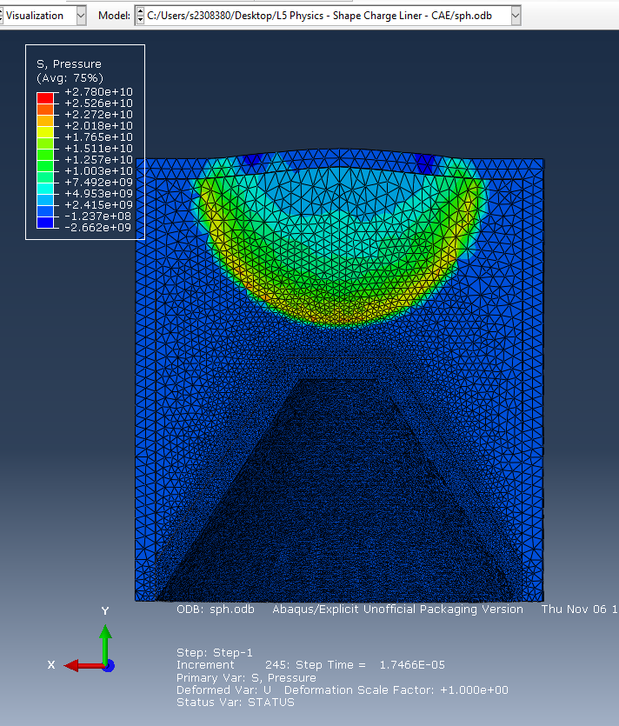
Mid Detonation (activation of SPH) | 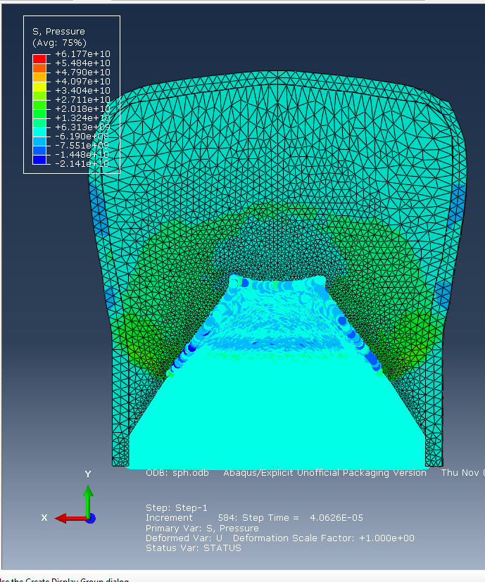
Jet Formation | 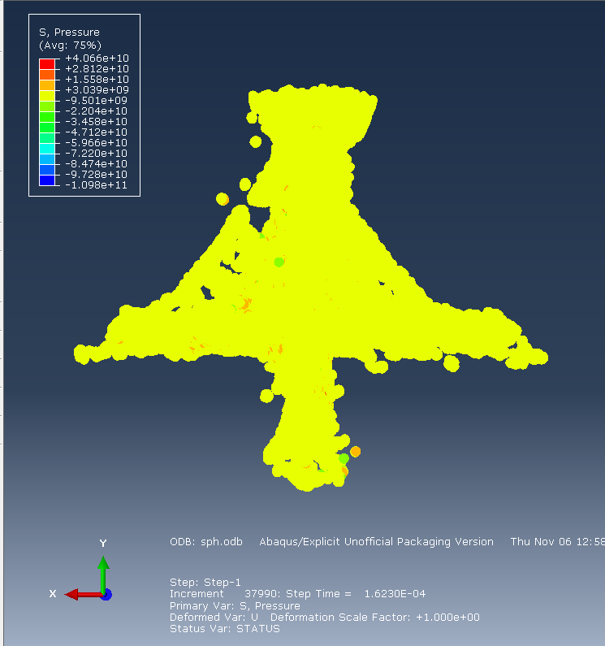
Complete Jet Formation | 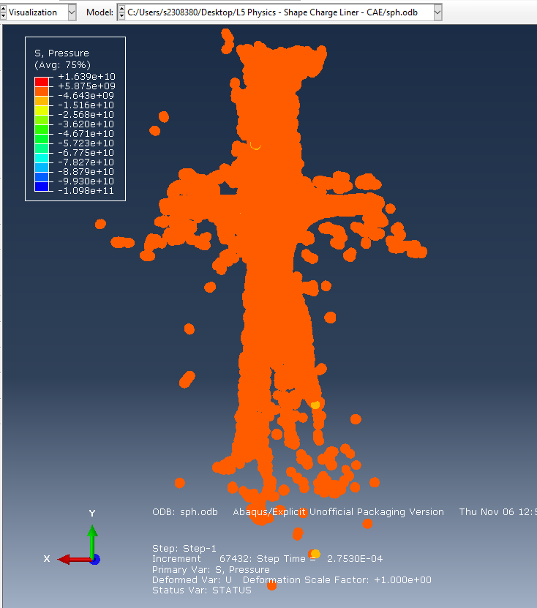  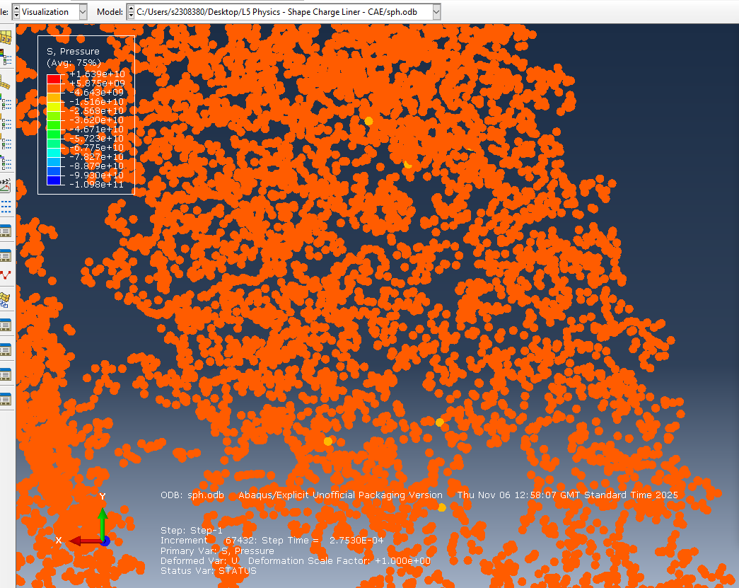
Table 13 - 3D SCJ SPH Simulation Images

Each subheading shows a vast amount of information that can be used by the viewer:
- Start of Detonation – This shows the initiation point used to start the explosive chain with a vast amount of pressure build up represented by the green and red colour, showing how the pressure is building up through the munition.
- Mid Detonation – This shows the shockwave propagating through the HE fill prior to the formation of a jet. Within this image you can see the SPH activation. This was set to occur at the point at which the detonation reached the liner to hit a balance between computational efficiency and requirement.
- Jet Formation – At this stage you can see the jet partially formed out of thousands of particles, demonstrating the simulation working with the SPH methodology. Within this image, you can see where the copper liner has started to fragment slightly rather than completely clumped together.
- Complete Jet Formation – This shows the complete jet formation at the point at which the simulation finished. Within this you can see a very clear outline of the copper jet that has formed; however, you can also see many fragmented particles that have ended up travelling in different directions to the general downwards facing blast. This provides a degree of realism that had been missing within all the previous simulations.

SPH Velocity Time Graph
 | 3D Simulation - SPH
Node Selection | 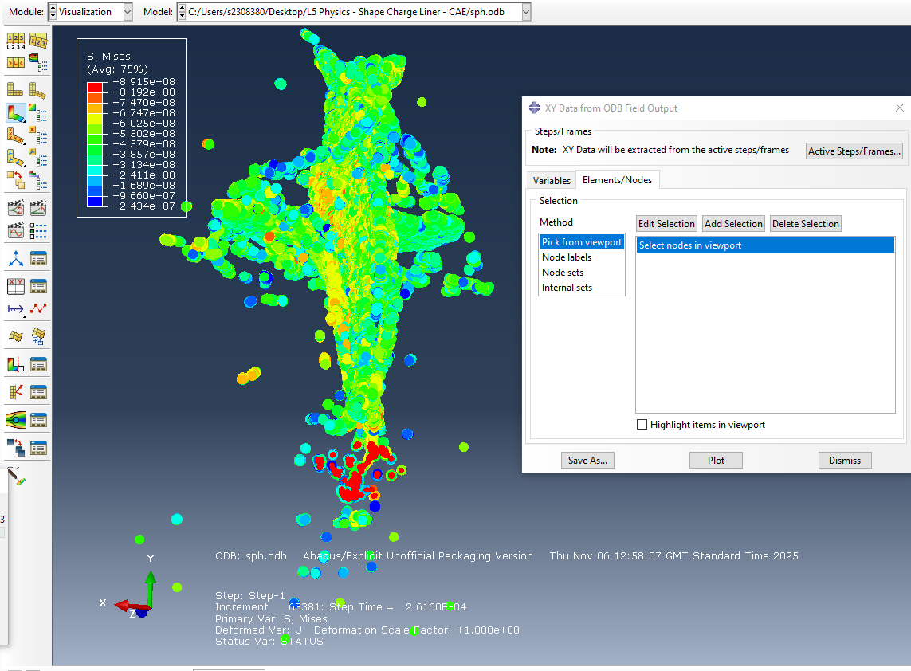
Velocity Diagram | 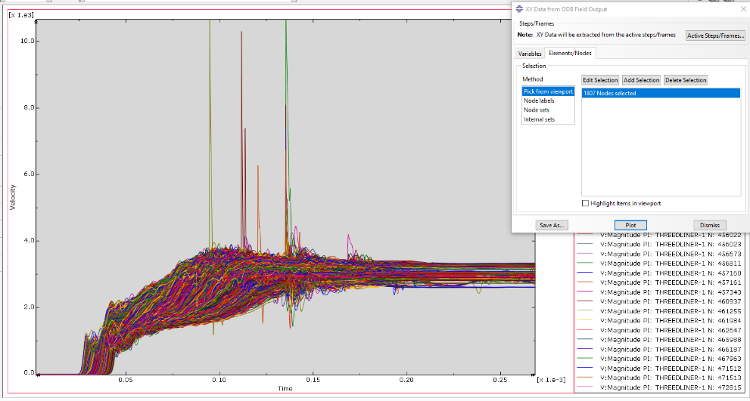
Table 14 - 3D SCJ SPH Velocity Time Graph
Within Table 14, the velocities maintained at a speed of around 3000-4000m/s. This is a significant drop in comparison to the velocities of 5000-6000m/s experienced within the 3D mesh simulation ran within Task 3. However, this is likely because the liner has been represented by many free particles thus meaning that they are able to flow freely into each other as well as into different directions rather than being purely pressed in on itself in a strict downwards direction, which is likely the main reason why there is a reduction in velocity. The nodes were selected to provide an insight into the velocities experienced the peak of the liner through liner collapse and deformation. The shape of the jet appears longer and thinner than those previously found and much more consistent with the literature referenced within this report.

Conclusion
This investigation has investigated a variety of methodologies surrounding the simulation of Shaped Charges, from 2D to 3D to the use of advanced methodologies such as SPH. From this experimentation the following conclusions can be made:
1. 2D simulations are a terrific way to quickly, safely and accurately model shaped charges. For any major change or idea that you do not require an immense level of accuracy and understanding of material failure with the Z direction, this type of simulation would suit the use case perfectly.
2. 3D simulations are a good improvement on the accuracy of simulations, providing greater visual detail and velocities. However, they require a lot more computational power and take a long time to run on worse machines. This would be a recommended method to use to improve on results gain from a proven 2D simulation to prevent time wasting.
3. The use of Smooth Particle Hydrodynamics is essential for any simulation that require a level of detail that 3D simulations with a lagrangrian mesh does not satisfy in relation to particle behaviour. However, the computational power required to adequately run these simulations are extreme, so would require thorough preparation with a final design that will not be changed or require repeating alongside the use of a capable machine.

References

[1] | “Sinula - Abaqus/Explicit,” DASSAULT SYSTEMS, [Online]. Available: https://www.3ds.com/products/simulia/abaqus/explicit. [Accessed 1 November 2025].
[2] | W. D. Walters, “A Brief History of Shaped Charges,” Army Research Laboratory, December 2008. [Online]. Available: https://apps.dtic.mil/sti/tr/pdf/ADA497450.pdf. [Accessed 26 October 2025].
[3] | D. Yang and J. Lin, “Numerical Investigation on the Formation and Penetration Behavior of Explosively Formed Projectile (EFP) with Variable Thickness Liner.,” Symmetry, 2021. [Online]. Available: https://www.mdpi.com/2073-8994/13/8/1342. [Accessed 15 December 2025].
[4] | A. J. Ruys, “Silicon Carbide CeramicsChapter 8 - Glass-Bonded SiC (GBSC): Pages 435-489,” In Elsevier Series in Advanced Ceramic Materials, 2023. [Online]. Available: https://www.sciencedirect.com/science/chapter/monograph/abs/pii/B9780323898690000058. [Accessed 5 December 2025].
[5] | F. Teixeira-Dias and D. Cardoso, “Modelling the formation of explosively formed projectiles (EFP),” Science Direct, July 2016. [Online]. Available: https://www.sciencedirect.com/science/article/pii/S0734743X16300513?casa_token=pSxXoAwBXZUAAAAA:neNzPaq9GlWMs9b9koCYKzwm1llrVJ5rAU-xGzjuiC_xHz4ptXYgVjFscyqbJ4AvQ8u24YV1ZGh6nA. [Accessed 20 November 2025].
[6] | “8 - Developing mine blast resistance for composite based military vehicles,” QinetiQ, 27 March 2024. [Online]. Available: https://www.sciencedirect.com/science/chapter/edited-volume/abs/pii/B9781845693992500081. [Accessed 5 January 2026].
[7] | S. R. and B. G., “Review of Jones-Wilkins-Lee equation of state,” EDP Sciences, 2010. [Online]. Available: https://www.epj-conferences.org/articles/epjconf/pdf/2010/09/epjconf_nmh2010_00021.pdf. [Accessed 1 December 2025].
[8] | H. S. Nam, J. S. Kim, J. J. Han, J. W. Kim and Y. J. Kim., “Ductile fracture simulation for A106 Gr.B carbon steel under high strain rate loading condition,” ScienceDirect, 2014. [Online]. Available: https://www.sciencedirect.com/topics/engineering/cook-model. [Accessed 1 December 2025].
[9] | H. Yamanda, T. Sakai, N. Ogasawara, M. Kokudai, D. Shiomitsu and T. Fukui, “Determination of a material constitutive equation that includes the effects,” Ocean Engineering, 23 November 2023. [Online]. Available: https://www.sciencedirect.com/science/article/pii/S0029801823021030?dgcid=rss_sd_all&#:~:text=Johnson%2DCook%20model%20(Johnson%20and,included%20in%20the%20CS%20model.. [Accessed 20 November 2025].
[10] | “What is Finite Element Analysis (FEA)?,” Ansys, [Online]. Available: https://www.ansys.com/en-gb/simulation-topics/what-is-finite-element-analysis. [Accessed 20 December 2025].
[11] | J. Shi, Z.-x. Huang, X.-D. Zu and Q.-q. Xiao, “Experimental and numerical investigation of jet performance based on Johnson-Cook model of liner material,” 6 August 2022. [Online]. Available: https://www.sciencedirect.com/science/article/pii/S0734743X22001865. [Accessed 4 November 2025].
[12] | K.-J. Wang, G. Rong and W.-J. Yi, “Design and Damage Performance Ability of Supercavitation,” Propellents, Explosives, Pyrotechnics - John Wiley & Sons, 2019. [Online]. Available: https://www.researchgate.net/publication/337976227_Design_and_Damage_Performance_Ability_of_Supercavitation_Projectile_with_Shaped_Charge. [Accessed 13 October 2025].
[13] | H. Cui, P. Song, X.-H. G. Gu, H. Zhou, B.-Y. Xing, L. Jiang and R. Guo, “Determination of the JWL Parameters of Detonation Products Using Adaptive Genetic Algorithm,” December 2020. [Online]. Available: https://www.researchgate.net/publication/347577108_Determination_of_the_JWL_Parameters_of_Detonation_Products_Using_Adaptive_Genetic_Algorithm. [Accessed 04 November 2025].
[14] | MW Components, “Carbon Steel Grade 1006 Data Sheet,” [Online]. Available: https://www.mwcomponents.com/uploads/Resource-Center/Elgin-Material-Sheets/Carbon-Steel-Grade-1006-Data-Sheet_Elgin-Fasteners.pdf. [Accessed 4 November 2025].
[15] | MatWeb, “Copper, Cu; Annealed,” MatWeb, [Online]. Available: https://www.matweb.com/search/DataSheet.aspx?MatGUID=9aebe83845c04c1db5126fada6f76f7e. [Accessed 4 November 2025].
[16] | S. I. Jackson, “Scaling of the Detonation Product State,” 8 December 2017. [Online]. Available: https://jackson.engr.tamu.edu/wp-content/uploads/sites/229/2021/06/2017-JacksonScaling.pdf?. [Accessed 4 November 2025].
[17] | S. Zaki, E. Uddin, B. Rashid, A. Mubashar and S. R. Shah, “Effect of liner material and explosive type on penetration effectiveness of shaped charge,” Institute of Mechanical Engineers, 10 January 2010. [Online]. Available: https://journals.sagepub.com/doi/10.1177/1464420717753233. [Accessed 12 October 2025].
[18] | “3D Meshing in Abaqus CAE,” Fidelis, [Online]. Available: https://www.fidelisfea.com/post/3d-meshing-in-abaqus-cae. [Accessed 1 November 2025].
[19] | C. Trento, “Ductility of Common Materials,” Stanford Advanced Materials, 24 July 2025. [Online]. Available: https://www.samaterials.com/content/ductility-of-common-materials.html. [Accessed 15 October 2025].
[20] | J. O'Connor, “Accelerating smoothed particle hydrodynamics with graph neural networks,” University of Edinburgh - EPCC, 29 February 2024. [Online]. Available: https://www.epcc.ed.ac.uk/whats-happening/articles/accelerating-smoothed-particle-hydrodynamics-graph-neural-networks#:~:text=Smoothed%20particle%20hydrodynamics%20(SPH)%20is,solution%20of%20the%20governing%20equations.. [Accessed 1 January 2025].

Appendices

– 2D SCJ Simulation Images

Copper SCJ
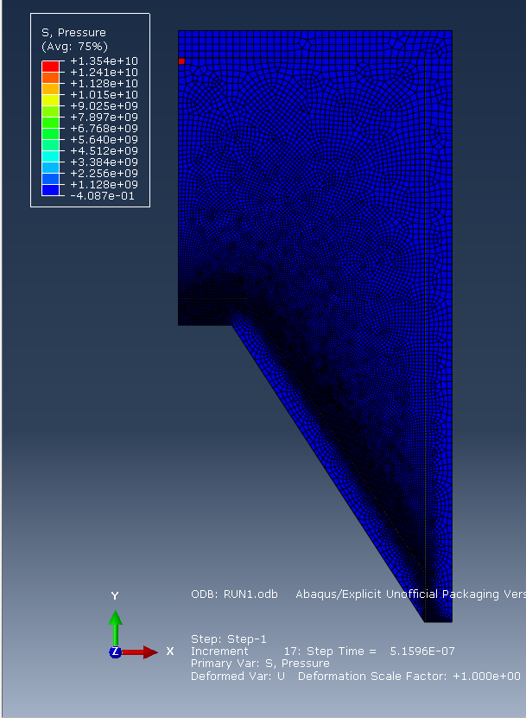
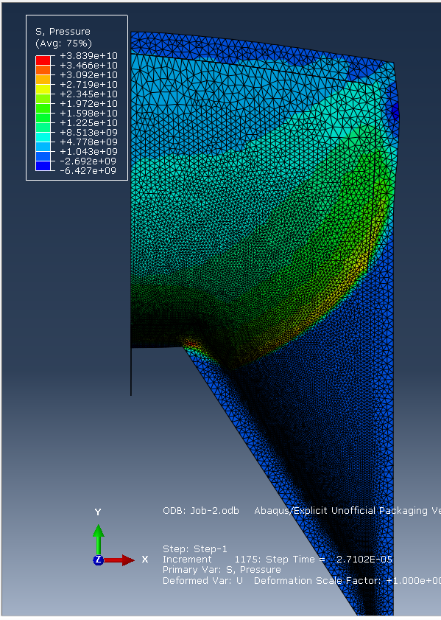
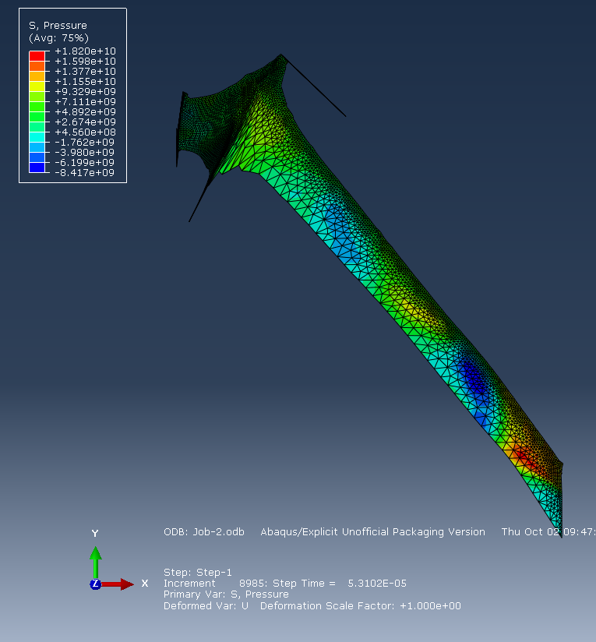

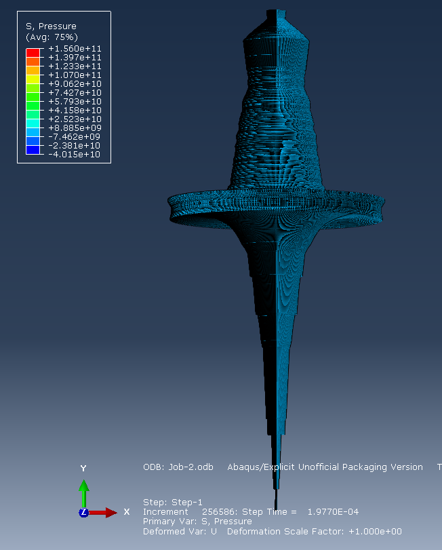

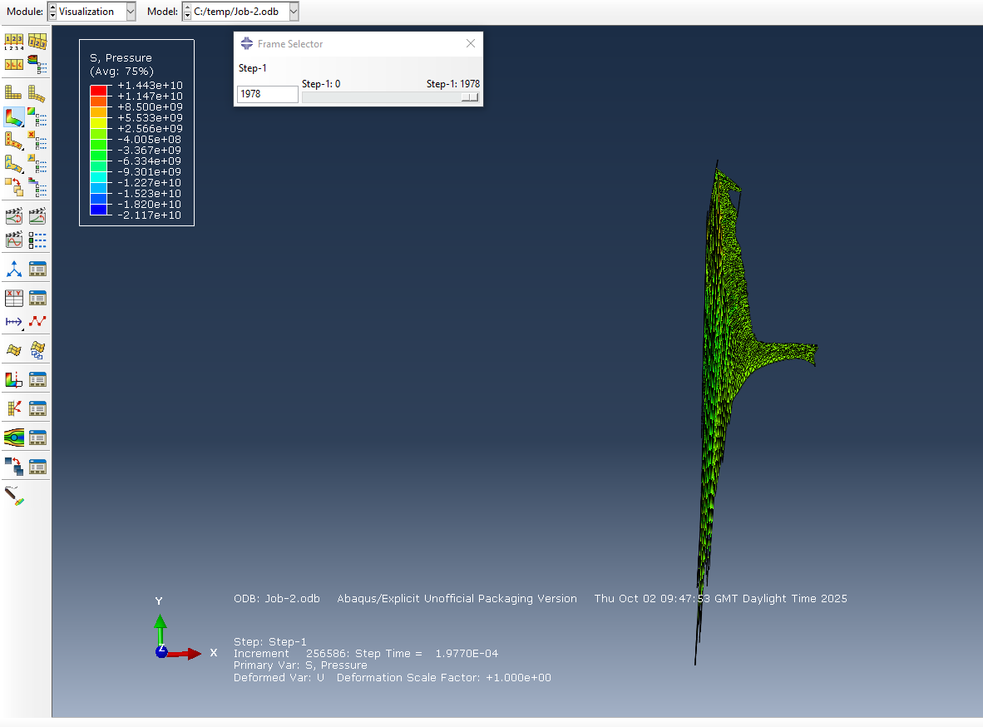

Steel SCJ
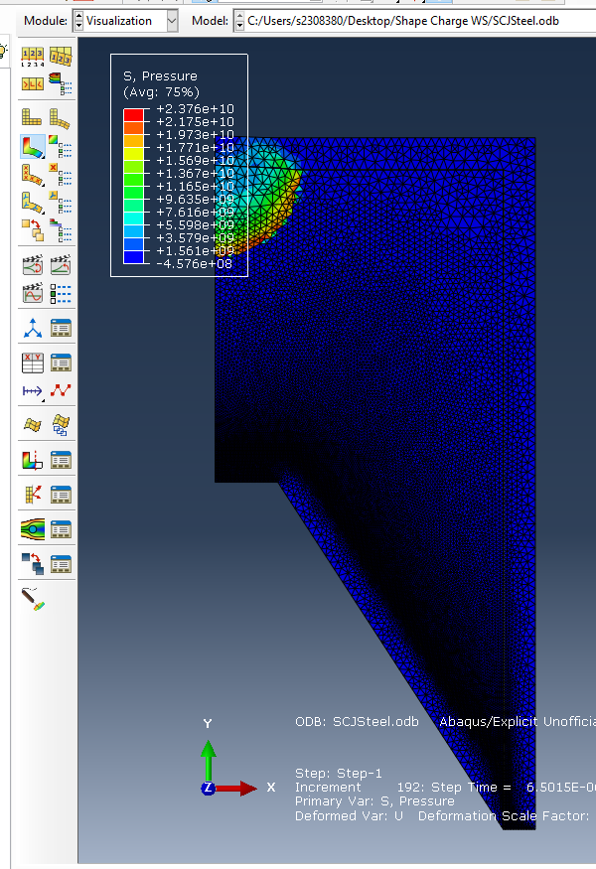
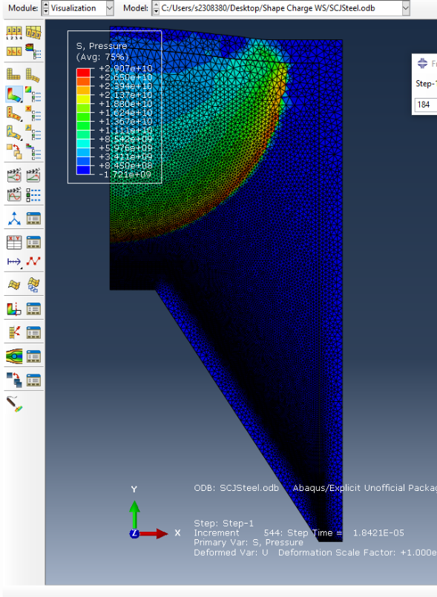

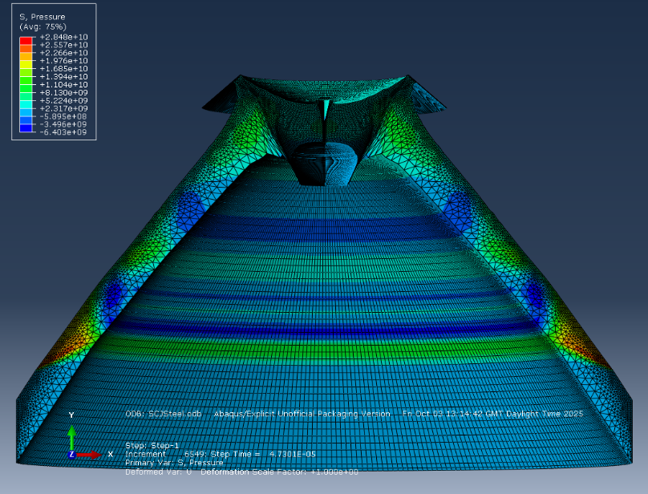
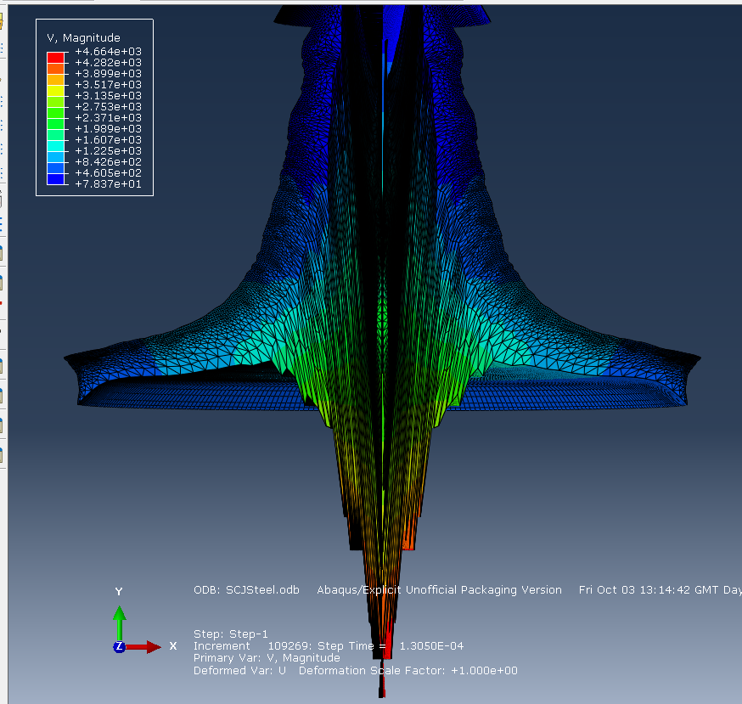

– 2D EFP Simulation Images

Copper EFP
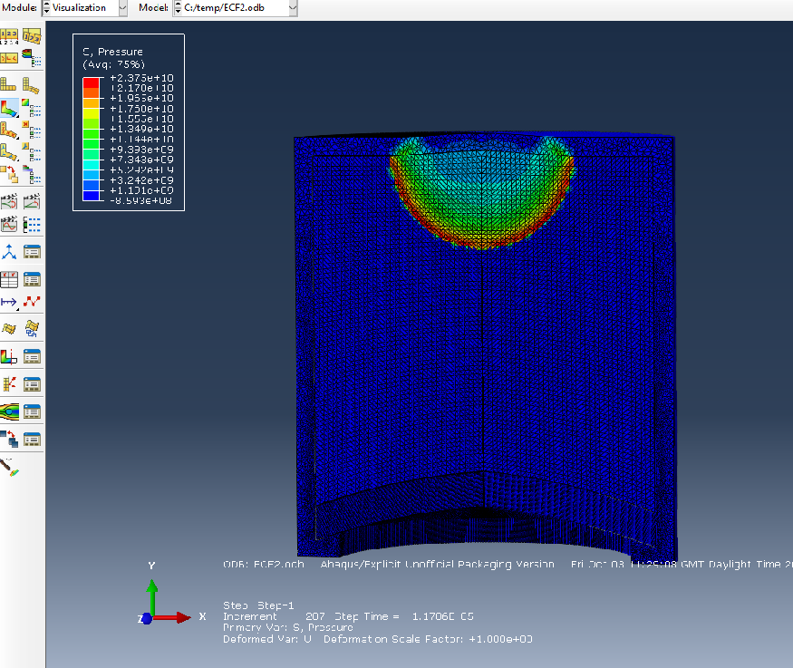
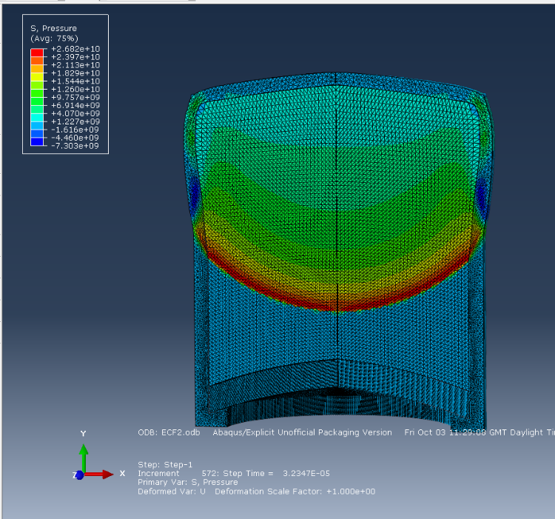
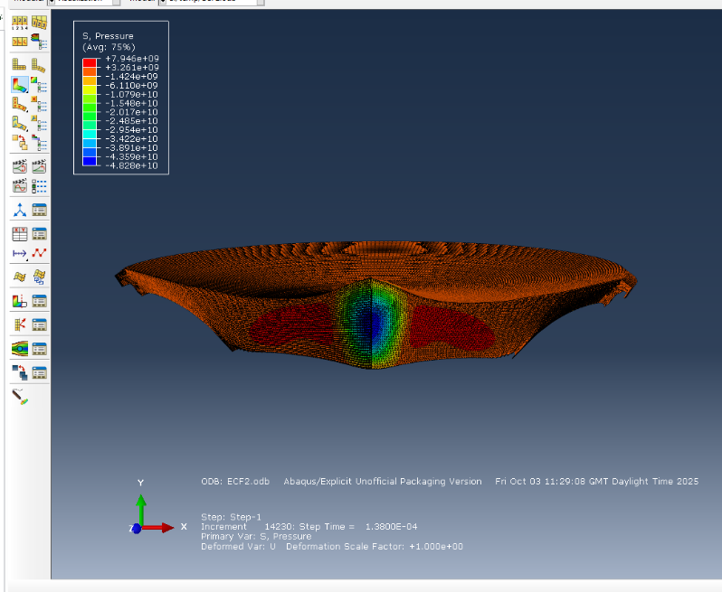
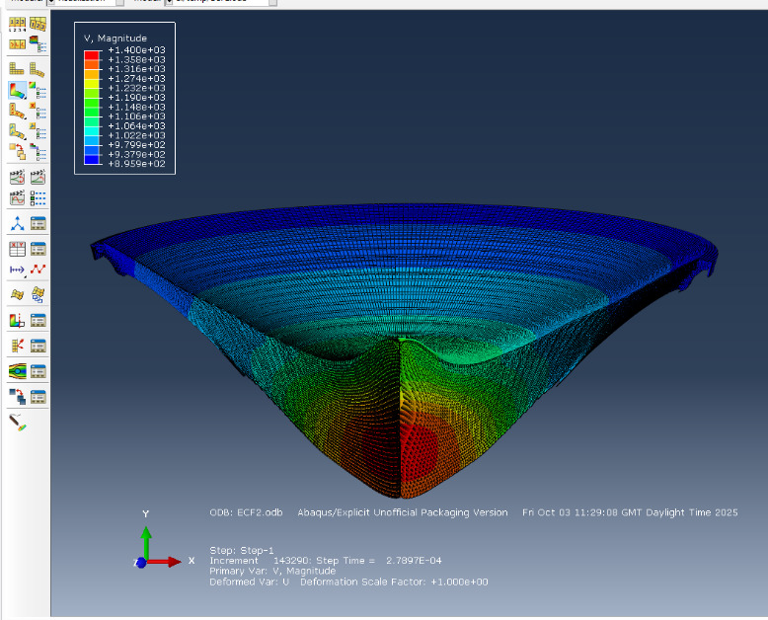

Steel EFP
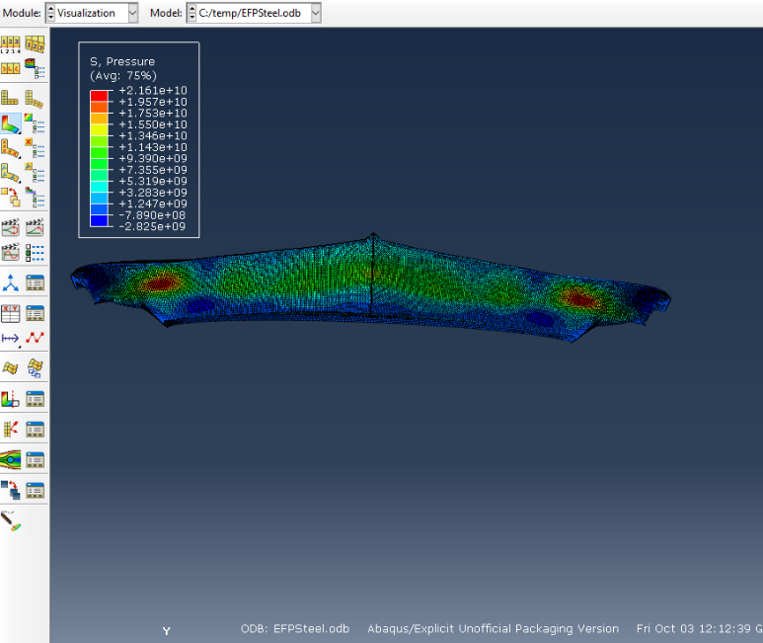
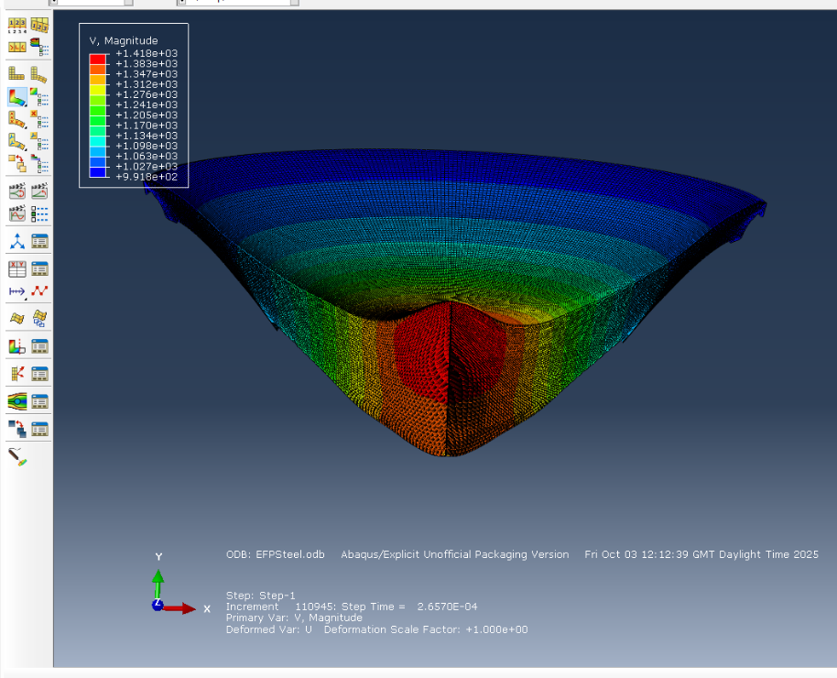

– 3D SCJ Simulation Images

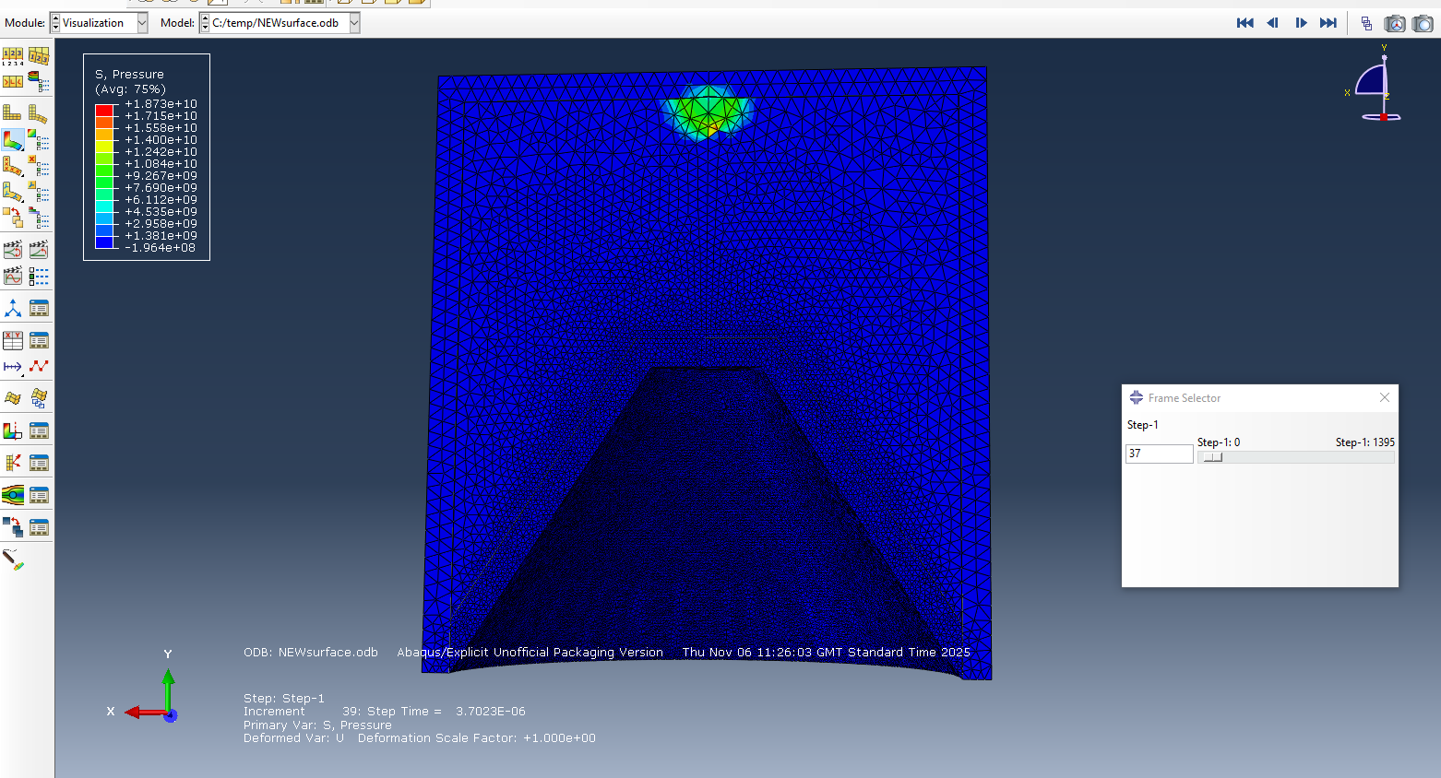
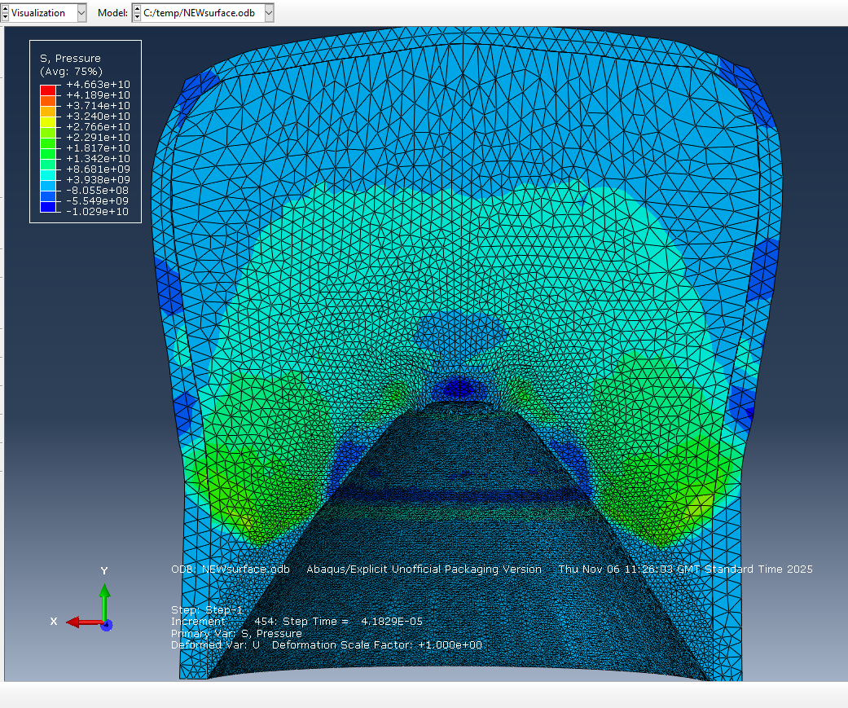
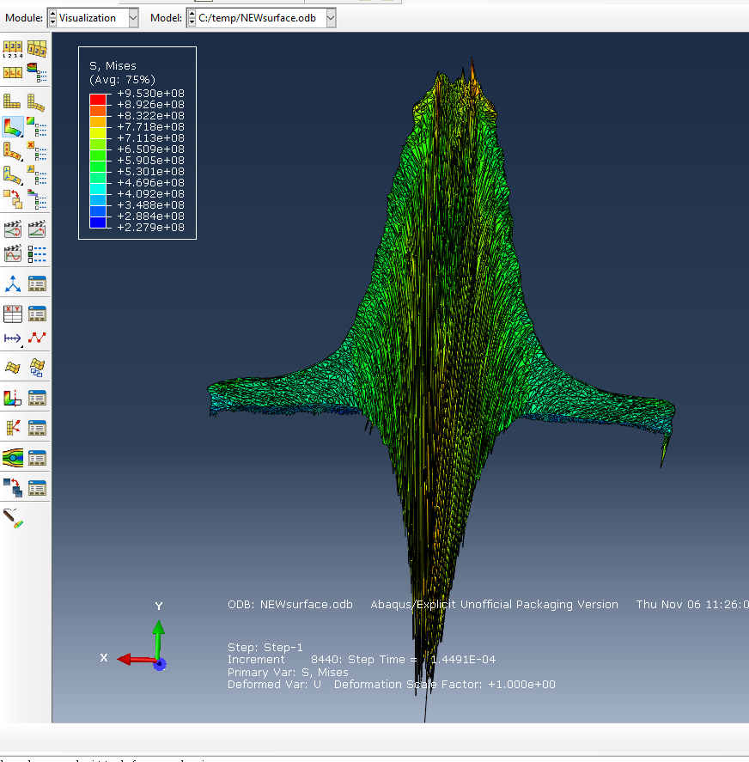

– SPH Simulation Images


