Design and Implementation of an
EcoRide Relational Database System
ACCA4023
2532111
Joseph Protheroe
Word Count: 1843

Table Of Contents
Table Of Contents 2
Introduction and scenario context 3
Scenario analysis: entities and relationships 3
ERD and implemented data structure 4
Validation rules and 3NF 6
Members Entity 6
Rentals Entity 6
Bikes Entity 6
Locations Entity 7
Services Entity 7
Staff Entity 7
NORMALISATION and 3NF 7
Sample data and query development 9
Sample Data 9
Queries 12
Testing and results 15
Validation Testing 15
User Interface Testing 19
Design decisions, CHALLENGES, and improvements 21
Conclusion 22
References 23

Introduction and scenario context
Eco Ride is a fictional scheme run by the local Swansea council, and is an electric e-bike rental scheme and the aim of which is to ensure that commuting in Swansea is healthy and green. The team running the scheme are facing issues due to the rising popularity of the scheme and the face they are still mainly running the scheme using paper, this is causing inefficiencies. Because of this I have designed and created a structured database solution to streamline operations. This was created using MS Access and its purpose is to centralise information and reduce errors. The Database contains information on Members, Bikes, Locations, Rentals and Servicing.

Scenario analysis: entities and relationships
The database has been designed to model the main operational areas of the EcoRide scheme. Each entity represents a real-world object or activity that the council needs to record, such as riders, bikes, rental activity, maintenance work, staff, and storage locations. Those requirements have ended up with me creating six entities within the database, they are as follows:
Entity | Purpose
Members | Stores the details for each rider
Bikes | Stores the information of each bike
Locations | Stores details on each location a bike is stored
Rentals | Records members renting a bike
Staff | Store employee detail
Services | Recording servicing and inspection activities
There are many relationships between these entities, they are as follows:
- One member can have many rentals.
- Each rental belongs to one member.
- One bike can appear in many historical rentals.
- Each rental relates to one bike.
- One location can hold many bikes.
- One bike can have many service records.
- One staff member can complete many services.
- Each service record relates to one bike and one staff member.
Rentals connect members and bikes over time as more bookings are made and similarly services connect staff and bike over time as well as storing information about the maintenance event itself.

ERD and implemented data structure
Access Relationship design window.
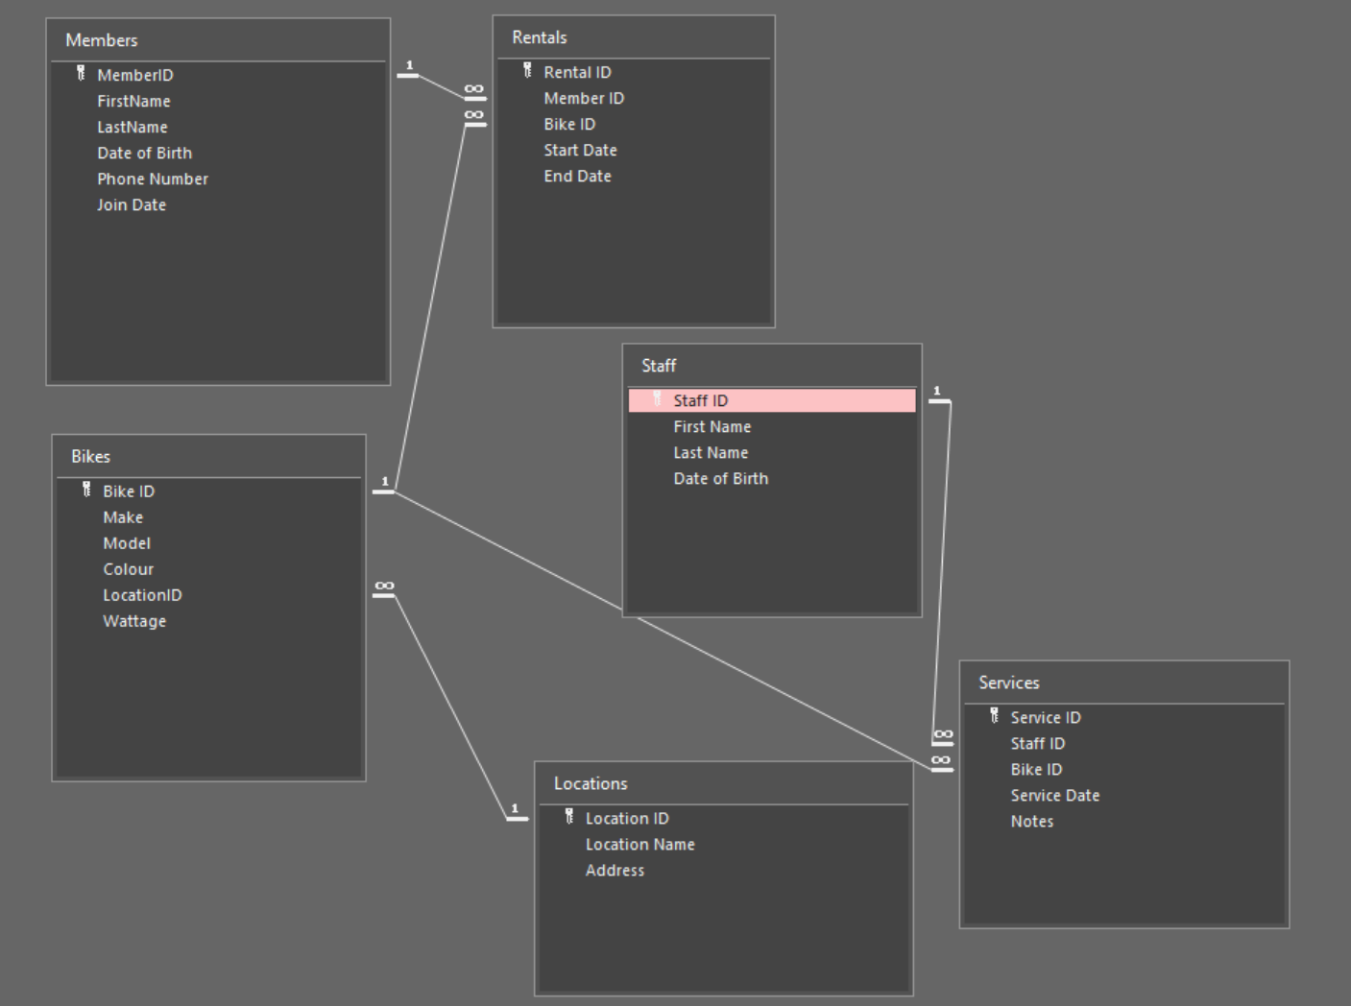

ERD diagram.
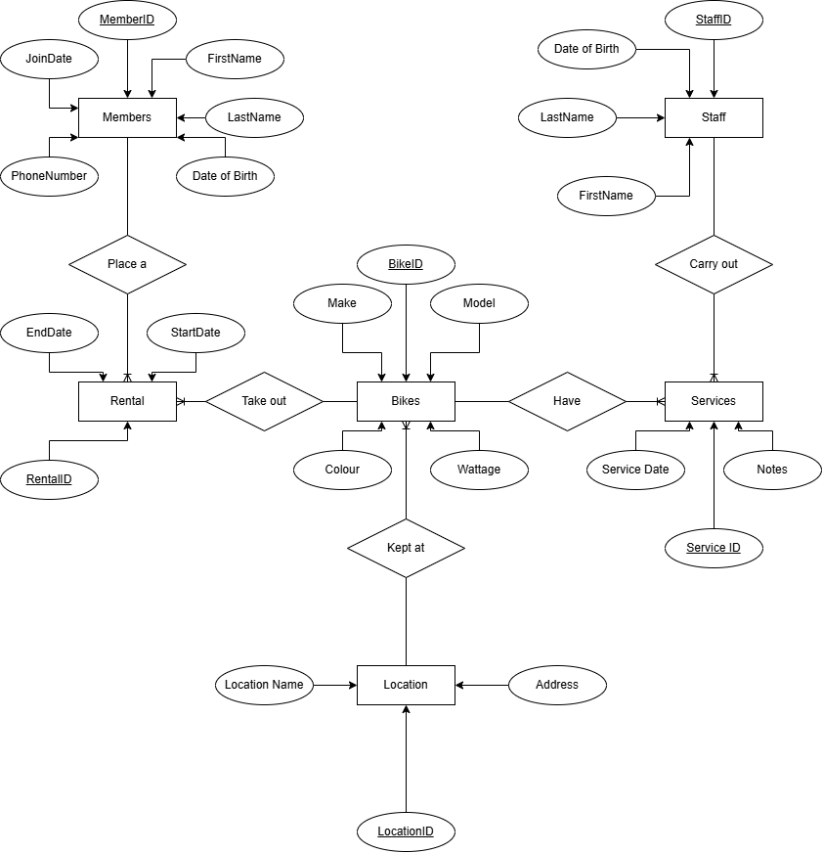
As you can see from the entity relationship diagram (ERD) The primary keys are
- MemberID
- RentalID
- BikeID
- LocationID
- StaffID
- ServiceID
This is not directly shown on the diagram but from the relations ships between entities there are multiple foreign keys those are as follows.
- Rentals.MemberID
- Rentals.BikeID
- Bikes.LocationID
- Services.StaffID
- Services.BikeID
Primary keys uniquely identify each record, while foreign keys link related records together. All relationships shown in the diagram are one-to-many. Referential integrity ensures that rentals and service records cannot refer to records that do not exist. Because of the structure of the ERD historical rental and service records are not overwritten and remain accessible indefinitely.

Validation rules and 3NF

Members Entity
FirstName - Required
LastName - Required
Date of Birth – Required, Between DateAdd("yyyy",-100,Date()) And DateAdd("yyyy",-16,Date()), “Members must be between 16 and 100 years old.”
Phone Number – Required, Field Size 11
Join Date – Required, Validation rule “<Date ()”, Validation text “Date cannot be in the future”.
The validation this way as all the fields is necessary, I restricted the phone number to field size of eleven as that is the length of a UK phone number and international numbers should not be used. The validation of the join date attribute ensures that the join date cannot be in the future and is reasonable as you cannot join a programme/scheme in the future only in the present and the validation on the date of birth ensure that the date entered is reasonable.

Rentals Entity
Start Date – Required, >=Date() , “Rental Start Date cannot be in the past”
End Date - Required, >=Date() , “End Date cannot be in the past”
Additional Validation - [End Date]> [Start Date], “End date must be after start date”
The validation for this entity ensures that the fields have been filled but also that start an end dates must be either in the present or future and that the end date must be after the start date.

Bikes Entity
Make - Required
Model - Required
Colour -Required
Wattage – Required, >0 And <=300, “Wattage must be between 1 and 300.”
All attributes are required and the validation on the wattage attribute ensure that the wattage is reasonable.

Locations Entity
Location name - Required.
Address- Required
Both these fields are required for operation.

Services Entity
Service Date - Required
Notes – Not Required
The purpose of this validation is that a service date may be entered for a service carried out either on that day or the day before and the notes are not required as

Staff Entity
First Name - Required
Last Name - Required
Date of Birth - Between DateAdd("yyyy",-100,Date()) And DateAdd("yyyy",-16,Date()), ”Enter a valid date of birth. Staff must be between 16 and 100 years old.”
All attributes are required for operation and the date of birth check ensures that the date entered is reasonable.

NORMALISATION and 3NF
This Database is in the third normal form, for example here are the functional dependencies to the database.
- MemberID -> FirstName, LastName, DateOfBirth, PhoneNumber, JoinDate
- RentalID -> MemberID, BikeID, StartDate, EndDate
- BikeID -> Make, Model, Colour, LocationID, Wattage
- LocationID -> LocationName, Address
- StaffID -> FirstName, LastName, DateOfBirth
- ServiceID -> StaffID, BikeID, ServiceDate, Notes
It meets 1NF because every field/attribute contains a single value and there are no repeating groups, so they are atomic. It then meets the 2NF as table only uses a single field as its primary key so there is no possibility of a partial dependency occurring. It further meets 3NF as every non key field depends directly on its tables primary key rather than any other field each entity only contains data on what that entity is for e.g. only member data is in the members table and so on and so forth. So the design of all the entities and attributes contained within prevents duplication and ensures that no deletion, update, or insertion errors occur.

Sample data and query development

Sample Data

Bikes
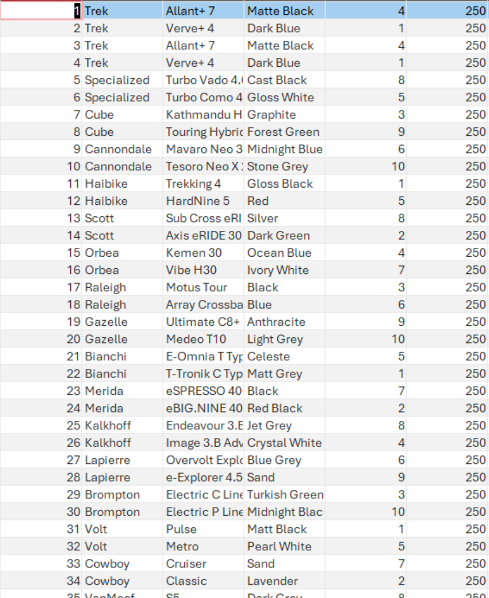

Locations
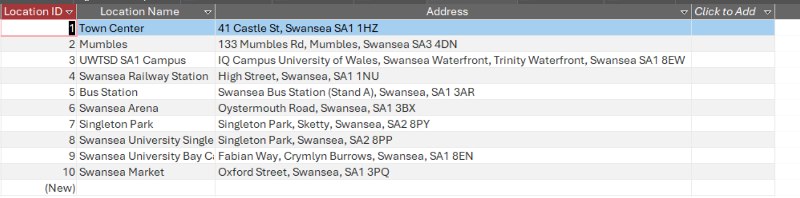

Members
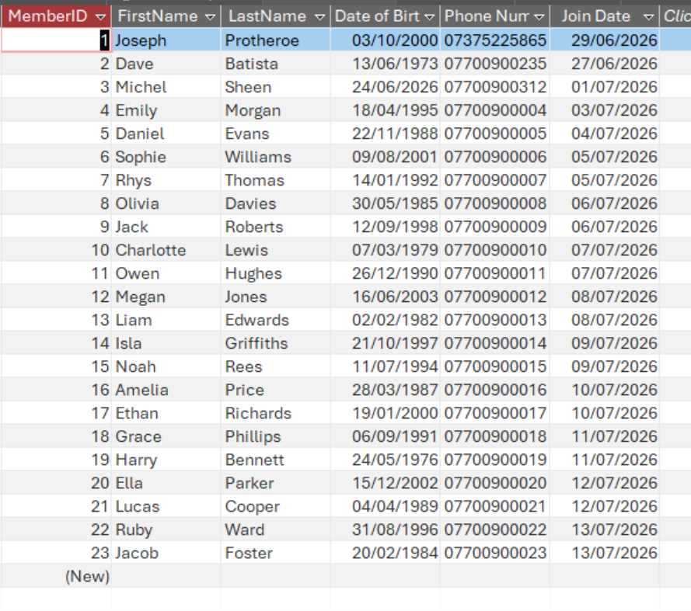

Rentals
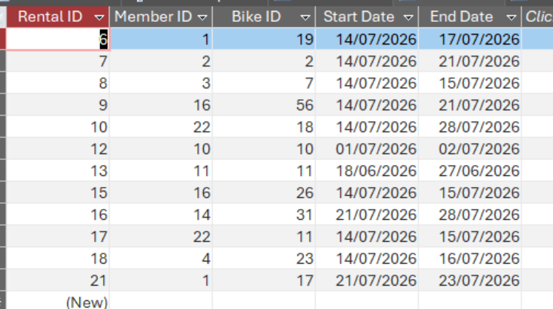

Services
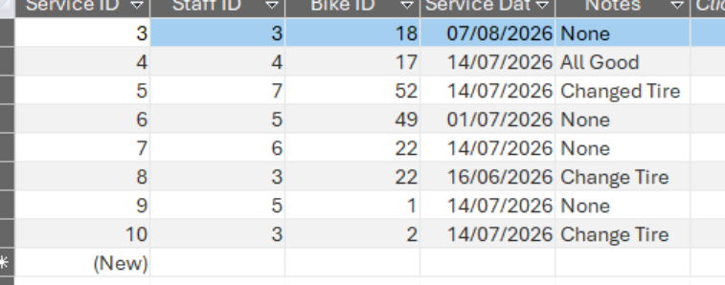

Staff
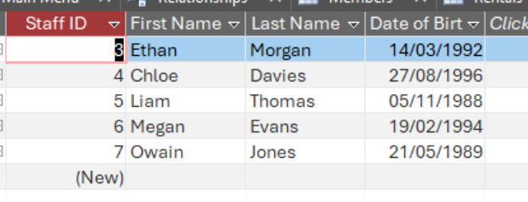

Queries
I have seven queries, Bike Service History, Bikes Available, Bikes Out, Bikes to service, Customer Usage, Location Stock and Location stock Detailed.

Bike Service History
Purpose: To show the services done on a specific bike by inputting its BikeID
Query Structure:
Bikes.BikeID criteria = [Please enter a bike ID]
Services.ServiceDate = sort ascending
Screenshot: (BikeID = 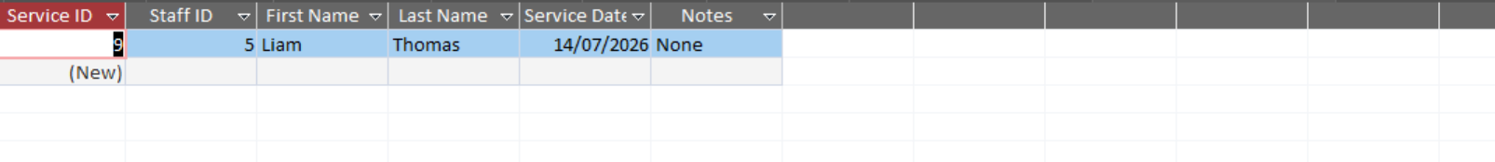

Bikes Available
Purpose: The show the bikes that are not currently being used by another member
Query Structure:
Location.LocationName = sort accending
BikesOut.BikeID (query) = “is Null” and not shown
Screenshot:
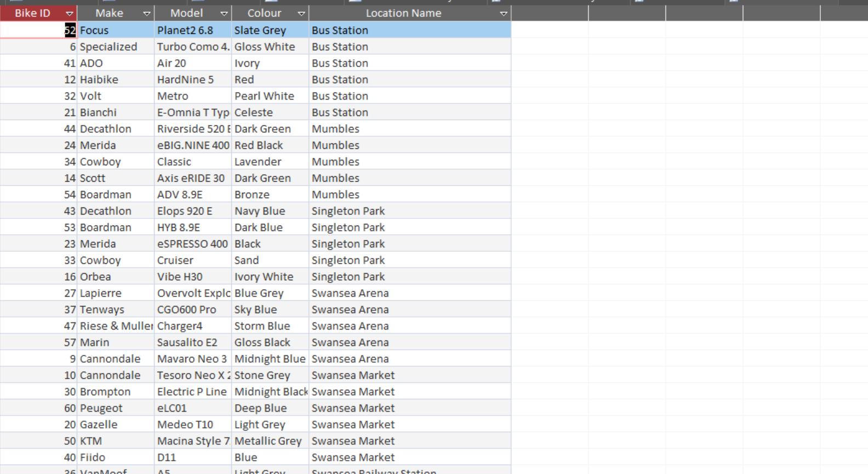

Bikes Out
Purpose: To show the bikes currently out on loan
Query Structure:
Rental.EndDate = “>Date()”
Screenshot: 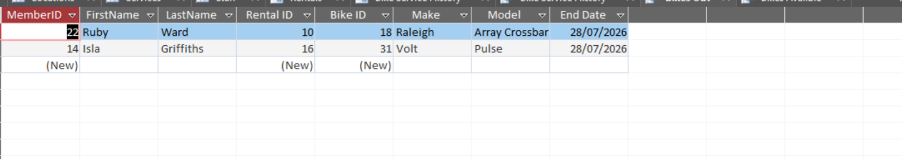

Bikes to service
Purpose: To show all bikes sorted by when each one had its last service
Query Structure:
Services.ServiceDate = sort Accending
Join Type = Show all records from bikes
Screenshot:
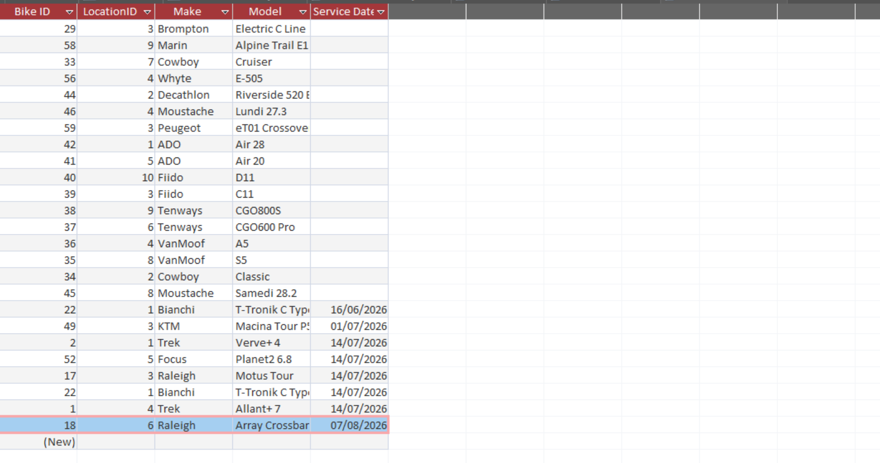

Customer Usage
Purpose: To show which members use the scheme the most
Query Structure:
Rental.RentalID = count, sort descending
Screenshot:
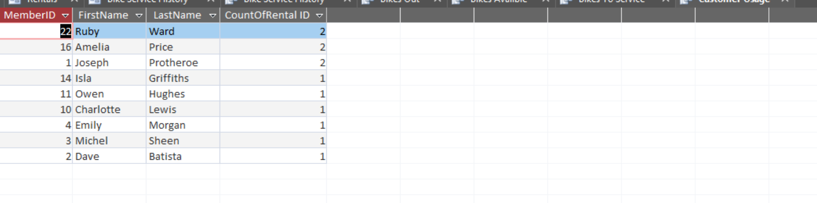

Location Stock
Purpose: To show the Amount of stock in each location
Query Structure:
Bikes.LocationID = count
Location.LocationID = Sort Accending.
Screenshot: 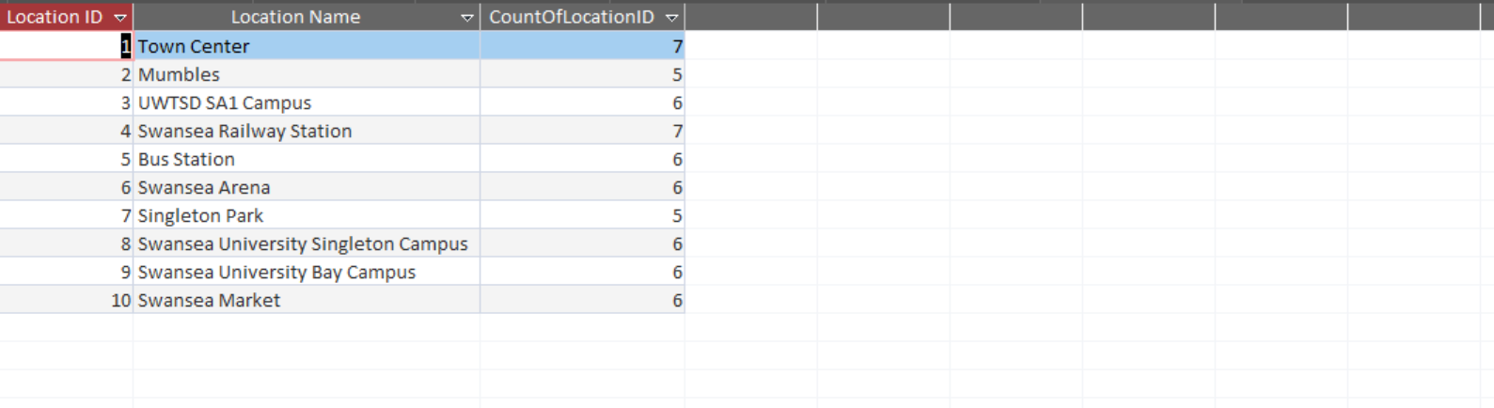

Location stock Detailed
Purpose: To show the stock of a location when Location ID is provided
Query Structure:
Bikes.LocationID = criteria “[Please enter a location ID]”
Screenshot: 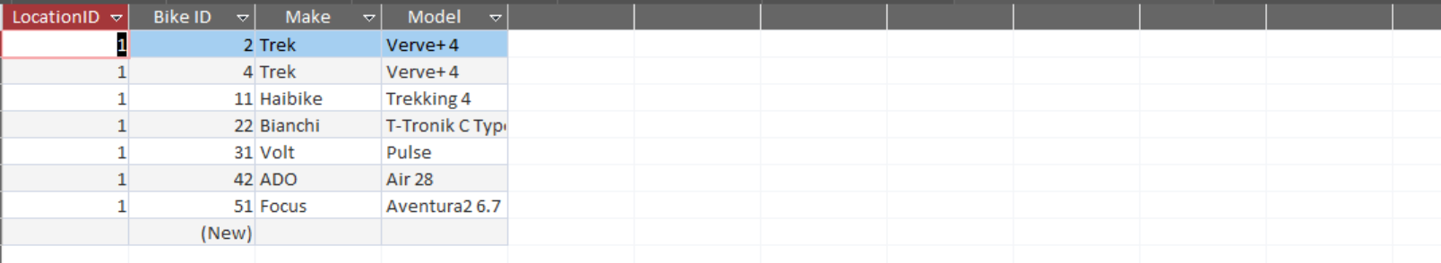

Testing and results

Validation Testing
There are 4 entities that required validation to be applied to them in order to ensure that the data captured by this database were reasonable.

Staff
The Validation on the staff entity is to ensure that the date of birth entered for the staff member is reasonable.
Test: Enter a DoB of 01/01/1066
Result
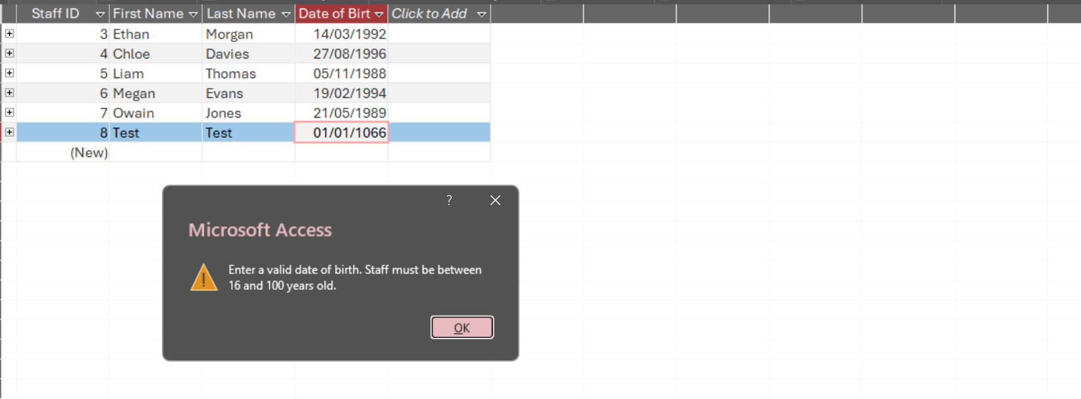
Conclusion: Pass

Members
The validation on the members entity serves a similar purpose to that on the staff entity. But additionally, to that there is also validation on the join date and phone number attributes.
Test: Enter a phone number of 12356789101112 , join date of 28/07/2050 and DoB of 01/01/1066
Result: 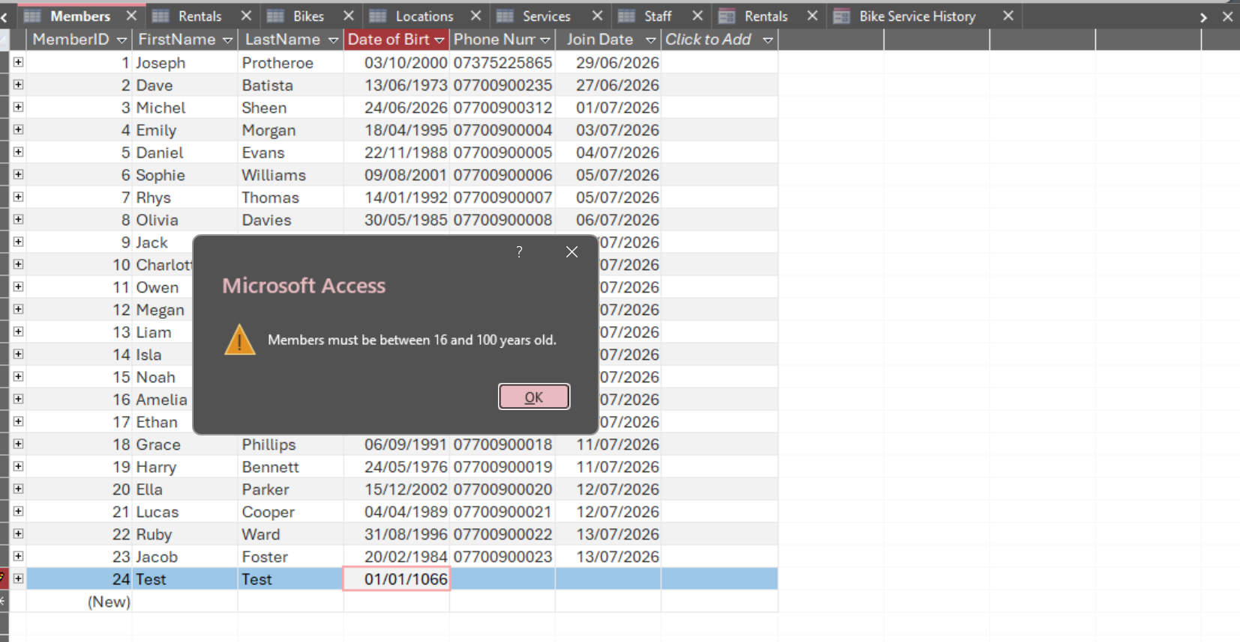
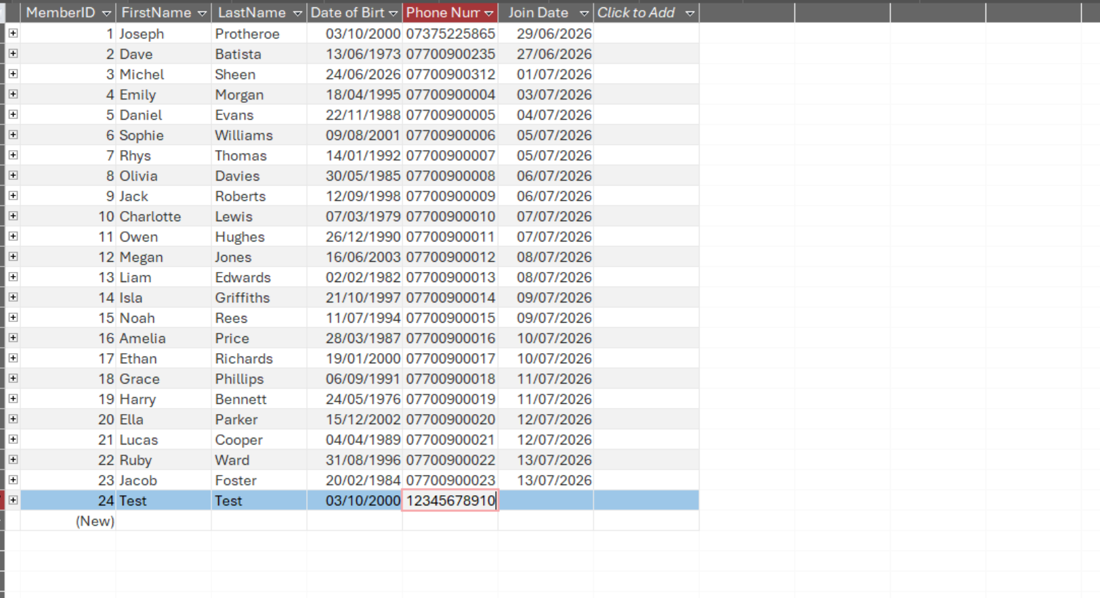(Will not allow me to continue typing)
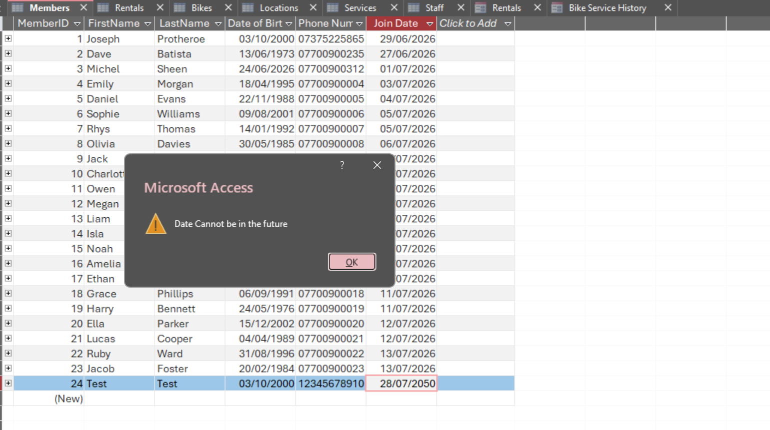
Conclusion: Pass

Rentals
On the rental entity there is validation for the start and end date of the entity
Test: Start Date = 27/07/2026 end = 26/07/2026 then start date = 28/07/2030
Result:
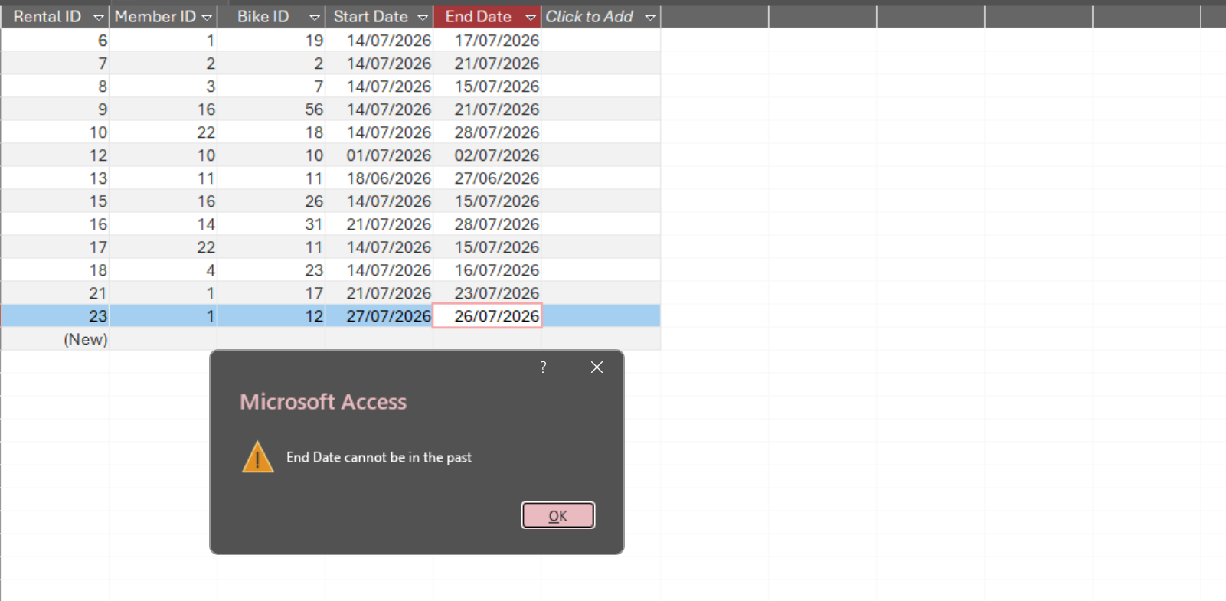
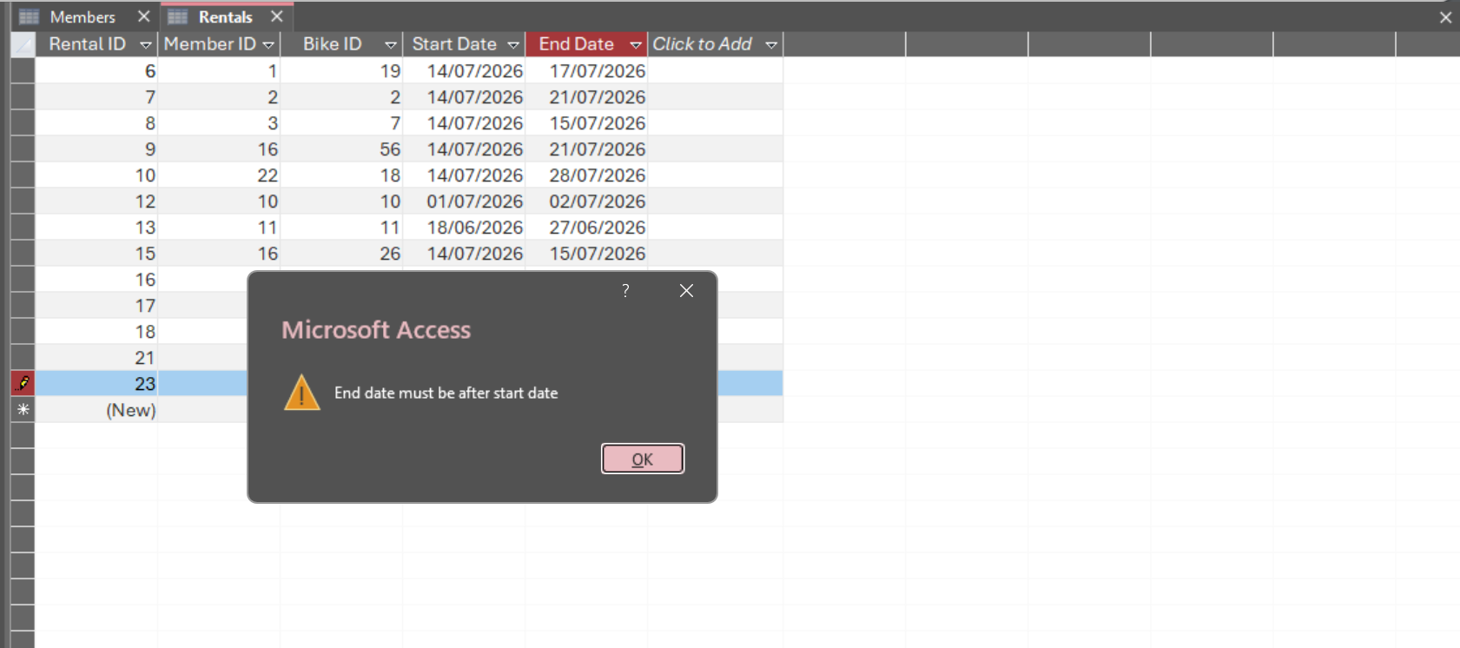
Conclusion: Pass

Bikes
On the bikes Entity there is validation on the wattage attribute it must be between 1 and 300
Test: 0 and 301
Result:
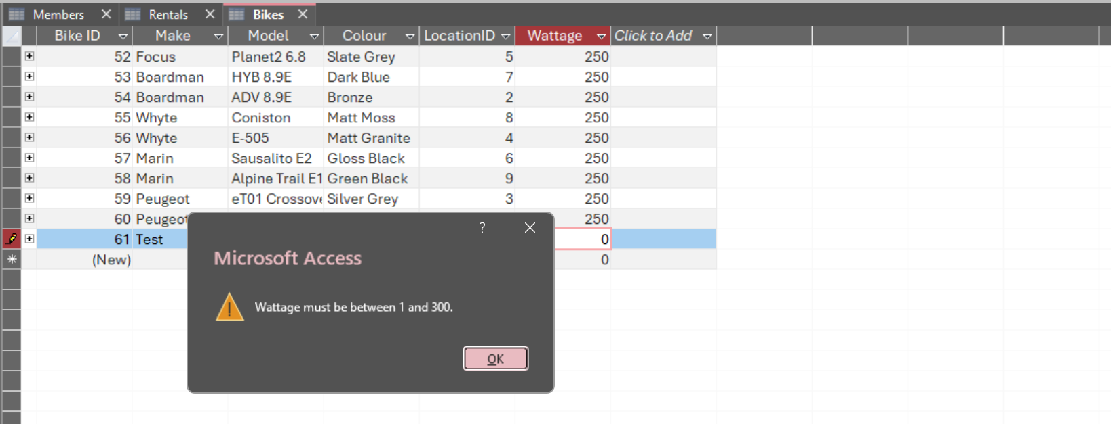
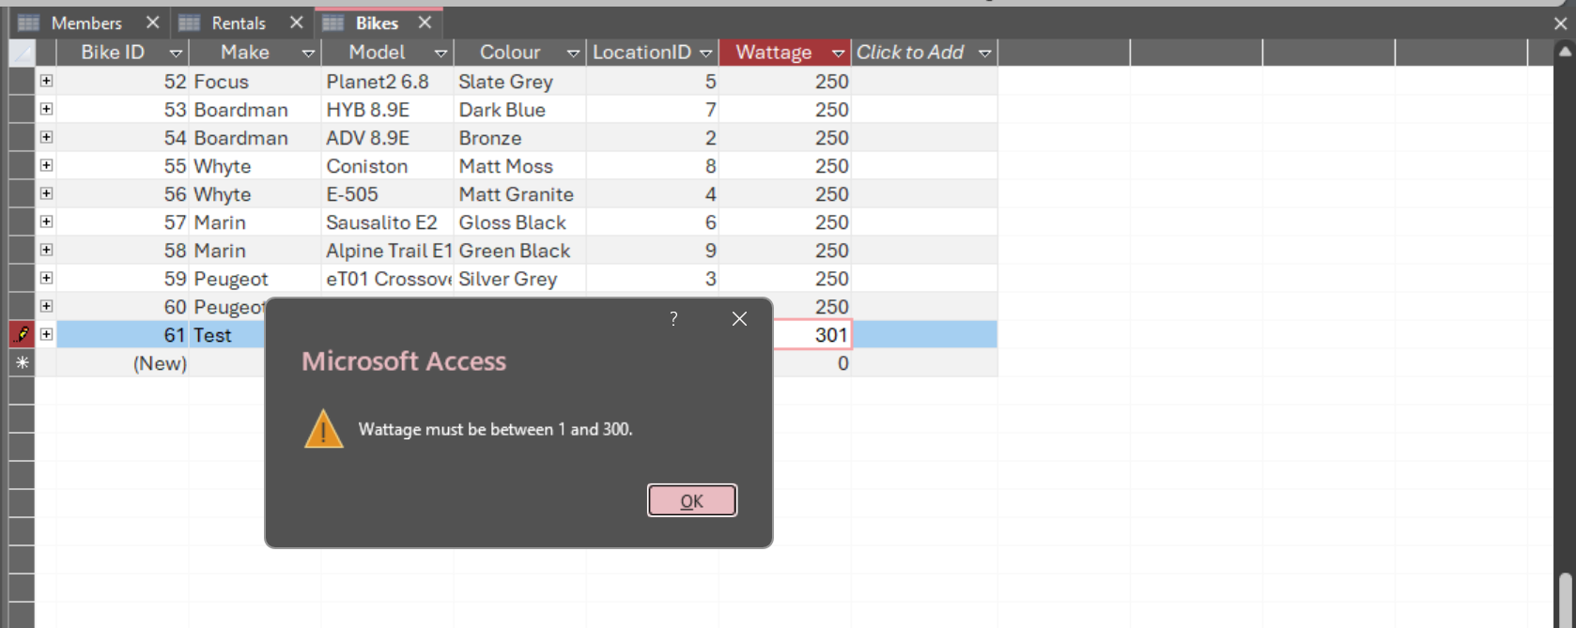
Conclusion: Pass

User Interface Testing
The Database contains forms that act as a menu system for navigation. Bellow is the main menu which acts as a hub connecting all other forms together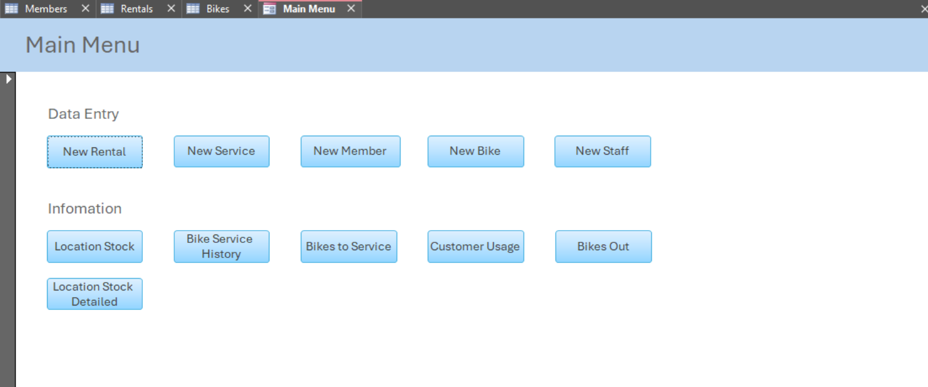
Below is the new rentals form which would be used to enter a new rental record It has buttons on the top of the form to return to the menu as well as control what record it is viewing and record deletion. The table at the bottom of the form is the bikes available query for ease of use.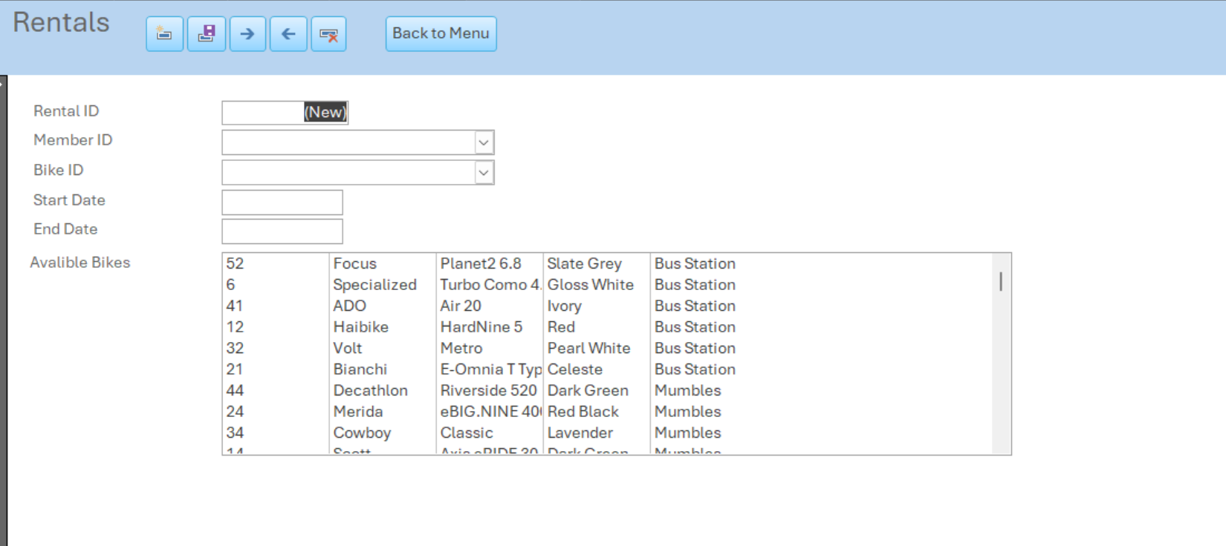
All date entry forms have the same button layout at the top of the form see bellow for the New members form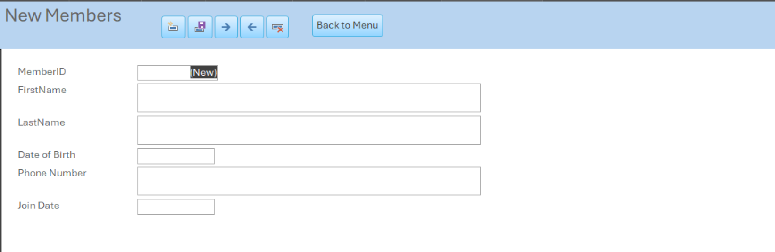
The main menu also allows navigation to queries. The screenshot bellow shows the bikes to services query; the top bar not only contains a button to close the query and return to the menu but also to open a new service form.
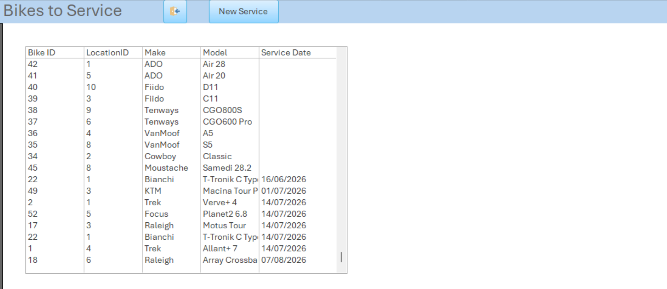
Again, here is another query with the same navigation button at the top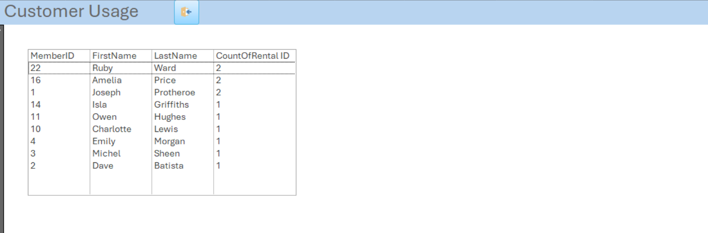

Design decisions, CHALLENGES, and improvements
Some Design decisions I made were, to include six subject based entities those being members, bikes, locations, rentals, staff and service. The primary key for each entity is auto numbers that provide stable identifiers and avoid using names or phone numbers as keys. The enforced referential integrity avoids records pointing at a non-existent record. A major decision was the validation used across the entities for example the restriction of both employee and members ages to be between 16 and 100 as well as the restrictions on start and end dates of rentals Aswell as wattage restrictions on the bikes themselves.
I found it difficult to create the sample records without breaking referential integrity and ensuring that records had continuity such as ensuring that the same bike was not taken out twice. Another challenge was doing the table joins for some of the queries as knowing which setting to have on the connection was new to me and took a while to understand.
To improve this database, I could include things such as a Rentals.ReturnLocationID to allow members to return bikes to a different location as well as extending the service entity to include information such as Services.ServiceType and Services.NextServiceDate.

Conclusion
The Aim of this piece of work was to provide EcoRide a database for them to be able to move away from paper records. The completed database contains information on Bikes, Rentals, Members, Services and Staff and allows for new entries to be created and for queries to be ran for operational purposes. The normalisation sections shows that this data base is in the third normal form. Future development should look to include features such as being able to return a bike to different site than collection and extend the service entity to support usability. But overall I think this piece of work satisfies the requirementsssss

References

[1] | Connolly, Thomas, Begg and Carolyn, Database Systems: A Practical Approach to Design, Implementation, and Management, Harlow: Pearson Education Limited, 2015.
[2] | E. F. Codd, “A Relational Model of Data for Large Shared Data Banks,” Communications of the ACM, vol. 13, no. 6, pp. 377-387, 1970.
[3] | Microsoft, “Database design basics,” [Online]. Available: https://support.microsoft.com/en-us/access/database-design-basics. [Accessed 27 July 2026].
[4] | Microsoft, “Guide to table relationships,” [Online]. Available: https://support.microsoft.com/en-us/access/guide-to-table-relationships. [Accessed 27 July 2026].
[5] | Microsoft, “Restrict data input by using validation rules,” [Online]. Available: https://support.microsoft.com/en-us/access/restrict-data-input-by-using-validation-rules. [Accessed 27 July 2026].
[6] | Microsoft, “Create a query based on multiple tables,” [Online]. Available: https://support.microsoft.com/en-us/access/create-a-query-based-on-multiple-tables. [Accessed 27 July 2026].
[7] | Information Commissioner's Office, “Principle (c): Data minimisation,” [Online]. Available: https://ico.org.uk/for-organisations/uk-gdpr-guidance-and-resources/data-protection-principles/a-guide-to-the-data-protection-principles/data-minimisation/. [Accessed 27 July 2026].
[8] | Information Commissioner's Office, “Principle (d): Accuracy,” [Online]. Available: https://ico.org.uk/for-organisations/uk-gdpr-guidance-and-resources/data-protection-principles/a-guide-to-the-data-protection-principles/accuracy/. [Accessed 27 July 2026].

