SJIE6002
2009174

Content Page

- Introduction – page 3
- Child A’s profile – page 3 - 4
- What is Literacy? – page 4 - 5
- Read Write Inc – page 5 - 6
- Reflective Placement Diary – page 7 - 10
- Conclusion – page 10 – 11
- Reference List – page 11 - 12
- Appendix 1 – page 13
- Appendix 2 – page 14
- Appendix 3 – page 15

Introduction
This portfolio will critically analyse a literacy programme and intervention called Read Write Inc. (Oxford, 2021) which is used throughout many educational settings in Britain. The researcher will provide an overview of the learner chosen for this case study and the chosen literacy intervention. Evidence of observations and assessments will be provided throughout, which were collected between September 2020 and April 2021. All details will be shared of Child A’s progress, from when he plateaued, to how this intervention was implemented daily to fill any gaps which were preventing him from moving on with the main literacy programme alongside his peers. A reflective diary will be included and it will highlight what went well and what could have been improved. The researcher will conclude an in depth critical evaluation of their method used throughout this research.
Child A’s profile
The learner chosen for this case study has a complex background; his Mum is Romanian and his dad is Irish and they are divorced so Child A spends his time evenly between both parents. Child A is currently in Year 2 and it is evident to see there have been significant gaps in his learning and difficulties in the core subjects started to show when he was in Year 1, but as he was attending Thrive sessions practitioners were unsure if these gaps were due to emotional issues rather than having an additional learning need (ALN). The Thrive Approach focuses on the emotional needs of children and it provides them with the skills needed to become more emotionally resilient. More than 34,000 staff throughout the UK have received Thrive training and it has been highly linked to increasing educational attainment levels (Thrive, 2021). Durlack et al (2011) believe that students who lack social and emotional competencies become less connected to school which negatively affects their academic performances. Child A was discharged from the Thrive Approach after 12 weeks and evidence showed he had made significant progress whilst attending these sessions however his learning continued to plateau and only a few months into starting Year 2 he was assessed and screened for language difficulties and results from his assessments showed his memory skills were worryingly inadequate for a child of his age. Child A has an Individual Development Plan (IDP) and has been referred to be assessed by an Educational Psychologist. Reid et al (2002) states that IDP’s are vital tools in planning programmes for individual pupils who may find literacy acquisition difficult and they also allow practitioners to assess pupils both formative and summative. Many interventions in various areas of learning has been implemented to support Child A - he is very social, has strong organisational skills, a great sense of humour and is a popular child within the classroom. He has a robust amount of knowledge about certain subjects and good descriptive and thinking skills however his difficulties are in literacy. Child A becomes very frustrated at completing any literacy activities, he struggles using expressive language and will shut down and is unable to find the words to express why he is frustrated however he seems to find receptive language less difficult to follow. Reyes (2020) explains that “Children often acquire elements of receptive language faster than expressive language. Because of this, our receptive language vocabulary is generally larger than that of our expressive language.” Child A has shared with the researcher that he is very aware that his peers find the academic subjects less difficult than he does and it is important to him “to be like his friends”.
.
What is Literacy?
Literacy is ordinarily described as having the skill to read and write however reading and writing skills vary between context and culture and both are ever-changing. Reading includes visuals, printed materials and digital media to name a few, unlike in the past where reading was usually from printed text, such as a newspaper or a book. Likewise, literacy can be perceived differently depending on culture, for example in the English language reading comprehension is a vital part of literacy whereas other cultures may not consider it to be important particularly where printed materials are seldom read. Literacy skills are a very important role in everyday life, not only is it used to read text but it is used to read signs, labels, maps, instructions, text based communication, social media and many more. Social media is a popular way of communicating nowadays, however Talib (2017) suggests that “research shows that young people are not as critically or technically skilled as they need to be in order to be effective digital citizens.” Therefore, it is evident that current complex media environments will eventually need an interdisciplinary pedagogical approach which prepares pupils to engage and understand digital media which is inevitably going to remain in their lives and will enable them to adapt to our forever changing digital world.
Best (2014) states that “literacy plays an important role in transforming students into socially engaged citizens”. Having the ability to read and write allows people to communicate effectively and keep up with current events (Best, 2014). Children learn about the process of reading long before they are able read and de code text, however research has consistently revealed that boys within the early years underachieve in reading and writing when compared to girls (Browne, pp117, 2007). These skills and the pathway to reading are implemented early in a child’s life. This is known as Emergent Literacy which includes the knowledge related to the alphabet, symbolic representation, communication and phonological awareness (Rohde, 2015). In practice, these abilities are initially taught in a Nursery class through songs, story time, role play and by following instructions. In practice, Nursery children start to become familiar with the RWI programme by learning a new set 1 sound each week. Practitioners will plan many enhanced provision activities around that sound, for example, when learning the sound ‘S’ activities could be playing in the sand or a pencil grip task to follow the shape of a snake or colouring images of socks, to name a few.
Read Write Inc.
RWI was founded by Ruth Miskin and was first introduced within educational settings in 2011. RWI is a systematic approach which teaches literacy. It is a programme which meets the higher expectation of the National Curriculum (Wales. Department of Skills and Education. 2008). Simple but effective assessments are carried out which encourage and accelerate pupils progress, preparing them for National Curriculum tests (oxford, 2021). More than a quarter of Primary settings in the UK have implemented this approach with the aim to “create fluent readers, confident speakers and willing writers” (Oxford, 2021). In practice RWI is taught as a whole school programme. Children are grouped to their ability and they are assessed at the end of each half term to determine whether they meet the criteria to be able to move up groups, however many children will plateau and remain in the same group unable to progress. In this case if a pupil has stayed in a group for up to three half terms then one to one literacy intervention is crucial. This intervention is called “RWI Phonics Fast Tracking Tutoring” (Oxford 2021). It accelerates pupils’ progress to enable them to move up groups once they are confident enough to and they are then reassessed. This intervention provides intensive, targeted support with the aim to address gaps in a pupils reading; it breaks down the phonics and reading strands of the RWI programme and focuses only on reading and blending sounds together with sessions lasting 20 minutes daily. Fast Track Tutoring is also an effective intervention for children who have Additional Learning Needs, significant learning difficulties or speak English as their Additional Language. Children are assessed against an Individual Progress record sheet (Appendix 1) before they initially start this intervention in order to determine where the pupils’ difficulties lie that are preventing them from moving groups. Ruth Miskin believes that children’s reading progress can only improve when practitioners find their challenge point – learning that is not too easy or too difficult (Oxford, 2021).
As shown on the assessment 2 individual record (Appendix 2) Child A was assessed in September 2020 along with all his peers at the start of Year 2 - his baseline is recorded in green highlighter. He was then later assessed in October 2020 – as shown on Appendix 2 - recorded in pink highlighter. These results showed that child A had progressed and was able to move up a group, however, Child A’s progress stayed the same from October 2020 to February 2021 as shown on Appendix 3 - these results initiated that the RWI Fast Track Tutoring intervention needed to be implemented. Child A has been in receipt of this intervention daily for 8 weeks and he has made significant progress as shown on the assessment (Appendix 3) - April 2021 recorded in pink highlighter. The researcher has completed a reflective diary for one of Child A’s sessions and will critically evaluate the method used.

Reflective Placement Diary
What happened?
What went well? | Child A enjoyed sounding out the sounds and words he is confident at reading.
What were the main challenges / problems/ difficulties you faced? | Child A became very frustrated when he was unsure of a sound or word and refused to partake in the lesson.
How did you react to the challenges? | I reassured Child A it was ok to be unsure of a sound and that we can learn them together.
How did you feel? | I felt calm and talked to Child A in very calm manner, making sure I was maintaining eye contact and down to his eye level to reassure him.
What surprised you? | Child A took a short while to co-operate but by adding humour into the lesson child A responded well and seemed less distressed.
What were you familiar with? | I am very confident at carrying out this intervention and have taught Child A for the last 4 years, therefore, we have built a strong relationship so I am able to detect when he is becoming frustrated and am able to deal with these emotions efficiently.
Have your beliefs and expectations changed or been challenged? | I am not confident that the RWI approach is ideal for all pupils, especially when children realise that the groups are made up of abilities and whilst some are celebrating their success of moving up groups others may be feeling very frustrated or inadequate when they plateau.

Critiquing your experience
How well did you think you managed the challenging situation? | I handled the situation well and by using positive language and praise I feel Child A finished the session feeling confident about himself.
Has this experience changed your mind or opinion in any way? | My opinion is that RWI can put pressure on some children because the main sessions are fast paced, so if a child is unable to keep up with their peers this can have a detrimental effect on their confidence and within these interventions practitioners are having to work on their confidence first before they are able to move on with their learning.
Were you given any feedback (formal or informal)? Can you seek further advice from anyone in order to give you another perspective? | The Class Teacher and I liaise often after each intervention. On this particular day I spoke with his Teacher and she agreed with the approach I used, which was to build on his confidence and review the sounds he was confident at reading before introducing a sound he is unsure of.
Is there any other reading or research you could follow up regarding the subject matter? | I can seek advice from the ALN team and ask if there are strategies that are effective to use when pupils become frustrated.
What skills do you need to develop to address this incident more effectively in the future? | I am confident at working alongside children with emotional needs and I am able to step away from the learning and see to their emotional needs before continuing, I need to work on pushing the learning along too, as the approach I use can be time consuming and the 20 minutes are used on listening to what the child wants rather than on the intervention.
What conclusions have you drawn? | In my conclusion, the RWI programme claims to be inclusive, however, by grouping children to their ability this does not mirror inclusion. For example, child A is in year 2 and is in a group which is made up of mostly children from a Reception class, Child A is aware he is not progressing as he should.

What next?
Given the same event; would you do anything different next time? | I would try and prompt more learning time into the session.
What are the key lessons learned for future use? | To allow children to leave an intervention feeling positive, build on their confidence and allow them to learn at their own pace and as a practitioner to not become too focused on moving children on within a certain time frame.
How might your learning feed into your assignment/s? | Child A’s experience is a strong example of Jean Piaget’s theory. Children build on existing schemas, connecting new information to the things they already know (Aubrey and Riley, pp42, 2019). Child A was unable to move up a group as he was still unsure of pre-existing sounds that had already been taught and therefore didn’t have confidence in his knowledge before progressing further.

Conclusion
In conclusion, this portfolio has researched and highlighted the importance of learning how to read and write in order for children to grow to be socially engaged citizens. However, the researcher has emphasised throughout that many children find literacy difficult to learn and that early intervention is implemented to fill potential gaps within learning and targeting the areas that are difficult. The researcher has written an overview of a child who has significant language difficulties and has evaluated the RWI Fast Track Tutoring intervention. As previously mentioned Child A plateaued for three consecutive half terms and this identified that he would benefit from this intervention. The researcher has provided evidence that this intervention has been successful for child A, however this success has not been achieved without its difficulties and the researcher documented a reflective diary based on one of the sessions carried out alongside Child A. It is evident throughout this case study that Child A may be described as complex. Gaps within Child’s A learning did not start to appear until Year 1 however in practice this is not uncommon as within a Nursery and Reception class children learn mostly through play - this links with the Foundation Phase (Wales, Department of skills and Education, 2018) and as Child A is very social these difficulties could have been masked.
The researcher evaluated the method used and shared that Child A enjoyed reading familiar sounds but when he was asked to read a sound he was unsure of he would become frustrated, refusing to partake in the lesson. After much reassurance and added humour Child A starting to engage in the learning and only revisited the sounds he was confident at. It was obvious to the researcher that Child A was comparing himself to his peers and was feeling inadequate when he was unable to read a sound. Child A was confused as to why he was in a group with children from the Reception class – as previously mentioned children are grouped to their ability. The researcher has concluded that even though RWI state that their programme is inclusive for all pupils and that the intervention is to be implemented when a child plateaus, this programme is not effective for children who struggle to learn at a fast pace. In fact, this programme highlights to other children who are progressing and who are not, as the more able and talented children are grouped with older children and the children who experience learning difficulties are grouped with younger children. This approach has had a detrimental effect on Child A’s confidence and it was evident to see he did not enjoy these lessons as he finds reading difficult. In practice the researcher has witnessed the RWI programme to be successful for many pupils but is uncertain that it is a holistic approach for all children.
Reference List
Aubrey and Riley. (2019). Understanding and Using Educational Theories. 2nd edn. Sage Publications LTD: London.
Best, J. (2017). ‘What is Literacy and why is it important?’ 3P Learning. August 17th. Available at: https://www.3plearning.com/blog/literacy-important/#:~:text=But%20beyond%20the%20functional%20level,that%20are%20shaping%20our%20world. (Accessed on: 29/04/21)
Browne, A. (2007). Teaching and Learning Communication, Language and Literacy. 11th edn. Sage Publications LTD: London.
Durlack, J, A. weissberg, R, P. Dymnicki, A, B. Taylor, R, D. Schellinger, K, B. (2011). ‘The Impact of Enhancing Students’ Social and Emotional Learning: A Meta-Analysis of School-Based Universal Interventions.’ Child development. 82 (1) pp. 405 - 432. Go Strengths. [online]. Available at: https://gostrengths.com/wp-content/uploads/2012/10/Meta-Analysis-Child-Development-Full-Article1.pdf (Accessed on: 29/04/21)
Oxford. (2021). Read Write Inc. Phonics Fast Track Tutoring. Available at: https://global.oup.com/education/content/primary/series/rwi/fast-track-tutoring/fast-track-tutoring-phonics/?region=uk (Accessed on: 29/04/21)
Oxford. (2021). Read Write Inc. Available at: https://global.oup.com/education/content/primary/series/rwi/?region=uk (Accessed on: 29/04/21)
Reid, G., Soler, J., & Wearmouth, J. (2002). Meeting Difficulties in Literacy Development: Research, Policy and Practice. London: Routledge
Reyes. (2020). ‘The Difference between Receptive and expressive Language.’ NAPA. May 16th. Available at: https://napacenter.org/receptive-vs-expressive-language/ (Accessed on: 03/05/21)
Rohde, L. (2015). ‘The Comprehensive Emergent Literacy Model: Early Literacy in Context’ Sage Open. 5 (1). Sage Journals. [Online]. Available at: https://journals.sagepub.com/doi/10.1177/2158244015577664 (Accessed on: 29/04/21)
Talib, S. (2018). Social media pedagogy: Applying an interdisciplinary approach to teach multimodal critical digital literacy. E-Learning and digital Media. 15 (2) pp. 55 – 56. Sage Journals. [Online]. Available at: https://journals.sagepub.com/doi/full/10.1177/2042753018756904 (Accessed on: 29/04/21)
Thrive. (2021). About Thrive. Available at: https://www.thriveapproach.com/ (Accessed on: 29/04/21)
Wales. Department of Skills and Education. (2008). Curriculum. [online]. Available at: https://hwb.gov.wales/curriculum-for-wales-2008/key-stages-2-to-4/?_ga=2.236175491.30673531.1620156562-1367223510.1599161774 (Accessed on: 03/05/21)
Wales. Department of Skills and Education. (2018). How is my child doing in the Foundation Phase?. [Online]. Available at: https://gov.wales/sites/default/files/publications/2018-06/how-is-my-child-doing-in-the-foundation-phase-a-guide-for-parents-and-carers.pdf (Accessed on: 03/05/21)

Appendix 1
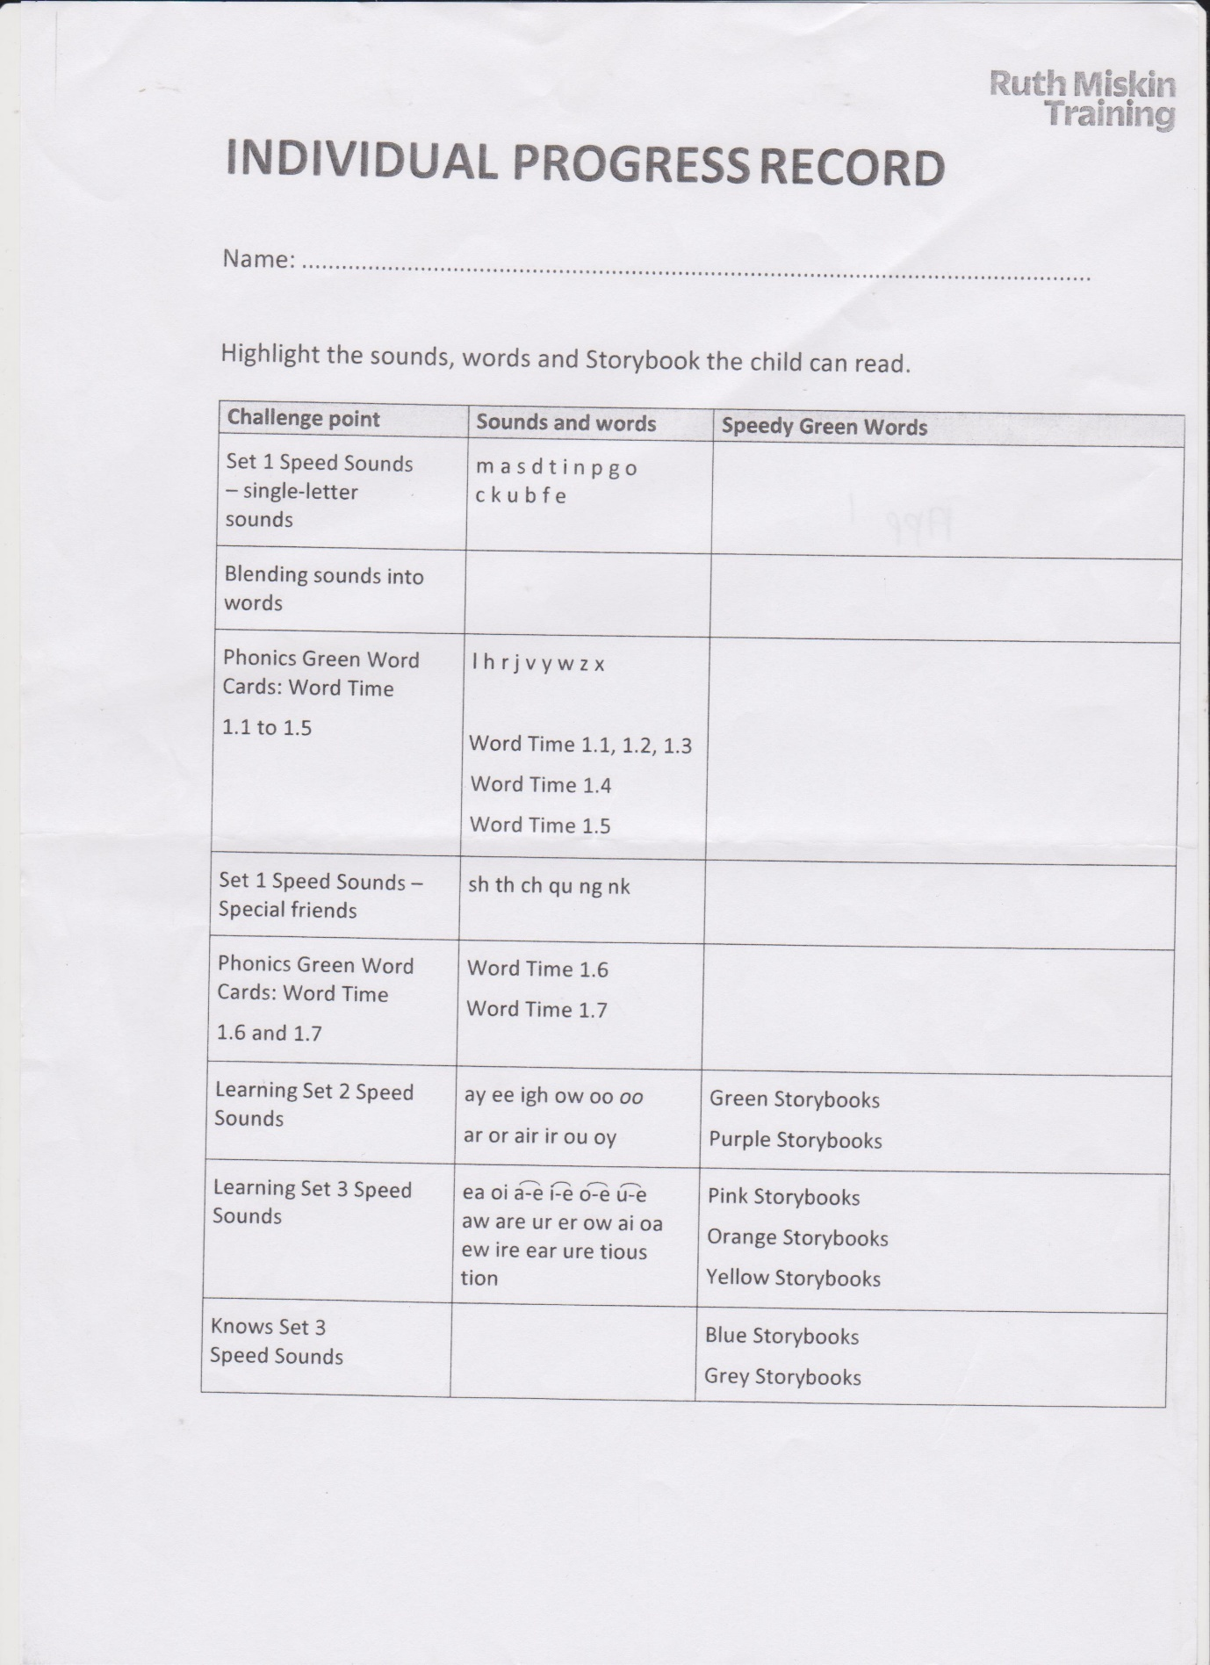

Appendix 2
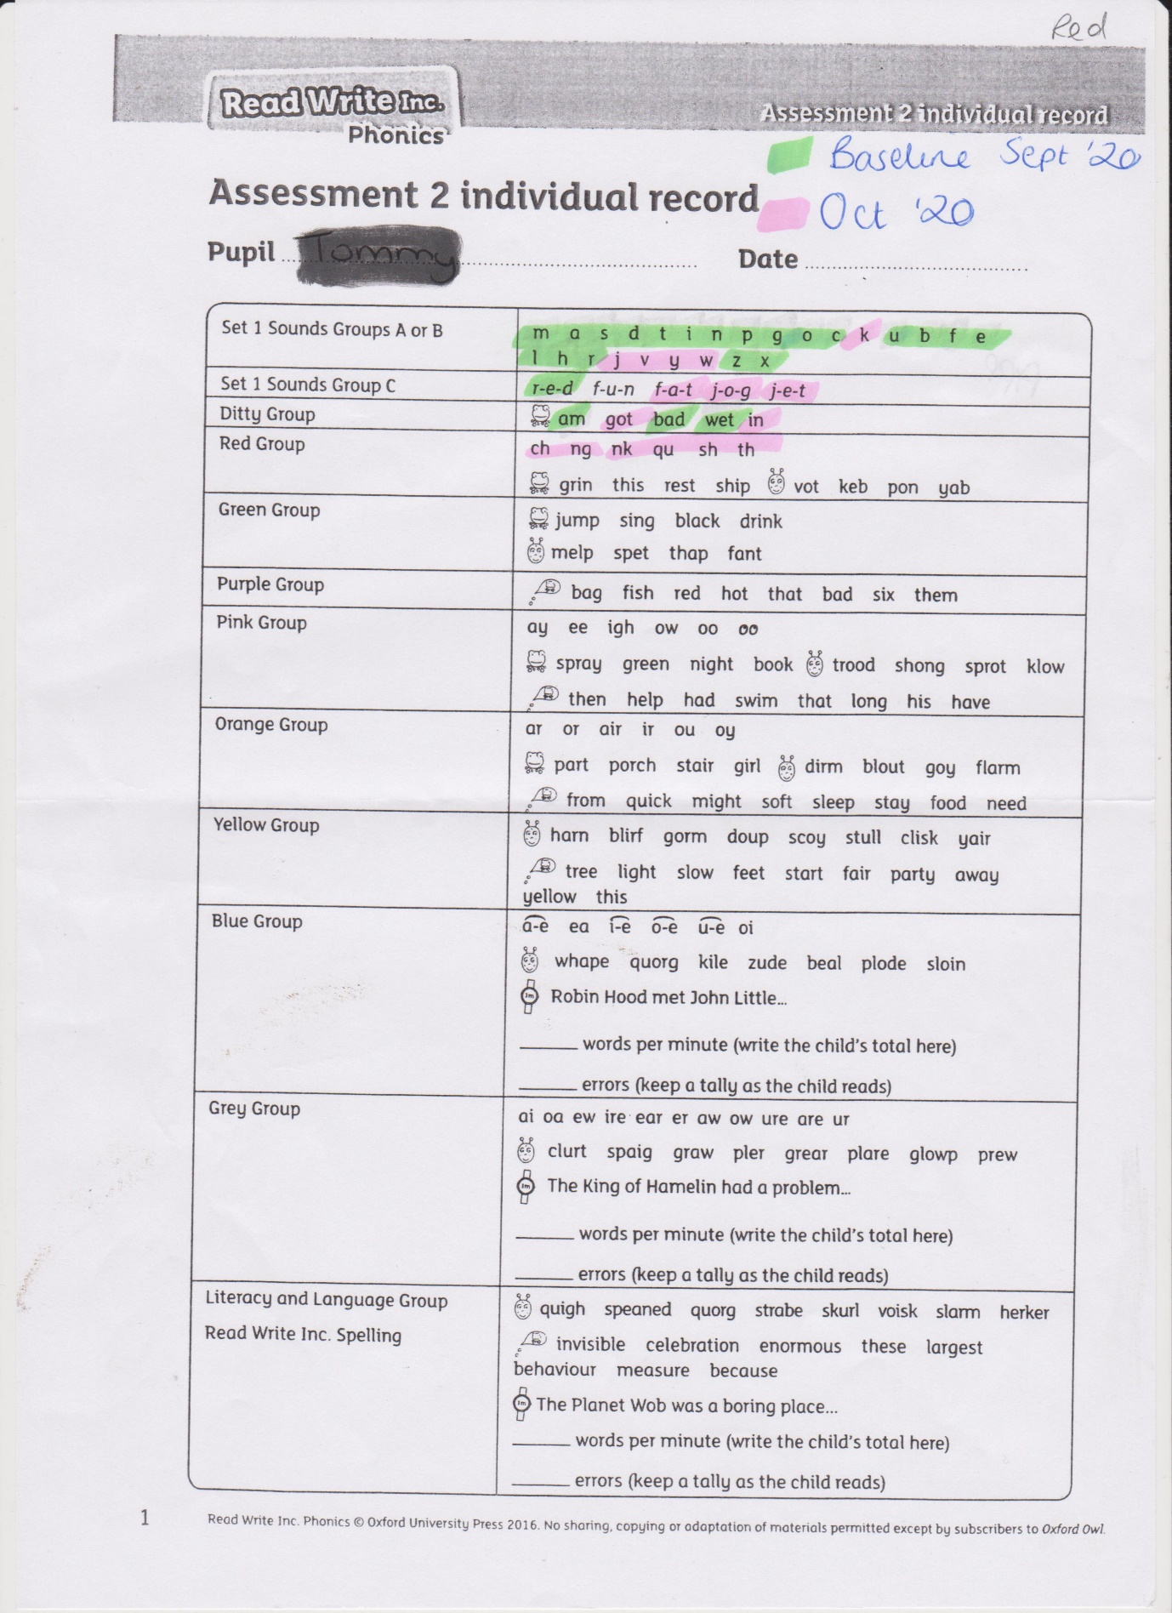

Appendix 3


