

Assignment 2 – Conference Presentation

Student Name : Filis Laris Osman
Student ID : 2025564
Module Name : Contemporary Themes in the Hotel and Hospitality Sector
Module Code : BMIH6001
Lecturer’s Name: Giulia Chifari

Table of Contents
Slide 1: Front Page 3
Slide 2: Introduction 4
Slide 3: System Theory and Strengths and Weakness 5
Slide 4: System Theory and Opportunities and Threats 6
Slide 5: Artificial Intelligence and the UK Hospitality Industry 7
Slide 6: Artificial Intelligence and InterContinental Hotels Group (IHG) 8
Slide 7: Contemporary Issues 10
Slide 8: Future Policy and Management Intiatives 12
Slide 9: Conclusion 14
Slide 10: References 15

Slide 1: Front Page

Slide 2: Introduction

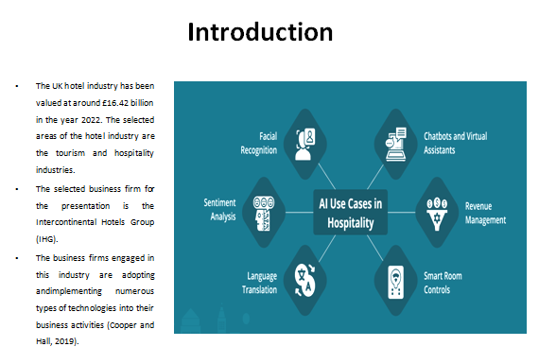

The presentation is being based on the wide variety of technological approaches which are being firmly adhered to and utilised by the participants of the hospitality industry to attain their desired objectives. It emphasises the systems theory which is directly interlinked with technological advancements (artificial intelligence). The presentation further conveys the use of artificial intelligence and its subsidiary technologies by the participants of the UK hospitality industry by emphasising the strengths and the limitations along with the contemporary issues. Lastly, the presentation entails the recommendatory measures which must be adopted and executed by the business firms of the industry to firmly cope with these adversities.

Slide 3: System Theory and Strengths and Weakness

The systems theory entails the developmental stages of the advancement of technologies and their dualistic impact on the community. The theory firmly assists the strengths of the company. This has been because the system theory entails the developmental stages which are being adopted and implemented by the company on a consecutive basis. This has been implied by the organisation onto the wide variety of artificial intelligence technologies which firmly assist the business firms to upraise their operational proficiency. Despite all these technological advancements, the company must train there to their personnel in the context of technical knowledge and expertise (International Monetary Fund, 2020).

Slide 4: System Theory and Opportunities and Threats

The adoption, and utilisation of artificial intelligence and its solutions by the company, will firmly assist the company as the systems theory entails the alterations which must be made to the technologies over a specific period. These will lead to the attainment of the desired goal like targeted marketing more effectively (Ford and Sturman, 2020). The major threats include the violation of the integral information of the business firm due to unauthorised access.

Slide 5: Artificial Intelligence and the UK Hospitality Industry

There are different trends which are prevalent in the hospitality segment of the country. The business firms engaged in the national hospitality industry of the United Kingdom are being adopted and executed by the management of the hospitality firms. One of the prevailing trends is that London has been emerging as one of the preferred tourist destinations throughout the country. These can be firmly recognised from the fact that there are various new projects which are being initiated due to which the RevPAR (Revenue per Available Room) has been dynamically increasing (Mondor Intelligence, 2024). To cope with these rapidly rising arrivals of visitors at the national and the international level, the UK hospitality industry has been adopting and utilising numerous types of technological advancements. Artificial intelligence has been recognised as the foremost technology which has been used by business organisations in the hospitality industry.

Slide 6: Artificial Intelligence and InterContinental Hotels Group (IHG)

Artificial intelligence has been considered one of the most prominent technologies which have been used by business firms in the national hospitality segment of the country. Artifical intelligence and its subsidiary technologies are being firmly utilised by the company in its business operations in a consecutive manner. It further leads to the accomplishment of their ultimate organisation objectives. This has been because these innovative technologies have firmly assisted the business firms in accomplishing their respective goals. This utilisation of these technologies has assisted the organisation to cope with the customer's care matters like timely attainment and the redressment of their issues. These technologies have raised the organisational goodwill of the company as their usage has led to an upsurge in the satisfaction of the visiting guests who come into the different hotels of the company (InterContinental Hotels Group, 2021).

Slide 7: Contemporary Issues

The business firms who are being operated in the hospitality segment of the country must emphasise artificial intelligence and its subsidiary technologies in their daily business operations. Business firms use artificial intelligence in their wide variety of business operations leads to the collection of personal information of the customers or guests who come for a visit to the headquarters of the company. Data privacy can be recognised as the main challenge for business organisations as it has led to the infringement of privacy norms due to unauthorised access. For instance, machine learning firmly assists business firms in accumulating the private data of their customers (European Parliament, 2020).
The allowance of ethical standards has also been considered one of the most challenging tasks for the business firms of the hospitality industry at the current time. The Corporations are expected to adhere to these ethical norms and the standards while utilising artificial intelligence and the re subsidiary technologies in the context of their business operations. This challenge can be firmly understood under the main head of artificial intelligence governance. Maintaining a competitive edge over their competitors has been recognised as another challenge for business firms in the national hospitality sector of the country. These all challenges are interlinked with the

Slide 8: Future Policy and Management Intiatives

The business organisation is being adopted and implementing a wide variety of initiatives to accomplish their respective objectives within a specific period by eliminating contemporary issues. These issues are being directly and indirectly intertwined with the usage of Artificial Intelligence and AI-based solutions in their consecutive business operations. Signals Intelligence (SIGINT) can be firmly recognised as an integral measure which will lead to the elimination of cyber threats to the internal information of the company (Aldrich, 2021). This is because Signals Intelligence (SIGINT) prohibits unauthorised users from approaching integral information. The State for Artificial Governance firmly assists business organisations to attain their respective goals while strictly adhering to the wide variety of ethical norms and the standards which are prevalent in prevalence at contemporary times. These further lead to the attainment of recognised organisational goodwill throughout the industry. Another recommendatory measure for the business firms who are operating in the hospitality segment of the country is wisely adopting and implementing numerous types of competitive strategies to sustain the competitive industry of hospitality. These strategies firmly assist the business firms to upraise their operational proficiency as the cut-throat competition has become the foremost challenge for the business firms due to the presence of innovative technologies (Tribe, 2009).

Slide 9: Conclusion

The recommendatory measures which are being wisely adopted and implemented by the company will further lead to the rise of their business growth and the systematic evaluation of the company's strengths etc by the systems theory.

Slide 10: References



