Name: Maria Ramona Petrache

Student id: 2215627

Module Code: LCBB4004

Module Name: Marketing Fundamentals
Lecture: DR. Piyumika Gamage

MARKETING FUNDAMENTALS EXTERNAL ANALYSIS & EVALUATION

Table of Contents
1. Introduction 3
2. Company Overview 3
3. The process and stages of Marketing of Tesco Plc 4
4. Understanding the role of the marketing environment and other situational analysis models 7
5. Determining credible future recommendations 11
6. Conclusion 13
7. References 15

1. Introduction
This report revolves around the marketing framework for the company Tesco Plc. The organization is one of the greatest retail chains in the United Kingdom. The report involves several approaches which are to be studied and are important in managing issues faced in the market, both internal and external ways. The marketing strategy is described as the outline that serves as the foundation for the company’s sales promotion. It involves establishing objectives and designing structure and content. A marketing approach could be used as a basic foundation for creating campaigns and marketing. It indicates that it is based on a strategic responsibility. It allows organizations to effectively plan and circumspectly study sales promotions at a preliminary phase (Rosnizam et al. 2020). Devoid of a strategic marketing framework, it will be very challenging to accomplish. If a company does not have a marketing plan, that indicates that the company is just reacting rather than taking proactive action.

2. Company Overview
Tesco is one of the target retail stores with general merchandise at the multinational level. The company Tesco specifically across the operations of the business and other activities through the multi-format of both offline and online stores. The organisation Tesco Plc also holds stores in various parts of the country with various sizes, ranges and with different products. The company Tesco was regarded as the third largest retailer in the universe which is thus measured through a gross set of revenues (retailgazette.co.uk, 2023). Moreover, it is also considered the world's ninth largest in terms of revenues. The vision of the organisation Tesco is that it serves the consumers, societies and the planet with better steps each day and keeps the customers satisfied with their demands regularly.
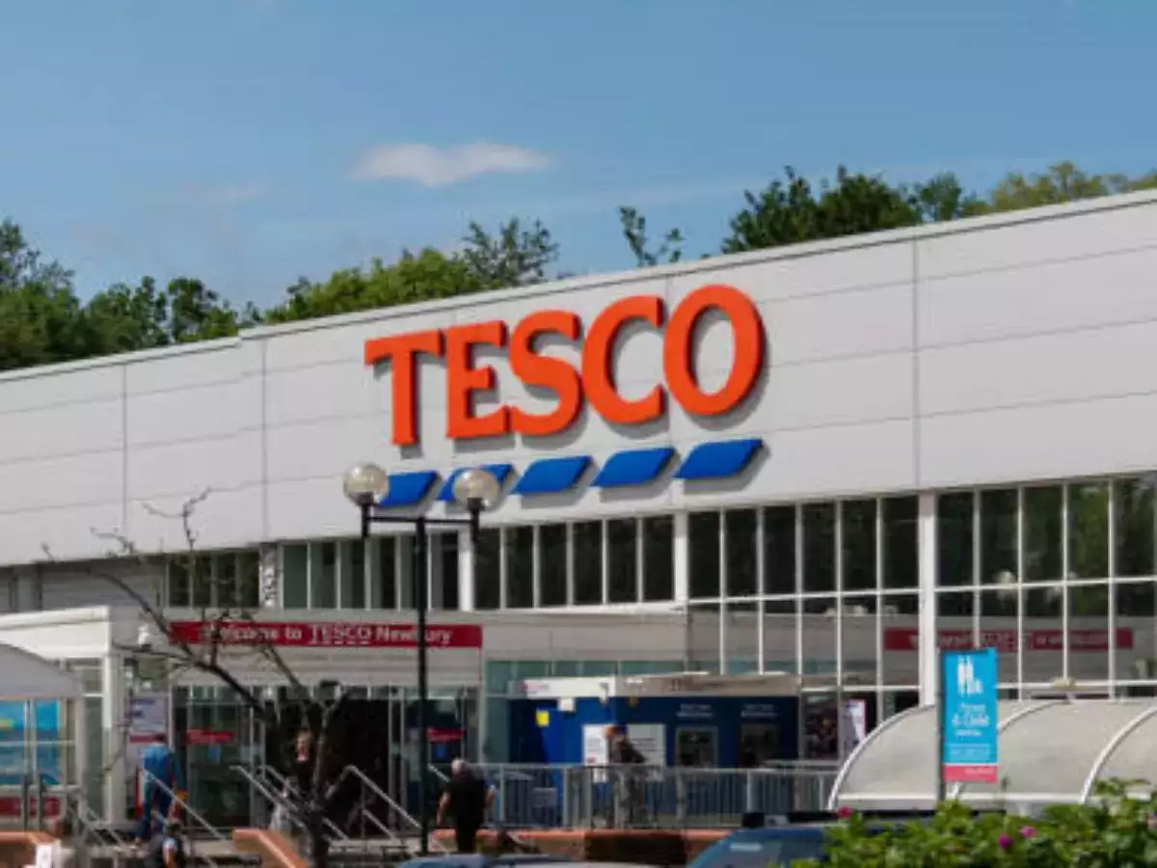
Figure 1: Tesco Plc
(Source: retailgazette.co.uk, 2023)

3. The process and stages of Marketing of Tesco Plc
Step 1: Marketing analysis
The marketing process of Tesco began with its very initial step of marketing. This involves very close observation of the organisation's portfolio and its terms. The marketing analysis of Tesco plc is mainly to advertise through the help of blueprint and media to send the information or the message to the customers or the target audience (Sadchenko et al., 2020). Moreover, to gain and retain customers, the marketing analysis of Tesco is being used as they usually buy items that buy one get one free. The marketing analysis is done that the target customers or dance of Tesco Plc are that there are some regular costumes and they effectively strategies to offer them club cards. The Pestle analysis marketing is being used by the organisation Tesco Plc as it helps to analyse the environment which is unpredictable at times and also operates by the factors of discussing the performance and its effects and operations. Collectively, the marketing analysis of the organisation Tesco Plc allows it to effectively track the behaviour of the customers and also helps to observe what they are doing so that the organisation can accordingly plan for the future (Rangaswamy et al., 2020). The marketing analysis also helps to run a campaign based on the responses of the customers and so on.
Step 2: Marketing goals
The stem of marketing goals is the defined goal of the organstions Tesco. The major marketing goal or aim of the organisation Tesco is that it is obliged to help the people of the organisation who are now a part of the Tesco family to serve them its best output and also the committees along with the entire universe. Moreover, the organisation Tesco Plc also holds its aims towards achieving the highest revenues and growth or development and becoming the best retail organisation in the entire globe (Tien et al., 2019). Collectively, the organisation Tesco Plc is also adopting the marketing goals in other sections of the business such as to build brand awareness among other individuals and also among the target audience. In addition to this, Tesco Plc's organisation ascertain its marketing goals with the high volume of several sets of qualified fields and also establish the leadership to maintain growth and development in the business which would help them to reach future goals and profits (Tien et al., 2019).
Each business work to ascertain revenues and Tesco by serving its community, plant and target audience on the path to goal achievement through several marketing strategies and analysis (Tien et al., 2019). Most importantly, the engagement of the brand is the major goal of the organisation Tesco to boost the retail market and become the best multinational retail company in the world.
Step 3: Marketing Strategy
The marketing strategy of Tesco precisely aims at its model customers. It is due to the fact that the company has an effective brand image. The company provides a broad range of products and services in different markets, and therefore could not divide in terms of psychographic and demographic aspects. The target market of Tesco is therefore price conscious that are more concerned with sales and bargains and value diversity. In order to appeal to more customers, Tesco primarily marketed itself as a low-cost and high-volume retailer; however, after the 1990s it remarketed as low-cost as well as the finest variety of products (Rosnizam et al. 2020). Tesco, with its branding, has endeavoured to strike a medium ground providing budget products alongside conventional choices from its best quality assortment. The company has made no surprise that they intended their store to offer a broad range of everything a customer demands to purchase at a lower cost.
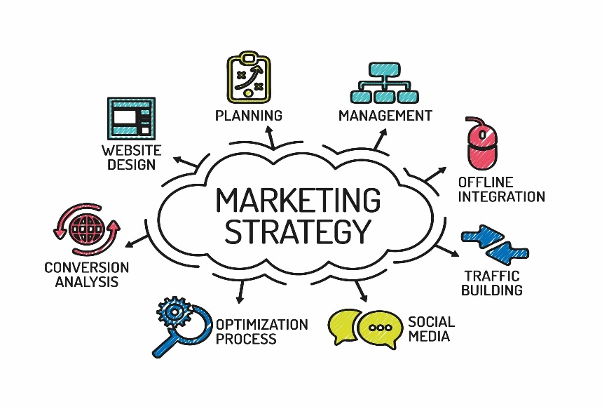
Figure 2: Marketing strategy
(Source: Rosnizam et al. 2020)
The company has been continuously developing its line of products in an attempt to draw a fresh consumer base. Tesco, in the year 2016, established a fresh brand of “farm fresh products” (Chen, 2022). This considerable rebranding of product lines such as fruits, vegetables and meat attracted consumers who were price aware, and who has earlier avoided purchasing from Tesco. In a nutshell, the company has created a loyal consumer base as well as an international brand due to its consumer-centric method. On the contrary, the reputation of Tesco is dependent on its brand image as an affordable and convenient chain.
Step 4: Marketing Mix

Figure 3: Marketing Mix of Tesco
(Source: Self-created)
Step 5: Marketing Monitoring
There are few effective strategies that help in marketing monitoring of Tesco. This is the last stage of Marketing. Tesco has mystery shopper who help to collect the feedback from customer and this is one of the unique strategy that this company implement. On the other hand, it has also identified that through the help of survey Tesco also gather customer feedback. This feedback helps Tesco to understand their marketing and how it creates impact on customers.

4. Recognizing the function of the marketing environment and additional situational analysis models
Role of the marketing environment
Tesco PLC is a global retailer of groceries and other goods with headquarters in the UK. The company operates in multiple countries and has over 6,800 stores worldwide (Chen, 2022). Tesco's success can be attributed to various factors, one of which is its ability to adapt to the changing marketing environment. The marketing environment refers to the external factors that affect a company's marketing efforts, such as economic, technological, political, social, and cultural factors. Conducting situation analysis allows a company to understand its situation with context to the overall business climate where it operates. A large organisation like Tesco must analyse its external as well as the internal area of operation.
Political | Tesco's marketing initiatives may also be impacted by the political climate. Tesco's business operations could be significantly impacted by changes to governmental policies, including tax laws and trade agreements (Catalão, 2022). For example, changes in import/export tariffs can affect the cost of Tesco's products, which can impact the company's pricing strategy. In addition to that, changes in labour laws can affect the cost of labour, which can impact Tesco's bottom line. Therefore, Tesco needs to keep a close eye on political developments and adjust its marketing strategy accordingly.
Economical | According to Catalão, (2022), the economic environment plays a significant role in Tesco's marketing strategy. The company's success depends on consumers' willingness and ability to spend money on its products. In a weak economy, consumers may be more cautious about their spending, which can affect Tesco's sales. Therefore, Tesco needs to monitor economic trends and adjust its marketing strategy accordingly. For example, during an economic downturn, Tesco may introduce more affordable products to appeal to price-sensitive consumers.
Social | The social and cultural environment can also affect Tesco's marketing efforts. The company operates in multiple countries, each with its unique cultural norms and values (Student, 2021). Therefore, Tesco needs to tailor its marketing campaigns to each specific market. For example, Tesco's advertising in the United Kingdom may differ from its advertising in China. In addition, Tesco needs to stay attuned to social trends, such as changing consumer preferences for healthier and more sustainable products. Tesco's ability to adapt to changing social and cultural trends has contributed to its success.
Technological | The technological environment has also had a significant impact on Tesco's marketing efforts (Ahmad Tajuddin, 2021). With the rise of e-commerce, Tesco has invested heavily in its online presence. The company's online platform allows customers to shop from anywhere and at any time, which has contributed to Tesco's success. Along with this, Tesco uses data analytics to track consumer behaviour, which allows the company to create more targeted marketing campaigns. Tesco's use of technology has allowed it to stay competitive in a rapidly evolving market. Tesco has initially achieved significant development in this area. The business should, however, do more to advertise these initiatives to customers and include sustainability in its marketing messages in a more significant way.
Legal | Tesco follow all the legal law and regulations. This effectiveness helps the company to avoid certain external challenges.
Environmental | UK environment help the company to improve it CSR and make the company more sustainable in the competitive market of UK
Table 1: PESTLE analysis
(Source: self-created)
Tesco operates in a highly competitive market, which requires the company to constantly monitor and adjust its marketing strategy (Zxhang, Haxo and Mat, 2023). Tesco's main competitors include other grocery and general merchandise retailers such as Walmart, Aldi, and Lidl. Therefore, Tesco needs to differentiate itself from its competitors by offering unique products and services. Along with that, Tesco needs to stay ahead of the curve by introducing new products and services before its competitors do. Tesco may also go into joint ventures with internet retailers such as Amazon or Alibaba to reach new clients and broaden its digital reach.
The above situation analysis regarding the company presents the fact that there are several challenges that the company has encountered in recent times and needs to adopt ways to combat them at the earliest. The company must take into consideration proper training and development programmes to hold its employees refrain from encountering any adverse situations.
Porter's Five Forces
Porter's Five Forces is a framework used to analyse the competitive landscape of an industry (Bruijl and Gerard, 2018). It includes five factors: the bargaining power of suppliers, the bargaining power of buyers, the threat of new entrants, the threat of substitutes, and the intensity of competitive rivalry. Tesco's position is relatively strong due to its size and scale, which give it a degree of bargaining power over suppliers and make it difficult for new entrants to establish a foothold in the market. Tesco needs to continually innovate and offer competitive pricing to maintain its market share and stay ahead of its competitors.
Bargaining power of suppliers | Low
Bargaining Power of Buyers | High
The threat of New Entrants | Low
The threat of Substitutes | High
Competitive Rivalry | High
Table 2: Porter’s five forces
(Source: self-created)
- “Bargaining Power of Suppliers: Low”
The bargaining power of suppliers refers to the degree to which suppliers can influence the price and quality of the goods or services they supply (Yang, Luo and Zhang, 2018). In the case of Tesco, the bargaining power of suppliers is relatively low (Moura, 2021). Tesco has a large number of suppliers, and it is one of the biggest buyers in the UK grocery market. As a result, Tesco can negotiate favourable terms with its suppliers and exert some degree of control over the price and quality of the products it sells.
- “Bargaining Power of Buyers: High”
The bargaining power of buyers refers to the degree to which buyers can influence the price and quality of the goods or services they purchase (Cheng et al., 2021). In the case of Tesco, the bargaining power of buyers is high. The UK grocery market is highly competitive, and consumers have a wide range of options to choose from. As a result, consumers have significant power to influence the price and quality of the products they buy. This means that Tesco needs to continually innovate and offer competitive pricing to maintain its market share.
- “The threat of New Entrants: Low”
The threat of new entrants refers to the degree to which new companies can enter the market and compete with existing players (Cozzolino and Rothaermel, 2018). In the case of Tesco, the threat of new entrants is relatively low. The UK grocery market is highly competitive, and Tesco faces competition from a range of players, including other large grocery retailers, discount supermarkets, and online retailers. However, the high cost of entry and the need for significant investment in infrastructure, logistics, and supply chain management make it challenging for new entrants to establish a foothold in the market.
- “The threat of Substitutes: High”
The potential for substitutes to displace the goods or services provided by current players is referred to as the threat of substitutes (Bruijl and Gerard, 2018). In the case of Tesco, the threat of substitutes is high. Consumers have a wide range of options when it comes to grocery shopping, including other large retailers, discount supermarkets, and online retailers. Furthermore, the rise of meal delivery services and meal kits has created a new source of competition for Tesco. To address this threat, Tesco needs to continually innovate and offer new products and services to differentiate itself from its competitors.
- “Competitive Rivalry: High”
The intensity of competitive rivalry refers to the degree to which existing players compete with one another. In the case of Tesco, the intensity of competitive rivalry is high (Monte, 2021). The UK grocery market is highly competitive, and Tesco faces competition from a range of players, including other large grocery retailers, discount supermarkets, and online retailers. Along with this, the market is characterized by low-profit margins, which means that companies need to continually innovate and offer competitive pricing to maintain their market share.
The situational analysis elucidates that Tesco needs to do more research within the marketing environment to strengthen its online presence even if it has a significant physical retail presence. Such steps will surely give Tesco better chance to multiply its e-commerce selections, thereby enhancing its website and mobile application, and spending money on digital promotion. At present, the company aims to reinvest in different government policies and initiatives and become more efficient in emerging as a top global player. Although the motive behind reinvestment by Tesco remains clear. The more one can understand the requirements of the customers, It would be great for that organisation to last long in the market and surpass any type of market complexities with ease. Diversifying the strategies of the business along with owning private brand levels around the company allowed it to present itself as a high-equity brand in the market. This allowed the company to sell its shares at a price above the market value and gain a huge amount of profits by doing so.

5. Determining credible future recommendations
Tesco is one of the largest retailers in the UK and operates in a highly competitive market. To maintain its market position and continue to grow, Tesco needs to continually adapt to changing market conditions and consumer preferences. A rising emphasis on sustainability is one of the most important trends in today's retail (Chakraborty, 2018). The environmental impact of consumer purchases is a growing issue for consumers, who are more likely to choose brands that place a higher priority on sustainability. With initiatives to cut down on food waste, do away with plastic packaging, and utilise more renewable energy, Tesco has already achieved major strides in this area. The business should, however, do more to advertise these initiatives to customers and include sustainability in its marketing messages in a more significant way. Tesco, for example, might start a marketing campaign to promote its environmental commitment and amplify its sustainability initiatives.
In the present era, shoppers need a more individualised shopping experience, and businesses that can meet this demand are more likely to prosper. Tesco might use consumer data to develop individualised marketing initiatives and incentives that catered to the tastes and previous purchasing habits of each customer. Personalized offers and discounts, targeted email marketing campaigns, and recommendations based on each customer's purchasing behaviour could all fall under this category. The shift to online shopping is another significant development in retail. As per the view of Mohanty (2022), Tesco needs to do more to strengthen its online presence even if it has a significant physical retail presence. This can entail increasing its e-commerce selections, enhancing its website and mobile application, and spending money on digital promotion. Tesco may also go into joint ventures with internet retailers such as Amazon or Alibaba to reach new clients and broaden its digital reach. Tesco might do more to take use of social media, which is now a crucial marketing tool for businesses. Tesco may utilise social media to highlight new items, communicate with customers, and promote its sustainability initiatives. Tesco may also utilise social media to offer customer service, address issues from customers, and solicit input from others. Tesco might advertise its own-brand products more. Own-brand products may be a substantial source of revenue for businesses. As opined by Evans and Mason (2018), own-brand items from Tesco are frequently less expensive than branded items, and they can increase the company's profit margins. Tesco may design targeted marketing efforts that highlight the benefits of its own-brand items, such as their high quality, good value, and low cost.
Tesco currently has a customer loyalty programme in place, but there is room for improvement in terms of how appealing it is to customers (Mohanty, 2022). Tesco may provide users of its loyalty programme with more generous prizes, tailored offers, and special discounts. Along with this, the business might use consumer data to develop tailored incentives and rewards depending on each customer's purchasing habits. Tesco competes fiercely for customers in a market that is constantly evolving, and as a result, the business must continually adapt. Tesco can hold onto its market position and expand in the years to come by putting a strong emphasis on sustainability, expanding its online presence, providing tailored marketing campaigns, utilising social media, pushing own-brand products, and enhancing its customer loyalty programme.
Personalised marketing is becoming increasingly important in the present age, as customers crave individualized experiences. Tesco PLC could leverage data analytics to tailor marketing messages and promotions to individual customers. This could be done through targeted emails, mobile app notifications, and social media messages. By providing relevant and personalized offers, Tesco PLC can improve customer satisfaction and loyalty. Influencer marketing has gained a lot of popularity in recent years, and it could be an effective strategy for Tesco PLC (Evans and Mason, 2018). By partnering with social media influencers who align with the company's values and vision, Tesco PLC can reach a wider audience and build trust with potential customers. Influencers can also create content that showcases Tesco PLC's products and services, thereby enhancing brand awareness and customer engagement.
As one of the largest retailers in the UK and a company that operates globally, Tesco PLC has already implemented various marketing strategies to attract and retain its customers (Chakraborty, 2018). However, the rapidly changing business environment demands a constant review of marketing strategies and the exploration of new avenues to enhance customer engagement, expand the customer base, and increase brand loyalty. Gamification can be a fun and engaging way to promote Tesco PLC's products and services. The company also plans to enter into different emerging markets which will not only around the company to enhance its market expertise but also give better scope to reach out to the target customers in the long run. Having a proper e-commerce presence by leveraging different digital media tools and techniques allows a company to understand market preferences and set up the operational base accordingly. Every company needs to accommodate steps like mergers and acquisitions in future. If the company can amalgamate with any low-profit-making company in future, then automatically it will emerge as one of the most accredited global brands and the chances of failure in the market will automatically evade.

6. Conclusion
Thus it can be concluded that by creating interactive games and challenges that involve shopping at Tesco PLC, the company can encourage customers to spend more and increase their loyalty. Tesco is undoubtedly one of the biggest brands in the markets of United Kingdom but the tactics mentioned in this section of the study will surely help to overcome any flaws and do business accordingly. Keeping a tab upon implementing the digital tools and techniques is some other effective way that makes the company competent enough to surpass any kind of business complexities. Gamification can also be used to educate customers about Tesco PLC's products and services, thereby enhancing their understanding and appreciation of the brand. Moreover, this study has highlighted the stages of marketing and highlight crucial recommendations. Social responsibility is another key issue for customers, and Tesco PLC could further emphasize its efforts in this area. It has also found that situational analysis has been also developed.

7. References
Ahmad Tajuddin, S., 2021. Technology Entrepreneurship Project (ENT 600): Tesco PLC.
Bruijl, D. and Gerard, H.T., 2018. The relevance of Porter's five forces in today's innovative and changing business environment. Available at SSRN 3192207.
Catalão, I.D.P., 2022. Equity research: Tesco PLC (Doctoral dissertation, Instituto Superior de Economia e Gestão).
Chakraborty, R., 2018. Marketing strategy and supply chain relations in grocery retailing (Doctoral dissertation, Loughborough University).
Chen, J.J., 2022. Tesco Plc. In International Cases of Corporate Governance (pp. 27-44). Singapore: Springer Nature Singapore.
Chen, J.J., 2022. Tesco Plc. In International Cases of Corporate Governance (pp. 27-44). Singapore: Springer Nature Singapore.
Cheng, L., Craighead, C.W., Crook, T.R. and Eckerd, S., 2021. Leaving it on the table? An examination of unrealized bargaining power in multimarket buyer–supplier exchanges. Journal of Operations Management, 67(3), pp.382-406.
Cozzolino, A. and Rothaermel, F.T., 2018. Discontinuities, competition, and cooperation: Competitive dynamics between incumbents and entrants. Strategic Management Journal, 39(12), pp.3053-3085.
Evans, B. and Mason, R., 2018. The lean supply chain: managing the challenge at Tesco. Kogan Page Publishers.
Mohanty, J., 2022. Sustainable Marketing of Csr Through Employee Volunteering: The Tesco Experience. Academy of Marketing Studies Journal, 26(S2).
Monte, A., 2021. A study of value chain reconfiguration processes under Covid-19 pressures: the case of Tesco PLC in the United Kingdom.
Moura, M.B.L.D., 2021. Equity Research in Food & Retail Industry-TESCO PLC (Doctoral dissertation, Instituto Superior de Economia e Gestão).
Rangaswamy, A., Moch, N., Felten, C., Van Bruggen, G., Wieringa, J.E. and Wirtz, J., 2020. The role of marketing in digital business platforms. Journal of Interactive Marketing, 51(1), pp.72-90.
Retailgazette.co.uk (2023), Tesco makes its “quiet hour” a permanent fixture Available at: https://www.retailgazette.co.uk/blog/2021/10/tesco-makes-its-quiet-hour-a-permanent-fixture/ [Accessed on: 14/03/23]
Rosnizam, M.R.A.B., Kee, D.M.H., Akhir, M.E.H.B.M., Shahqira, M., Yusoff, M.A.H.B.M., Budiman, R.S. and Alajmi, A.M., 2020. Market opportunities and challenges: A case study of Tesco. Journal of the Community Development in Asia (JCDA), 3(2), pp.18-27.
Sadchenko, О., Davydova, I., Yakymyshyn, L., Kovalchuk, S., Chernenko, D. and Zaitseva, A., 2020. Modern marketing to scale the business. International Journal of Advanced Research in Engineering and Technology (IJARET), 11(4).
Student, A., 2021. To examine the added value of implementing Corporate Social Responsibility practices in the UK supermarket industry, a case study of Tesco PLC 2015-2020 (Doctoral dissertation, University of Chichester).
Tien, N.H., Phu, P.P. and Chi, D.T.P., 2019. The role of international marketing in international business strategy. International journal of research in marketing management and sales, 1(2), pp.134-138.
Yang, H., Luo, J. and Zhang, Q., 2018. Supplier encroachment under nonlinear pricing with imperfect substitutes: Bargaining power versus revenue-sharing. European Journal of Operational Research, 267(3), pp.1089-1101.
ZXhang, Y.X., Haxo, Y.M. and Mat, Y.X., 2023. LON: TSCO TESCO PLC (No. Stock Analysis). AC Investment Research.

