

Student Name: Robert Nagy
Student Number: 1922896

Module: Contemporary Themes in the Hotel and Hospitality Sector (BMIH6001)
LEVEL 6
Programmes: BA (Hons) International Hotel Management
School of International Hotel Management

SUSTAINABILITY OF ENERGY AND ENVIRONMENTAL TECHNOLOGY AT CARDIFF MARRIOTT HOTEL

- Research Paper -

Lecturer: Giulia Chifari

Executive Summary

This paper reviews existing research into sustainability and sustainable development at the Cardiff Marriott Hotel. The escalation of climate change and global warming, resource depletion, chemical air and water pollution, and biodiversity loss are all contributing to a growing sense of crisis. Learning to live sustainably while preserving the environment is a task that all of humanity must overcome. In terms of environmental protection, green technology is a set of useful processes, methods, technologies, and materials that are used to minimise energy costs and increase the efficiency of life. The research carried out in this paper is to analyse the role of renewable energy production, digital technology change and environmental performance to promote the sustainable economic development of the hotel and hospitality industry.

Table of Contents

Introduction 4
Overview of Literature 4
Application to the hotel and hospitality sector 8
Evaluate future policy and management options for dealing with this issue 10
Conclusion…………………………………………………………………………………….11
Reference List 12
Appendices……………………………………………………………………………………16
Appendix 1……………………………………………………………………………………16
Appendix 2……………………………………………………………………………………16
Appendix 3……………………………………………………………………………………17
Appendix 4……………………………………………………………………………………17
Appendix 5……………………………………………………………………………………18
Appendix 6……………………………………………………………………………………18

Introduction

Sustainability is becoming a trend in recent days of operation for the business world, and it is also becoming one of the most important factors within the performing areas. The term "Sustainability" could be defined as maintaining the environmental responsibilities within the operation meeting the business objective and preserving the environment for future context (Hrustek, 2020). The hospitality sector provides services to customers to generate revenue and the people within the market are concerned about sustainable approaches. Thus, it is important for the industry to maintain sustainable approaches within the operating areas. The hospitality industry in the UK market has a huge market value of the industry is approximately 16.42 billion British pounds in the year 2022 (statista.com, 2023, a). The industry is based on the consumer satisfaction level as it provides services to create better performance and increase revenue generation. Cardiff Marriott Hotel is one of the most reputed hotel chains that provides quality hospitality services to generate revenue and attract customers (marriott.com, 2023). It is one of the most renowned hotel chains in the entire industry and the customers are highly satisfied with its services. The brand Marriot has brand recognition from about 80% of the customers (statista.com, 2023, b).

Overview of Literature

The research paper will utilise the PESTLE analysis, SWOT analysis, Transactional Leadership theory, and Circular economic concept to make the work achieve better evaluation.

PESTLE Analysis

Elements | Factors | Impact
Political | Brexit changes in the labour market of the country United Kingdom | Brexit in the country created a shortage of staff for all industries. It has been seen that the hospitality industry has increased about 10% of the wages to retain the remaining employees (Otte, 2023). The company Cardiff Marriott Hotel would have a negative impact on the business as the cost of production would rise and a lower number of staff would be retained.
Economic | Inflation rate changes in the UK market within the hospitality services | From a wider aspect, it has been seen that the inflation in the country is falling and it will reach 5% at the end of the year 2023 (bankofengland.co.uk, 2023). It has a positive impact on the companies in the hospitality industry, as lower costs would be required to provide the demanded services to the customers.
Social | Covid-19 rules and regulations impact the county's social aspects | The covid-19 outbreak has forced many changes in the operations of the hospitality industry. From the study, overnight stays in the hotels were restricted to 6 people (visitbritain.org, 2023). This has a negative impact on the companies, as it will reduce the revenue generation opportunity in the market.
Technological | Internet penetration rate changes in the nation United Kingdom | In the year 2020, the internet penetration rate in the nation was approximately 94.82%. However, it has increased to 96.7% in the year 2021 (statista.com, 2023, c). This shows an opportunity for companies in the hospitality industry as promotional campaigns could be conducted on virtual platforms having a wider reach in the market.
Legal | Data protection rules and regulations within the country | Data Protection Act 2018 provides protection against the theft of personal data (legislation.gov.uk, 2018). The hospitality industry requires developing the use of the data protection act as it deals with the personal information of the customers. For instance, Marriot was fined 100 million British pounds for breaching GDPR (Sweney, 2019). Therefore, maintaining the use of the Data Protection Act 2018 is required in the businesses operating within the industry
Environmental | Sustainability development goals made by the government of the nation | The government of the country was investing approximately 170 million British pounds to improve the manufacturing process into a sustainable aspect (great.gov.uk, 2023). It is beneficial for hotel services as the companies could improve customer attraction by being involved in sustainable measures.
Table 1: PESTLE Analysis
(Source: Created by the Learner)

SWOT Analysis

Strengths | Weaknesses
- The brand value of the company Marriot is a huge strength as it allows customer attraction. From the study, about 80% of the customer knows the brand Marriot (statista.com, 2023, b)  - The development of sustainable approaches would be considered a strength for the company as it will increase customer awareness within the market.  - Technology development in the country UK is also a strength for the company to provide effective services increasing consumer satisfaction level | - The high cost of production is a weakness for the company along with the Brexit impact that is creating a shortage of labour within the industry (Otte, 2023)  - Rules and regulations that are changing within the businesses are a major weakness for the companies.  - Poor technical knowledge could be proved as a weakness of the company as a lower online presence is seen within the market.
Opportunities | Threats
- Decreasing inflation within the country is one of the opportunities to attain a higher profit margin.  - Technological investment of the government is an advantage for the company.  - Sustainable investment would be an opportunity for the company as well | - Increasing cybercrime could create a threat to the business as it was already fined once.  - High technology usage could increase energy consumption and environmental issues, which is a potential threat for the hospitality service provider.  - Competition within the market is making the industry congested which is also a potential threat to the business.
Table 2: SWOT Analysis
(Source: Created by the Learner)

Transactional Leadership theory

Leadership is an essential factor in the business that helps in making the technology change and sustainable approach maintenance. As per the views of Cho et al. (2019), transactional leadership theory refers to performance-based rewards or punishment in the workspace. It could be said that sustainable development requires the inclusion of proper technologies in the area of operation. A leader is expected to guide the employees and bring the optimum potential out (Mansaray, 2019). The leader of the company tries to implement the technology while maintaining the technology usage in the company as well. For instance, Premier Inn is a company that makes use of technology to bring a change within the operation and generate customer satisfaction. The company utilises a technology called "Carbon Capture" to reduce carbon emissions and it has improvised the goal to reach NetZero by the year 2040 (premierinn.com, 2021). This shows that technology is essential for companies in the hospitality industry. Similarly, the leader could improve the performance and achieve the objective with the help of guiding the employees (Salas‐Vallina et al., 2021). The companies in the market could also develop the opportunity to create a better productive approach using technology to make repetitive work automated.

Maintaining continuous improvement is expected to develop a sustainable approach and technology implementation in the market. On the contrary, Banmairuroy et al. (2019) opined that the leader is expected to increase productivity within the hotel by providing training and development. It is beneficial to a certain aspect as the technology-related information would be provided to the employees. Companies such as the Hilton Hotel provide training and development to employees to achieve success (jobs.hilton.com, 2023). It could be said that the companies would improve the sustainable approach by utilising the technologies that will lower carbon emissions in most of the operative processes. Thus, implementing the transactional leadership theory is effective in the companies to achieve a change in the operational aspect such as maintaining sustainability and technological usage.

Circular Economy

Sustainability is an essential need for the hospitality industries, and it could be said that the companies would obtain the advantage of maintaining growth using sustainable measures. Similarly, technology usage is an effective measure to develop the performance; however, heavy implication within the companies is creating issues in the environmental aspects. According to the discussion by Busu (2019), a circular economy states to use of renewable energy and recycling to develop a sustainable environment. It has been seen that companies in the hospitality industry could create a high outcome by maintaining sustainable approaches. As per the investigation, people in the UK market are willing to pay extra to maintain sustainable approaches. From the study, it has been denoted that the people are willing to provide 25% extra payment approximately to create a sustainable environment (consultancy.uk, 2021). Therefore, it could be said that the companies in the hospitality industry create a sustainable approach and infuse technology to enhance it further obtaining scope to grow in the corporate market.

Application to the hotel and hospitality sector

A few issues and responses of the corporate companies in it are as follows:
Carbon dioxide emission: Carbon emission is a huge issue in the hospitality industry as the customers are more concerned about the sustainable output by the businesses. From the study, it has been identified that about 48.75 kilograms of carbon dioxide was produced by the hospitality industry in the year 2019 (statista.com, 2021). This shows that increasing carbon emissions is an issue within the sector that is required to be mitigated by corporate evidence. It could be said that most companies are trying to improve their sustainability goals and reduce carbon emissions within the competitive business area. For example, TUI is one of the largest hospitality-providing organisations that makes approaches and innovations for lower carbon emissions in practice. The company's hotels and resorts are reducing carbon emissions by approximately 46.2% (tuigroup.com, 2023). It has been seen that the firm uses science-based initiatives to develop lower carbon emissions around operation. Besides that, the company utilises solar and green energy to maintain a lower impact on the environment through its operation. Most of the hotels that are under TUI are sustainability certified showing that the management of the company takes initiatives to develop a better outcome in the environmental context.

Intercontinental Hotel Group Plc is another example that could be provided to show the carbon emission initiatives in the competitive market. It has been seen that the company makes sustainable approaches to develop the overall performance and reduce the use of carbon footprints. As per the investigation, the company has reduced carbon emissions in the market by about 46% (ihgplc.com, 2023). The company took the science-based approach and implemented technologies that mostly operate with the assistance of renewable energy. Thus, the corporate management is trying to develop measures that could resolve issues faced due to carbon emissions.

Improper waste management: Improper waste disposal is one of the biggest challenges for the companies that are operating in the hospitality industry as it creates issues for the development in a sustainable context. As per the research, it could be said that improper disposal could create an adverse impact on the health of the customers. Along with that, the World Health Organization's report shows that improper or hazardous waste disposal could directly harm waste management workers (who.int, 2023). Most of the citizens in the country are concerned about the sustainability practices of the organisations. It has been observed that the hospitality industry in the UK market has created approximately 0.81 million metric tons of waste in the year 2018 (statista.com, 2022). This shows that it is a huge issue for hotel chains to maintain a proper waste management approach to mitigate the issue of poor waste disposal. Premier Inn could be considered as a corporate example that takes this issue seriously and makes strategies to develop better outcome for future preservations.

The company makes use of renewable energy and converts all the waste into landfills as well as recycles the wastes that are useful. It has been seen that Premier Inn has approximately 800 hotels across the country and each of the hotel are instructed to make the waste recycled or landfill (premierinn.com, 2023). This shows the management approach of the company to maintain lower disposal of waste within the operative area. Creating sustainability, the company would be attracting customers that are more concerned about the sustainable measures. Similarly, Hilton Hotels tries to maintain sustainable approaches and it could be used as an example that makes proper waste management. From the study, the company makes use of the food waste or recycles it whereas, it also makes single use of plastics to improve the waste management practices (cr.hilton.com, 2020). Thus, resolving the issue of improper waste management is essential for the development of overall improvement and clamming sustainable measures.

Evaluate future policy and management options for dealing with this issue.

In the contemporary world of business, the UK hospitality industry is going with several sustainability approaches, however, also acquired a few challenges. As aforementioned, the two major issues can be carbon dioxide emission prevalence and inefficient waste management which may be refurbished by a strategic management of the future policies for the companies. In order to mitigate the first challenge, UK hospitality ventures can enforce the “Direct Air Capture method”. Based on the principles of this method, the process must scrub the carbon dioxide chemically from the ambient air and then remove it by sequestering it either underground or in enduring substances such as concrete (wri.org, 2023). Furthermore, the companies need to amalgamate different green strategies to gain valuable insight through using renewable energies. Green finance development can be a management option which can have a lot of economic and environmental advantages and as a result, it can acquire an equalisation of low-carbon transition certainly justifying the SDG goals. As stated by Rasoulinezhad and Taghizadeh-Hesary (2022), green finance can play an important role in grasping the opportunities of green energies and efficient management can help the green leaders guide the plan and implementation of carbon dioxide reduction.
Besides that, UK hospitality organisations can acquire a good range of hindrances against the sustainability approaches where the organisation can take off different futuristic policies to get rid of the obstacles. Reverse Logistic can be recommended to the hospitality organisation where the waste management purposes can be manifested more ethically and managing a diverse range of operations. Reverse logistics is the process of flow of information from the consumption end to the origin point having a motive to either recapture the value of any waste or dispose of it suitably (Peña-Montoya et al., 2020). To be more precise, activities in the process must include “collection, examination, processing, recovery or restructuring, and redistribution”.

Conclusion

The process of reusing wastes needs special emphasis to get an idea of whether the wastes will be restored, reconditioned, recycled, or disposed of. Within any organisation, furthermore, reverse osmosis can be a process where through a semi-permeable membrane any kind of impurities can be treated from water wastes. As a beneficial point of view, the process is cost-effective and can eradicate 99% of the water contaminants. Based on these strategies, organisations that are experiencing difficulties in managing sustainable measures within the workplace setting can refurbish the situation and manage the endeavours more empirically.
Technology and its accelerated development lately, if used in hospitality, can bring enormous benefits to industry and customers while ensuring a sustainable and cost-effective environment.

Word count: 2.529

Reference List

- bankofengland.co.uk, 2023. When will inflation in the UK come down? [Online]
Available at: https://www.bankofengland.co.uk/explainers/will-inflation-in-the-uk-keep-rising#:~:text=We%20expect%20inflation%20to%20fall,the%20first%20half%20of%202025.&text=Why%20is%20inflation%20high%3F [Accessed 12 October 2023]
- Banmairuroy, W., Kritjaroen, T. and Homsombat, W., 2022. The effect of knowledge-oriented leadership and human resource development on sustainable competitive advantage through organizational innovation's component factors: Evidence from Thailand’s new S-curve industries. Asia Pacific Management Review, 27(3), pp.200-209.
- Busu, M., 2019. Adopting circular economy at the European Union level and its impact on economic growth. Social Sciences, 8(5), p.159.
- Cho, Y., Shin, M., Billing, T.K. and Bhagat, R.S., 2019. Transformational leadership, transactional leadership, and affective organizational commitment: a closer look at their relationships in two distinct national contexts. Asian Business & Management, 18, pp.187-210.
- consultancy.uk, 2021. Third of consumers willing to pay more for sustainable products [Online] Available at: https://www.consultancy.uk/news/29424/third-of-consumers-willing-to-pay-more-for-sustainable-products [Accessed 12 October 2023]
- cr.hilton.com, 2020. WASTE [Online] Available at: https://cr.hilton.com/wp-content/uploads/2020/04/Hilton-Waste-Fact-Sheet.pdf [Accessed 12 October 2023]
- great.gov.uk, 2023. Sustainable infrastructure [Online] Available at: https://www.great.gov.uk/international/content/investment/sectors/sustainable-infrastructure/#:~:text=The%20UKRI%20Transforming%20Construction%20Challenge,sustainable%20manufacturing%20and%20digital%20processes. [Accessed 12 October 2023]
- Hrustek, L., 2020. Sustainability driven by agriculture through digital transformation. Sustainability, 12(20), p.8596.
- ihgplc.com, 2023. Carbon & energy [Online] Available at: https://www.ihgplc.com/en/-/media/ihg/files/responsible-business/2021-responsible-business-report/rbr-2022-27-34.pdf?la=en&hash=81A244B43750FA4909F05CA97F788A40#:~:text=Implement%20a%202030%20science%2Dbased,leased%20and%20managed%20lease%20hotels%3B&text=Target%20100%25%20new%2Dbuild%20hotels,zero%20carbon%20emissions%20by%202030%3B&text=Maximise%2Foptimise%20the%20role%20of%20renewable%20energy. [Accessed 12 October 2023]
- jobs.hilton.com, 2023. MANAGEMENT DEVELOPMENT PROGRAM [Online] Available at: https://jobs.hilton.com/us/en/MDP [Accessed 12 October 2023]
- legislation.gov.uk, 2018. Data Protection Act 2018 [Online] Available at: https://www.legislation.gov.uk/ukpga/2018/12/contents/enacted [Accessed 12 October 2023]
- Mansaray, H.E., 2019. The role of leadership style in organisational change management: a literature review. Journal of Human Resource Management, 7(1), pp.18-31.
- marriott.com, 2023. Visit Cardiff from our family friendly city centre hotel [Online] Available at: https://www.marriott.com/en-us/hotels/cwldt-cardiff-marriott-hotel/overview/ [Accessed 12 October 2023]
- Otte, J., 2023. ‘An all-time low’: UK hospitality bosses say industry is fighting for survival [Online] Available at: https://www.theguardian.com/business/2023/jul/21/an-all-time-low-uk-hospitality-bosses-say-industry-is-fighting-for-survival [Accessed 12 October 2023]
- Peña-Montoya, C.C., Bouzon, M., Torres-Lozada, P. and Vidal-Holguin, C.J., 2020. Assessment of maturity of reverse logistics as a strategy to sustainable solid waste management. Waste Management & Research, 38(1_suppl), pp.65-76.
- premierinn.com, 2021. Our pledge to reach net zero carbon emissions ten years early [Online] Available at: https://www.premierinn.com/gb/en/news/2021/net-zero-carbon-emissions.html [Accessed 12 October 2023]
- premierinn.com, 2023. We're a Force for Good [Online] Available at: https://www.premierinn.com/gb/en/why/force-for-good.html [Accessed 12 October 2023]
- Rasoulinezhad, E. and Taghizadeh-Hesary, F., 2022. Role of green finance in improving energy efficiency and renewable energy development. Energy Efficiency, 15(2), p.14.
- Salas‐Vallina, A., Alegre, J. and López‐Cabrales, Á., 2021. The challenge of increasing employees' well‐being and performance: How human resource management practices and engaging leadership work together toward reaching this goal. Human Resource Management, 60(3), pp.333-347.
- statista.com, 2021. Accommodation and food services carbon dioxide emissions in the UK 2006-2019 [Online] Available at: https://www.statista.com/statistics/769991/accommodation-and-food-service-co2-emissions-united-kingdom-uk/ [Accessed 12 October 2023]
- statista.com, 2022. Volume of food waste in the United Kingdom (UK) 2018 [Online] Available at: https://www.statista.com/statistics/1180157/volume-of-food-waste-parts-in-the-uk/#:~:text=Volume%20of%20food%20waste%20in%20the%20United%20Kingdom%20(UK)%202018&text=Hospitality%20and%20food%20service%20as,roughly%200.28%20million%20metric%20tons. [Accessed 12 October 2023]
- statista.com, 2023, a. UK hotel industry market size 2013-2023 [Online] Available at: https://www.statista.com/statistics/1364712/hotel-industry-market-size-uk/#:~:text=In%202022%2C%20the%20market%20size,reach%2019.76%20billion%20British%20pounds. [Accessed 12 October 2023]
- statista.com, 2023, b. Marriott brand profile in the UK 2022 [Online] Available at: https://www.statista.com/forecasts/1335619/marriott-hotels-brand-profile-in-the-uk [Accessed 12 October 2023]
- statista.com, 2023, c. Internet penetration in the United Kingdom (UK) 2000-2021 [Online] Available at: https://www.statista.com/statistics/468663/uk-internet-penetration/#:~:text=Internet%20penetration%20in%20the%20United%20Kingdom%20(UK)%202000%2D2021&text=96.7%20percent%20of%20the%20population,94.82%20in%20the%20previous%20year. [Accessed 12 October 2023]
- Sweney, M., 2019. Marriott to be fined nearly £100m over GDPR breach [Online] Available at: https://www.theguardian.com/business/2019/jul/09/marriott-fined-over-gdpr-breach-ico [Accessed 12 October 2023]
- tuigroup.com, 2023. Emission reduction roadmaps [Online] Available at: https://www.tuigroup.com/en-en/responsibility/sustainability/planet/emission-reduction-roadmaps [Accessed 12 October 2023]
- visitbritain.org, 2023. COVID-19 (new coronavirus) - latest information and advice for businesses [Online] Available at: https://www.visitbritain.org/covid-19-new-coronavirus-latest-information-and-advice-businesses-1 [Accessed 12 October 2023]
- who.int, 2023. Guidance on solid waste and health [Online] Available at: https://www.who.int/tools/compendium-on-health-and-environment/solid-waste#:~:text=Improper%20disposal%20can%20lead%20to,waste%20burning%20and%20neighbouring%20communities. [Accessed 12 October 2023]
- wri.org, 2023. 6 Ways to Remove Carbon Pollution from the Atmosphere [Online] Available at: https://www.wri.org/insights/6-ways-remove-carbon-pollution-sky#:~:text=The%20imperative%20for%20combating%20climate,pollutants%20like%20hydrofluorocarbons%20(HFCs). [Accessed 12 October 2023]

Appendices
Appendix 1: Figure 1: Hospitality industry market value in the UK
(Source: statista.com, 2023, a)

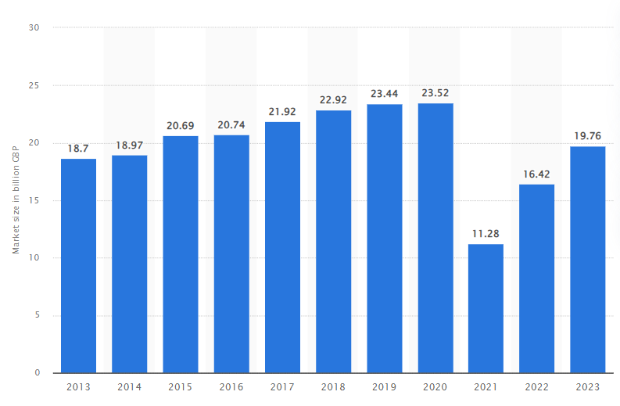

Appendix 2: Figure 2: Internet Penetration Rate of the UK
(Source: statista.com, 2023, c)
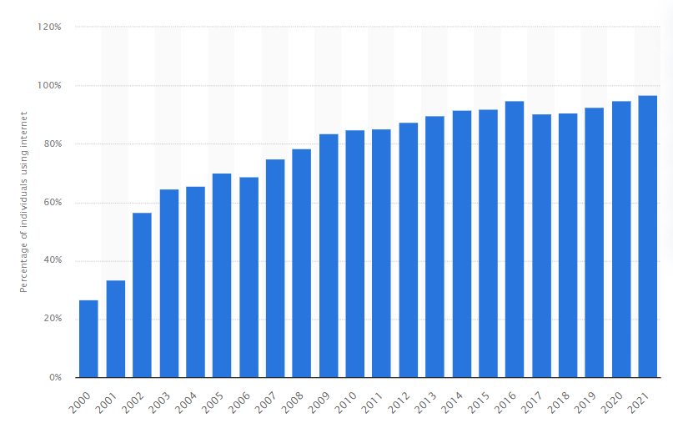

Appendix 3: Figure 3: Transactional Leadership Theory
(Source: Motivated by Cho et al., 2019)
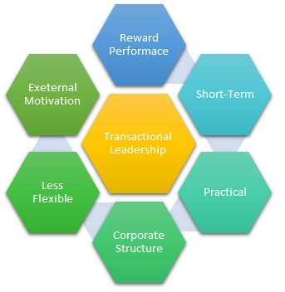

Appendix 4: Figure 4: Circular Economy
(Source: Motivated by Busu, 2019)
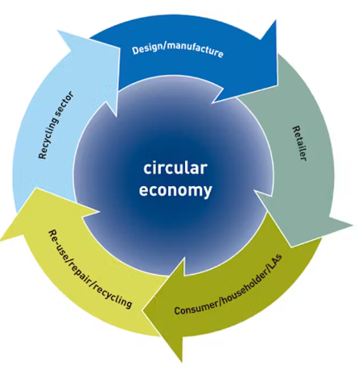

Appendix 5: Figure 5: Carbon emission by the Hospitality industry
(Source: statista.com, 2021)
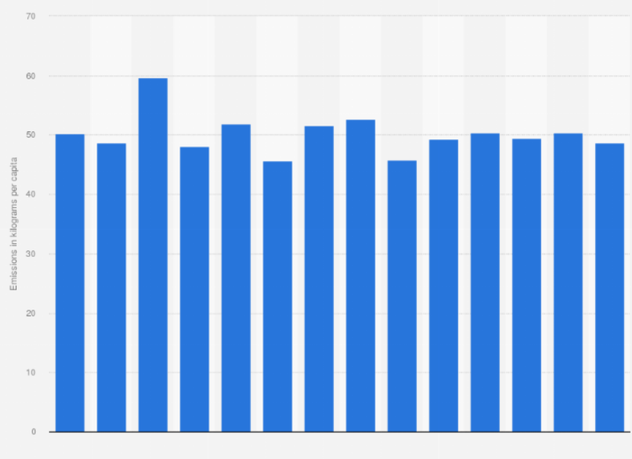

Appendix 6: Figure 6: Waste disposal by the hospitality industry in the UK
(Source: statista.com, 2022)


