Site layout during Steel frame construction
Pedestrian access on to site
Traffic direction
Site boundary
Heras fencing
Site offices
Site offices and welfare cabins
Delivery Access
Muster point
Muster point
Waste skips
Secured area for materials
Crane
Crane
Stone mat for 50tonne mobile crane
Stone surface for scissors lift / forklift access
Car park
Car park for visitors/ trades
Wheel cleaning area
Wheel cleaning area

Car park for visitors / trades
Site offices
Welfare units
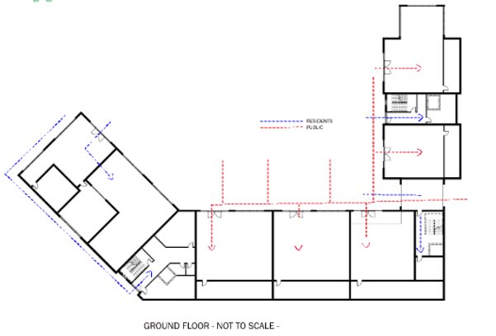
Muster point

Secured area for materials

Crane

Waste skips

Waste skips
Waste skips
Wheel cleaning area
Delivery exit
Delivery entrance

