Comparison of Machine Learning Methods on Walmart Sales
Apostol George-Adrian
(1807626)

Big Data (ACUA6002)
Terry Walcott

University of Wales: Trinity Saint David
BSc Cloud Computing
London
07/01/2021

Abstract
This paper aims to evaluate the efficiency and effectiveness of two machine learning algorithms. The performance between simple regression tree model and gradient boosted trees model was compared using the mean square error. Firstly, the data is normalised and then divided into tested and trained data, following a percentage of 20% for test data and the rest of 80% for train data. Focused on a basic regression tree on test data, an MSE of 0.021 occurred, but, once a gradient boosted tree is used, an MSE of 0.017 occurred. This result demonstrates that gradient boosted tree is more efficient than simple regression tree on Walmart sales data.

Index Terms—machine learning, simple regression tree, gradient boosted trees, mean square error

Table of Contents
1. Introduction 4
2. Literature review 4
3. Methodology 5
3.1 Data Set 6
3.2 Pre-processing 6
3.3 Splitting Data 6
3.4 Algorithms 6
3.4.1 Simple Regression Tree 6
3.4.2 Gradient boosted regression tree 7
4. Data analysis 7
5. Conclusions 10
6. References 11

Introduction

From the last few years machine learning is gaining popularity in all fields especially in finance, textile, engineering, medical field, and remote sensing. In all these fields machine algorithms are used for predictions. Machine learning uses two distinct forms of algorithms: supervised and unsupervised learning, respectively.
In supervised learning the data is already labelled while in unsupervised learning the dependent variable is not known, which means that data in not labelled. In supervised learning there are also two main techniques that are regression and classification. The most significant distinction between regression and classification is for the dependent variable, which is categorical in regression and continuous in regression. It depends on the case whether the problem is relating to classification or regression. Machine learning scientists have discovered different techniques for classification and regression.
In this study, the supervised learning approach has been used for analysis. Further in supervised learning the problem is related to regression. The main aim is to predict the weekly sales from Walmart sales by using simple regression tree and gradient boosted trees by taking other variables as independent variables and then compare the performance of these two algorithms [1].

Literature review

Decision tree is frequently applied for supervised learning method. It can approach both Regression analysis and Classification issues, but it can also be extended for the practical purposes [2]. Many machine learning methods were effectively implemented for the short-term load forecasting domain, such as neural networks, decision and gradient boosted trees, and so on [1].
Regression approaches are mostly used in the finance to predict the sales and demand of customers [3]. The usage of a specific group of supervised machine learning methods, such as simple regression trees and gradient boosted trees, was proposed in this research for the prediction of the super store weekly sales [4].
The simple regression tree sets up the structure design in the shape of a tree. It splits the data collection into progressively smaller subsets while simultaneously a linked decision tree is additional established [5]. Gradient boosted decision trees model assembles the decision trees for sequential training. Through integration of residual errors or negative gradients, GBDT discovers the decision trees in each iteration [6].
The biggest cost of gradient-boosted trees stands in mastering the decision trees, and discovering the optimal split points is by far the greatest time-consuming element of mastering a decision tree. Among the most common algorithms for identifying split points is the pre-sorted algorithm that operates by listing all potential split points on the pre-sorted function values. One technique for identifying level-set split points is the pre-sorted algorithm, that operates by listing all the potential split points on the pre-sorted function values [6]. This approach is simple, and it may identify appropriate split points, however, it might not be as effective in terms of training speeds and memory usage [7].

Methodology

In this section, a flow chart is created for the analysis purposes, as shown in figure 1 below.
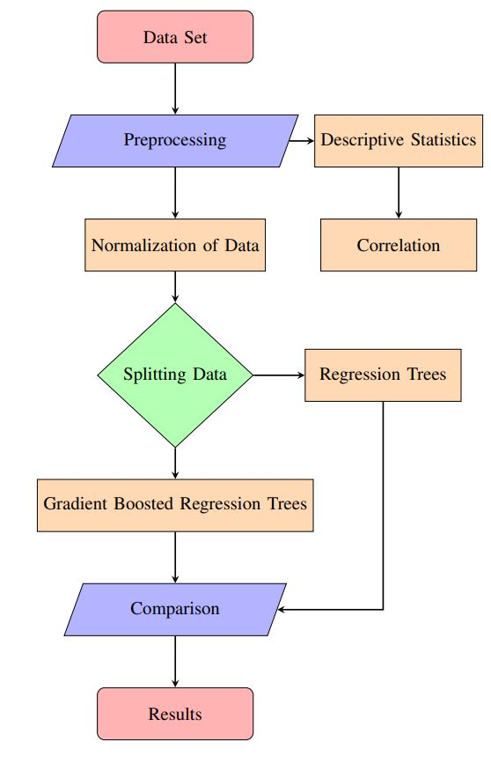

Figure 1. Proposed flow chart

Data Set
The dataset is taken from Walmart stores sales. In this data we have several variables of 45 stores. The variables are sales, Fuel Price, Holiday and unemployment rate etc. We take sales as our dependent variable and all other variables are independent variables.

Pre-processing
Pre-processing is the most important step in the machine-learning domain. The correlation and normalization of data is used to get the accurate results.

Splitting Data
This step divides the given dataset into testing and training data. The proposed model is trained on 80% and then those results are tested on 20% data.

Algorithms
Regression is the main issue in this case, so regression algorithms needs to be used. Two algorithms are selected, which are regression tree and gradient boosted regression trees. The results of these two algorithms will be compared to make a distinction [8].

Simple Regression Tree
Regression tree, which is basically the part of decision tree [9], is used when the given dependent variable is continuous. The decision tree models depend on nested if-else conditions. The algorithm starts assigning the data in two groups or partitions, exploiting each feasible binary split through each sector. The division which reduces the average of the mean's squared deviations into two independent partitions is selected by the algorithm. For any of the new branches, this division law is then extended until every node achieves a specific node size defined by the user and develop into a terminal node [10]. If the average of the mean's square deviations in a node is null, even if the node did not meet the minimum dimension, the node is labelled as a terminal node. The numerical score of the regression tree is given below.

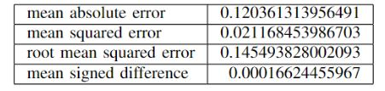
Table 1. Results on test data by using regression tree
It can be seen from the above table that the MSE value is 0.021 which is very low, providing a good performance on the test data.

Gradient boosted regression tree
This method in an ensemble method for the regression tree and it is more powerful than the first simple regression tree method used. The gradient boosted regression trees uses more complex structure [11] and it got depth higher than 1. Practically, the gradient boost is used with a cumulative leaves number within 8 and 32. As in can be seen in the table below, the current MSE is 0.017 which is lower than the regression tree, providing a better data performance.

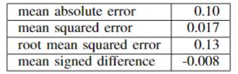
Table 2. Results on test data using the Gradient Boosted Regression Tree

Data analysis

As the dependant variable is Sales, a prediction of the variable is necessary. First, it needs to be calculated the correlation among all the variables and after that the data be normalized to get the best result on training and test data [12].
The correlation table is given below. It can be seen that there is negative correlation between weekly sales and temperature and also between CPI and unemployment.
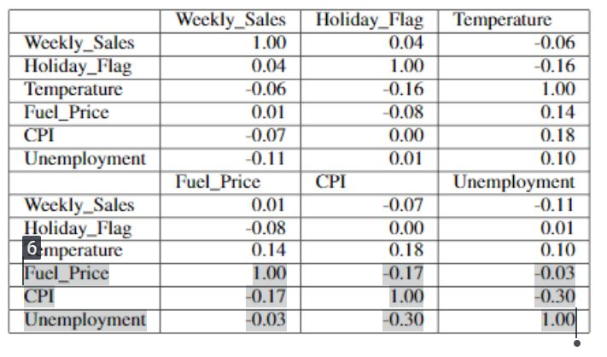
Table 3. Correlation between variables

The figure 2 below illustrates the workflow process.
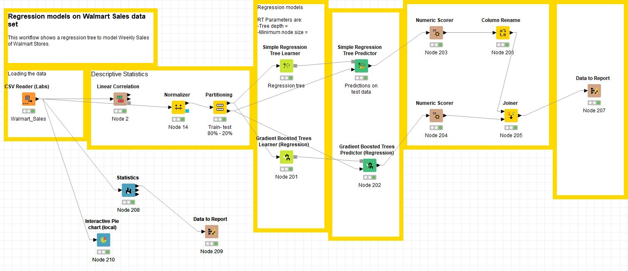
Figure 2. Walmart’s workflow development

The nodes incorporated through the workflow are briefly described below:
- Node 1 is a CSV Reader used for data loading. In this node the csv data is loaded. Node 1 is connected then with several nodes like Linear Correlation, Normalizer, Statistics and an Interactive Pie chart.
- In the second node, the linear correlation is calculated between numerical variables.
- The normalizer node is used to normalize the date between 0 and 1.
- Statistics node shows the summary of variables, illustrated in figure 3.

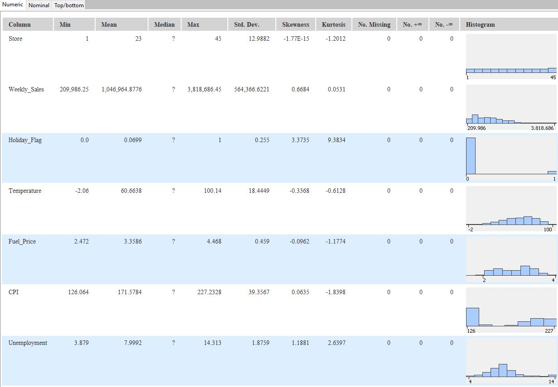
Figure 3. Statistical view

- Interactive pie chart is used to visualize the plain file with some custom setting, as shown in figure 4 below.

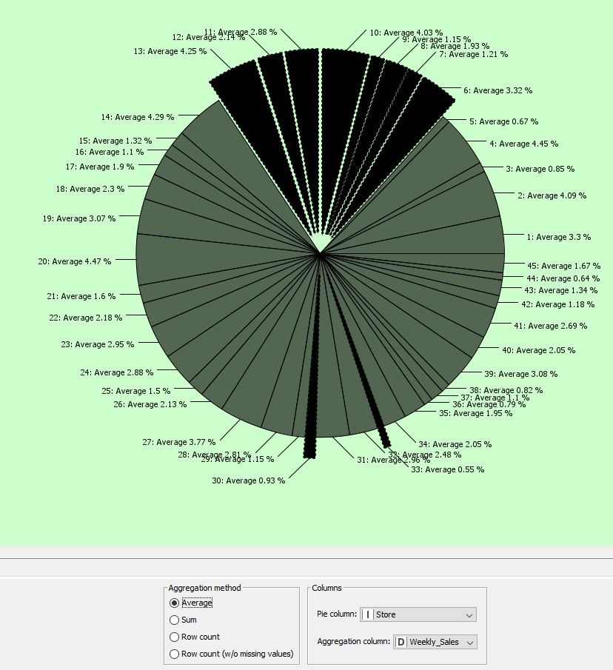
Figure 4. Representative Pie Chart

- Normalizer node connects to partitioning node which separate the data into training and test data (80% for training and 20% for testing data).
- The above side of partitioning node is connected to simple regression trees and gradient boosted trees, respectively. The lower side of the node is used to predict the unseen data or test data. That node is connected to simple regression tree predictor and gradient boosted tree predictor. A view of the regression tree is shown in figure 5.

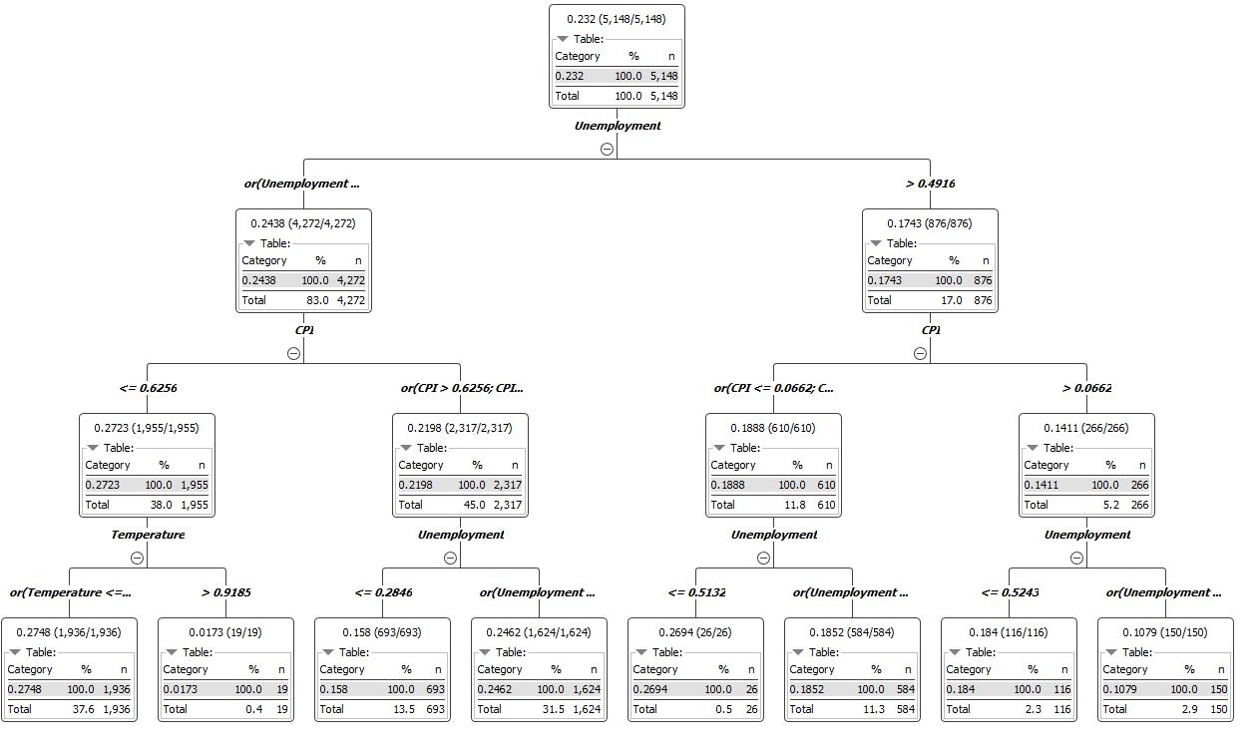
Figure 5. Simple Regression Tree view
- Both predictor nodes will be connected to a different numeric scorer node to calculate the MSE and RMSE errors.
- Then, the joiner node is used to link and compare the results of both models.
- Lastly, the data to report node is used to see the comparison results of each model and their performance. The output is displayed below.

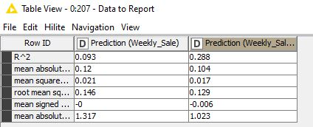
Figure 6. An overview of the regression models compared

Conclusions

As a conclusion, both algorithms perform well on the test data because their MSE in low. Following the second and third tables, it could be said that there is no significand difference between the simple regression tree and the gradient boost tree model. By comparing the overall performance between these two models it can be said that the gradient boosted regression trees performance is slightly better than the regression tree.
A single decision tree is a slow predictor, as is slowing the process when having more trees, but respectively easy to construct. The gradient boosted regression tree model provides a higher performance when the parameters are carefully selected.

References

[1] G. Tso and K. Yau, "Predicting electricity energy consumption: A comparison of regression analysis, decision tree and neural networks", Energy, vol. 32, no. 9, pp. 1761-1768, 2007. Available: 10.1016/j.energy.2006.11.010.
[2] M. Pratola, H. Chipman, E. George and R. McCulloch, "Heteroscedastic BART via Multiplicative Regression Trees", Journal of Computational and Graphical Statistics, vol. 29, no. 2, pp. 405-417, 2019. Available: 10.1080/10618600.2019.1677243.
[3] J. Taylor, L. de Menezes and P. McSharry, "A comparison of univariate methods for forecasting electricity demand up to a day ahead", International Journal of Forecasting, vol. 22, no. 1, pp. 1-16, 2006. Available: 10.1016/j.ijforecast.2005.06.006.
[4] M. Ruiz-Abellón, A. Gabaldón and A. Guillamón, "Load Forecasting for a Campus University Using Ensemble Methods Based on Regression Trees", Energies, vol. 11, no. 8, p. 2038, 2018. Available: 10.3390/en11082038.
[5] W. Charytoniuk, M. Chen and P. Van Olinda, "Nonparametric regression based short-term load forecasting", IEEE Transactions on Power Systems, vol. 13, no. 3, pp. 725-730, 1998. Available: 10.1109/59.708572.
[6] Ke, Guolin et al., "LightGBM: a highly efficient gradient boosting decision tree", Dl.acm.org, 2017. [Online]. Available: https://dl.acm.org/doi/10.5555/3294996.3295074. [Accessed: 04- Jan- 2021].
[7] M. Mehta, R. Agrawal and J. Rissanen, "SLIQ: A fast scalable classifier for data mining", Advances in Database Technology — EDBT '96, pp. 18-32, 1996. Available: 10.1007/bfb0014141 [Accessed 1 January 2021].
[8] Y. Lin, H. Luo, D. Wang, H. Guo and K. Zhu, "An Ensemble Model Based on Machine Learning Methods and Data Preprocessing for Short-Term Electric Load Forecasting", Energies, vol. 10, no. 8, p. 1186, 2017. Available: 10.3390/en10081186.
[9] J. Friedman, "Stochastic gradient boosting", Computational Statistics & Data Analysis, vol. 38, no. 4, pp. 367-378, 2002. Available: 10.1016/s0167-9473(01)00065-2 [Accessed 2 January 2021].
[10] T. Chen and C. Guestrin, "XGBoost: A Scalable Tree Boosting System", Dl.acm.org, pp. 785–794, 2016. [Online]. Available: https://dl.acm.org/doi/10.1145/2939672.2939785. [Accessed: 25- Dec- 2020].
[11] T. Chen et al., "Package ‘xgboost’", Cran.r-project.org, 2021. [Online]. Available: https://cran.r-project.org/web/packages/xgboost/xgboost.pdf. [Accessed: 03- Jan- 2021].
[12] Hastie, T.; Tibshirani, R.; Friedman, J.H., The Elements of Statistical Learning, 2nd ed.; Springer: New York, NY, USA, 2009; pp. 337–384. ISBN 0-387-84857-6.

