3/26/2026
University of Wales Trinity Saint David
London campus
E-Portfolio Link: https://m5z2t24jyj.wixsite.com/design-spectrum
Module Name: Learning In the Digital Era
Module Code: ACCA 4025

Student Name: Viacheslav Odrynskyi
Student ID: 2530812
Group: 3

Lecturer’s Name: Koushik Modak

LDE Assignment 1
E-Portfolio
Table of Contents
Introduction 2
Main Body 2
Task 1: Essential Academic and Employment Skills for the future career Path 2
Task 1 (a): Report on Essential Academic and Employment Skills 2
Task 1 (b): Evaluation of Task 1 (a) based on Similarity report 2
Task 2: Collaborative Mind Map and Individual Poster 2
Mind Map (Collaborative) 2
Poster (Individual) 2
Task 3: Virtual Collaboration and RefWorks 2
Report on Virtual Collaboration 2
Step-by-step process of using RefWorks with visuals 2
Task 4: E-Portfolio Creation and Evaluation 2
Task 4 (a): E-Portfolio Creation 2
Task 4 (b): Illustrative Review of E-Portfolio tool Selection 2
Conclusion 2
References 2
Task 1 References: 2
Task 3 References: 2

Introduction

Main Body

Task 1: Essential Academic and Employment Skills for the future career Path

Task 1 (a): Report on Essential Academic and Employment Skills
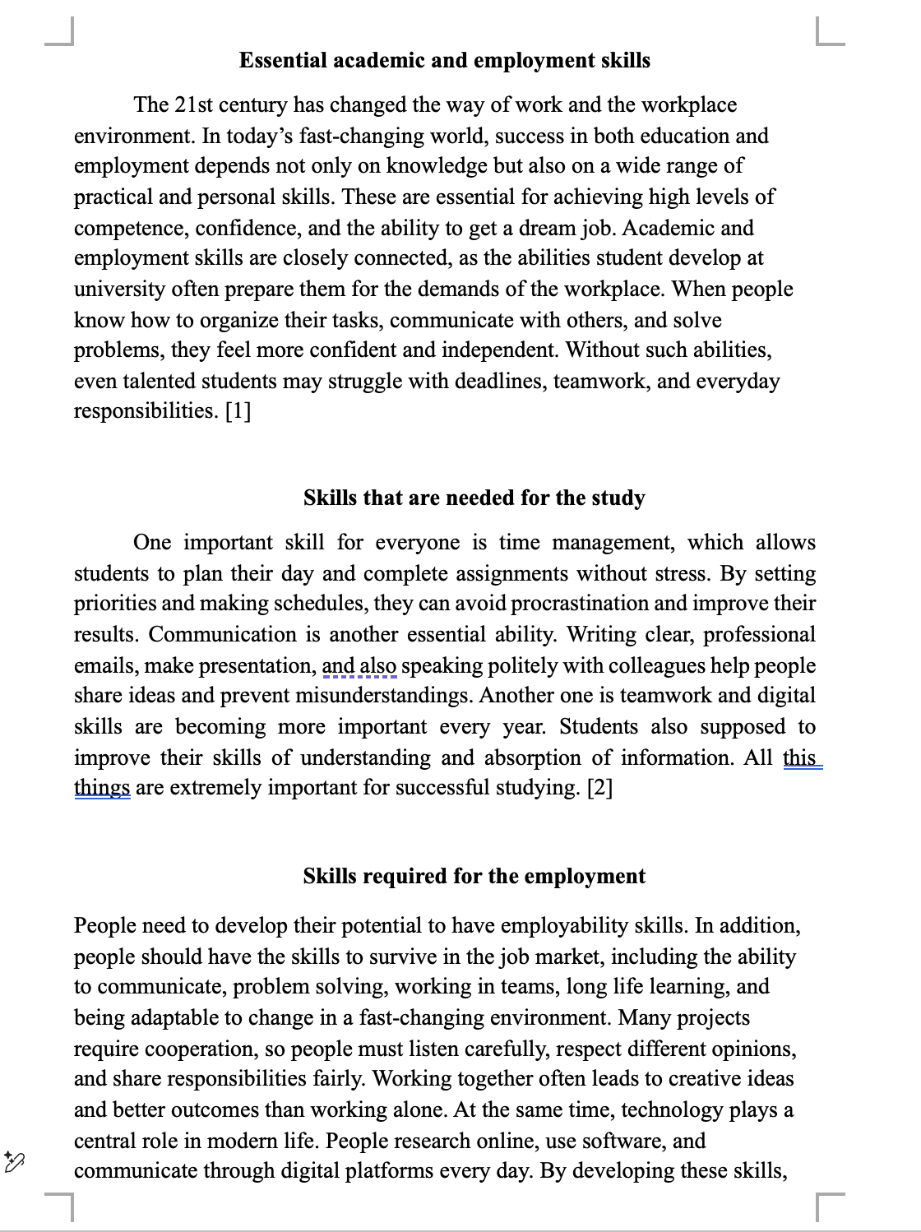

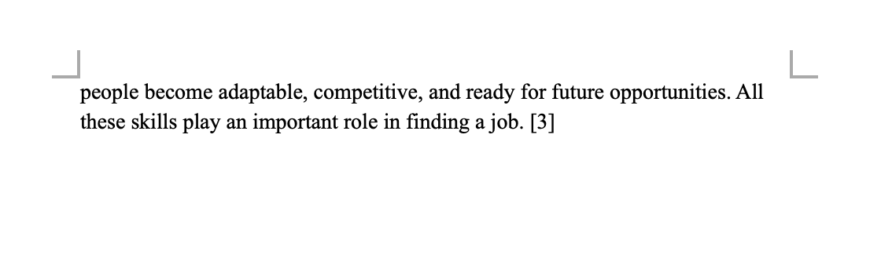

Task 1 (b): Evaluation of Task 1 (a) based on Similarity report
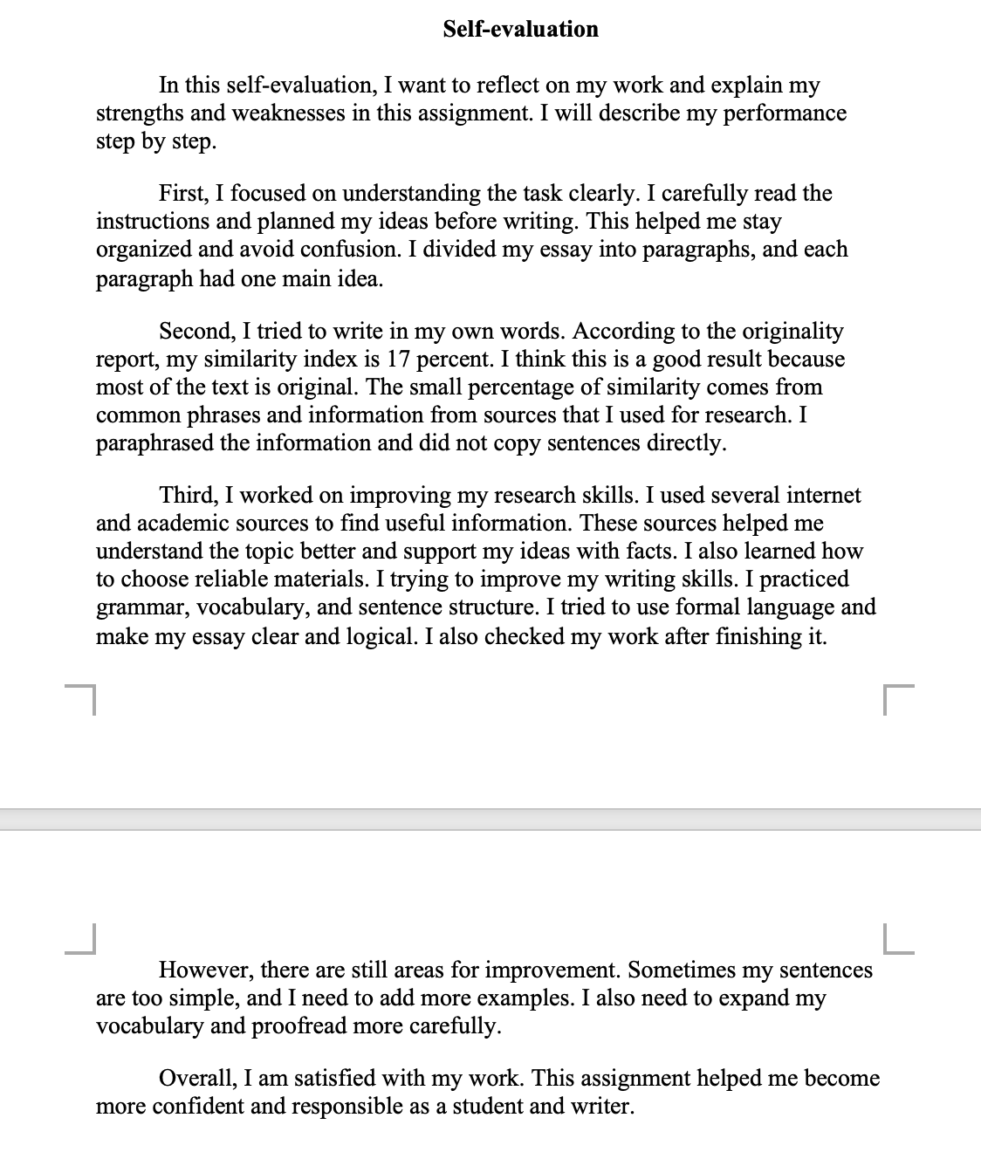
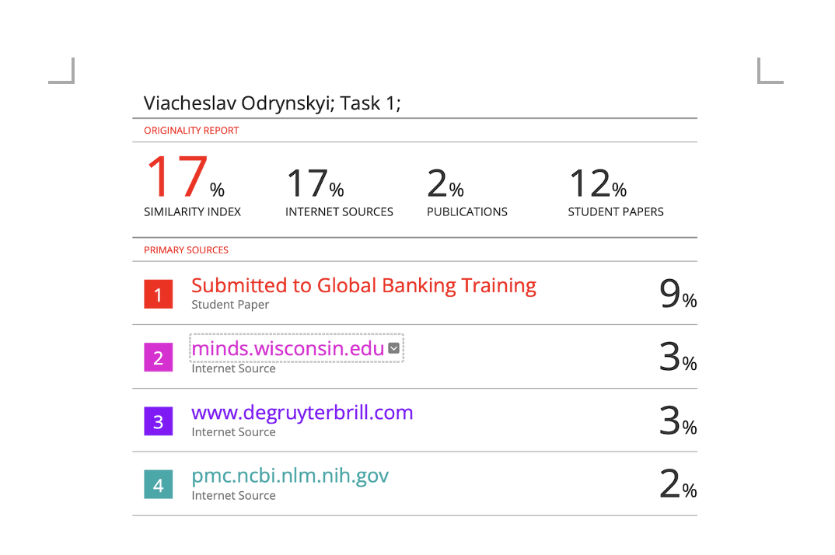

Task 2: Collaborative Mind Map and Individual Poster

Mind Map (Collaborative)
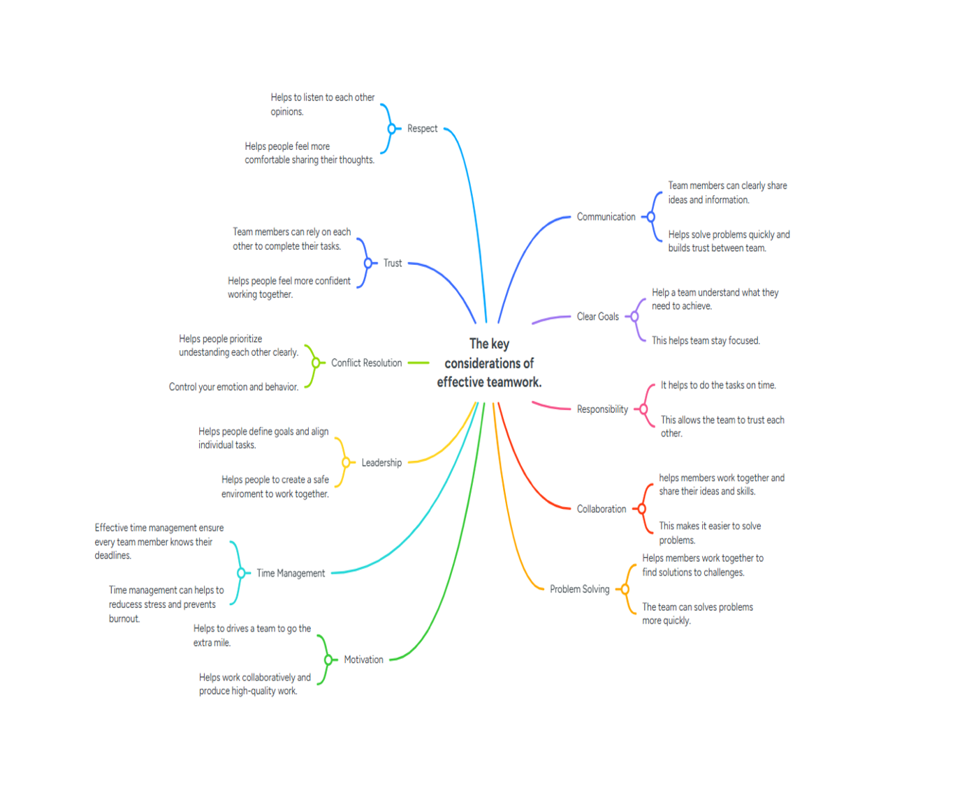

Poster (Individual)
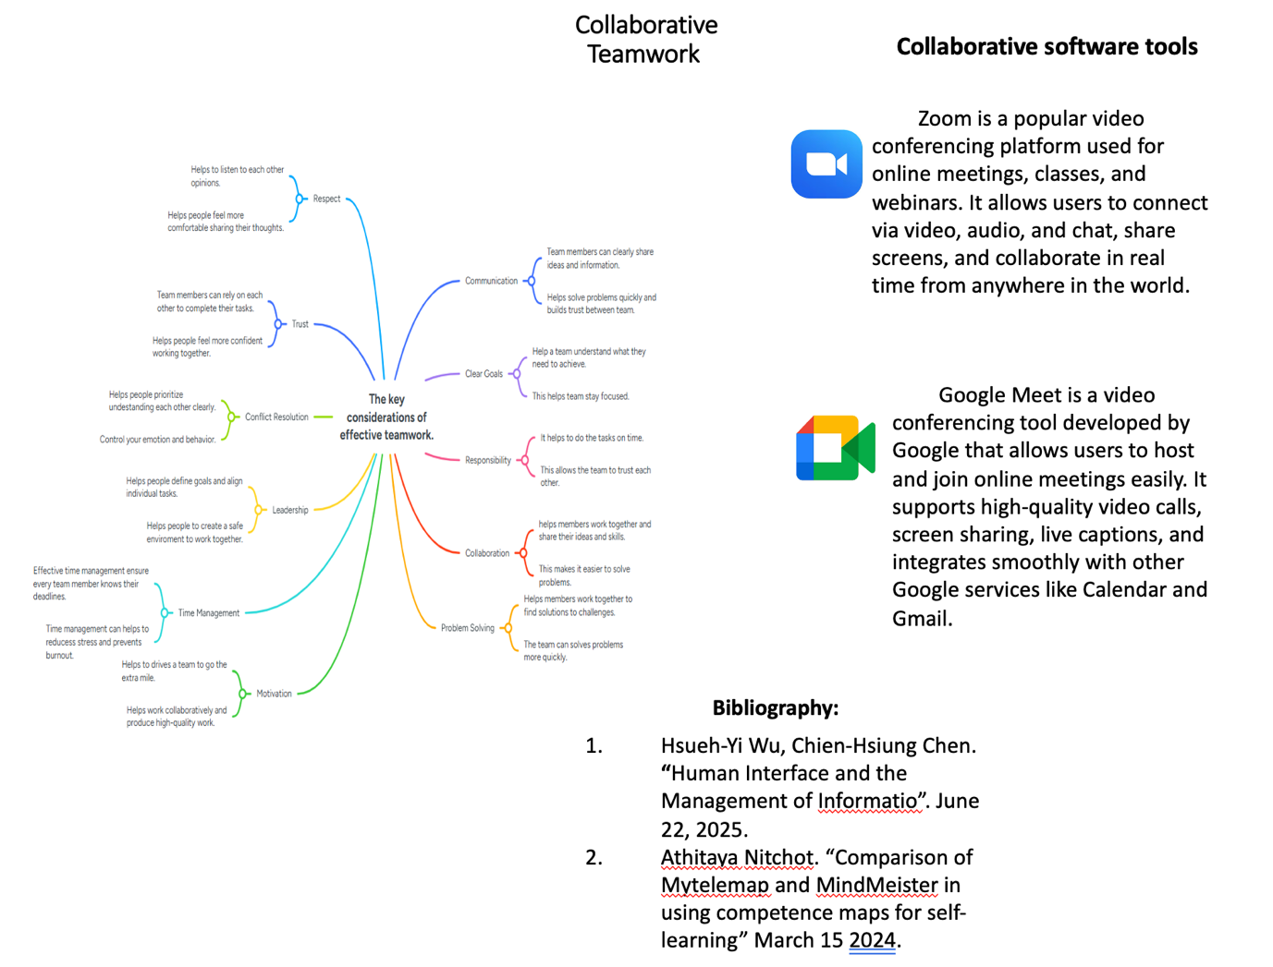

Task 3: Virtual Collaboration and RefWorks

Report on Virtual Collaboration
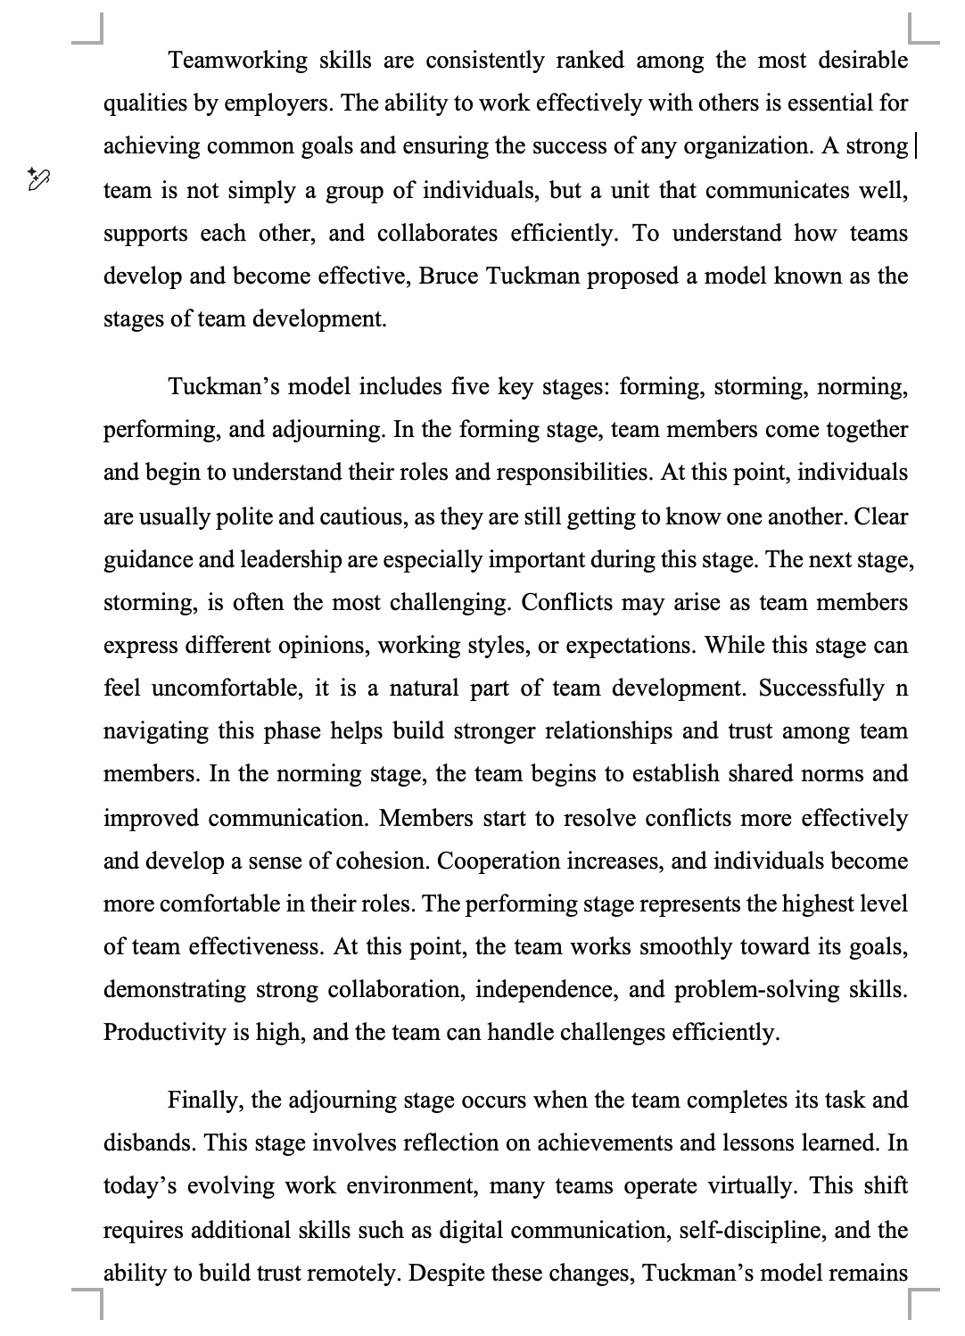

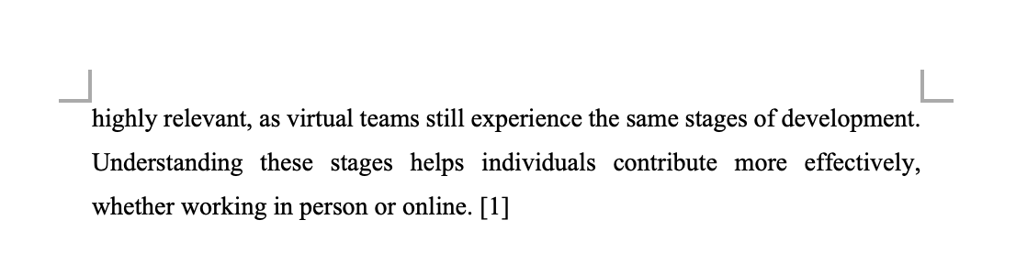
Step-by-step process of using RefWorks with visuals
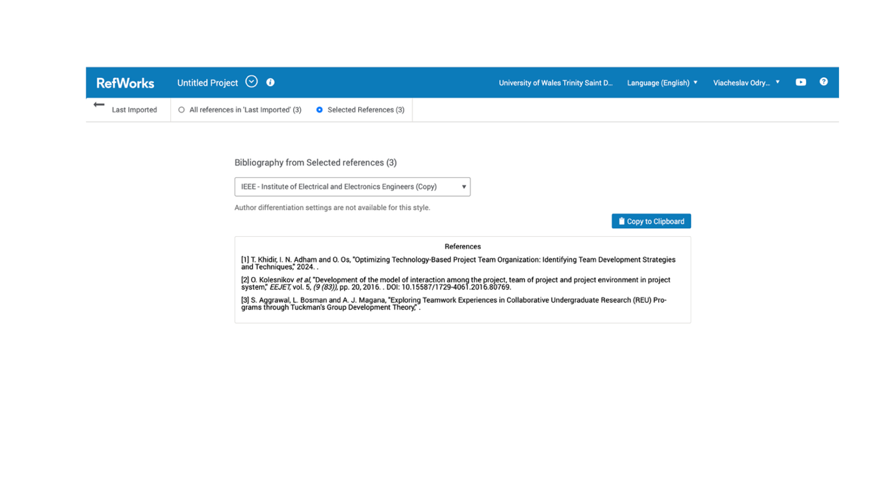
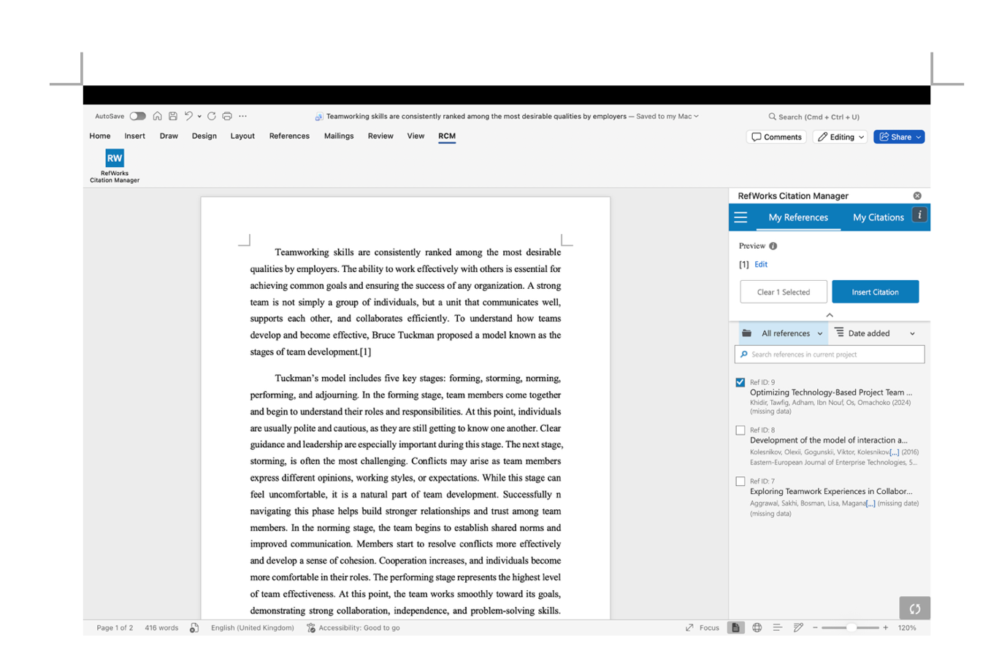
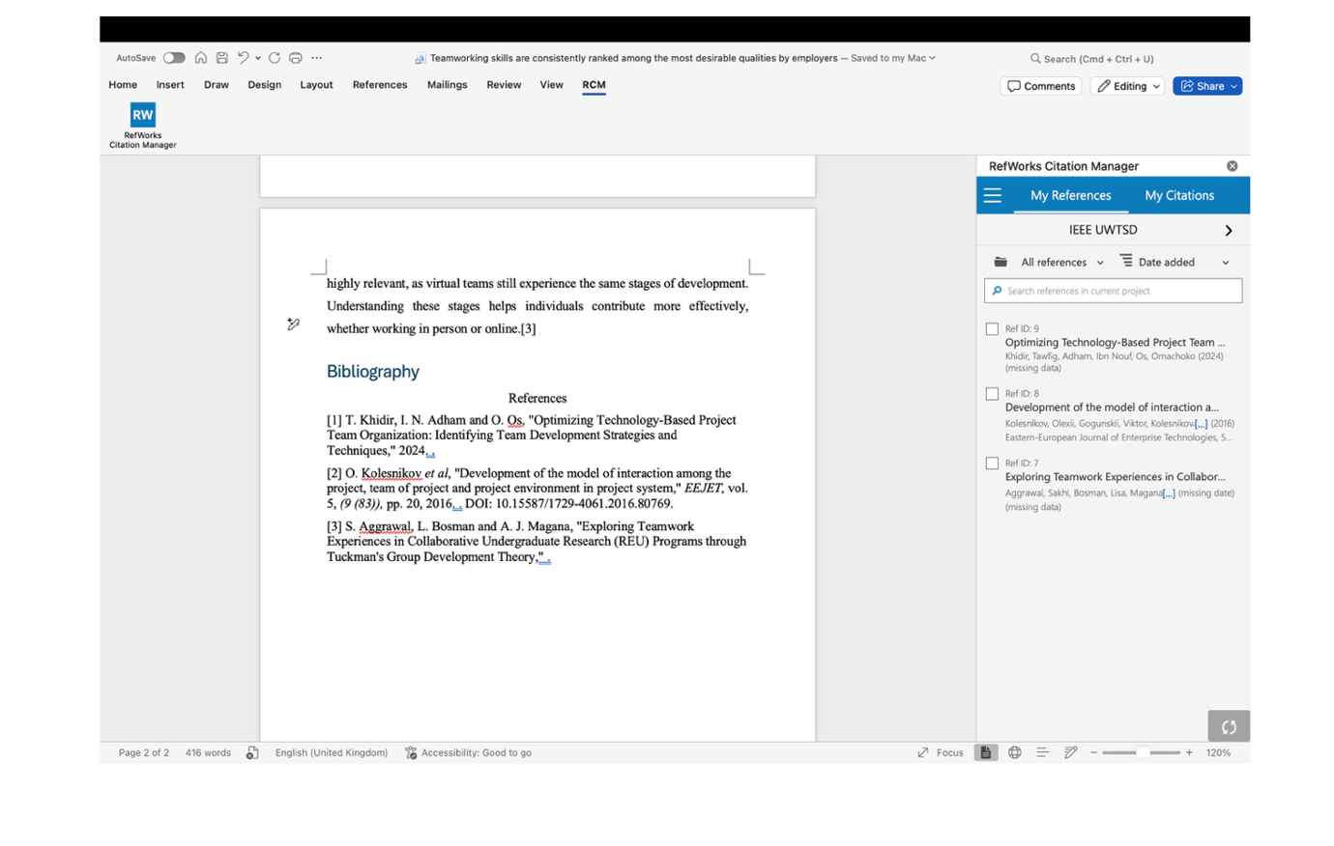

Task 4: E-Portfolio Creation and Evaluation

Task 4 (a): E-Portfolio Creation
Using Wix, I created my portfolio website quickly and without any need for coding. The platform’s large library of templates helped me choose a clean and professional design, and the intuitive drag-and-drop editor made it easy to customize every section. I also used Wix’s built-in SEO tools and apps to add extra features and improve the site’s functionality. Thanks to reliable hosting and automatic mobile optimization, the site looked great on all devices right away. Overall, Wix gave me full control over the design while keeping the whole process simple, fast, and convenient.
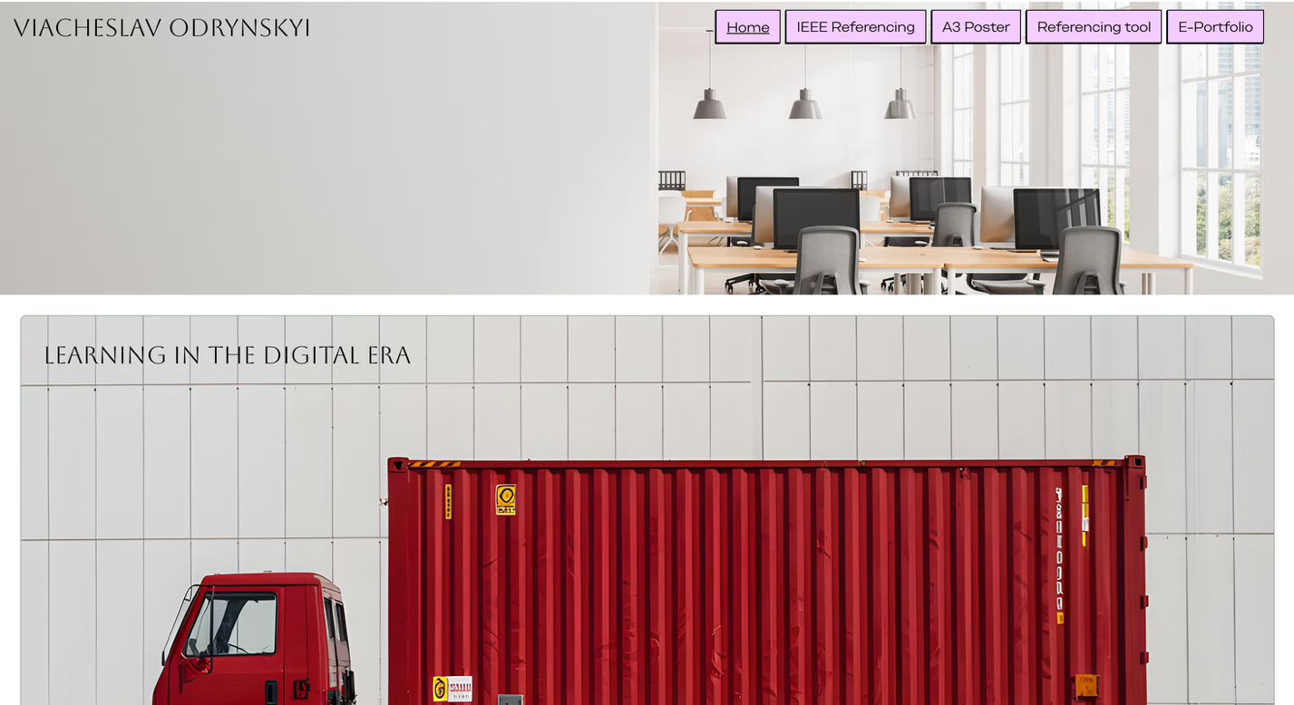

Task 4 (b): Illustrative Review of E-Portfolio tool Selection
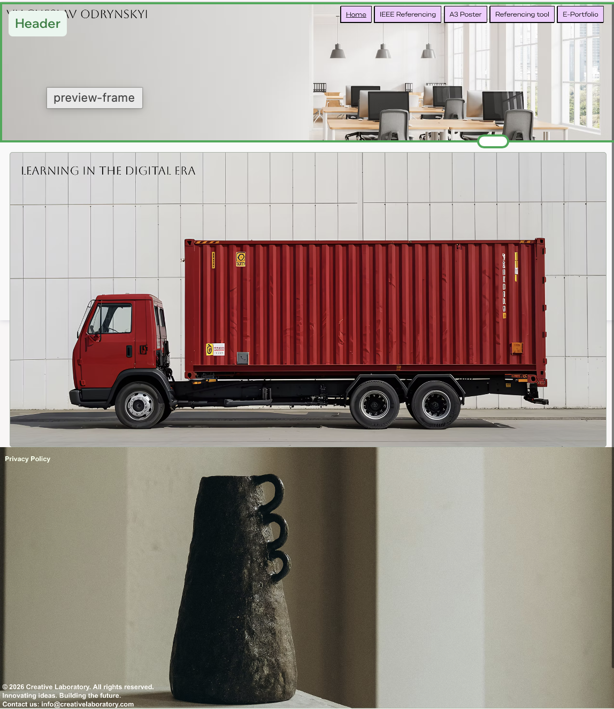
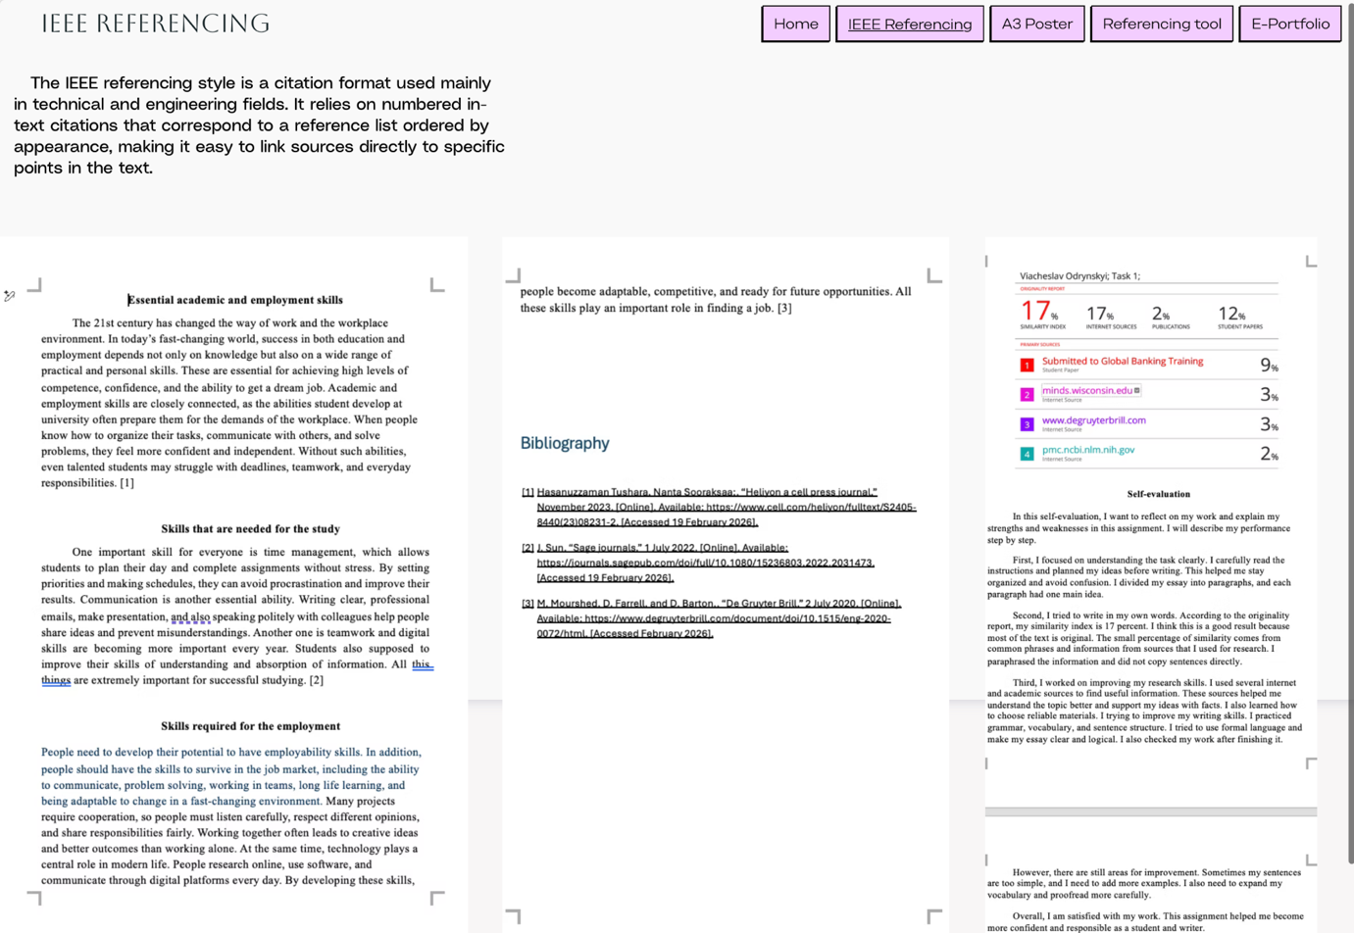
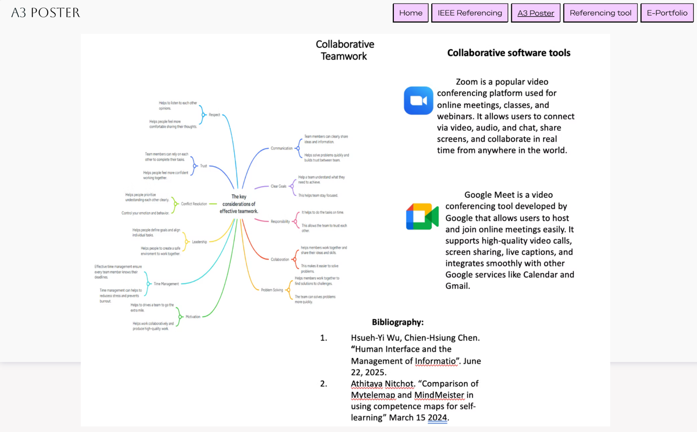
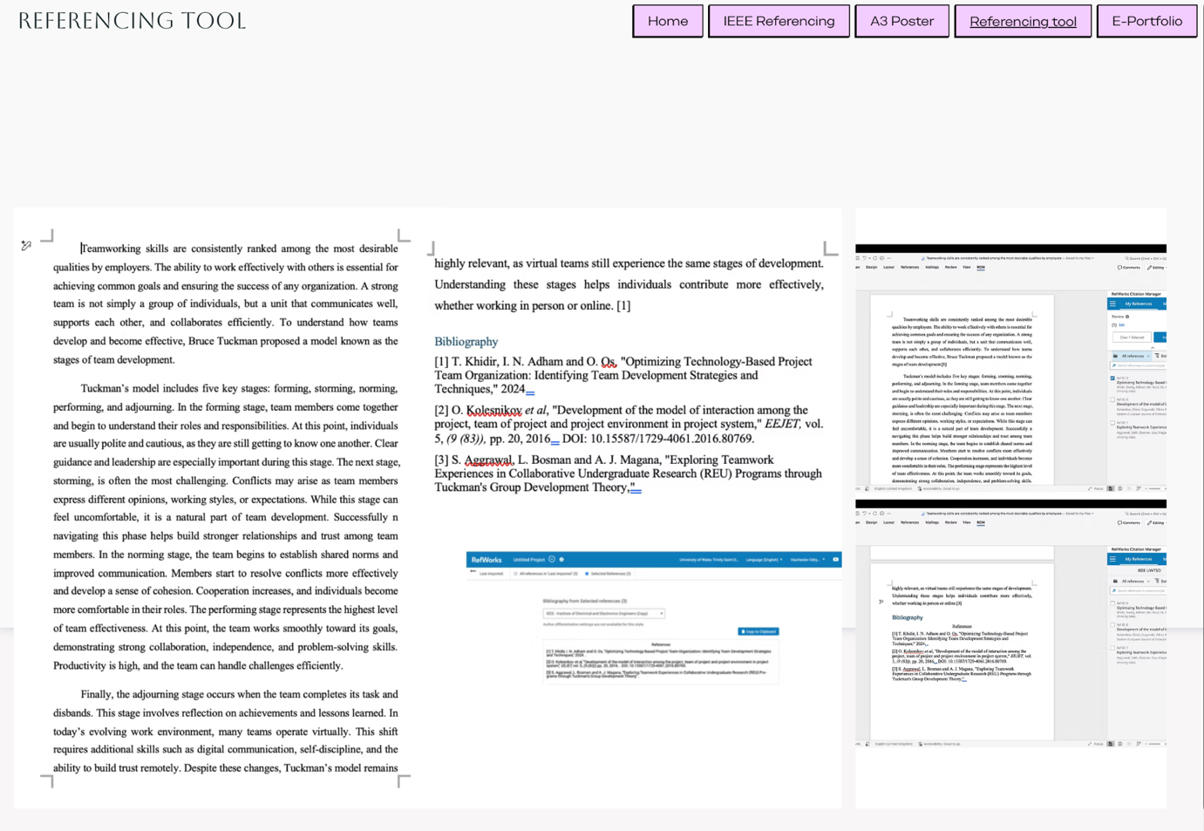
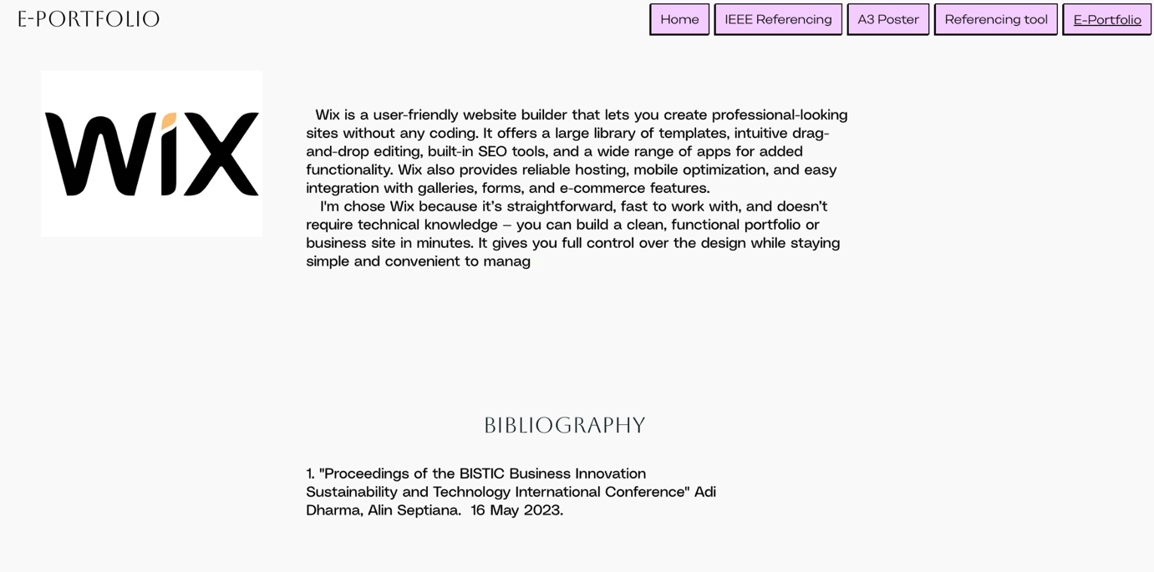

Conclusion
Throughout this project, I explored different aspects of learning and working in the digital era. I created various assignments, developed a mind map, and wrote article using the IEEE referencing style, which helped me improve my academic and technical writing skills. I also built a portfolio website using Wix, gaining practical experience with modern digital tools and online platforms. Altogether, these tasks demonstrated how technology enhances learning, creativity, and communication. They showed me that digital literacy is essential today—not only for organizing information but also for presenting ideas effectively and building a professional online presence.

References

Task 1 References:

Bibliography

[1] | Hasanuzzaman Tushara, Nanta Sooraksaa;, “Heliyon a cell press journal,” November 2023. [Online]. Available: https://www.cell.com/heliyon/fulltext/S2405-8440(23)08231-2. [Accessed 19 February 2026].
[2] | J. Sun, “Sage journals,” 1 July 2022. [Online]. Available: https://journals.sagepub.com/doi/full/10.1080/15236803.2022.2031473. [Accessed 19 February 2026].
[3] | M. Mourshed, D. Farrell, and D. Barton., “De Gruyter Brill,” 2 July 2020. [Online]. Available: https://www.degruyterbrill.com/document/doi/10.1515/eng-2020-0072/html. [Accessed February 2026].

Task 3 References:

Bibliography
[1] T. Khidir, I. N. Adham and O. Os, "Optimizing Technology-Based Project Team Organization: Identifying Team Development Strategies and Techniques," 2024. .
[2] O. Kolesnіkov et al, "Development of the model of interaction among the project, team of project and project environment in project system," EEJET, vol. 5, (9 (83)), pp. 20, 2016. . DOI: 10.15587/1729-4061.2016.80769.
[3] S. Aggrawal, L. Bosman and A. J. Magana, "Exploring Teamwork Experiences in Collaborative Undergraduate Research (REU) Programs through Tuckman's Group Development Theory," .

