Assignment 2 – A Personal Learning Environment

BMSP4003 – Learning & Collaboration for Global Citizenship

Name: Courtney Busby

Student ID: 1701941

Lecturer: Alex Bell

Deadline: 3rd April 2018

Introduction
The role of technology in the classroom has dramatically changed in the last two decades. Introducing technology into the classrooms have been widely praised as it is enticing new learners & encouraging the pupils to engage in their lessons. This includes social media as it is a fantastic tool to conduct research for all parties involved at a secondary school level & especially higher education, which challenges the conventional methods of traditional research using books, journals, articles etc.

The introduction of the internet was a new item that was widely revered & changed the public’s lives. Once the new development of the internet was released to the public, people were used to the first version which meant that web 2.0 changed lives again dramatically. Tim O’Reilly described web 2.0 as a “platform, spanning all connected devices” it is also described as an “intrinsic advantage” (Cormode & Krishnamurthy, 2018) as web 2.0 is more consumer operated. However, there is disagreement on the actual definition of Web 2.0 as there are those that think it is just a buzzword & others who think it is a new source of wisdom. There are many differences between Web 1.0 and Web 2.0 such as how businesses can create a revenue from the internet or how easy it is to find information for schoolwork. An example of the differences can be seen from an extract of, “What is Web 2.0: Designing Patterns and Business Models for the Next Generation of Software” by Tim O’Reilly;
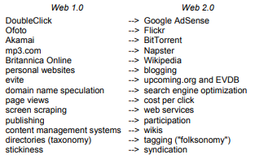
Figure 1 Differences between Web 1.0 & Web 2.0

However, there is a “digital divide” (Mpra.ub.uni-muenchen.de, 2018) due to the problem of having a lack of access to technology. Another example of a divide in technology is that students now have more knowledge about technology than their teachers. These students are called, “Generation M” (Mpra.ub.uni-muenchen.de, 2018) as they are surrounded by technology from birth which & affects their literacy. In America, literacy campaigns were created as a national development decreed that each child must have access to a computer to “make use of their lives” ((Mpra.ub.uni-muenchen.de, 2018) which was enabling them to achieve the best education possible. As well as this, social networking websites affect the learning environments as they are intense, media-rich & extremely accessible to children. One can argue that children are seduced by social media from a young age & are doomed to living out their lives on social networking sites & I agree to a certain point as children are introduced to social media at a young age due to their parents/guardians posting multiple photos of their children on it, but I do think that most children do not use social media until secondary school to keep in touch with their friends. “Generation M” (Mpra.ub.uni-muenchen.de, 2018) is defined as, “a collective group of students” (Mpra.ub.uni-muenchen.de, 2018) who are referred to “Generation Media” (Mpra.ub.uni-muenchen.de, 2018) or millennials & were born in-between the 1980’s & the 1990s. These people are comfortable with technology & view computers as a part of life rather than being disconnected from their lives. However, they are in the world of blurred lines regarding “consumption, creation, file sharing & cut & paste plagiarism” (Mpra.ub.uni-muenchen.de, 2018) where it is considered the norm, but the growing concern is the new “ease of web-assisted plagiarism” (Mpra.ub.uni-muenchen.de, 2018) as well as the ethics of using “detection services” (Mpra.ub.uni-muenchen.de, 2018). To combat this, educational institutions are using services such as, “Turnitin” which detects any type of plagiarism in a piece of work.

The classrooms of modern day have not changed much in the last 100 years, but the introduction of technology is changing rapidly & is having a lasting effect on education. This is because as technology advances so does students’ digital literacy which affects education. As a child grows, they learn to read & write which will lay foundations for education & is the basic requirements for all academic disciplines. These skills are also called, “verbal literacy” (Huffaker, 2018) & are crucial to achieving success throughout life. However, technology has introduced a new type of skill, “digital literacy” (Huffaker, 2018) which refers to, “the ways people become comfortable using technology” (Huffaker, 2018). Digital literacy will give two advantages such as the experience & “digital fluency” (Huffaker, 2018) to prosper in the new & advancing digital age. Another advantage is that it will also promote the other types of literacy needed for everyday life.
The value of digital literacy has been challenged so many times & the contemporary usage of digital literacy is a set of skills used to operate a digital device effectively which is often seen as the “functional definition” (Buckingham, 2018) of digital literacy. In Britain, the educational system includes ICT classes which teaches the basics of certain techniques such as how to use a word processor, the ability to save data, copy & paste etc. But the educational system does not include a lot of online safety which has become a vital part of online usage. Media represents the world more now than it has ever done as with the influx of social media, blogs, etc, everyone is online or has a persona online which means that the more informed & literate the users are, the safer the internet will be.

PLE
A PLE is a diagram, most commonly called a mind map, which shows what technology is used for certain categories. My PLE shows mainly social media & streaming websites to research information for my coursework. When creating the PLE, I discovered that I use a lot more digital technology than I thought I did, which does not include my digital devices like my laptop or my phone. It was interesting looking at how much technology I use on a day to day basis.
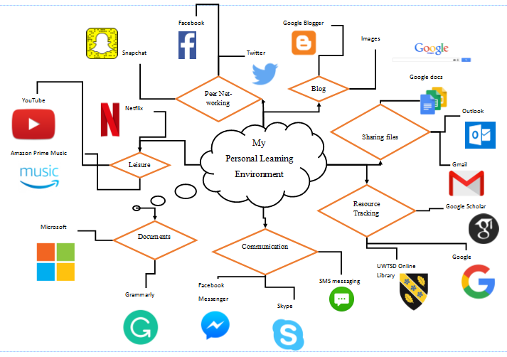

I mainly use Microsoft products/services to write my coursework, make timetables, track finances etc, but I often use Google docs to share files or write coursework online. To perfect my coursework, I like to use Grammarly which is a website/app that will critically analyse written work & discover any spelling mistakes, grammar mistakes etc. The advanced version requires payments & includes a plagiarism check which I find extremely useful. To conduct research for my coursework, I use a lot of the University of Wales Trinity Saint David’s online library as I find that the university’s database has thousands of books which are constantly being added to. Another source I use to conduct research is Google Scholar as there are a collection of papers, articles, journals, books etc that is extremely useful when writing my assessments. I also use a lot of social media to conduct research for certain assignments as well. For example, in a recent assignment for Generating Business Data & Analysis, I needed customer reviews & people are more honest & genuine on websites like Twitter & Facebook than Trip Advisor who can be biased.
It is interesting how much technology I use to complete my coursework now compared to when I was in secondary school. Granted, I did not have to find a variety of references & authors & times have changed in the last few years where children are now completing their homework on their school’s online portal.

Advantages of Digital Literacy
In this technological era, it is vital for students and teachers to have experience in digital technology as well as being “competent in life-long learning and teaching” (Vie, S. 2018). There are many advantages & disadvantages of digital technology. The first advantage is that enables lecturers to create virtual classrooms which can include a variety of students to teach students from across the world. Some lecturers create virtual classrooms through Facebook & allow the students to contact each other freely & create their own version of a blog.
Another advantage of digital technology in a learning environment is using discussion forums to discuss a variety of ideas, thoughts, facts etc about a topic. This form of communication can enlighten people on the discussed topic in an easy to read format as it will be centred around students. A useful website to create forums is Wikipedia.
As well as this, the use of technology within the learning environment enables students to contact each other & their teachers with questions on certain topics which will open the learning opportunities for every student within the vicinity. It also allows students to create a community through the means of technology which I have found particularly useful in the Business and Management course as well as previous academic experience as having contact with other students within the class or the course can help answer any questions that the lecturers may not be able to answer as well as meet new people & discover new things.
Additionally, the social interaction within these communities within classrooms have great benefits for lifelong commitments, for example, it would be useful within the working environment when you are drafting an email to a colleague or your boss. As well as this, social interaction can “enhance the skills needed to conduct research, the ability to evaluate written work and interact meaningfully with tools” (Vie, S. 2018).
Another way digital literacy has advanced is introducing new ways of learning in the classrooms using technology. The educational system has not changed since before the Victorian Era, but it is the teachers that change the way we are taught the same subject. The way we are taught a subject can change how we learn it, this is because the more fun the environment & the task is, the more likely we will remember the topic. For example, a great way to introduce games into the learning environment is when quizzing students or explaining a difficult part of the topic. From my personal experience, I found that the more fun & interactive the topic was, the more I remembered it. An example extracted from previous experience would be learning how to calculate the circumference & area of a circle during GCSE’s & 5 years later I still remember the video & the song the teacher has shown to us.
As well as this, the students will have a larger audience when using social networking websites to write their coursework as their work will be viewed by many more people. This means that the students will foster a sense of, “global interaction” (Vie, S. 2018) & prepare them for the future as the students will be able to communicate with their friends & teachers through social media. This will be more helpful to the students that are too shy to speak out, so it will give them a chance to give their input.
The last advantage is that digital technology has made it more efficient to identify learning difficulties such as dyslexia as the technology used to identify it has advanced. This means that students who are not diagnosed will know whether they need the extra help hopefully before they reach the stage where they will need it.

Disadvantages of Digital Literacy
The first disadvantage is that introducing blogs, social media & other similar websites it can increase the chance of distraction as these websites are still serving as entertainment. As well as this, teacher-student online relationships could be tricky as despite Simon (2008) stating that it will help students connect with their lecturers/teachers it can create inappropriate relationships as there have been many cases of student-teacher sexual relationships since social-media took over, so it is extremely important to keep the relationships to a minimum.
Another disadvantage is that the online forums & online classes take time to design, edit & modify in whatever program the lecturer decides on which means that it can be time-consuming and frustrating to search for all the materials. This means that the learners can be overwhelmed with information with little to no control over it. This can discourage the students from completing the work & even drop out of the class.
Additionally, for learners to participate in the classes/forums, they need to have access to the internet & a digital device. Recently, schools have given out a list of the starter kits & are often required to purchase an iPad for school. This would be difficult for many parents who cannot afford the technology which could lead to punishments & bullying.
As well as this, many students may find it difficult to read materials online as many students may be used to physical materials such as books. Also, many students with learning difficulties may not be able to read the screen as it could confuse them or hinder them from completing the task.
Another disadvantage is that students will create more time for gaming & chat online rather than completing work. Also, the students may feel more inclined to use the technology for a different use during class which could cause distraction & a fractured learning experience.
The last disadvantage is that the more technology is used, & more online tasks given may lead to students “copy & pasting” (Vie, S. 2018) from resources rather than explaining them or using the resource properly to complete homework quickly.

Conclusion
In conclusion, digital technology could really enhance education & the learning experience for children which could create a fun & inviting learning environment if used properly. However, there are cases such as requesting parents to buy certain technologies to complete homework which I think is out of order as the schools have not thought about finances & how much the parents could afford. I think that using digital technologies in classrooms could encourage learners to participate in the lessons & as a result, learn more & achieve higher grades.

Reference List:
Buckingham, D. (2018). Defining digital literacy – What do young people need to know about digital media? https://www.idunn.no/dk/2015/Jubileumsnummer/defining_digital_literacy_-_what_do_young_people_need_to_kn
Cormode, G. and Krishnamurthy, B. (2018). Key Differences between Web 1.0 and Web 2.0.
Digital literacy in the classroom. How important is it? – ResourcEd. (2018) https://resourced.prometheanworld.com/digital-literacy-classroom-important/
Files.eric.ed.gov. (2018). https://files.eric.ed.gov/fulltext/ED459714.pdf
https://www.ccsenet.org/journal/index.php/elt/article/viewFile/18613/12330
Huffaker, D. (2018) The educated blogger: Using Weblogs to promote literacy in the classroom. https://journals.uic.edu/ojs/index.php/fm/article/view/1156/1076
Mpra.ub.uni-muenchen.de. (2018). https://mpra.ub.uni-muenchen.de/4578/1/mpra_paper_4578.pdf
Vie, S. (2018). Digital Divide 2.0: “Generation M” and Online Social Networking Sites in the Composition Classroom. https://www.sciencedirect.com/science/article/pii/S8755461507000989

